**REVIEW PAPER ON WATSE WATER TREATMENT ON SEWAGE WATER USING SOAK PIT WITH THE HELP OF SAND AND CHARCOAL.**

Professor. Nikita Radke*1,Nikita Hatwar*2, Madhavi Murshedwar*3, Suchita Kamdi*4

*1Professor,*2,3,4 UG Student, Department of Civil Engineering, Smt. Radhikatai Pandav College Engineering Nagpur.

**ABSTRACT**

Waste water treatment is crucial for environmental sustainability and public health, especially in areas with limited access to centralized sewage treatment plants. This study explores the efficiency of a soak pit system integrated with sand and charcoal filtration for treating sewage wastewater. The soak pit, a cost- effective and low- maintains solution, facilitates natural percolation and filtration of wastewater into the ground. The sand layer acts as a physical filter, removing suspended solids, while the charcoal layer absorbs organic pollutants, chemicals, and odors, enhancing water quality. The experimental setup involves constructing a soak pit with multiple filtration layers and analyzing the treated water for key parameters such as Hardness, PH, Turbidity. Results indicates significant improvement water quality, making the system a viable solution decentralized waste water management in rural and semiurban areas. This method promotes ground water recharge while minimizing environmental pollution, offering a sustainable and ecofriendly approach to sewage of waste water treatment.

**Keyword**- Waste water treatment, soak pit, sand filtration, charcoal filtration, sewage management, decentralized treatment, groundwater recharge, ecofriendly.

**I**. **INTRODUCTION**

Water pollution caused by untreated sewage waste is a significant environmental and public health issue .in many rural and semiurban areas, treatment facilities to the direct discharge of sewage into water bodies, resulting in contamination and the spread of waterborne diseases. Sustainable and cost effective wastewater treatment methods are necessary to address this challenge. A soak pit system is a simple yet effective solution for treating sewage wastewater, especially in areas with low infrastructure development. It functions as a passive filtration system, allowing wastewater to percolate into the ground while undergoing natural treatment. The integration of sand and charcoal layers in the soak pit enhances its filtration efficiency by removing suspended solids, organic matter ,and harmful contaminants before the water reaches the groundwater table . sand serves as a physical barrier, trapping larger particles and sediments, removing organic pollutants, chemicals, and foul odors. This natural filtration process improves the water quality parameters, making the treated water safer for environmental discharge and potential reuse. This study aims to evaluate the effectiveness of a soak pit with sand and charcoal filtration for treating sewage wastewater. By analyzing key indicators such as biological oxygen demand [BOD], chemical oxygen demand [COD] total dissolved solids [TDS], and pH levels, the study seeks to establish this system as a low -cost, eco-friendly alternative to conventional wastewater treatment methods.

**Advantages :**

1. Low Cost & Simple Construction-Inexpensive materials ( Sand, charcoal, gravel, bricks) and easy to build without advanced skills.
2. Natural Filtration- Sand removes suspended solids, charcoal adsorbs odors and some organic pollutants.
3. Low Maintenances- Requires minimal upkeep compared to mechanical systems.
4. No Energy Requirement-Operates without electricity or machinery.
5. Reduces Surface Water Pollution-Helps prevent untreated wastewater from being discharged into drains or water.
6. Promotes Groundwater Recharge-Treated water percolates into the ground, aiding in groundwater replenishment.

**II. Study Materials**

1. Sand
2. Charcoal
3. Gravel

**Sand**-Removes suspended solids through physical filtration. Fine particles (0.1-2mm)in size. High surface area for filtration. Allows slow percolation, giving more time for physical removal of solids

**Charcoal**-Adsorbs dissolved organic materials and odors improves water clarity reduces harmful microbes. Helps remove chemical contaminants and improves taste and odor in reuse application. Provides some microbial filtration through surface adsorption.

**Gravel**-Provides support and prevents clogging of finer materials. It is coarse materials(2mm-50mm) strong, durable, and permeable. Provides structural support and maintain drainage.

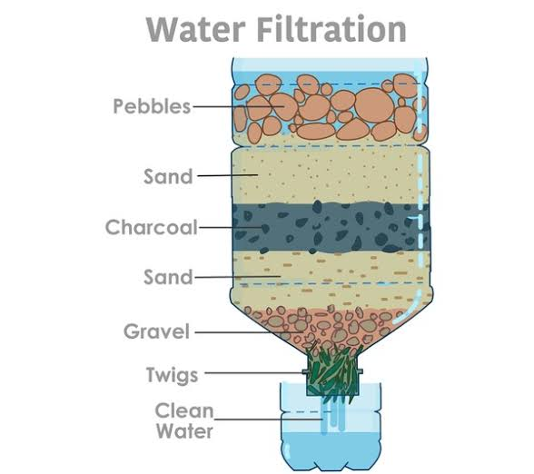

Fig. Water Filtration Process

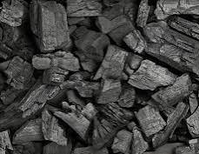 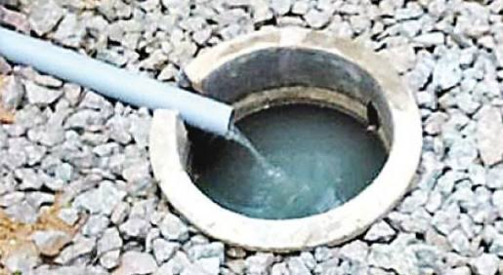

Fig. Charcoal Fig. Gravel

**III. LITERATURE REVIEW**

1. **Sand As A Filtration Medium In Wastewater Treatment:**

**Author: Elliott et al. Issue Year:2008**

The use of sand in filtration systems is well-documented in water and wastewater treatment. Sand is highly effective in removing particulate matter and suspended solid from water. According to Elliott et al. (2008), sand filters work through a combination of physical straining and biological processes. As water passes through the sand, larger particles and some pathogens are trapped, and biofilms can form on the surface of the sand grains, which aid in the breakdown of organic matter. In traditional slow sand filtration systems, the filtration layer removes turbidity and contributes to pathogen removal (Baumgartner et al.,2007). The depth and grain size of the sand used in a soak pit play a crucial role in determining its effectiveness in treating wastewater.

1. **Charcoal as an Adsorbent in Water Purification:**

**Author: Weber et al.-Issue Year:2006**

Charcoal, especially activated charcoal, is widely used in water purification due to its high adsorption capacity. Activated charcoal has a highly porous structure, allowing it to trap organic compounds, chemicals and certain heavy metals from wastewater (Weber,1972). Studies have shown that charcoal can significantly reduce odor, color, and organic pollutants in sewage water. Weber et al.(2006) further highlighted the ability of charcoal to adsorb organic contaminants, including pesticides, pharmaceutical residues, and other complex molecules, making it an essential component of natural filtration systems. The combination of sand and charcoal in soak pits improves not only the removal of suspended solids but also the adsorption of harmful dissolved substances.

1. **Combined Use Of Sand And Charcoal For Filtration .**

**Author: Stauber-Issue year:2006**

The integration of sand and charcoal in soak pit system has been studied in various contexts, particularly in rural wastewater treatment. charcoal enhance the treatment process by adsorbing organic and chemical pollutant that sand alone cannot remove. when wastewater passes through a sand charcoal filtration layer, the sand traps larger particle while the charcoal dissolved contaminants, improving the overall quality of the effluent. A study conducted by on bio-sand filters with added charcoal demonstrated improved removal of pathogens and contaminant. They concluded that charcoal porous structure makes it highly effective in removing a wide range of pollutant that pass through sand filtration. This is particularly useful in treating sewage water, which contains organic materials and potential chemical pollutants.

1. **A Study On Disposal Of Domestic Waste Water By Magic Soak Pit Method in Rural Areas.**

**Author: Akshay Matwadka, Sanket Patil- Issue Year :2019**

In this paper to study is about disposal of domestic waste water without creating unhygienic conditioned at domestic level. The study uses the method of magic soak pit for disposal waste water. The study identifies that the magic soak pit method is unhygienic safe to dispose the waste water. The method use is note only disposes the waste water. The method use is not only disposes the waste water but also increases the ground water level.

1. **Innovative Technologies For Waste Water Treatment.**

**Author: Shalini Kumari-Issue Year:2018**

The aim of this paper is to provide a review on the usage of different innovative technologies such as bioreactor septic tank and immobilizing commonly employed photocatalysts for degradation of organic pollutant. The immobilization of nano-sized photocatalysts can eliminate costly and impractical post treatment recovery of spent photocatalysts in large scale operation. Some commonly employed immobilization aids such as glass, carbonaceous substances, zeolites, clay and ceramics, polymers, cellulosic materials and metallic agents that have been previously discussed by various research groups have been reviewed. Another, cellulosic materials and for minimizing waste water is by using bio-reactor septic tank for treating waste water .In bio-reactor septic tank ,instead of soak pit three filter media is used namely coir filter, Surkhi adsorbent and sand filter.

1. **Aspects of Wastewater Collection ,Treatment and Reuse: Review of Principles and Practices**

**Author: Irefin M.O. and Okeke O.C. -Issue Year:2024**

The sources of wastewater also influence their composition and characteristics. Sewage is often used interchangeably with wastewater, although it often refers to liquid waste (mostly urine and faces from residential, industrial, institutional and commercial establishments. The purpose of wastewater treatment is to improve its quality for various purposes including drinking, domestic, industrial and agricultural uses. Two common methods of wastewater treatment are :biological treatment method (where microorganisms are used to reduce the BOD level in the wastewater) and mechanical treatment method (where a combination of physical, biological and chemical processes are used to achieve a treatment objective ,which are generally to reduce BOD,COD and TSS in the wastewater. In Nigeria and other countries of the world, wastewater may be used for groundwater recharge, as liquid in fire extinguishers and agricultural purposes (including irrigation).

1. **To Study the soak pit and bring a new view for future modification.**

**Author: Atharva Jadhav, Chetan Kshirsagar – Issue Year :2022**

A large number of Indian rivers are severely polluted due to disposal of domestic waste. The wastewater is directly discharged without treatment into the water bodies are causing environmental problems also affecting the health of human beings and it will create the environmental imbalance in aquatic life. Therefore the waste needs to be treated in rural areas in India there is less availability of drainage system so the waste water from house needs to be treated by decentralized method and make it available for domestic purpose like watering to the plants, washing clothes , agriculture etc. The object of this project is to treat the water at domestic level.

1. **Soak pits for wastewater management .water resources management;**

**Author: Haans, J, Khyar, S- Issue Year:2017**

Soak pits function by allowing wastewater to percolate through layers of soil, where physical ,chemical and biological processes degrade and filter contaminants .proper design, including appropriate sizing and location , is crucial for the efficacy of soak pits, as noted by Ghosh et al 2018.

1. **Household Waste Water Treatment With The Aid Of Activated Charcoal.**

**Author: Yadav S., Khan F., – Issue Year: 2024**

Using charcoal filtration resulted in a significant reduction in turbidity, with a 95% decrease. This suggest that charcoal filtration is highly effective at clarified water by successfully eliminating suspended particles. Further more,it substantially reduce 77% in total dissolved solid (TDS) demonstrating its effective elimination of dissolved contaminate from the water. we made significant progress in reducing BOD by 55% indicating successful degradation of organic contaminates.

1. **Multi Layer Filtration Systems For Waste Water Treatment.**

**Author: Rahman, M. – Issue Year:2020**

The combination of sand pit creates a multi layered filtration system that capitalizes on the strengths of both materials. As a this layer approach enhance removal efficiency of both particulate matter and dissolved contaminate.

**IV. CONCLUSION**

1] In this paper to study charcoal filtration effectively enhances various water quality ranges. Charcoal filtering reduced turbidity by 95.83%.charcoal particles remove suspended particles.

2] In this paper to study the waste water treatment refers to series of activities that are performed on waste water to remove or reduce their pollutant, particularly TDS, TSS, COD, BOD, Total Hardness, heavy metals, phosphorus and ammonia etc to make the waste water fit for reuses in several areas including ground water recharge, irrigation and liquid for fir extinguisher mechanical/biological treatment method are often used in the treatment process.

3] The review aim to focus on new application and advancements for reactor septic tank and photocatalyst increase. The construction is easy, consume less time and cost effective which is most important for developing countries.

4] After studying this method of disposing waste water found that the method is economical, easy to construct, effective in disposing the domestic waste water at house level.by using this method the problem of unhygienic condition near the houses is prevented and the production of mosquito is prevented. Hence the different decrease occurred due to unhygienic condition and mosquitos are prevented. This method gives a healthy life to people living in that particular area.

**V. REFERENCES**

1. Elliot, Sand as a filtration medium in waste water treatment Issue year-2008.
2. Weber, Charcoal as an Adsorbent in water purification. Issue year -2006.
3. Stauber, Combined use of sand and charcoal for filtration. Issue Year- 2006.
4. Akshay Matwadka, Sanket Patil, A study on disposal of domestic waste water by magic soak pit method in rural areas. Issue year -2019.International Research Journal of Engineering and technology ISSN2395-0056 Vol-06,Issue-03.
5. Shalini Kumari, Innovative Technologies for waste water treatment. Issue year-2018.International Journal for Multidisciplinary Research ISSN2582-2160,vol-1,Issue3.
6. Irefin M.O, Aspect of waste water collection, treatment and reuse. Issue Year-2024 International Journal of Geography & Environment Management vol 10 no.5.
7. Atharva Jadhav, Chetan Kshirsagar, To study the soak pit and bring a new view for future modification-2022
8. Haans, J, Khyar, S, Soak pit for waste water management water resources management issue year-2017. Water Resources Management.
9. Yadav S, Khan Household waste water treatment with the aid of activated charcoal. Issue year-2024.
10. Rahman,M,Multi layer filtration systems for waste water treatment. Issue year-2020. Journal of Cleaner Production.