TITLE: Advanced Solar Tracking System With Hybrid Sources.

**Authors details:**

Under the guidance of:

P.Dhanunjaya

9985017429

[Dhanunjaya.p@sseptp.org](mailto:Dhanunjaya.p@sseptp.org)

Sanskrithi School Of Engineering

Team members:

G.Sandhya – 7569790897 – [gunthapallisandhya@gmail.com](mailto:gunthapallisandhya@gmail.com) - Sanskrithi School Of Engineering.

M.Bhavana - 6305680343 – [mulakalabhavana@gmail.com](mailto:mulakalabhavana@gmail.com) - Sanskrithi School Of Engineering.

S.Komala – 7469380382 – [sallakomala24@gmail.com](mailto:sallakomala24@gmail.com) - Sanskrithi School Of Engineering.

T.Dhanusha- 8328118209- [tanguturidhanusha502@gmail.com](mailto:tanguturidhanusha502@gmail.com) – Sanskrithi School Of Engineering.

N. Mohammed Rasheed Ali – 7032407993- [n.mahammedrasheedali786@gmail.com](mailto:n.mahammedrasheedali786@gmail.com) - Sanskrithi School Of Engineering.

**ABSTRACT:**

This report paper deals with solar energy as key component in supplying the fast-increasing need for renewable energy. However, because of their stationary position, fixed solar panels are less efficient. In order to improve solar energy collecting, this project offers an Advanced Solar Tracking System with Hybrid Sources. Using stepper motors and an Arduino-based controller, the device moves the solar panel in a way that maximizes sunlight capture by following the path of the sun. A lithium-ion battery stores extra energy for a continuous power source, while a charge controller controls the energy flow. Even though solar energy is the primary source, a hybrid strategy is provided by the use of battery storage, which keeps the system running when there is little sunlight. When compared to fixed panels, the energy production is greatly increased by the tracking system. This idea offers a clever, affordable, and effective way to generate sustainable energy that may be used in remote and small-scale applications where dependable power is crucial.

**INTRODUCTION:**

The Advanced Solar Tracking System with Hybrid Sources is designed to increase solar energy efficiency and dependability. Because fixed solar panels are unable to track the movement of the sun, they are unable to collect as much energy as they could. This project uses an Arduino-controlled tracking system with stepper motors to allow the panel to follow the sun throughout the day. A charge controller securely controls the flow of power between the panel and a lithium-ion battery, which stores excess energy and uses it at night or during cloudy conditions. The system guarantees a continuous power supply and better energy usage, making it perfect for rural and remote areas with limited electricity. The goal is to provide a clever, economical, and sustainable energy solution using hybrid energy storage and tracking technology.

Monitoring the sun's location and storing solar energy for later use is how the project operates. A lithium-ion battery can be safely charged by a charge controller using electricity from a solar panel that collects sunshine. An Arduino rotates the panel to face the sun by using a motor driver to operate stepper motors. Energy generation and solar exposure are increased by this tracking. The load receives energy from the stored battery power when there is little sunlight. Simple parts of the system include the battery, stepper motors, charge controller, Arduino, solar panel, and driver. These components come together to form a dependable and effective system. The design is expandable and reasonably priced, making it appropriate for both home and field use. It performs more efficiently than static solar panels, particularly when the amount of sunshine varies.

There are numerous beneficial uses for this device in locations with inadequate or nonexistent power supplies. Remote monitoring stations, farms, off-grid areas, and rural houses can all use it. Even at night or in inclement weather, power is guaranteed by the battery backup. By improving solar panel performance by 20–30%, the tracking feature increases the efficiency of energy gathering. The technology supports clean energy goals and is inexpensive, environmentally beneficial, and simple to operate. Additionally, it teaches pupils about automation and embedded systems. It promotes carbon reduction and sustainable development by lessening dependency on fossil fuels. It creates a dependable power supply by combining energy storage, sophisticated control, and renewable energy. This makes it a sensible, environmentally friendly, and useful energy option for the future.

**PROPOSED SYSTEM:**

The proposed system is an advanced solar tracking setup that improves performance and efficiency using hybrid energy sources. It is comprised of a solar panel fixed on a tracking device that uses an Arduino-controlled stepper motor to track the sun's movement. The energy is stored and controlled by the system using a lithium-ion battery and a charge controller. Even with limited solar energy, the hybrid configuration guarantees that the power supply is maintained. A solar panel, charge controller, Arduino, stepper motor, motor driver, and battery are among the parts shown in the block diagram. This system is intended to supply reliable and efficient power from renewable sources in homes, businesses, or agricultural areas.

**WORKING THEORY:**

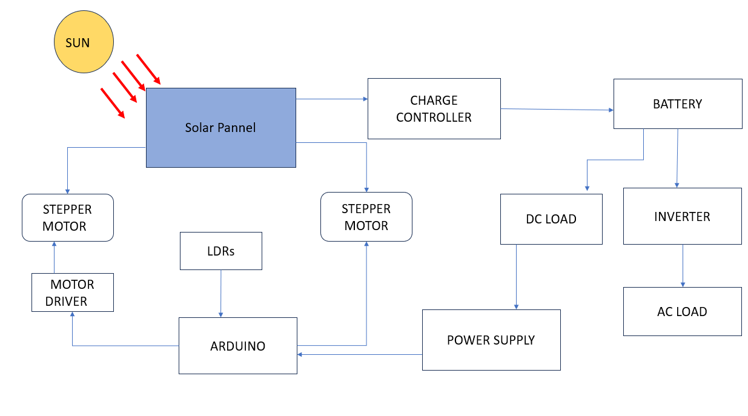

1. **SOLAR PANEL**: The solar panel generates electrical energy by absorbing sunlight. For optimal effectiveness, it is positioned on a frame that moves with the aid of stepper motors to continuously align itself with the sun.

2. **STEPPER MOTOR & DRIVER**: The panel is rotated in the direction of sunlight by stepper motors. To guarantee accurate and step-by-step movement, these are managed by a driver module (such as the ULN2003 or A4988), which receives control signals from the Arduino.

3. **CHARGE CONTROLLER**: The charge controller regulates the energy flow between the battery and the solar panel. By regulating voltage and current to prevent overcharging or deep draining of the lithium-ion battery, it guarantees safe and efficient charging.

4. **Arduino UNO**: It processes instructions to regulate the stepper motor's movement for panel alignment and battery charging logic after receiving inputs (such as time or sensor values, if applicable).

5. **LITHIUM-ION BATTERY**: A rechargeable lithium-ion battery stores the electrical energy produced by the solar panel. In overcast weather or at night when sunlight is scarce, this battery acts as a hybrid backup source to power the system.

6. **HYBRID POWER MANAGEMENT**: Depending on the amount of sunlight, the system automatically alternates between battery and solar power. The battery takes over to ensure continued functioning in the event that solar power is insufficient.

LDR: Detect the position of the sun by changing their resistance based on light intensity. Multiple LDRs help determine the sun’s direction, enabling the Arduino to adjust the panel’s position for optimal sunlight exposure.

**Software Requirements**: To program and upload control logic to the Arduino UNO board, the system is created using the Arduino IDE platform. The tools are discussed in the following paragraph.

**Arduino IDE**: Code can be written and uploaded to the Arduino UNO board using the Arduino IDE, an open-source integrated development environment. The stepper motors that turn the solar panel in the direction of the sun are controlled by the Arduino UNO, which is programmed using the Arduino IDE in the suggested way. Using straightforward control logic, it also regulates power input from the battery and solar panel. The IDE can be improved with additional libraries if a display or sensors are used, and it enables real-time testing and debugging using the Serial Monitor.

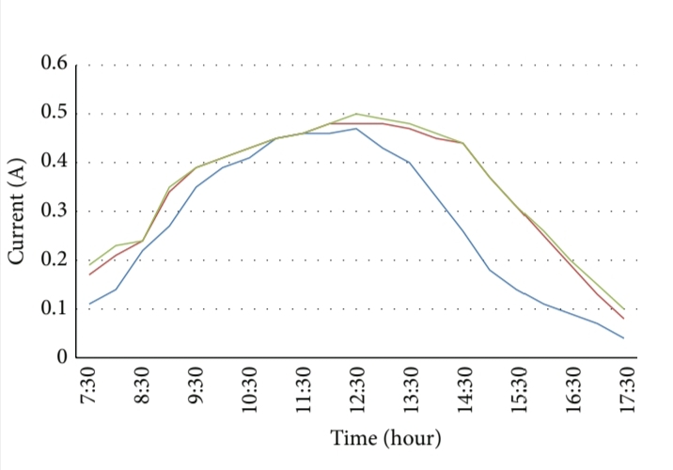

* length of solar panel, 𝐿 = 0.165 m; width of solar panel, 𝐷 = 0.23 m; height of solar panel, 𝐻 = 0.015 m;…….(1)
* Specifications of gears:

number of gear teeth, 𝑁1 = 𝑁2 = 24;

𝐽 = 𝜋 × 𝜌× 𝐿× 𝐷4 × ( 𝑁2 )2…….(2)

* Number of gear teeth ,N1 = N 2 so,

𝐽𝐺1 = 𝐽𝐺2 = 1 × 𝑚𝐺2 × 𝐷𝐺22 = 4.56 × 10−7 kg ⋅ m2….(3)

* Now, load torque is

𝑇𝐿 = 𝐹 × 𝐷 /2+ 𝑇𝐹 = 0.0423 N ⋅ m;………(4)

* Required motor torque is

𝑇𝑀 = 𝐾𝑠 × 𝑇𝑇 = 0.0958 N ⋅ m………(5)

**MODEL PIC:**

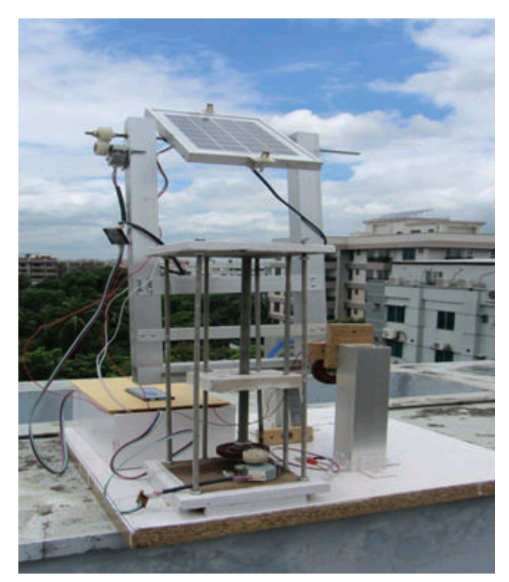

**OUTPUT PIC:**

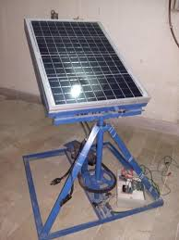

**CONCLUSION:**

A dependable and effective way to maximize solar energy utilization is the Advanced Solar Tracking System with Hybrid Sources. Compared to fixed systems, it greatly boosts power generation by automatically moving solar panels to follow the sun. The integration of hybrid sources like wind energy and battery backup enables uninterrupted power supply, even in low sunshine. The Arduino Uno-controlled system is affordable, adaptable, and easy to operate. It is perfect for both small- and large-scale use, particularly in rural and isolated locations, because it lessens reliance on fossil fuels and carbon emissions. There is a lot of promise for this environmentally friendly technology to be widely used in the industrial, residential, and agricultural sectors.

**References:**

[1] G. Deb and A. B. Roy, “Use of solar tracking system for

extracting solar energy,” International Journal of Computer and

Electrical Engineering, vol. 4, no. 1, pp. 42–46, 2012.

[2] T. Tudorache and L. Kreindler, “Design of a solar tracker system

for PV power plants,” Acta Polytechnica Hungarica, vol. 7, no. 1,

pp. 23–39, 2010.

[3] C.-L. Shen and C.-T. Tsai, “Double-linear approximation algorithm to achieve maximum-power-point tracking for photovoltaic arrays,” Energies, vol. 5, no. 6, pp. 1982–1997, 2012.

[4] K. Liu, “Dynamic characteristics and graphic monitoring design

of photovoltaic energy conversion system,” WSEAS Transactions on Systems, vol. 10, no. 8, pp. 239–248, 2011.

[5] T. Tudorache, C. D. Oancea, and L. Kreindler, “Performance

evaluation of a solar tracking PV panel,” U.P.B. Scientific

Bulletin, Series C: Electrical Engineering, vol. 74, no. 1, pp. 3–10,

2012.