**Dashboard Development Using PowerBI,Tableau,Excel**

**Rohini Sonawane, Tanuja More,Prerna Pawar,**

**Nilesh Sonawane,Tanvi Deshmukh,Jayshree Khairnar**

1Engineering Student, Artificial Intelligence & Data Science, GCOERC, Nashik, Maharashtra, India

2Engineering Student, Artificial Intelligence & Data Science, GCOERC, Nashik, Maharashtra, India

3Engineering Student, Artificial Intelligence & Data Science, GCOERC, Nashik, Maharashtra, India

4Professor,Artificial Intelligence & Data Science, GCOERC, Nashik, Maharashtra, India

5Professor,Artificial Intelligence & Data Science, GCOERC, Nashik, Maharashtra, India

6Professor,Artificial Intelligence & Data Science, GCOERC, Nashik, Maharashtra, India

**ABSTRACT (Font-Times New Roman, Bold, Font Size -12)**

Businesses are now able to make informed decisions thanks to the increasing importance of Data Science in the data-driven world. This internship at Acmegrade Pvt Ltd. Provided hands-on experience in Data analysis, presentation, and evaluation on dashboards.Using tools like Tableau, Excel,PowerBI.The primary focus was on Data cleaning, preprocessing, and visualization.Tips for making informed decisions based on empirical data.The internship involved working with a variety of Python libraries, including one by One.Pandas, NumPy, and Matplotlib.We utilized data visualization and manipulation.In addition to creating dashboards, SQL was used for database management and querying.Power BI and Tableau.Enhanced the effectiveness of data visualization and analysis.The internship led to the creation of an innovative product. Which is Amazon Prime dashboard in Tableau.Power BI data-driven project.This document details the practices, tools and techniques used during the internship; emphasis on these methods for industry-specific data analysis. The lessons learned have developed problem-solving skills and analytical proficiency, establishing a solid foundation for future employment in the field.

Data science and business intelligence.

**Keywords:** Data Science, Data Analytics, Python Programming,PoweBI,Tableau,Excel.

1. **INTRODUCTION (Font-Times New Roman, Bold, Font Size -12)**

The use of Data Science in the present day enables the extraction of information from vast amounts of data to make informed decisions. This Project Showcase experience in data analytics, visualization, and dashboard building using Python, Power BI, Tableau, or Excel. Specifically, the focus was on comprehending and utilizing data preprocessing/analysis/visualization techniques in real-world contexts.Internship training involved using Python libraries like Pandas and NumPy to manipulate data, SQL to manage databases effectively, and Power BI (Internet query processing) & Tableau to develop interactive dashboards. The real world aspect of business intelligence and analytics was showcased through the creation of an Amazon Prime Dashboard using Tableau. This was a significant experience. .

1. **METHODOLOGY**

This project's methodology outlines the approach taken to create interactive dashboards for Amazon Prime using Power BI, Tableau, Excel, and Python.The process involved data collection,preprocessing,analysis,and visualization,to extract meaningful insights from large datasets.

**2.1. Data Collection.**

Public datasets, APIs and SQL databases were all used to obtain the data. Python libraries like Pandas were utilized for data extraction and cleaning..

**2.2. Data Preprocessing.**

It also processed the raw data by preprocessing missing values, transforming the data and performing feature engineering. The use of normalization and encoding techniques was implemented to ensure the correctness of data against analytical tools.

**2.3. Data Analysis and Visualization.**

Statistical analysis, data manipulation and visualization are all possible uses of Python programming language.The purpose of SQL is to query structured databases and filter out pertinent data.Utilized in Excel for data manipulation, pivot tables, and initial exploratory testing.Utilizing Power BI and Tableau, it was utilized to create interactive dashboards that conveyed insights into Amazon Prime's user experience, trends, and content.Using Matplotlib & Seaborn: Used to produce detailed visual patterns of data.

**2.4. Dashboard Development**.

A complete Amazon Prime Dashboard was produced using Power BI, Tableau and Excel. A structured business intelligence model was created by these dashboards, which captured data on content trends, user engagement patterns, and streaming patterns.

**2.5. Conclusion.**

It also provided valuable lessons on data analysis and data visualization using Power BI, Tableau (a cross-platform modelling framework), Excel and Python. Key trends are effectively displayed on the newly created Amazon Prime dashboard, which facilitates data-driven decision-making.

1. **MODELING AND ANALYSIS**

This section discusses the methods and tools used for data modeling and analysis in the project. The aim was to Transform raw amazon prime data into meaningful insights using these tools.

3.1. Data Preparation and Cleaning.

The use of Python (Pandas & NumPy) is applicable for data manipulation, missing values, and feature engineering.Used for extracting, filtering and joining several sets of data using SQL.Utilized in Excel for preliminary data extraction, pivot tables, and exploratory work.

3.2. Data Modeling.

By using SQL, the dataset was sorted into tables that could be displayed.Dashboard integration was made possible by utilizing ETL (Extract, Transform and Load) processes for data cleaning and preparation.Power BI and Tableau were utilized to create data relationships and hierarchies for interactive reporting.

3.3 Data Analysis

Statistical Analysis:

Applied descriptive statistics (mean, median, standard deviation) to summarize trends.Recognized patterns in content viewing, user tastes, and geographic trends.

Visualization and Insights:

Power BI & Tableau dashboards were created to display trends in streaming behavior.Bar charts, pie charts, heatmaps, and time-series graphs were employed to examine engagement metrics.Matplotlib & Seaborn were used to create custom visualizations in Python.

3.4 Key Findings

Amazon Prime dashboard gave an accurate visualization of content trends, user demographics, and viewing patterns.Seasonal trends and in-demand genres were determined, permitting improved content suggestion.Interactive dashboards facilitated exploratory data analysis, allowing for easy access to insights.

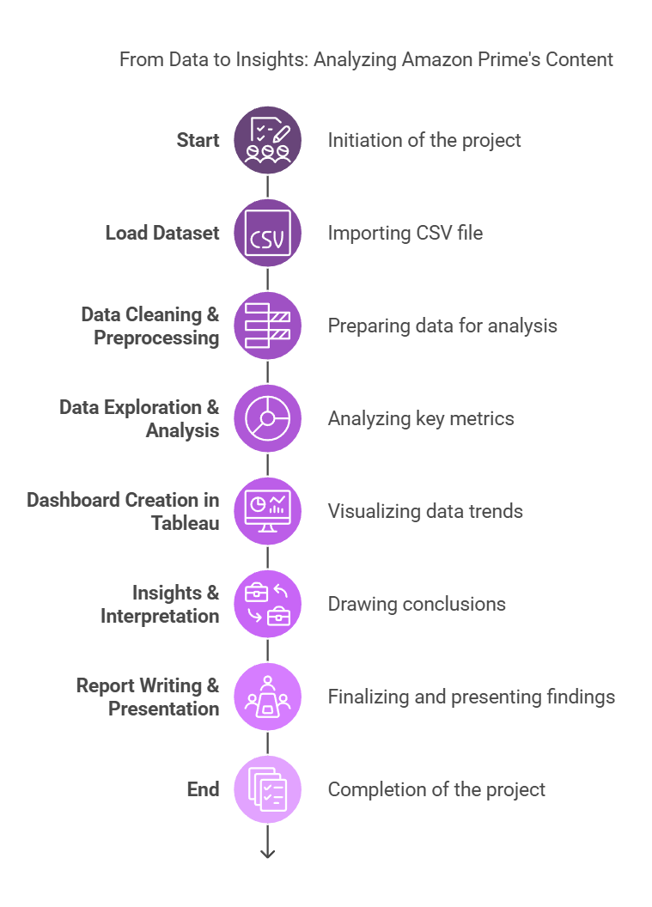

1. **RESULTS AND DISCUSSION**

4.1 Results-The project was able to create an Amazon Prime dashboard using Power BI, Tableau, Excel, and Python, and was able to gain important insights into streaming patterns. The findings point to:

Content Popularity: Determined the most streamed genres, movies, and television shows.

User Engagement: View patterns were analyzed in terms of region, time, and demographics.

Trend Analysis: Seasonal changes in streaming patterns were observed, with the highest activity observed during holidays.

Visual Representation: Interactive dashboards enabled dynamic filtering and data exploration.

4.2 Discussion

Data preprocessing facilitated valid and clean datasets to make the insights more reliable.

SQL and Python were used to execute complex queries and transformations efficiently to analyze data in-depth.Power BI and Tableau enabled interactive, visually appealing dashboards to interpret data better.The findings illustrate the significance of data-driven decision-making across streaming platforms to optimize content and target the audience better.

Limitations include data availability and possible bias in data collection, which can be addressed with a greater dataset.

1. **CONCLUSION**

The results of this project highlight the strength of data analytics in entertainment businesses, enabling companies to maximize their content strategy according to audience demand. Future enhancements may include real-time data integration and machine learning algorithms for predictive analytics.

**7.REFERENCES**

[1] https://docs.python.org/3/tutorial/index.html

[2] <https://www.geeksforgeeks.org/sql-tutorial/>

[3] <https://help.tableau.com/current/guides.htm>

[4] <https://learn.microsoft.com/en-us/power-bi/>

[5] http://powerbi.microsoft.com/en-us/blog/

[6] <https://www.mysql.com/products/workbench/>

[7] <https://www.kaggle.com/>