**EV BMS With Charge Monitor and Fire Detection**

A .Sree Varshitha*1 ,B .Harsha Nandini2 ,N.A Preethi Reddy3, K. Shiva Shankar Reddy4 , P. Rudrateja5

Department of Electrical and Electronics Engineering ,Sanskrithi School of Engineering , Puttaparthi , Andhra Pradesh, India.

**Abstract** : Electric vehicles (EVs) are undoubtedly the way of the future.However, in terms of efficiency and safety, EV technology has not yet realized its full potential as of 2023. Battery explosions or fires are the primary cause of most electric vehicle fire incidents. The integrated approach to managing EV battery systems shown in this study incorporates fire detection, charge monitoring, and a Battery Management System (BMS). The battery's voltage, current, and temperature are continuously monitored by the system, which is designed to cut off the battery's input or output right away if any unusual behavior is detected.

***Keywords:*** *EVs, BMS, Temperature Sensor*

**Introduction**

Electric vehicle (EV) adoption has been rising gradually in recent years due to a number of causes, including government incentives, fuel efficiency, and environmental concerns. To guarantee the security and effectiveness of EVs, however, controlling the battery systems that drive them is a significant problem that needs to be solved. An EV's battery system is made up of multiple battery cells that must be watched over and controlled to avoid overcharging or discharging, which could result in a lower battery life. Battery cells, battery life, decreased performance, and even safety risks like fires make up the BMS.

sensors and the battery management unit, which cooperate to keep an eye on and control the While the battery is charged, voltage sensors are employed to keep an eye on the voltage and regulate how much current can go to it. This is accomplished through the use of charging circuitry. The LCD shows the voltage of the battery. When connected to a load, the current sensor measures the current extracted from the battery and displays the parameter on the LCD. The battery's temperature is monitored by the temperature sensor during both charging and draining. If the battery temperature is observed to deviate from the usual values, the system automatically sounds a buzzer alarm and shows a message on the LCD. Consequently, the technology makes it possible for a clever and efficient battery charging and detection system.   
temperature, charge level, and overall health of the battery. Real-time input on the charging process, including power delivery, battery charge level, and charging pace, is provided via the charge monitoring system. In order to identify and stop possible fires, the fire protection system

also combines thermal management and fire suppression techniques.

2 Block diagram of BMS

The voltage regulator LM2576 family of monolithic integrated circuits provides all the active functions required for a step down (buck) switching regulator. There are fixed variants with fixed outputs of 3.3V, 5V, or 12V. Variable versions have an output voltage range of 1.23 to 37 volts. Both versions can drive a 3A load and have good line and load regulation.

A common microcontroller type seen in a wide variety of devices is the STM32. It can also be connected to a number of other types of microcontrollers. Based on a 32-bit ARM Cortex-M processing core, STMicroelectronics created the STM32 range of microcontroller units (MCUS). This micro controller can be connected to a wide range of external devices, such as sensors, cameras, motors, and other devices, using a series and parallel communication technique.

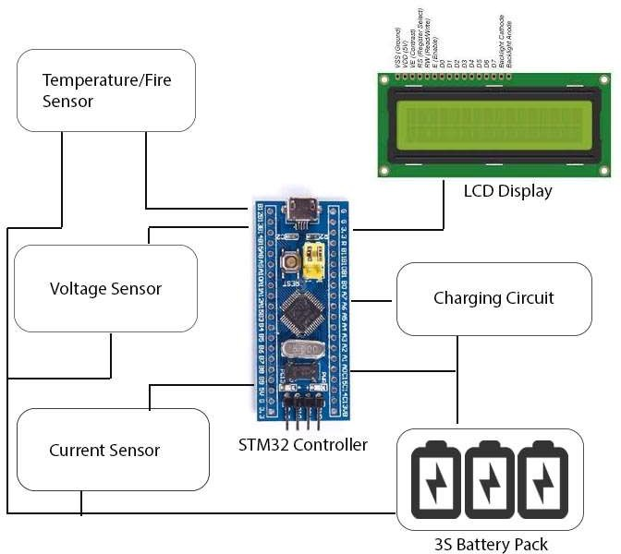

**Fig.1** Battery Management System

One popular temperature sensor is the DHT11. The circuit diagram is shown in Fig. 1. In addition to a specialized NTC for temperature measurement, the sensor features an 8-bit microcontroller for serial data output of temperature and humidity information. Additionally, the sensor is calibrated in the factory, making interaction with other micro controllers easier.   
With an accuracy of 1°C and 1%, the sensor can measure temperature between 0°C and 50°C and humidity between 20% and 90%.

**3 CIRCUIT DIAGRAM OF BMS**

To guarantee that the battery is charged safely and effectively, a Battery Management System (BMS) with a charge monitor usually keeps an eye on the battery pack's charge level and regulates the charging procedure.

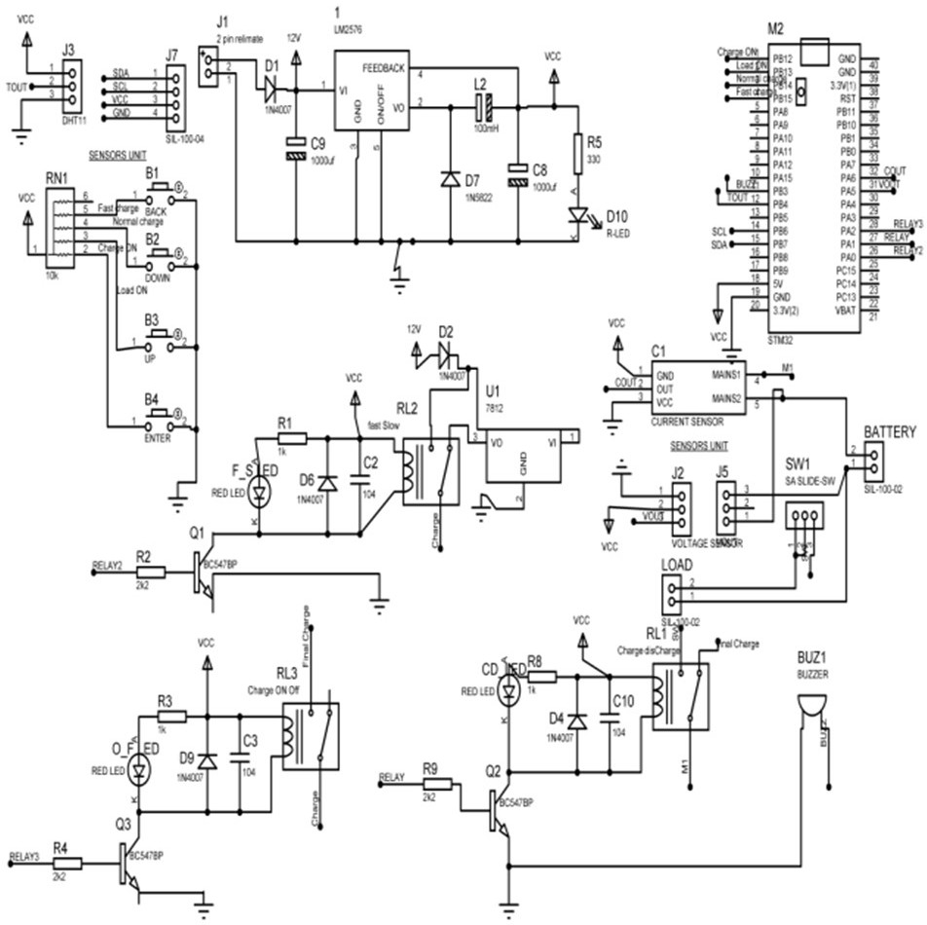

**Fig.3.** Circuit Diagram of BattryMangement System

1. The basic steps involved are as follows:

i.Charge monitoring: To ascertain the battery pack's state of charge (SOC), the BMS keeps an eye on its charging voltage and current.

ii.Charge control: To avoid overcharging and overheating, the BMS regulates the charging process by modifying the charging current and voltage based on the SOC data.

iii. Charge balancing: In order to avoid overcharging any cell, the BMS also makes sure that each cell in the battery pack is charged to the same voltage level.  
iv Data collection: The BMS gathers and keeps track of information regarding the battery's health and performance, including temperature, charging and discharging history, charge level, and any anomalies found while it is in use.

v. Communication: The BMS provides real-time information about the battery's health and performance to the user or the system where the battery is mounted.   
All things considered, the BMS with charge monitoring offers a comprehensive solution for controlling a battery pack's charging process, guaranteeing its secure and effective operation, and increasing its lifespan.

**4.PROTECTION IN BMS**

Designing Battery Management Systems (BMS) with fire prevention in mind is essential, particularly for large battery packs used in renewable energy systems, electric vehicles, and other applications. BMS can offer fire safety in the following ways:   
i. **Temperature monitorin**g: The BMS keeps an eye on the battery pack's and each cell's

temperature and takes appropriate action if it rises above the safe threshold. The BMS has the ability to sound alarms, cut off the battery pack from the load, or start other fire safety precautions if the temperature reaches a critical point.

ii. **Protection against overcharging and overdischarging:** The BMS guards against these two situations, which might result in overheating and a fire.

iii. **Protection from short circuits**: The BMS guards against short circuits, which can result in excessive current flows and fire.

iv. **Isolation:** To stop thermal runaway and the spread of fire, the BMS can separate a malfunctioning cell or module from the remainder of the battery pack.

v. **Ventilation**: To eliminate heat from the battery pack and lower the chance of a fire, the BMS can install a ventilation system.

vi. **Fire suppression**: In the event of an emergency, the BMS may incorporate a fire suppression system, such as a fire extinguisher or fire-retardant material, to put out or control fire.   
All things considered, fire safety is a key factor in BMS design, and a well-thought-out BMS can assist avoid fires and guarantee battery pack safety.

**5 Results**

The charging procedure is carried out by selecting the charge option using the push buttons attached to the STM32 Micro-Controller's B12, B13, B14, and B15 pins, as illustrated in Fig. 4.

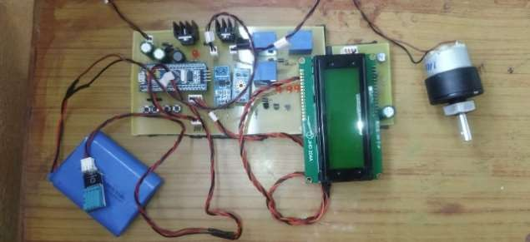

**Fig.4** Control Circuit Connections

i. The voltage gradually rises during the charging process, as shown by the LED glows and LCD display.

ii. The voltage cutoff occurs when the battery is fully charged because a voltage sensor detects a voltage above 12 volts, and an LED turns off. Sensors that are displayed on a 16*4 LCD display in Figure 5 monitor and regulate all changes in parameters like as current, voltage, temperature, and so on.

iii. The cutoff current, approximately 5 amperes, is much higher than what is needed for safe charging.

IV. Likewise, the voltage will drop throughout the discharging process seen in Fig. 6. The power consumption in this case is a load with a 12v voltage capacity. Additionally, when energy is used up, a process known as discharging occurs, which causes the temperature to steadily rise.

V. The temperature increase brought on by fire hazards or short circuit conditions is depicted in Figures 5.8.7 and 5.8.8. The buzzer, which is used for fire or heat indication, sounds if the temperature rises above the set limit, or 500C. Here, the temperature is sensed using the DHT11 module.  
Since it is generally recommended to charge below half the capacity, or 0.5c, for safe charging, it could be wise to install an additional CC or CV regulator to control the amount of current during charge.

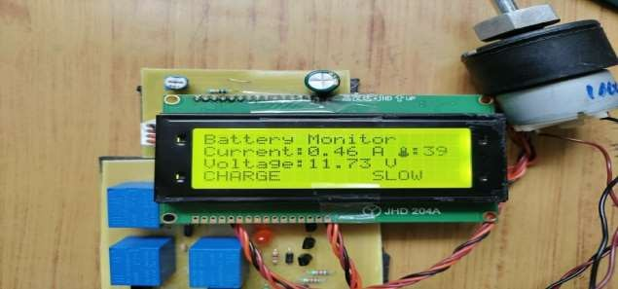

**Fig.5** DISPLAY OF BATTERY WHILE SLOW CHARGING

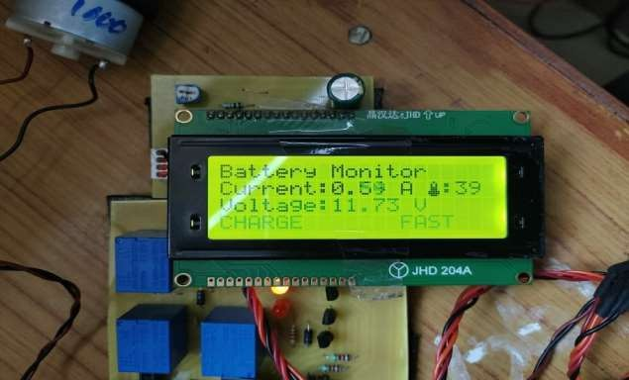

**Fig. 6** DISPLAY OF BATTERY WHILE FAST CHARGING

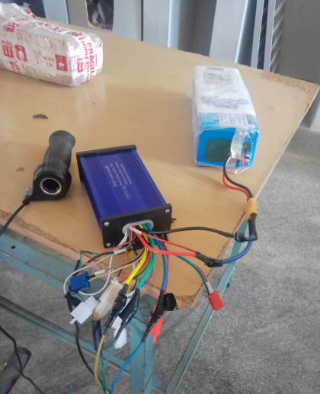

**Fig. 7** BMS WITH CONTROLLER CONNECTION

**6 Conclusions**

In the event that any unusual behavior is detected, the system is designed to quickly cease taking input or output from the battery and to continuously monitor battery voltage, current, and tempareture.   
This system provides the following benefits:

i.Display and monitoring of battery status

ii. Battery charging based on the required input parameters

iii.Automatically monitoring the temperature and cutting off

Our developed system will not only monitor the battery and safely charge it, but it will also prevent mishaps. The user can safely charge the 3S battery by turning on the system, which activates its charging and monitoring circuitry. When the battery is attached to a load, the current sensor measures the current and shows the parameter on the LCD screen.

These hardware modules were developed with the goal of providing a fundamental defense. We made an effort to incorporate nearly every platform-specific requirement into the design of these hardware modules, including: 1) Flexible 2) User-friendly 3) Have conversations with users 4) The latest advancements in technology Even with all of these features, there is still a lot of space for development, thus work on this platform will continue.

**REFERENCES**

1. M. Brandl *et al*., "Batteries and battery management systems for electric vehicles," *2012 Design, Automation & Test in Europe Conference & Exhibition (DATE)*, Dresden, Germany, 2012, pp. 971-976, doi: 10.1109/DATE.2012.6176637.
2. M. J. Riezenman, "Electric vehicles," in *IEEE Spectrum*, vol. 29, no. 11, pp. 18-21, Nov. 1992,
3. V. Vaideeswaran, S. Bhuvanesh and M. Devasena, "Battery Management Systems for Electric Vehicles using Lithium-Ion Batteries," *2019 Innovations in Power and Advanced Computing Technologies (i-PACT)*, Vellore, India, 2019, pp. 1-9, doi: 10.1109/i-PACT44901.2019.8959965.
4. J. Qiang, L. Yang, G. Ao and H. Zhong, "Battery Management System for Electric Vehicle Application," *2006 IEEE International Conference on Vehicular Electronics and Safety*, Shanghai, China, 2006, pp. 134-138, doi: 10.1109/ICVES.2006.371569.
5. K. Kadirvel, J. Carpenter, P. Huynh, J. M. Ross, R. Shoemaker, and B.Lum-Shue- Chan, “A Stackable, 6Cell, Li-Ion, Battery Management IC for Electric Vehicles With 13, 12-bit ΣΔ ADCs, Cell voltage balancing, and Direct-Connect Current-Mode Communications,” IEEE J. Solid-State Circuits, vol. 49, no. 4, pp. 928–934, 2014.