**AN ANALYSIS OF THE DIFFICULTIES FREIGHT FORWARDERS FACE**

Anujith S1,Abirami R2,

1MBA Student, School of Arts, Humanities and Management, Jeppiaar University, Chennai, India.

2Associate Professor, School of Arts, Humanities and Management, Jeppiaar University, Chennai, India.

1***anuanujith013@gmail.com***,

2***abi.prof2009@gmail.com***,

**ABSTRACT**

In order to satisfy customer needs, logistics management, also known as supply chain management, is the branch of supply chain management that organizes, carries out, and regulates the effective, efficient, forward, and reverse flow and storage of goods, services, and associated data between the point of origin and the point of consumption. An individual or business that arranges shipments for people or businesses to get bulk orders from producers or manufacturers to markets or ultimate distribution points is known as a freight forwarder. Analyzing the difficulties faced by freight forwarders from the perspective of carriers, businesses, and individual clients is crucial.to determine the degree of satisfaction with freight forwarding terms and conditions and customs clearance. Finding the answers to prevent issues and ensure that business operations run smoothly is simple. Logistics will be able to secure a fair market share with the aid of this. Convenience sampling is used in the study. The information was gathered from workers at reputable companies. One hundred and ten people answered the survey that was distributed using Google Form. The provided data was analyzed using a percentage approach.  
  
**KEYWORDS:** third-party logistics, logistics, freight forwarder, analysis, and difficulties.

**INTRODUCTION**

to transport high-quality goods both domestically and internationally. The freight transportation system is essential to nations. An individual or business that ships goods via asset-based carriers and reserves space for such shipments is known as a freight forwarder.  
  
A wide range of intricate long-distance transportation services are necessary for the transit of international freight between countries. Shippers, commercial for-hire carriers, third-party logistic providers, and consignees are among the several parties involved in the process. Furthermore, seaport services are essential to international trade because they enable the long-distance movement of massive amounts of goods via a range of transportation methods. For international trade to be effective, these services' and participants' interactions are essential.

Usually, freight forwarders plan the transportation of goods to a foreign location. Also known as international freight forwarders, they possess the knowledge and experience necessary to handle the associated tasks for overseas shipments in addition to preparing and processing the necessary paperwork. The commercial invoice is one of the documents that a freight forwarder usually reviews. documentation needed by the carrier or the nation of export, import, or transshipment, such as the shipper's export declaration and bill of lading. Nowadays, a large portion of this data is processed without paper.

**OBJECTIVES OF THE STUDY**

1. to research the difficulties that freight forwarders encounter.
2. to evaluate the difficulties that freight forwarders encounter from the airlines.
3. to examine the difficulties that freight forwarders encounter from both businesses and private clients.
4. to determine the degree of satisfaction with terms and conditions and customs clearance

**LITERATURE REVIEW**

In a 2009 study titled "Logistics and Customer Value," Mohitayalamanchi focuses on the value that businesses have created for their customers through logistics management as they look for innovative ways to gain a competitive advantage. Numerous new tools and strategies, such as a focus on logistical customer service, supply chain management, and the formation of strategic alliances, have surfaced as proactive components of the logistics response to the challenge of creating value for the customer. It explains the varied actions performed by various businesses to find and apply quality improvement procedures in the logistics domains.

Sebastian (2008): An Analysis of "Logistics Industry Issues." The study's goal was to identify the issues facing the logistics sector. He came to the conclusion that the logistics sector in India lacks adequate planning and that its present workforce should hone their abilities in a wide range of crucial transportation and logistics concepts. He concluded by saying that there should be a careful balance between practical application and sound knowledge.

"Logistics service driven loyalty: an exploratory study," by Beth R. Davis (2006). The Journal concludes that firms should continuously focus on enhancing logistics customer service and demonstrates that supply chain relationships can be a stable source of competitive advantage to firms in the supply chain due to their potential to establish barriers to existing competitors. Suppliers are making an effort to anticipate and be more proactive with their clients.  
  
Mayur S. Nakhava and S. Ramachandran (2018) emphasized the logistics industry's perspective on the problems and difficulties it faces. Infrastructure, technology, and services interact in the logistics sector to help customers save money and time on transportation.They examined the difficulties facing the port industry, transportation, storage infrastructure, technology, and its extent.  
  
S. Swathy (2018) discussed the main issues that exporters have with their service providers as well as their satisfaction with the freight forwarder's services. This study included surveys, data, and findings and was descriptive in nature. A created and validated questionnaire was used to gather data. The Garrett ranking system, weighted average, and basic percentage analysis were used to analyze the gathered data. The results are tabulated and explained.

**METHODOLOGY**

The primary objective of research methodology is to frame the research process as well as the designs and instruments that will be employed for the project. Analysis of the difficulties faced by freight forwarders from the carriers is aided by research technique. The purpose of the research technique is to examine the difficulties that freight forwarders encounter.

**RESEARCH DESIGN**

A study that aims to accurately portray the participants is known as descriptive research. In a nutshell, descriptive research is all about characterizing study participants.

**SAMPLING TECHNIQUE**   
One of the primary categories of non-probability sampling techniques is a convenience sample. People who are easily accessible make up a convenience sample.

**RESULTS**

percentage analysis

**TABLE 5.1: Mode of transport**

|  |  |  |
| --- | --- | --- |
| **Particular** | **No of response** | **Percentage** |
| Seaways | 45 | 41 |
| Airways | 33 | 30 |
| Railways | 13 | 12 |
| Roadways | 19 | 17 |
| total | 110 | 100 |

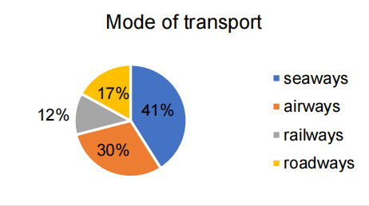

**INTERPRETATION**

According to the above table, 41% of respondents said they preferred taking the sea, while 30% said they preferred taking the air.

**TABLE 5.2: Challenge faced from carriers during freight forwarding**

|  |  |  |
| --- | --- | --- |
| **Particular** | **No of response** | **Percentage** |
| Delay shipment | 35 | 32 |
| Damaging of goods | 44 | 40 |
| Poor communication | 19 | 17 |
| Frequent rise in freight rate | 8 | 7 |
| Bulk order priority | 4 | 4 |
| Total | 110 | 100 |

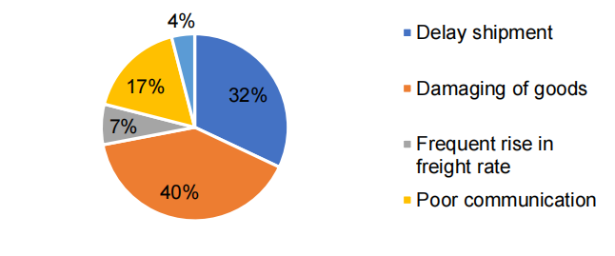

**INTERPRETATION**

According to the above data, 40% of respondents believe that the largest problem carriers face when forwarding freight is package damage.

**Table 5.3: Challenge faced from companies or individual customers during freight forwarding**

|  |  |  |
| --- | --- | --- |
| **Particular** | **No of response** | **Percentage** |
| Delay in receiving the goods | 42 | 38 |
| Damaged packages | 33 | 30 |
| Poor communication | 17 | 16 |
| Payment delays | 12 | 11 |
| Competitive pricing of freight rate | 6 | 5 |
| Total | 110 | 100 |

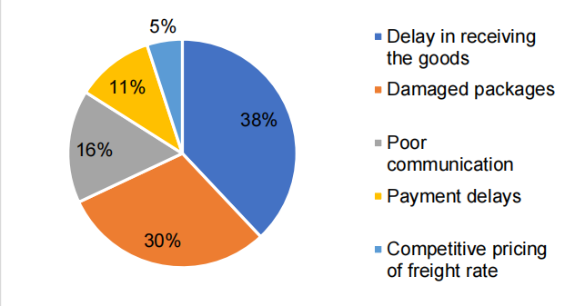

**INTERPRETATION**

According to the above data, 38% of respondents believe that the largest obstacle that businesses or individual consumers experience when shipping goods is a delay in receiving them.

**TABLE 5.4: Terms and conditions**

|  |  |  |
| --- | --- | --- |
| **Particular** | **No of response** | **Percentage** |
| High satisfied | 33 | 30 |
| Satisfied | 61 | 55 |
| Neutral | 11 | 10 |
| Dissatisfied | 5 | 5 |
| High dissatisfied | 0 | 0 |
| Total | 110 | 100 |

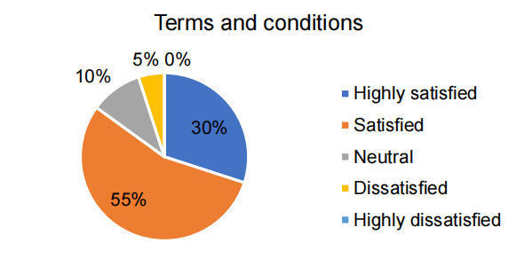

**INTERPRETATION**

According to the above table, 55% of respondents declare themselves satisfied with the terms and circumstances of freight forwarding, while 5% express dissatisfaction.

**TABLE 5.5: Custom Clearance**

|  |  |  |
| --- | --- | --- |
| **Particular** | **No of response** | **Percentage** |
| High satisfied | 33 | 30 |
| Satisfied | 57 | 52 |
| Neutral | 15 | 14 |
| Dissatisfied | 5 | 4 |
| High dissatisfied | 0 | 0 |
| Total | 110 | 100 |

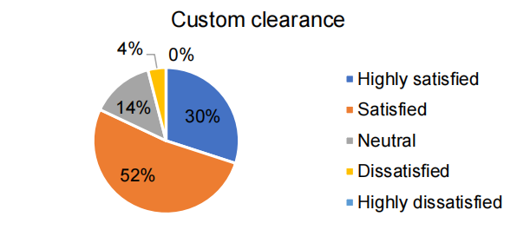

**INTERPRETATION**

It can be inferred from the preceding table that 52% of respondents are satisfied with the custom clearance, and 30% of respondents are extremely satisfied.

**FINDINGS**

1. The majority Seaways are the preferred means of transportation for 41% of the respondents.
2. The majority According to 40% of respondents, the largest problem carriers experience when forwarding freight is package damage.
3. The majority According to 38% of the respondents, the largest issue that businesses or individual consumers suffer with freight forwarding is a delay in obtaining the goods.
4. The majority The terms and conditions of freight forwarding are deemed satisfactory by 55% of the respondents.
5. The majority Of those surveyed, 52% are happy with the customs clearance.
6. The majority of respondents (43%) said they export items on a weekly basis.
7. The majority of respondents (41%) said they import products every two weeks.
8. The majority 38% of those surveyed are happy with freight costs.
9. The majority of respondents—41 percent—state that they conduct business worldwide.
10. The majority Seaways are the preferred means of transportation for 41% of the respondents.

**CONCLUSION**  
According to the report, the majority of participants express satisfaction with freight prices, freight forwarding terms and conditions, and customs clearance. According to the majority of respondents, the largest problems faced by carriers during freight forwarding are damaged packages, and the biggest problems faced by businesses or individual consumers during freight forwarding are delays in getting the goods. Therefore, the organization should work to prevent package damage and ensure that cargo arrives on schedule. and enhance their correspondence with carriers. The organization can guarantee complete protection against product damage and theft. It will improve the company's reputation.

**REFERENCES**

1. John Smith. "A Study on Problems Faced by Freight Forwarders in the Chennai Region." XYZ University Master's Thesis, 2022.
2. Ravi Patel, author of "An Analysis of Regulatory Constraints on Freight Forwarding Operations in Chennai." Journal of Logistics Management International, 2020.
3. Transportation Research, 2018. Gupta, Priya. "Infrastructure Bottlenecks in the Freight Forwarding Industry: A Case Study of Chennai Port."
4. Sanjay Kumar, "Impact of Customs Regulations on Freight Forwarders' Performance in Chennai: A Quantitative Analysis." 2021 International Journal of Transport and Shipping Logistics.
5. Bandeira, D.L., Becker, J.L. and Borenstein, D., 2009. A DSS for integrated distribution of empty and full containers. Decision Support Systems, 47(4), pp.383–397.
6. Boile, M., Theofanis, S. and Mittal, N., 2004. Empty intermodal containers—a global issue. Proceedings of the 2004 Transportation.
7. Braekers, K., Janssens, G.K. and Caris, A., 2011. Challenges in Managing Empty Container Movements at Multiple Planning Levels. Transport Reviews, 31(6), pp.681–708.
8. Brito, M. De and Konings, R., 2011. Container management strategies to deal with the East-West flows imbalance. In: Nectar Cluster Meeting on Freight Delft, pp.1–14.
9. Crainic, T., Gendreau, M. and Dejax, P., 1993. Dynamic and stochastic models for the allocation of empty containers. Operations Research, 41(1), pp.102–126.
10. Diaz, R., Talley, W. and Tulpule, M., 2011. Forecasting Empty Container Volumes. The Asian Journal of Shipping and Logistics, 27(2), pp.217–236.