RESEARCH ON SMART MEDICINE REMINDER USING ARDUINO AND RTC

# Prof. Ganesh Sarmokaddam [Guide]

Assistant Professor, Department Electronics and Communication, PCE ,Nagpur, India.

# Ms. Sonali Parate

Department Electronics and Communication, PCE ,Nagpur, India.

# Ms. Prerna Pimpalshende

Department Electronics and Communication, PCE ,Nagpur, India.

# Mr. Rakesh Nindekar

Department Electronics and Communication, PCE ,Nagpur, India.

# Mr. Abhay Ukey

Department Electronics and Communication, PCE ,Nagpur, India.

**ABSTRACT—** Elderly patients, especially those managing chronic conditions like diabetes, hypertension, respiratory issues, heart disease, and cancer, often face challenges in adhering to their prescribed pill schedules. This lack of adherence can lead to serious health complications. The inspiration for this paper came from observing the struggles of individuals in hospitals and in everyday settings who are dealing with these health issues. To address this concern, the Smart Medicine Reminder System was developed.

The Smart Medicine Reminder System is an innovative healthcare solution aimed at improving medication adherence and reducing missed doses. Built on an Arduino Mega platform, the system integrates a 4x4 keypad for user-friendly input of medication schedules, an RTC module for precise timing, and a 16x2 LCD display to provide clear visual instructions. At scheduled times, the system activates a buzzer and a voice alert module (APR33A3) to remind users to take their prescribed tablets. IR sensors monitor tablet compartments, detecting whether the tablets have been taken. If a dose is missed, the GSM SIM800L module sends an SMS notification to a caregiver or family member, ensuring prompt action. This system combines real-time monitoring, reminders, and communication features to promote better health outcomes and enhance patient compliance with prescribed medication regimens.

**Keywords- Medication Adherence, Smart Medicine Reminder, Healthcare Automation.**

## INTRODUCTION

Nowadays, people are always busy at their work. They can’t even pay attention to their own health. Which leads to serious health disorders. Also, the medicine taken by people is increasing day-by-day. Adherence to medication schedules is critical for managing chronic illnesses, maintaining health, and improving overall treatment outcomes. However, many individuals, especially the elderly or those with cognitive impairments, struggle to remember their medication schedules, leading to missed doses and potential health complications. The Smart Medicine Reminder System addresses this issue by providing an efficient, technology-driven solution to ensure timely medication intake while involving caregivers in real-time monitoring. This system combines multiple features like reminders, real-time monitoring, and SMS notifications, offering an integrated approach to medication management. By leveraging simple yet effective components, it ensures accessibility and affordability for users from diverse backgrounds.

At its core, the system uses an Arduino Mega microcontroller as its central unit, orchestrating the functions of a keypad, an RTC module, an LCD display, and IR sensors. Users can set medication schedules via the keypad, and the RTC module ensures precise execution of alerts at the programmed times. Visual prompts are displayed on the LCD, while auditory reminders are delivered through a buzzer and a voice alert module (APR33A3), ensuring that users are promptly

notified. IR sensors detect whether tablets have been removed from their respective compartments, and in case of non-compliance, the GSM SIM800L module automatically sends an SMS notification to caregivers. This multifaceted system enhances user convenience, automates medication reminders and tracks tablet intake, providing real-time notifications to both patients and caregivers, ensuring better compliance with prescribed treatments and reducing the risk of missed doses, ultimately improving patient health outcomes.

## LITERATURE REVIEW

1. Abdallah Kassem, et. al., This paper presents a comprehensive approach for a Smart Medicine Dispenser (SMD) prototype. The main purpose of the proposed system is to help patients, mainly seniors and elderly people, take their medications on time in an easy manner without the possibility of skipping pills and thus reducing the risk of accidental over/under dose treatment. An Android application is developed that is responsible for controlling the whole system as it constitutes a database awaited to be synchronised and on synchronisation the data is sent by the application that determines which motor should be rotated.
2. Nidhi Solanki, DR. P. H. Zope (July 2020). This Smart Pill Box 0was designed using GSM technology by which the system sends SMS alerts to the consumers or patients to their mobile phones like a reminder message. They used a pill box system containing three separate small pillboxes. Each box has a led display placed on the box. For the pill system, the user can store up to three different types of pills, which can be stored in those three small separate boxes. There main objective was to provide fast curing of patients by taking medicines on time in an appropriate dosage and in an efficient manner
3. Diaa Salama, Abdul Minaam. This paper consists of the conception, design and creation of a pillbox prototype intended to solve the deficiency in the medical area as it has the ability of sorting out the pills by itself. The medication pill box is focused on patients who frequently take medications or vitamin supplements, or attendants who deal with the more seasoned or patients.It has 9 compartment boxes as the previous paper consists three and it has alert remainder set through android application. The pillbox will remind clients or patients to take pills utilizing sound and light.
4. Ekbal Rosli and Yusnira Husaini. This smart medicine box was designed and developed to help the introverted patients taking their medicines without the help of others. They developed a robot which replaces the nurses in the hospital which avoided emotional disturbance in between the nurses and the introverted patients. They used IOT technology to control the medicine box which used sensors and robotic programming to store the database and response would take place based on the data given by the patient or the nurse whose attends the patients
5. Mohammed Asad Fasahate, (2020) In this paper author presented a

working model of an automatic pill reminder and dispenser setup that can alleviate irregularities in taking prescribed dosage of medicines at the right time dictated by the medical practitioner and switch from approaches predominantly dependent on human memory to automation with negligible supervision, thus relieving persons from error-prone tasks of giving wrong medicine at the wrong time in the wrong amount.

1. A. Jabeena, et. al., In this paper, the author have come up with a concept of IoT based automated medicine dispenser machine which is a computerised medicine storage system that ensures the supply of the medicine 24x7 hence it can also be named as Any Time Medicine (ATM) machine and also delivers the medicine in emergency conditions. In this IoT based automated medicine dispenser, we use a controller (Arduino mega) that controls the subsystems such as RFID reader, GSM module, Medicine dispenser, Inventor control, Wi-Fi module, and Servo motor. This project mainly focuses on delivering three types of OTC medication: Diabetes, Hypertension, and first aid kit. Finally, the paper concludes by describing the advantages, disadvantages, and future scope of the IoT based automated medicine dispenser.
2. K. K. and S. H. S.K., This project works on helping people to take medicines in time without any human interaction. A Dispenser will deliver the medicines according to the schedule given by the cloud app or mobile appalling with these medicines we need to provide a glass of water for every consignment. An alert system which in place will give a person an alarm after dispensing medicine and water, then it will note down the timings when a person has consumed his or her medicine.
3. Kumari, M. Viajaya, et. al, The primary objective of this project is to develop a Smart Medicine Box tailored for users with regular medication needs, especially those with lengthy prescription regimens that can be challenging to remember. The authors have devised a Smart Medicine Box that addresses the problem by establishing a timetable for prescribed medications outlined in the prescription. When it's time to take the medicine, the system activates a buzzer, illuminates specific pill boxes with a bright light, and opens the corresponding compartment. This way, the patient can easily identify the designated boxes for their medication.
4. Savarimuthu, Sabeenian Royappan, et. al, This paper presents a medicine reminder kit. This reminder kit is a programmable smart device, which allows medical caregivers or shoppers to verify the medicinequantity and require medicine pills, as well as the service times for each day. Where the user needs to select the timing slot, after selecting the desirable slot, this kit will be ready to remind the user or the patients to take the medicine using a sound and light alert signal, with the help of the Arduino via buzzerand led waves.
5. Krishna, Chsai, K. Nagachandrarao, et. al, This paper hence provides information about Components, Connections and Working of Automatic Medicine Reminder. Medication non-compliance isa prevalent issue affecting individuals of all ages, particularly those with complex medication regimens. This project introduces a versatile and user-friendly system designed to assist individuals in managing theirmedication schedules effectively, promoting better healthcare outcomes.

## METHODOLOGY

The proposed smart medicine reminder system is an Arduino Mega-based module designed to ensure timely medication adherence with enhanced clarity and accountability. Users can set medication schedules via a 4x4 keypad, with precise timing maintained by the real-time clock (RTC) module. At the scheduled time, a specific LED—blue, yellow, green, or white—glows to indicate the particular tablet due (1st, 2nd, 3rd, or 4th, respectively), while a buzzer alerts the user and the LCD display shows detailed medication information. The system also includes a voice alert module (APR33A3) to provide verbal instructions for additional guidance. Using IR sensors, it detects whether the tablets have been removed from their compartments. If a tablet is not taken within a predefined time, the GSM SIM800L module sends an SMS alert to a caregiver or concerned party, ensuring user safety and adherence. This integrated

solution offers an effective and user-friendly approach to managing medication schedules.

## BLOCK DIAGRAM

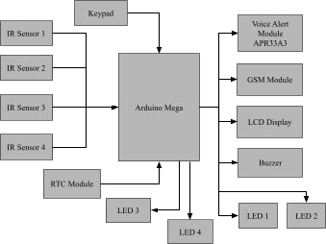

**DESCRIPTION**

In this Block diagram, we have used the Arduino Mega as the microcontroller. The system includes a 4x4 Keypad, Four IR Sensors and an RTC Module as input devices. A Voice Alert Module (APR33A3), the 16x2 LCD Display, a GSM SIM800L Module, four LEDs and a Buzzer is connected as an output device to the microcontroller.

**FLOW CHART**

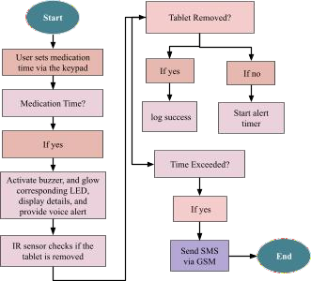

**CIRCUIT DIAGRAM**

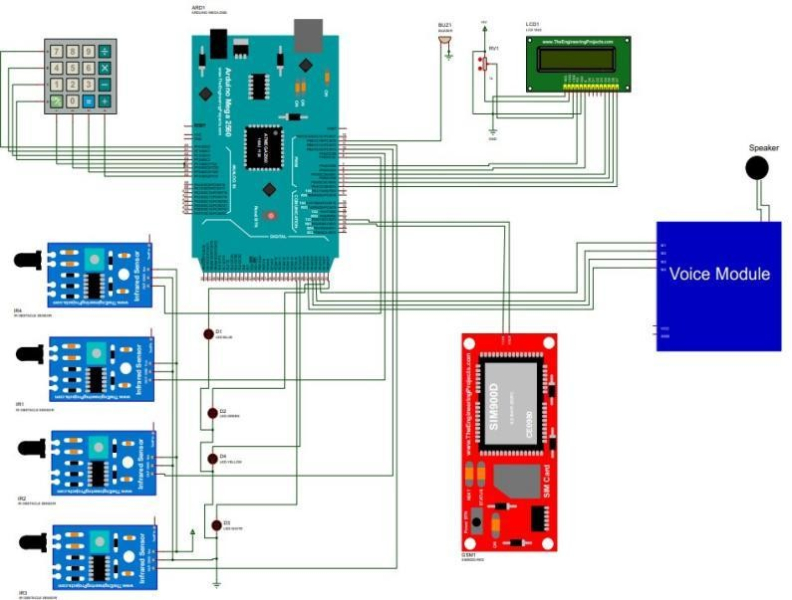

**WORKING**

The Smart Medicine Reminder System is built using Arduino Mega and incorporates various components to ensure efficient medication management. A 16x2 LCD is used to display information, while a 4x4 keypad allows the user to set medication timings. The system uses four IR sensors, one for each tablet compartment, to detect whether the tablets have been taken. At the scheduled time, the corresponding LED glows to indicate which tablet is due, and a buzzer provides an audible alert to notify that it’s time for a particular tablet. Additionally, the voice alert module APR33A3 gives a voice prompt indicating that it’s time for the specific tablet and later confirms whether the tablet has been taken or not. The RTC module ensures accurate time tracking. If the tablet is taken, the GSM SIM800L module sends a confirmation message to the caregiver, and if not, it sends a "Tablet not taken" alert. This process ensures timely medication adherence and keeps caregivers informed in real time.

## SYSTEM REQUIREMENT HARDWARE REQUIREMENT

1. Arduino Mega
2. IR sensors *4
3. Voice alert module APR33A3
4. GSM SIM 800L
5. 16X2 LCD display
6. RTC module
7. 4X4 Keypad
8. Buzzer
9. LED*4

## SOFTWARE REQUIREMENT

1. Arduino IDE
2. Proteus

## EXPERIMENTAL SETUP & RESULT

**EXPERIMENTAL SETUP**

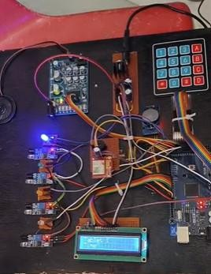

### Fig. shows the Experimental Setup of the system RESULT

The result of the Smart Medicine Reminder System demonstrates its effectiveness in ensuring timely medication adherence and enhancing user safety. The system successfully alerts users with a combination of visual indicators (LEDs), audible signals (buzzer), and verbal instructions (voice module) when it's time to take specific tablets. The integration of IR sensors accurately detects whether the tablets have been taken, and the GSM module provides real-time SMS notifications to caregivers if a tablet is missed. This ensures accountability and offers peace of mind to both users and their families. Overall, the paper proves to be a reliable and user-friendly solution for managing medication schedules.

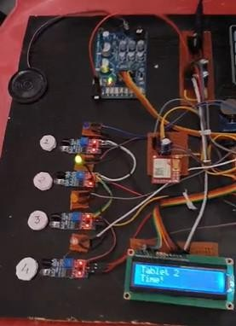

### Fig. shows that it is time for Tablet 2

At the scheduled time, the corresponding LED glows, a buzzer alerts the user, and the voice alert module APR33A3 announces the specific tablet's time and confirms whether it has been taken or not, and the related notification is displayed on the LCD.

When it is time to take the tablet, the GSM module will send the corresponding message to the user's mobile. If the tablet is not taken within the predefined time, the GSM SIM800L module sends a "Tablet not taken" alert to the caregiver's mobile, and if the tablet is taken, the GSM SIM800L module sends a confirmation message to the caregiver’s mobile, notifying them that the tablet has been taken.

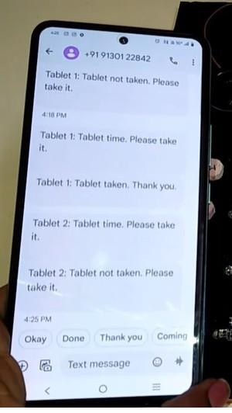

### Fig. shows the output of messages about Tablet 2 status

**Fig. shows the output indicating that Tablet 2 has been taken**

## CONCLUSION

The system is a well-designed and highly effective solution for ensuring that patients take their medications on time. The Smart Medicine Reminder System offers a transformative approach to medication management by integrating advanced technologies with user-centric features. By automating reminders through audible, visual, and SMS alerts, and monitoring tablet intake using IR sensors, the system ensures timely and accurate adherence to prescribed schedules. Traditional methods often fall short in providing real-time feedback and caregiver involvement, which this paper effectively addresses. With its simple design and reliable functionality, this system not only promotes better health outcomes but also provides peace of mind to users and their families. The device can be easily programmed and customized, allowing users to set up personalized medication schedules and reminders. In conclusion, this innovative solution bridges the gap in traditional medication management, offering an accessible and efficient tool to improve quality of life and reduce health risks associated with missed doses.

## REFERENCE

1. Abdallah Kassem, A Comprehensive Approach for A Smart Medication Dispenser, International Journal of Computing and Digital Systems, March 2021, ISSN 2210- 142X.
2. Nidhi Solanki, and DR. P. H. Zope, “Smart Pill Box Health Care System” International Research Journal of Engineering and Technology, Volume: 05, Issue: July 2020, e-ISSN: 2395-0056.
3. Diaa Salama, Abdul Minaam, and Mohamed Abd-ELfattah, Smart drugs: Improving healthcare using Smart Pill Box for Medicine Reminder and Monitoring System, Future Computing and Informatics Journal, Volume 3, Issue 2, 2022, ISSN 2314-7288.
4. Ekbal Rosli and Yusnira Husaini, “Design and Development of Smart Medicine Box” 2022 IOP Conf. Ser.: Mater. Sci. Eng. 341

012004.

1. Mohammed Asad Fasahate, “Smart medicine box using IoT”. International Journal of Scientific & Engineering Research, Volume 9, issue 2, February 2020, ISSN 2229-5518.
2. A. Jabeena, A. K. Sahu, R. Roy and N. S. Basha, "Automatic pill reminder for easy supervision," 2021 International Conference on Intelligent Sustainable Systems (ICISS), Palladam, 2020, pp. 630-637.
3. K. K. and S. H. S.K., "Medical Dispense System Using IoT," 2020 International Conference on Vision Towards Emerging Trends in Communication and Networking (ViTECoN), Vellore, India, 2020,

pp. 1-3.

1. Kumari, M. Viajaya, Gokul Anumula, Kasavu Anusha, Miryala Kedhar Eshwar, Parella Venkata, and Sai Kumar. "Smart Drug Administration System using IoT-driven RTC Timer for Medication Management in Chronic Patients." International Journal of Engineering Science and Advanced Technology (IJESAT) Vol23 Issue 12,2023.
2. Savarimuthu, Sabeenian Royappan, Premakumari Thangamani, Saranya Kumar, Madhiyarasan Vengadesan, and Selvaprakash Rajendran. "Medicine reminder using embedded system." In AIP Conference Proceedings, vol. 2857, no. 1. AIP Publishing, 2023.
3. Krishna, Chsai, K. Nagachandrarao, G. Sai Uday Bhaskar, K. Ramanjaneya Venkata Ganesh, Ch Anil Kumar, And B. Mahesh. "A Focus on Making of Simple Medicine Reminder Using Arduino." System 14, No. 1: 2024.