**Implementing GPS, an IOT-based drone is capable of improving product deliveries**

T. Harika1, **Mr.B.Nagaraju2**,P.Roshini3,G.V.N.A.L.Alekhya4, CH.Gowrishwari5

2Assistant Professor and 1,3,4&5IV-B.Tech(ECE)

Department of Electronics and Communication Engineering

**RISE Krishna Sai Prakasam Group of Institutions (Autonomous),Ongole,AP,India**

**(**[**1harikathatigolla8145@gmail.com**](mailto:1harikathatigolla8145@gmail.com) **, 2**[**rajurise201221@gmail.com**](mailto:nagaraju.d@gmail.com) **, 3**[**roshiniruby07@gmail.com**](mailto:roshiniruby07@gmail.com) **,** [**4alekhyag724@gmail.com**](mailto:4alekhyag724@gmail.com) **,** [**5gowrishwari69@gmail.com**](mailto:5gowrishwari69@gmail.com)**)**

# ABSTRACT

The recent years have seen a rise in the incorporation and integration of new smart connected devices and platforms such as Unmanned Aerial Vehicles (UAVs) to the ubiquitous network of Internet of Things (IoT). UAVs not only offer new means of delivering value-added IoT services through a wide range of applications ranging from monitoring and surveillance to on-demand last-mile delivery and people transport, but they also promise a pragmatic solution to the limitations of fixed terrestrial IoT infrastructure. Owning to their potential, UAVs are expected to soon be an integral part of our cities, dominating the shared low-altitude airspace. This introduces new research challenges in privacy, security and most notably in the safe management of UAVs’ operation under high traffic demands. To this end, this work presents a holistic study on the current state-of-the-art of UAVs and low-altitude airspace traffic management.

# INTRODUCTION:

The Internet of Things (IoT) may be described as a network of uniquely addressable and interconnected devices, built on standard communication protocols, the point of convergence of which is the internet . IoT hence enables a vast array of services that otherwise could not be realised.

Although IoT, as explained in, can be seen as part of the next generation internet, IoT has its unique vision that expands beyond the confinements of internet to enabling an inter-connected world of’’ things’’, both, physical and virtual. To this end, the technologies of IoT catalysed the growth of data–driven applications as well as encouraged the integration of new connected devices, in turn, creating new value-added services in almost every market sector and unleashing a magnitude of new opportunities for businesses, individuals and society . The economic impacts of IoT are, therefore, beyond doubt.

Never the less, a part from the buzz–termand the idea of interconnected things, IoT is a complex technological paradigm[5].IoT can be seen as a system of systems while it is not a single technology, but rather a composition of various technologies working together in tandem. The fundamental building block of IoT is the device, commonly referred to as‘‘thing’’. Device scan be broadly categorized as sensors, actuators or a combination of both. Sensors are devices that gather information from the environment, while actuators are devices that reach out and act on the world.

These devices connect directly or indirectly to the internet using wireless and wired technologies. Over there cent years the rapid development in communication technologies as well as the mini at urisation of sensors and actuators, encouraged the integration of new connected devices and plat forms to the ubiquitous IoT network.One promising set of devices and plat forms that have quickly found their way into IoT, as connected ‘‘things’’, are Unmanned Aerial Vehicles (UAVs).Commercial UAVs not only promise new means of interacting with the world, to collect and deliver new value– added services through a wide range of application domains ranging from monitoring and surveillance to on- demand last-mile delivery as well as people transport, but they also present a potential solution to the challenges of solely relying on fixed terrestrial IoT infrastructure. Owning to their potential, UAVs are expected to soon become an integral part of modern aviation, dominating the low–altitude airspace over populated cities.

This foreseeable future introduces new research challenges such as autonomous UAV safeguards [6] and efficient operations management under high traffic demands. In response to this, the scientific community, industry and standardisation bodies initiatedahandful of constructs for the management of the low–altitude air space; however, to the best of our knowledge there is no study that addresses the lack of harmonization between the different actors and combines the state-of-the-artintechnical standardisation, scientific research as well as industry To this end, the successful realisation of UAVs’ potential does not rely on a single technology but a multitude of interconnected systems building on international standards, regulations and novel approaches. In this context, the main contribution of this work is to present a holistic study on the evolution of UAVs with in IoT, exploring:•how digitization led the transformation of UAVs into smart, connected devices and platforms; • challenges obstructing the deployment of UAVs within cities from of safety, security, data protection and privacy perspectives; • current state-of-the-arto flow–altitude airspace traffic management in the scientific literature; • current development in UAV technical standardisation landscape.

The structure of the paper is as follows. Section IIprovidesan overview of the conceptual and technological UAV landscape, highlighting UAVs’ key definitions, notions and evolution as they find their way in to IoT. SectionIII presents current state-of-the- art of UAVs’ role within IoT and devises at axonomy for some predominant commercial UAV applications found in literature. The section additionally explores the inherent challenges of IoT introduced as UAVs become part of the connected ubiquitous network. Section IV presents current state-of-the-art of the low– altitude airspace traffic management with focus on UAVs. The paper investigates the concept of UAV Traffic Management constructs followed by a compilation and classification of their key functionalities with respect to safety and operational support.

The section follows with a comparison of predominant UAV Traffic Management constructs in literature, namely, the NASA UTM and the EU U- Space concepts of operations as well as other national constructs. Section V explores the current state-of the- art in UAVs technical standardisation. Finally, section.

# LITERATURESURVEY

This paper provides an in-depth review of the use of unmanned aerial vehicles (UAVs) in aerial photography and surveillance. It outlines the evolution of drone technology, highlighting improvements in camera systems, stabilization mechanisms, and flight control algorithms. The study discusses various applications of drones, particularly in the fields of environmental monitoring, security, and search-and rescue operations. Additionally, it emphasizes the role of GPS and real-time video transmission in enhancing drone functionality.

Key challenges highlighted include the optimization of battery life, the need for light weight components, and the complexities of autonomous flight control. The paper concludes with a discussion on the future potential of drone-camera systems, suggesting that continued advancements in AI and machine learning will enable drones to perform increasingly sophisticated tasks Autonomous Flight Control in Drones with Cameras (2021) this paper explores the use of autonomous flight control algorithms in drones, particularly those equipped with cameras.

The authors analyze various flight control systems that allow drones to operate autonomously, including the use of AI and machine learning for route planning, obstacle avoidance, and stabilization during camera operations. Emphasis is placed on visual odometry and sensor fusion techniques that allow drones to navigate without relying heavily on GPS, which is crucial in urban environments where GPS signals can be weak. The paper provides insights into how autonomous flight systems are becoming more reliable and accurate, making drones safe rand more effective for tasks like infrastructure inspection and surveillance. Real-Time Video Transmission in Drone Systems (2019) This paper focuses on the challenges and solutions in real-time video transmission from drones equipped with cameras. The authors review various communication protocols such as Wi-Fi, LTE, and5G for transmitting high-definition video streams.

They emphasize the importance of minimizing latency and optimizing band width for continuous and clear video feed, particularly in high-speed flight scenarios. The study presents case studies where drones have been used for live broadcasting events and surveillance operations. It also high lights the limitations posed by wireless interference, long-distance communication, and the need for robust error correction techniques.

Finally, the paper discusses future advancements, particularly with 5G technology, which promises to revolutionize real-time video streaming for drones. Drones in Infrastructure Inspection: A Case Study (2020) This paper presents a case study on the use of drones with cameras for infrastructure inspection, focusing on their application in monitoring bridges, power lines, and tall buildings. The authors review how drones equipped with high-resolution and thermal cameras can capture detailed images of structures, identifying potential weaknesses or damage that may not be visible from the ground.

The paper outlines the advantages of using drones over traditional inspection methods, including increased safety, reduced costs, and faster data collection. Additionally, it discusses the challenges of dealing with weather conditions, flight duration limitations, and image processing for accurate structural analysis.

Real-Time Video Transmission in Drone Systems (2019) This paper focuses on the challenges and solutions in real-time video transmission from drones equipped with cameras. The authors review various communication protocols such as Wi-Fi, LTE, and 5G for transmitting high-definition video streams. They emphasize the importance of minimizing latency and optimizing band width for continuous and clear video feed, particularly in high-speed flight scenarios. The study presents case studies where drones have been used for live broadcasting events and surveillance operations. It also high lights the limitations posed by wireless interference, long-distance communication, and the need for robust error correction techniques. Finally, the paper discusses future advancements, particularly with 5G technology, which promises to revolutionize real-time video streaming for drones.

**PROPOSED METHOD**

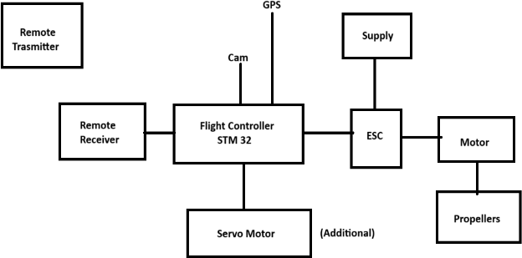

**Fig: Drone Block Diagram**

For the IoT drone, the IoT system is needed to be integrated with the drone or UAV. Asin Figure3, the system consists of Devices(drones),gateway, internet, IoT Cloud, and remote for the user interface The Gateway is used as a data transmission medium between drones and other IoT components, microcontrollers, the internet, and IoT Cloud. Usually, the gate way is place data fixed location for other applications. In this case, the IoT gateway can be located in any location, base station, or also can be mounted on another drone, to make it mobile and flexible. Therefore, the connection between the base station and the IoT drones can be extended in along-range with the mobile gateway.

Some researchers presented the performance analysis of the power outage probability of small- scale drones. The experimental area size was set and the IoT sensors were placed within the area. The result shows that the power outage probability is zero when the drone reaches a certain height(80 meters in this case),while at the same time the data streaming cannot be linked to the IoT devices.

This power outage probability analysis is helpful to ensure the best performance in terms of connectivity network, by setting the height threshold of the drones. In the power charging aspect, previous research develops evaluate the charging plat form namely Drone-box. The drone box consists of a control unit that controls the power supply to the subsystems and platforms.

The hangar was built with an opening tray of platform for the drone landing process, and also a charging monitoring system. The structure of the Drone-box was built . The charging and discharging profile were recorded with other parameters such as battery capacity for multiple cycles. Other previous researchers developed and proposed solutions for the battery system for drones. There searchers focused on wireless charging mechanisms, power source stations, and automatic battery replacement for continuous flying drones. In previous research, trajectory planning and algorithm were developed for controlling drones' motion and localization. Their search work reduces the trajectory complexity and tracked the shortest path for drones while reducing energy consumption and positioning delay. The simulations were performed, and the system was improved with a new approach named semi-dynamic mobile anchor guiding (SEDMAG) for drones. For many years, drones perform localization based on the received location data through GPS. However, the accuracy of the localization did not meet the positioning requirements, which means that it has some accuracy loss. To increase the localization accuracy, the re searchers studieda method named cooperative drone positioning measuring method (CDPM), through the equipped sensors system. The positioning accuracy was improved from 0.55 to 0.6 ratio . Another localization accuracy analysis was performed for the drone in Lo Ra IoT Network. The Lo Ra gateway was mounted on the drone as a mobile gate way to expand the communication range between nodes.

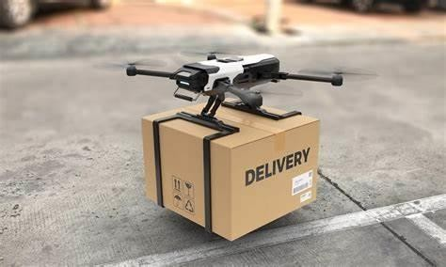

**Fig: Drone delivery**

Medical, healthcare, and rescue There are a few IoT drone works that were developed for people's health monitoring. The IoT drones were integrated with the smart shoes (with data transmitters). The smart shoes were used by patients who have some disability, old people, and diseases (for example Parkinson's). The shoes contained a tracking module, sensors at the pressure point, and other diagnosis modules. Those IoT drones and smart shoes are for health monitoring and diagnosis purposes. In the Covid- 19 pandemic case, the IoT drone was used for human screening, temperature detection, wearing facemask detection among the public, and also crowd surveillance.

Those IoT drone tasks were performed through Big Data, deep learning, and machine learning process. In the end, the system could monitor the people, and reduce the risk of viruses spreading during the Covid-19 pandemic. There is still the covid-19 pandemic and endemic across the countries with different viruses and influenza variants name, which need to be handled, mitigated, and monitored.

IoT medical drones also were used in the delivery task, to transfer and distribute the required drug, blood, medicines, and Covid-19vaccines to patients and isolated people. The IoT drone used the carrier and picking mechanism for carrying medicines, and other IoT control devices, block chain technology, GPS module, etc. A few significant researchers developed and utilized the IoT drone for rescuing tasks. In rescue missions, the IoT drone helps the rescuer detect a human in hazardous areas, collapsing buildings, and fire. The drone also uses sensors to detect hazardous gasses and clouds in the atmosphere. The IoT drone implementations were discussed and proposed in smart city planning. The IoT drone swarm scan be used in traffic control, fire and disaster detection, accident detection, pollution monitoring, vehicle parking monitoring, building security, energy data gathering, and connectivity improvement. The improvements and technologies were studied in the IoT drone development for the smart city including communication, drone trajectory, sensors data gathering, and coverage area. Figure 13 shows the ecosystem of the IoT drone with multipurpose tasks in the Smart City.

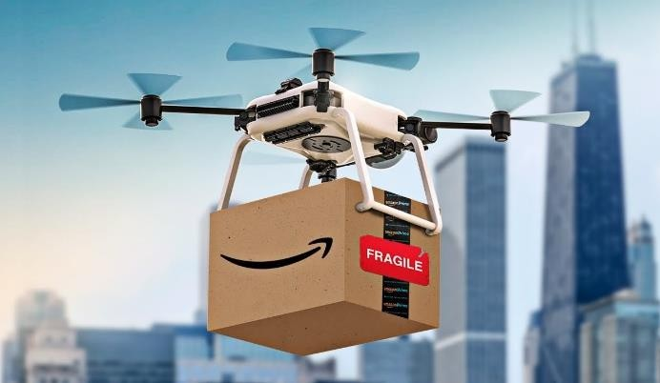

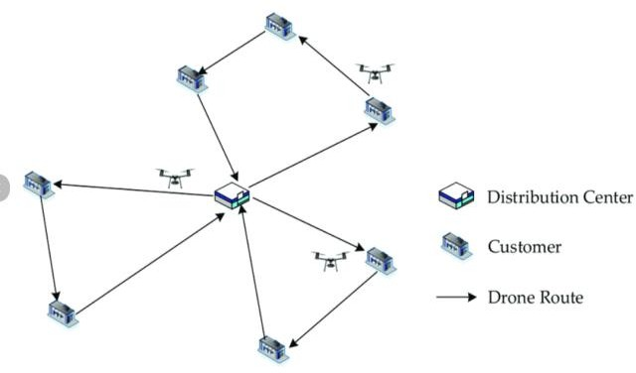

**CONCLUSION**

The IoT drone is the integration between the drone and the Internet of Things, producing a mobile IoT system that can expand and further the benefits in many fields. It helps people to control, monitor, and perform tasks in a large range, to extend the ability in managing through an Ai-based IoT drone. It reduces time, cost, energy, and risks while using the flying IoT. Many applications are affected by the IoT drone including agriculture, energy management, healthcare, industry, and smart cities. This paper reviews the IoT drone implementation in those Applications and reviews there searchers’ discussion and studies on IoT drone optimization.

**Acknowledgment**

The Institute of Informatics and Computing in Energy (IICE),the Innovation & Research Management Centre (iRMC),and UNITENare acknowledged for their ongoing support of this study.

# REFERENCES

# [1].Jiang,Y.,&Xie,L.(2018).SurveyonUAVs for Aerial Photography and Surveillance. Journal of Drone Technology,15(3),112-125.

# [2]. Singh, R.,& Meena, A. (2020). Design and Development of a Drone for Agricultural Monitoring. International Journal of Agricultural Technology, 12(4), 255-267.

# [3].Li,X.,&Zhang,H.(2019).Real-Time Video Transmission in Drone Systems. Journal of Communication Networks, 22(6), 450-462.

# [4].Patel,D.,&Sharma,R.(2021).Autonomous Flight Control in Drones with Cameras. International Journal of Robotics and Automation, 39(2), 80-95.

# [5]. Kumar, P.,& Sinha, A. (2017). Enhancing Image Stabilization in Drone Cameras. Journal of Visual Technology, 9(1), 27-34.

# [6].Thompson,J.,&Lopez,M.(2020).Dronesin Infrastructure Inspection: A Case Study. Engineering and Technology Review, 14(2), 102-115.

# [7].Ravi, S.,& Rao, P. (2019). The Role of Drones in Search and Rescue Operations. International Journal of Emergency Services, 7(1), 23-35.

# [8].Jamal, F., & Patel, N. (2021). Drones for Environmental Monitoring: Current Applications and Future Trends. Environmental Technology Journal, 18(4), 167-180.

# [9]. Murphy, T.,&Chan,E.(2018). Integration of Thermal Imaging in Drone Camera Systems.Journal of Remote Sensing, 24(3),290-303.

# [10].Zhou, L.,& Wang, Y. (2020). Machine Learning Algorithms for Drone Image Analysis. Journal of AI and Robotics,11(2), 99-112.

# [11].Wu, X.,& Chen, Z. (2021). Drones in Precision Agriculture: A Review of Camera Technologies and Applications. International Journal of Precision Agriculture, 23(2),45-58.

# [12].Chen, S., &Liu, Y. (2018). Development of Stabilization Systems for UAV Cameras in Aerial Photography. Journal of UAV Research,20(4),99-112.

# [13]. Zhang, H.,& Yang, J. (2019). Real-Time Data Processing and Image Analysis for Drones with Cameras. Journal of Image Processing and Machine Vision,31(1),70-85.

# [14].Shishika, M.,& Tiwari, R. (2020). Advancements in Camera Technology for UAV- Based Remote Sensing. Journal of Remote Sensing Applications, 11(5), 275-285.