Phyllanthus amarus Extract Mediated Synthesis Of Silver Nanoparticles And Its Cytotoxic Effect On Hep-2 Cell Line
- Muthu Kumara Pandian¹, Sheeba Smartina M ², Thrisha K ³, Ashwin M⁴ , S. Justin Packia Jacob⁵, Anli Dino A⁶
¹Department of Biotechnology, Vivekanandha College of Engineering for Women, Tiruchengode, Tamilnadu.
^{2,3,4} Department of Biotechnology, St.Joseph’s College of Engineering, Chennai, Tamilnadu .
^{5,6} Department of Biotechnology, St.Joseph’s College of Engineering, Chennai, Tamilnadu .

ABSTRACT
Nanotechnology because of its wide applicability emerges out as an important technology of mankind. Metal nanoparticles have long been synthesized by wet chemical techniques which may be toxic. The recent technology of using plant extract is a green synthesis, and a single step environmentally friendly process for production of nanoparticles. The biomolecules present in the aqueous extract of the whole plant Phyllanthus amarus (Euphorbiaceae) is responsible for the reduction of silver nitrate to silver nanoparticles and also act as capping agent. Silver nitrate (10-3 M) was used with aqueous extract to produce silver nanoparticles. It has very good activity than its macro counterparts and reported to contain antibacterial effect. The surface Plasmon resonance (SPR) caused color change measured using UV-Vis spectrophotometer. The size of the silver nanoparticles were found to be spherical in range of 40 – 100 nm found from Scanning Electron Microscope. Fourier Transform Infrared spectroscopy (FTIR) was carried out to determine the presence of biomolecules in them. Its cytotoxic effect been studied on HEp-2 (Larynx) cancerous cell line and normal VERO cell line , MTT assay was done to test its optimal concentration and efficacy which gives valuable information for the use of silver nanoparticles for future cancer therapy.Keywords: Nanotechnology, Silver Nanoparticles, Green Synthesis, Phyllanthus amarus, HEp-2 Cell Line

- INTRODUCTION
Nanotechnology stands as an emerging interdisciplinary field which has gained substantial notice because researchers use it for applications across physics, chemistry, materials science, electrical engineering and nowadays it shows increasing importance in life sciences especially biomedical and biotechnological areas. New treatment methods for drugs and diagnostics alongside antimicrobial agents and cancer treatments can be developed using nanoscale material alteration (1-100 nm) [1]. The main benefit of nanotechnology stems from its ability to modify materials within the nanoscale (1-100 nm) range which grants them special physiological features along with electrical features and biological properties unlike bulk counterparts [2]. Effects of nanotechnology on biomedical sciences include enhanced reactivity along with greater surface-to-volume ratio and stronger mechanical properties and distinctive optical features [3]. Elaborate research about Silver nanoparticles (AgNPs) is underway because they show strong action against multiple bacteria and fungal pathogens and cancer cells. Numerous research studies examine AgNPs because these nanomaterials disrupt cell membranes thus causing threshold stress and blocking cellular signaling pathways to efficiently fight multidrug-resistant pathogens [4,5]. Silver nanoparticles show great potential in treating cancer since studies show they specifically destroy cancer cells without harming normal cells [6]. The production methods for AgNPs require physical and chemical techniques which use considerable amounts of energy alongside hazardous reducing agents that create safety issues for both the environment and biological compatibility [7]. Plant-mediated green synthesis of silver nanoparticles represents an environmentally sustainable and friendly method to overcome these production challenges. Plant-based bioactive compounds function as reducing stabilizing agents in this synthesis method so scientists do not need to use harmful chemicals nor expensive inputs of energy [8]. Medicinal plant-derived synthesis of nanoparticles benefits from secondary metabolites including flavonoids and terpenoids and polyphenols and alkaloids because these compounds assist in nanoparticle formation and improve their biological activity [9,10]. Multiple researchers have examined various medicinal plants regarding their ability to generate silver nanoparticles. Scientists have used Piper longum [11]. leaves as a source material to successfully create AgNPs that displayed strong cytotoxic action against HEp-2 (laryngeal cancer) cells. Cancer cell killing was proven to be an exceptional feature of AgNPs produced from Piper nigrum [12].leaf extract while demonstrating the therapeutic potential of plant-developed nanoparticles. Various plants like Azadirachta indica, additionally to Ocimum sanctum and Phyllanthus niruri along with Withania somnifera have successfully produced eco-friendly AgNPs with observable antimicrobial and anticancer effects [13].Cancer remains globally significant as a health concern because medical experts need advanced therapeutic options which perform more effectively while generating minimum side effects. The medical world has explored silver nanoparticles as potential cancer treatment agents because they can induce apoptosis alongside cell growth suppression and reactive oxygen species (ROS) production in tumor cells [6,4]. Laboratory experiments demonstrate that green-synthesized AgNPs possess better biocompatibility with selective toxicity which confirms their potential as suitable agents to target cancer [10].
This investigation studies the AgNP synthesis through Phyllanthus amarus plants which possess strong anticancer and antibacterial and liver-protective effects [14]. The manufacturing process yielded nanoparticles that received HEp-2 (laryngeal cancer) cell line cytotoxicity measurements together with minimal toxic effects on normal VERO cell lines. This research examined the synthetized nanomaterials through a comparative method to determine their specific toxicity against target cells. Through the expected mechanism the nanoparticles would selectively target cancer cells for destruction yet remain non-harmful against healthy cells. The method demonstrates high cost-effectiveness and preserves nanoparticle stability thus making it an excellent option for biomedical applications including cancer medicine. This research investigation extends the existing scientific knowledge about green nanotechnology along with its applications for performing safe and effective cancer treatments.
METHODOLOGY 2.1 Collection of plant material :Researchers obtained the plant sample Phyllanthus amarus from the Arakkonam district farming areas before cleansing it with tap water. The Botanist at Central Research Institute of Siddha in Chennai identified the gathered material before storing its specimen in a herbarium. Multiple water washing cleansed the plant materials completely. The extract producers utilized the entire plant material.2.2 .Procedure :The plant pieces underwent chopping before weighing 25 g of plant matter into which 100 ml of distilled water was added. Next the plant material received a measurement. The mixture received heat at 90°c while boiling for twenty minutes. The mixture rested in room temperature until it reached a cool state. Whatman no: 40 filter paper was used to filter the solution three times. A single bottle received the filtrate which was collected during the procedure. Forthcoming utilization will require keeping the extract in refrigerator.2.3.Synthesis of nanoparticles :A mixture of 50ml 1mM (10-3 M) silver nitrate solution combined with 50ml plant extract solution. The solution was placed under microwave heat and dark and sunlit conditions before exposure. After the mixture receives exposure time it needs 10-minute centrifugation at 10000 rpm. Hot air oven conditions were used to obtain the pellet. Supernatant was stored in refrigerator. The analysis used the obtained pellet.2.4. Microwave exposure :Placing an equal mixture of plant extract and silver nitrate solution under microwave heating reached 90°c. The developer checked the surface plasmon resonance color formation through microwaves therefore recording the time needed for color development during 30sec intervals. In the closed space of the near infra red spectrum only the intended reaction occurs without interference from external sources.2.5 Incubation in dark :The mixture received dark room incubation at room temperature during twenty-four hours. The solution was checked at different time points for the development of dark brownish color.2.6 . Sunlight exposure :A glass beaker received the mixture with 33°c temperature reading obtained from Chennai Metrological Centre. The mixture underwent constant stirring for homogenization during the time it spent under direct sunlight exposure. The experiment proceeded until the reaction mixture reached dark brownish color.2.7. UV–vis spectra analysis :The detection of pure Ag+ ions reduction occurred through UV–vis analysis of overnight-incubated reaction medium after diluting an aliquot of the solution with distilled water. The appearance of color transformations in silver nanoparticles (AgNPs) solution became visible through distilled water observation. The substance exhibited a yellowish-brown color during particle synthesis. The production quantity of AgNP was measured using Systronics UV double-beam spectrophotometer (model 2201) at 1 nm resolution throughout 200 to 600 nm wavelength range with 10-mm-optical-path-length quartz cuvettes.2.8. FTIR (Fourier-transform IR):The presence of silver nanoparticles was confirmed through analysis done by Nicolet Impact 400 FTIR spectroscopy on the acquired samples.2.9. SEM Analysis of Silver Nanoparticles :JEOL 6380A (Tokyo, Japan) served as the scanning electron microscope to obtain pictures of the formulated AgNPs.2.10. Cytotoxicity and anticancer activity :2.10.1. MTT assay :The MTT (3-[4,5-dimethylthiazol-2-yl]-2,5-diphenyl tetrazolium bromide) product was acquired from Invitrogen based in USA. The remaining collection of fine chemicals originated from Sigma, Aldrich.2.10.2. Cell culture :VENO cells that NCCS (National Centre for Cell Science from Pune) distributed grew in Rose-well Park Memorial Institute RPMI medium with 10% fetal bovine serum together with penicillin/streptomycin (250 U/mL) and gentamycin (100 µg/mL) and amphotericin B (1 mg/mL) from Sigma Chemicals based in MO USA. The conditioned incubation required all cell cultures to operate at 37ºC under controlled conditions of 5% CO2 with saturated humidity. Cells achieved complete confluency within a period of 24 h before researchers used them.2.10.3. Cell growth inhibition studies by MTT assay :The MTT reduction assay as described by Mosmann (1983) served to measure cell viability. The experiment began by seeding HT29 cells at 5×103 cells/well density in 200 µL RPMI 10% FBS solution that made up the culture media in 96-well plates. The researchers transferred the culture supernatant before adding Yenamarugu zinc nanoparticles solutions (3.906–500 µg/mL concentration) for a 48-hour incubation period as a result. The treated cells received MTT solution (10 µL, 5 mg/mL) at 37°C before receiving DMSO at room temperature. The spectrophotometer analyzed plate readings through the wavelength of 595 nm using its scanning multi-well setup. Cell viability (%) = Mean OD / Control OD × 100

- RESULTS AND DISCUSSION
3.1 Synthesis of silver nanoparticles :The synthesis of silver nanoparticles uses plant extract as an elemental raw material. The nanoparticles formed through observations of color changes from light green to dark brownish hues. The observed color change correlates with the surface Plasmon vibrations of previous works in this method.Table 1.Time taken for appearance of dark brownish color
Exposure ConditionsP.amarus mediated AgNPSYield /100mlMicrowave70 seconds210mgDarkIncubated - 24 hrs150mgSunlight8 minutes20 mg
Microwave radiation causes the color modification while silver nitrate reduction occurs under microwave-supported reactions where plant extracts serve to assist in this process. The microwave method produced 210mg of yield as the maximal output after operating for 70sec in P.amarus experiments (Table.1). The dark incubation resulted in observable yield after 24 hours of incubation yet the yield level under sunlight remained superior.3.2 UV-Vis spectroscopy analysisUV-Vis spectroscopy served to verify the formation of silver nanoparticles. The λ max value appeared at 400 nm after scanning the samples between 200 -800 nm. The characteristic feature of silver determined that maximum absorbance occurred at 400nm and thus provided evidence for silver nanoparticles. The exposure conditions using microwave generated the highest absorbance during analysis.
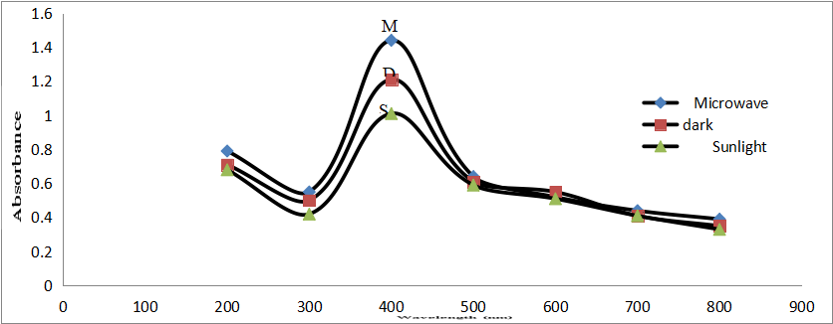
Figure 1: UV-Vis spectra P.amarus extract mediated AgNPs3.3 Scanning Electron Microscopy Analysis (SEM)High Resolution Field Emission Electron Microscope analysis provided the information regarding nanoparticle dimensions and shapes. The analysis of solutions that were subjected to microwave exposure under dark conditions resulted in the determination of nanoparticle size and shape. UV-Vis absorption spectra analysis showed its connection to these results. SEM analysis yielded the calculations for size measurements. P.amarus mediated AgNPs exposed to microwave radiation yielded spherical nanoparticles between 35 – 70 nm according to Henglein A (1993) [15], measurements with mean diameter at 43 nm (Fig 2). The spherical nanoparticles (Fig 3) obtained in the dark environment displayed diameters ranging from 35 – 140 nm with a mean value of 75 nm.
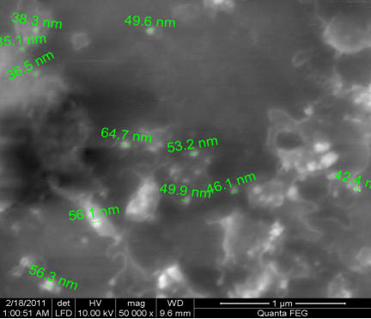
Figure 2 :SEM image of AgNPs synthesized by P.amarus extract – microwave exposure
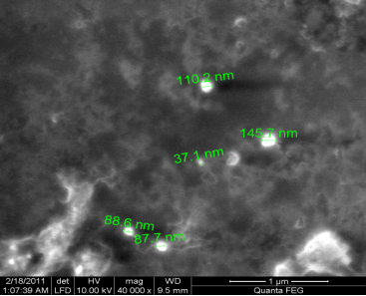
Figure 3: SEM image of AgNPs synthesized by P.amarus extract – dark incubation3.4 Fourier Transform Infrared Spectroscopy analysis (FTIR)FTIR analysis provides excellent biomolecule detection capabilities because its results can reference standard IR fingerprint references. The stretching vibrations of O-H between 3100 – 3400 cm-1 in the broad spectrum stem from the hydroxyl group of phenol, alcohols (Fig 12). The intense band at 1640 cm-1 due to C=C stretching of aromatic ring plays a primary role for metal ion reduction in terpenoids ( Fig 4 and 5). The presence of C=O ketones found in flavonoids could also be the reason behind these findings. Ultraviolet and visible absorbance spectra of silver nitrate solutions confirmed the presence of NO2 stretching quintessences. The C-N stretching vibration of aliphatic amides generates the bands between 1020 – 1220 cm-1. AgNPs surface interactions lead to many medium to weak bands between 1200-1300 cm-1 because COOH carboxylate group binds to the surface of the nanoparticles. The OH bending vibration from alcohol or phenol functional groups or from COOH provided both C-O stretching and OH bending signals. Stable silver nanoparticles depend on the protein molecule function as reducing agent and ligand that transforms silver nitrate into AgNPs. A significant proportion of reducing agents normally exists within plant extracts.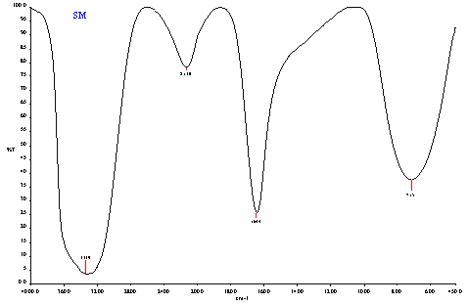
Figure 4: FTIR spectra of Silver Nitrate (AgNO₃)
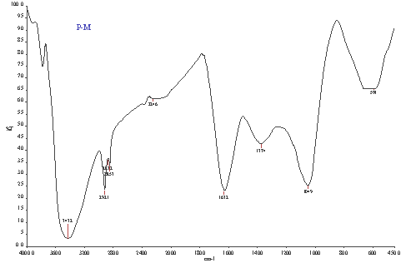
Figure 5: FTIR spectra of P.amarus mediated AgNPs (microwave exposed)
3.5 Cytotoxic assay (MTT)A cytotoxicity study of plant extract nanoparticles focused on their effect against HEp-2 cell line and VERO cell line using MTT (3-(4, 5-dimethyl thiazol-2yl)-2, 5-diphenyl tetrazolium bromide) [16]. The cell lines received drugs of different concentrations during 37°c incubation which lasted 24 hrs in 5% CO2 conditions. The research evaluated drug toxicity using both HEp-2 Larynx cancerous cell line for LD 50 determination and VERO cell line for testing normal cell compatibility.
Table 2 .Invitro cytotoxicity effect of P.amarus mediated AgNPs (microwave exposed) and silver nitrate on HEp-2 cancerous cell line
S.noConcentration (µg/ml)DilutionsAbsorbance at 595 nmPMcell viability%SNcell viability%PMSN1500Neat0.190.2530.1535.2122501:10.210.3533.3349.2931251:20.230.3936.5054.92462.51:40.250.4546.0363.38531.251:80.350.5455.5576.05615.6251:160.440.5969.8483.0977.81251:320.550.6587.3091.5483.9061:640.590.6793.6594.369Cell control-0.630.71100100
Table 3: Invitro cytotoxicity effect of P.amarus mediatedAgNPs (microwave exposed) and silver nitrate on VERO cell line
S.noConcentration (µg/ml)DilutionsAbsorbance at 595 nmPMcell viability%SNcell viability%PMSN1500Neat0.210.2032.3027.0322501:10.250.2738.4636.4931251:20.340.3352.3044.59462.51:40.470.4572.3060.81531.251:80.490.5075.3867.57615.6251:160.520.528070.2777.81251:320.550.5684.6175.6883.9061:640.590.6090.7681.089Cell control-0.650.74100100

Testing of cytotoxic effects for silver nanoparticles produced from P.amarus extract used the MTT-assay method on HEp-2 cell lines (Fig.6). A substantial number of cells died during P.amarus treatment when exposed to 500 µg/ml solution which resulted in a 70% mortality rate (Fig 6). The lethal dose for 50% cells reached 62.5 µg/ml. Test results indicated that silver nitrate (AgNO3) brought about 65% cell mortality when used at 500 µg/ml concentration (Fig 7) while reaching its LD 50 value at 250 µg/ml concentration. The P.amarus AgNPs treated VERO cells exhibited maximum cell mortalities reaching 68% at 500 µg/ml (Fig.8) and reached the LD 50 of 48% at 125 µg/ml. The experimental condition of 500µg/ml silver nitrate produced 83% cell death while the LD 50 occurred at 62.5µg/ml. The gliomacells displayed this killing effect because of ROS generation within their structure. The three ROS radicals including superoxide radical and hydrogen peroxide and hydroxyl radical function to create cellular damage that ends in cell death [17]. The killing effect of silver nanoparticles against HEp-2 cells supports their potential use as cancer treatment medicines. Cancer treatment effectiveness can emerge from using lower concentration AgNPs since these nanoparticles possess harmful effects towards regular VERO cells. Studies should continue to clarify how you can use these nanoparticles in cancer treatment for humans and the biological factors leading to their effects.
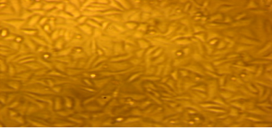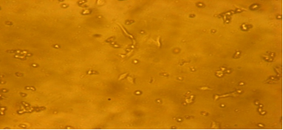

(a)Normal HEp-2 cell line(b) High conc. 500µg/ml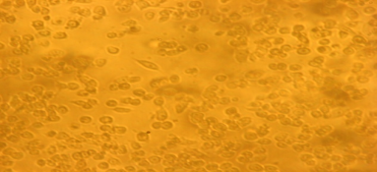
(c) LD 50 (62.5 µg/ml)
Figure 6 . Invitro cytotoxic effect of P.amarus mediated AgNPs (microwave exposed). On HEp-2 cell line

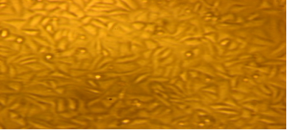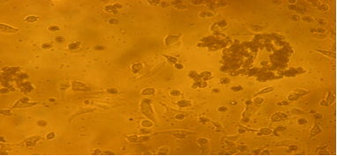
- Normal HEp-2 cell line b) High conc. 500µg/ml

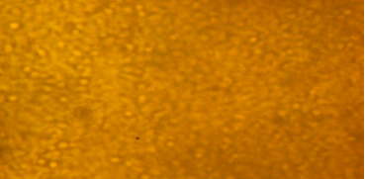
c)LD 50 (250ug/ml)
Figure 7 . Invitro cytotoxic effect of silver nitrate at various conc. on HEp-2 cell line
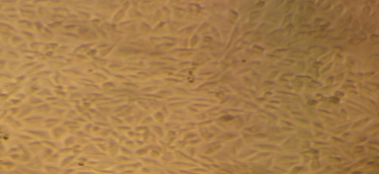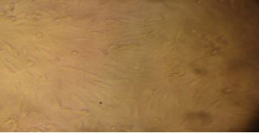
a) Normal VERO cell line b) High conc. 500µg/ml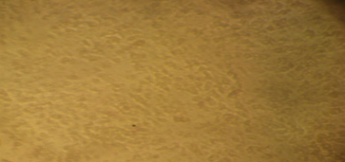
c)LD 50 (125 µg/ml)
Figure 8. Invitro cytotoxic effect of P.amarus mediated AgNPs (microwave exposed) at various conc. on VERO cell line.
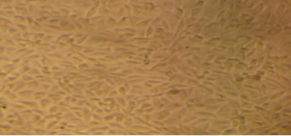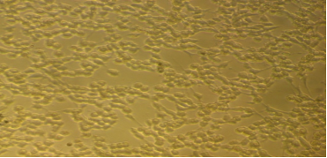
- Normal VERO cell line b) High conc. 500µg/ml
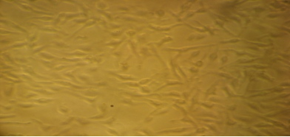
(c)LD 50 (62.5 µg/ml)
Figure 9 Invitro cytotoxic effect at increasing conc. Of Silver nitrate on VERO cell line
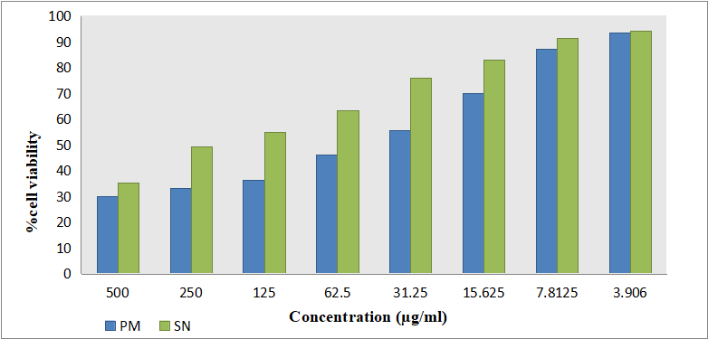
Figure 10: Invitro cytotoxicity effect of P.amarus, mediated AgNPs (microwave exposed) and silver nitrate on HEp-2 cell line (MTT assay)
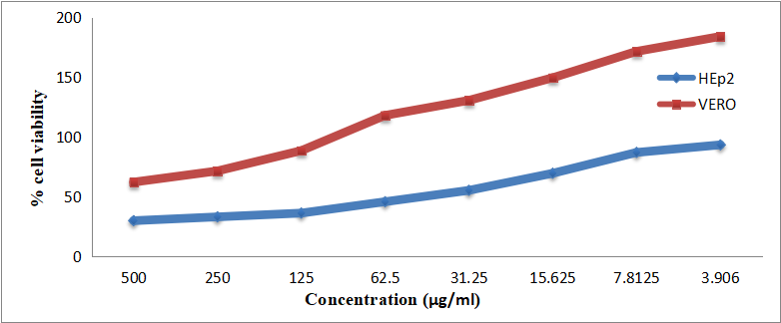
Figure 11: Invitro anticancer effect of P.amarus –AgNPs (microwave exposed) -comparison between VERO and HEp-2 cell lines
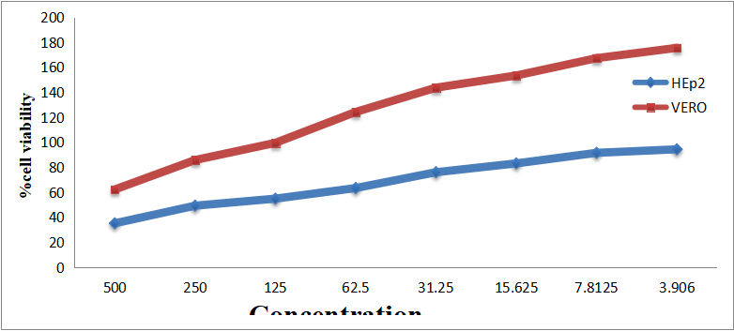
- Figure 12: Invitro anticancer effect of silver nitrate- comparison between VERO and HEp-2 cell linesCONCLUSION
- The plant extract Phyllanthus amarus mediated synthesis of silver nanoparticles was found to be more effective and the plant itself has got the medicinal property so tapping these resources seems to be ecofriendly and easy to produce these nanoparticles. Bioreduction of Ag+ ions to silver nanoparticles by the plant extracts occur. The plant aqueous extract act as reducing and capping agent of silver nanoparticles. The SEM analysis and FTIR analysis gave details about the size and also the presence of biomolecules. Among several physical conditions microwave treatment gave maximum yield and the colour change occur within 70 seconds at faster rates. Already reports are available on the usage of Nanoparticles for antibacterial activity; hence in our present study we put an innovative step in using these AgNPs for invitro cytotoxic effect on HEp-2 cell line. Several compounds present in the plant extracts acts as a ligand in the reduction process, which would be involved in the stabilization of these AgNPs. P.amarus extract mediated AgNPs exposed to microwave was cytotoxic and LD50 was at 62.5 µg/ml on cancerous cell line and at the same concentration in normal VERO cell line 73% viable cells were present. The cytotoxic assay was also carried on normal VERO cell line and it was toxic at very high concentration but at low concentration it was nontoxic to normal cell line. This makes the use of these plant mediated AgNPs for cancerous treatment. Thus green synthesis seems to be a very effective, innovative step and the nanoparticles produced by this method can be used to treat cancer.REFERENCES
- Singh, R., Purohit, B., Bhardwaj, P., & Gupta, A. (2016). Nanotechnology applications in biomedical sciences and its future prospects. International Journal of Nanomedicine, 11, 1425-1443.Buzea, C., Pacheco, I. I., & Robbie, K. (2007). Nanomaterials and nanoparticles: Sources and toxicity. Biointerphases, 2(4), MR17-MR71.Laurent, S., Forge, D., Port, M., Roch, A., Robic, C., Vander Elst, L., & Muller, R. N. (2008). Magnetic iron oxide nanoparticles: Synthesis, stabilization, vectorization, physicochemical characterizations, and biological applications. Chemical Reviews, 108(6), 2064-2110.Rai, M., Yadav, A., & Gade, A. (2009). Silver nanoparticles as a new generation of antimicrobials. Biotechnology Advances, 27(1), 76-83.Sharma, V. K., Yngard, R. A., & Lin, Y. (2009). Silver nanoparticles: Green synthesis and their antimicrobial activities. Advances in Colloid and Interface Science, 145(1–2), 83–96. https://doi.org/10.1016/j.cis.2008.09.002
Patra, H. K., Banerjee, S., Chaudhuri, U., Lahiri, P., & Dasgupta, A. K. (2008). Cell selective response to gold nanoparticles. Nanomedicine: Nanotechnology, Biology and Medicine, 4(1), 64-71.Guzmán, M. G., Dille, J., & Godet, S. (2009). Synthesis of silver nanoparticles by chemical reduction method and their antibacterial activity. International Journal of Chemical and Biomolecular Engineering, 2(3), 104-111.Iravani, S. (2014). Green synthesis of metal nanoparticles using plants. Green Chemistry, 16(7), 2636-2650.Mittal, A. K., Chisti, Y., & Banerjee, U. C. (2013). Synthesis of metallic nanoparticles using plant extracts. Biotechnology Advances, 31(2), 346-356.Ahmed, S., Saifullah, Ahmad, M., Swami, B. L., & Ikram, S. (2016). Green synthesis of silver nanoparticles using Azadirachta indica aqueous leaf extract. Journal of Radiation Research and Applied Sciences, 9(1), 1-7.Justin Packia Jacob, S., Finub, S., & Anand Narayanan, P. R. (2011). Synthesis of silver nanoparticles using Piper longum leaf extracts and its cytotoxic activity against Hep-2 cell line. Colloids and Surfaces . Biointerfaces, 91, 212–214. doi:10.1016/j.colsurfb.2011.11.001Justin Packia Jacob, S., Anand Narayanan, P. R., & Finub, J. S. (2013). Green synthesis of silver nanoparticles using Piper nigrum leaf extracts and its cytotoxic activity against Hep-2 cell line. World Journal of Pharmaceutical Research, 2(5), 1607-1616.Kumar, A., Vemula, P. K., Ajayan, P. M., & John, G. (2012). Silver-nanoparticle-embedded antimicrobial paints based on vegetable oil. Nature Materials, 7(3), 236-241.Akhter, M. S., Rahman, M. A., Ripon, R. K., Mubarak, M., Akter, M., Mahbub, S., Mamun, F. A., & Sikder, M. T. (2024). A systematic Review on Green Synthesis of Silver Nanoparticles Using Plants Extract and Their Bio-medical Applications. Heliyon, 10(11), e29766. https://doi.org/10.1016/j.heliyon.2024.e29766Henglein, A. (1993). Physicochemical properties of small metal particles in solution: “microelectrode” reactions, chemisorption, composite metal particles, and the atom-to-metal transition. The Journal of Physical Chemistry, 97(21), 5457–5471. Mosmann, T. (1983). Rapid colorimetric assay for cellular growth and survival: Application to proliferation and cytotoxicity assays. Journal of Immunological Methods, 65(1–2), 55–63. Xia, T., Kovochich, M., Brant, J., Hotze, M., Sempf, J., Oberley, T., Sioutas, C., Yeh, J. I., Wiesner, M. R., & Nel, A. E. (2006). Comparison of the abilities of ambient and manufactured nanoparticles to induce cellular toxicity according to an oxidative stress paradigm. Nano Letters, 6(8), 1794–1807.

