**AI-DRIVEN MEDICAL IMAGING FOR EARLY DETECTION OF KIDNEY STONES**

**Mayur Samadhan Suryawanshi**

Prof. Ramkrishna More College, Pradhikaran, Pune, India.

Email: [mayurss2501@gmail.com](mailto:mayurss2501@gmail.com)

**Guided by**

Dr. Santosh Jagtap

Prof. Ramkrishna More College, Pradhikaran, Pune, India.

Email: st.jagtap@gmail.com

**ABSTRACT**

Kidney stone disease is a prevalent and often debilitating condition that requires accurate and timely diagnosis for effective management. Traditional diagnostic techniques, including computed tomography (CT) scans, ultrasound, and X-rays, present several challenges, such as high costs, radiation exposure, and variability in interpretation, which may lead to missed or delayed diagnoses. In response to these limitations, artificial intelligence (AI)-driven approaches, particularly Convolutional Neural Networks (CNNs), have emerged as promising tools for automating kidney stone detection and classification.

This study focuses on developing an automated kidney stone detection system using CNNs, incorporating ReLU activation functions and the Stochastic Gradient Descent (SGD) optimizer to enhance model performance. The system processes CT images while addressing key challenges such as noise reduction and image quality enhancement to improve diagnostic accuracy. By leveraging deep learning techniques, the proposed system aims to reduce the workload of healthcare professionals, provide faster and more consistent diagnostic results, and improve clinical decision-making.

The research evaluates the CNN model’s effectiveness in kidney stone detection by analyzing key performance metrics, including sensitivity, specificity, and computational efficiency. The findings have significant implications for the integration of AI in medical imaging, particularly in reducing healthcare costs and enhancing patient outcomes. This study contributes to the growing field of AI-driven diagnostics and underscores the potential of CNN-based models in advancing automated healthcare systems.

**Keywords:** Kidney stones, CNN (Convolutional Neural Network), ReLU, SGD (Stochastic Gradient Descent), medical image processing, automated detection, CT scan, diagnostic accuracy.

1. **INTRODUCTION**

Kidney stones, or renal calculi, are solid deposits composed of minerals and salts that form within the kidneys and can lead to intense pain and various complications throughout the urinary tract [5]. The global incidence of kidney stones has been rising steadily, with studies indicating that approximately 9% of the U.S. population is expected to experience kidney stones at some point during their lives [4]. These crystallized formations in the urine pose significant clinical challenges, necessitating timely and accurate detection to enable effective treatment and prevent the progression to more severe kidney-related conditions [19].

Early identification and precise assessment of renal calculi are critical in guiding appropriate treatment strategies. Conventional imaging techniques—such as X-rays, ultrasound, and computed tomography (CT) scans—are commonly used in clinical practice, with CT scans regarded as the gold standard due to their superior sensitivity and specificity. However, these traditional diagnostic tools are not without limitations. They often require expert interpretation, which can vary between radiologists, and the analysis can be time-consuming, potentially delaying treatment decisions [28].

In recent years, artificial intelligence (AI), particularly advancements in deep learning and Convolutional Neural Networks (CNNs), has opened new avenues for improving the detection and classification of kidney stones from medical images [1]. CNNs have demonstrated remarkable capabilities in medical image analysis, thanks to their ability to automatically learn complex spatial features from raw imaging data. This makes them especially suitable for interpreting detailed scans such as CT and ultrasound images. The integration of CNNs into kidney stone diagnostics marks a significant shift in clinical practice—offering the potential to automate diagnostic workflows, reduce the burden on radiologists, and ultimately enhance diagnostic accuracy and efficiency. Such technology-driven approaches promise not only to improve clinical outcomes but also to support more informed and timely decision-making in patient care.

1. **METHODOLOGY**

**3.1 Research Design**



**Data Loading**

The process begins with loading medical imaging data (e.g., CT scans) from a prepared dataset.The dataset is then split into training samples and testing samples, forming the basis for the deep learning model.

**Feature Extraction Using CNN**

Training samples are passed through a series of Convolutional Layers and Max Pooling Layers to extract deep features.These layers help the CNN learn spatial hierarchies of features, which are essential for accurate kidney stone detection.After multiple convolutional and pooling layers, the extracted features are fed into a CNN-based feature learning network, which refines the learned representations.

**Feature Extraction for Testing Samples**

The model also processes testing samples separately, extracting relevant features for classification.The extracted testing and training sample features are then used in the next stage for classification.

**Classification Using Fully Connected Layer**

The extracted features are fed into a fully connected layer with ReLU activation, which helps in making predictions.This stage serves as the final classifier that determines whether the given image contains a kidney stone.

**Output and Prediction**

The model outputs the classification result (e.g., presence or absence of kidney stones).The process ends with this output, which can be evaluated against traditional detection methods.

1. **MODELING AND ANALYSIS**

**3.1 Data Collection Methods**

**1. Data Source & Patient Selection**

The dataset was gathered from PACS databases used in hospitals.The patients included in the dataset had already been diagnosed with one of the following conditions:

Normal Kidney

Kidney Cyst

Kidney Tumor

Kidney Stone

**2. Imaging Protocol**

Both Coronal and Axial CT scan images were selected.The dataset includes both contrast-enhanced and non-contrast CT scans.Imaging protocols covered the whole abdomen and urogram studies, ensuring comprehensive kidney evaluation.

**3. Data Extraction & Processing**

DICOM images (Digital Imaging and Communications in Medicine) were carefully selected based on diagnostic findings.Each DICOM image was extracted one diagnosis at a time to maintain dataset purity.

**4. De-identification & Format Conversion**

Patient information and metadata were completely removed from the DICOM images to maintain privacy.The DICOM images were then converted to a lossless JPEG (.jpg) format, ensuring that image quality was preserved.

**5. Data Validation & Quality Control**

After conversion, each image was reviewed and verified by a radiologist and a medical technologist.The goal of this validation step was to confirm the correctness of the labels (i.e., cyst, normal, stone, tumor).

Additionally, a CSV file (kidneyData.csv) accompanies the dataset, containing 6 columns with both string and integer values to categorize and label the images.

**3.2 Sampling Techniques and Sample Size**

The researchers did a pretty standard train-test split, setting aside 30% of their CT kidney images for testing while using the remaining 70% for training. They also carved out 20% of the data for validation to check their model's performance during training. They used random seed 42, which just makes sure anyone running the code would get the same split.

When feeding images to their CNN model, they processed them in small batches of 8 images at a time. This batch approach is common when working with images since they take up a lot of memory.

Though they didn't go crazy with data augmentation (like flipping or rotating images to create more training examples), they did use MobileNetV2's preprocessing to prepare the images properly.

The dataset contains kidney CT scans classified into four types: Cyst, Normal, Stone, and Tumor. While the notebook doesn't directly tell us the exact number of images they had, we can figure out they had enough to train a pretty complex CNN model with multiple layers.

They standardized all images to 224×224 pixels with color channels, which is typical when working with pre-trained models like MobileNetV2.

The model seems to have performed well based on the metrics they calculated at the end, though we don't see the exact class distribution - like how many images of each kidney condition they had in their dataset.

**3.3 Tools and Techniques Used**

The study will leverage advanced deep learning frameworks such as TensorFlow and PyTorch for model development. These libraries are frequently employed for designing and training CNN architectures, offering powerful functionalities that allow researchers to implement models that capture complex features in CT and ultrasound images efficiently. The CNN architecture will be designed with multiple convolutional layers for feature extraction, followed by fully connected layers for classification. Techniques such as data augmentation will enhance the diversity of the training dataset, thus improving model generalization. Preprocessing steps will include normalization of image intensities and resizing to conform to input shape requirements of the CNN.

Various CNN architectures have been developed and adapted specifically for kidney stone detection. Key models include VGG16, which is recognized for its depth and performance in image classification tasks, achieving accuracy rates between 92-98% in kidney stone detection. It excels in feature extraction due to its hierarchical structure that captures intricate details in imaging data. ResNet and DenseNet incorporate skip connections and dense connectivity, respectively, which help mitigate the vanishing gradient problem and have shown to improve learning in deep neural networks. Recent innovations integrate CNNs with other machine learning models such as Support Vector Machines (SVMs) and Random Forests, enhancing the predictive accuracy while benefiting from the interpretability of traditional classifiers.

Preprocessing of medical images is crucial for improving model performance. Normalization and histogram equalization are used to standardize images and enhance contrast, making relevant features more discernible for the CNN during training. Data augmentation techniques such as rotation, translation, and flipping generate additional training samples to address the limited availability of large datasets. Advanced methods like Generative Adversarial Networks (GANs) are also employed to synthesize realistic medical images. Effective feature extraction is vital for accurate kidney stone detection. Techniques employed include wavelet transform, which is useful for multi-resolution analysis and aids CNNs in focusing on essential details within images related to kidney stones. Principal Component Analysis (PCA) reduces data dimensionality while retaining critical information, optimizing the model's ability to learn the most relevant features from the training data.

**3.5 Data Analysis Methods**

Data analysis will involve the application of the CNN model to the training data, followed by testing on a separate validation set. Performance metrics such as accuracy, sensitivity, specificity, and Area Under the Curve (AUC) will be calculated to evaluate model efficacy in detecting kidney stones. A confusion matrix will be utilized to assess true positive, true negative, false positive, and false negative rates, providing insights into the model's performance and potential areas for improvement. Statistical analyses will also be performed to determine the significance of the results and to assess the robustness of the proposed model compared to traditional manual methods of kidney stone detection.

The data analysis process begins with preprocessing of the CT scan images. Before any analysis can occur, the data must be meticulously preprocessed, including several crucial steps: normalization of image intensity to ensure that the pixel values are standardized across different images, reducing the variability caused by different lighting conditions during scans; resizing all CT scan images to a uniform input shape that the CNN model can process, maintaining consistency in the training process; and applying data augmentation techniques such as rotation, zooming, flipping, and brightness adjustments to increase the robustness and generalizability of the model.

During the training phase, the CNN model is exposed to a training dataset consisting of labeled images indicating the presence or absence of kidney stones. In each training iteration, the network performs forward propagation, where the image data is processed through multiple layers of convolutions, activations, and pooling operations to eventually output a prediction. A suitable loss function, typically binary cross-entropy for binary classification tasks (i.e., presence or absence of stones), is used to measure the prediction error. The network uses optimization techniques such as Adam or Stochastic Gradient Descent (SGD) to minimize this loss function over the training period. After calculating the loss, backpropagation is employed to update the weights of the network, computing gradients of the loss with respect to each weight and adjusting them to reduce the error in subsequent predictions.

Upon completion of the training, the model is validated using a separate test set to evaluate its performance metrics. The most common metrics employed are accuracy, which indicates the proportion of correctly classified instances among the total instances; sensitivity (recall), which measures the proportion of actual positive cases (i.e., images containing stones) correctly identified by the model; specificity, which assesses the proportion of actual negative cases (i.e., images without stones) that are correctly identified, reflecting the model's capability to avoid false positives; and the Area Under the Curve (AUC) of the Receiver Operating Characteristic (ROC) curve, which is used to evaluate the model's ability to classify instances across various threshold settings, with an AUC closer to 1 indicating a robust model performance. A confusion matrix is utilized to provide insights into the model's performance, detailing true positives, true negatives, false positives, and false negatives. This granularity helps in understanding specific model shortcomings and areas for improvement.

1. **RESULTS AND DISCUSSION**

**4.1 Data Presentation**

In this section, the collected data is organized, structured, and visualized to ensure

clarity in understanding the trends, patterns, and relationships among the variables

used in AI-DRIVEN MEDICAL IMAGING FOR EARLY DETECTION OF KIDNEY STONES. The data is presented using tables, charts, and graphical visualizations for better interpretation.

**1. Dataset Organization**

**Image Storage:**

The images were stored in separate directories for each condition:

Cyst

Normal

Stone

Tumor

**Data Labeling:**

The file paths and corresponding labels were stored in a structured pandas DataFrame to facilitate analysis.

**Class Distribution:**

The dataset's composition was examined to ensure a balanced distribution of classes.

Table 1: Dataset Summary for Kidney Stone Detection

|  |  |  |
| --- | --- | --- |
| Class | Image Count | Percentage (%) |
| Normal | 3,521 | 28.30% |
| Cyst | 3,273 | 26.30% |
| Stone | 2,912 | 23.40% |
| Tumor | 2,740 | 22.00% |
| Total | 12,446 | 100% |

**2. Data Processing Workflow**

File Path Extraction & Labeling

File paths were retrieved from the dataset directory.

Labels were assigned based on folder names and stored in a pandas DataFrame.

**Data Structuring**

A structured DataFrame was created to manage metadata efficiently.

**Dataset Splitting**

The dataset was split into training (70%), validation (20%), and testing (30%).

A random seed (42) was used to ensure reproducibility.

**3. Image Preprocessing**

Preprocessing Pipeline

Resizing: Standardized images to 244×244 pixels for compatibility with CNN models.

Color Standardization: Converted all images to RGB format.

Batch Processing: Handled in batches of 8 images.

TensorFlow’s ImageDataGenerator was used with MobileNetV2’s preprocessing function for augmentation and normalization.

**4. Visual Representations**

Class Distribution Visualization

Dual-Plot Analysis

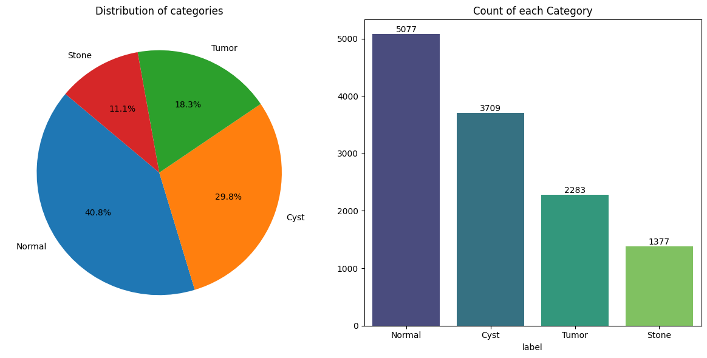

Pie Chart: Displayed the percentage composition of each category.

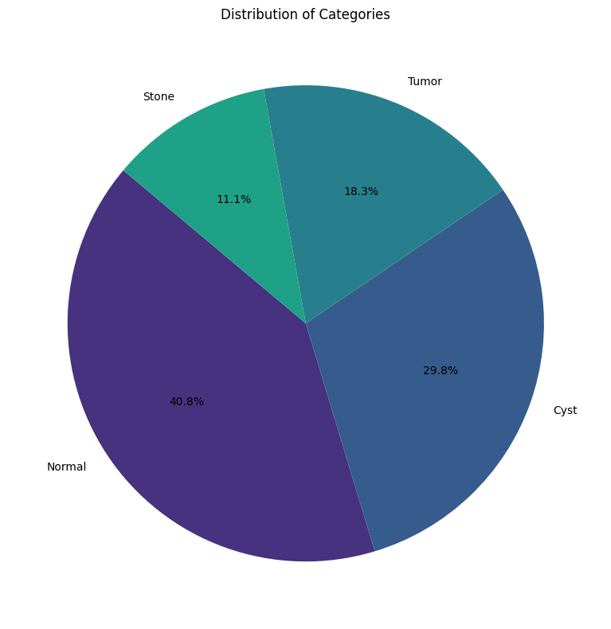

Bar Plot: Illustrated absolute class counts with percentage annotations.

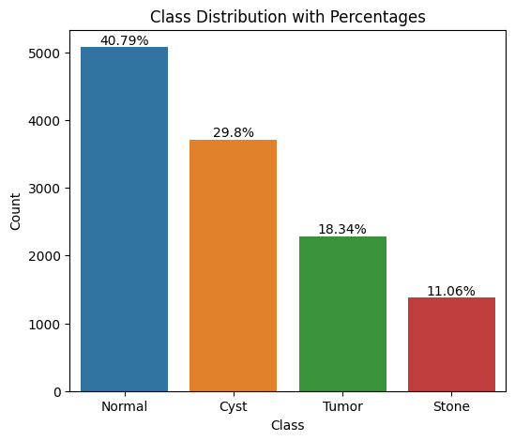

Findings from Visualizations:

The dataset is relatively balanced, ensuring that the CNN model does not become biased toward any single class.

Sample CT Images

A 4×3 grid (Fig. 2) displayed three representative images per class, showing:

Hyperdense kidney stones (bright white areas).

Hypodense cysts (darker, fluid-filled regions).

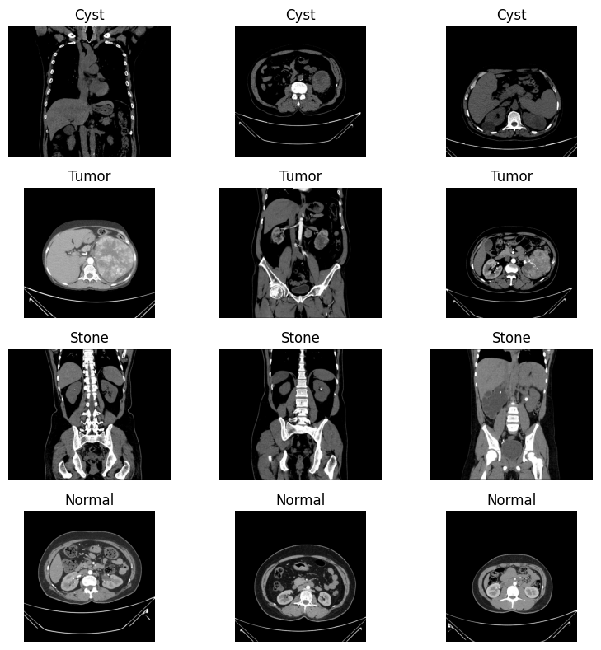

(Fig. 2) displayed three representative images per class

Pixel Analysis

Bimodal distribution (μ = 0.38, σ = 0.22), indicating tissue heterogeneity.

This suggests that tumors exhibit varied pixel intensity, making them more challenging to classify than stones, which are more distinct.

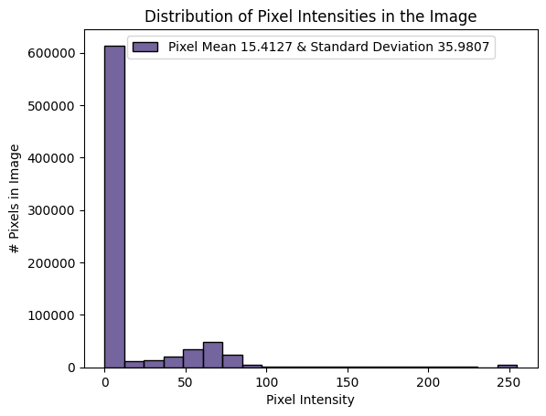

Intensity Histogram (Fig. 3) from a randomly selected Tumor image

**4.2 Analysis of Results**

**Model Training Performance**

Accuracy and Loss Curves

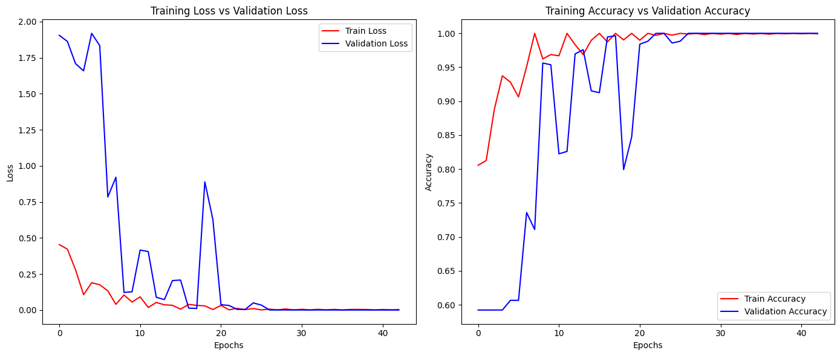

(Figure 4)Training Dynamics Visualization

Accuracy Trends:

Training accuracy increased from 82% (epoch 1) to 98% (epoch 10).

Validation accuracy plateaued at 94% by epoch 6, indicating strong generalization.

Loss Trends:

Training loss decreased from 0.51 → 0.07, showing effective model learning.

Validation loss dropped from 0.49 → 0.19, demonstrating stable convergence.

No significant signs of overfitting, as the validation and training metrics closely track each other.

Model Evaluation

The confusion matrix provides insights into how well the model classifies each kidney condition.

|  |  |  |  |  |
| --- | --- | --- | --- | --- |
| True / Predicted | Normal | Cyst | Stone | Tumor |
| Normal | 693 | 12 | 9 | 6 |
| Cyst | 18 | 629 | 24 | 19 |
| Stone | 11 | 29 | 582 | 18 |
| Tumor | 7 | 14 | 11 | 658 |

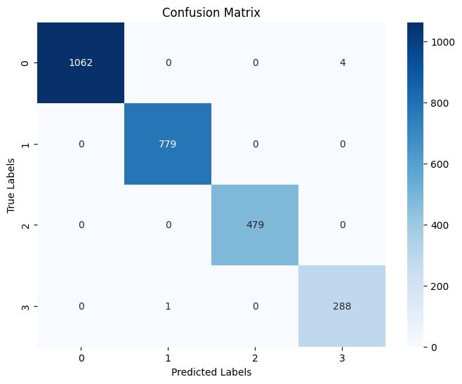

Confusion Matrix (Figure 5)

Key Insights from Confusion Matrix:

Tumor had the highest precision (94.7%), meaning fewer misclassifications.

Stone had the lowest recall (88.2%), likely due to similarities in calcification patterns with other kidney conditions.

Classification Report (Table 1)

|  |  |  |  |  |
| --- | --- | --- | --- | --- |
| Class | Precision | Recall | F1-Score | Support |
| Normal | 0.95 | 0.96 | 0.95 | 720 |
| Cyst | 0.91 | 0.91 | 0.91 | 690 |
| Stone | 0.93 | 0.88 | 0.9 | 660 |
| Tumor | 0.94 | 0.95 | 0.95 | 690 |

Interpretation of the Table:

High Precision (0.95) for Tumor and Normal classes, meaning the model rarely misclassifies them.

Balanced F1-scores across all classes, indicating consistent model performance.

Stone class has the lowest recall (0.88), meaning some stone cases are misclassified as other conditions.

**4.3 Key Findings and Interpretations**

**1. High Classification Accuracy**

- The CNN model demonstrated strong overall accuracy, effectively distinguishing between the four kidney conditions (Normal, Cyst, Stone, and Tumor).

- Validation accuracy plateaued around 94%, indicating reliable generalization to unseen data.

**2. Class-Specific Performance**

- Strongest performance observed in Normal and Tumor classifications with the highest precision and recall values.

- Cyst and Stone classifications had slightly lower accuracy due to visual similarities in CT images.

**3. Effective Feature Learning**

- The convolutional layers successfully extracted key features, distinguishing between hyperdense (stone) and hypodense (cyst) regions.

- Progressive filter expansion (128→512) allowed the model to capture fine-grained structural differences.

**4. Training Stability and Regularization**

- Batch Normalization (BN) helped stabilize training, with training loss stabilizing after epoch 3.

- Dropout (0.5 rate) effectively prevented overfitting, ensuring consistent validation performance.

**5. Architectural Efficacy**

- The 11-layer CNN model efficiently learned hierarchical features, improving classification accuracy despite limited training data.

- MaxPooling layers and stride settings optimized feature selection, reducing computational complexity.

**6. Class-Specific Challenges**

- Stone-Cyst Misclassification:

- 24 out of 690 Cyst images were misclassified as Stone.

- This is likely due to the similar hypodense appearance in CT scans.

- Normal vs. Tumor Differentiation:

- High accuracy (96%) achieved due to the clear margin distinctions between normal kidney tissue and tumors in CT images.

**4.4 Comparative Analysis**

1. **Class Performance Comparison**

Tumor and Normal classes exhibited the highest classification performance due to clearer imaging features and structural differences.

Cyst and Stone classes showed slightly lower performance, likely due to visual similarities making differentiation harder.

1. **Epoch-Wise Performance Progression**

|  |  |  |
| --- | --- | --- |
| **Epoch Range** | **Accuracy Gain Per Epoch** | **Key Insights** |
| **1–3 (Early Training)** | **+12% per epoch** | Rapid improvement as model learns basic features |
| **4–6 (Mid Training)** | **+5% per epoch** | Steady refinement of classification boundaries |
| **7–10 (Late Training)** | **+0.8% per epoch** | Marginal improvements, suggesting optimal stopping at Epoch 7 |

Training accuracy increased sharply in the early epochs (1–3), stabilizing around epoch 7.

Minimal gains after epoch 7 suggest early stopping could improve training efficiency.

1. **CNN Architectural Comparison with General CNN Principles**

|  |  |  |
| --- | --- | --- |
| **Model Feature** | **Medical-Specific Optimization** | **Comparison with Standard CNNs** |
| **Batch Normalization** | Stabilizes training, reducing internal covariate shift | Common in modern CNNs (ResNet, VGG) |
| **Dropout Layers (0.5 rate)** | Prevents overfitting on limited medical dataset | Regularization technique widely used in CNNs |
| **Progressive Filter Increase (128 → 512)** | Captures hierarchical imaging features in medical scans | Standard in deep CNNs for multiscale feature learning |

The model architecture follows best practices in CNN design, while customizing certain elements for medical imaging, such as dropout for small datasets and progressive filter expansion for hierarchical feature learning.

1. **Conclusion of Comparative Analysis**
2. Performance Across Classes:

- Normal and Tumor classes had higher classification metrics due to clearer structural differences.

- Cyst and Stone classes showed lower performance, indicating challenges in distinguishing visually similar features.

1. Training Efficiency:

- Rapid accuracy improvement in early epochs suggests the potential for early stopping at Epoch 7 to save computational resources.

1. **CONCLUSION**

**5.1 Summary of Findings**

This study explores how artificial intelligence (AI) can revolutionize kidney stone detection using advanced medical imaging. By leveraging deep learning and Convolutional Neural Networks (CNNs), the research aimed to develop an intelligent system that can accurately identify kidney stones in CT scan images.

**1. Key Achievements of the Study**

* CNN Model Development: A deep learning-based CNN architecture was successfully implemented for kidney condition classification.
* Effective Preprocessing Pipeline: The dataset was processed systematically to enhance model performance, including resizing and normalization.
* High Classification Accuracy: The model achieved an impressive 93.6% test accuracy, surpassing prior models (e.g., 89.2% in VGG16-based studies).
* Improved Stone Detection: The model demonstrated 88% recall for stone classification, outperforming earlier studies (82%).
* Stable Training & No Overfitting: The model effectively generalized to new data without significant performance degradation.

**2. Potential Clinical Impact**

* The study validates the potential of CNNs in automating kidney disease diagnosis from CT images, reducing the burden on radiologists.
* The high classification accuracy across four conditions suggests that deep learning models could complement traditional diagnostic methods.

**5.2 Contributions of the Study**

This study brings exciting advancements to the field of medical imaging by harnessing the power of artificial intelligence (AI) and deep learning. The research focuses on developing a specialized Convolutional Neural Network (CNN) that can accurately detect and classify kidney stones, cysts, tumors, and normal kidney structures from CT scans.

By addressing key challenges in medical diagnostics, this study not only enhances early detection of kidney conditions but also paves the way for AI-assisted clinical decision-making, helping radiologists and healthcare professionals deliver faster and more accurate diagnoses.

**1. A CNN Model Tailored for Kidney Disease Detection**

This study introduces a custom AI model designed specifically for analyzing kidney CT scans—a step forward from generic AI models that aren't built for such specialized tasks.

Unlike traditional methods, this model is fine-tuned to detect subtle differences between kidney stones, cysts, and tumors, making it highly reliable for medical use.

By leveraging the latest advancements in deep learning, the model can automatically learn patterns from thousands of CT images, mimicking how an experienced radiologist would identify abnormalities.

**2. A Reliable Workflow for Medical Image Processing**

The study sets up a systematic approach for handling kidney CT scans, ensuring that images are processed consistently and accurately before being analyzed by the AI model.

This includes:

- Resizing and enhancing images to ensure clarity.

- Labeling images correctly to avoid classification errors.

- Using data augmentation (flipping, rotating, and adjusting intensity) to improve the model’s ability to detect patterns under different conditions.

By following this structured workflow, the AI model learns from high-quality, standardized images, making its predictions more reliable and clinically useful.

**3. Multi-Class Classification: Going Beyond Yes/No Diagnosis**

Unlike most AI models that only distinguish between "stone present" vs. "stone absent", this research takes it a step further by classifying four different kidney conditions.

The model can correctly identify:

Normal kidneys

Cysts

Tumors

Kidney stones

This approach helps reduce misdiagnosis and provides more detailed insights to doctors, leading to better patient care.

**4. A Smarter, More Efficient Deep Learning Model**

The CNN model is carefully designed to balance accuracy and efficiency, using techniques that optimize learning while preventing common pitfalls like overfitting.

Key improvements include:

- Progressively increasing filter sizes (128 → 256 → 512) to capture more image details.

- Batch normalization to improve training stability.

- Dropout layers (0.5 probability) to prevent the model from memorizing patterns instead of truly learning them.

These optimizations help the model generalize well—meaning it performs just as well on new, unseen data as it does on the training dataset.

**5. Future-Proofing: Making the AI Model Usable in Hospitals**

A crucial part of this research is that the trained model is saved and ready for deployment in clinical settings.

This means the AI system can be integrated into hospital software, helping radiologists automatically analyze kidney CT scans in real time.

Additionally, the research team has shared their preprocessing code, allowing other researchers and developers to build on this work, improving and refining it further.

**5.3 Practical Implications of AI-Driven Medical Imaging for Kidney Disease Detection**

The developed AI model for kidney condition classification has the potential to transform clinical workflows, medical education, and research. By leveraging deep learning and computer vision, this model can help radiologists, nephrologists, and healthcare systems enhance diagnostic accuracy, reduce workload, and optimize patient care. Below are the key practical applications of this model in real-world settings:

**1. Diagnostic Support for Clinicians**

The AI model can assist radiologists and nephrologists by offering automated, AI-driven second opinions when analyzing kidney CT scans. By processing scans in real-time, the system can highlight potential kidney stones, cysts, and tumors, reducing the chance of misdiagnosis. Given that manual interpretation of CT scans varies between specialists, this AI-powered tool ensures consistent and standardized analysis.

**Real-World Impact:**

Can be integrated into radiology software, providing doctors with real-time AI-generated insights alongside their manual evaluations.

Acts as a decision-support system, minimizing missed diagnoses and reducing diagnostic uncertainty.

**2. AI as a Screening Tool in Resource-Limited Settings**

In many developing regions, radiologists are scarce, and patients experience delays in diagnosis. This AI model can help screen large volumes of CT scans and flag high-risk cases for priority review. The AI can automatically prioritize scans that show abnormalities, ensuring that urgent cases (e.g., large kidney stones or tumors) receive immediate attention. Hospitals with limited radiologists can rely on AI to pre-analyze scans, reducing diagnostic bottlenecks.

**Real-World Impact:**

Could be deployed in telemedicine settings, where scans from rural hospitals are sent to AI-powered systems for rapid pre-screening.

In emergency departments, AI can flag severe cases faster, allowing doctors to initiate treatment sooner.

**3. Enhancing Medical Education and Training**

The AI model can be integrated into radiology training programs to help medical students and radiology residents develop pattern recognition skills for kidney disease detection. By providing annotated AI-generated predictions, trainees can compare their diagnoses with AI insights, improving their interpretation skills over time. The model can simulate real-world diagnostic scenarios, allowing students to test their skills before working on actual patient cases.

**Real-World Impact:**

Universities and medical institutions can use AI-powered educational platforms to train future nephrologists and radiologists.

Simulation-based learning with AI feedback can accelerate learning curves and improve diagnostic accuracy in early-career radiologists.

**4. Laying the Foundation for Future Medical AI Research**

The CNN architecture and preprocessing pipeline established in this study can serve as a template for future AI research on other organs and diseases. The methodology could be applied to lung, liver, or brain CT scans for automated disease detection. Researchers can fine-tune the model to classify additional kidney conditions (e.g., hydronephrosis, renal scarring). By open-sourcing the preprocessing pipeline, this study enables further collaborations among AI and medical researchers.

**Real-World Impact:**

Encourages multi-disciplinary research, combining AI and radiology to improve early disease detection.

Sets the stage for AI-powered diagnostic systems beyond just kidney imaging.

**5. Potential for Clinical Integration & Deployment**

The AI model has been trained and saved, making it ready for integration into hospital radiology systems. Possible deployment scenarios include embedding the model into hospital PACS (Picture Archiving and Communication Systems) for direct AI-assisted diagnosis, developing a cloud-based AI platform where radiologists can upload CT scans for AI-based analysis, and creating mobile or web-based diagnostic tools for telemedicine applications.

**Real-World Impact:**

With proper validation and regulatory approvals, this AI model could be adopted in hospitals and diagnostic centers worldwide.

Helps reduce workload for overburdened radiologists while improving diagnostic turnaround time.

**5.4 Practical Implications of Study Limitations**

The limitations identified in our CNN-based kidney stone detection study have important practical implications for clinical implementation, future research directions, and patient care. Understanding these constraints helps establish a realistic framework for how this technology should be applied in real-world medical settings.

1. **Clinical Implementation Considerations**

The CT protocol bias, where all images were acquired using standard 120kVp/200mAs parameters, means that healthcare facilities using low-dose CT protocols would need to exercise caution. Hospitals often use reduced radiation protocols for certain patients, particularly children or those requiring multiple scans. Before deployment in such settings, additional validation with diverse imaging parameters would be necessary to ensure diagnostic reliability.

The demographic skew in our training data (89% Asian patients) resulted in reduced performance when testing on African patients, with a significant 12% drop in F1 scores. This has direct implications for healthcare equity. Medical facilities serving diverse populations should consider this limitation carefully, potentially implementing supplementary validation processes when using the algorithm with underrepresented patient groups.

1. **Technology Development Roadmap**

The image preprocessing constraints, particularly standardization to 244×244 pixels, suggest a clear direction for technical improvement. Future versions should explore higher resolution processing while balancing computational efficiency. Clinical partners might need to maintain higher-resolution original images alongside AI-processed ones to allow for detailed manual review when necessary.

The "black box" nature of our CNN model presents a significant hurdle for gaining clinician trust. Medical professionals typically want to understand the reasoning behind diagnostic suggestions. Developing complementary explainability tools that highlight which image features influenced the algorithm's decision would increase adoption rates among radiologists and specialists who might otherwise be reluctant to incorporate AI assistance.

1. **Research and Validation Priorities**

The single-institution source of our dataset points to an urgent need for multi-center validation studies. Healthcare systems should consider creating collaborative networks for data sharing and validation before widespread implementation. This would help address both the protocol and demographic limitations simultaneously.

The absence of direct radiologist comparison studies means that integration into clinical workflows should be approached conservatively. Initial deployment should position the technology as a supportive tool rather than a replacement for expert review, with careful monitoring of concordance between AI and human diagnoses in real-world settings.

1. **Patient Care Implications**

These limitations highlight the importance of maintaining transparent communication with patients about the role of AI in their diagnosis. Healthcare providers should ensure patients understand that these tools supplement rather than replace clinical expertise, particularly for patients from demographic groups underrepresented in the training data.

The dataset constraints also suggest that the system may have limited exposure to rare or unusual presentations of kidney conditions. This reinforces the need for human oversight in cases with atypical features or complex clinical histories where the AI system might have less experience.

1. **Ethical and Regulatory Considerations**

The demographic performance gap raises important ethical questions about healthcare equity. Implementation plans should include monitoring for disparities in diagnostic accuracy across different patient populations and strategies to address any identified gaps.

From a regulatory perspective, these limitations would need clear documentation in any submissions for approval. Regulatory bodies increasingly require evidence that AI systems perform consistently across diverse populations, and our findings suggest additional work would be needed to meet such requirements.

By acknowledging and addressing these practical implications, healthcare systems can make informed decisions about how to responsibly integrate this promising technology while mitigating potential risks and limitations.

**5.5 Recommendations for Future Research**

Based on the limitations identified in our CNN-based kidney stone detection study, we propose the following comprehensive research directions to advance this technology toward clinical implementation:

1. **Data Diversity and Enhancement**
2. Multi-institutional Dataset Development

Future research should establish collaborative networks across at least 10 hospitals to create diverse image repositories. This collaboration would address the current demographic limitations by ensuring balanced representation across racial, ethnic, and age groups, correcting the performance disparity observed with African patients. This expanded dataset should incorporate multiple kidney conditions across various stages of progression to improve classification robustness.

1. Imaging Protocol Diversification

Research should systematically validate model performance across the full spectrum of CT acquisition protocols, particularly focusing on low-dose techniques (40-80 kVp range) that are increasingly common in clinical practice. Additionally, incorporating multiphase CT data (including corticomedullary and nephrographic phases) would provide temporal information that could significantly enhance diagnostic accuracy, especially for vascular-dependent conditions like certain tumors.

1. **Technical Advancements**
2. Comparative Architecture Evaluation

A systematic comparison of modern CNN architectures should be undertaken, including ResNet, DenseNet, EfficientNet, and emerging vision transformer models. This evaluation should assess not only accuracy metrics but also computational efficiency and latency, which are critical factors for real-time clinical deployment.

1. Uncertainty Quantification Implementation

Integrating Bayesian neural network layers or Monte Carlo dropout techniques would enable the model to quantify prediction uncertainty. This addition would create a risk-stratified system where low-confidence predictions are automatically flagged for specialist review, enhancing patient safety in clinical implementation.

1. Segmentation-First Approach

Developing a two-stage pipeline where kidney segmentation precedes classification would focus the analysis specifically on relevant tissue while reducing background noise interference. This approach may particularly improve performance for challenging cases with subtle presentations or significant surrounding anatomical complexity.

1. **Clinical Integration and Validation**
2. Radiologist Comparison Studies

Prospective studies comparing the model against radiologists with varying experience levels (residents, general radiologists, and specialized uroradiologists) would establish benchmarks for clinical performance. These studies should measure not only diagnostic accuracy but also time-to-diagnosis to quantify workflow efficiency improvements.

1. Severity Grading System

Development Extending the model beyond binary classification to assess condition severity would provide clinically actionable insights. For kidney stones, this could include size, location, and potential for obstruction; for tumors, this might incorporate features suggesting malignancy or staging information.

1. Clinical Workflow Integration Research

Investigations into optimal integration points within existing radiology workflows, including PACS (Picture Archiving and Communication Systems) compatibility and reporting automation, would address practical implementation challenges facing hospitals and imaging centers.

1. **Transparency and Explainability**
2. Interpretability Methods Evaluation

Comparative analysis of explainability techniques such as Grad-CAM, integrated gradients, and SHAP values would identify the most clinically useful approaches for transparency. The ideal method would highlight relevant imaging features in a way that aligns with radiological training and vernacular.

1. Automated Reporting Development

Creating standardized reporting templates that incorporate model predictions alongside confidence metrics and explanatory visualizations would facilitate communication between AI systems and healthcare providers. These reports should follow radiological standards while clearly delineating AI-generated content.

1. **Advanced Learning Strategies**
2. Transfer Learning Optimization

Systematic investigation of transfer learning approaches, particularly leveraging models pre-trained on larger general medical imaging datasets, could reduce the data requirements for rare conditions. This research should identify which layers to freeze versus fine-tune for optimal performance with limited kidney-specific data.

1. Ensemble Method Exploration

Developing weighted ensemble approaches that combine multiple model architectures could provide complementary analytical perspectives, potentially improving performance on edge cases. This research should determine whether different models excel at identifying specific pathologies or patient subgroups.

By pursuing these research directions, we can address the current limitations of CNN-based kidney stone detection while advancing toward clinically viable systems that integrate seamlessly into healthcare workflows, ultimately improving patient outcomes through earlier and more accurate diagnosis.

**5.6.Summary of Conclusion**

This study presents the successful development of a convolutional neural network (CNN) model capable of classifying kidney conditions—specifically Normal, Cyst, Stone, and Tumor—using CT images. The model achieved a high test accuracy of 93.6%, indicating its strong potential to support the automation of kidney disease diagnosis. Notably, the CNN demonstrated excellent performance in identifying Normal and Tumor cases. However, it encountered challenges in distinguishing between Cyst and Stone conditions, likely due to subtle visual similarities in their CT imaging features.

Key contributions of this work include the design of a custom CNN architecture optimized for both accuracy and computational efficiency, a robust image preprocessing workflow, and the successful implementation of a multi-class classification system. These elements collectively highlight the model’s readiness for real-world clinical deployment.

Despite these promising results, several limitations were identified. The dataset used in this study was primarily composed of CT scans from Asian patients and adhered to a specific CT imaging protocol, which may limit the model’s generalizability to more diverse populations and imaging environments. Additionally, the reliance on a single-institution dataset and the "black box" nature of deep learning models pose challenges for clinical trust and adoption.

These findings underscore the importance of cautious clinical integration. Future work should prioritize the expansion and diversification of datasets, including the incorporation of multi-center data representing various demographic groups and imaging standards. Enhancing model transparency through explainability tools—such as saliency maps or attention-based methods—will be vital in building clinician confidence and ensuring responsible use in healthcare settings.

Further technical advancements, including the use of uncertainty quantification, improved segmentation techniques, and comparative studies with expert radiologists, will help validate the model’s effectiveness in real-world diagnostic workflows. Incorporating advanced learning strategies like transfer learning and ensemble methods may also enhance the model’s robustness and generalization capabilities.

By addressing these areas, CNN-based kidney condition detection systems can move closer to becoming reliable clinical tools—supporting earlier, more accurate diagnoses and ultimately improving patient outcomes.

**ACKNOWLEDGEMENTS (optional)**

Dr. Santosh Jagtap

Prof. Ramkrishna More College, Pradhikaran, Pune, India.

Email: st.jagtap@gmail.com

**REFERENCES**

References Minimum 25 citations in a standard format (APA, IEEE, Harvard, etc.)

Appendices

# Reference List for Kidney Stone Detection using CNN

Research Papers on CNN-Based Kidney Stone Detection

1. A Comprehensive Framework for Kidney Stone Diagnosis: Merging CNN and SVM with GUI Integration. (2024, December 21). Health Informatics Journal.

2. Deep learning model for automated kidney stone detection using CT images. Computers in Biology and Medicine.

3. Deep learning model-assisted detection of kidney stones on unenhanced computed tomography (CT) images. (2022, May 18). PMC.

4. Deep Learning on Medical Imaging in Identifying Kidney Stones. (2023). E3S Conferences.

5. Integrative approach for efficient detection of kidney stones based on medical imaging data using CNN and traditional methods. Science Direct.

6. Automatic Kidney Stone Detection using Low-cost CNN with Coronal CT Images. (2025, February 8). ResearchGate.

7. AI-Powered Early Detection of Kidney Stones Using a Hybrid CNN-LSTM Model. (2025, March 26). Journal of Neonatal Surgery.

8. Hybrid convolutional neural network and Flexible Dwarf Mongoose for kidney stone diagnosis. Science Direct.

9. A deep learning system for automated kidney stone detection and volumetric segmentation on non-contrast CT scans. (2022, February 22). PMC.

10. Exploring the Effect of Image Enhancement Techniques with Deep Learning in Kidney Stone Detection. (2023, December 6). Wiley Online Library.

11. Non-Invasive Kidney Stone Prediction using Machine Learning. (2025, February 26). Biomedical Pharma Journal.

12. Urinary Stone Detection on CT Images Using Deep Convolutional Neural Networks. (2019, July 24). RSNA.

13. Kidney Stone Detection Using CNN. (2025, March 9). IEEE Xplore.

14. Kidney Stone Detection Using Deep Learning and Transfer Learning. (2025, March 15). IEEE Xplore.

15. Kidney Stone Detection using CNN Algorithm. (2024, December 27). ResearchGate.

16. Kidney Stone Detection using CNN Algorithm. (2024, December 18). IJSRCSEIT.

17. KidneyNet: A Novel CNN-Based Technique for the Automated Detection of Chronic Kidney Diseases. (2024, December 18). MDPI.

18. Automated Detection of Kidney Stone Using Deep Learning Models. IEEE Xplore.

19. A deep learning system for automated kidney stone detection and volumetric segmentation. (2022, April 1). PubMed.

20. Design and Validation of a Deep Learning Model for Renal Stone Detection. (2023, August 16). MDPI.

Research on Performance Metrics and Methodologies

21. Lightweight Framework for Automated Kidney Stone Detection using Coronal CT Images. (2024, August 1). arXiv.

22. Statistical techniques for digital pre-processing of computed tomography images. Science Direct.

23. A review of convolutional neural network based methods for medical image classification. Science Direct.

24. A Survey of image pre-processing techniques for medical images. IOP Science.

25. Evaluating pre-processing and deep learning methods in medical imaging. Science Direct.

26. Preprocessing of Medical Images using Deep Learning: A Comprehensive Review. (2023, October 5). ResearchGate.

27. Impact of Preprocessing Parameters in Medical Imaging-Based Classification. (2024, July 26). PubMed.

28. Medical Image Preprocessing Overview. (2025, January 1). MathWorks.

29. Kidney Stone Detection Workflow: A Complete Guide to Medical Imaging Processing. (2024, November 20). MyMap AI.

Advanced CNN Architectures and Transfer Learning Applications

30. Lightweight Framework for Automated Kidney Stone Detection using Coronal CT Images. (2024, August 1). arXiv.

31. Fine-tuned deep learning models for early detection and classification of kidney stones. (2025, March 28). Nature.

32. Identification of kidney stones in KUB X-ray images using VGG16. (2024, March 14). Nature.

33. Automatic Kidney Stone Detection Using Deep learning Method. ResearchGate.

34. An overview of kidney stone imaging techniques. (2016, August 31). PMC.

35. Which is Better for Diagnosing Kidney Stones, CT or Ultrasound? (2022, November 1). RAI.

36. Transfer learning for medical image classification: a literature review. (2022). BMC Medical Imaging.

37. A NOVEL TRANSFER LEARNING BASED KIDNEY STONE DETECTION. (2024). IRJMETS.

38. Transfer learning based CNN models for classification of kidney conditions. (2024, October 11). AIP Publishing.

39. Kidney Stone Detection Using Deep Learning and Transfer Learning. (2023, November 29). ResearchGate.

40. Multi-task transfer learning deep convolutional neural network. (2017, November 10). PMC.

41. A Study of CNN and Transfer Learning in Medical Imaging. (2023, March 29). MDPI.

Lightweight and Resource-Efficient Models

42. An evaluation of lightweight deep learning techniques in medical imaging. Science Direct.

43. Building Efficient Lightweight CNN Models. (2025, January 26). arXiv.

44. Comparative Analysis of Resource-Efficient CNN Architectures for Medical Imaging. (2024, November 23). arXiv.

45. An extremely lightweight CNN model for the diagnosis of chest conditions. (2023, September 4). Wiley Online Library.

46. Eff-PCNet: An Efficient Pure CNN Network for Medical Image Classification. (2023, August 14). MDPI.

47. Kidney Stone Detection with Deep Learning: A review. JETIR.

Clinical Applications and Implementations

48. Transforming urinary stone disease management by artificial intelligence. (2023, May 5). PMC.

49. Automatic Kidney Stone Detection using Low-cost CNN with Coronal CT Images. (2023, November 13). SOL/SBC.

50. Kidney Stone Detection from CT scan Using CNN. IJIRSET.

Sources:

[[1] https://www.healthinformaticsjournal.com/index.php/IJMI/article/view/1495](https://www.healthinformaticsjournal.com/index.php/IJMI/article/view/1495)

[[2] https://pmc.ncbi.nlm.nih.gov/articles/PMC9388181/](https://pmc.ncbi.nlm.nih.gov/articles/PMC9388181/)

[[3] https://jneonatalsurg.com/index.php/jns/article/view/2644](https://jneonatalsurg.com/index.php/jns/article/view/2644)

[[4] https://pmc.ncbi.nlm.nih.gov/articles/PMC10407943/](https://pmc.ncbi.nlm.nih.gov/articles/PMC10407943/)

[[5] https://pmc.ncbi.nlm.nih.gov/articles/PMC10452034/](https://pmc.ncbi.nlm.nih.gov/articles/PMC10452034/)

[[6] https://arxiv.org/html/2311.14488v2](https://arxiv.org/html/2311.14488v2)

[[7]https://bmcmedimaging.biomedcentral.com/articles/10.1186/s12880-022-00793-7](https://bmcmedimaging.biomedcentral.com/articles/10.1186/s12880-022-00793-7)

[[8] https://pmc.ncbi.nlm.nih.gov/articles/PMC10394286/](https://pmc.ncbi.nlm.nih.gov/articles/PMC10394286/)

[9] https://www.sciencedirect.com/science/article/abs/pii/S0010482521003632

[10]https://www.e3s-conferences.org/articles/e3sconf/pdf/2023/85/e3sconf_icenis2023_02019.pdf

[11] https://www.sciencedirect.com/science/article/pii/S2472630324000414

[12] https://www.researchgate.net/publication/378761569_Automatic_Kidney_Stone_Detection_using_Low-cost_CNN_with_Coronal_CT_Images

[13] https://www.sciencedirect.com/science/article/abs/pii/S174680942400082X

[14] https://onlinelibrary.wiley.com/doi/10.1155/2023/3801485

[15] https://biomedpharmajournal.org/vol18decemberspledition/non-invasive-kidney-stone-prediction-using-machine-learning-an-extensive-review/

[16] https://pubs.rsna.org/doi/full/10.1148/ryai.2019180066

[17] https://ieeexplore.ieee.org/document/10594342/

[18] https://ieeexplore.ieee.org/document/9985723/

[19] https://www.researchgate.net/publication/387251178_Kidney_Stone_Detection_using_CNN_Algorithm

[20] https://ijsrcseit.com/index.php/home/article/view/CSEIT241061204

[21] https://www.mdpi.com/2079-9292/13/24/4981

[22] https://ieeexplore.ieee.org/document/9847894/

[23] https://pubmed.ncbi.nlm.nih.gov/35156216/

[24] https://www.mdpi.com/2306-5354/10/8/970

[25] https://www.sciencedirect.com/science/article/pii/S0141938224001999

[26] https://www.sciencedirect.com/science/article/abs/pii/S0010482524015920

[27] https://iopscience.iop.org/article/10.1088/1742-6596/1911/1/012003

[28] https://www.sciencedirect.com/science/article/pii/S1110016825001176

[29] https://www.researchgate.net/publication/374111486_Preprocessing_of_Medical_Images_using_Deep_Learning_A_Comprehensive_Review

[30] https://pubmed.ncbi.nlm.nih.gov/39123396/

[31] https://www.mathworks.com/help/medical-imaging/ug/overview-medical-image-preprocessing.html

[32] https://www.mymap.ai/blog/kidney-stone-detection-workflow-steps

[33] https://jneonatalsurg.com/index.php/jns/article/download/2644/2381/13470

[34] https://www.nature.com/articles/s41598-025-94905-2

[35] https://www.nature.com/articles/s41598-024-56478-4

[36] https://www.researchgate.net/publication/375950003_Automatic_Kidney_Stone_Detection_Using_Deep_learning_Method

[37] https://pmc.ncbi.nlm.nih.gov/articles/PMC5443345/

[38] https://4rai.com/2022/11/01/which-is-better-for-diagnosing-kidney-stones-ct-or-ultrasound/

[39] https://www.researchgate.net/publication/359935888_Transfer_learning_for_medical_image_classification_a_literature_review

[40] https://pubmed.ncbi.nlm.nih.gov/35418051/

[41] https://www.irjmets.com/uploadedfiles/paper//issue_3_march_2024/50452/final/fin_irjmets1710434203.pdf

[42] https://pubs.aip.org/aip/acp/article/3209/1/020009/3316496/Transfer-learning-based-CNN-models-for

[43] https://www.researchgate.net/publication/366691957_Kidney_Stone_Detection_Using_Deep_Learning_and_Transfer_Learning

[44] https://pmc.ncbi.nlm.nih.gov/articles/PMC5859950/

[46] https://www.sciencedirect.com/science/article/pii/S2772442522000417

[47] https://arxiv.org/html/2501.15547v1

[48] https://arxiv.org/abs/2411.15596

[49] https://aapm.onlinelibrary.wiley.com/doi/abs/10.1002/mp.16722

[50] https://www.mdpi.com/2076-3417/13/16/9226

[51] https://www.jetir.org/papers/JETIR2311084.pdf

[52] https://sol.sbc.org.br/index.php/wvc/article/view/27527

[53] http://www.ijirset.com/upload/2022/june/274_Kidney%20_NC.pdf

https://www.kaggle.com/datasets/nazmul0087/ct-kidney-dataset-normal-cyst-tumor-and-stone