Machine for Multi-utility Incense Products from Agriculture Waste to Uplift Farmer Economy

Prof. Abhijeet Raut1, Prof. Piyush Pande2, Abhay Gedam3, Pavan Patil4, Ankush Baheshwar5, Utkarsh Dhore6

(Assistant Professor, Department of Mechanical Engineering, Nagpur Institute of Technology, Nagpur Email: [abhijeetraut21@gmail.com](mailto:abhijeetraut21@gmail.com) )

(Assistant Professor, Department of Mechanical Engineering, Nagpur Institute of Technology, Nagpur Email: [piyushspande@gmail.com)](mailto:piyushspande@gmail.com)

(Student, Department of Mechanical Engineering, Nagpur Institute of Technology, Nagpur Email: [gedamabhay898@gmail.com)](mailto:nikodepiyush05@gmail.com)

(Student, Department of Mechanical Engineering, Nagpur Institute of Technology, Nagpur) (Student, Department of Mechanical Engineering, Nagpur Institute of Technology, Nagpur) (Student, Department of Mechanical Engineering, Nagpur Institute of Technology, Nagpur)

**------------------------------------------------------------------------------------------------------**

**Abstract:**

The purpose of this project is to address the economic challenges faced by farmers, particularly smallholders, by introducing an innovative machine that transforms agricultural waste into multi-utility products, specifically incense products. The methodology involves developing a specialized machine designed to process various agricultural residues, such as crop residues, husks, and stalks, which are often discarded or burned, contributing to environmental pollution. The findings indicate that this machine not only reduces waste but also creates a sustainable and profitable value chain for farmers, enabling them to diversify their income streams and reduce dependency on traditional crop sales. Furthermore, the project fosters community engagement and collaboration among farmers, encouraging them to work together in collecting and processing agricultural waste on a larger scale. The research implications highlight the potential for this initiative to uplift the farmer economy, particularly in regions struggling with low profitability and economic instability. Additionally, it promotes sustainable agricultural practices by encouraging efficient resource use and aligning with global efforts towards a circular economy. The value of this project lies in its dual impact: it not only provides farmers with an additional source of income but also contributes to environmental conservation by minimizing waste and reducing the carbon footprint associated with conventional manufacturing processes. This project represents a significant step towards enhancing the livelihoods of farmers while promoting sustainable practices in agriculture.

***Keywords*** — Agricultural waste, incense products, farmer economy, sustainability, multi-utility.

# INTRODUCTION

Agriculture is the backbone of many economies, particularly in developing countries, but it generates significant amounts of waste, including crop residues, husks, stalks, and other by-products. These residues are often burned or left to decompose, contributing to environmental pollution, greenhouse gas emissions, and the loss of valuable resources. At the same time, farmers, especially smallholders, face economic hardships due to fluctuating market prices, low productivity, and limited access to value-added opportunities.

This project seeks to bridge these gaps by introducing an innovative machine that transforms agricultural waste into multi-utility products, particularly incense products, thereby creating a sustainable and profitable value chain for farmers. The core of the project lies in the development of a specialized machine designed

to process agricultural waste into high-quality incense sticks, cones, and other related products. Incense products are widely used in religious, cultural, and therapeutic practices across the global, creating a steady and growing market demand. By utilizing agricultural waste as the primary raw material, the machine not only reduces the environmental impact of waste disposal but also provides farmers with an additional source of income. The machine is designed to be cost-effective, energy-efficient, and easy to operate, making it accessible to farmers in rural areas with limited technical expertise or financial resources. It integrates various processes, such as shredding, mixing, binding, and shaping, to convert raw agricultural waste into finished incense products ready for market distribution.

One of the key advantages of this project is its potential to uplift the farmer economy. By enabling farmers to convert waste into valuable products, the machine empowers them to diversify their income streams and reduce dependency on traditional crop sales. This is particularly significant in regions where farmers struggle with low profitability and economic instability. Additionally, the project promotes sustainable agricultural practices by encouraging the efficient use of resources and reducing waste. It aligns with global efforts to promote a circular economy, where waste is minimized, and materials are reused to create new products.

The production of incense products from agricultural waste also has a lower carbon footprint compared to conventional manufacturing processes, contributing to environmental conservation and climate change mitigation. Furthermore, the project has the potential to create employment opportunities in rural areas, from operating the machine to marketing and distributing the final products. It fosters community engagement and collaboration, as farmers can work together to collect and process agricultural waste on a larger scale. The project also encourages innovation and entrepreneurship, as farmers can explore new markets and product variations, such as organic or scented incense, to cater to diverse consumer preferences.

By turning agricultural waste into valuable incense products, the project not only addresses environmental concerns but also provides a practical solution to improve the livelihoods of farmers. It represents a step towards a more sustainable and equitable agricultural system, where waste is seen as a resource, and farmers are empowered to thrive in a competitive global market.

# WORKING PRINCIPLE

This project is designed to process cow dung and agricultural waste into various incense-related products such as Agarbatti (incense sticks), Dhoop, Diyas, and Sambrani cups. The machine is manually operated using a pedal mechanism, which ensures ease of use, cost-effectiveness, and sustainability. The process can be broken down into the following steps:

## Raw Material Preparation

* + - The primary raw materials, cow dung and agricultural waste (sawdust, husk, or dried leaves), are finely ground and mixed with natural binding agents such as gum or herbal resins.
    - Water is added in controlled quantities to achieve the required consistency for molding or extrusion.

## Pedal-Operated Mechanism

* + - The machine operates using a pedal-driven system that transmits motion through a chain and sprocket drive or rack-and-pinion mechanism to power different components.
    - Pressing the pedal moves a compression plate, extruder, or molding system, depending on the product being manufactured.

## Product Manufacturing

1. Agarbatti (Incense Stick) Making
   * The prepared mixture is loaded into an extrusion chamber.
   * A screw or piston extruder (driven by pedal movement) pushes the material through a nozzle to form thin cylindrical sticks.
   * Bamboo sticks are manually inserted and coated with the material.
   * The formed agarbatti sticks are then set aside for drying.
2. Dhoop Making
   * A compression molding system is used, where the mixture is placed into a cylindrical mold.
   * Pedal action compresses the material into uniform dhoop sticks or cones.
   * The formed dhoop sticks are ejected and kept for drying.
3. Diya Manufacturing
   * A mold pressing plate (activated by the pedal mechanism) shapes the semi-solid cow dung mixture into diya molds.
   * The pressed diyas are carefully removed and sun-dried for further hardening.
4. Sambrani Cup (Incense Cup) Making
   * The material is placed in a cup-shaped mold, and the pedal action ensures uniform pressing.
   * The compacted sambrani cups are released and dried before use.

## Cutting Mechanism

* + - Once the dhoop sticks are extruded, they move towards the left side cutting station for size adjustment.
    - A manual cutter precisely slices the sticks into uniform lengths.
    - The cut products are then collected for drying and finishing

## Drying and Finishing

* + - The finished products are dried naturally under sunlight or in a low-heat chamber to remove moisture and improve strength.
    - Optional scenting, coating, or packaging can be done after the drying process.

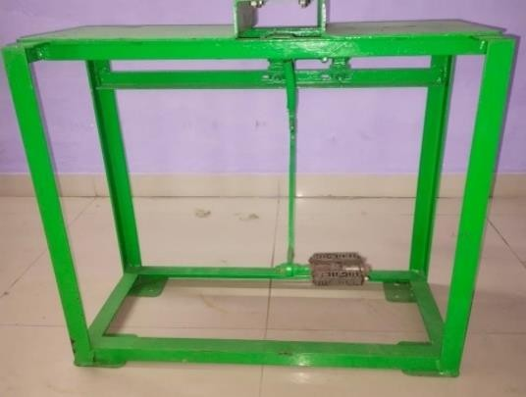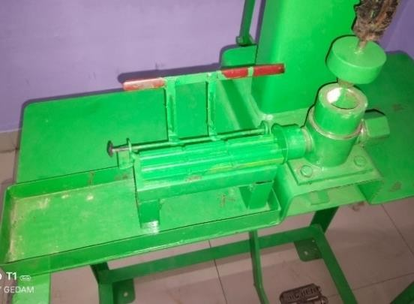

Fig no. 1: Frame for Machine Fig no. 2: Cutting arrangement

## Components and Tools

1. Angles
2. Rack and pinion
3. 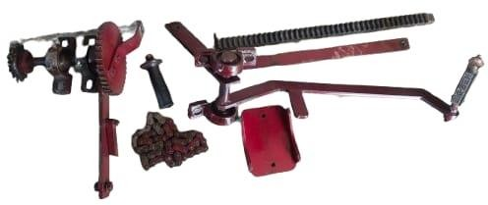Spring
4. Rocket
5. Dies
6. Cutting mechanism
7. Flat plate
8. Hand lever
9. Chain drive
10. Spur Gear
11. Shaft fig. no.3: Machine components
12. Pedal drive
13. Bearing

### Material Selection for Multi-utility machine

The Processing Unit (WPU) is designed for durability and efficient operation. To achieve this, careful consideration was given to the selection of materials for each component. The frame, which provides the core structure of the unit, is constructed from mild steel angles. This material offers a good balance between strength and weight, making it suitable for supporting the weight of the processing components while maintaining a stable platform.

For power transmission and the cutting assembly, a combination of materials was selected based on their specific properties. Mild steel is used for the chain sprocket and the stainless steel is used for hopper, dies and rocket due to its high strength and wear resistance, crucial for handling the forces involved in the processing mechanism. Mild steel is chosen for the shafts due to its machinability and affordability. Hard plastic is used for gripper handle and pedal press due to its high strength, durability and cost-effectiveness.

### Material used

1. Material And Process Selection

*Materials*

* 1. Mild Steel: -
     + Low Carbon Content
     + Mild steel is highly malleable and ductile, which means it can be easily bent, formed, and welded into various shapes without cracking or breaking.
     + Mild steel is known for its excellent weldability.
     + Mild steel is cost-effective and readily available.
  2. Stainless Steel: -
     + Stainless steel is a durable, corrosion-resistant alloy composed of iron, chromium, and other elements like nickel and manganese.
     + It exhibits high strength, excellent heat resistance.
     + Hopper, rocket and dies are made from stainless steel. Hard plastic: -
     + Hard plastic is a robust, lightweight material known for its high strength, durability, and resistance to impact, chemicals, and moisture.
     + It is versatile, cost-effective and widely used in manufacturing and construction work.
     + Gripper handle and Pedal press made from hard plastic.

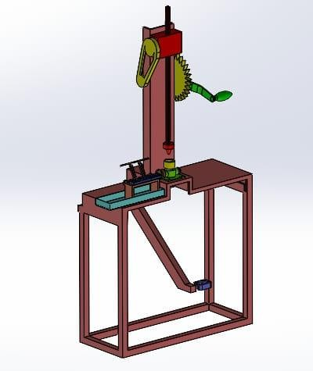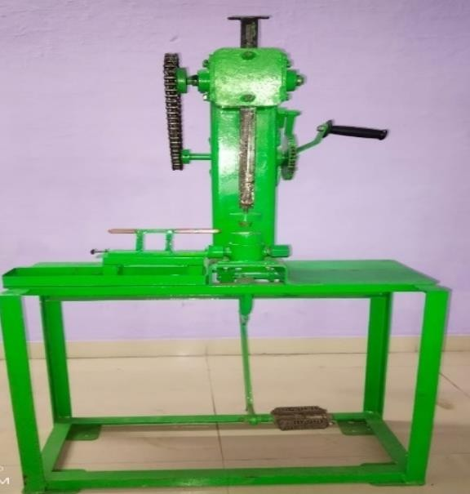

Fig No: 4 CAD model of machine Fig No: 5 Fabricated Incense Products Machine

# DESIGN CALCULATIONS

* **FOR FOUR COLUMNS**

To calculate, whether 35mm x 35mm MS angle columns are sufficient to support a 10 kN load on a tabletop with dimensions 0.68m x 0.30m, and a column height of 0.70m.

* + Calculations:

Compressive Stress: Stress = Force / Area

Stress = 2,500 N / 0.000325 m^2 = 7,692,307 Pa (7.69 MPa)

Allowable Stress:

Buckling Check: Euler's buckling formula for a column with pinned ends: Pcr = (π² * E * I) / (L²)

Pcr = 6386 N.

The critical buckling load (6386 N) is greater than the load per column (2500 N).

* + Result:

Based on these calculations, the 35mm x 35mm MS angle columns, with a 5mm thickness, appear to be sufficient to support the 10 kN load.

# FOR C- CHANNEL

To determine the safe thickness in millimeters for the mild steel C-channel of size 0.285meters * 0.125meters and 0.065meters height which is welded on the MS plate of size 0.68 meters * 0.3 meters to keep on table top of the mechanical press machine to bear 10 KN force safely without bending, design calculations for mechanical press application.

* + Calculating the Bending Moment:

Load per length (w) = 10,000 N / 0.285 m = 35087.7 N/m

The maximum bending moment (M) for a simply supported beam with a uniform load M = (w * L²) / 8

M = 356.5 Nm = 356,500 Nmm

* + Determining the Required Section Modulus σ = M / Z

σ allowable = σy / SF = 250 MPa / 2 = 125 MPa.

Z = M / σ allowable = 356,500 Nmm / 125 N/mm² = 2852 mm³

* + Calculating the Thickness of the C-Channel

We will assume that the flanges are 125mm wide, and the web is 65mm high. Let the thickness be "t".

The moment of inertia of the flanges about the neutral axis is approximately 2* (1/12) * 125 * t³ + 2 * 125 * t * (65/2)^2.

The moment of inertia of the web is (1/12) * t * 65³

The distance from the neutral axis to the extreme fibre is 65/2.

* + Result: A safe thickness for the mild steel C-channel is approximately **6 mm**.

# TOP PLATE

To determine safe thickness in millimeters for the MS (Mild Steel) plate of size 0.68 meters * 0.3 meters to keep on table top of the mechanical press machine to bear 10 KN force safely without bending, design calculations for mechanical press application.

* + Formulae:

Stress (σ): Force per unit area (σ = F/A)

* + Calculations:

Allowable Stress (σ): σy / FOS = 250 MPa / 2 = 125 MPa (125 N/mm²) M = (F * L) / 4 = 750,000 N-mm

Z = I / (h/2) = (b * h^2) / 6

* + Solving for Thickness (h):

125 >=750000 * 6 / (680 * h^2)

h >= 7.27 mm

* + Result: The minimum safe thickness of the MS plate is approximately 7.27 mm

.

# FOR CHAIN DRIVE

To determine the safe thickness of a chain sprocket, drive to transmit a force of 10 kN, we need to consider the mechanical design principles, including the tensile strength of the chain, the load distribution, and the safety factors.

* + Problem:

Transmitted force, F=10 kN=10,000N Driven sprocket diameter, D2=0.135m Driven sprocket teeth, N2=26

Driving sprocket diameter, D1=0.08m Driving sprocket teeth, N1=15

Center distance, C=0.250m

* + Chain Pitch Calculation:

p=D⋅πN

For the driven sprocket: p=16.3mm For the driving sprocket: p=16.8mm

The average pitch is approximately p=16.5 mm

* + Chain Selection:

Based on the pitch, select a standard roller chain (e.g., ANSI standard chain). For a pitch of

16.5 mm, a suitable chain is **ANSI 100** with a pitch of p=15.875 mm Tensile strength, T chain=22,000 N (from manufacturer specifications). Chain Thickness:

t chain=2⋅tp+dr=2⋅3.18+10.16=16.52 mm

* + Verification of Center Distance: L=2C+N1+N22+(N2−N1)24π2C

Substituting the values:26 links.

# FOR RACK AND PINION

Consider Rack as a column which is used for pressing operation.

To determine the safe thickness of the rack in a rack and pinion mechanism, we need to ensure that the rack can withstand a compressive force of 10 kN without buckling. The rack can be modeled as a column, and we will use Euler's buckling formula to calculate the required thickness.

* + Problem:

Compressive force, P=10 kN=10,000 N Height of the rack, L=0.50 m

Width of the rack, b=0.025 m Young's modulus, E=210×10^9 Pa

Factor of safety, FOS=3 (typical for mechanical designs)

* + Euler's Buckling Formula: P critical=π2EI(KL)2

Moment of Inertia for Rectangular Cross-Section: I=12*bt^*3. Critical Buckling Load with Factor of Safety: P critical ≥ P×FOS Substitute P critical from Euler's formula: π2EI(KL)2≥P×FOS

* + Substitute I and solve for t

Substitute I=12*bt^*3 into the inequality: π2E(12bt3) (KL)2≥P×FOS Solve for t^3: t3≥12(KL)2P×FOS*π2Eb

* + Solve for t:

Take the cube root to find t:

t≥1.737×10^-6*3≈0.012 m=22 mm

* + Conclusion:

The safe thickness of the rack to prevent buckling under a compressive force of 10 kN is approximately **22 mm.**

## Performance Test Results of machine

The result of the performance test of the incense products manufacturing machine with Profit Margin is shown in Table.

Table 1: **Performance Testing Result**

|  |  |  |  |  |  |  |  |
| --- | --- | --- | --- | --- | --- | --- | --- |
| Sr.  No. | Products | Material quantity | No. of pieces | Price/piece | Selling price/piece | Profit/piece | Profit/kg |
| 1 | Samrani cup | 1kg | 67 | Rs. 0.50 | Rs. 3.00 | Rs. 2.50 | Rs.167.50 |
| 2 | Dhoop | 1kg | 232 | Rs. 0.10 | Rs. 1.00 | Rs. 0.90 | Rs. 208.8 |
| 3 | Agarbatti | 1kg | 1200 | Rs. 0.10 | Rs. 0.50 | Rs. 0.40 | Rs. 480 |
| 4 | Diya | 1kg | 35 | Rs. 1.00 | Rs. 4.00 | Rs. 3.00 | Rs. 105 |

Table No: 1 – Performance Testing Result

|  |  |  |  |  |  |  |
| --- | --- | --- | --- | --- | --- | --- |
| **Composition of raw material for Mosquito Repellent (For 100%)** | | | | | | |
| Sr. No. | Ingredients | Sample 1 | Sample 2 | Sample 3 | Sample 4 | Sample 5 |
| 1 | Cow Dung Powder | 40% | 40% | 40% | 40% | 40% |
| 2 | Gaur Gum Powder | 8% | 8% | 8% | 8% | 8% |
| 3 | Maida Lakdi Powder | 6% | 6% | 6% | 4% | 4% |
| 4 | Tulsi Powder | 10% | 6% | 10% | 10% | 10% |
| 5 | Neem Powder | 10% | 10% | 6% | 10% | 6% |
| 6 | Purna Powder | 4% | 10% | 10% | 10% | 6% |
| 7 | Jatamasi Powder | 6% | 4% | 4% | 4% | 6% |
| 8 | Chandan Powder | 6% | 6% | 6% | 4% | 8% |
| 9 | Kaurkachri Powder | 4% | 4% | 4% | 6% | 6% |
| 10 | Ral Powder | 6% | 6% | 6% | 4% | 6% |

Table No.2: Composition for mosquito repellent

# CONCLUSIONS

* Machine for Multi-utility Products from Agriculture Waste to Uplift Farmer Economy is a transformative initiative that combines technology, sustainability, and economic development. By turning agricultural waste into valuable incense products, the project not only addresses environmental concerns but also provides a practical solution to improve the livelihoods of farmers.
* It represents a step towards a more sustainable and equitable agricultural system, where waste is seen as a resource, and farmers are empowered to thrive in a competitive global market.

# REFERENCES

1. Bakhle, M., Gite, S., Poyarekar, A., Siddiqui, A., & Patil, S. (2016). Design And Fabrication of An Incense Stick Making Machine. *INTERNATIONAL JOURNAL OF SCIENTIFIC & TECHNOLOGY RESEARCH*,

*5*(04). [www.ijstr.org](http://www.ijstr.org/)

1. Ghinmine, S. v, Pradhan, S. K., Hunge, P. D., Girade, S. A., Taiwade, A. P., Pinjare, A. K., Waghmare, P. S., & Tote, S. S. (n.d.). *Development & Fabrication of Pedal Operated Multi-Purpose Incense Stick Making Machine* (Vol. 5). [www.ijariie.com](http://www.ijariie.com/)
2. Ragul, S., Arunkumar, M., Diviyan, S., Gowtham, M. C., & Kumaravel, G. (n.d.). Design and Fabrication of Incense Stick Making Machine. *International Journal of New Innovations in Engineering and Technology Special Issue on ICET*, 2020.
3. Yadav, V. K. (2020). The Current Scenario of Indian Incense Sticks Market and Their Impact on the Indian Economy. *Indian Journal of Pure & Applied Biosciences*, *8*(3), 627–636. [https://doi.org/10.18782/2582-](https://doi.org/10.18782/2582-2845.8168) [2845.8168.](https://doi.org/10.18782/2582-2845.8168)
4. Qin, Z., Song, Y., & Jin, Y. (2019). Green Worship: The Effects of Devotional and Behavioral Factors on Adopting Electronic Incense Products in Religious Practices. *International Journal of Environmental Research and Public Health*, *16*(19), 3618.
5. Lui, K.H., Bandowe, B.A.M., Ho, S.S.H., Chuang, H.C., Cao, J.J., Chuang, K.J., Lee, S.C., Hu, D., Ho, K.F.

(2016). Chemical characterization and bioreactivity of fine particulate matter (PM2.5) during incense burning. *Environmental Pollution, 213*, 524-532.

1. Lee, C. W., Vo, T. T. T., Wee, Y., Chiang, Y. C., Chi, M. C., Chen, M. L., Hsu, L. F., Fang, M. L., Lee, K.

H., Guo, S. E., Cheng, H. C., & Lee, I. T. (2021). The Adverse Impact of Incense Smoke on Human Health: From Mechanisms to Implications. *Journal of Inflammation Research*, *14*, 5451– 5472. [https://doi.org/10.2147/JIR.S332771.](https://doi.org/10.2147/JIR.S332771)