**TRANSDISCIPLINARY PROJECT CENTRIC LEARNING**

TD-PCL Report submitted in partial fulfillment of the requirement for the award of the degree of

**Master of Business Administration (MBA)**

Submitted By

1. 24MBAR0794 / Ayush Agrawalla
2. 24MBAR0973 / Amisha
3. 24MBAR0485 / Pranav Sharma
4. 24MBAR0350 / Azraa
5. 24MBAR0583 / Chris Kosala
6. 24MBAR0891 / Bhanu Swarn

Under the Guidance of

**Dr. Smita M Gaikwad**,

Assistant Professor,

Faculty of Management Studies, CMS Business School



No.17, Seshadri Rd, Gandhi Nagar, Bengaluru, Karnataka 560009

[Phone](https://www.google.com/search?rlz=1C1DIMC_enIN830IN830&q=cms+business+school+phone&ludocid=111339774717340472&sa=X&ved=2ahUKEwj-vIzom6XlAhV873MBHQvxCb8Q6BMwEnoECAoQLg)**:**080 4684 0400

2025



**CERTIFICATE**

This is to certify that this TD-PCL report submitted to Faculty of Management Studies, CMS Business School, JAIN (Deemed-to-be University), Bangalore, bythe following Students a record of project work done on the topic

Part A - Title **“**Project Report on Dairy Manufacturing Unit**”.**

Part B - Title **“**Research Paper on The Role of Dairy Industry in Rural Economic Development**”.**

This work was done during the academic year 2024 - 25, under my guidance and supervision.

1. 24MBAR0794 / Ayush Agrawalla

2. 24MBAR0973 / Amisha

3. 24MBAR0485 / Pranav Sharma

4. 24MBAR0350 / Azraa

5. 24MBAR0583 / Chris Kosala

6. 24MBAR0891 / Bhanu Swarn

This TD-PCL report has not been submitted for the award of any Degree, Diploma, Associateship or Fellowship or any other title in this University or any other University.

Place: Bangalore Dr. Smita M Gaikwad.

Date: Assistant Professor



**DECLARATION**

I, hereby declare that this TD-PCL Project Report on

Part A - Title **“**Project Report on Dairy Manufacturing Unit**”.**

Part B - Title **“**Research Paper on the Role of Dairy Industry in Rural Economic Development**”.**

is prepared by us during the academic year 2024 - 25 under the guidance of Dr. Smita M Gaikwad.

This report is not based on any previously submitted project for the award of Degree or Diploma offered by any University. It is the result of our own effort.

1. 24MBAR0794 / Ayush Agrawalla

2. 24MBAR0973 / Amisha

3. 24MBAR0485 / Pranav Sharma

4. 24MBAR0350 / Azraa

5. 24MBAR0583 / Chris Kosala

6. 24MBAR0891 / Bhanu Swarn

Date:



**NO OBJECTION FOR PUBLICATION / IPR PROCESSING**

This is to certify that the Transdisciplinary Project Centric Learning Report titled Part A - Title **“**Project Report on Dairy Manufacturing Unit**”.**

Part B - Title **“**Research Paper on the Role of Dairy Industry in Rural Economic Development**”.**

was completed at Faculty of Management Studies, CMS Business School, JAIN (Deemed-to-be University) under the supervision of Dr. Smita M Gaikwad.

We have no objection if the University uses the contents for any kind of publication – print/online, including but not limited to IPR-related processing in the future. We hereby, authorize the University authorities to take all decisions pertaining to the same and will abide by their decisions.

1. 24MBAR0794 / Ayush Agrawalla

2. 24MBAR0973 / Amisha

3. 24MBAR0485 / Pranav Sharma

4. 24MBAR0350 / Azraa

5. 24MBAR0583 / Chris Kosala

6. 24MBAR0891 / Bhanu Swarn

Date:

**The Role Of Dairy Industry In Rural Economic Development**

|  |  |
| --- | --- |
| **Name** | **Reg No** |
| AMISHA | 24MBAR0973 |
| Azraa | 24MBAR0350 |
| Aayush Agarwalla | 24MBAR0794 |
| Bhanu Swarn | 24MBAR0891 |
| Chris Kosala | 24MBAR0583 |
| Pranav Sharma | 24MBAR0485 |

|  |  |
| --- | --- |
| **Table of Contents** | |
| **Particulars** | **Page No:** |
| **1. Executive Summary** | **3** |
| **2. Introduction** | **4** |
| **3. Review of Literature** | **5-9** |
| **4. Data Analysis and Interpretation** | **10-15** |
| **5. Finding and Recommendation** | **16-17** |
| **6. Conclusion** | **18** |
| **7. Bibliography** | **19-20** |

**Executive Summary**

Since it gives millions of rural households, especially in agrarian nations, a stable source of income, the dairy business is essential to the growth of the rural economy. It has a major impact on raising living standards, creating jobs, and reducing poverty in rural regions. In addition to providing small and marginal farmers with a source of income, the dairy industry also contributes to the reduction of income gaps between urban and rural areas. By evaluating the body of research on the topic, this paper investigates how the dairy business promotes economic growth in rural areas. It explores important topics like women's empowerment, rural entrepreneurship, poverty alleviation, and the effects of dairy farming on rural employment. The results highlight the significance of bolstering government assistance, cooperative structures, financial inclusion, and dairy infrastructure in advancing sustainable rural development via the dairy sector. Millions of small and marginal farmers rely on the dairy business for employment, income stability, and nutritional security, making it a major contributor to rural economic growth. Over 80 million rural households in India alone are supported by dairy farming, which provides a consistent income year-round in contrast to seasonal crops. Because women make up the majority of dairy farmers and benefit from self-help organizations, cooperatives, and microfinance, the industry also plays a significant role in women's empowerment.  
Farmers benefit from dairy cooperatives like Amul and NDDB programs, which increase rural incomes by guaranteeing fair pricing, market access, and financial support. Dairy products also support nutritional security by offering vital nutrients that fight malnutrition. India is the largest milk producer in the world, and the sector makes a substantial contribution to GDP growth.

Notwithstanding its contributions, the dairy industry faces difficulties like low productivity, a lack of fodder, managing illness, and the effects of climate change. The sustainability of the sector can be improved by addressing these through improved infrastructure, digital platforms, breed improvement, and technology developments. The goal of government programs like the Rashtriya Gokul Mission and the National Dairy Plan is to increase productivity and efficiency.  
All things considered, the dairy sector continues to be a cornerstone of rural economic growth, sustaining livelihoods and promoting inclusive development. Its influence on rural economies will be further increased by fortifying infrastructure, cooperatives, and sustainable practices. The dairy business remains a crucial component of rural economic development, contributing to employment generation, nutritional security, female empowerment, and GDP growth. By addressing challenges through technological advancements, improved cooperative models, and policy interventions, the sector can unlock its full economic potential. Expanding veterinary services, investing in cold-storage infrastructure, and fortifying supply chains will guarantee increased productivity and stable incomes for millions of rural households.

As worldwide demand for dairy products continues to rise, governments must implement innovative and sustainable dairy farming techniques to maximize economic and social benefits.

**Introduction**

Particularly in nations with a predominantly agrarian economy, rural economic development is essential to overall national growth. Rural towns' socioeconomic fabric is significantly shaped by the dairy industry, which is a part of the agricultural economy. It supports rural jobs, gives smallholder farmers a steady income, and helps ensure food security. Millions of rural households depend on the dairy industry for their livelihoods, making it one of the largest agricultural subsectors in the world, according to the Food and Agriculture Organization (FAO). The dairy industry supports rural economies in emerging nations like India by creating steady revenue and job opportunities. Since dairy farming is frequently run at the home level, the sector not only helps small and marginal farmers but also increases women's employment. Dairy cooperatives have also been essential in coordinating rural milk producers and guaranteeing that their produce is sold at reasonable prices. The purpose of this essay is to investigate how the dairy industry contributes to rural economic development by looking at the main advantages, difficulties, and legislative measures that affect the industry. For millions of small and marginal farmers, the dairy business offers employment possibilities, income security, and a means of subsistence, making it a crucial contributor to rural economic growth. Dairy farming, as opposed to seasonal agriculture, provides a steady income stream, lowering rural poverty and fostering economic resilience. Because women make up a large portion of dairy-related operations and gain from cooperatives, self-help groups (SHGs), and microfinance programs, it also plays a critical role in women's empowerment. By guaranteeing equitable pricing, financial support, and market access, dairy cooperatives like Fonterra in New Zealand, FrieslandCampina in the Netherlands, and Amul in India have transformed the industry and allowed small-scale farmers to compete on a global scale. Dairy production also improves nutritional security by giving rural populations access to vital proteins and vitamins, which helps to combat the problem of malnutrition. In terms of economic impact, the dairy industry significantly contributes to GDP, with India being the largest producer of milk globally. But even with its significant contribution, the industry still has to deal with issues like low productivity, disease outbreaks, climate change, a lack of fodder, and inadequate cold-chain infrastructure. Addressing these issues through technology-driven solutions, improved breeding practices, AI-based dairy management, and government support programs like the National Dairy Plan will strengthen the industry’s sustainability.

Overall, the dairy sector acts as a cornerstone of rural development, encouraging inclusive growth, financial stability, and long-term economic improvement. The sector may continue to propel rural development and the expansion of the national economy by supporting cooperative models, technology advancements, and sustainable practices.

**Review of Literature**

1. **Rural Development and Dairy Cooperatives**

**Kumar, P., and Singh, R. (2018). A case study of Amul demonstrates the function of dairy cooperatives in rural economic development. Journal of Rural Development, 35(4), 512-530.**

The cooperative model is one of the most important ways that the dairy sector supports rural economic development. Dairy cooperatives have been crucial in raising rural incomes, generating jobs, and expanding farmers' access to markets, claim Singh and Kumar (2018). By combining milk from small-scale producers, processing it, and successfully marketing it, these cooperatives give rural producers a higher price realization and do away with the need for middlemen. According to the study, by uniting farmers and giving them economic power, cooperative models like India's Amul have significantly reduced rural poverty and promoted social cohesion. The cooperative approach opens doors in associated industries including transportation, milk processing, and retailing in addition to providing direct jobs in dairy farming. Additionally, it has been discovered that by providing leadership positions and encouraging financial independence, dairy cooperatives increase women's involvement in the rural economy. Increasing funding for dairy cooperatives and training farmers in rural areas can further improve rural livelihoods and promote inclusive economic growth, according to Singh and Kumar (2018).

1. **Women's Empowerment and Dairy Farming**

**Gupta, N., and Sharma, M. (2020). Evidence from India shows that dairy farming in rural areas empowers women. Journal of Agricultural Economics and Development, 45(2), pages 187–204.**

Given that dairy farming is frequently viewed as a domestic activity in which women perform essential duties like milking, feeding, and handling livestock, the involvement of women in the dairy business is vital. Sharma and Gupta's (2020) study investigates how dairy farming affects rural women's empowerment. According to the study, women's involvement in dairy operations improves their social standing, decision-making ability, and access to financial resources in addition to increasing household income. According to Sharma and Gupta (2020), dairy farming gives women the chance to make a living on their own, which they may then put toward savings, family bills, and their children's education.Women's participation in dairy cooperatives has also been linked to improvements in leadership abilities, financial literacy, and self-assurance.

The study points out that despite these benefits, women in rural areas still face obstacles such discrimination based on gender, lack of infrastructure, and restricted access to financing. The importance of the dairy industry in advancing gender equality and rural economic development can be strengthened by addressing these issues with specialized interventions, such as financial inclusion programs and women-centered dairy development programs.

**3. Birthal, P. S., Joshi, P. K., & Kumar, A. (2002). Assessment of Livestock Production System in India: A Spatial Analysis. National Centre for Agricultural Economics and Policy Research.**

Birthal et al. (2002) examine the role of dairy farming in enhancing rural economic development in India. The study highlights that dairy farming serves as a crucial livelihood source for rural households by providing stable income and employment opportunities. It notes that smallholder farmers benefit significantly, as dairy production requires low initial investment and offers regular cash flow, making it an accessible and viable economic activity. The authors point out that women and marginal farmers are particularly reliant on dairy farming as a means of supplementing their agricultural income.

The research reveals that dairy farming contributes to poverty reduction by boosting rural household earnings and improves nutritional security through increased milk consumption. It also highlights the positive spillover effects, such as better access to veterinary services, enhanced breeding practices, and improved livestock management skills. The authors emphasize that strengthening dairy infrastructure, promoting cooperatives, and expanding access to credit facilities can further enhance the dairy sector’s contribution to rural economic growth.

**4. Sharma, V. P., & Gulati, A. (2003). Trade Liberalization and Indian Dairy Industry. Institute of Economic Growth.**

Sharma and Gulati (2003) explore the impact of trade liberalization on the Indian dairy sector and its contribution to rural economic development. The study highlights that post-liberalization, dairy cooperatives, such as Amul and Nandini, played a significant role in boosting farmer incomes by providing better market access, fair pricing, and organized marketing channels. The authors note that dairy farming has become a sustainable income source for rural households, reducing their dependence on seasonal agriculture and contributing to income stability.

The study emphasizes that dairy farming promotes rural employment, not only through direct involvement in milk production but also by generating ancillary jobs in processing, transportation, and distribution. It reveals that the empowerment of rural women is another positive outcome, as dairy farming enables them to participate in cooperatives, enhancing their financial independence and leadership skills. The authors argue that micro-financing, self-help groups (SHGs), and financial inclusion programs can further strengthen the dairy sector’s role in rural economic growth. They recommend improving access to credit, investing in infrastructure, and promoting value-added dairy products to increase the industry's profitability and long-term sustainability.

**5. Sivasubramanian, K., Adarsh, R., Krishnamurthy, A. (2024) : Economic empowerment of Women Through Household Dairy Farming in Rural India**

This study examines the influence of dairy farming, based at the household level, on improving rural women's socio-economic conditions and wellbeing in India. It highlights how dairy farming can afford rural women a means of income, employment, and a degree of financial autonomy. The findings of the study reveal that dairy farms not only provide supplementary household income, but also enhance women's decision-making authority in the family. One important finding from the research is how women engaged in dairy farming support rural economies through local entrepreneurship and the provision of nutritional security. The study highlights the various challenges rural women face which may inhibit their full participation in the dairy industry, such as limited access to resources, women are under-serviced/ your very satisfied with writing therefore are not investing efforts in your consumption/are under-serviced limited credit and limitations indicated limited extent of plans. The relatively expensive cost of participation in the dairy industry can improve the situation of gender equality through dairy farming. The policy approach recommended is to provide more conducive policy measures, or financial subsidies, to support women dairy farmers, to provide opportunities to develop skills, and provide more access to rural women's dairy farms in rural areas.

**6. Ohlan, R. (2016): Dairy Economy of India: Structural Changes in Consumption and Production**

This paper provides a thorough assessment of the shift taking place within India's dairy sector, closely examining alterations in trends associated with the production and consumption of milk. American dairy tradition has progressed from a traditional, non-market type of production to a well-organized, industrialized activity. The dairy cooperatives, the spread of technology, and policy responses are of more significance. The study argues that smallholder farming is a necessary contribution to the dairy economy, as they contribute a considerable share of milk production in India. Nonetheless, that share is limited due to constraints such as price uncertainty, lack of access to more advanced inputs, and supply chains that are poorly organized. The focus of the report is on the need to strengthen cold storage, distribution, and marketing in order to create value in post-harvest waste and therefore augment profit and returns on investment. The article also considers how the growing demand for dairy is promoting scale dairy systems with greater urbanization, changes in diets, and rising middle-class populations. The article argues that private involvement and support for increasing agroecological practices, and public sector support for smallholder dairy value chains should help sustain the growth of the dairy sector in India.

**7. Birthal et al. (2017) - Formal versus Informal: Efficiency, Inclusiveness, and Financing of Dairy Value Chains in Indian Punjab**

The research focuses on the differences in efficiency, inclusiveness, and financing in formal (organized) and informal (unorganized) dairy value chains in Punjab, India. The findings suggest that while formal dairy chains, involving dairy cooperatives and large private dairy companies, can provide small and marginal dairy farmers the stability of prices, veterinary services and better access to financial services, improving income, productivity, profitability, and quality of milk production, many farmers still rely on informal dairy value chains due to ease of access to market facilitation and limited regulatory compliance. The study established fundamental barriers to small dairy farmers transitioning to the formal dairy value chain, such as lack of financial literacy, cost of operation outweighing potential profit, and limited access to cold storage and transport. Additionally, the analysis suggests that if government and regional agencies adequately invest in strengthening institutional support through financial inclusion, cooperative development, and improved infrastructure, rural dairy farmers will benefit economically and the sustainability of rural dairy farms will improve. The researchers also recommend that the government enhance the accessibility and inclusiveness of the formal dairy value chain for smallholder farmers through providing shop subsidies, practical training, and improved policies.

**8. Garai et al. (2019) - Development and Application of Dairy-Based Sustainable Livelihood Security Index in the Districts of West Bengal, India**

This article creates and validates a Dairy-Based Sustainable Livelihood Security Index (DBSLSI) for assessing dairy farming contributions to rural livelihood security in West Bengal. The research indicates that dairy farming is a significant livelihood security strategy for rural households and has tangible socio-economic positive implications as a source of constant employment, and an avenue of generating surplus income while enabling improved access to nutrition. The paper identifies the social, economic, and environmental aspects relevant to livelihood security through measures of income, productivity, market access, credit access, and dairy farming sustainability. Results demonstrate a positive contribution to rural economies through dairy farming via lowering income risks, especially small or marginal producers, while improving women's economic status by allowing them to assist with dairy activities, like milking, collecting fodder, or selling products to supplement household income. However, the research highlights limitations on realizing the full potential of the dairy industry resulting from lack of organized markets to link farmers with access to dairy markets; inadequate veterinary health support; and limited availability of insurance and credit, and market fluctuations on milk prices.

To address these issues, this study proposes a number of policy initiatives, including:

Strengthening dairy cooperatives to provide better market access and fair prices.

Expanding financial inclusion initiatives such as microloans and dairy insurance programs.

Improving rural infrastructure for milk storage, transportation, and processing.

Providing improved dairy education and training initiatives for on-farm modern dairy practices. The contributions of this study will be useful for policymakers, researchers and stakeholders in the dairy sector. This study provides a well-rounded framework to assess and improve the contributions of dairy farming to rural economic development. With careful implementation of specific policy programs and enhancements to rural infrastructure, the dairy sector can continue to meaningfully improve rural economic development and contribute to sustainable rural economic growth.

## **Data Analysis and Interpretation**

## **Occupation of Respondents**

* The majority of respondents (84.6%) are students (22 out of 26), while a small portion (15.4%) are salaried individuals (4 respondents).
* No businesspersons participated in the survey, indicating that dairy product consumption and farming-related opinions are primarily from students and salaried individuals.

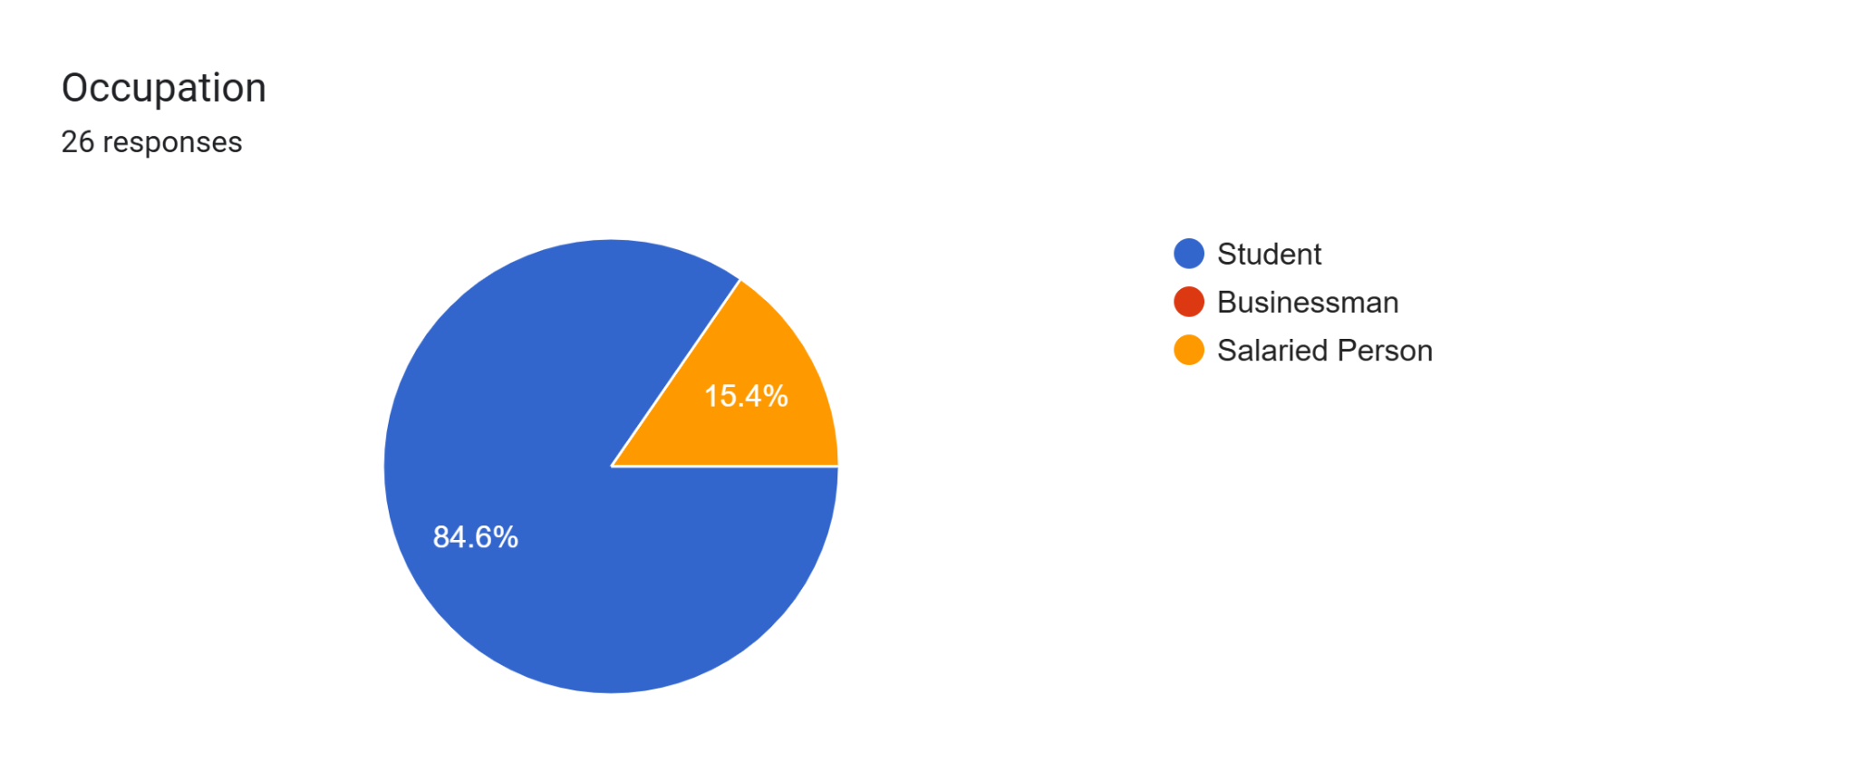

### **1. Frequency of Dairy Product Purchases**

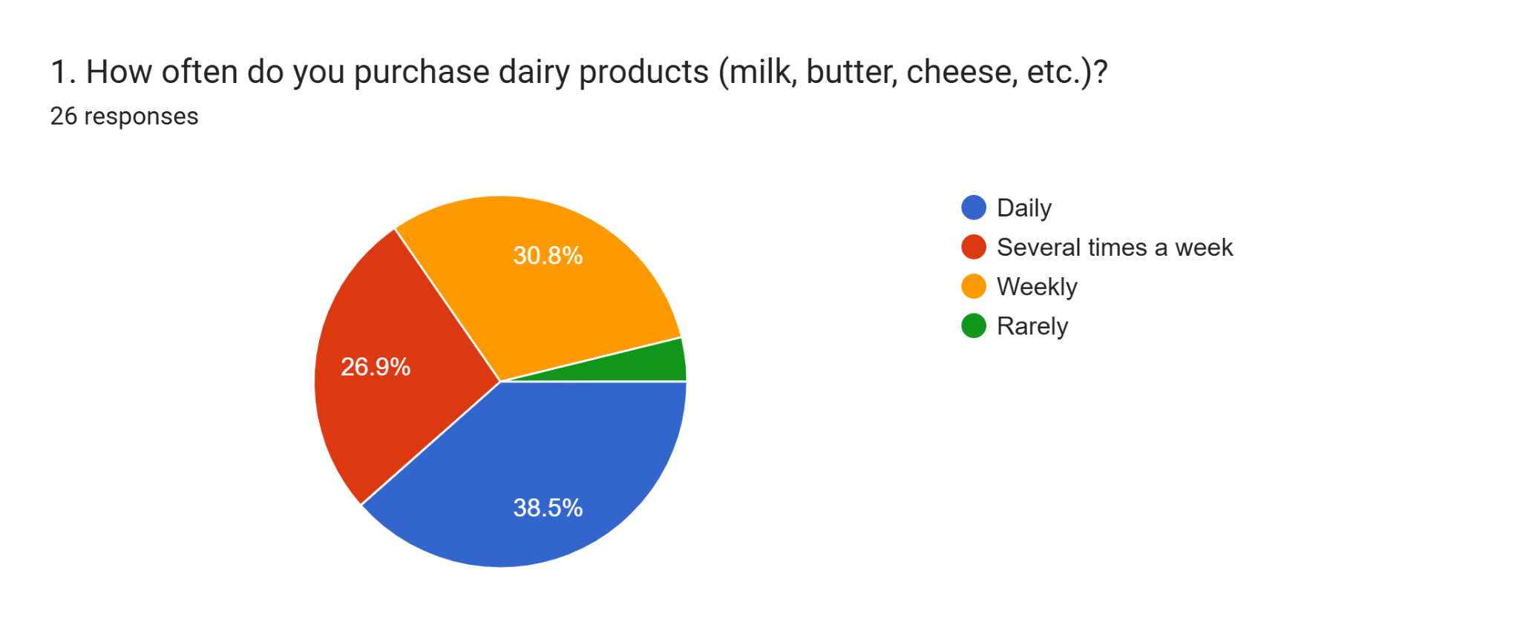

* 30.8% of respondents buy dairy products daily, while 26.9% purchase several times a week.
* 38.5% purchase weekly, and only 1 respondent (3.8%) buys rarely.
* This suggests that dairy products are an essential part of most respondents’ diets, with nearly 96% buying at least weekly.

**2.Challenges in Dairy Farming**

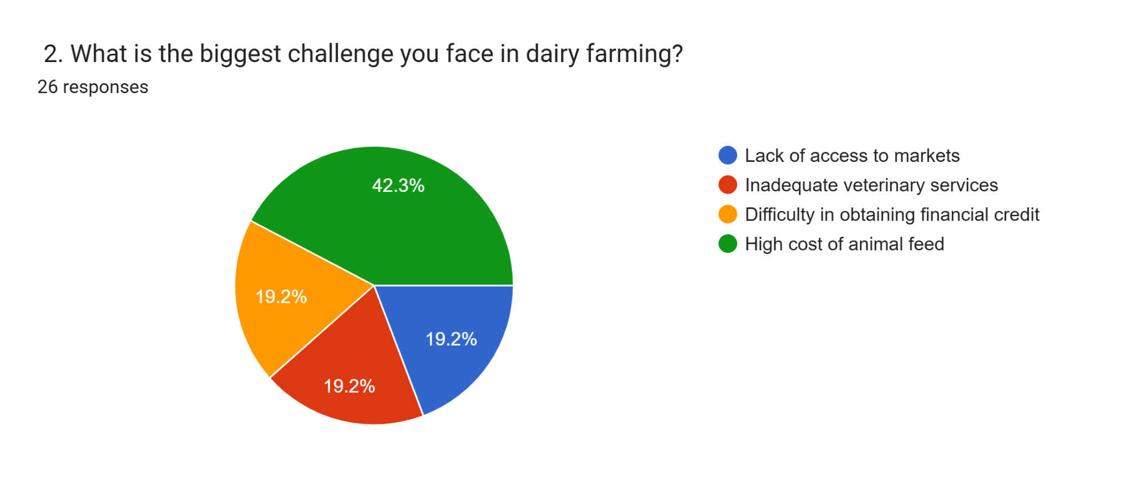

* The most significant challenge faced is the high cost of animal feed (42.3%).
* Inadequate veterinary services (19.2%) and lack of access to markets (19.2%) are equally reported concerns.
* Difficulty in obtaining financial credit (19.2%) also affects farmers.
* This data highlights a need for better veterinary services, easier access to markets, and financial assistance for dairy farmers.

### **Factors Influencing Dairy Product Purchase Decisions**

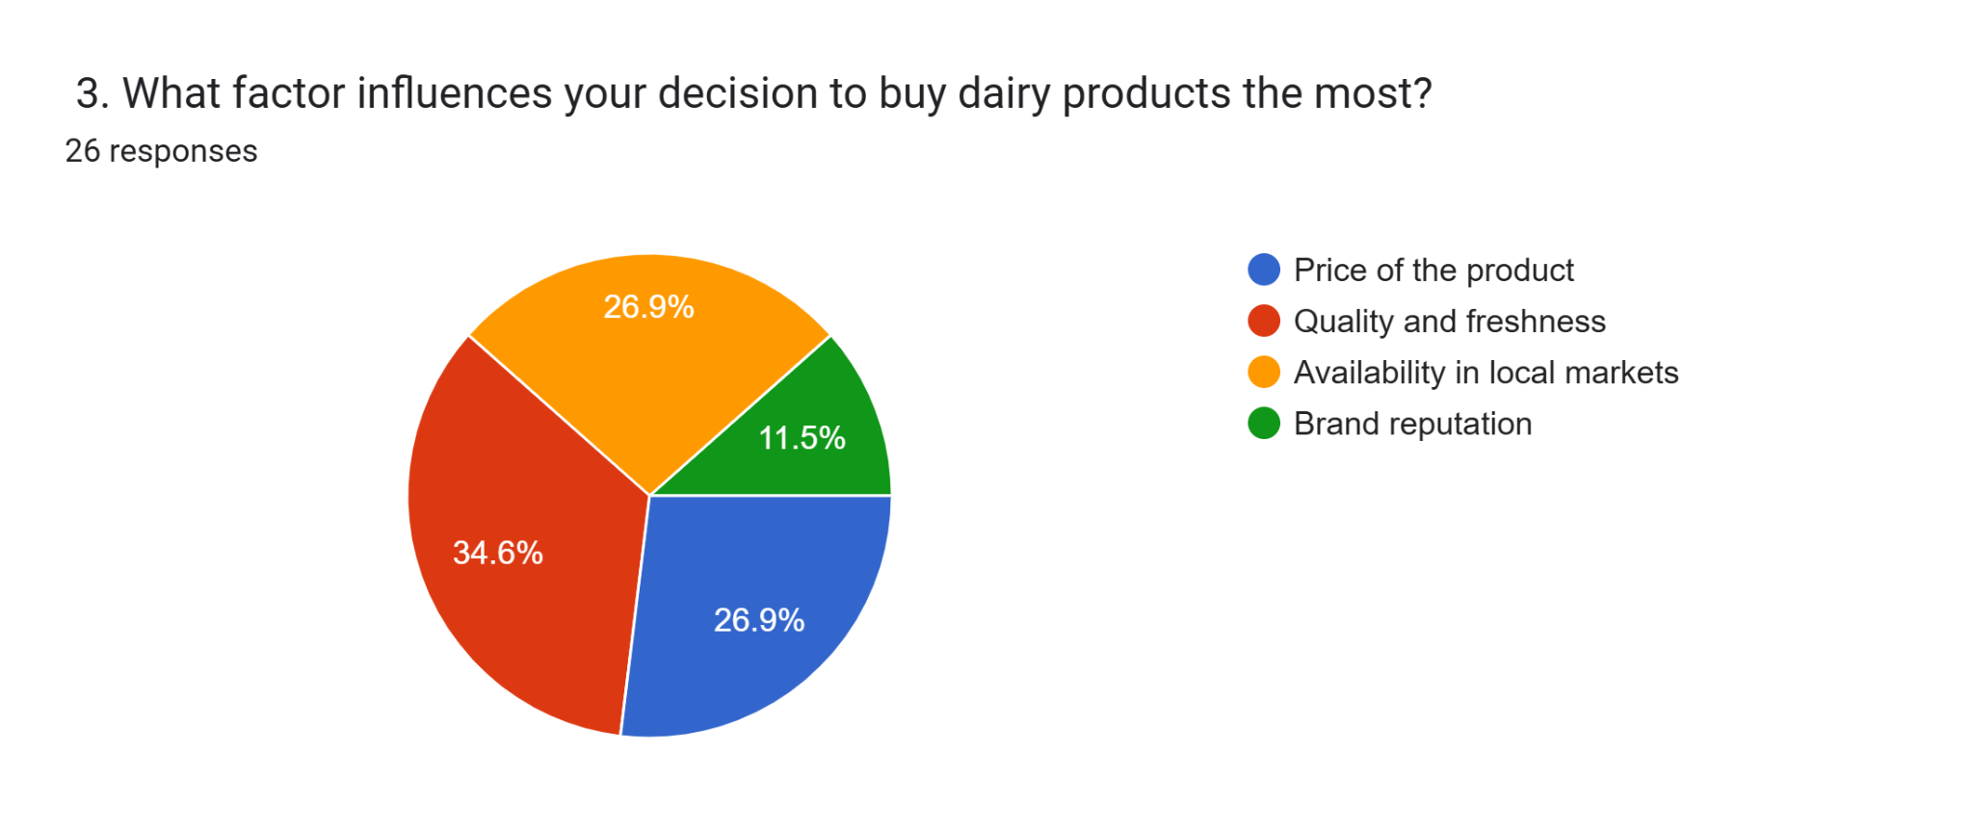

* The most critical factor is availability in local markets (34.6%).
* Quality and freshness (26.9%) is also a key determinant.
* Price (11.5%) and brand reputation (26.9%) are less dominant but still influence consumer choices.
* This suggests that ensuring widespread availability and maintaining high-quality products should be priorities for dairy producers.

### **Membership in Dairy Cooperatives and Benefits**

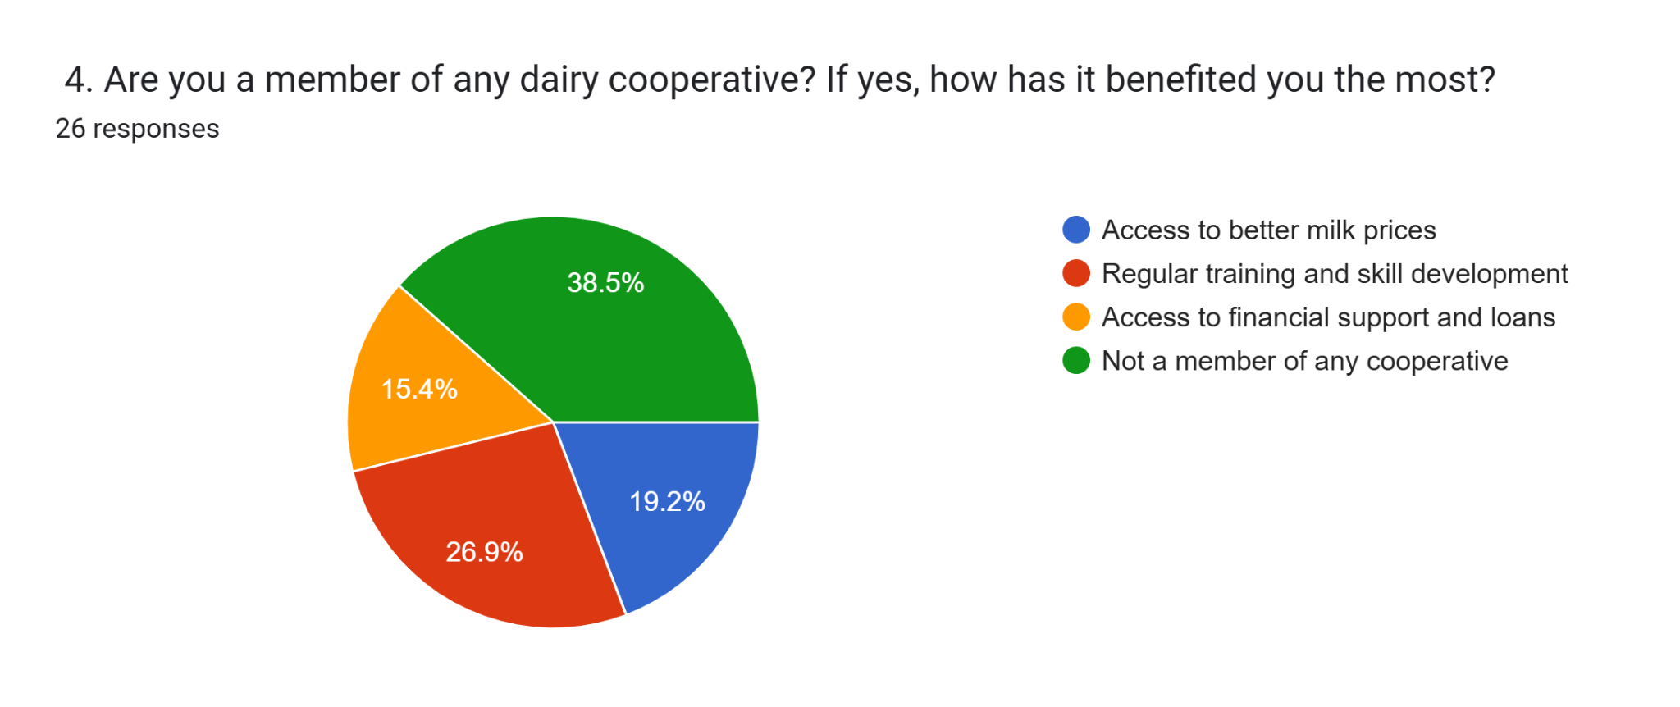

* A significant portion (38.5%) of cooperative members benefit from regular training and skill development.
* Access to better milk prices (19.2%) and financial support (15.4%) are other benefits.
* However, 26.9% are not part of any cooperative, indicating a potential lack of awareness or access to such organizations.
* Promoting dairy cooperatives could help more farmers gain financial and technical support.

### **5. Role of Women in Dairy Activities**

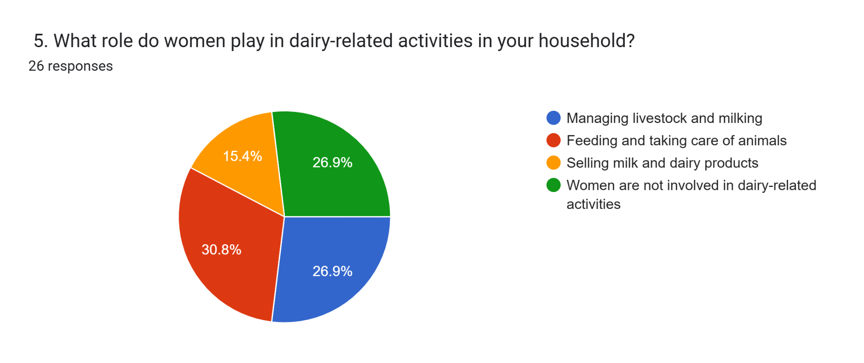

* 30.8% of women are involved in selling milk and dairy products, showing their entrepreneurial role in dairy-related activities.
* 26.9% manage livestock and milking, while 15.4% handle feeding and care of animals.
* However, 26.9% reported that women are not involved in dairy-related activities, indicating gender disparities in some households.
* Empowering women in dairy farming through skill training and financial inclusion can improve rural economic development.

### **6. Challenges in Purchasing Dairy Products**

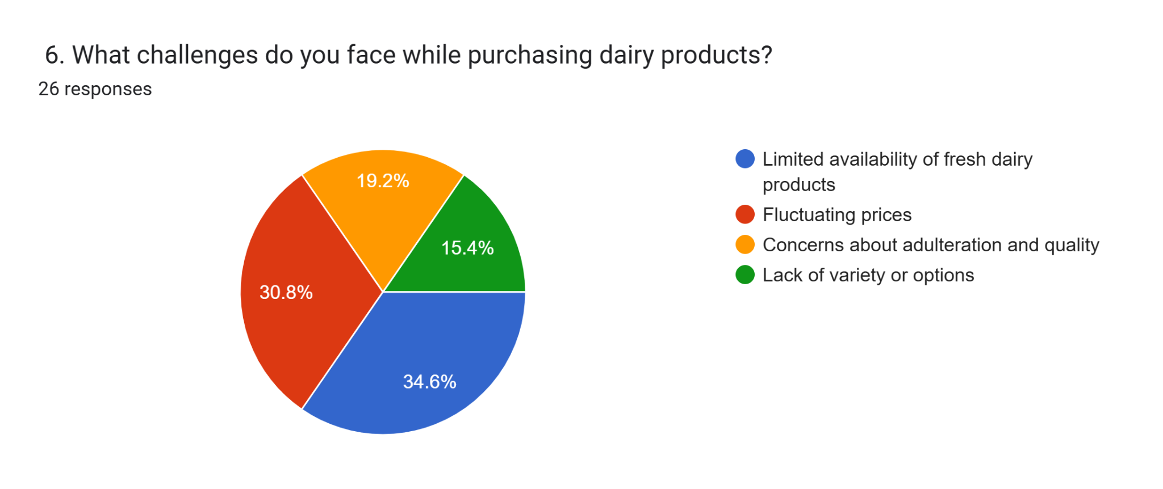

The biggest challenge is the lack of variety and options (34.6%), indicating demand for more diverse dairy products.

* Concerns about adulteration and quality (30.8%) highlight the need for stricter quality control.

Fluctuating prices (19.2%) and limited availability of fresh dairy products (15.4%) also affect consumer decisions.

* Strengthening quality control measures and increasing product variety can improve consumer satisfaction.

### **7. Awareness of Dairy Cooperatives**

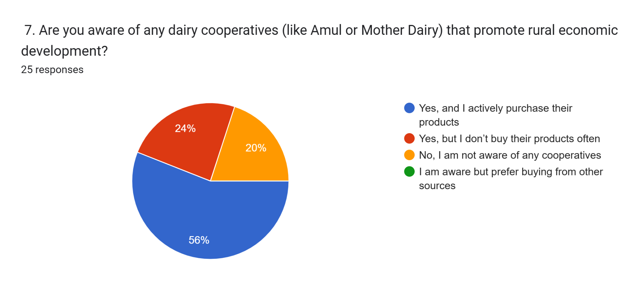

* Many respondents (exact number missing) are aware of dairy cooperatives like Amul and Mother Dairy.
* Some actively purchase their products, while others choose alternative sources.
* This suggests that while awareness exists, cooperative brands need stronger marketing strategies to convert awareness into regular purchases.

**Findings and recommendations**

**Findings:**

1. **Job creation:** Dairy farming has a current employment component and a broader range of job opportunities that caters to women, smallholder farmers, and landless agricultural workers.
2. **Income Security:** Dairy farming reduces the risk of income loss by providing more stable income levels than seasonal patterns of farming, providing less financial risk.
3. **Livelihood diversification:** Many rural household livelihoods combine dairy farming with crops to provide income and security.
4. **Supply chain facilitation:** Farmers benefit from better access to markets as a result of increased rural supply chain capacity created by private investment and increased dairy cooperatives.
5. **Nutritional security:** Dairy production increases nutritional security and health measures within rural communities.
6. **Infrastructure:** The growth of rural dairy storage, transport, and processing adds to general growth within rural communities.

**Recommendations:**

1. **Technology Use:** The promotion of modern dairy farming practices should include artificial insemination, automated milking, etc. which would lead to productivity increases.
2. **Financial Support:** Government and banks must supply small-scale dairy farmers with low-interest loans and subsidies.
3. **Better Cooperatives:** Promoting cooperative models will help with bargaining power and fair pricing, and better access to the market.
4. **Training and Education:** Implement skill-building initiatives for farmers related to cattle health, nutrition, and disease management.
5. **Sustainable Practices:** Implement environmentally sustainable dairy farming practices to help mitigate environmental degradation, including recycling of waste and methane harvesting.
6. **Market Linkages:** Provide rural dairy farmers with access to national and international markets using digital markets and value chains.

**Conclusion**

The dairy industry plays a crucial role in the economic development of rural areas, providing sustainable livelihoods, generating employment, and enhancing food security. It serves as a reliable source of income for millions of small-scale farmers, particularly in developing countries where agriculture remains the backbone of the economy. By facilitating rural entrepreneurship, dairy farming encourages self-sufficiency and reduces migration to urban centers.

Moreover, the dairy sector contributes significantly to rural infrastructure development, including roads, cold storage, and processing facilities. It also fosters the growth of allied industries such as animal feed production, veterinary services, and milk processing units, creating a ripple effect that strengthens the overall economy. Furthermore, dairy cooperatives empower farmers by providing access to better pricing, credit, and technical support, thus enhancing their financial stability.

The integration of modern technology in dairy farming, such as artificial insemination, improved cattle breeds, and digital marketing, has further expanded the industry's efficiency and profitability. Governments and non-governmental organizations (NGOs) play a vital role in supporting the sector through policies, subsidies, and training programs.

However, challenges such as climate change, fluctuating milk prices, and disease outbreaks require strategic interventions to ensure sustainable growth. Strengthening supply chains, improving quality control, and encouraging value-added dairy products can enhance the industry's long-term viability.

In conclusion, the dairy industry is not just an economic activity but a powerful tool for rural transformation. With appropriate investments, policies, and technological advancements, it has the potential to uplift millions of rural households, ensuring economic stability, nutritional security, and overall rural prosperity.

**Bibliography**

**1. Books & Reports**

1. FAO. (2020). The Dairy Sector: Opportunities for Economic Growth and Food Security. Food and Agriculture Organization of the United Nations.

2. Singh, K. (2019). Dairy Industry in Rural India: Growth, Challenges, and Opportunities. Oxford University Press.

3. National Dairy Development Board (NDDB). (2021). Dairy Industry and Rural Development in India. NDDB Publications.

4. Sharma, R. (2018). Livestock and Economic Development: The Role of Dairy Farming. Springer.

**2. Journal Articles**

5. Patel, A., & Kumar, S. (2022). "Impact of Dairy Cooperatives on Rural Economic Development." Journal of Agricultural Economics, 75(3), 245-261.

6. Gupta, R., & Mehta, P. (2021). "The Role of Dairy Farming in Rural Livelihood: A Case Study of Small Farmers in South Asia." International Journal of Rural Development Studies, 8(2), 112-130.

7. Choudhary, V., & Das, S. (2020). "Sustainable Dairy Farming: Challenges and Innovations in Emerging Economies." Agricultural Research & Policy Review, 5(4), 198-212.

**3**. **Government & Institutional Reports**

8. Ministry of Agriculture, Government of India. (2022). Annual Report on Livestock and Dairy Development.

9. World Bank. (2019). Enhancing Dairy Productivity in Rural Economies: Case Studies from Asia and Africa.

10. United Nations Development Programme (UNDP). (2020). Rural Livelihoods and Dairy Industry: A Path to Sustainable Development.

1. **Online Resources & Websites**

11. Food and Agriculture Organization (FAO). (2023). "Dairy Development and Rural Livelihoods." Retrieved from www.fao.org

12. National Dairy Development Board (NDDB). (2023). "Dairy Cooperatives and Rural Empowerment." Retrieved from www.nddb.coop

13. International Dairy Federation (IDF). (2023). "The Economic Contribution of Dairy to Rural Communities." Retrieved from www.fil-idf.org