**WeedWatcher (Weed & Weed based Disease Detection in Agriculture Fields)**

A Comprehensive System for Weed Detection and Disease Classification

Palak Patel1, Lovelish Chauhan2, Dr. Ashish Baiswar3

1UG student of Department of Information Technology, Shri Ramswaroop Memorial College of Engineering and Management, Uttar Pradesh, Lucknow

[palak04patel@gmail.com](mailto:palak04patel@gmail.com)

2UG student of Department of Information Technology, Shri Ramswaroop Memorial College of Engineering and Management, Uttar Pradesh, Lucknow

[lovelish0010@gmail.com](mailto:lovelish0010@gmail.com)

3Associate Professor of Department of Information Technology, Shri Ramswaroop Memorial College of Engineering and Management, Uttar Pradesh, Lucknow

[ashishbaiswar@srmcem.ac.in](mailto:ashishbaiswar@srmcem.ac.in)

**Abstract**

Weeds and weed-induced diseases pose significant threats to agricultural productivity and environmental sustainability. Traditional management methods rely on manual identification or chemical treatments, which are often inefficient and environmentally harmful.

This research introduces an AI-based system for the automatic detection and classification of weeds and related diseases in agricultural fields. Using advanced image processing techniques and machine learning algorithms, the system analyzes weed images in real time to identify species and diagnose diseases. It incorporates a comprehensive database of weed and disease profiles, offering precise recommendations for disease identification and management. Additionally, the system enhances visualization of weed infestations and disease outbreaks, promoting optimized resource utilization and sustainable agricultural practices.

Keywords – Weed detection, weed-based diseases, AI-based identification, image processing, optimized resource utilization.

**Introduction**

Weeds and weed-borne diseases remain persistent challenges in agriculture, significantly impacting crop yields, soil health, and overall ecosystem stability. Traditional weed management relies on manual identification and chemical treatments, which are time-consuming, labor-intensive, and environmentally harmful. The growing need for efficiency and sustainability calls for automated solutions to detect, analyze, and manage weeds and related diseases.

This research leverages visualization and machine learning techniques to accurately identify weed species and detect associated diseases in real time. The proposed approach involves model development using a custom dataset, incorporating training, validation, and testing processes. Experimental results and performance evaluations demonstrate the effectiveness of the method, highlighting its potential to enhance weed detection in smart and precision agriculture systems. By bridging gaps in current agricultural practices, this system aims to minimize environmental impact while improving productivity and profitability.

**Literature Review**

Recent advancements in deep learning and image processing have significantly contributed to automated weed detection and classification in agriculture. Studies have demonstrated the effectiveness of deep learning models in distinguishing weeds from crops, diagnosing plant diseases, and optimizing precision agriculture practices, like

Patil and Bodhe (2011) introduced an image segmentation approach using color-based clustering methods, such as K-Means clustering, to differentiate diseased and healthy leaf regions. Their findings demonstrated the efficacy of segmentation in isolating affected regions before classification.

Kaur et al. (2019) examined various machine learning techniques, including Support Vector Machines (SVM) and Convolutional Neural Networks (CNNs), for plant disease detection. They highlighted that CNNs significantly improve classification accuracy when trained on large datasets. However, these methods often require substantial computational resources, making them less accessible for small-scale farmers.

Wang A, et al. reviewed ground-based machine vision and image processing for weed identification in 2019. The research included feature extraction, picture segmentation, and classification methods for agricultural weed detection. The research highlighted precision agriculture and automated weed identification using machine vision.

Shrivastava and Prasad (2021), have incorporated K-Means clustering as a preprocessing step to enhance disease detection. This method effectively segments images into regions of interest, improving the accuracy of subsequent classification models. The researchers emphasized that combining K-Means clustering with feature extraction techniques, such as Histogram of Oriented Gradients (HOG) or Gray-Level Co-occurrence Matrix (GLCM), enhances disease pattern recognition.

CNN and UAV images were used to create an automated weed identification system by Haq MA (2022). This study found that UAVs with cameras can identify weeds over wide agricultural regions using high-resolution photos. CNNs might distinguish crops from weeds, providing an inexpensive and practical method for real-time weed monitoring in precision farming.

In 2023, Haq, et al. investigated wheat field weed detection using AI and image analysis. Their wheat field weed detection study used AI. The research showed that artificial intelligence and image processing can manage weeds in 5 large-scale agriculture where less pesticides and physical labour are needed.

Using region-based CNN for sesame crop weed identification and classification, Naik (2024) found Deep learning helps RCNNs detect and categorise sesame crop weeds better than other approaches. Regional CNN approaches provide potential for precision-sensitive agriculture, according to their findings.

**Importance of Rice in Global Agriculture**

Rice is one of the most critical staple crops globally, serving as a primary source of sustenance for over half of the world's population. Rice accounts for approximately 20% of the world’s dietary energy supply, making it the second most consumed cereal crop after wheat. It provides essential nutrients, including carbohydrates, proteins, and vitamins, particularly in developing nations where it constitutes the daily diet. Over 150 million smallholder farmers depend on rice cultivation for their livelihoods. Countries such as India, China, Indonesia, and Vietnam derive significant portions of their GDP from rice production and export. Rice is grown in various ecosystems, including rainfed lowlands, uplands, and irrigated systems, making it a versatile crop adaptable to different climatic conditions. Rice consumption is expected to rise with increasing population growth, particularly in urbanizing regions. It is one of the most traded commodities, with major exporters like Thailand, India, and Vietnam playing a critical role in the global rice market.

Rice's unparalleled significance in global agriculture underscores the importance of addressing challenges like weed infestations and diseases that threaten its productivity. Innovations in precision agriculture, such as automated weed and disease detection systems, are essential for ensuring sustainable rice production to meet future demands.

**Challenges in Rice Cultivation**

1. **Impact of weeds -** Common weeds like barnyardgrass (*Echinochloa crus-galli*), purple nutsedge (*Cyperus rotundu.*), and red rice (*Oryza sativa f. spontanea*) are some weeds types that are found in rice fields.

Negative impact of weeds are:

* **Environmental Impact:** Excessive use of chemical herbicides to control weeds can harm soil health, aquatic ecosystems, and biodiversity.
* **Yield Reduction**: Uncontrolled weed growth can result in yield losses of up to 30-50%, especially in poorly managed fields.
* **Quality Deterioration:** Certain weeds can affect the quality of harvested rice by contaminating grains or interfering with harvesting equipment.

1. **Weed based diseases -** Weeds not only compete with rice crops but also act as hosts for various pathogens and pests, exacerbating disease outbreaks in rice fields. These weed-based diseases can lead to significant crop damage, affecting both productivity and quality. For example, Blast Disease, Bacterial Blight, Nematode Infestations, Viral diseases etc**.**

**Theory**

*(Diseases caused by weeds in Rice Production)*

**1. Rice Blast or Blast of Rice**

* **Causal agent:** Pyricularia oryzae (Sexual stage: Magnaporthe grisea)
* **Affecting stages:** All crop stages from seedling to late tillering and ear heading stage. It is one of the most destructive Paddy diseases. The disease affects all parts of rice plants, mainly leaves, neck and nodes. It is expected to cause grain loss by 70 – 80%.

**Symptoms of Rice Blast:**

* **Leaf Blast of Rice**– Spindle-shaped spots with grey centre and brown margin, later causing a ‘Blasted’ or ‘Burnt’ appearance
* **Neck Blast of Rice**– Greyish brown lesions on the neck, panicle breaks and fall off
* **Node Blast of Rice** – Affected nodes show black lesions which later break up

**2. Bacterial Leaf Blight of Rice:**

* **Causal agent:** Xanthomonas oryzae
* **Affecting stages:** Tillering stage to Heading stage

**Symptoms of Bacterial Leaf Blight of Rice:**

* Water-soaked spots appear on leaves which gradually coalesce to form blotches and white streaks form the tip of the leaf to the base.
* Wilting and yellowing of leaves
* Usually known as ‘Seedling wilt’ or ‘Kresek’

**3. Sheath Blight of Rice**

* **Causal agent:** Rhizoctonia solani
* **Affecting Stages:** Tillering to heading

**Symptoms of Sheath Blight of Rice:**

* Initially, greenish-grey oval or elliptical lesions appear on the leaf sheath near the water level.
* Later, it forms irregular lesions with a greyish-white centre and brown margin.

**Problem Statement**

There are different research in area of crop disease detection but there remains need to improve the flexibility as well as scalablity. CNN model used in conventional model where not eligible to provide better accuracy and performance. Thus, proposed model is providing advance solution where image are compressed and processed by noise filter to improve the performance and accuracy during image classification for detection of weed based disease detection.

**Proposed Idea**

The **WeedWatcher** project proposes an innovative, AI-driven software solution designed to address the challenges of weed and weed-based disease management in agricultural fields. The idea centers around leveraging advanced image processing and artificial intelligence to accurately detect, classify, and map weed species in real-time. This system aims to visualize weed distribution and density, allowing for data-driven decision-making that minimizes the environmental impact of herbicides and enhances crop productivity.

**WeedWatcher** works by capturing field images under various environmental conditions and analyzing them using machine learning algorithms to classify weed species. The system integrates real-time data to provide actionable insights, with a user-friendly interface designed to cater to farmers, even those with minimal technical knowledge. This approach provides farmers with a powerful tool to manage weed infestations efficiently while ensuring the long-term health of their crops and the surrounding environment.

**Key features of proposed system**

* AI powered Weed and Weed Based Disease Detection
* High-Resolution Image Processing
* Automated Classification and Reporting
* Real Time Monitoring and Analysis
* Sustainability driven approach
* Scalability and Climatic Adaptations
* Integration with IOT Devices (in future)

**Procedure / Methodology**

1. **Image Acquisition Module**

* Capture Images: High-resolution images of plants showing disease symptoms are captured using cameras or smart phones.
* Image Database: Create a database of various plant diseases and their corresponding images for training and validation purposes.

1. **Image Preprocessing**

* Image Cleaning: Remove noise, unwanted artifacts, and irrelevant information from the images.
* Image Enhancement: Improve the quality of images by adjusting contrast, brightness, and sharpness.
* Normalization: Normalize the image data to ensure consistency in feature scales.

1. **Segmentation Image**

* Thresholding: Separate the diseased regions from the healthy parts of the plant by setting a suitable threshold.
* Color-Based Segmentation: Use color information to identify diseased areas, as diseases often cause changes in plant color.
* Texture-Based Segmentation: Analyze texture patterns to distinguish between healthy and diseased areas.

1. **Feature Extraction:**

* Shape Features: Extract features like area, perimeter, and circularity of the diseased regions.
* Color Features: Extract color-related features such as mean color, color histograms, etc.
* Texture Features: Extract texture features using methods like Haralick texture features, Gabor filters, etc

1. **Machine Learning Model:**

* Training Data: Use the preprocessed images and extracted features as input data for training machine learning algorithms.
* Selection of Algorithm: Choose appropriate machine learning algorithms such as Support Vector Machines (SVM), Convolutional Neural Networks (CNN), or Random Forest for classification.
* Training and Validation: Split the dataset into training and validation sets. Train the model on the training set and validate its performance on the validation set.

1. **Disease Classification:**

* Prediction: Use the trained model to predict the presence of diseases in new, unseen images.
* Accuracy Assessment: Evaluate the accuracy of the model using metrics like accuracy, precision, recall, and F1-score.

1. **Post-Processing and Decision Making:**

* Classification Refinement:Use of advanced AI models to distinguish between similar weed species and specific disease symptoms. Identification of disease severity levels based on visual patterns, such as leaf discoloration or lesion size.
* Educational Insights for Farmers:Informing farmers about the identified weeds and diseases, including their characteristics and impact on crops so that they can make preventive measures to reduce the likelihood of future infestations or outbreaks***.***

1. **Deployment and Monitoring:**

* Integration: Integrate the developed system into mobile apps or web applications for easy access by farmers.
* Continuous Monitoring: Continuously monitor the system’s performance and retrain the model periodically to adapt to new disease patterns.

**Implementation:**

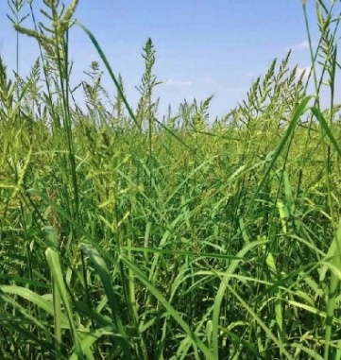 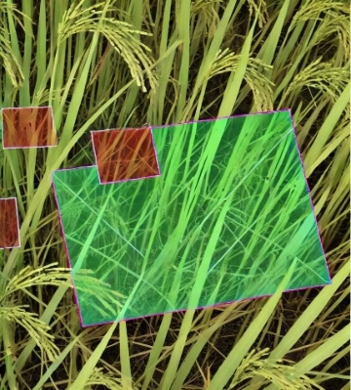 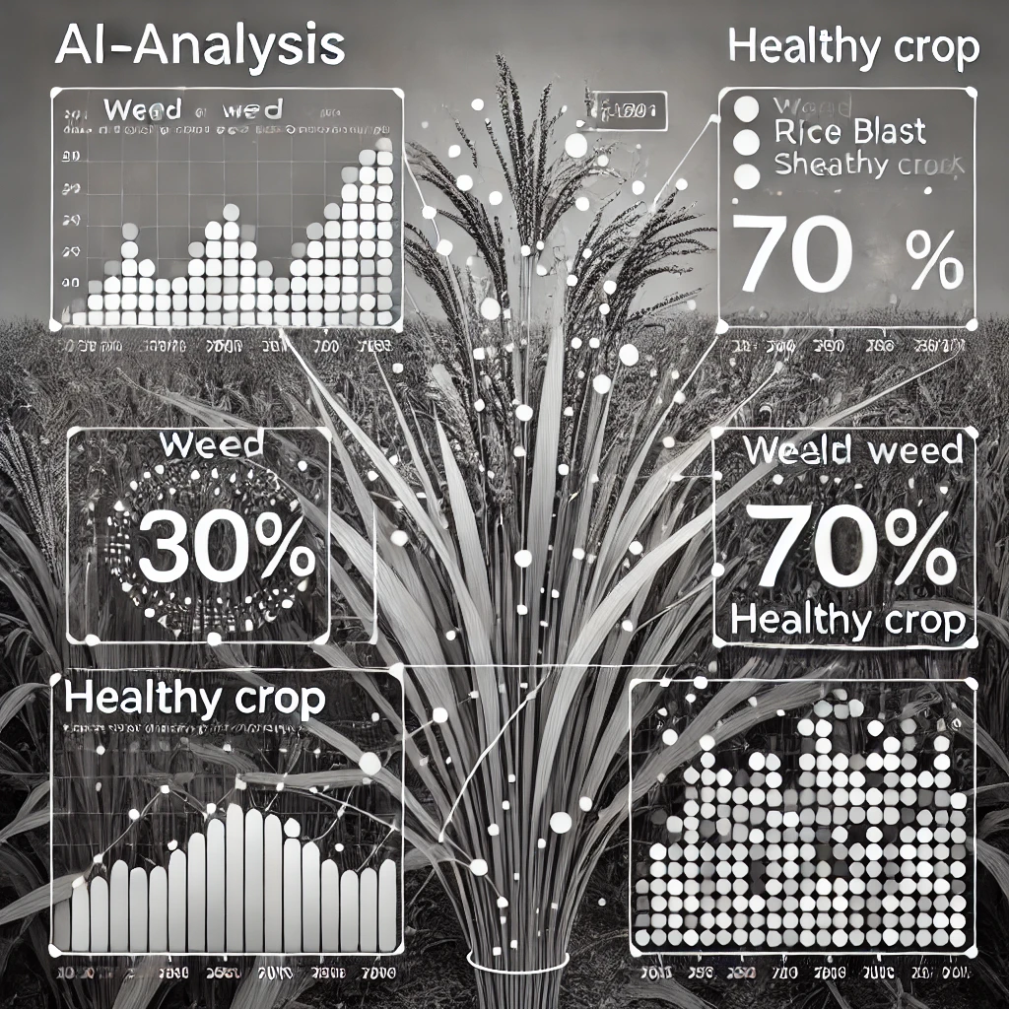



*3. OUTPUT*

*2. PROCESSING*

*1. INPUT*

**Step 1: Input Stage**

* We will capture the image of the rice crop field using our web application, WeedWatcher.
* The captured image represents the raw field data, including rice crops and barnyard grass weeds.

**Step 2: Processing Stage**

1. **Preprocessing**

* Once the image is uploaded, WeedWatcher preprocesses it to enhance quality.
* Noise is reduced, contrast is adjusted, and the image is normalized for clarity.
* The image undergoes segmentation using K-means clustering, where the field

is divided into regions representing healthy crops *(green),* detected weeds *(red).*

* Highlight clusters or sections that the model focuses on for weed detection.

1. **Feature Extraction and Model Classification**

* WeedWatcher extracts key features from the segmented image, such as **Color:** To distinguish the weeds' unique shades from the crops, **Texture:** To differentiate between the smooth texture of rice crops and the rough texture of barnyard grass, **Shape:** To identify characteristic leaf shapes unique to barnyard grass.
* The processed data is then passed through the trained model, which classifies each cluster as either rice crop or barnyard weed.

**Step 3: Output Stage**

1. **Detection and Visualization**

* Captured image is analysed and processed in a way that field is divided into healthy crops and weeds seperately, the stats are analysed by the model as well as associated causes, such as excessive moisture, nutrient imbalance, etc.
* The system detects the growth stage of barnyard grass, indicating whether it’s in the early vegetative stage or more mature stages where it competes with rice for nutrients and light and finally suggests the type of diseases it can cause if proper treatment of these barnyard grass is not taken into acrion.
* **For eg**. Rice Blast or Blast of Rice can be caused by these barnyard grass taken as a sample. Few insights for this disease are:

**Causal agent:** Pyricularia oryzae (Sexual stage: Magnaporthe grisea)

**Symptoms:**

1. **Leaves -** Small, elliptical or diamond-shaped lesions appear on the leaf blades having grayish center and a reddish-brown border.
2. **Stem -** Brown to gray lesions on the nodes. These lesions may cause the stem to become brittle, leading to lodging (falling over) and further reducing the plant’s ability to produce grain.
3. **Panicle -** Irregularly shaped lesions on the flowering panicle
4. Infected plants may experience grain abortion or shriveling, which directly impacts yield.

**Conclusion**

The WeedWatcher project marks a significant advancement in agricultural weed management by integrating cutting-edge technologies such as image processing, artificial intelligence, and real-time data analysis. Addressing long-standing challenges in weed and disease control, WeedWatcher utilizes Convolutional Neural Networks (CNNs) to deliver a high-precision, automated solution for weed detection and classification, making it a breakthrough in precision agriculture.

By visualizing weed distribution and density, the system provides farmers with actionable insights to implement targeted, eco-friendly weed control strategies. This approach reduces excessive herbicide use, minimizes crop damage, and promotes higher yields through sustainable farming practices. The inclusion of real-time monitoring and data-driven recommendations further enhances decision-making throughout the crop cycle.

Additionally, WeedWatcher features a user-friendly interface, making it accessible even to farmers with limited technical expertise. Its scalable and adaptable design ensures suitability across various agricultural settings, accommodating different soil types, climates, and crop varieties.

**Future Scope**

* Enhanced Model Training – Expanding the dataset with more weed species and disease patterns for improved accuracy and adaptability.
* Advanced Imaging Integration – Using hyperspectral and multispectral imaging for more precise weed identification.
* IoT and Drone Integration – Enabling large-scale, real-time weed monitoring through smart sensors and drones.
* Mobile and Offline Accessibility – Developing a mobile application with offline functionality for small-scale farmers.

**References**

[1]. Sushil Kumar, Malay K. Bhowmick and Puja Ray, “Weeds as alternate and alternative hosts of crop pests,” Indian Journal of Weed Science 53(1): 14–29, 2021

[2]. L. H. Ziska and G. B. Runion, “Weed Ecology in Natural and Agricultural Systems,” Cambridge University Press, 1st Edition, pp. 1-256, 2010

[3]. M. Byron, D. Treadwell, and P. Dittmar, “Weeds as Reservoirs of Plant Pathogens Affecting Economically Important Crops,” Plant Health Progress, Vol. 20, No. 1, pp. 2-12, 2019

[4]. G. Goyal, H. K. Gill, and R. McSorley, “Common Weed Hosts of Insect-Transmitted Viruses of Florida Vegetable Crops,” Florida Entomologist, Vol. 95, No. 1, pp. 1-9, March 2012

[5]. J. L. Capinera, “Relationships between Insect Pests and Weeds: An Evolutionary Perspective,” Weed Science, Vol. 53, No. 6, pp. 892-901, November-December 2005

[6]. "Insect Pests, Diseases and Weed Management**,"** National Council of Educational Research and Training (NCERT), Unit 6, pp. 97-122, 2020

[7]. N. M. Salem, M. Abumuslem, M. Turina, N. Samarah, A. Sulaiman, B. Abu-Irmaileh, and Y. Ata, “New Weed Hosts for Tomato Brown Rugose Fruit Virus in Wild Mediterranean Vegetation,” *Journal of Plant Pathology*, Vol. 104, No. 3, pp. 567-576, September 2022

[8]. K.S. Shastry, “Role of Weed Hosts in the Perpetuation of Virus and Virus-Like Disease,” Virus Ecology, eds., A. Mishra and H. Polasa South Asian Publishers, New Delhi, 1984, 59-90

[9]. Jin X, Che J, Chen Y. Weed identification using deep learning and images processing in vegetable plantation. IEEE access. 2021 Jan 8;9:10940-50

[10]. Kumar KV. Jayasankar T. An identification of crop disease using image segmentaion. Int. J. Pharm. Sci. Res. 2019;1-(3):1054-64

[11]. Naik NS, Chaubey HK. Weed detection and classification in sesame crops using region-based convolution neural networks. Neural Computing and Applications. 2024 Oct;36(30):18961-77

[12]. Wu Z, Chen Y, Zhao B, Kang X, Ding Y. Review of weed detection methods based on computer vision. Sensors. 2021 May 24;21(11):3647

[13]. Hasan AM, Sohel F, Diepeveen D, Laga H, Jones MG. A survey of deep learning techniques for weed detection from images. Computers and electronics in agriculture. 2021 May 1;184:106067