**TALENT ACQUISITION CHALLENGES: NAVIGATING THE EVOLVING WORKFORCE LANDSCAPE**

**Author 1:** Syeda Nikhath Bano, Asst Prof, Dept of MBA, Santhiram Engineering College,Nandyal.

**Author 2:** Thagulla Keerthana, Student of MBA, Santhiram Engineering College, Nandyal.

## ABSTRACT

Talent acquisition is a crucial function of human resource management that involves identifying, attracting, and retaining skilled professionals to enhance organizational success. However, organizations face several challenges in this dynamic landscape, including skills shortages, intense competition for top talent, diversity and inclusion barriers, and the integration of technology in recruitment. Additionally, factors such as candidate experience, employer branding, and the shift toward remote and hybrid work models further complicate the talent acquisition process. This paper explores these challenges, examines their underlying causes, and discusses effective strategies for overcoming them. By leveraging innovative hiring practices, embracing technology responsibly, and prioritizing workforce development, businesses can enhance their talent acquisition efforts and build resilient, high-performing teams for long-term success.

**Keywords:**Talent Acquisition, Recruitment, Skill Shortages, Employer Branding, Workforce Expectations, Technology, Diversity and Inclusion.

**RESEARCH METHODOLOGY**

The objective of this article is to analyze the key challenges faced by organizations in talent acquisition and propose effective strategies to address them. By understanding factors such as skill shortages, technological advancements, employer branding, and candidate experience, businesses can refine their recruitment processes and build a sustainable talent pipeline. Additionally, the paper aims to highlight the significance of diversity and inclusion, along with the role of technology in modern hiring practices.

**INTRODUCTION**

Talent acquisition (TA) is a critical function of human resource management (HRM), responsible for identifying, attracting, and retaining top talent to drive organizational success. However, in today’s dynamic business environment, companies face numerous challenges in acquiring skilled professionals. These challenges are driven by factors such as technological advancements, changing workforce expectations, skill shortages, and increasing competition. This paper explores the major talent acquisition challenges and strategies for overcoming them, backed by relevant literature and industry insights.

**1. Skills Shortages and Talent Gaps**

One of the primary challenges in talent acquisition is the growing skills gap across industries. Rapid technological advancements have created a demand for specialized skills, particularly in information technology (IT), healthcare, and engineering (Deloitte, 2021). However, educational institutions often struggle to keep up with industry trends, leading to a mismatch between graduates’ skills and employer requirements (World Economic Forum, 2020).

To address this issue, organizations must invest in reskilling and upskilling programs. Collaborating with educational institutions, offering apprenticeships, and providing on-the-job training can help bridge the skills gap and build a future-ready workforce (LinkedIn Talent Solutions, 2022).

**2. Competition for Top Talent**

In an increasingly globalized world, companies compete for the best talent not only locally but also internationally. Large corporations, startups, and even remote-first companies are vying for skilled professionals, making it difficult for smaller firms to attract and retain top-tier candidates(SHRM, 2021).

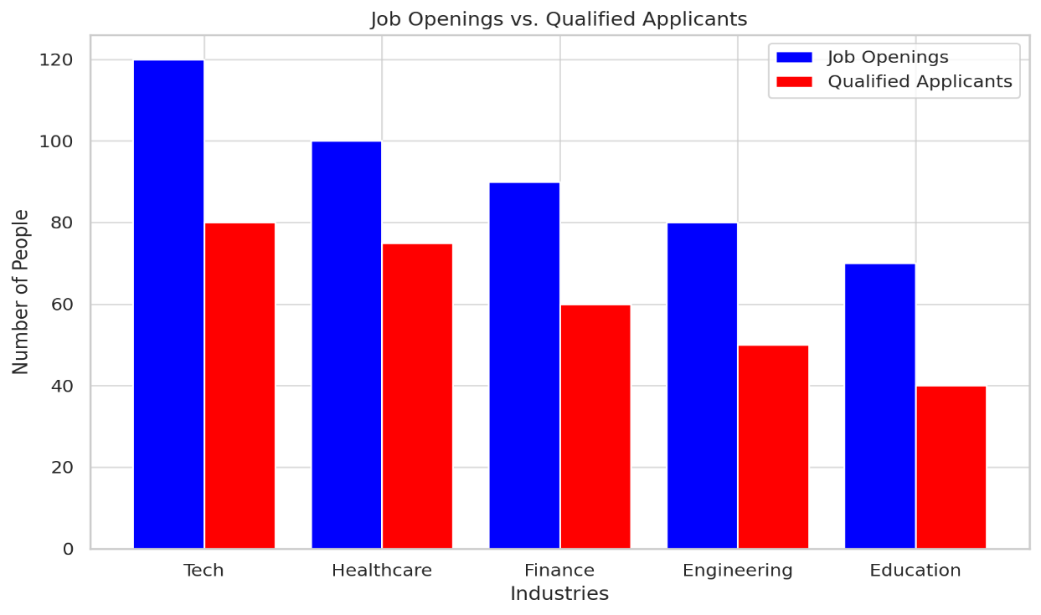

Employer branding plays a crucial role in standing out in the competitive talent market. Organizations must cultivate a strong brand presence, highlight their company culture, and showcase employee testimonials to attract potential candidates (Glassdoor, 2021). Competitive compensation packages, flexible work arrangements, and career development opportunities also contribute to talent retention.

**3. Diversity, Equity, and Inclusion (DEI) Challenges**

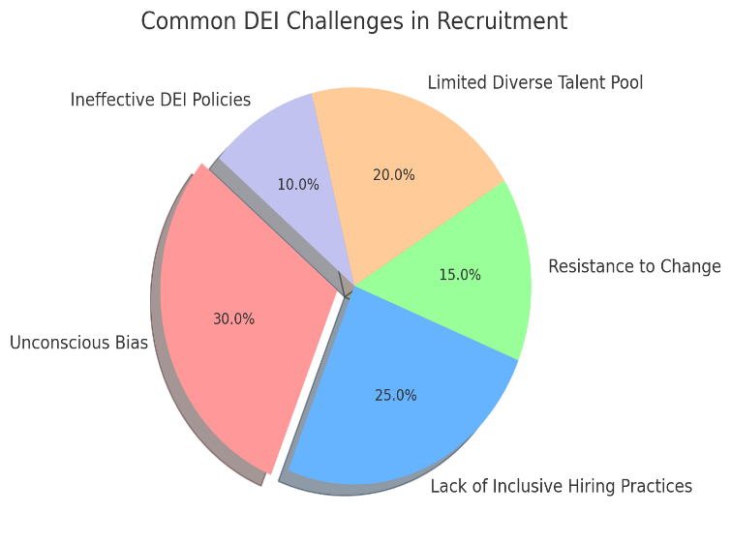Diversity, equity, and inclusion have become significant focal points in modern talent acquisition. Companies are under increasing pressure to build diverse teams that reflect the global workforce. However, unconscious bias, lack of inclusive recruitment practices, and resistance to change hinder progress (McKinsey & Company, 2020).

To overcome DEI challenges, organizations should implement unbiased hiring practices, such as blind resume screening and structured interviews (Harvard Business Review, 2021). Additionally, fostering an inclusive workplace culture and setting measurable DEI goals can help create a more diverse workforce.

**4. Leveraging Technology and Artificial Intelligence (AI)**

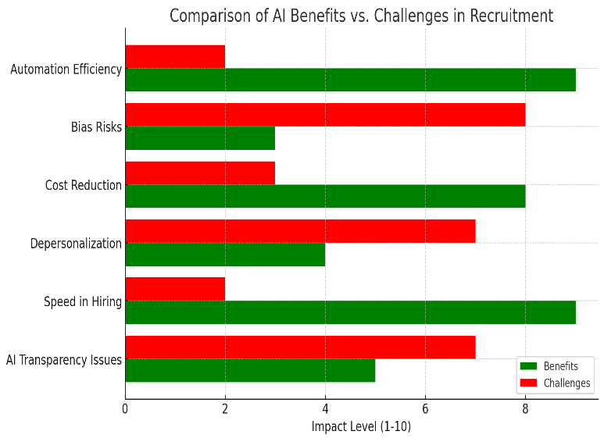While technology has revolutionized recruitment, it also presents new challenges. Many organizations struggle to integrate AI-driven tools effectively into their talent acquisition processes. Automated screening, chatbots, and predictive analytics enhance efficiency, but they can also introduce biases and depersonalize the candidate experience (MIT Sloan Management Review, 2022).

Companies must strike a balance between automation and human interaction. Ensuring that AI algorithms are transparent, unbiased, and regularly audited is essential for ethical recruitment practices (Gartner, 2021). Additionally, personalized communication with candidates should not be overlooked, as it significantly impacts employer perception.

**5. Candidate Experience and Employer Branding**

A poor candidate experience can damage an organization’s reputation and hinder future hiring efforts. Research suggests that 60% of job seekers abandon applications due to lengthy processes or lack of communication (IBM Smarter Workforce Institute, 2020). Negative experiences can also lead to unfavorable online reviews, deterring potential applicants (Indeed, 2021).

Organizations should streamline their recruitment processes by simplifying application procedures, providing timely feedback, and enhancing transparency. Engaging with candidates through social media and employer branding initiatives can improve perceptions and attract high-quality talent (LinkedIn, 2022).

**6. Remote Work and Hybrid Workforce Challenges**

The COVID-19 pandemic accelerated the shift toward remote and hybrid work models. While these arrangements offer flexibility, they also introduce challenges in talent acquisition. Employers must now assess candidates’ ability to work independently, manage remote onboarding effectively, and maintain team cohesion in virtual environments (Forbes, 2021).

To address these challenges, organizations should invest in digital collaboration tools, create structured remote onboarding programs, and establish clear remote work policies (PwC, 2022). Additionally, offering remote-friendly benefits, such as flexible schedules and mental health support, can enhance employee satisfaction.

**CONCLUSION**

Talent acquisition is an evolving discipline influenced by economic, technological, and social factors. Organizations must adapt to these challenges by embracing innovation, fostering a positive candidate experience, and prioritizing diversity and inclusion. By leveraging strategic workforce planning and technology-driven solutions, businesses can build resilient, high-performing teams that drive long-term success.

**REFERENCES**

1. Deloitte. (2021). The Future of Work: Skills and Workforce Transformation.
2. World Economic Forum. (2020). The Future of Jobs Report.
3. SHRM. (2021). The State of the Workplace: Competition for Talent.
4. Glassdoor. (2021). Employer Branding Trends.
5. McKinsey & Company. (2020). Diversity Wins: How Inclusion Matters.