**EXPERIMENTAL INSIGHTS ON PROXY BY CRUSHED ROCK SAND WITH NATURAL SAND AND VOLCANO ASH WITH BINDER ON M40 GC**

**Shaik Dadavali, P. Subhasri2(Font-Times New Roman, Bold, Font Size -12)**

1PG Scholar, Dept of Civil Engineering, Dr KV Subba Reddy Institute of Technology, Kurnool, AP, India.

2Assistant Professor, Dept of Civil Engineering, Dr KV Subba Reddy Institute of Technology, Kurnool, AP, India.

**ABSTRACT**

The construction industry is affected by the constant growth in the populations of urban areas. The demand for cement production has an increasing environmental impact, and there are urgent demands for alternative sustainable solutions. Volcanic ash (VA),Calcinated Natural Pozzolanic for use as a Mineral Admixture in Portland Cement Concrete. It can be suitably used in cement, mortar, and concrete. On the other hand, in the past few decades, the availability of suitable natural sand for concrete production near the point of consumption has been exhausted around many populated regions in the world. This has led to a search for a new replacement material; therefore mentioned surplus fines from crushing operations are expected to be the next best alternative – due to both great availability and suitable physical properties. There is a lot of pressure to stop using natural sand and instead use crushed rock sand (CRS) in concretes.

This paper presents comprehensive details of the physical, chemical properties of volcanic ash and crushed rock sand. It also covers effect of volcanic ash and crushed rock sand the slump, compressive strength, tensile strength and flexural strength. The Crushed Rock Sand(CRS) were taken on 0%, 10%, 20%, 30%, 40%, with replacement of fine aggregate and Volcano Ash(VA) were taken on constant 10% with replacement of cement on M40 Grade. It holds paramount significance as it not only serves to substitute natural sand and cement but also plays a vital role in reducing construction expenses. Because of the severe shortage in many locations, as well as expense and environmental concerns, an alternative is being considered.

**Keywords:** crushed rock sand, volcano ash, pozzolanic, mortar and surplus fines.

1. **INTRODUCTION (Font-Times New Roman, Bold, Font Size -12)**
   1. **Crushed Rock Sand**

Crushed rock sand, often called crushed stone sand, is an aggregate material that mimics the texture and appearance of natural sand by smashing rocks. It is a popular substitute for or addition to natural sand in concrete, mortar, and other building materials used in civil engineering and construction projects.

**1.1.1 Prominent Features of Crushed Rock Sand**: The hard rocks that are mined and crushed into CRS include granite, basalt, limestone, and other similar materials. The rocks are ground into smaller pieces, which are then sorted according to size, including the fine aggregates that builders require.

**1.1.2 The following steps are usually included in the manufacturing of CRS:**

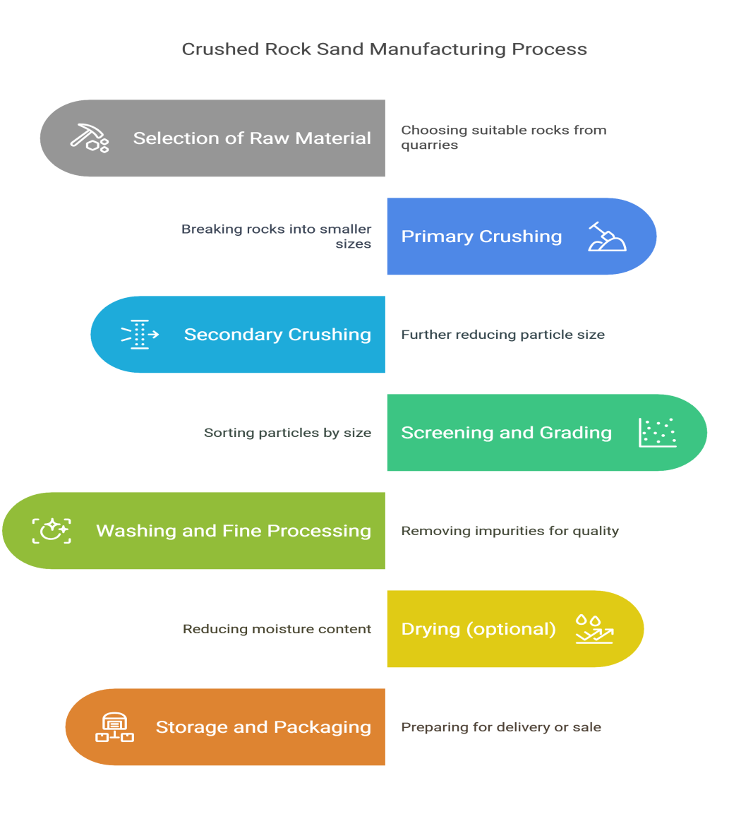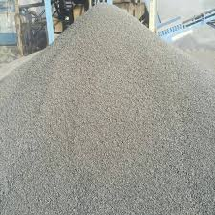

**Figure 1:** Manufacturing Process of Crushed Rock Sand

Volcanic Ash refers to tiny particles of rock, mineral, and glass generated during intense volcanic eruptions. When a volcano erupts, it may spew huge volumes of gas, ash, and debris into the sky. The ash particles are generally extremely minute, averaging less than 2 millimeters in diameter, and may fly tremendous distances, sometimes even reach the stratosphere.

* 1. **Volcano Ash**
     1. **Manufacturing process of volcano ash:**

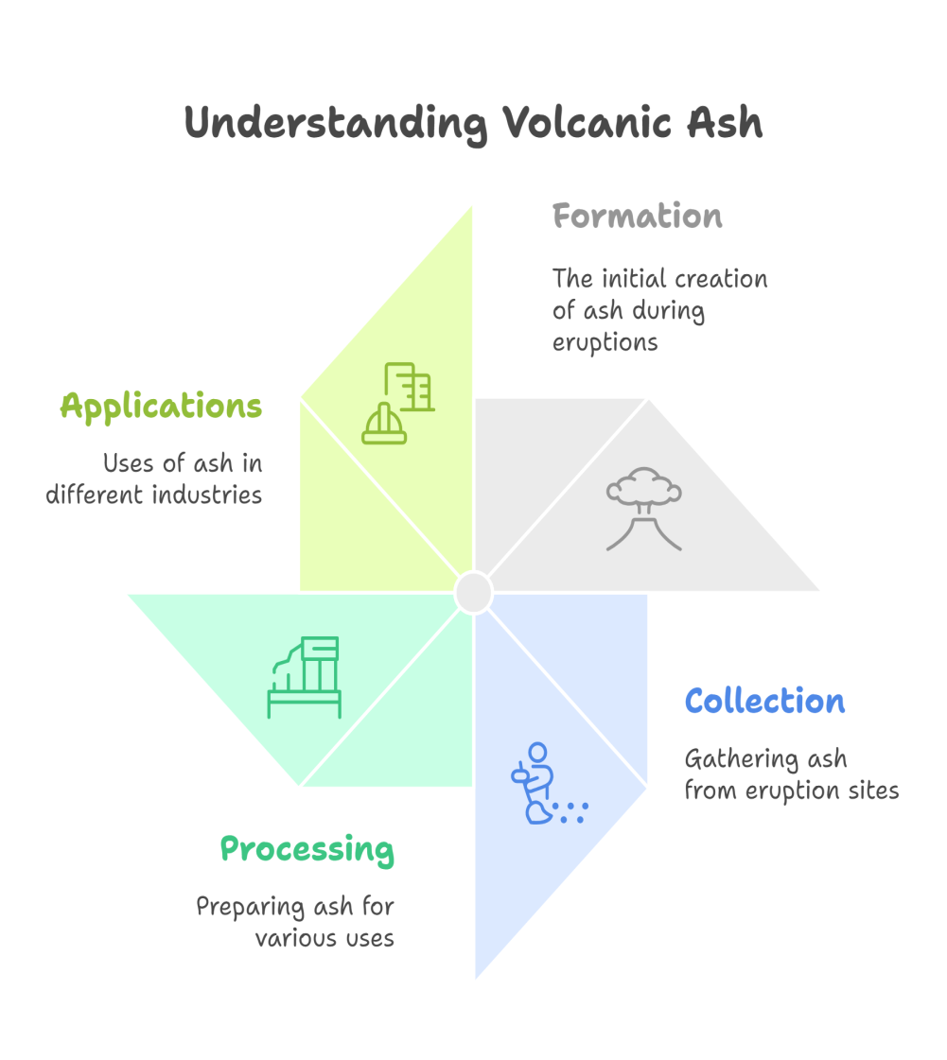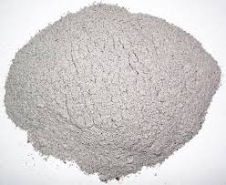

**Figure 2 Manufacturing Process of Volcano Ash**

**1.2.2 Key Points about Volcano Ash:**

* **Structure:**

1. Volcanic ash formed during explosive volcanic eruptions when magma is quickly fractured owing to the pressure of gas trapped within the volcano.
2. This causes the lava to fracture into small particles that cool and harden as they are blasted into the air.
3. The particles that make up volcanic ash are frequently made of fine rock fragments, minerals, and glass (e.g., basalt, andesite, or rhyolite).

**1.2.2 Characteristics:**

* **Size:** Volcanic ash comprises of small particles, generally ranging from a few microns to around 2 millimeters in diameter.
* **Composition:** The mineral composition might vary based on the kind of volcano and its magma. Common components include silica, aluminum, iron, calcium, magnesium, and sodium.
* **Color:** The color of volcanic ash can range from gray and brown to black or even greenish, depending on the nature of the erupted lava.
* **Distribution:** Volcanic ash may reach hundreds of kilometers from the eruption site. Its dispersion relies on elements such the eruption's strength, wind conditions, and air pressure.

**1.3 Applications and Advantages of CRS:**

**1.3.1 Applications:**

Crushed rock sand is commonly used in:

* + Concrete production (as a fine aggregate)
  + Mortar and plaster
  + Road construction (as part of the aggregate mix)
  + Landscaping and fill material
  + Manufacturing of precast concrete products

**1.3.2 Advantages:**

1. **Sustainability:** Reduces dependency on natural sand, helping to conserve ecosystems. Accessibility: Often more easily accessible, particularly in locations with significant quarry activities.
2. **Expenditure:** Can be more economical, depending on local supply and demand variables.
3. **Customization**: Can be made in different grades to satisfy individual building demands.
4. **Quality Control:** The Characteristics of CRS might vary depending on the source rock and manufacturing method, making quality control crucial for consistent performance in building applications.
5. **Dust Formation**: The crushing process might create fine dust, which has to be handled throughout manufacturing and transportation.
6. **Performance**: Depending on the kind of rock used, CRS could have varied workability and performance qualities in concrete compared to natural sand.

**1.4 Applications and Advantages of Volcanic Ash:**

Despite its destructive potential, volcanic ash has some useful uses:

* Construction: In certain locations, volcanic ash (especially from silica-rich eruptions) is used as a component in the manufacturing of concrete, notably in creating pozzolanic cement, which has superior durability and strength than conventional cement.
* Agriculture: Volcanic ash is commonly applied to soils to boost fertility owing to its high mineral content, including key minerals like potassium, phosphorus, and magnesium.
* Water Filtration: In certain civilizations, volcanic ash is employed for water filtration owing to its porous nature.
* Art and Cosmetics: In certain regions, volcanic ash is pulverized into fine powders and utilized for personal care items or art materials.
* Health Impacts: Volcanic ash may have serious health impacts, particularly on the respiratory system. Inhaling tiny ash particles may lead to respiratory troubles, eye discomfort, and skin disorders. Vulnerable groups, including as children, the elderly, and persons with pre-existing lung diseases, are at increased danger during ash falls.

1. **LITERATURE REVIEW**

**Strength Performance of Concrete Produced with Volcanic Ash as Partial Replacement of Cement**

Agboola Shamsudeen Abdulazeez1, Mamman Adamu Idi2, Tapgun Justin3, Bappah Hamza4

There is global need for the preservation of natural resources, reduction of carbon dioxide emission and sustainability of concrete structures; this and other problems associated with material production have fuelled the search for alternative cementing material to produce environment-friendly construction materials. The mining of cement raw materials leads to depletion of natural resources and degradation of environment. Cement production also pollutes the environment due to the emission of CO2. Volcanic ash is suitable material for replacement of cement in concrete production. Chemical composition of volcanic ash as well as the specific gravity, bulk density, workability, compressive strength split tensile strength and flexural strength properties of varying percentage of volcanic ash blended cement concrete and 100% cement concrete of mix ratio 1:2:4 and water-cement ratio of 0.5 were examined and compared. Slump test and compacted factor test was carried out to check the effect of volcanic ash on the workability of fresh concrete. Volcanic ash partially replace cement in the order of 0%, 5%, 7.5%, 10%, 12.5%, 15% and 20% were cast. The concrete were tested at the ages of 7, 14, 21 and 28 days. The results showed that volcanic ash is a good pozzolan with combined SiO2, Al2O3 and Fe2O3 of 74.8%. The highest compressive strength at 28 days was 29.2N/mm2 and 28.3N/mm2 at for 10% and 7.5% respectively, as compared to plain concrete which was 27.8N/mm2; in addition 5% replacements of cement with volcanic ash present same value with the control concrete. The highest split tensile strength at 28 days was 3.48N/mm2 and 3.45N/mm2 at for 10% and 7.5% respectively, as compared to plain concrete which was 3.42N/mm2; in addition 15% replacements of cement with volcanic ash present same value with the control concrete. A 10% replacement of cement with volcanic ash was found convincing and indicate the optimum replacement level of cement. The highest flexural strength at 28 days was 4.91N/mm2 and 4.83N/mm2 at for 10% and 15% respectively, as compared to plain concrete which was 4.70N/mm2; in addition 5% and 7.5% replacements of cement with volcanic ash both present higher value of 4.75N/mm2which is higher than the control concrete. The strength test results indicated that volcanic ash concrete gave better strength compared to control samples. However can be used up-to 15% replacement level due to its promising result. The research recommends use of volcanic ash as partial replacement of cement in aggressive environment, increased water cement ratio.

**Strength Analysis of Concrete Containing Crushed Rock Particles AS Partial and Total Replacement of Sand**

Syed Afzal Basha, B Jayarami Reddy, C Sashidhar

In recent past, the demand for natural river sand has rapidly increased for constructional purposes. This high demand led to extraction of sand from river beds. Depletion of natural sand creates the environmental issues and hence sand excavating is restricted by government which resulted in shortage and substantial increase in its cost. In this context, there is a need to recognize reasonable elective material from mechanical waste instead of stream sand. The usage of squashed shake sand which is a waste material has been acknowledged as building material in numerous nations for as long as three decades. In this paper, attempt is being made to replace natural river sand partially and completely with stone dust. The cube compressive strength test and split tensile tests were conducted. Experimental investigations have revealed that the mechanical properties of concrete using stone dust are almost similar to the conventional concrete. Hence the detrimental effects on environment caused due to excessive mining of river sand can be minimized.

1. **MATERIALS & METHODOLOGY**

**3.1 Cement:**

A cement particle bonds firmly to the stone when it comes into touch with water. The compounds found in cement stay in the finished result, giving it the desired qualities and encouraging its inclusion into the concrete. The cement is ACC cement, more precisely Ordinary Portland cement (OPC 43 Review).

**3.2 Fine Aggregate:**

Fine sums are tiny particles with a diameter of 4.75mm that are extensively used in the improvement business. They are used to fill the gaps between larger particles, which are mostly made of 77% calcium oxide. This improves the dimensional robustness of the concrete mix. The sand used is locally obtained and fits zone I specifications. It underwent strainer testing inside the investigation office in accordance with IS 383:1970 guidelines.

**3.3 Coarse Aggregate:**

The coarse particles of a certain size and irregular shape used in development activities make up the approximate amounts acquired by the mining approach. These sizes, which include ratings exceeding 40mm, 20mm, and 10mm, are offered in the showcase. This raises the concrete's quality considerably. According to IS 383-1970, the quantity utilized is roughly one and rated at 20 mm.

* 1. **Crushed Rock Sand (CRS):**

It is possible to generate crushed rock sand, which is often referred to as manufactured sand (M-sand), by crushing rocks into smaller particles in order to form aggregates that are the size of sand. As a replacement for natural river sand, it is often used in the building industry, particularly in situations where there is a dearth of natural sand resources readily available.

The following is a concise explanation of crushed rock sand: The production process involves crushing hard rock’s such as granite, basalt, or limestone in crushers to create a texture and size similar to that of sand.

The advantages of crushed rock sand are that it is accessible in huge amounts, that it can be made in a variety of sizes, and that it is of a constant quality. Additionally, it helps lessen the dependence on river sand, which is often harvested in a manner that is not sustainable.As a substitute for natural sand, it finds widespread use in the building industry, particularly in the fields of concrete and plastering. As a result of its angular design and homogeneity, it has the potential to enhance the strength and durability of concrete.

**Table No 3.1. Physical properties of Crushed Rock Sand (CRS):**

|  |  |  |
| --- | --- | --- |
| **S.No** | **Physical Property** | **Crushed Rock Sand (CRS)** |
| 1 | **Particle Size Distribution** | 0.075 mm to 4.75 mm |
| 2 | **Shape** | Angular or sub-angular |
| 3 | **Surface Texture** | Rough |
| 4 | **Specific Gravity** | 2.5 to 2.9 |
| 5 | **Water Absorption** | 1% to 5% |
| 6 | **Soundness** | Good (varies with parent rock) |

**Table No 3.2. Chemical properties of CRS & FA:**

|  |  |  |  |
| --- | --- | --- | --- |
| **S.No** | **Chemical Property** | **Crushed Rock Sand** | **Natural Fine Aggregate (River Sand)** |
| 1 | **Silica (SiO₂)** | 60% to 70% | 70% to 85% |
| 2 | **Alumina (Al₂O₃)** | 10% to 15% | 8% to 40% |
| 3 | **Calcium Oxide (CaO)** | 2% to 5% | 2% to 10% |
| 4 | **Magnesium Oxide (MgO)** | 1% to 10% | 0.5% to 1.5% |
| 5 | **Sodium Oxide (Na₂O)** | 0.5% to 2% | 0.5% to 2% |
| 6 | **Iron Oxide (Fe₂O₃)** | 5% to 7% | 10% to 20% |
| 7 | **Loss on Ignition (LOI)** | 1% to 5% | 0.5% to 10% |
| 8 | **Sulphur Content (SO₃)** | Trace to low | Trace to low |
| 9 | **Potassium Oxide (K₂O)** | 0.5% to 2% | 0.5% to 1.5% |

**3.5 Volcano Ash**

Volcanic ash is made up of tiny fragments of rock, minerals, and volcanic glass that are ejected during a volcanic eruption. It is formed when magma is explosively fragmented during the eruption, and it can range in size from fine particles (smaller than 2 mm) to larger chunks.

Formation: Volcanic ash is produced when magma explodes from a volcano, breaking apart into small particles as it cools and solidifies in the air. These particles can be carried over large distances by wind.

Appearance: Volcanic ash is typically gray or black, though its color can vary depending on the composition of the erupted materials.

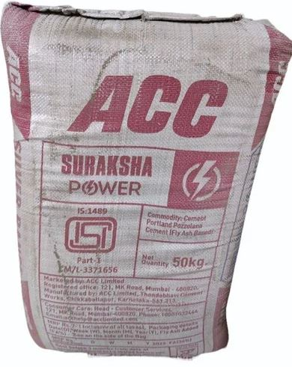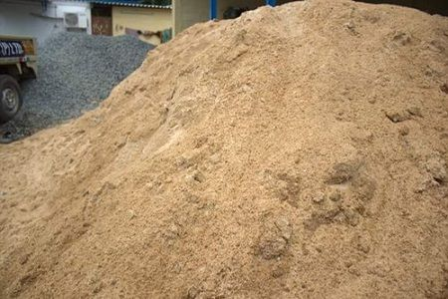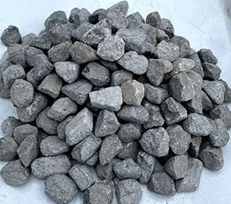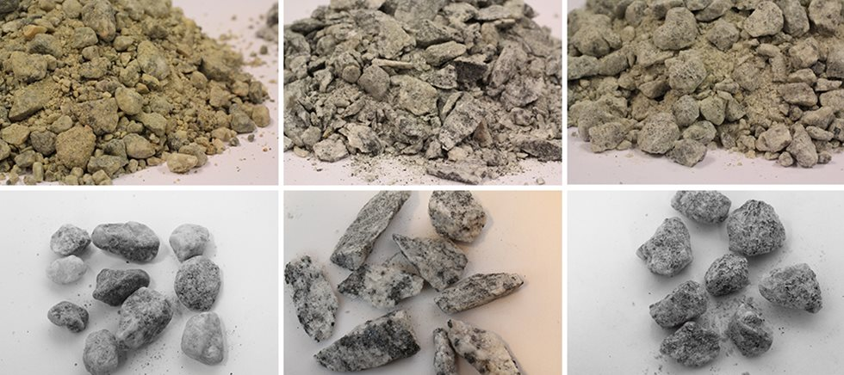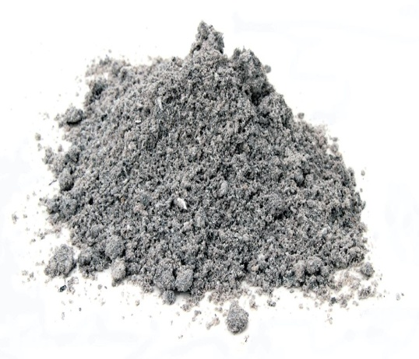

**Figure 3 Cement, Fine Aggregate, Coarse Aggregate, Crushed Rock Sand, Volcano Ash**

**Table No 3.3. Physical properties of Volcano ash (VA):**

|  |  |  |
| --- | --- | --- |
| **S.No** | **Physical Property** | **Volcano ash (VA)** |
| 1 | **Particle Size** | Less than 2 mm (typically fine-grained) |
| 2 | **Shape** | Angular, sharp, irregular |
| 3 | **Color** | Typically gray, black, or brown |
| 4 | **Specific Gravity** | 2.2 to 2.8 |
| 5 | **Surface Texture** | Rough, porous |
| 6 | **Water Absorption** | 15% to 30% |

**Table No 3.4. Chemical properties of Volcano ash (VA) & Cement:**

|  |  |  |  |
| --- | --- | --- | --- |
| **S.No** | **Chemical Composition** | **OPC (%)** | **VA (%)** |
| 1 | **Silica (SiO₂)** | 40% to 70% | 20% to 25% |
| 2 | **Alumina (Al₂O₃)** | 10% to 20% | 10% to 8% |
| 3 | **Iron Oxide (Fe₂O₃)** | 5% to 10% | 2% to 20% |
| 4 | **Calcium Oxide (CaO)** | 2% to 10% | 60% to 67% |
| 5 | **Magnesium Oxide (MgO)** | 1% to 10% | 2% to 10% |
| 6 | **Sodium Oxide (Na₂O)** | 0.5% to 10% | 0.5% to 1.5% |
| 7 | **Potassium Oxide (K₂O)** | 0.5% to 2% | 0.5% to 1.5% |
| 8 | **Sulfur Trioxide (SO₃)** | Low to trace | 1% to 10% |
| 9 | **Loss on Ignition (LOI)** | 5% to 15% | 10% to 5% |
| 10 | **pH Level** | Typically 5.5 to 7.5 | Typically 12 to 13 |

**3.6 Methodology**

The Methodology describes the fill-ins used & mechanical attributes done over this paper:

1. Understudy of Volcano ash to Cement & Crushed rock sand to Sand with a fixed proportion of 10% in cement & a variable proportion of 0%-40% with frequency of 10% in Sand respectively.

2. Property check of Compressive Strength for cubes with a size of 150mm*150mm*150mm.

3. Property check of Tensile Strength for cylinder with dimensions of 150mm diameter & 300mm Height.

4. Property check of Bending Strength for Beam with a dimensions of 500mm*100mm*100mm.

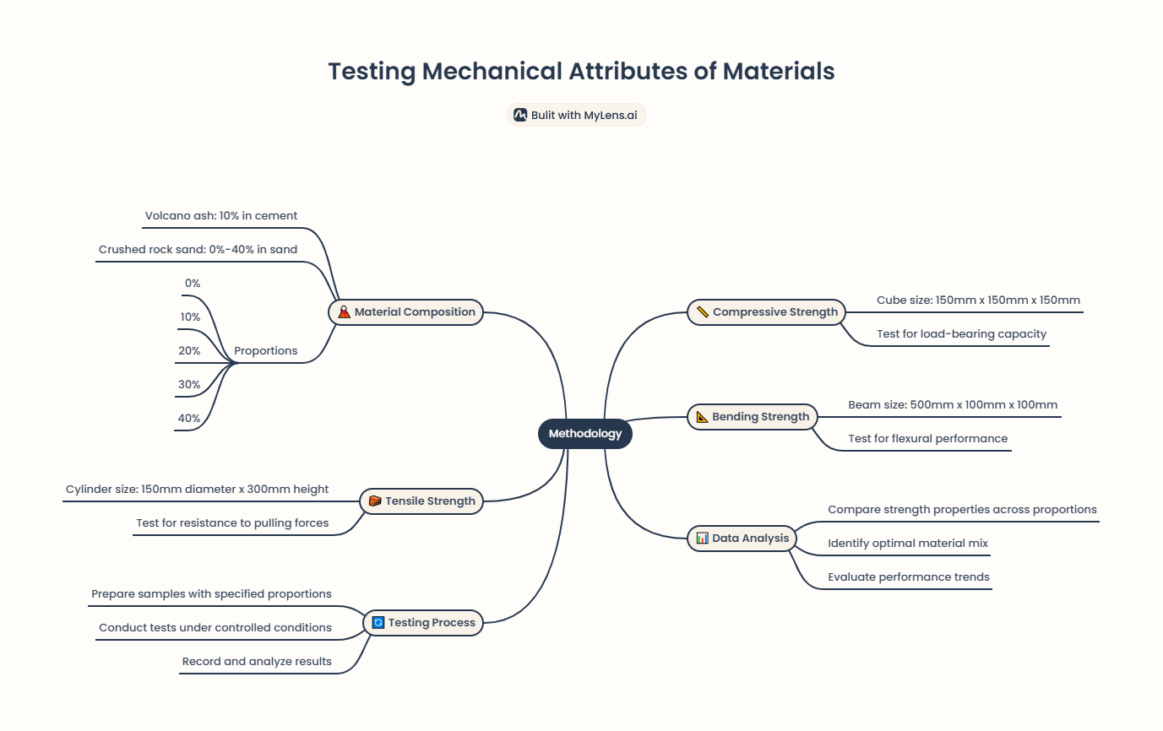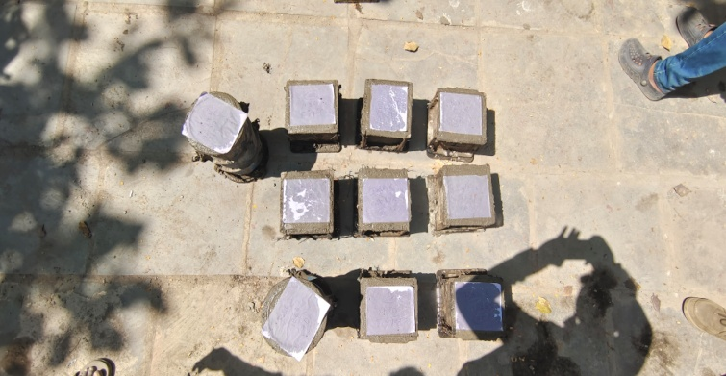

**Figure 4 Methodology &Casting of cubes**

1. **MIX DESIGN RATIO**

|  |  |
| --- | --- |
| Grade | **M40** |
| Proportion | **1:1.6:2.06** |
| W/C ratio | **0.4** |
| Cement | **477.01** |
| Fine Aggregate | **763.9** |
| Coarse Aggregate | **984.54** |
| Water | **192.7** |

1. **TEST RESULTS**

**5.1 Compressive Strength To Volcano Ash For 28 Days At Different Percentages**

Table 5.1 Compressive strength to volcano ash for 28 days

|  |  |
| --- | --- |
| **Mix % Replacement** | **Compressive Strength for 28 days in Mpa** |
| 0% VA | 40.52 |
| 5% VA | 42.67 |
| 10% VA | 47.89 |
| 15% VA | 41.01 |

Graph 5.1 compressive strength to volcano ash for 28 days

**5.2 Split Tensile Strength To Volcano Ash For 28 Days At Different Percentages**

Table 5.2 Split tensile strength to volcano ash for 28days

|  |  |
| --- | --- |
| **Mix % Replacement** | **Split Tensile Strength to volcano ash for 28 days in Mpa** |
| 0% VA | 4.03 |
| 5% VA | 4.2 |
| 10% VA | 4.6 |
| 15% VA | 4.01 |

Graph 5.2 Split tensile strength to volcano ash for 28 days

**5.3 Flexural Strength To Volcano Ash For 28 Days At Different Percentages**

**Table 5.3 Flexural strength to volcano ash for 28 days**

|  |  |
| --- | --- |
| **Mix % Replacement** | **Flexural Strength to volcano ash for 28 days in Mpa** |
| 0% VA | 5.6 |
| 5% VA | 6.1 |
| 10% VA | 6.4 |
| 15% VA | 5.8 |

**Graph 5.3 Flexural strength to volcano ash for 28 days**

As per the above study of Compressive, split tensile strength & Flexural strength properties I have taken 10% constant volcano ash as replacement of fine aggregate because the flexural strength is increased at 10% of volcano ash in fine aggregate so I have taken the highest compressive strength gained value in the project.

**5.4 Test results of Compressive Strength**

**Table no 6.2.4 Test results of Compressive Strength at 7 days, 14 days & 28 days :**

|  |  |  |  |
| --- | --- | --- | --- |
| **Mix % Replacement** | **7 days in Mpa** | **14 days in Mpa** | **28 days in Mpa** |
| 0 % VA + 0 % CRS | 30.14 | 43.35 | 49.35 |
| 10% VA + 10% CRS | 31.25 | 44.28 | 50.54 |
| 10% VA + 20% CRS | 32.57 | 45.64 | 51.83 |
| 10% VA + 30% CRS | 33.84 | 46.45 | 52.92 |
| 10% VA + 40% CRS | 29.99 | 43.21 | 49.25 |

**Graph No 5.4 Contrast values of Compressive strength for 7 days, 14 days & 28 days**

**5.5 Test results of Split Tensile Strength**

**Table no 5.5 Test results of Split Tensile Strength at 7 days, 14 days & 28 days:**

|  |  |  |  |
| --- | --- | --- | --- |
| **Mix % Replacement** | **7 days in Mpa** | **14 days in Mpa** | **28 days in Mpa** |
| 0 % VA + 0 % CRS | 2.21 | 3.4 | 4.13 |
| 10% VA + 10% CRS | 2.53 | 3.62 | 4.21 |
| 10% VA + 20% CRS | 2.68 | 3.8 | 4.35 |
| 10% VA + 30% CRS | 2.92 | 3.94 | 4.49 |
| 10% VA + 40% CRS | 2.6 | 3.85 | 4.2 |

**Graph No 5.5 Contrast values of Split Tensile strength for 7 days, 14 days & 28 days**

**5.6 Test results of Flexural Strength**

**Table no 5.6 Test results of Flexural Strength at 7 days, 14 days & 28 days:**

|  |  |  |  |
| --- | --- | --- | --- |
| **Mix % Replacement** | **7 days in Mpa** | **14 days in Mpa** | **28 days in Mpa** |
| 0 % VA + 0 % CRS | 4.1 | 5.97 | 6.8 |
| 10% VA + 10% CRS | 4.52 | 6.27 | 7.2 |
| 10% VA + 20% CRS | 5.02 | 6.64 | 7.49 |
| 10% VA + 30% CRS | 5.57 | 6.74 | 7.7 |
| 10% VA + 40% CRS | 5.33 | 5.88 | 5.99 |

**Graph No 5.6 Contrast values of Flexural strength for 7 days, 14 days & 28 days**

1. **CONCLUSION**

In this study, the applicability of producing and using crushed rock sand and volcano ash from the natural resources has been presented as a partial replacement for fine aggregate and cement in concrete production. This paper briefly described the production process of the crushed rock sand and volcano ash as well as an intensive material Characterization (physical and chemical). The produced crushed rock sand (CRS) and volcano ash (VA) has proven its applicability as a fine aggregate and cement replacement potential candidate because of its acceptable portion of total pozzolanic essential compounds. In this investigation, the produced ash has been used as CRS as fine aggregate with different replacement ratios (0%, 10%, 20%, 30% and 40%) and cement replacement with VA with constant 10% replacement. The different replacements ratios showed a increase in the compressive strength, split tensile strength, flexural strength at early ages of 28 days, however, the concrete mixes with volcano ash and crushed rock sand gained strength at 10% VA and 30% CRS even surpassing the control mix. The mechanical properties of the VA and CRS developed concrete can be summarized as follows:

* The 10% cement replacement and 30% fine aggregate showed the best performance in terms of compressive, flexural, and tensile splitting strength compared to the other tested replacement ratios and slump value of 89mm.
* Furthermore, the impact of using cement with higher grade had been assessed by changing the cement grade to the control mix and the 10% cement replaced mix and 30% Fine aggregate mix. Moreover, the cost and environmentally friendly of concrete using the both natural resources had been assessed throughout the two replacements in concrete and also more durability should be included including chemical resistance and the degradation of the developed concrete under thermal cycles.
* Here both the materials are an abundant low-cost material, paramount significance as it not only serves to substitute natural sand and cement but also plays a vital role in reducing construction expenses.

1. **REFERENCES**
2. C ¸elik, T., Marar, K., 1996. Effects of crushed stone dust on some properties of concrete. Cement Concrete Res. 26 (7), 1121—1130.
3. Ilangovan, R., 2000. Studies on strength and behaviour of concrete by using quarry dust as fine aggregate. In: Proceedings of All India Seminar on Materials and Machines for Construction. New Age International, pp. 99—102.
4. Sahu, A.K., Sunil Kumar Sachan, A.K., 2003. Quarry stone waste as fine aggregate for concrete. Indian Concrete J., 845—848.
5. Shahul Hameed, M., Sekar, A.S.S., 2009. Properties of green con crete containing quarry rock dust and marble sludge powder as fine aggregate. ARPN J. Eng. Appl. Sci. 4 (4), 83—89
6. Tumingan M., Tjaronge W., Djamaluddin R., and Sampebulu V. 2014. Compression Strength of Concrete with Pond Ash As Replacement of Fine Aggregate. ARPN Journal of Engineering and Applied Sciences. 9(12):2923-2928.
7. Latif D.O., Rifa’I A., & Suryolelono K.B., 2017 Impact of Volcanic Ash and Lime Adding on Expansive Soil for Subgrade Layer, International Review of Civil Engineering (I.RE.C.E.). Vol. 8(5):255-260.
8. Latif D.O., Rifa’I A., & Suryolelono K.B., 2016 Chemical Characteristics Of Volcanic Ash In Indonesia For Soil Stabilization: Morphology And Mineral Content, International Journal of GEOMATE. Vol. 11(26):2606-2610.
9. Waruwu, A., Hardiyatmo G.C., Rifa’I A., 2017 Deflection Behavior Of The Nailed Slab System Supported Embankment On Peat Soil, Journal of Applied Engineering Science Vol. 15 (4): 556 563.