**Car Rental Management System**

KAPIL M1

Student

Dept of Computer Science with Cognitive Systems Dr. N. G. P. Arts and Science College

Coimbatore, India

Email: [kp643640@gmail.com](mailto:kp643640@gmail.com)

Dr.SENTHIL KUMAR R 2

Professor

Dept of Computer Science with Cognitive Systems Dr. N. G. P. Arts and Science College

Coimbatore, India

Email: [senthilkumar.r@drngpasc.ac.in](mailto:senthilkumar.r@drngpasc.ac.in)

**Abstract:**

This paper provides a comprehensive examination of the evolution of online car rental systems and their profound impact on the automotive sector. As e-commerce and digital platforms continue to gain traction, car rental businesses are increasingly adopting online services to enhance operational efficiency and improve customer satisfaction. This study explores the essential features, advantages, challenges, and emerging trends associated with online car rental systems, offering valuable insights for companies, technology developers, and policymakers to optimize their strategies and fully harness the potential of these systems.

**I. Introduction**

The automotive industry has experienced a significant transformation with the rise of online platforms and the growing acceptance of e-commerce. The car rental sector, in particular, has benefited from this digital revolution, providing customers with convenient access to a diverse range of vehicles and simplified booking processes.

**1. Background:**

Traditionally, car rental services required customers to visit physical locations, which often led to lengthy paperwork, limited vehicle options, and time-consuming processes. Customers had to navigate through various forms and wait for assistance, which could be frustrating and inefficient.

The rapid expansion of the internet and advancements in technology have enabled car rental companies to establish online platforms. These platforms allow customers to rent vehicles at their convenience, from anywhere and at any time, thus revolutionizing the rental experience.

**2.Research Objectives:**

The primary objective of this research is to analyze the online car rental system's impact on the automotive industry. The study aims to examine the key features, benefits, challenges, and emerging trends associated with online car rental systems.

By understanding these factors, the research seeks to provide valuable insights for car rental companies, technology providers, and policymakers to enhance customer experiences and optimize their strategies.

**3. Methodology**:

To conduct this research, a comprehensive literature review will be carried out, exploring existing academic studies, industry reports, and case studies related to online car rental systems. This review will provide a foundation for understanding the current landscape of the industry.

Additionally, empirical analysis will be conducted through surveys and interviews with industry experts and customers. This firsthand data will offer insights into user experiences and expectations, allowing for a more holistic understanding of the topic.

**II. Related Work**

Numerous studies have explored various aspects of online car rental systems, which can be categorized into several key themes:

**1.System Development and Implementation:**

Research in this area focuses on the technical aspects of developing and implementing online car rental systems. This includes discussions on system architecture, integration of functionalities such as vehicle inventory management, booking systems, payment gateways, and customer support. These studies provide insights into the challenges and best practices for launching successful online car rental platforms.

**2. User Experience and Interface Design:**

Enhancing user experience is critical for the success of online car rental systems. Research in this area examines user interface design principles, usability testing, and user-centered design approaches. The goal is to create intuitive navigation, clear vehicle descriptions, and simplified booking processes that enhance the overall user experience.

**3. Efficiency and Optimization:**

Studies have been conducted on optimizing operational efficiency within online car rental systems. This includes research on fleet management, inventory tracking, and resource allocation. The aim is to improve the utilization of rental vehicles, minimize downtime, and enhance overall operational efficiency through data-driven decision-making and optimization techniques.

**5. Security and Privacy:**

Given the sensitive nature of customer data in online car rental systems, research has been conducted on security and privacy concerns. These studies address topics such as data protection, secure payment processing, fraud detection, and compliance with privacy regulations. Ensuring the security and privacy of customer information is critical for building trust among users.

**III. Problem Statement**

The traditional car rental industry has long been plagued by various challenges and inefficiencies, such as limited accessibility, cumbersome booking processes, and restricted vehicle choices. These issues have hindered the overall customer experience and inhibited the industry's growth potential. To address these limitations, online car rental systems have emerged as a promising solution. However, despite their advantages, several problems and obstacles persist within the realm of online car rental systems, necessitating further investigation and improvement.

The key problem addressed by this research project is the identification and analysis of the challenges and limitations faced by online car rental systems, which include:

**A. User Interface and Experience:**

Many online car rental platforms struggle to provide a user-friendly interface that is intuitive and easy to navigate. Complicated booking processes, unclear vehicle descriptions, and limited filtering options can lead to frustration and confusion among customers, hindering their overall experience.

**B. Vehicle Inventory Management:**

Maintaining an up-to-date and accurate inventory of available vehicles is crucial for online car rental systems. Discrepancies between online listings and actual vehicle availability, as well as delays in updating inventory status, can result in customer dissatisfaction and loss of trust in the system.

**C. Customer Support and Communication:**

Prompt and effective customer support is vital for resolving queries, addressing concerns, and handling emergency situations in online car rental systems. Insufficient or delayed support, lack of clear communication channels, and unavailability of multilingual support can undermine customer satisfaction and trust.

**D. Data Security and Privacy:**

Online car rental systems handle sensitive customer information, including personal details and payment data. Ensuring robust data security measures, complying with privacy regulations, and safeguarding customer data against breaches and unauthorized access are critical challenges in maintaining customer trust.

**F. Technical Infrastructure and Integration:**

The successful operation of an online car rental system relies on a robust technical infrastructure, seamless integration with various systems (such as inventory management and payment gateways), and compatibility with multiple devices and platforms. Technical glitches, system downtime, and integration complexities can disrupt the system's functionality and hamper the customer experience**.**

**IV. Justification**

In today's digital age, online car rental systems have become a necessity for the car rental industry. The project aims to leverage the advantages of online platforms to enhance customer convenience, operational efficiency, and competitiveness. Implementing an online car rental system offers significant benefits, including:

**Enhanced Convenience:** Customers can access a wide range of vehicles and make reservations at any time and from anywhere. This eliminates the need for physical visits to rental offices and provides flexibility in planning rentals based on individual schedules.

**Expanded Vehicle Choices:** Online platforms allow customers to easily browse through a diverse fleet of vehicles, selecting the one that suits their specific needs and preferences. Real-time tracking of vehicle availability minimizes instances of unavailability, ensuring that customers have more options to choose from.

**Streamlined Booking Processes:**User-friendly interfaces, step-by-step guidance, and instant confirmation simplify the booking process, reducing paperwork and wait times. This efficiency saves time for customers and enhances their overall rental experience.

Improved Operational Efficiency: By automating various processes, such as vehicle inventory management, documentation, and payment processing, companies can reduce manual labor, minimize errors, and allocate resources more efficiently. This leads to cost savings and streamlined operations.

**V. Functional Requirements**

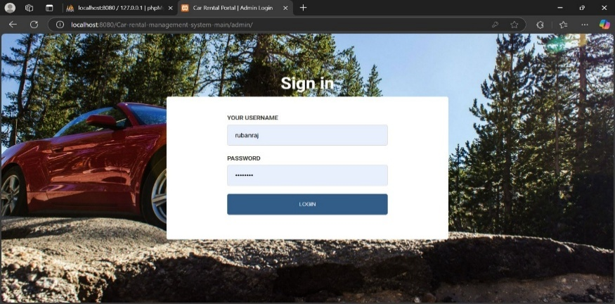Functional requirements for an online car rental system project can vary depending on the specific needs and scope of the system. However, the following are common functional requirements that should be considered:

**1. User Registration and Authentication**

* Provide a user registration process allowing customers to create an account with their personal information.
* 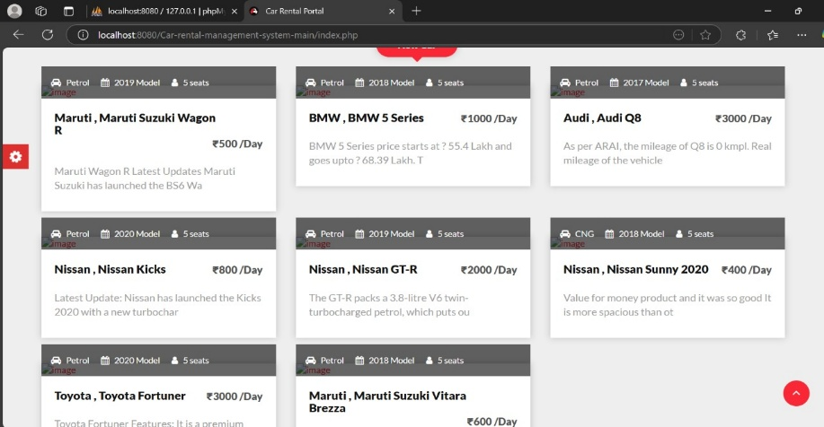Implement secure authentication mechanisms, such as username and password, or integration with social media accounts.

**2.Vehicle Inventory Management**

* Maintain a database of available vehicles with relevant details such as make, model, year, features, and availability status.
* Allow users to search and filter vehicles based on their preferences, including vehicle type, transmission, fuel type, and seating capacity.

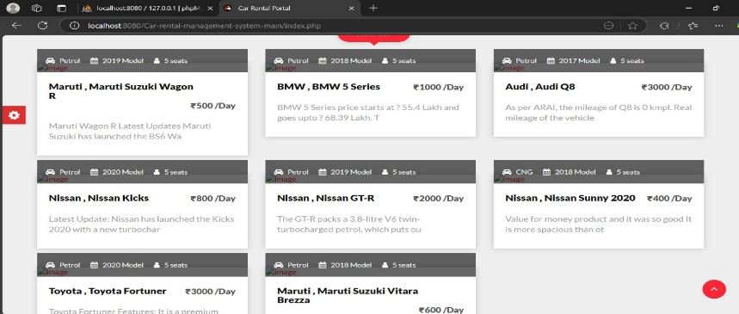**3. Booking and Reservation**

* Enable users to select a desired vehicle, specify pick-up and drop-off locations, and choose rental dates and times.
* Calculate rental rates based on the selected vehicle and rental duration, including any additional charges or fees.
* 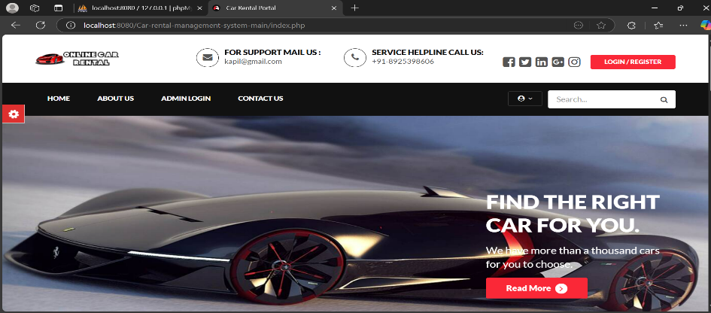Provide a booking confirmation mechanism to secure the reservation.

**4.User Profile and Preferences**

* Allow users to create and manage their profiles, including personal information, contact details, and payment preferences.
* 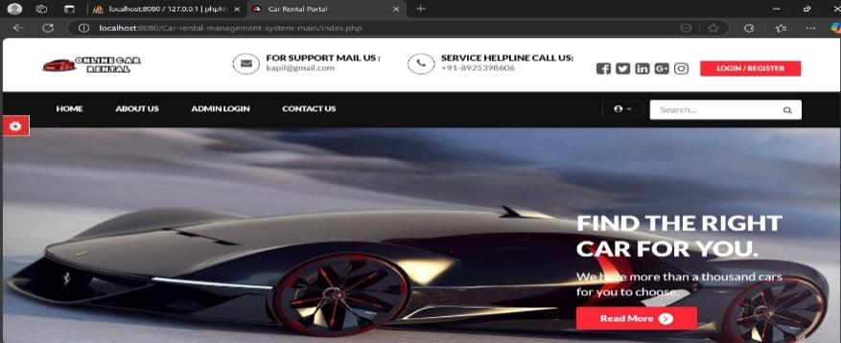Provide options for users to save their preferences, such as preferred vehicle types, pick-up locations, or insurance options.

**5.Administrative Dashboard**

* Provide an administrative dashboard to manage and monitor the online car rental system.
* Enable administrators to manage user accounts, vehicle inventory, pricing, promotions, and generate reports.

**VI. System Design**

The design of the online car rental system aims to centralize data management, reduce the risk of fraud, and ensure user data integrity through secure payment systems and verification processes. Key design considerations include:

* Centralized Data Management: The system will centralize all data related to vehicle inventory, user accounts, and transactions, allowing for efficient management and real-time updates.
* Fraud Prevention Measures: To mitigate the risk of fraud, the system will implement features such as document upload for verification of licenses and identification, ensuring compliance with regulations.
* User Data Security: The system will utilize secure payment gateways and encryption protocols to protect sensitive user information, ensuring data integrity and confidentiality.
* User-Friendly Interface: The design will prioritize a simple and intuitive interface, minimizing the amount of data required for users to complete bookings. This approach aims to encourage more users to engage with the system.
* Real-Time Notifications: The system will incorporate a real-time notification system to alert staff for user verification and authentication, enhancing operational efficiency.

**VII. Conclusion**

The online car rental business has transformed customer experiences, allowing for efficient management and satisfaction through digital platforms. The shift from traditional rental processes to online systems has not only improved accessibility and convenience for customers but has also enabled car rental companies to streamline their operations and enhance service delivery. As the industry continues to evolve, embracing technology will be crucial for meeting customer expectations and staying competitive in the market.

**VIII. Future Enhancements**

Looking ahead, the project plans to introduce several enhancements to further improve the online car rental experience:

* Daily Car Rentals: The introduction of daily car rental options will provide customers with more flexibility and convenience, allowing them to rent vehicles for shorter durations.
* Pay After the Trip Feature: Implementing a "pay after the trip" feature will enhance customer satisfaction by allowing users to complete their rentals without upfront payment, thereby increasing accessibility.
* Increased Automation: The project aims to increase automation within the system to streamline processes further and enhance user experience. This may include automated customer support features, such as chatbots, to assist users with inquiries and bookings.

By continuously innovating and adapting to customer needs, the online car rental system can remain at the forefront of the industry and provide exceptional service to users.

**IX. References**

• **Shaheen, S., & Cohen, A. (2019).** "Shared Mobility: The Potential of Ridehailing and Carsharing," *International Transport Forum Discussion Papers.*

• **Turo Inc. (2023).** "The Future of Peer-to-Peer Car Rental Services."

• **Chung, C., & Kwon, S. (2020).** "Security Challenges in Online Car Rental Systems," *Journal of Information Security & Applications.*

• **Enterprise Holdings. (2022).** "Trends in Car Rental Services and Digital Transformation."

• **KPMG Global. (2021).** "Future of Mobility: The Rise of Digital Car Rental Platforms."