The Review Article On Treatment And Management Of Bronchial Asthma

## Student Name :

1. Puja Nimba Mahajan
2. Harshada Bharat Chaudhari
3. Aishwarya Ganesh Pardeshi
4. Gayatri Vijaysing Rajput
5. Vaishnavi Shailendra Pawar
6. Harshada Kailas Jadhav

## Guidance By :

1. Mr. Awais Mohommad
2. Mr. Nazeer Ahmed

# Abstract :

Bronchial asthma is a chronic inflammatory disorder of the airways, characterized by provocative exposure and increased response to respiratory ducts to accidental airflow deflections. Global health is especially high in the Western world. Learn more about causes, pathophysiology, phenotype, and asthma genetics. Treatments will be available to ensure proper asthma control roles. It can also contribute to the development and implementation of optimal strategies for development and prevention.The purpose of writing the current review paper is to review the history ,current situation ,control history ,challenges and on going to management programme of asthma .

All prescribed medications like antiasthmatic drugs should be continue used .

# Introduction :

Asthma is one of the oldest diseases of the respiratory tract, and is characterized by chronic invasion and disturbed respiratory function [1]. Despite many advances in asthma treatment and diagnosis, large populations still agree, and it becomes the best infectious disease worldwide. Approximately 10% of children and 5% of adults are eligible for the disease. Who's

facts on May 3, 2021 at asthma said that around 262 million people will be reported in 2019 through this lifelong illness, with this number being reported to be expected in the future. Other symptoms are also characterized, such as epithelial fractures, hypertrophy of the respiratory duct, smooth muscle, excessive secretion of the mucosa of the bronchial wall, shortness of breath, cough, and behavioral type (Figure fig. 1).

Adequate treatment for asthma is not available, but this can be controlled with proper management and helps asthma patients live a better life in a better way [2]. The WHO (World Health Organization) main preventive measures for asthma and disease management are tobacco smoke reduction, and the initiatives MPower and Mtobacco Stay allow advances in this area of tobacco control Use has ended.

It is an allergic or dicing active ingredient symptom for the treatment of asthma and is an internationally recognized strategy for its healing. ICS (inhaled corticosteroids) can provide ideal disease control, but not as a monotherapy. Additional treatments such as SABA (short-change "two agonists), LABA (long effective ²²Ömtonister), LTRA (Leukotria receptor antagonist therapy), and theophyllin are required [3]. The main goal of writing this review is to easily understand asthma.

# Pathogenesis :

The pathogenesis of asthma is complex and involves inflammation and redesign of the airways. It consists mainly of two phases: immediate and delayed (delay) phase .

#### The immediate phase of the asthmatic attack :

According to the challenge, you will recover for the next 24 hours. Degranulation of mast cells through mediator release is probably an important mechanism involved in early responses. [4]

In the sensitive individuals, allergens interacted with dendritic cells and CD4+Tcell, leading to the development of Th0 helper lymphocytes that lead to Croner-helper-lymphocytes. Th2 lymphocytes produce cytokines such as interleukin (IL)-5, IL-4, and IL-13. IL-5 and Granulocyte Macrophages-Colony Stimulating Factor (GMCSF) for the release of prime eosinophile and granular proteins that damage the epithelium.

It also promotes IgE synthesis and responsibility in some asthma patients. (IL-4 and IL-13) cause allergen-specific IgE to remove allergen-specific IgE with inherited moles, which causes allergen-specific IgE that binds to mast cells. Histamine and Leukotria B4 and Prostaglandin (PG) D2 The first two are powerful enhancers of bronchitis inflammatory protein-1 ± ± Tumor necrosis factor (TNF) - ± Tumor necrosis factor (TNF). Various chemotaxis and chemokines draw leukocytes, particularly eosinophilic and mononuclear cells, setting delayed phase stages.[5]

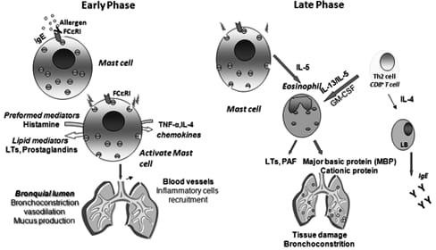

#### The late phase of asthmatic attack :

During this late reaction, the respiratory tract is not particularly stimulating, such as histamine. Histamine can take up to two weeks from one allergen exposure. This is a progressive inflammatory response of the essence that occurred in the first stage, and is particularly important influx of Th2 lymphocytes.

Inflammatory cells contain activated eosinophils. This release of Cysteinylleukotrien; interleukins IL-3, IL-5 and IL-8; toxic proteins, cationic eosinophil proteins, major founding proteins, and neurotoxins derived from eosinophils. Other suspect mediators of delayed inflammatory treatments are that adenosine, no (nitrogen oxide) and neuropeptides are induced. [10] However, in chronic asthma, recovery is incomplete due to ineffective repair. This leads to a renovation of the breathing structure. Persistent epithelial damage and loss of its protective function continue to expose deeper respiratory structures, leading to persistent inflammation and cell infiltration. The various mediators released cause angiogenesis, smooth muscle growth, fibrosis, and airway thickening, leading to continuous obstruction of the airflow. Various enzymes and growth factors are important in this conversion process . [5]

# Treatment of bronchial asthma :

The purpose of asthma treatment is to achieve normal respiratory function without symptoms, deterioration, or side effects.Normal respiratory function in patients with respiratory removal cannot be restored, so it can be evaluated based on its highest value [6]. The most effective treatment for asthma is the identification and removal of triggers such as smoke, pets, and aspirin. The medical care used depends on the severity of the disease and the frequency of symptoms [7]. Approaches to asthma treatment are used to prevent exposure to antigens. Reduction of bronchial tubes Inflammation and hyperactivity. Dilatation of narrowed bronchi of the lungs. Complete Antashma medications can be administered by inhalation. Paths with three obvious benefits: i) improvement therapeutic effects (by direct transmission of drugs to the point of activity),ii) minimize l systemic effects, and iii) reduction of acute seizures is rapid .

## Non- pharmacological treatment of bronchial asthma :

Removal of allergens, especially pets with feathers or fur, is an important component of non- pharmacological treatment. Life style Modifications should be a regular, balanced diet that involves smoking.Please avoid a sitting lifestyle. Sitting is to reduce lung strength and avoid obesity or weight loss. Obesity increases the overall inflammatory response in humans. Although physical exercise restrictions are not recommended, asthma should be encouraged to participate in exercises. Improved self-management has led to better symptomatic control, a decrease in the number of asthma attacks and emergencies, and improved spread of illnesses taken from school and work and the number of days spent in hospitals.Physical training (reduced asthma symptoms, improved movement Resistance, improved quality of life, reduced morbidity); Respiratory treatment and physical therapy (e.g. respiratory techniques, lips, breathing); Smoking cessation (using medical and non-medical assistance if necessary); Psychosocial treatment approach (family therapy).

## Pharmacological treatment of bronchial asthma :

Pharmacological treatment of asthma components consists of two types of drug products. Long-term controller active ingredients are used continuously for long-term management. The controller is defined as a "normal use agent" intended to achieve appropriate control, and the relief is defined As rescue tool intended to treat asthma degradation. They are administered orally by inhalation, injection (drip injection, subcutaneous or intramuscular) or by skin stains. Inhaled funds allow direct access to the inflammation points with increased local concentrations. Therefore, the active ingredients are very effective anmainly, the systemic concentration of the drug is maintained at a lower value, allowing systemic side effects to be at a lower frequency[6]. However, the Global Initiative (GINA), Classification System for Asthma is

based on the degree of clinical control achieved, ranging from controlled to uncontrolled, uncontrolled, uncontrolled, and uncontrolled.

This new classification aims to emphasize that the severity of asthma is underlying It depends not only on the severity of the disease itself, but also on the response to treatment. Furthermore, asthma severity can fluctuate considerably over a significant period of years from now. Gina's global strategy defines clinically controlled asthma as follows: During the day, there is no maximum of twice a week.There are no restrictions on activities in daily life, including physical movements. I have no symptoms at night and am not waking up due to asthma. There is no need to activate bronchodilators quickly for symptomatic treatment (Relief or up to twice, normal or nearly normal lung function, no deterioration. (6)

# Management of bronchial asthma :

## Bronchodilators :

In healthy conditions, the caliber of the bronchi is primarily controlled by the balance of the parasympathetic and sympathetic nervous systems. Bronchodilators affect muscle tone in airway bronchoconstriction. [8]

### Sympathomimetic Agents (adrenergic drugs):

Sympathomimetics cause rapid relaxation of the respiratory tractSmooth muscles are the most common reason for asthma. These vary in potency, duration of action, elimination mode, and side effects. Sympathomimetics such as adrenaline, isoprenaline, and ephedrine are active ingredients with mixed î²1 and î²2 agonist effects. Used to treat asthma,Their effects are immediate but remained influences such as motor pit, heart arrhythmia, tachycardia, angina pectoris, fear, sweating, and trembling. Therefore, selective "two agonists" are drugs of choice to minimize side effects. [9].

Currently, certain stimulants, such as salbutamol, are available, resulting in bronchodilation with minimal cardiac effects. adrenergic agonists increase adenylsilase activity and promote the conversion of ATP to cyclic adenosine monophosphate (C-AMP), which reduces intracellular calcium, increases membrane-potassium conductivity, and reduces myosin light chain activity. Their combination leads to smooth muscle relaxation and bronchiodilation. [10,11] the eosinophil chemotactic factor ( ECF-A )from the mast cells.[12]

These two agonists can continue to be classified as short-term and long-term effective agonists

#### Short –Acting 2 Agonist :

The short acting selective 2 adrenergic stimulant are the preferred rescue drugs . for example. Salbutamol, isoetaline, terbutaline, fenoterol, vitolterol. These are extremely effective in treating acute attacks caused by bronchial asthma and in preventing asthma induced by training. They are not very useful if they are recorded regularly and should only be used as It's safe during pregnancy. Salbutamol It is described as a prototype of this class. [13]

#### Salbutamol :

Salbutamol is the most frequently used drug and can be administered oral IV inhalation and through inhalation of a meter socket. The normal dose contains essentially no cardiovascular effects. Oral dosage is 2-4 mg three times a day.Aerosols are small and safe. In the case of inhalation,100-200 µg inhalation of up to 8 µg can be repeated in 24 hours in 4 hours. [14] .The bronchodilation effect of fast insertion (1-5 minutes after inhalation) is prominent, with one inhalation dose (100 µg) lasting approximately 4-6 hours. Salbutamol is used in mild, intermittent asthma when necessary. [13]

#### .Long -Acting 2 Agonists:

Salmeterol and Formatelsol are long agonists,The starting effect is slow (10 -15 min) and the last effect is 12 hrs.[15] Therefore, they are used in chronic bronchial asthma.

#### Salmeterol:

Salbutamol is the selective and salbutamol as an 2 agonist. Inhalation at a dose of 12 µg bids intensive, in more serious cases, increased to a bid of 24 µg. it is used as the drug of choice in the prevention of nocturnal bronchial asthmatic attack [16]. And those induced by exercise.[17] In adults, symptoms improve with inhaled steroids. This advantage is uncertain in children. [18] They should not be used without the accompanying steroids that claim to be at high risk for severe symptoms, including deterioration in both children and adults. [19,20]

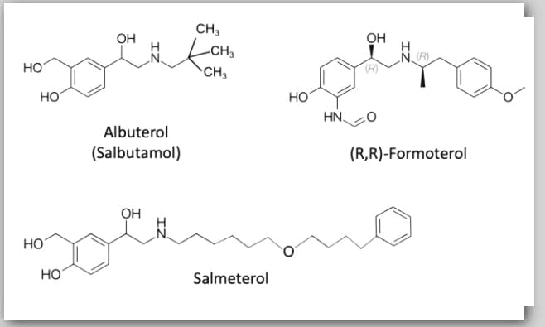

### Anticholinergic agent:

Eg. Atropin, Pratropium bromide, Oxitropium Bromide,Tiotropium bromide. These are competitive antagonists of the muscarinic acetylcholine receptor. It leads to broncho relaxation and reduced slime secretion. There are several subtypes of muscular receptors, three of which are located primarily in the smooth muscles of the respiratory duct, but at density in the proximal respiratory pathways and subglands.[21] Reducing bronchial secretion from asthma makes the remaining secretion viscous and it is difficult to remove from the bronchial tubes. [9]

#### Atropine :

Inhaled atropine is severely absorbed through the respiratory duct. Therefore, side effects (tachycardia, genital sculpture, blurred gaze, constipation, difficulty in urination) and slow insertion of activity are not found in the treatment of bronchial asthma.[9,14]

#### Ipratropium Bromide:

It is a quaternary ammonium salt derived from atropine.Unlike atropine,Iptratropium is not significantly absorbed by and appears to have fewer side effects on the whole body. I'm irritated. [22,23] It is especially useful for cardiac patients. [24] Current guidelines recommend using a combination of Beta2 agonists and anticholinergic agents, particularly using patients.

[25,26,27] The combination of ipratropium and ²2 agonists by inhalation acts on large and medium sized bronchi, while, which produces an additive effect. [13]

#### Tiotropium bromide:

Tiotropium bromide is long-effective anticholinergic, with great effect as a selective antagonist to the acetylcholine receptor of muscarin and as a kinetic selectivity. Tiotropium dissociates rapidly from autoin inhibitory M2 receptors, but slowly from M1 and M2 receptors, which transmit acetylcholine-mediated bronchoconstriction and adhesive secretion. This increases the binding time of M3 receptors leads to longer bronchodilation, allowing daily doses compared to the 3-4 daily doses required with iProtrophium. [28]

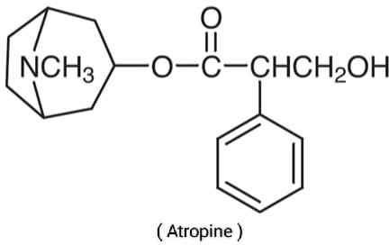

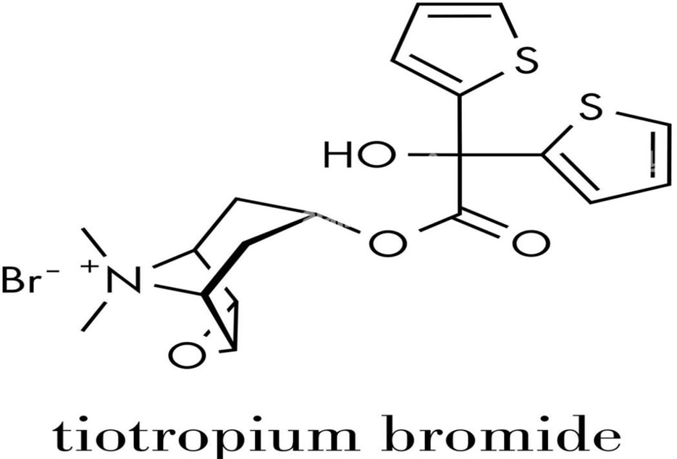

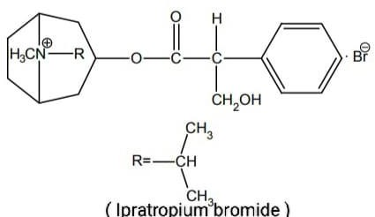

### Methylxanthine and its derivatives:

Eg. Theophylline, aminophylline, diproferin, and These are non-authorized phosphodiesterase (PDE) inhibitors. PDE types III and IV destroy down cyclic adenosine monophosphat (cAMP) into 5-AMP ,whereas PDE V break down cyclic guanosine monophosphate (cGMP) at 5-gmp. Inhibition of this enzyme recycling company from CGMP and CAMP and Campen. This will break the Bronchuratock, camp, camp, camp, camp, camp, and camp in order, causing you to fall into CGMP and camp nutrition. Inflammatory cells. [29] Xanthine Another mechanism that bronchiectasis produces blocking of adenosine receptors located in various organs, generates adenosine mediated by these receptors, leading to bronchiectasis. In addition, it improves mucus membrane clearance. BronchialImproved ventilation activity in asthma. [30]

These funds are not used due to the narrow area of treatment. In cases of refractory, and in severe attack, xanthine is used orally or intravenously (combined). Pulse rate and blood pressure should be monitored during intravenous infusion. [30,31]

#### Asthma attack:

Aminophylline is a combination of theophylline and ethylendiamin, and is one of the most effective preventive, more serious, and serious drugs. It is also effective for patients who do not respond to catecholamines. 250-500 mg in 10 ml solutionSlowly. First lineage of patients with severe asthma challengeInjections or IV infusions as treatment. [9]

Treatment with a reasonable dose of inhaled selectively selective α2 agonist is injected at a dose of 5 mg/kg over 15-30 minutes. ,followed by 0.5-1 mg/kg/hour for several hours.[13]

Theophylline designated in the evening serves as an addiction to prevent nightly attacks. [30,32]

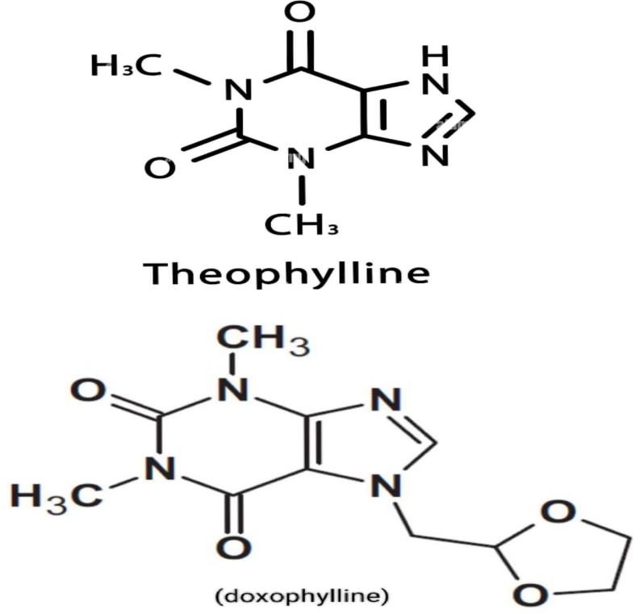

## Leukotriene modifiers :

Leukotrien (LT4, Ltd4, LTE4) is released during inflammation. They increase mucus secretion, reduce mucosa and increase vascular permeability. Leukotria modifiers have no bronchodilation effect, but they do have preventive effects.Corticosteroid doses can be enabled. [9,13]

The following drugs that modify the leukotriene system are :

1. Competitive antagonist of LT 1 receptor : Montelukast , Zafirlukast
2. Leukotriene synthesis inhibitor : Zileuton

### Competitive Antagonists of LT1 Receptors :

leukotrien-receptor antagonists are a hybrid of anti-inflammatory and bronchodilators at and have a unique profile of being accepted as a tablet or twice a day. Published data using Monterukast or Zafirlukast demonstrates excellent aggression activity of a wide range of asthma heavy use, either monotherapy or inhaled steroids. [33]

#### Montelukast :

Montelukast - Sodium is an oral, potent, selective antagonist of the cysteinyl leukotriene 1 receptor (CysLT1Rs ), which transmits bronchoconstrictor factors. [34]

Montelukast provides significant protection against For bronchoconstriction, it was trained 2 hours after a single oral administration. [35] In sensitive individuals, montelukast has been shown to inhibit bronchoconstriction caused by aspirin [36] inhaled allergens [37] (both children and adults). [38-40] more sustained Bronchial protection against EIB than LABA salmeterol(50µgdaily).[41]

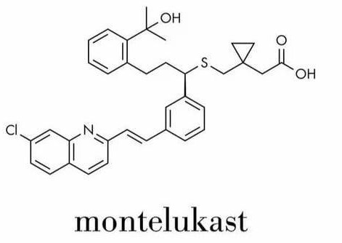

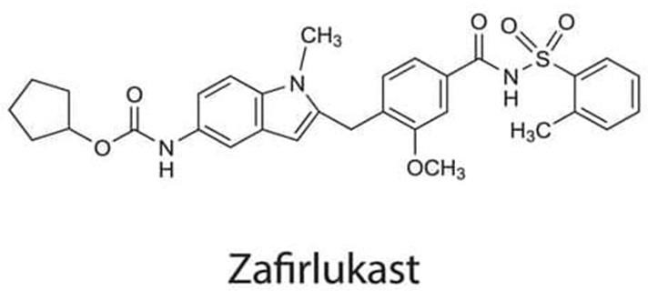

### Leukotriene synthesis inhibitor :

The leukotriene pathaway is initiated when arachidonic acid is converted to leukotriene A4 by the enzyme 5-lipoxygense by the drug zileuton reduce thr biosysnthesis of LTA4 and its active derivatives the cysteinyl leukotriene. [42,43]

Anti-inflammtory effects may modulate underlying airways inflammation.[44] In addition, Zileuton can prevent worsening from asthma, which requires prednisone treatment.[45] The FDA recommends that liver function is tested monthly for three months and quarterly next year, followed by intermittent testing. [46] In rare cases, Churg-Strauss syndrome (CSS) was reported in patients who received antagonists of leukoccitoinal infections, but the consensus was due to the withdrawal of corticosteroid therapy, which over shadowed the disease. [47,48]

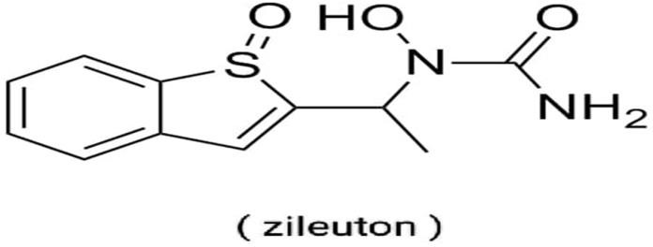

## Anti-inflammatory agent :

### Inhaled Corticosteroids (ICS):

Asthma as a chronic inflammatory disorder of the airways, Respiratory inflammatory disorders are ICS of all patients (children, teenager, adults) ICS with severe mixing, in severe mixing, in the persistent management and serious mixing, in serious mixing, in the asthma.

Generally, they are part of daily asthma treatments and are used daily. Inhaled corticosteroids help to control and treat inflammation in the airways, and only very small amounts of medication are contained in the body. These drugs do not cause serious side effects such as weakening the bones.Corticosteroids can be caused when taking liquids, pills, or spray-type (full-body corticosteroids). [49]

Inhaled corticosteroids are the most powerful and most effective medicine for the long-term control of asthma in most people. If you are taking it consistently, improve your lung function, symptoms, reduces asthma attacks, and reduces asthma approval to hospitals. [50]

The exact mechanism is unknown, but they are (i) called anti-inflammatory properties and multiple levels. They have no bronchodilation effect and are slow to begin with. [9] Corticosteroids alter the transcription of many genes. In general, corticosteroids increase the transcription of genes encoding ²2 adrenergic receptors and many anti-inflammatory proteins, such as IL-10, IL-12, IL-1 receptor antagonists (IL-1RA). Corticosteroids Reduces transcription of genes encoding many inflammatory proteins. Examples include IL-2, IL-3, IL-4, IL-5, IL-6, IL-11, IL-13, IL-15, TNF-INS±, GM-CSF, SCF, Endotheradiode molecules, chemokines, inducible nitrogen

synthesis (permeability), Cyckoxys (Inososisis), Cyckoxys (Inososisis), (Cyclokoxys (Cox), Phospholipase A2, Endothelin-1 and NK1-2 receptors. IL-4 is important for inducing IgE B cell production, and IL-5 is an important supplement for eosinophils. Therefore, inhibition of IL-4 and IL-5 significantly reduces the inflammatory response in asthma. [31]

Childrens who use inhaled corticosteroids do not have increase risk for broken bones as comparaed to who are not using the medicine. [ 51] The greatest potential of ICS monotherapy should be investigated prior to alternative treatments such as leukotria modifiers and LABA. Regular use of ICS reduces the rate of asthma degradation and prevents an increase in excess

[52] and pulmonary function. [53] Combination with other active ingredients such as theophylline [54] ,Long acting 2-agonists and leukotrinantagonists are useful. [55]

#### Undesirable Effects:

Chronic use of steroids by inhalation can be made for pharyngeal candidiasis (T lymphocytes for protection against fungal infections) and sore throat and croaky voice. Respiratory pathways Depletion alleviates these problems. [56,57]

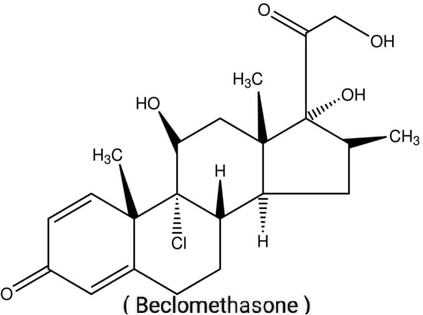

## Mast Cell Stabilizers :

Cromolyn, nedocromil cromolyn and nedochromil are inhalation means suppressing bronchial inflammation. Both medications are used quickly to prevent asthma in patients with moderate asthma. Its anti-inflammatory effect is lower than glucocorticoids. Cromorin: Cromorin is a very safe and effective drug for preventing asthma, but it does not help reset ongoing attacks. Administration is performed through inhalation and effects on the lungs, and cromolyn suppresses inflammation. It's not a bronchodilator.

Medicine functions in part by stabilizing the cytoplasmic membrane of mast cells, preventing the release of histamine and other mediators. Furthermore, cromolyn inhibits eosinophils,

macrophages, and other inflammatory cells. Cromolyn is administered by inhalation. The lung absorbed fact is small (approximately 8%), producing a whole body effect and is not altered in the urine.

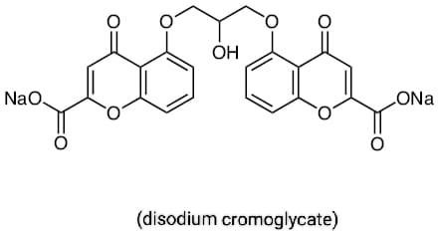

## Anti-IgE antibody :

Omalizumab is a humanized anti-human antibody. In Japan, Omalizumab is available for the following asthma patients: (i) Patients suffering from unstable asthma symptoms, even when treated with high doses from ICSS and treated with high doses with one or more controllers.

(ii) People who test positive for multi-year inhaled antigens such as those used as dust in the household. (iii) The dose and frequency of administration are determined based on the dosage table according to the patient's weight and serum-IgE level (30e1500 IU/mL serum IgE).

Omalizumab has the following benefits in patients with low asthma control despite treatment for high ICS: (i) Prevents degradation. (ii) Reduced the frequency of asthma symptoms.(iii) Improve QOL. (iv) Frequency of emergency rooms Reduce visits and hospital intrusions. (v) Reduce steroid doses.

Omalizumab conservatively improves FEV1 and PEF values. Inadequately managed patients treated with ICS/LABA were confirmed to be effective. Omalizumab should be used as a treatment for Step 4 for severe persistent asthma. After 16 weeks of administration, the effectiveness of the treatment can be comprehensively assessed and it is necessary to determine whether the need for treatment continued. [ 58,59,60]

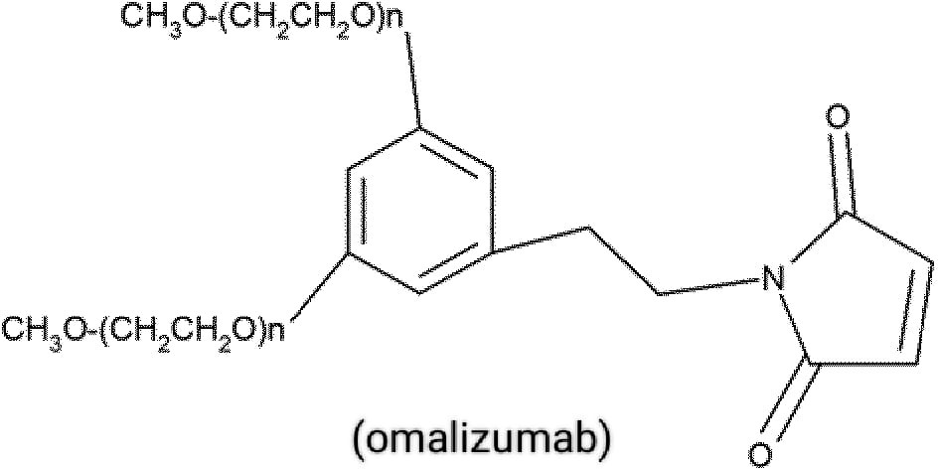

## Conclusion :

Airway inflammation, a prominent feature in asthma, needs to be targeted with effective medication. Inhaled corticosteroids play a vital role in combating airway inflammation and control of bronchial asthma. Although additional anti-inflammatory, leukotrienes modifires , mast cell stabilizer and bronchodilator treatment is needed as per patients conditions and severity of asthma. As we learn more about asthma pathophysiology and the various inflammatory phenotypes may make it possible to target drug therapy to the various pathways of the disease, even may help in development and implementation of an optimal strategy for its management and prevention.

## References :

1. Löwhagen O (2015) Diagnosis of asthma–new theories. J Asthma 67(6):713–717. https:// doi. org/ 10. 3109/ 02770 903. 2014. 991971
2. Stein SW, Thiel CG (2017) The history of therapeutic aerosols: a chronological review. J Aerosol Med Pulm Drug Deliv 30(1):20–41. https:// doi. org/ 10. 1089/ jamp. 2016. 1297
3. Bergmann KC (2014) Asthma. Chem Immunol Allergy 100:69–80. https:// doi. org/ 10. 1159/ 00035 8575
4. Satoskar RS, Bhandarkar SD and Rege NN. Pharmacology and pharmacotherapeutics. Popular prakashan. Mumbai. 2009; 21sted: pp. 353.
5. Rang HP, Dale MM and Ritter JM. Rang & Dale’s Pharmacology. Churchill Livingstone Elsevier. China. 2007; 6th ed: pp. 358-359.
6. M Ichinose, et al. Japanese guidelines for adult asthma. Allergology International. 2017; 66: 163-189.
7. Sami Manzoor, et al. To Compare the Efficacy of Doxophylline from Theophylline in Asthma. Journal of Clinical and Diagnostic Research. 2015; 9: FC05-FC08.
8. TripathiKD. Essentials of medical pharmacology. Jaypee brothers publisher. New Delhi. 2008; 6thed: pp. 93-116.
9. Budhiraja RD. Elementary pharmacology and toxicology. Popular prakashan. Mumbai. 2009; 4thed: pp. 221-227.
10. Johnson M. Beta2-adrenoceptors: mechanisms of action of beta2- agonist. Paediatric Respiratory Reviews. 2 (1); 2001: 57-62.
11. Johnson M. Molecular mechanisms of beta2-adrenergic receptor function, response, and regulation. Journal of Allergy and Clinical Immunology. 117(1); 2006: 18-24.
12. Lewis RA et al. Formation of slow-reacting substance of anaphylaxis in human lung tissue and cells before release. The Journal of Experimental Medicine. 140(5); 1974: 1133-1146.
13. Satoskar RS, Bhandarkar SD and Rege NN. Pharmacology and pharmacotherapeutics. Popular prakashan. Mumbai. 2009; 21st ed: pp. 355-363.
14. Barar FSK. Essentials of Pharmacotherapeutics. S. Chand & company. New Delhi. 2011; 6th ed: pp. 544-547.
15. Ullman A and Svedmyr N. Salmeterol, a new long acting inhaled beta2adrenoreceptor agonist: comparison with salbutamol in adult asthmatic patients. Thorax. 43(9); 1988: 674- 678.
16. Fitzpatrick MF et al. Salmeterol in nocturnal asthma: a double blind, placebo controlled trial of a long acting inhaled beta 2 agonist. British Medical Journal. 301(6765); 1990: 1365-1368.
17. Green CP and Price JF. Prevention of exercise induced asthma by inhaled salmeterol xinofoate. Achives of Disease in Childhood. 67(8); 1992: 1014-1017.
18. Ducharme FM et al. Addition of long-acting beta2-agonists to inhaled corticosteroids versus same dose inhaled corticosteroids for chronic asthma in adults and children. Cochrane Database of Systematic Reviews. 12(5); 2010: CD005535.
19. Fanta CH. Asthma. New England Journal of Medicine. 360(10); 2009: 1002-14.
20. Cates CJ and Cate MJ. Regular treatment with salmeterol for chronic asthma: serious adverse events. Cochrane Database of Systematic Reviews. 16(3); 2008: CD006363.
21. FDA Drug Safety Communication: New safety requirements for long-acting inhaled asthma medications called Long-acting beta-agonists (LABAs). FDA. Feb 2010. <http://www.fda.gov/> Drugs/DrugSafety/PostmarketDrugSafetyInformationforPatientsandProviders/ucm213836.h tm.
22. Barnes PJ. Muscarinic receptor subtypes in airways. Life Sciences. 52(5-6); 1993: 521-527.
23. Chapman KR. History of anticholinergic treatment in airways disease. In Gross NJ, ed. London. Franklin Scientific Publications Ltd. 1993. pp. 9-17.
24. Scullion JE. The development of anticholinergics in the management of COPD. International Journal of Chronic Obstructive Pulmonary Disease. 2(1); 2007: 33-40.
25. Rodrigo G, Rodrigo and Burschtin O. A meta-analysis of ipratropium bromide in adults with acute asthma.The American Journalof Medicine. 107(4); 1999: 363-370.
26. GINA (Global Initiative for Asthma) 2012. pp. 37.
27. Stoodley RG, Aaron SD and Dales RE. The role of ipratropium bromide in the emergency management of acute asthma exacerbation: a meta-analysis of randomized clinical trials. Annals of Emergence Medicine. 34(1); 1999: 8-18.
28. Plotnick LH and Ducharme FM. Combined inhaled anti-cholinergics and beta2-agonists for initial treatment of acute asthma in children. Cochrane Database of Systematic Reviews. 4; 2000. CD000060.
29. Barnes PJ. The pharmacological properties of tiotropium. Chest. 117(2 suppl); 2000: 63-66.
30. Barnes PJ and Pauwels RA. The theophylline in the management of asthma: time for reappraisal? European Respiratory Journal. 7(30); 1994: 579-591
31. Bele V. Pharmacology. Career publications. Nashik. 2008; 1st ed: pp. 223.
32. Golan DE, Tashjian AH, Armstrong EJ and Armstrong AW. Principles of pharmacology: the pathophysiologic basis of drug therapy. Lippincott Williams & Wilkins. Philadelphia. 2008.2nded: pp. 830-836.
33. Barnes PJ, Greening AP, Neville L, Timmers J, Poole GW. Single dose slow-release aminophylline at night prevents nocturnal asthma. Lancet. 1(8267); 1982: 299-301.
34. Lipworth BJ. Leukotriene-receptor antagonists.Lancet. 353(9146); 1999: 57-62.
35. Zuzana D, Eva M and Leif B. Montelukast in the treatment of asthma and beyond. Expert Review of Clinical Immunology. 5(6); 2009: 639-658.
36. Philip G et al. Protection against exercise-induced bronchoconstriction two hours after a single oral dose ofmontelukast. Journal of Asthma. 44 (3); 2007: 213-217.
37. Dahlen SE et al. Improvement of aspirin-intolerant asthma by Montelukast, a leukotriene antagonist: a randomized, double- blind, placebo-controlled trial.American Journal of Respiratory and Critical Care Medicine. 165(1); 2002: 9-14.
38. Diamant Z et al. the effect of montelukast (MK-0476), a cysteinyl leukotriene receptor antagonist, on allergen-induced airway responses and sputum cell counts in asthma. Clinical & Experimental Allergy. 29(1); 1999: 42-51.
39. Leff JA et al. Montelukast, a leukotriene-receptor antagonist, for the treatment of mild asthma and exercise-induced bronchoconstriction. The New England Journal of Medicine.339 (3); 1998: 147-152.
40. Villaran C et al. Montelukast versus salmeterol in patients with asthma and exercise- induced bronchoconstriction. The Journal of Allergy and Clinical Immunology. 104(3.1); 1999: 547-553.
41. Edelman JM et al. Oral montelukast compared with inhaled salmeterol to prevent exercise- induced bronchoconstriction. Annals of Internal Medicine. 132(2); 2000: 97-104.
42. Storms W et al. A comparison of the effects of oral montelukast and inhaled salmeterol on response to rescue bronchodilatation after challenge. Respiratory Medicine. 98(11); 2004: 1051-1062.
43. Bell RL et al. The discovery and development of zileuton: an orally active 5-lipoxygenase inhibitor. International Journal of Immunopharmacology. 14(3); 1992: 505-510.
44. Israel E et al. The effect of inhibition of 5-lipoxygenase by zileuton in mild to moderate asthma. Annals of Internal Medicine. 119(11); 1993: 1059-1066.
45. Wenzel SE et al. Effect of 5-lipoxygenase inhibition on bronchoconstriction and airway inflammation in nocturnal asthma. American Journal of Respiratory and Critical Care Medicine. 152(3); 1995: 897-905.
46. Israel E et al. Effect of treatment with zileuton, a 5- lipoxygenase inhibitor, in patients with asthma. The Journal of the American Medical Association. 275(12); 1996: 931-936.
47. Krawiec ME and Wenzel SE. Use of leukotriene antagonist in childhood asthma. Current Opinion in Pediatrics. 11(6); 1999: 540-554.
48. Jamaleddine G et al. Leukotriene antagonists and the Churg- Strauss syndrome. Seminars in Arthritis and Rheumatism. 31(4); 2002: 218-227.
49. Wechsler ME et al. Churg-Strauss syndrome in patients receiving montelukast as treatment for asthma. Chest. 117(3); 2000: 708-713.
50. WebMd. Asthma Health centre. Inhaled corticosteroids for long-term control of asthma. March 2011. Available from:<http://www.webmd.com/asthma/inhaled-corticosteroids-for-> long-term-control-of-asthma.
51. Expert Panel Report 3: Guidelines for the Diagnosis and Management of Asthma. National Institutes of Health (2007). National Asthma Education and Prevention Program.NIH Publication No. 08-5846. pp. 216-220. Available from:http:/[www.nhlbi.nih.gov/guidelines/asthma/index.htm.](http://www.nhlbi.nih.gov/guidelines/asthma/index.htm)
52. Schlienger RG et al. Inhaled corticosteroids and the risk of adult fractures in children and adolescents. Pediatrics. 114(2); 2004: 469-473.
53. Juniper EF et al. Effect of long-term treatment with an inhaled corticosteroid (budesonide) on airway responsiveness and clinical asthma in nonsteroid dependent asthmatics. The American Review of Respiratory Disease. 142(2); 1990: 832-836.
54. Haahtela T et al. Comparison of a β2-agonist, terbutaline, with an inhaled corticosteroid, budesonide, in newly detected asthma.The New England Journal of Medicine. 325; 1991: 388-392.
55. Evans DJ et al. A comparison of low-dose inhaled budesonide plus theophylline and high- dose inhaled budesonide for moderate asthma. The New England Journal of Medicine.337; 1997: 1412-1418.
56. Laviolette M et al. Montelukast added to inhaled beclomethasone in treatment of asthma. American Journal of Respiratory and Critical Care Medicine. 160; 1999: 1862- 1868.
57. Rang HP, Dale MM and Ritter JM. Rang & Dale’s Pharmacology. Churchill Livingstone Elsevier. China. 2007; 6th ed: pp. 364.
58. MH Smolensky, et al. Chronobiology and chronotherapy of allergic rhinitis and bronchial asthma. Advanced Drug Delivery Reviews. 2007; 59: 852-882.
59. 34. B Ding and M Small. “Disease burden of mild asthma: findings from a cross-sectional real-world survey,” Advances in, erapy. 2017; 34: 1109-1127.
60. 35. Buhl R, Berdel D, Criee C-P, Gillissen A, Kardos P, Kroegel C, et al. Leitlinie zur Diagnostik und Therapie von Patienten mit Asthma. Pneumologie. 2006; 60: 139-183.