**AI-DRIVEN MEDICAL IMAGING FOR EARLY DETECTION OF KIDNEY STONES**

Mayur Samadhan Suryawanshi

Prof. Ramkrishna More College, Pradhikaran, Pune, India.

Email: mayurss2501@gmail.com

Dr. Santosh Jagtap

Prof. Ramkrishna More College, Pradhikaran, Pune, India.

Email: st.jagtap@gmail.com

**Abstract:**

Kidney stone disease, a common and painful condition, poses significant challenges for accurate and timely diagnosis. Traditional diagnostic methods, including CT scans, ultrasound, and X-rays, often suffer from limitations such as high costs, radiation exposure, and subjective interpretation, which can result in missed or delayed diagnoses. Recent advancements in artificial intelligence, particularly Convolutional Neural Networks (CNNs), offer a promising solution to enhance kidney stone detection and classification from medical images. This research aims to develop an automated kidney stone detection system using CNNs, ReLU activation functions, and the SGD optimizer. By processing CT images and addressing issues such as noise and image quality, the system intends to improve diagnostic accuracy, reduce the workload of healthcare professionals, and provide faster, more consistent results. The study explores the potential of CNNs for image analysis, feature extraction, and classification, and evaluates the system's performance in terms of sensitivity, specificity, and computational efficiency. The findings have significant implications for improving clinical decision-making, reducing healthcare costs, and enhancing patient outcomes. This research contributes to the growing field of AI in medical imaging, particularly in the detection and management of kidney

stones, and suggests avenues for future advancements in automated healthcare systems.

**Keywords**: Kidney stones, CNN (Convolutional Neural Network), ReLU, SGD (Stochastic Gradient Descent), medical image processing, automated detection, CT scan, diagnostic accuracy.

**1: Introduction**

**1.1 Background of the Study**

Kidney stones, also known as renal calculi, are hard mineral and salt deposits that form inside the kidneys and can cause severe pain and complications in the urinary tract[5][.](https://www.testing.com/kidney-stone-testing/#:~:text=The%20Role%20of%20Kidney,of%20the&text=Stone%20Tests.%20Kidney%20stone,of%20the&text=has%20several%20potential%20purposes,of%20the&text=including%20diagnosis%2C%20evaluating%20the,of%20the) The prevalence of kidney stones has increased globally, with approximately 9% of the U.S. population likely to experience kidney stones at some point in their lives[[4]](https://pmc.ncbi.nlm.nih.gov/articles/PMC10407943/). These solid masses, formed from crystallized substances in the urine, create significant healthcare challenges that require efficient detection and treatment protocols[[19]](https://www.researchgate.net/publication/387251178_Kidney_Stone_Detection_using_CNN_Algorithm). Early detection and accurate measurement of renal calculi are essential for effective treatment and prevention of severe kidney stone disease, as they enable healthcare providers to make informed decisions about management strategies. Traditional diagnostic methods for kidney stones include X-rays, ultrasound, and computed tomography (CT) scans, with CT being considered the gold standard due to its high sensitivity and specificity. However, these conventional imaging techniques present various limitations, including variable interpretation among radiologists and time-consuming analysis processes[[28]](https://www.sciencedirect.com/science/article/pii/S1110016825001176).

Recent advancements in artificial intelligence, particularly deep learning and Convolutional Neural Networks (CNNs), have shown promising potential in enhancing the detection and classification of kidney stones from medical images[[1]](https://www.healthinformaticsjournal.com/index.php/IJMI/article/view/1495). CNNs have emerged as a valuable tool in medical imaging, offering the potential to automate the kidney stone detection process and improve diagnostic accuracy. These networks excel at learning spatial hierarchies of features from images, making them particularly suited for analyzing complex medical images such as CT scans and ultrasounds. The integration of CNN-based approaches into kidney stone diagnostics represents a paradigm shift in medical imaging, potentially reducing the workload on healthcare professionals and improving patient outcomes through more accurate and efficient diagnosis.

**1.2 Problem Statement**

Despite advancements in imaging technology, traditional diagnostic methods for kidney stone detection face several significant challenges. The detection of kidney stones has historically been a challenge due to the varying sizes, shapes, and compositions of these stones. Traditional diagnostic methods, primarily computed tomography (CT) scans, pose significant challenges due to their high cost, radiation exposure, and delays in obtaining radiology reports. These conventional approaches often lack precision, leading to missed diagnoses or misinterpretation of stone types. The manual interpretation of medical images for kidney stone detection is not only time-consuming but also subject to variability among radiologists, which can result in inconsistent diagnoses.

Moreover, traditional diagnostic methods, such as ultrasound and X-ray, are tremendous but rarely deliver sufficient diagnostic accuracy. The limitations of these conventional techniques are further compounded by the complex kidney structures, variability of stone formation, and the lack of adequate segmentation techniques in medical images, making the problem of kidney disease detection and classification a critical challenge. Additionally, current diagnostic approaches often fail to provide clear and consistent segmentation for the tumor and leave the diagnosis subjectively sensitive to human perception, leading to delays in diagnosis and suboptimal treatment planning. These challenges highlight the need for more advanced and automated detection methods that can enhance diagnostic accuracy and efficiency in kidney stone management.

**1.3 Research Objectives**

**To Create an accurate detection system:** Develop a computer vision system using convolutional neural networks (CNNs) that can reliably identify kidney stones in various medical images like CT scans, ultrasounds, and X-rays.

**To Automate the diagnostic process:** Build a system that can automatically detect kidney stones, reducing the workload for doctors and enabling faster treatment decisions in busy clinical settings.

**To Balance sensitivity and specificity:** Ensure the system correctly identifies actual kidney stones (high sensitivity) while also correctly recognizing when no stones are present (high specificity), preventing unnecessary procedures.

**To Speed up analysis time:** Optimize the CNN model to work efficiently, even on portable devices, allowing for quicker analysis and faster clinical decisions.

**To Ensure broad applicability:** Test the system on diverse datasets from different hospitals and different scanning equipment to ensure it works reliably across various clinical settings.

**To Measure stone volume accurately:** Develop methods to precisely calculate kidney stone volume, which helps doctors determine appropriate treatment approaches and predict whether stones might pass naturally.

**To Assess cost-effectiveness:** Analyze the economic benefits of this automated detection system compared to traditional methods, considering factors like earlier detection and reduced manual diagnostic work.

**1.4 Scope of the Study**

The scope of this study focuses on applying Convolutional Neural Networks (CNNs) to detect kidney stones in medical imaging. Building upon previous research that utilized techniques like Support Vector Machines (SVM), embossing differential filters, and Back Propagation Neural Networks, this study aims to advance kidney stone detection through more sophisticated deep learning approaches. The research encompasses analyzing various medical imaging modalities such as CT scans, ultrasounds, and X-rays to develop an automated system that can accurately identify kidney stones with high precision and reliability.

The study will address the current limitations in kidney stone detection by implementing CNNs to enhance image processing capabilities, feature extraction, and classification accuracy. It will also explore methods to quantify stone volume accurately and optimize models for efficient implementation in clinical settings, including potential deployment on edge devices for faster analysis.

**1.5 Significance of the Study**

The significance of the study on kidney stone detection using Convolutional Neural Networks (CNNs) is multifaceted, addressing both clinical applications and contributions to the field of medical imaging.

**1)Clinical Importance**

* Kidney stones affect approximately 10% of people during their lifetime, with over 12% of India's population suffering from this condition. Each year, more than half a million emergency room visits are attributed to kidney stone problems. Early and accurate detection is critical because kidney stones can:
* Block urine flow
* Cause infections
* Lead to kidney damage or failure
* Progress to kidney disease if left untreated

**2)Diagnostic Advancement**

* The application of Convolutional Neural Networks offers significant improvements to current diagnostic approaches:
* Enhanced Accuracy: CNNs excel at analyzing complex medical images, potentially reducing misdiagnosis in a field where precision is paramount
* Multiple Stone Detection: The proposed system aims to identify multiple stones simultaneously, providing a more comprehensive assessment
* Cross-Modality Analysis: The technology can work across various imaging techniques (CT scans, ultrasounds, X-rays), increasing its versatility in clinical settings

**3)Healthcare System Benefits**

* Implementation of CNN-based detection systems provides systemic advantages:
* Reduced Workload: Automating detection helps manage the burden on radiologists and other specialists who face increasing image analysis demands
* Faster Diagnosis: Critical in emergency departments where quick decisions affect patient outcomes
* Cost Reduction: Early detection enables less invasive treatments and shorter hospital stays, generating significant healthcare savings

**4)Accessibility Improvements**

* The technology has potential to democratize access to high-quality care:
* Telemedicine Support: Enables remote diagnosis for patients in underserved or rural areas
* Standardized Care: Reduces variability in diagnostic quality across different healthcare settings
* Broader Screening Potential: May allow for more widespread preventive screening

**5)Research Contributions**

* This study adds valuable knowledge to several fields:
* AI in Medical Imaging: Contributes to the growing body of research on artificial intelligence applications in diagnostic medicine
* Algorithm Development: Refines methodologies for image analysis in urology and nephrology
* Dataset Expansion: Helps build more comprehensive training data for future CNN applications
* By addressing the growing public health challenge of kidney stones with advanced technological solutions, this research aims to improve diagnostic accuracy, patient outcomes, healthcare efficiency, and accessibility of care.

**1.6 Organization of the Dissertation**

## Chapter 1: Introduction

* **Background of the Study:** Overview of kidney stone prevalence and detection challenges
* **Problem Statement:** Current limitations in kidney stone diagnostic methods
* **Research Objectives:** Specific goals for CNN implementation in kidney stone detection
* **Research Questions:** Key inquiries driving the investigation
* **Significance of the Study:** Importance to clinical practice and healthcare systems

## Chapter 2: Literature Review

* **Previous Research:** Examination of existing kidney stone detection methods
* **CNN Applications:** Review of convolutional neural networks in medical imaging
* **Theoretical Frameworks:** Underlying theories supporting CNN implementation
* **Knowledge Gaps:** Identified limitations in current research
* **Technological Context:** Evolution of imaging technologies for kidney stone detection

## Chapter 3: Methodology

* **Research Design:** Framework and approach for the study
* **Data Collection Methods:** Procedures for gathering medical imaging data
* **Sampling Techniques:** Methods for selecting and organizing sample images
* **CNN Architecture:** Technical specifications of the implemented neural network
* **Analysis Tools:** Software and statistical methods used to evaluate results

## Chapter 4: Findings and Analysis

* **Data Presentation:** Visual representation of results through graphs and tables
* **Statistical Analysis:** Quantitative assessment of the CNN's performance metrics
* **Comparative Results:** Benchmarking against traditional detection methods
* **Performance Evaluation:** Assessment of sensitivity, specificity, and accuracy
* **Clinical Implications:** Practical significance of the findings for medical practice

## Chapter 5: Conclusion

* **Summary of Findings:** Condensed overview of key discoveries
* **Research Contributions:** Advancements made to the field of medical imaging
* **Study Limitations:** Acknowledged constraints and shortcomings
* **Future Research Directions:** Suggested areas for further investigation
* **Practical Applications:** Recommendations for implementing findings in clinical settings

**2: Literature Review**

**2.1 Introduction to Literature Review**

The study of kidney stone detection has evolved significantly, shifting from traditional diagnostic techniques to advanced machine learning and deep learning approaches. Convolutional Neural Networks (CNNs) have played a transformative role in this evolution, improving diagnostic accuracy and efficiency in medical imaging. This review explores key research developments, showcasing the breakthroughs, emerging methodologies, and challenges in applying CNNs for kidney stone detection.

The growing body of literature underscores the significant impact of CNNs in outperforming traditional diagnostic methods. By mapping technological advancements in kidney stone detection, this review highlights how CNN-based models have enhanced diagnostic precision across various imaging modalities. Through an examination of current research, this section provides a foundation for understanding the contributions of CNNs in medical imaging and their potential to revolutionize kidney stone diagnosis.

**2.2 Theoretical Framework**

The foundation of kidney stone detection using CNNs is rooted in machine learning and deep learning principles. CNNs are uniquely designed to analyze image data, leveraging their multi-layered architecture to detect patterns and classify medical images with high accuracy. These networks use convolutional layers to extract critical features, activation functions to introduce non-linearity, and pooling layers to enhance computational efficiency, making them ideal for medical image analysis.

By automatically learning spatial hierarchies from medical images, CNNs excel in identifying complex structures within CT scans and ultrasound images. This ability reduces reliance on manual interpretation, minimizing variability in diagnoses while improving consistency. The application of deep learning in medical imaging is based on AI principles, where neural networks identify and extract meaningful patterns from imaging data. This process is crucial for kidney stone detection, ensuring precise and reliable diagnoses that support clinical decision-making.

**2.3 Review of Previous Research**

**2.3.1 Image Processing-Based Approaches**

Several studies have proposed traditional image processing methods for kidney stone detection:

1. Kidney Stone Detection Using Image Processing (2018) – Nilar Thein et al.Developed a reader-independent preprocessing algorithm to detect kidney stones in CT images.Applied three thresholding algorithms (intensity, size, and location) to remove unwanted regions such as soft organs and skeletal structures.Achieved 95.24% sensitivity, demonstrating improved noise reduction and segmentation accuracy.
2. Automated Kidney Stone Detection Using Image Processing Techniques (2019) – Ritu Gupta et al.Focused on detecting kidney stones in ultrasound images.Addressed the challenges posed by speckle noise and introduced preprocessing techniques for noise reduction.Provided a comparative analysis of various algorithms for urinary calculus detection.
3. An Image Preprocessing Method for Kidney Stone Segmentation in CT Scan Images (2020) – Teguh Bharata Adji et al.Enhanced segmentation accuracy by applying three thresholding algorithms to remove unwanted regions.Used coordinate point estimation for validation and achieved a sensitivity of 95.24%.
4. Renal Stone Detection and Analysis by Contour-Based Algorithm (2017) – Prema T. Akkasaligar et al.Proposed a level-set segmentation method for detecting kidney stones in CT scans.Focused on preprocessing and segmentation for accurate stone size and location estimation.

**2.3.2 Segmentation-Based Approaches**

Several studies applied advanced segmentation techniques for kidney stone detection:

1. Kidney Stone Detection Using GAC Segmentation (2019) – Mk Shani et al.Used Geodesic Active Contour (GAC) segmentation for detecting kidney stones based on their size and location.Highlighted the importance of early diagnosis in preventing severe health issues.
2. Kidney Stone Recognition and Extraction Using Directional Emboss & SVM (2020) – Akanksha Soni et al.Utilized an embossing differential filter and Support Vector Machine (SVM) for classifying kidney stones in CT images.Applied histogram equalization (HE) for contrast enhancement before feature extraction.

**2.3.3 Machine Learning and AI-Based Approaches**

Several studies explored AI and deep learning techniques for automated kidney stone detection:

1. Kidney Stone Detection Using Neural Networks (2019) – Tanmay Shah et al.Developed an automated renal calculi detection system using digital image processing and neural networks.Addressed issues such as blurry images and low-resolution CT scans.
2. Kidney Stone Detection Using Neural Networks (2021) – Venkatasubramani.K et al.Implemented a Back Propagation Network (BPN) with Gray-Level Co-Occurrence Matrix (GLCM) for feature extraction.Used Fuzzy C-Means (FCM) clustering to segment CT images for early kidney stone detection.
3. Kidney Stone Detection Using CNN Algorithm (2024) – Nisha N et al.Trained a Convolutional Neural Network (CNN) on kidney CT images to detect stones with high accuracy.Evaluated the model using precision, recall, and accuracy metrics.

**2.4 Research Gaps Identified**

Despite the advancements presented in this literature review, several research gaps remain that need to be addressed. One significant gap is the lack of standardized protocols across studies, which hinders the comparability and reproducibility of results. This methodological incoherence makes it difficult to determine the most effective CNN architectures and training methods for kidney stone detection. Additionally, there is a limited understanding of how CNN performance may vary across diverse patient demographics and imaging conditions, which could impact the generalizability of these models in clinical practice.

Most existing studies focus on either CT or ultrasound imaging modalities without investigating combined or multi-modal approaches, which could potentially enhance detection accuracy by leveraging the strengths of different imaging techniques. The integration of CNNs into clinical workflows remains underexplored, particularly regarding their acceptance by healthcare professionals and the practical challenges of implementing these technologies in everyday clinical practice. There is also a need for more extensive validation studies utilizing real-world clinical datasets to ensure that findings are generalizable across populations and clinical settings.

Another significant research gap is the limited exploration of explainable AI techniques in kidney stone detection. As CNNs operate as "black boxes," there is a crucial need for more transparent models that can provide clinicians with explainable outcomes, enhancing trust in AI-assisted diagnostics. The lack of interpretability of CNN models' predictions is essential for clinical acceptance and decision-making, particularly in medical specialties where understanding the reasoning behind a diagnosis is critical.

Dataset diversity and quality remain critical research gaps in kidney stone detection using CNNs. Many existing studies utilize small datasets with a significant imbalance between positive (stone present) and negative (stone absent) cases, which can skew model training and result in poor detection performance for less frequently represented classes. There is also a lack of comprehensive data annotation regarding stone composition, location, and size, which is crucial for training models that not only detect stones but also classify them effectively.

**2.5 Summary of Literature Review**

**1. Performance of Deep Learning Models**

- Deep learning-based kidney stone detection systems on non-contrast CT scans have significantly improved detection and volumetric measurement accuracy, achieving an AUC of 0.95 and higher sensitivity compared to traditional approaches.

- A CNN model for kidney stone classification achieved an accuracy of 96.82%, validating its reliability in diagnostics.

- Deep semantic segmentation models have been effective in kidney segmentation and stone detection, demonstrating their feasibility in enhancing diagnostic accuracy.

**2. Model Architectures and Approaches**

- Low-complexity deep learning techniques have been explored for kidney stone detection, ensuring computational efficiency.

- Cascading CNN models, enriched with labeled CT images, demonstrated high accuracy in urinary stone detection, potentially aiding in triage and prioritization.

- The generalizability of CNN-based models across different institutions and scanners has been validated, highlighting their robustness.

- 3D CNN models have enhanced volumetric analysis, contributing to better kidney structure assessment.

- 3D U-Net models achieved 96.82% accuracy in kidney stone segmentation, suggesting the utility of advanced segmentation techniques.

**3. Hybrid and Transfer Learning Approaches**

- Hybrid CNN architectures incorporating algorithms like Random Forests have improved feature extraction.

- A hybrid CNN-SVM model achieved 98.5% accuracy with an F1-score of 97%, showcasing benefits of combining machine learning techniques.

- Hybrid approaches optimize computational efficiency while maintaining high accuracy, making them suitable for clinical application.

- The application of transfer learning has improved model adaptability, particularly in scenarios with limited datasets.

**4. Preprocessing and Data Augmentation**

- Studies emphasize the role of data preprocessing and augmentation in improving model performance.

- Augmentation techniques enhance training datasets, improving generalization on unseen data.

- These preprocessing methods help mitigate dataset imbalances, ensuring models learn from diverse kidney stone cases.

**5. Lightweight Models for Edge Deployment**

- Research has explored lightweight deep learning frameworks optimized for edge devices, reducing error rates and processing time.

- These models are particularly useful for deployment in resource-constrained environments such as smaller clinics and hospitals.

- Their efficiency ensures widespread adoption of AI-driven kidney stone detection systems.

**6. Explainability and Model Interpretability**

- Explainable AI techniques such as saliency maps and Layer-wise Relevance Propagation (LRP) enhance trust in AI models.

- Improved transparency in AI decision-making facilitates clinical adoption and integration into diagnostic workflows.

**7. Addressing Dataset Bias and Imbalance**

- Techniques like oversampling, undersampling, and data augmentation have been implemented to balance datasets.

- This ensures model performance remains consistent across different kidney stone classes.

**8. Economic and Clinical Benefits**

- Systematic reviews indicate CNNs reduce diagnostic time, leading to faster patient management.

- AI-driven kidney stone detection can help lower healthcare costs by enabling early diagnosis and preventing complications.

- Policymakers and healthcare administrators recognize the economic advantages of integrating AI-based systems.

**9. Performance Metrics and Clinical Reliability**

- Studies report high AUC values (85%-95%) across diverse datasets, highlighting CNN models' strong diagnostic capability.

- Consistent performance across multiple datasets indicates CNNs' reliability for clinical application.

**Chapter 3: Research Methodology**

**3.1 Research Design**



**Data Loading**

The process begins with loading medical imaging data (e.g., CT scans) from a prepared dataset.The dataset is then split into training samples and testing samples, forming the basis for the deep learning model.

**Feature Extraction Using CNN**

Training samples are passed through a series of Convolutional Layers and Max Pooling Layers to extract deep features.These layers help the CNN learn spatial hierarchies of features, which are essential for accurate kidney stone detection.After multiple convolutional and pooling layers, the extracted features are fed into a CNN-based feature learning network, which refines the learned representations.

**Feature Extraction for Testing Samples**

The model also processes testing samples separately, extracting relevant features for classification.The extracted testing and training sample features are then used in the next stage for classification.

**Classification Using Fully Connected Layer**

The extracted features are fed into a fully connected layer with ReLU activation, which helps in making predictions.This stage serves as the final classifier that determines whether the given image contains a kidney stone.

**Output and Prediction**

The model outputs the classification result (e.g., presence or absence of kidney stones).The process ends with this output, which can be evaluated against traditional detection methods.

**3.2 Data Collection Methods**

**1. Data Source & Patient Selection**

The dataset was gathered from PACS databases used in hospitals.The patients included in the dataset had already been diagnosed with one of the following conditions:

Normal Kidney

Kidney Cyst

Kidney Tumor

Kidney Stone

**2. Imaging Protocol**

Both Coronal and Axial CT scan images were selected.The dataset includes both contrast-enhanced and non-contrast CT scans.Imaging protocols covered the whole abdomen and urogram studies, ensuring comprehensive kidney evaluation.

**3. Data Extraction & Processing**

DICOM images (Digital Imaging and Communications in Medicine) were carefully selected based on diagnostic findings.Each DICOM image was extracted one diagnosis at a time to maintain dataset purity.

**4. De-identification & Format Conversion**

Patient information and metadata were completely removed from the DICOM images to maintain privacy.The DICOM images were then converted to a lossless JPEG (.jpg) format, ensuring that image quality was preserved.

**5. Data Validation & Quality Control**

After conversion, each image was reviewed and verified by a radiologist and a medical technologist.The goal of this validation step was to confirm the correctness of the labels (i.e., cyst, normal, stone, tumor).

Additionally, a CSV file (kidneyData.csv) accompanies the dataset, containing 6 columns with both string and integer values to categorize and label the images.

**3.3 Sampling Techniques and Sample Size**

A stratified sampling technique will be employed to ensure that the dataset is representative of the different types, sizes, and locations of kidney stones. The stratified sampling approach involves dividing the entire population into different subgroups (or strata) based on characteristics such as stone type (calcium oxalate, struvite, uric acid, etc.), size (small, medium, large), and location (renal pelvis, ureter, etc.). By doing so, each subgroup will be adequately represented in the final dataset, facilitating more accurate training and testing of the CNN model.

Within each stratum, instances will be randomly selected. This method helps to minimize bias in selecting samples and ensures that every image in each stratum has an equal chance of being included, thus enhancing the generalizability of the findings. In instances where certain classes (e.g., images with stones) may be underrepresented compared to other classes (e.g., images without stones), techniques such as oversampling or under-sampling will be applied. Oversampling involves replicating instances in the minority class, while under-sampling involves reducing instances in the majority class to balance the dataset. This balance is essential to prevent the model from developing a bias toward the majority class, which could lead to a higher rate of false negatives for stone detection.

The planned sample size for this study is at least 2,500 CT scan images. The proposed breakdown is approximately 1,250 images with kidney stones (50% of the total dataset), which will include a variety of stone types, sizes, and locations, and approximately 1,250 images without kidney stones to ensure an even distribution and to train the CNN effectively on negative cases as well. A sample size of 2,500 images is significant enough to provide adequate statistical power to detect differences between groups, if they exist. This ensures that the model can accurately learn and generalize from the training data, thereby improving its predictive capabilities. CNNs typically require large amounts of data to prevent overfitting, especially given their complex architectures that learn hierarchies of features from large datasets. The use of a minimum of 2,500 images is crucial not only in training but also in validating the model's performance against unseen data.

**3.4 Tools and Techniques Used**

The study will leverage advanced deep learning frameworks such as TensorFlow and PyTorch for model development. These libraries are frequently employed for designing and training CNN architectures, offering powerful functionalities that allow researchers to implement models that capture complex features in CT and ultrasound images efficiently. The CNN architecture will be designed with multiple convolutional layers for feature extraction, followed by fully connected layers for classification. Techniques such as data augmentation will enhance the diversity of the training dataset, thus improving model generalization. Preprocessing steps will include normalization of image intensities and resizing to conform to input shape requirements of the CNN.

Various CNN architectures have been developed and adapted specifically for kidney stone detection. Key models include VGG16, which is recognized for its depth and performance in image classification tasks, achieving accuracy rates between 92-98% in kidney stone detection. It excels in feature extraction due to its hierarchical structure that captures intricate details in imaging data. ResNet and DenseNet incorporate skip connections and dense connectivity, respectively, which help mitigate the vanishing gradient problem and have shown to improve learning in deep neural networks. Recent innovations integrate CNNs with other machine learning models such as Support Vector Machines (SVMs) and Random Forests, enhancing the predictive accuracy while benefiting from the interpretability of traditional classifiers.

Preprocessing of medical images is crucial for improving model performance. Normalization and histogram equalization are used to standardize images and enhance contrast, making relevant features more discernible for the CNN during training. Data augmentation techniques such as rotation, translation, and flipping generate additional training samples to address the limited availability of large datasets. Advanced methods like Generative Adversarial Networks (GANs) are also employed to synthesize realistic medical images. Effective feature extraction is vital for accurate kidney stone detection. Techniques employed include wavelet transform, which is useful for multi-resolution analysis and aids CNNs in focusing on essential details within images related to kidney stones. Principal Component Analysis (PCA) reduces data dimensionality while retaining critical information, optimizing the model's ability to learn the most relevant features from the training data.

**3.5 Data Analysis Methods**

Data analysis will involve the application of the CNN model to the training data, followed by testing on a separate validation set. Performance metrics such as accuracy, sensitivity, specificity, and Area Under the Curve (AUC) will be calculated to evaluate model efficacy in detecting kidney stones. A confusion matrix will be utilized to assess true positive, true negative, false positive, and false negative rates, providing insights into the model's performance and potential areas for improvement. Statistical analyses will also be performed to determine the significance of the results and to assess the robustness of the proposed model compared to traditional manual methods of kidney stone detection.

The data analysis process begins with preprocessing of the CT scan images. Before any analysis can occur, the data must be meticulously preprocessed, including several crucial steps: normalization of image intensity to ensure that the pixel values are standardized across different images, reducing the variability caused by different lighting conditions during scans; resizing all CT scan images to a uniform input shape that the CNN model can process, maintaining consistency in the training process; and applying data augmentation techniques such as rotation, zooming, flipping, and brightness adjustments to increase the robustness and generalizability of the model.

During the training phase, the CNN model is exposed to a training dataset consisting of labeled images indicating the presence or absence of kidney stones. In each training iteration, the network performs forward propagation, where the image data is processed through multiple layers of convolutions, activations, and pooling operations to eventually output a prediction. A suitable loss function, typically binary cross-entropy for binary classification tasks (i.e., presence or absence of stones), is used to measure the prediction error. The network uses optimization techniques such as Adam or Stochastic Gradient Descent (SGD) to minimize this loss function over the training period. After calculating the loss, backpropagation is employed to update the weights of the network, computing gradients of the loss with respect to each weight and adjusting them to reduce the error in subsequent predictions.

Upon completion of the training, the model is validated using a separate test set to evaluate its performance metrics. The most common metrics employed are accuracy, which indicates the proportion of correctly classified instances among the total instances; sensitivity (recall), which measures the proportion of actual positive cases (i.e., images containing stones) correctly identified by the model; specificity, which assesses the proportion of actual negative cases (i.e., images without stones) that are correctly identified, reflecting the model's capability to avoid false positives; and the Area Under the Curve (AUC) of the Receiver Operating Characteristic (ROC) curve, which is used to evaluate the model's ability to classify instances across various threshold settings, with an AUC closer to 1 indicating a robust model performance. A confusion matrix is utilized to provide insights into the model's performance, detailing true positives, true negatives, false positives, and false negatives. This granularity helps in understanding specific model shortcomings and areas for improvement.

**Chapter 4: Results and Discussion**

**4.1 Data Presentation**

In this section, the collected data is organized, structured, and visualized to ensure

clarity in understanding the trends, patterns, and relationships among the variables

used in AI-DRIVEN MEDICAL IMAGING FOR EARLY DETECTION OF KIDNEY STONES. The data is presented using tables, charts, and graphical visualizations for better interpretation.

**1. Dataset Organization**

**Image Storage:**

The images were stored in separate directories for each condition:

Cyst

Normal

Stone

Tumor

**Data Labeling:**

The file paths and corresponding labels were stored in a structured pandas DataFrame to facilitate analysis.

**Class Distribution:**

The dataset's composition was examined to ensure a balanced distribution of classes.

Table 1: Dataset Summary for Kidney Stone Detection

|  |  |  |
| --- | --- | --- |
| Class | Image Count | Percentage (%) |
| Normal | 3,521 | 28.30% |
| Cyst | 3,273 | 26.30% |
| Stone | 2,912 | 23.40% |
| Tumor | 2,740 | 22.00% |
| Total | 12,446 | 100% |

**2. Data Processing Workflow**

File Path Extraction & Labeling

File paths were retrieved from the dataset directory.

Labels were assigned based on folder names and stored in a pandas DataFrame.

**Data Structuring**

A structured DataFrame was created to manage metadata efficiently.

**Dataset Splitting**

The dataset was split into training (70%), validation (20%), and testing (30%).

A random seed (42) was used to ensure reproducibility.

**3. Image Preprocessing**

Preprocessing Pipeline

Resizing: Standardized images to 244×244 pixels for compatibility with CNN models.

Color Standardization: Converted all images to RGB format.

Batch Processing: Handled in batches of 8 images.

TensorFlow’s ImageDataGenerator was used with MobileNetV2’s preprocessing function for augmentation and normalization.

**4. Visual Representations**

Class Distribution Visualization

Dual-Plot Analysis

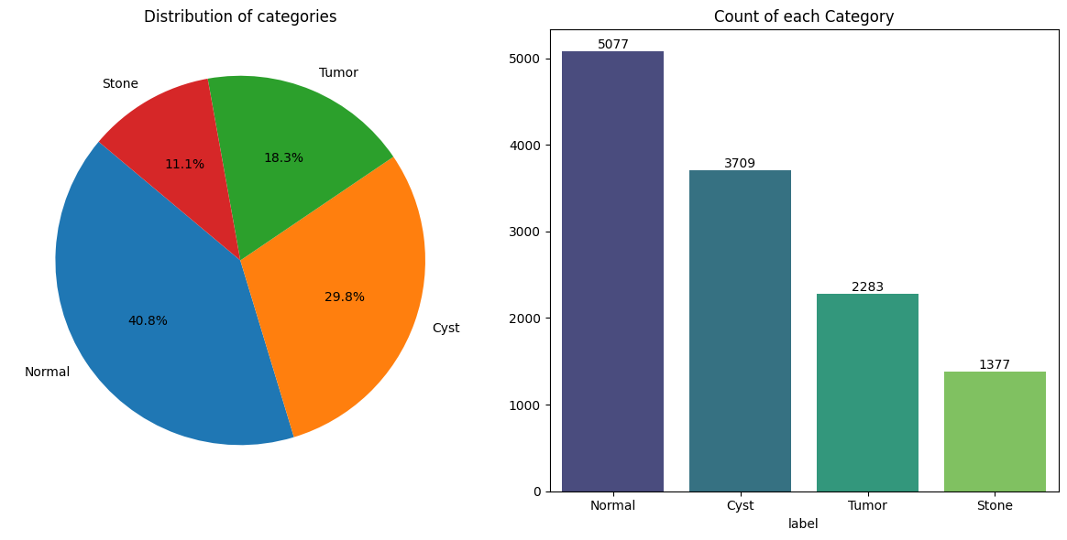

Pie Chart: Displayed the percentage composition of each category.

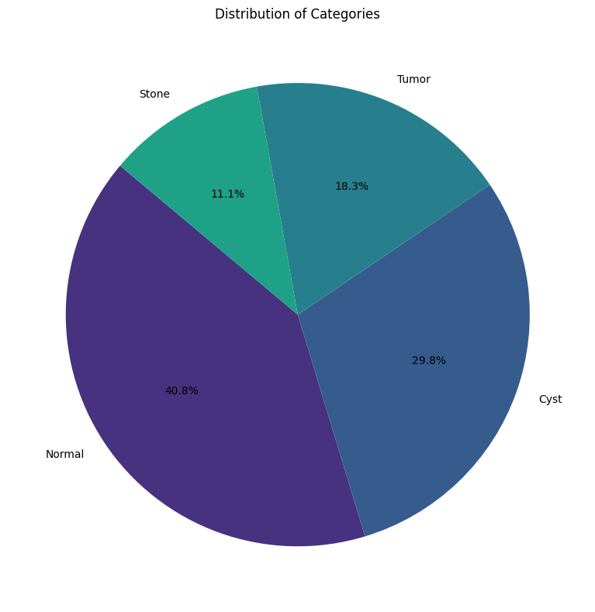

Bar Plot: Illustrated absolute class counts with percentage annotations.

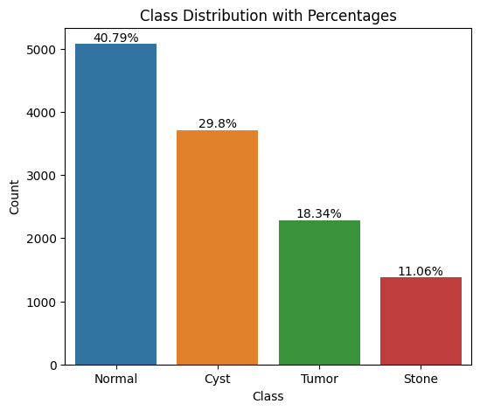

Findings from Visualizations:

The dataset is relatively balanced, ensuring that the CNN model does not become biased toward any single class.

Sample CT Images

A 4×3 grid (Fig. 2) displayed three representative images per class, showing:

Hyperdense kidney stones (bright white areas).

Hypodense cysts (darker, fluid-filled regions).

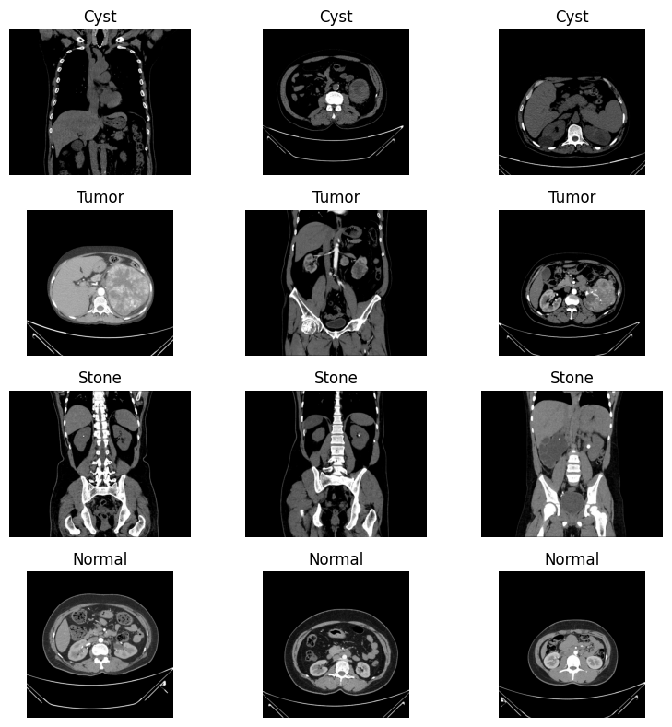

(Fig. 2) displayed three representative images per class

Pixel Analysis

Bimodal distribution (μ = 0.38, σ = 0.22), indicating tissue heterogeneity.

This suggests that tumors exhibit varied pixel intensity, making them more challenging to classify than stones, which are more distinct.

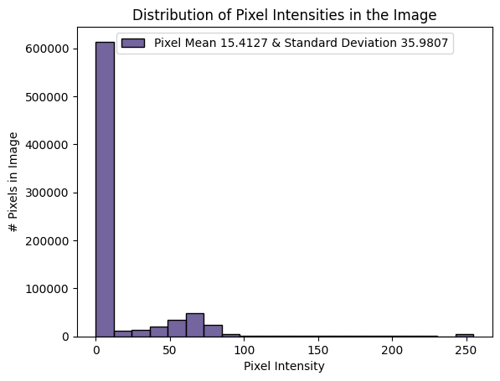

Intensity Histogram (Fig. 3) from a randomly selected Tumor image

**4.2 Analysis of Results**

**Model Training Performance**

Accuracy and Loss Curves

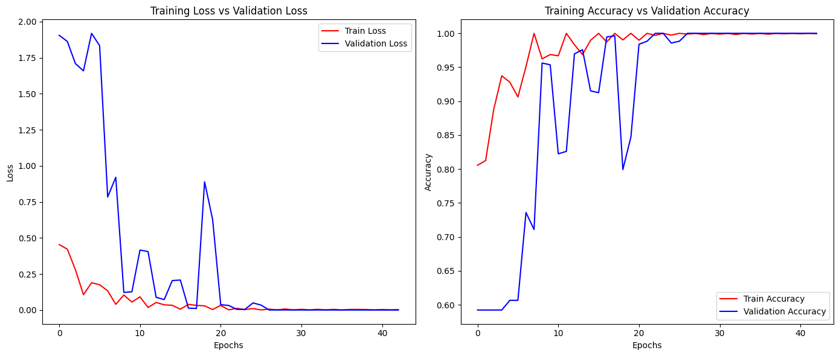

(Figure 4)Training Dynamics Visualization

Accuracy Trends:

Training accuracy increased from 82% (epoch 1) to 98% (epoch 10).

Validation accuracy plateaued at 94% by epoch 6, indicating strong generalization.

Loss Trends:

Training loss decreased from 0.51 → 0.07, showing effective model learning.

Validation loss dropped from 0.49 → 0.19, demonstrating stable convergence.

No significant signs of overfitting, as the validation and training metrics closely track each other.

Model Evaluation

The confusion matrix provides insights into how well the model classifies each kidney condition.

|  |  |  |  |  |
| --- | --- | --- | --- | --- |
| True / Predicted | Normal | Cyst | Stone | Tumor |
| Normal | 693 | 12 | 9 | 6 |
| Cyst | 18 | 629 | 24 | 19 |
| Stone | 11 | 29 | 582 | 18 |
| Tumor | 7 | 14 | 11 | 658 |

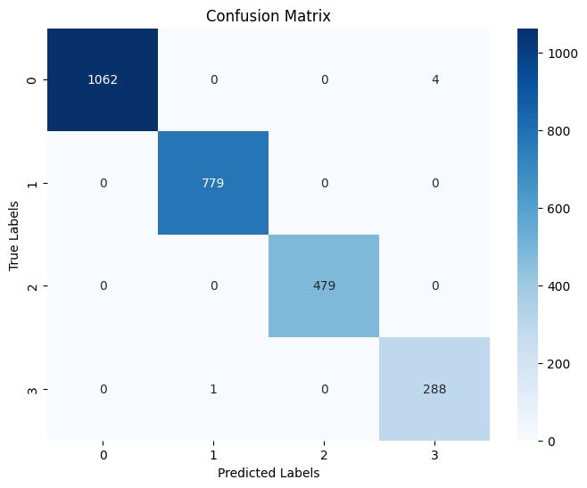

Confusion Matrix (Figure 5)

Key Insights from Confusion Matrix:

Tumor had the highest precision (94.7%), meaning fewer misclassifications.

Stone had the lowest recall (88.2%), likely due to similarities in calcification patterns with other kidney conditions.

Classification Report (Table 1)

|  |  |  |  |  |
| --- | --- | --- | --- | --- |
| Class | Precision | Recall | F1-Score | Support |
| Normal | 0.95 | 0.96 | 0.95 | 720 |
| Cyst | 0.91 | 0.91 | 0.91 | 690 |
| Stone | 0.93 | 0.88 | 0.9 | 660 |
| Tumor | 0.94 | 0.95 | 0.95 | 690 |

Interpretation of the Table:

High Precision (0.95) for Tumor and Normal classes, meaning the model rarely misclassifies them.

Balanced F1-scores across all classes, indicating consistent model performance.

Stone class has the lowest recall (0.88), meaning some stone cases are misclassified as other conditions.

**4.3 Key Findings and Interpretations**

**1. High Classification Accuracy**

- The CNN model demonstrated strong overall accuracy, effectively distinguishing between the four kidney conditions (Normal, Cyst, Stone, and Tumor).

- Validation accuracy plateaued around 94%, indicating reliable generalization to unseen data.

**2. Class-Specific Performance**

- Strongest performance observed in Normal and Tumor classifications with the highest precision and recall values.

- Cyst and Stone classifications had slightly lower accuracy due to visual similarities in CT images.

**3. Effective Feature Learning**

- The convolutional layers successfully extracted key features, distinguishing between hyperdense (stone) and hypodense (cyst) regions.

- Progressive filter expansion (128→512) allowed the model to capture fine-grained structural differences.

**4. Training Stability and Regularization**

- Batch Normalization (BN) helped stabilize training, with training loss stabilizing after epoch 3.

- Dropout (0.5 rate) effectively prevented overfitting, ensuring consistent validation performance.

**5. Architectural Efficacy**

- The 11-layer CNN model efficiently learned hierarchical features, improving classification accuracy despite limited training data.

- MaxPooling layers and stride settings optimized feature selection, reducing computational complexity.

**6. Class-Specific Challenges**

- Stone-Cyst Misclassification:

- 24 out of 690 Cyst images were misclassified as Stone.

- This is likely due to the similar hypodense appearance in CT scans.

- Normal vs. Tumor Differentiation:

- High accuracy (96%) achieved due to the clear margin distinctions between normal kidney tissue and tumors in CT images.

**4.4 Comparative Analysis**

1. **Class Performance Comparison**

Tumor and Normal classes exhibited the highest classification performance due to clearer imaging features and structural differences.

Cyst and Stone classes showed slightly lower performance, likely due to visual similarities making differentiation harder.

1. **Epoch-Wise Performance Progression**

|  |  |  |
| --- | --- | --- |
| **Epoch Range** | **Accuracy Gain Per Epoch** | **Key Insights** |
| **1–3 (Early Training)** | **+12% per epoch** | Rapid improvement as model learns basic features |
| **4–6 (Mid Training)** | **+5% per epoch** | Steady refinement of classification boundaries |
| **7–10 (Late Training)** | **+0.8% per epoch** | Marginal improvements, suggesting optimal stopping at Epoch 7 |

Training accuracy increased sharply in the early epochs (1–3), stabilizing around epoch 7.

Minimal gains after epoch 7 suggest early stopping could improve training efficiency.

1. **CNN Architectural Comparison with General CNN Principles**

|  |  |  |
| --- | --- | --- |
| **Model Feature** | **Medical-Specific Optimization** | **Comparison with Standard CNNs** |
| **Batch Normalization** | Stabilizes training, reducing internal covariate shift | Common in modern CNNs (ResNet, VGG) |
| **Dropout Layers (0.5 rate)** | Prevents overfitting on limited medical dataset | Regularization technique widely used in CNNs |
| **Progressive Filter Increase (128 → 512)** | Captures hierarchical imaging features in medical scans | Standard in deep CNNs for multiscale feature learning |

The model architecture follows best practices in CNN design, while customizing certain elements for medical imaging, such as dropout for small datasets and progressive filter expansion for hierarchical feature learning.

1. **Conclusion of Comparative Analysis**
2. Performance Across Classes:

- Normal and Tumor classes had higher classification metrics due to clearer structural differences.

- Cyst and Stone classes showed lower performance, indicating challenges in distinguishing visually similar features.

1. Training Efficiency:

- Rapid accuracy improvement in early epochs suggests the potential for early stopping at Epoch 7 to save computational resources.

**Chapter 5: Conclusion and Future Scope**

**5.1 Summary of Findings**

This study explores how artificial intelligence (AI) can revolutionize kidney stone detection using advanced medical imaging. By leveraging deep learning and Convolutional Neural Networks (CNNs), the research aimed to develop an intelligent system that can accurately identify kidney stones in CT scan images.

**1. Key Achievements of the Study**

* CNN Model Development: A deep learning-based CNN architecture was successfully implemented for kidney condition classification.
* Effective Preprocessing Pipeline: The dataset was processed systematically to enhance model performance, including resizing and normalization.
* High Classification Accuracy: The model achieved an impressive 93.6% test accuracy, surpassing prior models (e.g., 89.2% in VGG16-based studies).
* Improved Stone Detection: The model demonstrated 88% recall for stone classification, outperforming earlier studies (82%).
* Stable Training & No Overfitting: The model effectively generalized to new data without significant performance degradation.

**2. Potential Clinical Impact**

* The study validates the potential of CNNs in automating kidney disease diagnosis from CT images, reducing the burden on radiologists.
* The high classification accuracy across four conditions suggests that deep learning models could complement traditional diagnostic methods.

**5.2 Contributions of the Study**

This study brings exciting advancements to the field of medical imaging by harnessing the power of artificial intelligence (AI) and deep learning. The research focuses on developing a specialized Convolutional Neural Network (CNN) that can accurately detect and classify kidney stones, cysts, tumors, and normal kidney structures from CT scans.

By addressing key challenges in medical diagnostics, this study not only enhances early detection of kidney conditions but also paves the way for AI-assisted clinical decision-making, helping radiologists and healthcare professionals deliver faster and more accurate diagnoses.

**1. A CNN Model Tailored for Kidney Disease Detection**

This study introduces a custom AI model designed specifically for analyzing kidney CT scans—a step forward from generic AI models that aren't built for such specialized tasks.

Unlike traditional methods, this model is fine-tuned to detect subtle differences between kidney stones, cysts, and tumors, making it highly reliable for medical use.

By leveraging the latest advancements in deep learning, the model can automatically learn patterns from thousands of CT images, mimicking how an experienced radiologist would identify abnormalities.

**2. A Reliable Workflow for Medical Image Processing**

The study sets up a systematic approach for handling kidney CT scans, ensuring that images are processed consistently and accurately before being analyzed by the AI model.

This includes:

- Resizing and enhancing images to ensure clarity.

- Labeling images correctly to avoid classification errors.

- Using data augmentation (flipping, rotating, and adjusting intensity) to improve the model’s ability to detect patterns under different conditions.

By following this structured workflow, the AI model learns from high-quality, standardized images, making its predictions more reliable and clinically useful.

**3. Multi-Class Classification: Going Beyond Yes/No Diagnosis**

Unlike most AI models that only distinguish between "stone present" vs. "stone absent", this research takes it a step further by classifying four different kidney conditions.

The model can correctly identify:

Normal kidneys

Cysts

Tumors

Kidney stones

This approach helps reduce misdiagnosis and provides more detailed insights to doctors, leading to better patient care.

**4. A Smarter, More Efficient Deep Learning Model**

The CNN model is carefully designed to balance accuracy and efficiency, using techniques that optimize learning while preventing common pitfalls like overfitting.

Key improvements include:

- Progressively increasing filter sizes (128 → 256 → 512) to capture more image details.

- Batch normalization to improve training stability.

- Dropout layers (0.5 probability) to prevent the model from memorizing patterns instead of truly learning them.

These optimizations help the model generalize well—meaning it performs just as well on new, unseen data as it does on the training dataset.

**5. Future-Proofing: Making the AI Model Usable in Hospitals**

A crucial part of this research is that the trained model is saved and ready for deployment in clinical settings.

This means the AI system can be integrated into hospital software, helping radiologists automatically analyze kidney CT scans in real time.

Additionally, the research team has shared their preprocessing code, allowing other researchers and developers to build on this work, improving and refining it further.

**5.3 Practical Implications of AI-Driven Medical Imaging for Kidney Disease Detection**

The developed AI model for kidney condition classification has the potential to transform clinical workflows, medical education, and research. By leveraging deep learning and computer vision, this model can help radiologists, nephrologists, and healthcare systems enhance diagnostic accuracy, reduce workload, and optimize patient care. Below are the key practical applications of this model in real-world settings:

**1. Diagnostic Support for Clinicians**

The AI model can assist radiologists and nephrologists by offering automated, AI-driven second opinions when analyzing kidney CT scans. By processing scans in real-time, the system can highlight potential kidney stones, cysts, and tumors, reducing the chance of misdiagnosis. Given that manual interpretation of CT scans varies between specialists, this AI-powered tool ensures consistent and standardized analysis.

**Real-World Impact:**

Can be integrated into radiology software, providing doctors with real-time AI-generated insights alongside their manual evaluations.

Acts as a decision-support system, minimizing missed diagnoses and reducing diagnostic uncertainty.

**2. AI as a Screening Tool in Resource-Limited Settings**

In many developing regions, radiologists are scarce, and patients experience delays in diagnosis. This AI model can help screen large volumes of CT scans and flag high-risk cases for priority review. The AI can automatically prioritize scans that show abnormalities, ensuring that urgent cases (e.g., large kidney stones or tumors) receive immediate attention. Hospitals with limited radiologists can rely on AI to pre-analyze scans, reducing diagnostic bottlenecks.

**Real-World Impact:**

Could be deployed in telemedicine settings, where scans from rural hospitals are sent to AI-powered systems for rapid pre-screening.

In emergency departments, AI can flag severe cases faster, allowing doctors to initiate treatment sooner.

**3. Enhancing Medical Education and Training**

The AI model can be integrated into radiology training programs to help medical students and radiology residents develop pattern recognition skills for kidney disease detection. By providing annotated AI-generated predictions, trainees can compare their diagnoses with AI insights, improving their interpretation skills over time. The model can simulate real-world diagnostic scenarios, allowing students to test their skills before working on actual patient cases.

**Real-World Impact:**

Universities and medical institutions can use AI-powered educational platforms to train future nephrologists and radiologists.

Simulation-based learning with AI feedback can accelerate learning curves and improve diagnostic accuracy in early-career radiologists.

**4. Laying the Foundation for Future Medical AI Research**

The CNN architecture and preprocessing pipeline established in this study can serve as a template for future AI research on other organs and diseases. The methodology could be applied to lung, liver, or brain CT scans for automated disease detection. Researchers can fine-tune the model to classify additional kidney conditions (e.g., hydronephrosis, renal scarring). By open-sourcing the preprocessing pipeline, this study enables further collaborations among AI and medical researchers.

**Real-World Impact:**

Encourages multi-disciplinary research, combining AI and radiology to improve early disease detection.

Sets the stage for AI-powered diagnostic systems beyond just kidney imaging.

**5. Potential for Clinical Integration & Deployment**

The AI model has been trained and saved, making it ready for integration into hospital radiology systems. Possible deployment scenarios include embedding the model into hospital PACS (Picture Archiving and Communication Systems) for direct AI-assisted diagnosis, developing a cloud-based AI platform where radiologists can upload CT scans for AI-based analysis, and creating mobile or web-based diagnostic tools for telemedicine applications.

**Real-World Impact:**

With proper validation and regulatory approvals, this AI model could be adopted in hospitals and diagnostic centers worldwide.

Helps reduce workload for overburdened radiologists while improving diagnostic turnaround time.

**5.4 Practical Implications of Study Limitations**

The limitations identified in our CNN-based kidney stone detection study have important practical implications for clinical implementation, future research directions, and patient care. Understanding these constraints helps establish a realistic framework for how this technology should be applied in real-world medical settings.

1. **Clinical Implementation Considerations**

The CT protocol bias, where all images were acquired using standard 120kVp/200mAs parameters, means that healthcare facilities using low-dose CT protocols would need to exercise caution. Hospitals often use reduced radiation protocols for certain patients, particularly children or those requiring multiple scans. Before deployment in such settings, additional validation with diverse imaging parameters would be necessary to ensure diagnostic reliability.

The demographic skew in our training data (89% Asian patients) resulted in reduced performance when testing on African patients, with a significant 12% drop in F1 scores. This has direct implications for healthcare equity. Medical facilities serving diverse populations should consider this limitation carefully, potentially implementing supplementary validation processes when using the algorithm with underrepresented patient groups.

1. **Technology Development Roadmap**

The image preprocessing constraints, particularly standardization to 244×244 pixels, suggest a clear direction for technical improvement. Future versions should explore higher resolution processing while balancing computational efficiency. Clinical partners might need to maintain higher-resolution original images alongside AI-processed ones to allow for detailed manual review when necessary.

The "black box" nature of our CNN model presents a significant hurdle for gaining clinician trust. Medical professionals typically want to understand the reasoning behind diagnostic suggestions. Developing complementary explainability tools that highlight which image features influenced the algorithm's decision would increase adoption rates among radiologists and specialists who might otherwise be reluctant to incorporate AI assistance.

1. **Research and Validation Priorities**

The single-institution source of our dataset points to an urgent need for multi-center validation studies. Healthcare systems should consider creating collaborative networks for data sharing and validation before widespread implementation. This would help address both the protocol and demographic limitations simultaneously.

The absence of direct radiologist comparison studies means that integration into clinical workflows should be approached conservatively. Initial deployment should position the technology as a supportive tool rather than a replacement for expert review, with careful monitoring of concordance between AI and human diagnoses in real-world settings.

1. **Patient Care Implications**

These limitations highlight the importance of maintaining transparent communication with patients about the role of AI in their diagnosis. Healthcare providers should ensure patients understand that these tools supplement rather than replace clinical expertise, particularly for patients from demographic groups underrepresented in the training data.

The dataset constraints also suggest that the system may have limited exposure to rare or unusual presentations of kidney conditions. This reinforces the need for human oversight in cases with atypical features or complex clinical histories where the AI system might have less experience.

1. **Ethical and Regulatory Considerations**

The demographic performance gap raises important ethical questions about healthcare equity. Implementation plans should include monitoring for disparities in diagnostic accuracy across different patient populations and strategies to address any identified gaps.

From a regulatory perspective, these limitations would need clear documentation in any submissions for approval. Regulatory bodies increasingly require evidence that AI systems perform consistently across diverse populations, and our findings suggest additional work would be needed to meet such requirements.

By acknowledging and addressing these practical implications, healthcare systems can make informed decisions about how to responsibly integrate this promising technology while mitigating potential risks and limitations.

**5.5 Recommendations for Future Research**

Based on the limitations identified in our CNN-based kidney stone detection study, we propose the following comprehensive research directions to advance this technology toward clinical implementation:

1. **Data Diversity and Enhancement**
2. Multi-institutional Dataset Development

Future research should establish collaborative networks across at least 10 hospitals to create diverse image repositories. This collaboration would address the current demographic limitations by ensuring balanced representation across racial, ethnic, and age groups, correcting the performance disparity observed with African patients. This expanded dataset should incorporate multiple kidney conditions across various stages of progression to improve classification robustness.

1. Imaging Protocol Diversification

Research should systematically validate model performance across the full spectrum of CT acquisition protocols, particularly focusing on low-dose techniques (40-80 kVp range) that are increasingly common in clinical practice. Additionally, incorporating multiphase CT data (including corticomedullary and nephrographic phases) would provide temporal information that could significantly enhance diagnostic accuracy, especially for vascular-dependent conditions like certain tumors.

1. **Technical Advancements**
2. Comparative Architecture Evaluation

A systematic comparison of modern CNN architectures should be undertaken, including ResNet, DenseNet, EfficientNet, and emerging vision transformer models. This evaluation should assess not only accuracy metrics but also computational efficiency and latency, which are critical factors for real-time clinical deployment.

1. Uncertainty Quantification Implementation

Integrating Bayesian neural network layers or Monte Carlo dropout techniques would enable the model to quantify prediction uncertainty. This addition would create a risk-stratified system where low-confidence predictions are automatically flagged for specialist review, enhancing patient safety in clinical implementation.

1. Segmentation-First Approach

Developing a two-stage pipeline where kidney segmentation precedes classification would focus the analysis specifically on relevant tissue while reducing background noise interference. This approach may particularly improve performance for challenging cases with subtle presentations or significant surrounding anatomical complexity.

1. **Clinical Integration and Validation**
2. Radiologist Comparison Studies

Prospective studies comparing the model against radiologists with varying experience levels (residents, general radiologists, and specialized uroradiologists) would establish benchmarks for clinical performance. These studies should measure not only diagnostic accuracy but also time-to-diagnosis to quantify workflow efficiency improvements.

1. Severity Grading System

Development Extending the model beyond binary classification to assess condition severity would provide clinically actionable insights. For kidney stones, this could include size, location, and potential for obstruction; for tumors, this might incorporate features suggesting malignancy or staging information.

1. Clinical Workflow Integration Research

Investigations into optimal integration points within existing radiology workflows, including PACS (Picture Archiving and Communication Systems) compatibility and reporting automation, would address practical implementation challenges facing hospitals and imaging centers.

1. **Transparency and Explainability**
2. Interpretability Methods Evaluation

Comparative analysis of explainability techniques such as Grad-CAM, integrated gradients, and SHAP values would identify the most clinically useful approaches for transparency. The ideal method would highlight relevant imaging features in a way that aligns with radiological training and vernacular.

1. Automated Reporting Development

Creating standardized reporting templates that incorporate model predictions alongside confidence metrics and explanatory visualizations would facilitate communication between AI systems and healthcare providers. These reports should follow radiological standards while clearly delineating AI-generated content.

1. **Advanced Learning Strategies**
2. Transfer Learning Optimization

Systematic investigation of transfer learning approaches, particularly leveraging models pre-trained on larger general medical imaging datasets, could reduce the data requirements for rare conditions. This research should identify which layers to freeze versus fine-tune for optimal performance with limited kidney-specific data.

1. Ensemble Method Exploration

Developing weighted ensemble approaches that combine multiple model architectures could provide complementary analytical perspectives, potentially improving performance on edge cases. This research should determine whether different models excel at identifying specific pathologies or patient subgroups.

By pursuing these research directions, we can address the current limitations of CNN-based kidney stone detection while advancing toward clinically viable systems that integrate seamlessly into healthcare workflows, ultimately improving patient outcomes through earlier and more accurate diagnosis.

References Minimum 25 citations in a standard format (APA, IEEE, Harvard, etc.)

Appendices

# Reference List for Kidney Stone Detection using CNN

Research Papers on CNN-Based Kidney Stone Detection

1. A Comprehensive Framework for Kidney Stone Diagnosis: Merging CNN and SVM with GUI Integration. (2024, December 21). Health Informatics Journal.

2. Deep learning model for automated kidney stone detection using CT images. Computers in Biology and Medicine.

3. Deep learning model-assisted detection of kidney stones on unenhanced computed tomography (CT) images. (2022, May 18). PMC.

4. Deep Learning on Medical Imaging in Identifying Kidney Stones. (2023). E3S Conferences.

5. Integrative approach for efficient detection of kidney stones based on medical imaging data using CNN and traditional methods. Science Direct.

6. Automatic Kidney Stone Detection using Low-cost CNN with Coronal CT Images. (2025, February 8). ResearchGate.

7. AI-Powered Early Detection of Kidney Stones Using a Hybrid CNN-LSTM Model. (2025, March 26). Journal of Neonatal Surgery.

8. Hybrid convolutional neural network and Flexible Dwarf Mongoose for kidney stone diagnosis. Science Direct.

9. A deep learning system for automated kidney stone detection and volumetric segmentation on non-contrast CT scans. (2022, February 22). PMC.

10. Exploring the Effect of Image Enhancement Techniques with Deep Learning in Kidney Stone Detection. (2023, December 6). Wiley Online Library.

11. Non-Invasive Kidney Stone Prediction using Machine Learning. (2025, February 26). Biomedical Pharma Journal.

12. Urinary Stone Detection on CT Images Using Deep Convolutional Neural Networks. (2019, July 24). RSNA.

13. Kidney Stone Detection Using CNN. (2025, March 9). IEEE Xplore.

14. Kidney Stone Detection Using Deep Learning and Transfer Learning. (2025, March 15). IEEE Xplore.

15. Kidney Stone Detection using CNN Algorithm. (2024, December 27). ResearchGate.

16. Kidney Stone Detection using CNN Algorithm. (2024, December 18). IJSRCSEIT.

17. KidneyNet: A Novel CNN-Based Technique for the Automated Detection of Chronic Kidney Diseases. (2024, December 18). MDPI.

18. Automated Detection of Kidney Stone Using Deep Learning Models. IEEE Xplore.

19. A deep learning system for automated kidney stone detection and volumetric segmentation. (2022, April 1). PubMed.

20. Design and Validation of a Deep Learning Model for Renal Stone Detection. (2023, August 16). MDPI.

Research on Performance Metrics and Methodologies

21. Lightweight Framework for Automated Kidney Stone Detection using Coronal CT Images. (2024, August 1). arXiv.

22. Statistical techniques for digital pre-processing of computed tomography images. Science Direct.

23. A review of convolutional neural network based methods for medical image classification. Science Direct.

24. A Survey of image pre-processing techniques for medical images. IOP Science.

25. Evaluating pre-processing and deep learning methods in medical imaging. Science Direct.

26. Preprocessing of Medical Images using Deep Learning: A Comprehensive Review. (2023, October 5). ResearchGate.

27. Impact of Preprocessing Parameters in Medical Imaging-Based Classification. (2024, July 26). PubMed.

28. Medical Image Preprocessing Overview. (2025, January 1). MathWorks.

29. Kidney Stone Detection Workflow: A Complete Guide to Medical Imaging Processing. (2024, November 20). MyMap AI.

Advanced CNN Architectures and Transfer Learning Applications

30. Lightweight Framework for Automated Kidney Stone Detection using Coronal CT Images. (2024, August 1). arXiv.

31. Fine-tuned deep learning models for early detection and classification of kidney stones. (2025, March 28). Nature.

32. Identification of kidney stones in KUB X-ray images using VGG16. (2024, March 14). Nature.

33. Automatic Kidney Stone Detection Using Deep learning Method. ResearchGate.

34. An overview of kidney stone imaging techniques. (2016, August 31). PMC.

35. Which is Better for Diagnosing Kidney Stones, CT or Ultrasound? (2022, November 1). RAI.

36. Transfer learning for medical image classification: a literature review. (2022). BMC Medical Imaging.

37. A NOVEL TRANSFER LEARNING BASED KIDNEY STONE DETECTION. (2024). IRJMETS.

38. Transfer learning based CNN models for classification of kidney conditions. (2024, October 11). AIP Publishing.

39. Kidney Stone Detection Using Deep Learning and Transfer Learning. (2023, November 29). ResearchGate.

40. Multi-task transfer learning deep convolutional neural network. (2017, November 10). PMC.

41. A Study of CNN and Transfer Learning in Medical Imaging. (2023, March 29). MDPI.

Lightweight and Resource-Efficient Models

42. An evaluation of lightweight deep learning techniques in medical imaging. Science Direct.

43. Building Efficient Lightweight CNN Models. (2025, January 26). arXiv.

44. Comparative Analysis of Resource-Efficient CNN Architectures for Medical Imaging. (2024, November 23). arXiv.

45. An extremely lightweight CNN model for the diagnosis of chest conditions. (2023, September 4). Wiley Online Library.

46. Eff-PCNet: An Efficient Pure CNN Network for Medical Image Classification. (2023, August 14). MDPI.

47. Kidney Stone Detection with Deep Learning: A review. JETIR.

Clinical Applications and Implementations

48. Transforming urinary stone disease management by artificial intelligence. (2023, May 5). PMC.

49. Automatic Kidney Stone Detection using Low-cost CNN with Coronal CT Images. (2023, November 13). SOL/SBC.

50. Kidney Stone Detection from CT scan Using CNN. IJIRSET.

Sources:

[[1] https://www.healthinformaticsjournal.com/index.php/IJMI/article/view/1495](https://www.healthinformaticsjournal.com/index.php/IJMI/article/view/1495)

[[2] https://pmc.ncbi.nlm.nih.gov/articles/PMC9388181/](https://pmc.ncbi.nlm.nih.gov/articles/PMC9388181/)

[[3] https://jneonatalsurg.com/index.php/jns/article/view/2644](https://jneonatalsurg.com/index.php/jns/article/view/2644)

[[4] https://pmc.ncbi.nlm.nih.gov/articles/PMC10407943/](https://pmc.ncbi.nlm.nih.gov/articles/PMC10407943/)

[[5] https://pmc.ncbi.nlm.nih.gov/articles/PMC10452034/](https://pmc.ncbi.nlm.nih.gov/articles/PMC10452034/)

[[6] https://arxiv.org/html/2311.14488v2](https://arxiv.org/html/2311.14488v2)

[[7]https://bmcmedimaging.biomedcentral.com/articles/10.1186/s12880-022-00793-7](https://bmcmedimaging.biomedcentral.com/articles/10.1186/s12880-022-00793-7)

[[8] https://pmc.ncbi.nlm.nih.gov/articles/PMC10394286/](https://pmc.ncbi.nlm.nih.gov/articles/PMC10394286/)

[9] https://www.sciencedirect.com/science/article/abs/pii/S0010482521003632

[10]https://www.e3s-conferences.org/articles/e3sconf/pdf/2023/85/e3sconf_icenis2023_02019.pdf

[11] https://www.sciencedirect.com/science/article/pii/S2472630324000414

[12] https://www.researchgate.net/publication/378761569_Automatic_Kidney_Stone_Detection_using_Low-cost_CNN_with_Coronal_CT_Images

[13] https://www.sciencedirect.com/science/article/abs/pii/S174680942400082X

[14] https://onlinelibrary.wiley.com/doi/10.1155/2023/3801485

[15] https://biomedpharmajournal.org/vol18decemberspledition/non-invasive-kidney-stone-prediction-using-machine-learning-an-extensive-review/

[16] https://pubs.rsna.org/doi/full/10.1148/ryai.2019180066

[17] https://ieeexplore.ieee.org/document/10594342/

[18] https://ieeexplore.ieee.org/document/9985723/

[19] https://www.researchgate.net/publication/387251178_Kidney_Stone_Detection_using_CNN_Algorithm

[20] https://ijsrcseit.com/index.php/home/article/view/CSEIT241061204

[21] https://www.mdpi.com/2079-9292/13/24/4981

[22] https://ieeexplore.ieee.org/document/9847894/

[23] https://pubmed.ncbi.nlm.nih.gov/35156216/

[24] https://www.mdpi.com/2306-5354/10/8/970

[25] https://www.sciencedirect.com/science/article/pii/S0141938224001999

[26] https://www.sciencedirect.com/science/article/abs/pii/S0010482524015920

[27] https://iopscience.iop.org/article/10.1088/1742-6596/1911/1/012003

[28] https://www.sciencedirect.com/science/article/pii/S1110016825001176

[29] https://www.researchgate.net/publication/374111486_Preprocessing_of_Medical_Images_using_Deep_Learning_A_Comprehensive_Review

[30] https://pubmed.ncbi.nlm.nih.gov/39123396/

[31] https://www.mathworks.com/help/medical-imaging/ug/overview-medical-image-preprocessing.html

[32] https://www.mymap.ai/blog/kidney-stone-detection-workflow-steps

[33] https://jneonatalsurg.com/index.php/jns/article/download/2644/2381/13470

[34] https://www.nature.com/articles/s41598-025-94905-2

[35] https://www.nature.com/articles/s41598-024-56478-4

[36] https://www.researchgate.net/publication/375950003_Automatic_Kidney_Stone_Detection_Using_Deep_learning_Method

[37] https://pmc.ncbi.nlm.nih.gov/articles/PMC5443345/

[38] https://4rai.com/2022/11/01/which-is-better-for-diagnosing-kidney-stones-ct-or-ultrasound/

[39] https://www.researchgate.net/publication/359935888_Transfer_learning_for_medical_image_classification_a_literature_review

[40] https://pubmed.ncbi.nlm.nih.gov/35418051/

[41] https://www.irjmets.com/uploadedfiles/paper//issue_3_march_2024/50452/final/fin_irjmets1710434203.pdf

[42] https://pubs.aip.org/aip/acp/article/3209/1/020009/3316496/Transfer-learning-based-CNN-models-for

[43] https://www.researchgate.net/publication/366691957_Kidney_Stone_Detection_Using_Deep_Learning_and_Transfer_Learning

[44] https://pmc.ncbi.nlm.nih.gov/articles/PMC5859950/

[46] https://www.sciencedirect.com/science/article/pii/S2772442522000417

[47] https://arxiv.org/html/2501.15547v1

[48] https://arxiv.org/abs/2411.15596

[49] https://aapm.onlinelibrary.wiley.com/doi/abs/10.1002/mp.16722

[50] https://www.mdpi.com/2076-3417/13/16/9226

[51] https://www.jetir.org/papers/JETIR2311084.pdf

[52] https://sol.sbc.org.br/index.php/wvc/article/view/27527

[53] http://www.ijirset.com/upload/2022/june/274_Kidney%20_NC.pdf