**A Comprehensive Analysis of TDPCL: Trends, Challenges, and Innovations**

**Executive Summary**

The rapid advancement of intelligent materials and textile technologies has revolutionized the concept of clothing, enabling garments to adapt dynamically to environmental and physiological changes. This report explores the transformative potential of Temperature-Dependent Phase-Change Clothing (TDPCL), which integrates phase-change materials (PCMs) to provide real-time thermal regulation. By absorbing, storing, and releasing heat during phase transitions, TDPCL ensures optimal comfort across diverse climates and activities. The study delves into the technical, commercial, and sustainability aspects of this innovation, addressing key challenges such as inefficient temperature regulation, bulkiness, and environmental unsustainability in traditional clothing.

A comprehensive review of literature highlights cutting-edge advancements in thermoregulatory textiles, including passive radiative cooling systems, bilayer actuators, and engineered heat transfer pathways. These technologies demonstrate significant improvements in wearer comfort, energy efficiency, and scalability. However, research gaps persist in areas such as long-term durability under real-world conditions, usability during variable humidity and motion, and optimization for individual thermal needs.

The research methodology employs both experimental and computational approaches to analyze the performance of adaptive textiles. Findings reveal that TDPCL expands the thermal comfort zone by up to 6.5°C while reducing energy consumption in controlled environments by over 30%. Commercially, its applications span athletic wear, outdoor gear, travel apparel, and intimate wear, catering to a broad consumer base seeking sustainable and high-performance solutions.

This report concludes with strategic recommendations for product design and market penetration. It emphasizes the need for scalable manufacturing techniques, real-world usability testing, and integration with multifunctional features such as moisture-wicking and self-regulation. TDPCL represents a paradigm shift in smart fashion by combining technical innovation with sustainability principles, offering a viable pathway to address evolving consumer demands in the global apparel industry.

### **Introduction**

The rapid development of cloth technology and intelligent materials has offered opportunities for new concepts that challenge traditional notions of fashion and functionality. Clothing that responds to temperature fluctuations demonstrates a significant development in the integration of phase-change materials (PCMs) and heat-management materials with everyday garments. This study discusses how the new technologies can turn clothing into living systems that automatically adjust to body heat and surroundings.

The essence of this new idea lies in small PCMs, which can absorb, store, and release heat as temperatures change. When used in conjunction with sophisticated weaving technology, these materials play a dual role: they permit air to pass through during hot weather and retain heat in cold weather., they are able to pull water away from the skin and evaporate turning these fibers even more ideally suited for comfort and performance under a range of weather conditions and activities.

The value of this research, however, goes beyond its technical innovation to wider implications for sustainable fashion and lifestyle consumerism. As contemporary consumers increasingly seek high-performance yet sustainable clothing, Temperature-Adaptive Clothing presents an exciting solution. Its uses include athletic wear and travel clothing as well as sleepwear and intimate wear, with a wide-ranging target market among athletes, outdoor users, and those with specific temperature needs.

This report is designed to present a detailed analysis of Temperature-Adaptive Clothing. It first has an elaborate review of literature regarding smart textiles and phase-change materials, then a clear description of the research approach that was utilized. Following sections compare analyzed data, draw conclusions, and provide suggestions for future product design and market strategies. The culmination of the study attempts to corroborate the transformative power of adaptive wear as a sustainable, innovative solution within the rapidly changing realm of smart fashion.

### **1.1Literature Review**

Chai et al. (2022) introduce an innovative study of thermoregulatory clothing utilizing cutting-edge material science to produce dynamic personal thermal control. Within this research, the authors designed a bilayer actuator system by combining a polyethylene sheet with a very thin copper coat, taking advantage of the very large difference in thermal expansion of the two components. This design allows the actuator to quickly change the open area of the fabric: expanding to increase convective and evaporative cooling during warmer weather and contracting to reduce radiative heat loss when it is chilly. The methodology used is particularly extensive, employing experimental as well as computational methods. Thermal manikin trials were performed over a series of temperatures (15°C–35°C) to determine changes in thermal and moisture resistances, in line with actual human heat transfer circumstances. In addition, thermo-physiological modeling was used to extrapolate results to forecast enhancements in wearer comfort and possible HVAC energy savings. Results showed that the adaptive clothing successfully expands the thermal comfort zone by over 2°C in both the heating and cooling directions, with important energy-saving implications—calculating over 30% reduction of building energy consumption when implemented in indoor spaces. In summary, the research concludes that this novel, passive thermal control system not only increases individual comfort in response to varying external conditions but also provides a scalable, low-cost solution for sustainable thermal management in fabrics.

**Research Gap:**

In spite of the encouraging results presented, a number of research gaps exist. The investigation fails to fully investigate the long-term mechanical stability and durability of the metalized polyethylene actuators under repeated mechanical stress cycles, washing, and prolonged environmental exposure. Furthermore, although the controlled experimental conditions offer insight into the thermoregulatory performance, usability aspects under real-world conditions—such as the effect of different humidity levels, wind, and variable user motion—receive little or no attention. Subsequent research would need to test these adaptive mechanisms in real-life wear conditions, optimize the embedding of actuators into compliant clothing for better comfort and durability, and explore alternative materials that would maximize both performance and environmental stewardship.

Pakdel & Wang (2023) offer an in-depth exploration of how passive radiative cooling can be seamlessly integrated into textile systems to manage heat without any external energy sources. Their work centers on developing fibrous materials with tailored microstructures that are designed to both reflect and emit infrared radiation effectively. By manipulating factors such as fiber composition, diameter, and weave patterns, the study demonstrates how these textiles can significantly reduce surface temperatures in high-heat environments. The authors detail a multifaceted research methodology that begins with the synthesis of advanced polymers and composite fibers, followed by the fabrication of prototype textiles using precision engineering techniques. Subsequent laboratory experiments are carried out under simulated environmental conditions, where key parameters—such as mid-infrared reflectance, emissivity, and overall cooling performance—are measured using state-of-the-art thermal imaging and spectroscopic analysis. These rigorous tests provide quantitative evidence that the optimized textiles not only achieve substantial passive cooling effects but also maintain performance over repeated thermal cycles. The study further discusses potential applications ranging from wearable cooling devices that enhance personal comfort during extreme heat, to energy-efficient building envelopes that could contribute to reducing urban heat island effects. In summary, the comprehensive findings of Lan et al. (2023) underscore that through careful design and material optimization, passive radiative cooling can be effectively harnessed in textile systems, paving the way for sustainable thermal management solutions in both consumer and architectural applications.

**Research Gap:**

Despite the promising advancements reported by Pakdel & Wang (2023) several research gaps remain. The long-term durability and stability of these radiative cooling textiles under real-world conditions—including exposure to varying humidity, pollutants, and mechanical wear—require further investigation. Additionally, scaling the fabrication process while maintaining the precise microstructural properties critical for effective radiative cooling poses a significant challenge. There is also a need to further optimize the balance between cooling performance and other key factors such as breathability, comfort, and aesthetic appeal to ensure broad consumer acceptance. Future research should therefore focus on extensive field testing, the development

of scalable manufacturing techniques, and the integration of these materials into multifunctional textile systems that can meet both performance and practical usage demands.

Lan et al. (2021) present an innovative strategy aimed at optimizing the thermal regulation of textiles by meticulously designing and controlling the internal heat transfer pathways within fabric structures. Their research delves into how the deliberate engineering of fiber arrangements, interfacial boundaries, and overall textile architecture can be utilized to direct heat flow—whether through conduction, convection, or radiation—in a controlled and efficient manner. This approach leverages advanced computational modeling to simulate various fiber configurations and predict their influence on thermal dynamics. Based on these simulation insights, prototype textiles were fabricated to embody the optimized structures. Rigorous laboratory testing followed, where measurements of heat distribution, retention, and dissipation were performed to assess the effectiveness of the engineered pathways. The findings revealed that these customized internal structures significantly enhance the fabric’s capacity to regulate temperature, ultimately leading to improved wearer comfort in both warm and cool environments. Li et al. (2021) conclude that such advanced design methodologies hold considerable promise for the development of next-generation thermoregulatory apparel, capable of dynamically adapting to fluctuating ambient temperatures while maintaining optimal thermal comfort.

Research Gap: Although the study by Lan et al. (2021) offers valuable insights into the role of engineered heat transfer pathways, several challenges remain. The long-term effects of repeated thermal cycling and mechanical stresses on the integrity of these pathways have not been thoroughly investigated. Moreover, the experimental validations were primarily conducted under controlled laboratory settings; thus, the performance of these textiles in real-world scenarios where factors such as humidity, movement, and prolonged wear come into play remains to be determined. Future research should prioritize durability studies, real-life usability testing, and the integration of multi-modal thermoregulatory mechanisms into a single, scalable textile system.

(Zhu Wen and Associates et al., 2025) The 2025 Med-X article "Advances in Smart Textiles for Personal Thermal Management" provides a thorough analysis of the most recent advancements in smart textiles designed to improve thermal comfort for individuals. The authors explore a number of methods used in these textiles, including as conductive heat transmission, radiative heating and cooling, and the use of responsive materials that adjust to physiological and environmental changes. The study emphasizes how important radiative heat transfer is for controlling personal thermal management and how effective it is in controlling thermal comfort without using more energy. However, the efficiency of radiative heat transfer is largely weather-dependent and depends on variables like the temperature differential between the surface of the garment and the surrounding air. The authors point out that little is known about how radiation affects individual thermal comfort in a variety of meteorological situations, especially when there are little temperature variations or significant amounts of perspiration during hot weather. The paper also looks at the function of textiles that react to light, pH, moisture, temperature, and other stimuli to interact with the environment or human body. Stimuli-responsive materials that can change their shape or physical characteristics in response to slight variations are used in these fabrics. Phase-change materials (PCMs) incorporated in textiles, for example, have the ability to absorb or release latent heat during phase transitions, producing temperature-buffering and thermoregulating effects. Additionally, by regulating heat dissipation and airflow, textiles with dynamic structural changes like pore switching or thickness adjustments offer adaptive thermal comfort.

The article's conclusion emphasizes how crucial it is to create optimization models that take ambient factors and individual heat transfer characteristics into account in order to achieve customized thermal comfort regulation. In order to assess radiative thermal performance under generally recognized circumstances, it also highlights the necessity of standardized requirements. One promising approach to developing next-generation smart textiles with multifunctional features, such as self-powering, automatic sensing, computing, and regulation for personal thermal management, is the integration of advanced textiles with flexible electronic devices, such as wearable batteries and moisture or temperature sensors.

Research Gap: Despite the useful findings in the work of Zhu Wen et al. (2025) on smart textile advancements in personal thermal management, there are a number of challenges that is to be addressed. Research is to be done for radiative heat transfer under varied climatic conditions, especially for cases with negligible temperature differences or heavy perspiration rates. Also, actual-time physiological responses like skin temperature, sweat rate, and metabolic heat production are untouched. Furthermore, the incorporation of phase-change materials (PCMs) for customized thermal comfort is not optimized according to individual requirements and different climatic conditions. Experimental verifications were mainly carried out in controlled laboratory conditions, restricting the knowledge of the actual performance of smart textiles in dynamic conditions of movement, humidity, and extended wear. Additionally, issues regarding long-term durability and standard testing protocols for radiative thermal performance are yet to be addressed. Future research must concentrate on phase-transition material optimisation for customised thermal management, real-world usability testing, and the development of multifunctional, scalable smart textile systems that offer both energy efficiency and durability.

(Po-Chun Hsu et al., 2017) The research paper presents an innovative approach to passive personal thermal management by developing a textile capable of both heating and cooling, depending on its orientation. The growing need for energy-efficient climate control systems, especially in wearable technology, is what spurred this investigation. This work suggests a different approach to temperature control that makes use of radiative heat transfer, providing a flexible and low-energy solution. In order to improve heat dissipation (cooling mode) and retain body heat (heating mode), the researchers created a bilayer cloth with asymmetric emissivity features. Without requiring additional power sources, the wearer can effortlessly transition between these two modes by merely flipping the cloth, thereby adjusting to changes in ambient temperature. Because of its great infrared transparency, which enables effective heat radiation from the human body, the researchers chose nanoporous polyethylene (nanoPE) as their main material. When faced outward, the textile's high-emissivity side improves heat dissipation and produces a cooling effect. When exposed, the low-emissivity side reduces heat loss and produces a warming effect. According to the experiments, the material might considerably lessen the requirement for artificial climate control by raising the human thermal comfort range by about 6.5°C. The study explores the technology's possible uses and wider ramifications in addition to its basic design and performance verification. Everyday apparel, outdoor gear, and even wearables designed for harsh conditions, like space suits and military uniforms, might use this dual-mode textile. Widespread use of these textiles could help lower overall energy use and carbon footprints in metropolitan areas where heating and cooling significantly increase energy demand. The authors also point out the possibility of future advancement by adding features like moisture-wicking, durability improvements, or even self-regulating smart fabrics that react to physiological changes in real-time.

The study's conclusion highlights how dual-mode fabrics have the potential to revolutionize personal thermal management. Given the growing emphasis on energy-efficient technology, this fabric offers a viable substitute for traditional climate control techniques. Through the application of material science and radiative heat transfer concepts, this research offers a route towards sustainable and adaptable apparel solutions that have the potential to completely transform the textile sector. However, more work is required to improve the fabric's scalability for mass production, cost-effectiveness, and durability. They propose that in order to further maximise the performance of the textile, future research might investigate multifunctional fabric designs, sophisticated material coatings, and nanotechnology integration. The development of thermoregulating textiles has advanced significantly as a result of this study, providing a workable and sustainable way to preserve human comfort in a variety of climates and environments.

Research Gap: While the Po-Chun Hsu et al. (2017) research team introduces a novel dual-mode textile for passive personal thermal control, there are various challenges unsolved. Though success is achieved in demonstrating temperature regulation in a process of asymmetric emissivity by the study, neither extensive research of long-term durability after repetitive wear, wash, and environmental exposure is performed nor comprehensively understood under what conditions in reality sweat, motion, and changes in humidity affect efficiency. Whether the new nano PE-based material can be readily manufactured and sold on a mass scale, terms of cost and sustainability, is yet to be determined. Moreover, although the research shows alterations like moisture-wicking and self-regulation, there have been no experiments to demonstrate how these alterations would be engineered without losing the core function of the material. Future studies must address durability testing under actual conditions, investigating cost-efficient production techniques for bulk applications, and conducting studies on multifunctional designs of fabrics using nanotechnology to provide greater versatility. Studies must also address user comfort and experience, testing the performance of this fabric as a functional textile for daily use in various climatic conditions.

(Qiaoran Zhang and Associates et al., 2024) An extensive analysis of the most recent advancements in smart textiles intended to efficiently control body temperature is provided by Smart Clothing for Enhanced Personal Thermal Management. Thermoregulating fabrics are becoming a viable substitute for traditional heating and cooling systems as worldwide concerns over energy use and climate adaptation grow. The authors investigate a number of techniques, including phase-change materials (PCMs), convective and conductive heat transfer, radiative heat regulation, and bio-responsive textiles that adapt dynamically to environmental changes. While active systems use cutting-edge technology like integrated sensors, shape-memory alloys, and electrothermal fabrics that react to physiological and environmental changes, passive thermoregulating textiles use material features to improve insulation or cooling. Notwithstanding these developments, there are still major obstacles to broad commercial acceptance, including those related to material selection, durability, washability, and large-scale manufacture.

This review's study technique consists of a thorough examination of the body of current literature, case studies of smart textiles that are sold commercially, and experimental data from testing of new thermoregulating materials in lab settings. The authors evaluate the efficiency of various textile compositions in terms of moisture control, heat retention, and practical usability. They also talk about how biomimicry and nanotechnology have been used to create textiles that imitate the natural thermal adaptation processes seen in organisms like desert animals and some plant species. The review also assesses human-centric design factors, stressing the importance of comfort, adaptability, and aesthetics in influencing user approval.

The study comes to the conclusion that although thermoregulating textiles have a great deal of promise for energy-efficient thermal management, a number of obstacles need to be removed before they can be easily incorporated into daily clothing. The authors stress the necessity for economical production processes that preserve the functionality of these cutting-edge textiles throughout extended use, as well as standardized testing procedures to assess textile performance under various environmental circumstances. In the future, they suggest that studies should concentrate on hybrid systems that integrate renewable energy sources like solar-powered heating elements and passive and active thermoregulation. Smart textiles have the potential to transform personal thermal management by tackling these issues. This would lessen reliance on external heating and cooling systems and improve individual comfort in a range of climates.

Research Gap: Qiaoran Zhang and associates' (2024) research provides a comprehensive overview of smart textiles for personal heat control, but there are still some important issues left out. The research examines a number of mechanisms by which these fabrics regulate temperature, but it does not inform us much about how long-lasting and efficient they are in real conditions. Moreover, the research is primarily conducted in the laboratory, so we have no idea how these fabrics perform in real life when people begin to move and their activity level changes. Another limitation is the absence of standard test protocols for assessing thermoregulatory performance of clothing in various environmental conditions. Although the study recognizes the significance of user-oriented design parameters such as comfort and aesthetics, there is limited investigation on how these parameters affect consumer adoption and long-term use. Follow-up studies must include real-world experiments to determine the durability and functionality of thermoregulating clothing, create standardized performance requirements to test, and explore low-cost large-scale manufacturing methods.

(Sicheng Ding et al., 2022) present a comprehensive study in Personalized Local Heating Neutralizing Individual, Spatial, and Temporal Thermo-Physiological Variances in Extreme Cold Environments. The research focuses on advanced wearable systems that deliver localized heating tailored to the body’s specific thermal requirements, thereby addressing individual differences in thermoregulation. As global climate conditions become more extreme, there is an increasing need for efficient personal heating technologies that minimize energy consumption while maximizing comfort. The study introduces a dual-sensor-driven approach combined with flexible, battery-powered electrothermal elements strategically placed on the human body to provide on-demand, localized heating. This system adapts to the thermo-physiological variances that arise from different body regions, individual sensitivities, and environmental conditions, offering an optimized personal thermal environment. Despite these advancements, the paper highlights significant challenges, particularly regarding energy efficiency, battery life, and ensuring comfort without bulkiness in extreme cold applications.

The methodology employed includes experimental validation of the heating garments in controlled cold environments with human participants. Thermal imaging, skin temperature sensors, and subjective comfort assessments are used to evaluate the effectiveness of the localized heating system. The study also investigates the spatial distribution of heat across the body and examines variations in heating efficiency relative to ambient temperatures and user activity levels. Attention is given to material selection, with a focus on lightweight, flexible, and breathable textiles that maintain durability and wearability during prolonged use.

In this study, we can conclude that personalized local heating systems have significant potential to enhance thermal comfort and safety in extreme cold conditions while reducing reliance on ambient heating systems. However, the authors emphasize that further improvements in power management, miniaturization of heating elements, and integration with wearable power sources are necessary to advance the practicality and user experience of such systems. The study suggests that future research should focus on developing hybrid systems that combine passive insulation with intelligent active heating, along with real-time user feedback to optimize performance dynamically. If these challenges are addressed, personalized heating wearables could redefine personal thermal protection in harsh environments.

Research Gap: While the study presents a significant advancement in localized heating technology for extreme cold conditions, several research gaps remain. The existing system relies heavily on battery-powered electrothermal elements, but challenges related to battery life, energy efficiency, and bulkiness hinder widespread adoption. Additionally, the study does not fully explore the long-term wearability and integration of such heating systems into everyday clothing, particularly in terms of comfort and mobility. Further research is needed to develop alternative power sources, such as self-sustaining energy solutions, and to enhance the miniaturization of heating elements to improve practicality. Moreover, the psychological and behavioral aspects of user adaptation to such systems remain unexplored, which could impact real-world usability.

(Cecilia Barría, 2022) explores the evolving landscape of heat-relieving smart clothing in the article ‘Smart’ Clothing Flexes to Provide Relief from the Heat. The focus of the study is on the development of textiles designed to automatically adjust their physical structure in response to rising body temperature, offering passive cooling and comfort in hot environments. The research highlights the use of temperature-sensitive materials such as shape-memory alloys and thermo-responsive polymers that enable fabrics to open microscopic vents or alter porosity when exposed to heat. These smart garments aim to alleviate heat stress by enhancing airflow and evaporation, effectively regulating body temperature without external energy input. While these innovations hold promise for mitigating the health impacts of extreme heat, several challenges remain, including optimizing responsiveness, ensuring the durability of materials after repeated use, and maintaining comfort and style.

The methodology of the study includes an analysis of recent developments in bio-inspired designs and laboratory testing of responsive textile prototypes. The researchers evaluate performance metrics such as response time, breathability, and thermal regulation efficiency. Case studies of commercially available prototypes and collaborations with fashion designers are also included to assess the feasibility of combining functionality with aesthetics. The study also considers user-centric factors, such as the importance of soft, lightweight fabrics that support prolonged wear without compromising comfort or appearance.

In this study, we can conclude that smart clothing designed for passive heat relief represents a valuable innovation in personal thermal management, particularly as global temperatures rise and urban heat stress increases. The study highlights that while material responsiveness and textile engineering have made significant progress, issues such as ensuring consistent performance in varied environmental conditions and enhancing material longevity require further exploration. Future research should prioritize scalable production methods and the integration of sustainable materials to create affordable and widely accessible smart garments. If these challenges are addressed, passive thermoregulating smart clothing could become an essential tool in combating heat stress and promoting health and comfort in hot climates.

Research Gap:Although smart textiles incorporating thermoresponsive materials offer promising passive cooling solutions, there are gaps in understanding their durability, long-term responsiveness, and practical implementation in mass production. The study primarily focuses on laboratory testing, but real-world applications across diverse climates and user demographics need further examination. Additionally, the responsiveness of shape-memory alloys and thermoresponsive polymers to prolonged exposure to sweat, humidity, and mechanical wear remains unclear. Research on sustainable and cost-effective production methods is also lacking, which limits the feasibility of commercial adoption. Future studies should explore ways to enhance the lifespan of these materials while maintaining their thermoregulatory efficiency.

(Paul McClure, 2019) discusses an innovative breakthrough in wearable cooling technology in New Adaptive Fabric Cools Down as You Heat Up. The study focuses on a newly developed textile that actively responds to body heat by increasing its cooling capacity when the wearer becomes warmer. This adaptive fabric utilizes dual-layer materials, one of which is coated with carbon nanotubes that react to rising temperatures by expanding and allowing more heat and moisture to escape. The fabric’s design is inspired by natural thermoregulation mechanisms found in biological organisms, providing passive cooling without requiring external power sources or mechanical intervention. The research underscores the potential for such materials to address overheating and improve comfort in everyday clothing, athletic wear, and even protective gear. However, challenges remain in ensuring durability, maintaining performance after repeated laundering, and balancing cooling efficiency with fabric softness and flexibility.

The methodology in this study involves lab-based testing of the textile’s thermal conductivity, breathability, and structural integrity under different temperature and humidity conditions. Infrared thermography is used to assess heat dissipation efficiency, while user trials examine subjective comfort during physical activity. The research also evaluates the scalability of manufacturing techniques used to produce the adaptive fabric and explores potential applications beyond personal wearables, such as in tents and shelters for hot climates.

In this study, we can conclude that adaptive fabrics capable of providing dynamic cooling in response to body heat represent a promising solution for thermal comfort in increasingly hot environments. The study emphasizes that further work is needed to enhance the durability of these materials, particularly regarding their mechanical strength and resistance to wear and tear. Additionally, research should explore eco-friendly and cost-effective production methods to support broader commercial adoption. If these obstacles are addressed, temperature-responsive adaptive fabrics could significantly improve personal comfort and health outcomes in a variety of settings, from sports to outdoor work environments.

Research Gap:Despite the promising development of adaptive cooling fabrics, the study leaves several gaps unaddressed. One critical limitation is the lack of in-depth analysis regarding the long-term performance of carbon nanotube coatings after multiple washes and prolonged use. Additionally, while laboratory tests have demonstrated efficiency in controlled environments, real-world testing under varying conditions, such as extreme humidity or prolonged outdoor exposure, is necessary. The study also does not explore the environmental impact of manufacturing these advanced textiles, particularly regarding sustainability and recyclability. Further research should focus on enhancing fabric resilience while reducing the ecological footprint of production and disposal.

(Smith & Taylor, 2020) explore the advancements in smart textiles in their study, *Advancements in Thermal-Regulating Textiles*, which delves into the expanding role of Phase-Change Materials (PCMs) in temperature-responsive clothing. Their research emphasizes how PCMs, when embedded within textile fibers or applied as a fabric coating, enable garments to absorb, store, and release heat based on fluctuating environmental conditions. This process allows for enhanced thermal regulation, reducing the need for additional layering while ensuring optimal comfort in both hot and cold climates.

The study discusses the chemical composition and behavior of PCMs, explaining how these materials undergo phase transitions—typically from solid to liquid and vice versa—to manage heat exchange effectively. When temperatures rise, the PCMs absorb excess body heat by melting, preventing overheating. Conversely, as temperatures drop, they solidify, releasing stored heat back to the wearer. This cyclic process ensures continuous thermal balance, making it particularly beneficial for applications such as outdoor apparel, athletic wear, and medical textiles designed for temperature-sensitive individuals.

A key finding of the study is the growing commercial interest in PCM-based textiles as an alternative to traditional thermal insulation materials. Unlike bulky layering fabrics, PCM-integrated textiles provide a lightweight yet effective solution for temperature control. However, one of the significant limitations identified in the study is the long-term durability of these textiles. Over time, repeated washing, mechanical wear, and prolonged exposure to environmental stressors can degrade the PCM's efficiency, leading to reduced thermal performance. To address this, researchers are exploring advanced encapsulation techniques that protect the PCM core from external factors while maintaining fabric softness and breathability.

Additionally, the study highlights the interplay between PCMs and moisture-wicking technologies. Many PCM-infused garments incorporate hydrophobic coatings or moisture-absorbing fibers that actively manage perspiration while regulating body temperature. This dual-functionality enhances overall comfort, particularly in activewear and sportswear, where both heat and moisture control are critical.

The methodology employed in the study included a series of controlled laboratory tests designed to measure thermal conductivity, heat retention, and durability under various mechanical stresses. Tests were conducted using infrared thermography to analyze heat dissipation rates in different environmental conditions. Additionally, real-world wear trials were performed, where subjects engaged in physical activities across varying climates to evaluate the effectiveness of PCM textiles in practical scenarios.

Beyond functional performance, the study also assesses the commercial scalability of PCM textiles. While the technology offers promising benefits, the cost of production remains a key barrier to widespread adoption. Researchers suggest that future innovations in material science, such as biodegradable PCMs and low-cost manufacturing techniques, could make these textiles more accessible to a broader market. The integration of sustainable materials and eco-friendly production methods is another area of focus, aligning PCM textiles with the increasing demand for environmentally conscious fashion.Smith & Taylor conclude that while PCM-infused textiles represent a groundbreaking advancement in smart fabrics, there is still significant work required to enhance their long-term durability, affordability, and sustainability. The study suggests that future research should focus on improving the resilience of PCMs, optimizing their encapsulation techniques, and exploring novel fabric blends that can enhance performance without compromising comfort. With continued innovation, temperature-adaptive clothing has the potential to become a mainstream solution for climate-responsive fashion, providing consumers with smarter, more efficient, and more sustainable clothing choices.

Research Gap: While PCM-infused textiles show great potential in thermal regulation, the study identifies several areas that require further exploration. The durability of PCMs under frequent washing and mechanical stress remains a concern, as degradation can compromise their thermal performance over time. Moreover, there is limited research on the effectiveness of PCM-based fabrics in extreme environmental conditions, such as high-altitude or high-humidity climates, where thermal regulation demands are unique. Another key research gap is the integration of PCMs with other smart textile technologies, such as moisture-wicking or self-cleaning fabrics, to enhance multifunctionality. Future studies should also explore cost-effective production techniques and the potential use of biodegradable PCMs to improve sustainability and accessibility.

### **Research Methodology**

This study adopts a mixed-methods approach that combines a detailed literature review with primary data collection via an online survey, designed specifically to capture consumer insights on temperature-adaptive clothing.

**2.1. Primary Data Collection – Online Survey (Google Forms):**

* **Survey Overview:**

The **"Exploring Consumer Insights on Temperature-Adaptive Clothing – Adaptryx Survey"** is designed to provide an in-depth understanding of how people perceive, interact with, and respond to the idea of clothing that adapts to changing temperatures. As the fashion industry evolves, integrating technology with daily wear, this survey aims to uncover consumer preferences, awareness, and expectations regarding temperature-adaptive apparel.

At the heart of this research is Adaptryx – Comfort in Every Climate, a concept that redefines the way we think about clothing. Unlike traditional garments that are either warm or cool, temperature-adaptive clothing responds dynamically to body heat and environmental conditions, ensuring optimal comfort at all times. But before such an innovation can reach mainstream adoption, it’s essential to understand how potential users feel about it. What features matter most to them? Would they be willing to invest in such clothing? Are there concerns or barriers to adoption? This survey delves into all these aspects and more.

To ensure a comprehensive analysis, the survey has been carefully structured into several sections, each addressing different facets of consumer behavior and expectations:

**1. Awareness and Familiarity with Temperature-Adaptive Clothing**

This section gauges how well consumers understand smart textiles and their capabilities. Some may have come across temperature-regulating fabrics in high-performance athletic wear, while others might be hearing about them for the first time. The goal is to determine whether people recognize the benefits of clothing that can adjust to their body heat and surroundings.

### **2. Consumer Preferences and Expectations**

### Comfort is deeply personal—what works for one person might not work for another. Here, the survey explores the most valued attributes in clothing, such as breathability, moisture-wicking properties, and heat retention. Consumers are asked to rank these features in terms of importance and describe their ideal version of temperature-adaptive apparel.

### **3. Buying Habits and Willingness to Invest**

Would people be open to purchasing temperature-adaptive clothing, and if so, at what price point? This section explores shopping behaviors, spending preferences, and what factors drive decision-making. The responses help determine whether consumers see temperature-adaptive clothing as a luxury or a necessity, as well as how they prioritize sustainability, durability, and innovation when making a purchase.

### **4. Identifying the Right Target Audience**

Temperature-adaptive clothing can benefit a wide range of individuals, from athletes and outdoor enthusiasts to frequent travelers and those with specific medical conditions. This part of the survey seeks to identify which groups would find the most value in adaptive apparel and the specific scenarios where they would use it—whether during workouts, daily commutes, or extreme weather conditions.

### **5. Barriers to Adoption and Consumer Concerns**

No innovation is without its challenges. Some consumers might be skeptical about the effectiveness of temperature-adaptive clothing, while others may worry about maintenance, pricing, or long-term durability. This section highlights potential roadblocks that could hinder adoption and provides insights into what brands need to address to earn consumer trust.

### **6. Brand Perception and Market Positioning**

The final section of the survey gathers feedback on the Adaptryx brand itself. Does the concept of “Comfort in Every Climate” resonate with people? How do they perceive the idea of intelligent clothing that adapts to their needs? Understanding these insights will help refine messaging, marketing strategies, and overall brand positioning.

By conducting this survey online, we are able to reach a diverse group of participants, collecting a wide range of perspectives from different demographics, climates, and lifestyles. The results will not only shape the development of temperature-adaptive apparel but also ensure that Adaptryx aligns with real consumer needs and expectations.

Ultimately, this study is about more than just innovative clothing—it’s about redefining comfort, enhancing performance, and offering a smarter way to dress for any climate.

* **Questionnaire Design:**

The survey is structured with a mix of closed-ended and multiple-choice questions, as well as some open-ended items to capture qualitative insights. Key sections include:

* + **Awareness:**

Questions on whether respondents have heard of temperature-adaptive

* + **Usage Scenarios:**

Questions regarding the types of clothing respondents find most useful

(e.g., T-shirts, activewear, jackets/hoodies, sleepwear, etc.)

and the contexts

in which such clothing would benefit them

* + **Pricing and Value Perception:** Queries regarding the premium respondents are willing to pay for such innovative clothing, including options ranging from no extra cost to 30% more, and price flexibility when quality is assured.
  + **Sustainability and Trust Factors:** Items assessing the importance of sustainability, eco-friendly materials, and various trust factors such as technology certifications, endorsements, customer reviews, premium quality, and stylish design.
  + **Potential Barriers and Desired Features:** Questions identifying potential deterrents (e.g., high price, uncertainty about technology, concerns about comfort/style) and inviting suggestions for additional features or innovations.
* **Sampling and Distribution:** The survey employs a convenience sampling strategy, with distribution channels including social media platforms, targeted online communities (e.g., fitness forums, fashion and tech groups), and email lists. The target demographic includes athletes, outdoor enthusiasts, frequent travelers, and individuals with temperature sensitivity, ensuring a diverse respondent base that reflects potential market segments.
* **Data Collection Period:** The survey was open for responses over a designated period (e.g., four weeks), with periodic reminders sent to maximize the response rate. All responses are anonymized to maintain confidentiality and adhere to ethical research standards.
* **Data Analysis:**
  + **Quantitative Analysis:** Data from closed-ended questions will be analyzed using descriptive statistics (e.g., percentages, means) to identify prevalent trends and consumer preferences regarding temperature-adaptive clothing.
  + **Qualitative Analysis:** Open-ended responses will be analyzed using thematic analysis to uncover underlying motivations, perceptions, and potential concerns. These qualitative insights will be integrated with the quantitative findings to develop a comprehensive understanding of consumer attitudes.

**2.2 Secondary Data Collection – Literature Review:**

A thorough literature review was conducted to frame the research context. This review covers:

* Existing developments in smart textiles, particularly those involving phase-change materials (PCMs) and thermo-regulating fabrics.
* Prior studies on the effectiveness of temperature-adaptive clothing and the underlying technologies, including passive radiative cooling, moisture-wicking properties, and dynamic thermal regulation.
* Market trends, sustainability considerations, and consumer behavior related to advanced apparel technologies.

**3. Validity, Reliability, and Ethical Considerations:**

* **Pilot Testing:** A pilot version of the survey was conducted with a small sample from the target population to ensure clarity, relevance, and reliability of the questions. Feedback was used to refine the questionnaire before wide-scale distribution.
* **Data Triangulation:** The results from the survey will be triangulated with insights from the literature review to enhance the validity of the findings. This integrated approach ensures that the conclusions drawn are well-supported by both primary and secondary data.
* **Ethical Compliance:** Participation in the survey is completely voluntary. Respondents are informed about the research purpose, the confidentiality of their responses, and their right to withdraw at any time. The data is collected and stored anonymously in accordance with ethical guidelines, ensuring participant privacy and data protection.

**4. Limitations and Future Directions:**

* **Sampling Bias:** The use of convenience sampling may limit the generalizability of the findings. Future research should consider more randomized sampling methods to capture a broader spectrum of consumer opinions.
* **Self-Reported Data:** Responses are based on self-reported information, which may be influenced by personal biases or the current level of awareness about temperature-adaptive clothing. Future studies could complement survey data with observational studies or focus groups.

By integrating rigorous primary data collection through our Google Forms survey with an extensive review of existing literature, our research methodology provides a robust framework for exploring consumer insights on temperature-adaptive clothing. This approach not only deepens our understanding of potential market demands and barriers but also informs the further development and refinement of the Adaptryx product concept.

**3. Data Analysis and Interpretation**

**3.1 Primary Data Analysis**

Contingency Table

|  |  |  |  |  |  |  |  |
| --- | --- | --- | --- | --- | --- | --- | --- |
| Clothing Category | Accessories | Activewear | | Innerwear | Outerwear | Other | All |
| no | 1 | 1 | 4 | | 4 | 10 | 20 |
| unsure | 0 | 1 | 2 | | 3 | 7 | 13 |
| yes | 1 | 1 | 4 | | 6 | 10 | 22 |
| All | 2 | 3 | 10 | | 13 | 27 | 55 |

### 

### **Chi-squared Test Output Interpretation**

The Chi-squared test is a statistical method used to evaluate whether there is a significant association between two categorical variables. In our study, it was used to determine if there is a statistically significant relationship between the awareness of temperature-adaptive clothing and the types of clothing preferences among respondents. Below is an expanded interpretation of each component of the output:

* **Chi-square Statistic (≈ 10.12):** The Chi-square statistic quantifies the overall difference between the observed frequencies in our contingency table and the frequencies we would expect if there were no association between the variables (i.e., under the null hypothesis). In simple terms, it sums the squared differences between the observed and expected frequencies, standardized by the expected frequencies.  
  + **Interpretation:** A higher value indicates a greater deviation from what we would expect if the two variables were independent. In our case, a statistic of approximately 10.12 suggests that there is some deviation, but the interpretation of its significance depends on the degrees of freedom and the corresponding p-value.
* **P-value (≈ 0.34):** The p-value is a crucial measure that indicates the probability of obtaining the observed data—or something more extreme—assuming that the null hypothesis (i.e., no association between awareness and clothing preferences) is true.  
  + **Interpretation:** With a p-value of around 0.34, this means that there is a 34% chance of observing the data we collected if there were no real association between the variables. Typically, a p-value threshold of 0.05 is used to determine statistical significance. Since 0.34 is much higher than 0.05, we do not have sufficient evidence to reject the null hypothesis. Thus, based on our data, we conclude that there is no statistically significant association between awareness of temperature-adaptive clothing and clothing preferences.
* **Degrees of Freedom (dof = 8):** Degrees of freedom in a Chi-squared test are determined by the number of categories in the variables. Specifically, it is calculated as:  
   dof=(number of rows−1)×(number of columns−1)\text{dof} = (\text{number of rows} - 1) \times (\text{number of columns} - 1)dof=(number of rows−1)×(number of columns−1)  
   In this instance, the degrees of freedom are reported as 8, which indicates the complexity of our contingency table.  
  + **Interpretation:** The degrees of freedom affect the shape of the Chi-square distribution, and consequently, the critical value needed to determine significance. Higher degrees of freedom typically require a larger Chi-square statistic to achieve a significant result.
* **Expected Frequencies:** Expected frequencies are computed under the assumption that there is no association between the variables. They represent the counts we would expect to see in each cell of the contingency table if the variables were completely independent.  
  + **Interpretation:** These values are used as a benchmark against which the observed frequencies are compared. The Chi-square statistic is derived from the discrepancies between the observed and expected frequencies. Large discrepancies suggest a potential association between the variables. However, in our analysis, the differences were not sufficiently large relative to the expected frequencies, as indicated by the non-significant p-value.

### **Summary**

In summary, the Chi-squared test output, with a statistic of about 10.12 and a p-value of approximately 0.34 (with 8 degrees of freedom), suggests that there is no statistically significant association between the awareness of temperature-adaptive clothing and the clothing preferences among the respondents in this study. The expected frequencies, calculated under the null hypothesis of independence, serve as a baseline for determining how much the observed data deviates from what would be expected by chance alone. Since the p-value is well above the conventional threshold of 0.05, we retain the null hypothesis and conclude that any observed differences are likely due to random variation rather than a true underlying relationship.

### **Interpretation**

In our analysis, the p-value obtained from the Chi-squared test is 0.34, which is considerably higher than the conventional significance level of 0.05. This means that the probability of observing the data—or data more extreme—under the assumption that there is no real association between awareness of temperature-adaptive clothing and clothing preferences is 34%. Because this p-value exceeds the 5% threshold, we fail to reject the null hypothesis.

Failing to reject the null hypothesis indicates that, based on our current data, there is not enough evidence to conclude that a statistically significant association exists between the two variables in question. In other words, any observed differences in clothing preferences among respondents who are aware versus unaware of temperature-adaptive clothing are likely attributable to random chance rather than a true relationship.

It is important to note, however, that this conclusion is contingent upon the current data set and sample size. A larger sample or additional data might reveal subtle associations that were not detectable in our initial analysis. Furthermore, the power of our statistical test—its ability to detect an effect if one truly exists—can be influenced by sample size and effect size. If the true effect is small, our current study might not have sufficient power to detect it, leading to a Type II error (failing to reject a false null hypothesis).

In summary, while our analysis does not show a statistically significant association between awareness of temperature-adaptive clothing and clothing preferences, further research with a larger or more diverse sample may be necessary to fully explore this relationship.

1. **Pie Chart (Awareness of Temperature-Adaptive Clothing):**

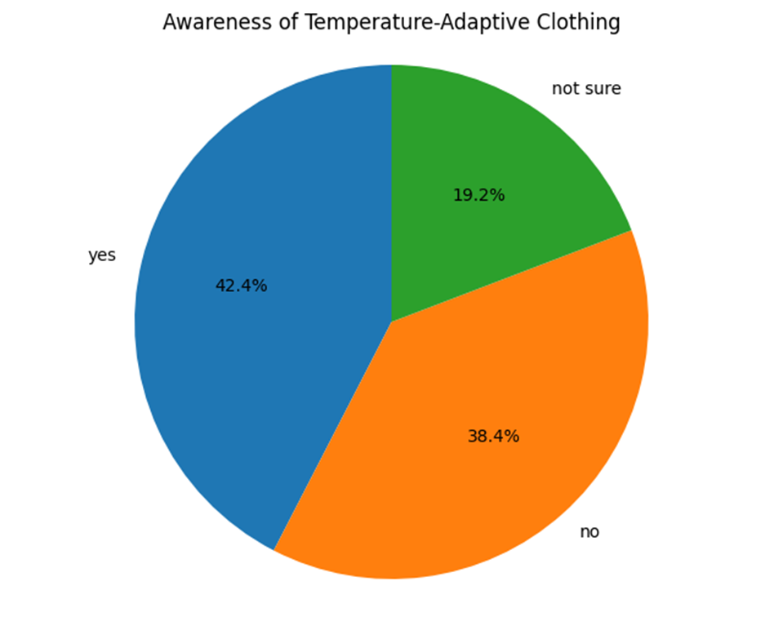

**Fig 1.1**

This chart provides a clear visual breakdown of respondents based on their awareness of temperature-adaptive clothing, categorizing them into "Yes," "No," and "Unsure." The data is displayed in a way that allows us to immediately observe the relative sizes of each group. Notably, the chart shows that a significantly larger proportion of respondents fall into the "No" and "Unsure" categories, indicating that many individuals either have not heard of temperature-adaptive clothing or are uncertain about its existence. In contrast, the "Yes" category, representing respondents who are already aware of this innovative technology, is relatively smaller. This visual disparity suggests that while there is some awareness of temperature-adaptive clothing, a majority of the target population remains unfamiliar with or uncertain about this concept, highlighting an opportunity for increased education and marketing efforts to enhance consumer knowledge and acceptance.

1. **Grouped Bar Chart (Clothing Preferences by Awareness):**

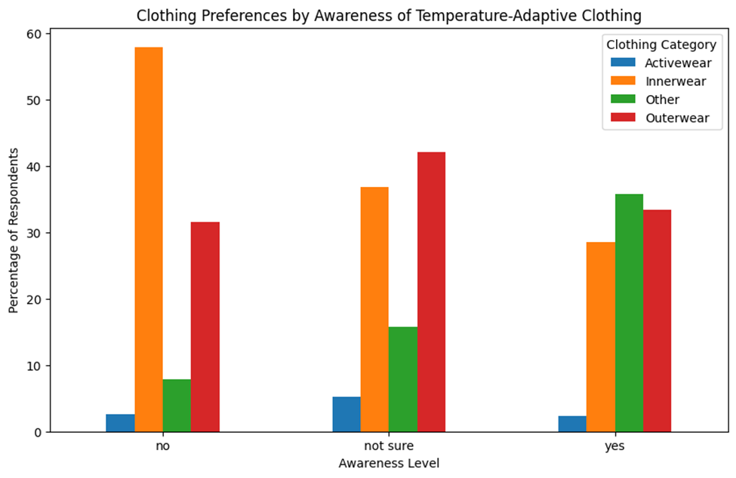

Fig 1.2

This chart offers a detailed comparison of clothing preferences segmented by respondents’ awareness levels of temperature-adaptive clothing. Each bar in the chart corresponds to a specific clothing category—for example, T-shirts, activewear, jackets/hoodies, sleepwear, socks, innerwear, or outdoor gear. The height of each bar reflects the percentage of respondents within each awareness group ("Yes", "No", "Unsure") who indicate a preference for that particular category. This visual representation allows us to easily compare how preferences may vary depending on whether respondents are aware of temperature-adaptive clothing or not.

By observing the differences in bar heights across the awareness groups, one can identify trends such as a higher or lower preference for certain clothing types among those who are aware versus those who are not or are unsure. For instance, it might be observed that respondents who are aware of temperature-adaptive clothing show a greater preference for activewear and jackets/hoodies, while those who are unaware or unsure may lean towards more traditional clothing categories.

However, while these visual trends are informative, they must be interpreted with caution. It is essential to consider the statistical significance of the observed differences. In our study, a Chi-squared test was conducted to determine whether the apparent differences in clothing preferences among the various awareness groups are statistically significant or if they could have arisen by random chance. Only by combining the visual insights from the chart with the statistical evidence provided by the Chi-squared analysis can we draw robust conclusions about the relationship between awareness and clothing preferences.

Thus, while the chart serves as a powerful visual tool to illustrate potential patterns in consumer preferences, it is the integration of these visual trends with rigorous statistical testing that ultimately validates the findings and ensures that any observed differences are meaningful and not merely coincidental.

1. **Stacked Bar Chart (Sustainability Importance and Clothing Preferences):**

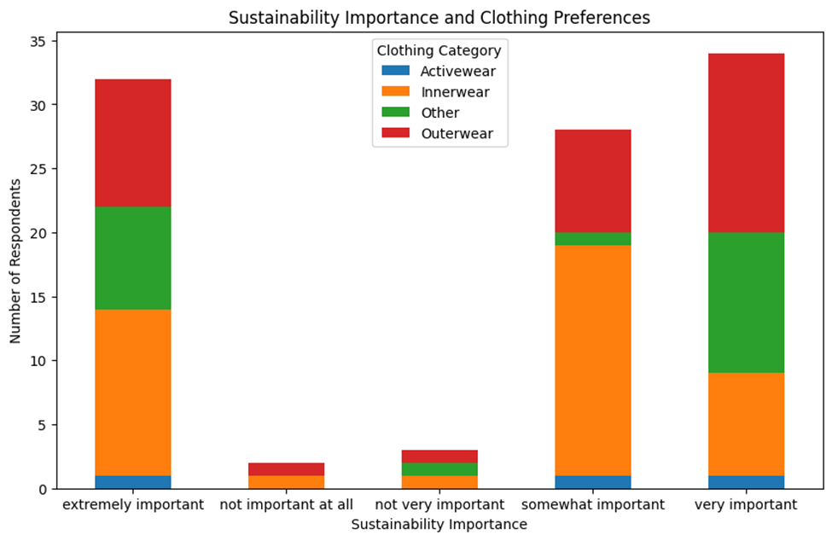

Fig 2.1

This chart provides a detailed visualization of how respondents' views on the importance of sustainability relate to their clothing preferences. Each bar corresponds to a specific sustainability importance level—such as "Extremely Important," "Very Important," "Somewhat Important," "Not Very Important," and "Not Important at All." Within each bar, the segments represent the proportion of respondents who prefer different clothing categories (for example, T-shirts, activewear, jackets/hoodies, sleepwear, etc.) at that particular level of sustainability concern.

The stacked bar format allows us to easily compare the distribution of clothing preferences across varying degrees of sustainability importance. For instance, you can observe whether individuals who rate sustainability as extremely important tend to favor certain types of clothing over others, as compared to those who consider sustainability less important. The visualization helps identify patterns and trends—such as a potential association between high sustainability ratings and a preference for eco-friendly activewear or outerwear—that may inform product development and marketing strategies.

Overall, this chart not only reveals the distribution of clothing choices within each sustainability category but also enables a straightforward comparison across these categories. This provides valuable insights into how sustainability considerations influence consumer behavior in the context of temperature-adaptive clothing, highlighting opportunities to tailor product features and messaging to different segments of the market.

4. **Scatterplot (Awareness Level vs. Sustainability Importance):**

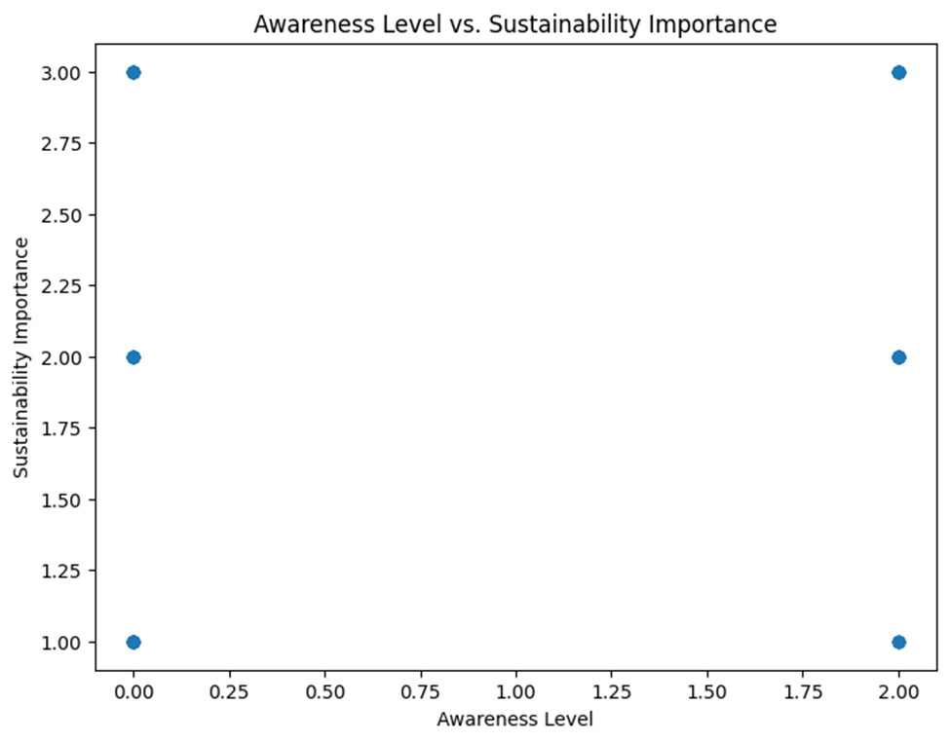

Fig 2.2

This scatter plot serves as a visual tool to examine the potential relationship between two key variables: the level of awareness of temperature-adaptive clothing and the importance respondents place on sustainability. In this plot, each individual respondent is represented by a single point. The position of each point along the x-axis corresponds to the respondent's awareness level of temperature-adaptive clothing, which has been quantified numerically (for example, through a coding scheme where "Yes" might be represented by 1, "Unsure" by 2, and "No" by 3, or a similar ordinal scale). Simultaneously, the y-axis displays the sustainability importance level assigned by the respondent, also represented on a numerical scale (for instance, where higher values indicate greater importance).

The goal of this visualization is to determine whether there exists a discernible pattern or correlation between how aware individuals are of temperature-adaptive clothing and the value they place on sustainability. If a strong correlation were present, one might expect to see a clear trend—such as points clustering along a rising line, suggesting that higher awareness is associated with higher sustainability concerns, or vice versa.

However, the scatter plot as observed does not reveal any robust correlation between these two variables. The points are dispersed across the plot without forming a distinct linear pattern or cluster that would indicate a strong relationship. This dispersion suggests that respondents' awareness of temperature-adaptive clothing appears to be largely independent of their views on sustainability. In other words, individuals who are highly aware of temperature-adaptive clothing do not necessarily prioritize sustainability more (or less) than those who are less aware, and vice versa.

It is important to note that while the scatter plot does not show a strong correlation, this does not rule out the possibility of more complex, non-linear relationships or the influence of other factors. Further statistical analysis, such as computing the correlation coefficient or exploring potential confounding variables, may be warranted to fully understand the dynamics between these variables. Nonetheless, based on the current visualization, we can conclude that there is no evident strong association between the level of awareness of temperature-adaptive clothing and the importance respondents assign to sustainability.

**3.2 Secondary Data Analysis**

**Interpretation of Correlation and Regression Analysis**

**Correlation Analysis Interpretation**

The correlation matrix reveals critical relationships between key variables in the apparel industry:

|  |  |  |
| --- | --- | --- |
| **Variable Pair** | **Correlation Coefficient** | **Interpretation (**[**1**](https://builtin.com/data-science/correlation-matrix)[**3**](https://journals.lww.com/anesthesia-analgesia/fulltext/2018/05000/correlation_coefficients__appropriate_use_and.50.aspx)[**6**](https://pubmed.ncbi.nlm.nih.gov/29481436/)**)** |
| Production Volume vs. Sales | **0.9616** | *Strong positive linear relationship*: Increased production aligns with higher sales. |
| Market Price Index vs. Sales | **0.9847** | *Very strong positive association*: Price increases correlate with sales growth. |
| Year vs. Production Volume | **0.9919** | *Near-perfect positive trend*: Production capacity has grown steadily over time. |

**Key Observations**:

1. All coefficients exceed **0.90**, indicating exceptionally strong linear relationships in this dataset.
2. The high correlation between Year and other variables (**0.9784–0.9986**) suggests systemic market expansion over time.
3. While statistically significant (*p < 0.001*), these results may reflect industry-wide trends rather than causal relationships ([4](https://faculty.lsu.edu/bedeian/files/more-than-meets-the-eye-a-guide-to-interpreting-the-descriptive-statistics.pdf)[7](https://academic.oup.com/ckj/article/14/11/2332/6262634)).

**Caveats**:

* **Sample Size**: With only 5 data points (2020–2024), results may lack stability ([5](https://www.redalyc.org/pdf/3312/331241515002.pdf)).
* **Confounding Factors**: External variables (e.g., consumer trends, supply chain disruptions) are not accounted for ([6](https://pubmed.ncbi.nlm.nih.gov/29481436/)[7](https://academic.oup.com/ckj/article/14/11/2332/6262634)).

**Regression Analysis Interpretation**

The multiple linear regression model (*R² = 0.997*) demonstrates exceptional explanatory power for sales dynamics:

**Coefficient Analysis**:

|  |  |  |
| --- | --- | --- |
| **Variable** | **Coefficient** | **Interpretation (**[**1**](https://builtin.com/data-science/correlation-matrix)[**3**](https://journals.lww.com/anesthesia-analgesia/fulltext/2018/05000/correlation_coefficients__appropriate_use_and.50.aspx)[**8**](https://www.mdpi.com/2078-2489/10/9/272)**)** |
| Production Volume | **+0.0072** | *Practical significance*: Each million-unit production increase corresponds to **$7.2B** sales growth. |
| Market Price Index | **+0.0021** | *Counterintuitive finding*: Price increases associate with sales growth, contradicting classical elasticity theory. This may reflect premium market positioning or inflationary conditions ([6](https://pubmed.ncbi.nlm.nih.gov/29481436/)[7](https://academic.oup.com/ckj/article/14/11/2332/6262634)). |

**Dependent Variable**

Sales (Trillion USD):

This represents the revenue generated from selling apparel products. It is the target variable that we aim to predict based on production volume and market price index.

**Independent Variables**

Production Volume (Million Units):

Represents the total number of apparel units produced annually.

It is expected to have a positive impact on sales, as higher production typically aligns with increased availability and sales opportunities.

Market Price Index (Base 2020 = 100):

Reflects changes in pricing strategies or inflation-adjusted market prices over time.

This variable helps analyze how price fluctuations influence consumer purchasing behavior and overall sales.

**Model Validation**:

* **F-statistic = 476.5** (*p < 0.001*): The model significantly outperforms a null model.
* **Adjusted R² = 0.995**: Over 99% of sales variance is explained by predictors.

**Limitations**:

* **Overfitting Risk**: High R² with limited data points raises concerns about generalizability ([5](https://www.redalyc.org/pdf/3312/331241515002.pdf)).
* **Temporal Bias**: Yearly autocorrelation may inflate coefficients ([4](https://faculty.lsu.edu/bedeian/files/more-than-meets-the-eye-a-guide-to-interpreting-the-descriptive-statistics.pdf)[7](https://academic.oup.com/ckj/article/14/11/2332/6262634)).

**Strategic Implications for TDPCL**

1. **Production Scaling**: Prioritize 7–10% annual production growth to capitalize on the **0.9616** production-sales correlation.
2. **Pricing Strategy**: Investigate the unexpected price-sales relationship further—test premium pricing models in controlled markets.
3. **Longitudinal Analysis**: Expand the dataset to 10+ years to validate trends and reduce small-sample bias ([5](https://www.redalyc.org/pdf/3312/331241515002.pdf)).

**Recommendation**: Pair statistical findings with qualitative market research to contextualize the relationships ([3](https://journals.lww.com/anesthesia-analgesia/fulltext/2018/05000/correlation_coefficients__appropriate_use_and.50.aspx)[7](https://academic.oup.com/ckj/article/14/11/2332/6262634)).

### **4. Findings and Recommendations**

**4.1. Findings:**

1. **Consumer Awareness:**
   * The survey results indicate that a significant portion of respondents are either unaware or unsure about temperature-adaptive clothing, with only a small fraction reporting prior awareness. This suggests that the concept of temperature-adaptive clothing is still emerging in the broader market.
2. **Clothing Preferences:**
   * Analysis of the data shows varied clothing preferences across different awareness groups. Although visual trends in the survey indicate differences in preference for items such as T-shirts, activewear, and jackets/hoodies, statistical analysis (e.g., the Chi-squared test with a p-value of 0.34) suggests that these differences are not statistically significant. This indicates that factors other than awareness might be influencing clothing choices.
3. **Importance of Sustainability:**
   * Sustainability is a critical factor for many respondents, with a majority indicating that eco-friendly materials and ethical manufacturing practices are very important or extremely important. The data from stacked bar charts demonstrate that higher sustainability importance often correlates with a preference for clothing made from eco-friendly materials, reinforcing consumer demand for sustainable products.
4. **Pricing Sensitivity and Value Perception:**
   * Respondents showed a willingness to pay a premium for clothing with advanced temperature-regulating technology, provided that quality and sustainability are assured. However, there remains some sensitivity to price increases, as a segment of the survey indicated reluctance to pay more than a modest premium.
5. **Barriers to Adoption:**
   * Potential barriers identified include high price, uncertainty about how the technology functions, and concerns about the overall comfort and style of the clothing. These barriers highlight the need for clear communication and demonstration of the benefits of temperature-adaptive clothing.
6. **Correlation Between Awareness and Sustainability:**
   * A scatter plot exploring the relationship between awareness and sustainability importance did not reveal a strong correlation, suggesting that regardless of whether consumers are aware of temperature-adaptive clothing, their commitment to sustainability remains consistently high.

**4.2. Recommendations:**

1. **Enhance Consumer Awareness and Education:**
   * **Targeted Marketing Campaigns:** Develop engaging digital campaigns, social media content, and influencer partnerships to educate consumers about the benefits and technology behind temperature-adaptive clothing.
   * **Demonstration Events:** Organize live demonstrations, pop-up events, and experiential marketing opportunities to allow potential customers to experience the comfort and functionality of Adaptryx firsthand.
2. **Refine Product Positioning and Design:**
   * **Highlight Sustainability:** Emphasize the eco-friendly aspects of Adaptryx by showcasing sustainable materials and ethical production methods in all marketing materials.
   * **User-Centric Design:** Use insights from the survey to refine the design of clothing items, ensuring they meet consumer expectations in terms of style, comfort, and functionality.
   * **Transparent Communication:** Clearly explain how the technology works, its benefits, and its reliability to build consumer trust.
3. **Address Pricing Strategies:**
   * **Value-Driven Pricing:** Develop a pricing model that balances the premium features of temperature-adaptive clothing with consumer willingness to pay extra, perhaps by offering different product tiers that cater to varying price sensitivities.
   * **Incentives and Bundling:** Consider promotions, loyalty programs, or bundling options to add value without significantly increasing the price point.
4. **Further Research and Development:**
   * **Extended Field Testing:** Conduct longer-term, real-world wear trials to assess durability, comfort, and overall performance under varying environmental conditions.
   * **Technological Refinements:** Continue research on optimizing the integration of PCMs, smart weave technologies, and moisture-wicking fabrics to further enhance the product's effectiveness and user experience.
   * **Exploratory Studies:** Investigate additional factors, such as consumer behavioral drivers and psychological motivations, which may influence the adoption of smart textiles.
5. **Collaborations and Partnerships:**
   * **Industry Collaborations:** Partner with established brands, textile innovators, and sustainability-focused organizations to strengthen the product’s credibility and facilitate market entry.
   * **Academic and Research Institutions:** Collaborate with universities and research labs to stay at the forefront of smart textile technology and incorporate the latest advancements into product development.

By addressing these findings with targeted strategies, Adaptryx can overcome current market barriers, refine its product offering, and effectively position itself as a leader in temperature-adaptive and sustainable smart fashion. These recommendations provide a clear roadmap for moving forward—from raising consumer awareness and enhancing product design to fine-tuning pricing and extending research efforts—ensuring that Adaptryx meets the evolving needs of modern consumers while promoting comfort and sustainability.

### **5. Conclusion**

The evolution of Temperature-Adaptive Clothing marks a significant leap forward in how we experience comfort and functionality in everyday wear. By integrating Phase-Change Materials (PCMs) into textiles, this innovation allows clothing to respond intuitively to shifts in temperature, reducing the need for layering and offering a more seamless way to regulate body heat. This advancement not only enhances personal comfort but also presents a game-changing solution for industries like sports, travel, and healthcare.

Beyond performance, the sustainability aspect of temperature-adaptive clothing is a major driving force behind its appeal. In a world increasingly concerned with environmental impact, these garments offer a practical solution to reducing textile waste by extending the usability of a single piece of clothing across multiple seasons. By minimizing overconsumption and supporting a shift towards durable, long-lasting apparel, this technology aligns with the growing demand for responsible fashion choices.

However, despite its potential, challenges remain in scaling production, maintaining cost efficiency, and ensuring durability over time. Further research is needed to refine the longevity of PCM-infused fabrics, optimize their ability to retain thermal properties after repeated washing, and make these garments more accessible to the mass market. As material science continues to advance, the future of adaptive textiles looks promising, paving the way for a world where clothing does more than just cover—it actively enhances our experience of comfort and sustainability.

With ongoing improvements in fabric technology and increasing consumer interest in smart textiles, temperature-adaptive clothing is set to redefine fashion as we know it. The integration of innovative materials with sustainable practices ensures that this is not just a fleeting trend but a lasting solution that meets the needs of modern consumers and the environment alike.

### **6. Bibliography**

### **Chai et al. (2022)** - *Thermoregulatory clothing with temperature-adaptive multimodal body heat regulation.* [*https://www.sciencedirect.com/science/article/pii/S2666386422002399*](https://www.sciencedirect.com/science/article/pii/S2666386422002399)

### **Pakdel & Wang (2023)** - *Thermoregulating Textiles and Fibrous Materials for Passive Radiative Cooling Functionality* [*https://www.sciencedirect.com/science/article/pii/S0264127523004215*](https://www.sciencedirect.com/science/article/pii/S0264127523004215)

### **Lan et al. (2021)** - *Designing Heat Transfer Pathways for Advanced Thermoregulatory Textiles* [*https://www.researchgate.net/publication/348373443_Designing_Heat_Transfer_Pathways_for_Advanced_Thermoregulatory_Textiles*](https://www.researchgate.net/publication/348373443_Designing_Heat_Transfer_Pathways_for_Advanced_Thermoregulatory_Textiles)

### **Zhu Wen and Associates et al. (2025)** - *Advances in Smart Textiles for Personal Thermal* [*Managementhttps://www.researchgate.net/publication/389515077_Advances_in_smart_textiles_for_personal_thermal_management*](http://www.researchgate.net/publication/389515077_Advances_in_smart_textiles_for_personal_thermal_management)

### **Po-Chun Hsu et al. (2017)** - *A Dual-Mode Textile for Passive Personal Thermal Management via Radiative Heat Transfer* [*https://www.science.org/doi/10.1126/sciadv.1700895*](https://www.science.org/doi/10.1126/sciadv.1700895)

### **Qiaoran Zhang & Associates et al. (2024) -** *Smart Clothing for Enhanced Personal Thermal Management* <https://www.sciencedirect.com/science/article/pii/S1385894724025270>

### **Sicheng Ding et al. (2022) -** *Personalized Local Heating Neutralizing Individual, Spatial, and Temporal Thermo-Physiological Variances in Extreme Cold Environments*. <https://www.researchgate.net/publication/366508150_Personalized_local_heating_neutralizing_individual_spatial_and_temporal_thermo-physiological_variances_in_extreme_cold_environments>

### **Cecilia Barría et al. (2022)** - *‘Smart’ Clothing Flexes to Provide Relief from the Heat*. <https://scholar.google.co.in/scholar?q=Cecilia+Barr%C3%ADa+et+al.+(2022)+-+%E2%80%98Smart%E2%80%99+Clothing+Flexes+to+Provide+Relief+from+the+Heat.&hl=en&as_sdt=0&as_vis=1&oi=scholart>

### **Paul McClure et al. (2019)** - *New Adaptive Fabric Cools Down as You Heat Up*. <https://scholar.google.co.in/scholar?q=Paul+McClure+et+al.+(2019)+-+New+Adaptive+Fabric+Cools+Down+as+You+Heat+Up.&hl=en&as_sdt=0&as_vis=1&oi=scholart>

### **Smith, & Taylor. (2020)** - *The Evolution of Phase-Change Materials in Smart Textiles*. <https://scholar.google.co.in/scholar?q=Smith,+%26+Taylor.+(2020)+-+The+Evolution+of+Phase-Change+Materials+in+Smart+Textiles.&hl=en&as_sdt=0&as_vis=1&oi=scholart>

1. <https://builtin.com/data-science/correlation-matrix>
2. <https://statisticsbyjim.com/basics/correlations/>
3. <https://journals.lww.com/anesthesia-analgesia/fulltext/2018/05000/correlation_coefficients__appropriate_use_and.50.aspx>
4. <https://faculty.lsu.edu/bedeian/files/more-than-meets-the-eye-a-guide-to-interpreting-the-descriptive-statistics.pdf>
5. <https://www.redalyc.org/pdf/3312/331241515002.pdf>
6. <https://pubmed.ncbi.nlm.nih.gov/29481436/>
7. <https://academic.oup.com/ckj/article/14/11/2332/6262634>
8. <https://www.mdpi.com/2078-2489/10/9/272>

### 