**DIVERSITY, IMPORTANCE AND CHALLENGES OF EDIBLE INSECT CONSUMPTION IN EKITI-STATE, NIGERIA.**

**Ayotunde-Ojo, M.O,1* Aiyeku, O.S2.**

Department of Forest Resources and Wildlife Management, Faculty of Agricultural Sciences,

Ekiti State University, P.M.B. 5363, Ado-Ekiti, Nigeria.

*Corresponding Author

**ABSTRACT**

Edible insects are highly rich and healthy food sources of protein, fat, vitamins, fibre and mineral content, which provide a valuable source of nutrition for the human body. This study investigates the diversity, importance and challenges of edible insect consumption in Ekiti State. Four local government areas were selected from the ecological zone and one village was selected from each LGA. Structured questionnaires were administered to thirty (30) respondents in each of the four selected villages. The result revealed that the majority of the respondents (65%) are married, 65% are male and 72.5% are below the age of 41 years, with farming as the major occupation of the respondents (45%). Eight insect species were consumed by the respondents in the study area; *Imbrasia belina, Macrotermes bellicosus, Macrotermes natalensis, Apis mellifera, Oryctes boas, Rhynchophorus phoenicis, Zonocerus variegatus* and *Bombyx mori*. *Rhynchophorus phoenicis* was identified as the most consumed insect in the study area. The result also revealed that 53% of the respondents consume edible insects as an alternative to meat, 26% consume insects as food and 4% use them for medicinal purposes. The respondents in the study area faced significant challenges such as inadequate storage facilities, limited awareness of their nutritional benefits, and seasonal availability.The study recommends that awareness should be created on modern techniques for processing and storage to enhance their shelf life.

**Keywords:** Diversity, Edible Insect, Consumption, Importance, Ekiti State.

1. **INTRODUCTION**

For thousands of years, humans have relied on insects as an emergency food source, while in other cases, they have been consumed as staples or even as culinary delicacies. The majority of consumed insect species belong to four primary orders: Coleoptera, Hymenoptera, Orthoptera, and Lepidoptera, collectively accounting for 80% of edible insects (Ramos-Elorduy, 2005). The forest and its products, in addition to timber, firewood and charcoal, are of vital importance to the rural population. Some of the non-timbre forest products harvested and utilized by the rural population include various fruits and vegetables, edible insects and mushrooms (Adedutan and Bada, 2004). Edible insects have been reported to be a source of protein, vitamins, and fat in the human body. Insects have been reported to be rich in protein, minerals, vitamins, and essential fatty acids (Ebenebe *et al*., 2017).Several studies have shown that edible insects contain appreciable amounts of protein (Olaofe *et al.,* 1998; Ramos-Elorduy *et al*., 1997).

Edible insects can be consumed in the absence of meat and fish in some traditional villages where fish and meat are scarce. Edible insect has the potential to provide a valuable source of nutrition to the body of rural dwellers and also generate income for people living in rural areas. Edible insects serve as valuable protein sources, contributing to the improvement of human diet, particularly for those suffering from dietary deficiencies. Shortage of animal protein in the human diet has been linked to the high rate of infant and maternal mortality in Africa and other developing countries (Agboola *et al.,* 2024).

About 50% of deaths among children of this age group are believed to be associated with Protein-energy malnutrition in developing countries (UNICEF, 2018). Malnutrition is widespread in Nigeria, especially in the rural areas to inadequate food and nutrient supply (Musa and Idris, 2023). In recent times, there has been a strong desire to use insects as an alternative source of protein for both human consumption and animal feed on a global scale (Van Huis *et al.,* 2013). Many of these edible insects are yet to be critically studied, and their nutritional contributions to the human diet have not been widely explored. Limited knowledge of edible insects could be a factor in the lack of widespread awareness and utilization of their potential benefits (Van Huis *et al.,* 2015). Therefore, consumption of insects as part of the diet can be beneficial in addressing malnutrition among children. However, this study is designed to ascertain the diversity, importance, and challenges of edible insect consumption in Ekiti State.

1. **METHODOLOGY**

**2.1 Study area**

The study was carried out in Ekiti State, Southwest Nigeria, as shown in Figure 1. The state covers about 7,500km2 of land mass located between Longitude 4°51 and 5°451 East and Latitudes 7° 151 and 8° 51 North of the equator. The state enjoys a tropical climate with two distinct seasons; the wet season between April to October and the dry season between November to March. Temperature ranges between 21°C and 28°C, with little variation throughout the year. The mean annual precipitation in the southern part of the state is about 1,700 mm and in the northern part is hardly over 1,500 mm (Adebayo, 1993).

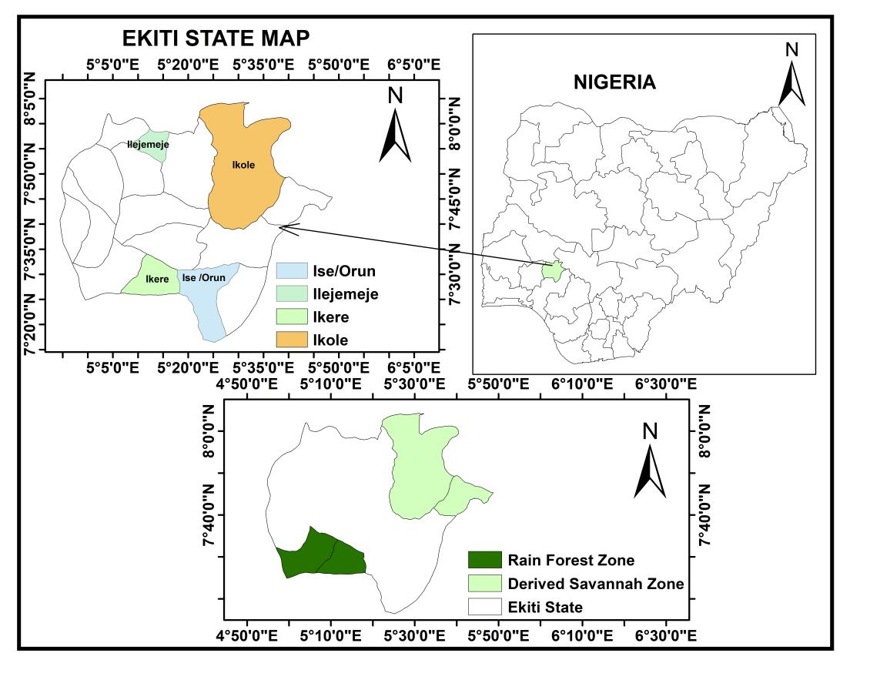

**Figure 1: Map showing the study area**

**2.2 Sampling techniques, data collection and analysis**

The study area was stratified into two ecological zones: tropical rainforest and derived savanna. From each zone, four local government areas were selected, as shown in Table 1. Using snowball sampling techniques, questionnaires were distributed to thirty (30) respondents in each of the selected villages.

**Table 1: Distribution of Respondents in the study area**

|  |  |  |  |
| --- | --- | --- | --- |
| **Ecological zone** | **Local government** | **Community** | **Number of Respondents** |
| Tropical rain forest | Ise LGA | Ise-Ekiti | 30 |
|  | Ikere LGA | Ikere-Ekiti | 30 |
|  |  |  |  |
| Derived savannah | Ikole LGA | Ikole-Ekiti | 30 |
|  | Ilejemeje LGA | Ilejemeje-Ekiti | 30 |
| **Total 2** | **4** | **4** | **120** |

**2.3 Statistical analysis**

Data obtained were analyzed using descriptive statistics of frequency tables and percentages

1. **RESULTS**

**Socio-economic characteristics of respondents**

Table 2 indicated that the respondents were majorly men (65%), with (37.5%) within the age range of (31-40) years. (65%) of the respondents were married, (25%) were single, (7.5%) were widowed and (2.5%) were divorced. The results further showed that (60%) had secondary education and farming (45%) was the major occupation of the respondents.

**Table 2: Socio-economic characteristics**

|  |  |  |
| --- | --- | --- |
| **Variables** | **Frequency** | **Percentage (%)** |
| **Age** |  |  |
| 21-30 | 42 | 35 |
| 31-40 | 45 | 37.5 |
| 41-50 | 50 | 20 |
| 50-above | 9 | 7.5 |
| **Gender** |  |  |
| Male | 78 | 65 |
| Female | 42 | 35 |
| **Marital status** |  |  |
| Single | 30 | 25 |
| Married | 78 | 65 |
| Widowed | 9 | 7.5 |
| Divorced | 3 | 2.5 |
| **Educational background** |  |  |
| No Formal Education | 0 | 0 |
| Primary | 15 | 12.5 |
| Secondary | 72 | 60 |
| Tertiary | 33 | 27.5 |
| **Occupation** |  |  |
| Civil Servant | 9 | 7.5 |
| Farmer | 54 | 45 |
| Trading | 30 | 25 |
| Artisans | 27 | 22.5 |
| **Total** | 120 | 100 |

**Common edible insects consumed in the study area.**

Table 3 shows that eight (8) insects were commonly eaten by the respondents in the study area*.* The result revealed *Rhynchophorus phoenicis* (19%) as the highest consumed insect; other insects with high demand are *Orycetes boas* (17%), *Macromeres bellicose* (16%), while *Imbrasia belina* and *Bombyx mori* (9.5%) each were ranked as the lowest consumed insects by the respondents.

**Table 3: Common edible insects consumed in the study area.**

|  |  |  |  |
| --- | --- | --- | --- |
| Scientific name | Common name | Frequency | Percentage (%) |
| *Imbrasia belina* | Mopane Worm | 30 | 9.5 |
| *Macrotermes bellicosus* | Winged Termites | 50 | 16 |
| *Macrotermes natalensis* | Termites Solders | 40 | 13 |
| *Apis mellifera* | Honey Bee | 25 | 8 |
| *Oryctes boas* | Scarab Beetle | 55 | 17 |
| *Rhynchophorus phoenicis* | Palm Weevil | 60 | 19 |
| *Zonocerus variegatus* | Grasshopper | 25 | 8 |
| *Bombyx mori* | Silkworm Larva | 30 | 9.5 |
| Total | 8 | 315* | 100 |

**\*Multiple responses**

**Seasonal availability**

The seasonality of availability of the insect is presented in (table 2). 50% were ere available in wet season, 7.5% were available in the dry season and 12.5.5% available all year round.

**Figure 2: Seasonal availability of edible insects**

**Uses of edible insects**

Figure 3 presents the uses of edible insects by respondents in the study area. 53% stated that edible insects serve as an alternative to meat, 4% as treating one ailment or the other, 26% as a form of diet especially diabetic and overweight patients while 17% have different views on edible insect such as pleasure, tradition.

**Figure 3: Uses of edible insects**

**Economic contribution to the livelihood of people in the study area**

Table 4 showed that 15% of the respondents earn money from edible insects, while 85% do not make an income from edible insects. The result further showed that 25% of the respondents generate between ₦10,000- ₦20,000, 47.5% generate between ₦21,000 to ₦30,00, 20% generate ₦31,000-40,000 while 7.5% generate above ₦40,000 on sales of edible insects monthly.

**Table 4: Distribution of respondents on sales of edible insects.**

|  |  |  |
| --- | --- | --- |
| Variables | Frequency | Percentage (%) |
| Sales |  |  |
| YES | 18 | 15 |
| NO | 112 | 85 |
| Income Range |  |  |
| ₦10,000-₦20,000 | 30 | 25 |
| ₦21,000-30,000 | 57 | 47.5 |
| ₦31,000-40,000 | 25 | 20 |
| >₦40,000 | 9 | 7.5 |
| Total | 120 | 100 |

**Method of collection and processing of edible insect**

Table 5 revealed the methods of collecting and processing insects. The result showed that trapping (75%) was the most adopted method of collecting or harvesting edible insects, 13% collect by hand picking method. The processing methods used were frying, roasting, and cooking. Frying was the highest 33%, followed by roasting, 30%, cooking had 25% while other methods accounted for 12%.

**Table 5: Distribution of respondents by methods of processing edible insects**

|  |  |  |
| --- | --- | --- |
| Variables | Frequency | Percentages (%) |
| Collection method |  |  |
| Trapping | 90 | 75 |
| Chemical | 6 | 5 |
| Hand-picking | 16 | 13 |
| Others | 8 | 7 |
| Processing Method |  |  |
| Frying | 40 | 33 |
| Roasting | 36 | 30 |
| Cooking | 30 | 25 |
| Others(sun drying) | 14 | 12 |
| Total | 120 | 100 |

**Constrainst to edible insects consumption**

Figure 4 presents the challenges faced by respondents, the result showed lack of storage facilities accounted for 42%, followed by ignorance on nutritional values (28%), seasonal availability (12%), and Unpleasant odour (10%).

**4. DISCUSSION**

The study revealed a higher number of married male that were involved in the collection and consumption of edible insects. The involvement of married men could be attributed to the fact that fact that men mostly engage in farming activities and are solely responsible for providing for their families. This assertion is in agreement with Meludu and Onaja (2018), who reported that men are more involved in edible insect collection and consumption than women. The involvement of a high number of middle-aged people attests to the fact individuals in this age group maintain notable agility and strength, which enables them to pursue the hunting of edible insects actively. Most individuals involved in edible insect harvesting were farmers, though some business operators also participated in the trade. Sixty per cent of those involved have secondary education. This shows that the collection of insects is not a business for people who are poor and uneducated; diverse people in the society are involved in the collection and consumption of edible insects. The involvement of people may be due to the high premium placed on some edible insects due to their high nutritional value, which are essential parts of the human diet, as affirmed by Okweche and Atah (2019).

The result presented eight insect species as commonly eaten in the study area; these insects cut across the following orders; coleoptera, isoptera, hymenoptera, and Lepidoptera. The study revealed that *Rhynchophorous phoenicis* as the most common eaten insect, while *Apis mellifera* was the least consumed. This corroborates the findings of Ekop *et al.,* 2010; and Elemo *et al.,* 2011 who reported *Rhynchophorous phoenicis* and *Oryctes monoceros* as the most commonly eaten insects in southwestern Nigeria.

The seasonal availability of insects, as observed in this study, showed that insects are mostly available in the wet season, which agrees with the findings of Van Huis (2013), who reported that most insect species occur seasonally depending on the availability of their host plant. The findings highlighted the diverse applications of edible insects, many individuals consume insects as a more affordable protein source compared to meat, while others use them as a remedy for ailments such as malnutrition in children, diabetes management, and weight loss. Siddiqui *et.al.,* (2023), reported *Macrotermes nigeriensis* as avital food component for people with high blood cholesterol levels and those at risk of cardiovascular disease due to its low saturated fatty acid. Additionally, fat is essential for supplying the human body with energy. Consuming these insects could potentially enhance energy levels, reducing malnutrition associated with energy deficiencies in developing countries. (Akhtar and Isman, 2018). Edible insects have been reported to be rich in protein content (Kim *et al.,* 2019).

The study also revealed that edible insects contribute to socio-economic well-being and also have a positive impact on their livelihood by meeting their economic and household needs. This submission corroborates the findings of Olujobi and Abdulsalam (2022), who reported that edible insects contribute to the socio-economic well-being of the people. This assertion was also evident in the income generated from the sales of the insects. The result also revealed *Rhynchophorus phoenicis* as the most abundant insect, which might be due to the high forest vegetation of the study area. This is in line with the findings of Adeoye *et al.,* (2014), who reported that Rhinoceros beetle as the most commercially available insect in the study area.

The study revealed that trapping is the most adopted method of collecting insects, which agrees to the findings of Ayotunde-Ojo and Omoyeni, (2024) who reported trapping as the as the most common method of collection. The most preferred method of processing these insects before consumption is by frying. This agrees with the findings of Olujobi and Abdulsalam (2022), who reported that frying is the most common processing method. The major constraints reported by respondents were; lack of storage facilities, followed by ignorance on the nutritional values of the insects. This observation is in line with that of Olukunle, (2013) who reported the lack of modern techniques for processing and storage of farm produce as a major production problem among farmers.

1. **CONCLUSION AND RECOMMENDATIONS**

The study concluded that *Rhynchophorus phoenicis* was the most abundant insect in the study area, and also highlighted the significant role of edible insects in contributing to the socio-economic well-being and livelihood of rural dwellers.

Based on this study, there is need for public awareness and education of the public on the consumption, health benefits, and nutritional value of edible insects, as they have the potential to combat malnutrition. Additionally, the government should establish insect farming training centers to support farmers in large-scale insect production. Moreover, efforts should be made to promote modern techniques for processing and storage to extend the shelf life of these edible insects.

1. **REFERENCES**
2. Adebayo, W.O. (1993). Weather and climate. In: Ebisemiju, F.S. (ed.) Ado- Ekiti Region. A geographical analysis and master plan. Lagos. Alpha Prints, 11-14.
3. Adeduntan, S. A and Bada, F. A. (2004). Socioeconomic importance of local silkworm (Anaphe venata) to the rural dwellers in Ondo state, Nigeria. In *papers presented at the 35th Annual Conference of the Entomological Society of Nigeria* held at the Federal University of Akure Vol. 3, 7-10.
4. Adeoye O.T, Alebiosu B.I, Akinyemi O.D and Adeniran O.A (2014). Socio-economic analysis of forest edible insect species consumed and its role in the livelihood of people in Lagos State. *Journal of Food Studies* 3(1):103-120.
5. Agboola, I. S., Agboola, F. O., Ayandokun, A. E. and Ete, J. A. (2024). Potentials of Edible Insects as a Food Source. *Journal of Applied Sciences and Environmental Management*, *28*(10), 3253-3258.
6. Akhtar, Y and Isman, M. B. (2018). Insects as an Alternative Protein Source. In Protein in Food Processing 2nd edition 263-288
7. Ayotunde-Ojo, M.O. and Omoyeni, A.A (2024) Processing, Uses and Constraints to Edible Insect Consumption in Ekiti State, Nigeria, *British Journal of Multidisciplinary and Advanced Studies,* 5(4),27-37
8. Ebenebe C, Ameobi M, Udegbala C, Ufele A, Nwaze B (2017) Survey of edible insect consumption in southeastern Nigeria. *Journal insects as food and feed* 3(4): 241-251.
9. Ekop E.A, Udoh A.I and Akpan P.E (2010). Proximate and anti-nutrient composition of four edible insects in Akwa Ibom State, Nigeria. *World J. Appl. Sci. Technol.* 2 (2): 224 – 231
10. Elemo B.O, Elemo G.N, Makinde M.A, and Erukainure, O.L. (2011). Chemical evaluation of African palm weevil, *Rhychophorus phoenicis*, larvae as a food source. *J. Insect Sci.,* 11: 146.
11. Kim, T. K., Yong, H. I., Kim, Y. B., Kim, H. W., and Choi, Y. S. (2019). Edible insects as a protein source: A review of public perception, processing technology, and research trends. *Food science of animal resources*, *39*(4), 521.
12. Meludu N.T and Onaja M.N. (2018). Determinants of Edible Insects Consumption Level in Kogi State, Nigeria. *Journal of Agricultural Extension* 22 (1): 156-170.
13. Musa, I. A., and Idris, M. (2023). Impact of malnutrition on under-five children mortality in Nigeria Polac Economics Review (PER) 3(2) : 2814-0842
14. Okweche S. I. and Atah V.A. (2019). Edible insects value chain in Cross River state. Nigeria. *Global Journal of Agricultural Sciences*; 18(1):1-11
15. Olaofe O, Arogundade L.A, Adeyeye E.I and Falusi, O.M. (1998). Composition and food properties of the variegated grasshopper (*Zonoccerus variegatus*). *Trip. Sci.* 38:233-236.
16. Olujobi O.J and Abdulsalam M.A (2022). Survey of edible forest insects utilized by the people in Southwest Nigeria *Innovare Journal of Agricultural Science* 10(6): 10-15.
17. Olukunle, O.T. (2013). Challenges and prospects of agriculture in Nigeria: the way forward. *Journal of Economics and sustainable development*, *4*(16):37-45.
18. Ramos-Elorduy J, Moreno J. M. P, Prado E. E, Perez M. A, Otero J. L and De Guevara, O. L. (1997). Nutritional value of edible insects from the state of Oaxaca, Mexico. *Journal of Food Composition and Analysis*, 10(2), 142–157
19. Ramos-Elorduy J. (2005). Insects: A Hopeful Food Source. In: GM. Paoletti, editors. Ecological implications of mini livestock (Potential of Insects, Rodents, Frogs and Snails). Plymouth: *Science Publishers, Inc*; 263-291.
20. Siddiqui, S. A., Fernando, I., Saraswati, Y. R., Rahayu, T., Harahap, I. A., Yao, Q., and Shah, M. A. (2023). Termites as human foods - A comprehensive review. *Comprehensive Reviews in Food Science and Food Safety*, *22*(5), 3647-3684.
21. UNICEF (2018) Levels and trends in child malnutrition. Journal of Social Sciences. 10(4): 83 – 92.
22. Van Huis A. (2013). Potentials of insects as food and feed in assuring food security. *Annual Review of Entomology* 58(1): 56-583
23. Van Huis, A, Van Itterbeeck J, Klunder H, Mertens E, Halloran A and Muir G. (2015). Edible insects: future prospects for food and feed security. FAO Forestry Paper 171. *Rome Food and Agriculture Organization of the United Nations.*