**‘A STUDY ON EMPLOYEE TRAINING NEED ANALYSIS IN URBAN COMPANY’**

**S. Eesha Sharma1 DR. Padmavathy N2**

**1MBA Student, School of Arts, Humanities and Management, Jeppiaar University, Chennai.**

**2School of Arts, Humanities & Management Jeppiaar University, Chennai.**

**1Corresponding Author Email-ID*: [eeshas2001@gmail.com](mailto:eeshas2001@gmail.com)**

**2Corresponding Author Email-ID*: [dean_ahm@jeppiaaruniversity.ac.in](mailto:dean_ahm@jeppiaaruniversity.ac.in)**

**ABSTRACT**

Its primary goal is to establish how organizational objectives can be achieved by implementing a staff training program aimed at enhancing or transforming the skills, knowledge, and attitudes of those involved or impacted by change. In addition to evaluating individual training needs, the process also considers alignment with functional and organizational goals. An effective and thorough TNA offers numerous advantages, including the creation of a well-defined and mutually agreed-upon training strategy and the design of training solutions tailored to specific requirements. It also aids in identifying prerequisites for training, as well as the risks, assumptions, constraints, and dependencies that might influence the training plan. Furthermore, it promotes the development of a learning culture, fostering quicker and more efficient change within the organization. This project report centers on the Training Needs Analysis process at Urban Company, a global leader in the service industry. Initially starting with a limited number of partners, Urban Company has grown to become the top provider of services across various sectors. The primary objective of this project is to illustrate the key steps involved in identifying employee training needs. “Training Needs Analysis” serves as a crucial and foundational system that every organization must implement to ensure the successful execution of subsequent tasks. This report comprehensively explains the methods, techniques, and processes associated with training needs analysis, specifically in the context of Urban Company.

**INTRODUCTION**

Which can make their current performance better. Training involves a dimension in perspective, skills, and information of an individuals with their saltant improvement in the behavior. For training to be effective, it must be a planned activity conducted with a need analysis at varied levels and target at bound competencies, and it ought to be conducted during a learning atmosphere. Training could be a means to make sure that staff has information and right skills to be ready to do their work effectively and aptly. Training could also be required once there’s a difference between the desired or expected performance, and the current performance, and therefore the reason for that gap is lack of liability or information. Technology is fast changing at a very quick pace. Along with that, the performance betterment of employees is needed. With correct training and development, the productivity will increase manifold. Varied corporations have in-house specialists who train staff on varied aspects of the business. Normally, a calendar is puzzled out a head with the help of which varied sessions are listed out and which staff will choose their business demand to reinforce personal development needs. Training and development that was at a point of time not given a bund ant importance, is currently very important for any company to fulfil its broad goals and objectives. There are several aspectsto be considered oncemanagers are distinguishing training needs oftheir team members. Thus, once the work force is provided support for innovation, it will facilitate increased productivity and improve growth rate of business. However, it’s essential to use TNA best practices to spot performance gaps and whether the training material is on par. Overall, it Is conducted that with a correct analysis and implementation, (which go together) it is made sure that each worker is happy and extremely productive. Training need analysis approach bridges the gap between performance from expected or desired state to the current state. This gap will occur at the Structure level or at the individual level. From this gap analysis, one can assume the resources needed and set up the budget consequently. It additionally ensures strategic designing or a SWOT analysis of the organization. These strengths will be bolstered with requisite training, and any weakness could also be assessed as a dimension one has to pay 2 stressto, whereas opportunities understand areas that one needs to be trained in. To the paper, approximant organization in the real estate's Ector is taken as an example. The paper not only highlights the training need analysis undertaking the company but also shows prioritization of various needs based on competencies expected in future.

**REVIEW OF LITERTURE**

According to Boy dell and Leary (1996), the need for training identifies the gap that has to be filled in between expected and actual performance. Internally, too, people tend to view training as a passing phase. However, the role that the training department has played recently has caused this perspective to change. Most books on training requirement assessment focus on responsibilities inside the organization for departments. Most of them concur that the evaluation of training needs ought to happen ata different hierarchical level, such as the company, the job, or the individual. Simultaneously, therearen't many materials available regarding the organization- wide training need analysis that identifies the general and training needs to create plans that will allow for the provision of "the learning opportunities required to achieve the organization's goals."

A large portion of the material in the books Reid and Barrington, 1999 also discusses the artfulness needed when identifying areas of organizational training deficiency through training need analyses. Assessment of training needs is portrayed in many texts by Anderson (1994) and Holton et al. (2000) as a process that facilitates transformation. Holton et al. (2000) explored the process of training demand assessment on a wide scale, and Anderson (1994) suggested an approach to training need analysis based on action and research that views TNA as an intervention in a system. Holton (2000) also discusses how to accommodate different cultural challenges and how an organization goes through a process of transformation, including what compromises to make and what analysis to do. The question, “What role can a TNA play in Organization change?" was cited by Jacqueline Reed in 2003.

It is evident from Cecilia Nfila's 2005 "Training Needs Analysis for Bachi Banga Company in Botswana" that employee performance cannot be fully improved by staff training alone. To ensure that the skills and knowledge learned during training are applied, employees must provide regular feedback on what they learned from the training programming and perform follow-up actions at their individual companies or places of employment

The development of the requirement analysis process within an organization is significantly influenced by a variety of change-related challenges as well as the organizational culture. It was challenging at first to develop a strategy for assessing training needs, but eventually the process was made simpler by the finalization and simplification of the particular techniques. It's also 17 noteworthy that a lot of books on assessing training needs place more of an emphasis on methods than on organizational culture and change management concerns.

The "Needs Assessment and Analysis Method" by Angelina Messne (2009)lists a few methods that have been found to evaluate needs and several kinds of analyses, including work and task analysis, performance improvement, competency and strategic needs assessment, and knowledge and skill assessment. It may be unclear to novice practitioners how and when to apply these training strategies. An issue may emerge at the organizational level, or if it doesn't, it may subsequently occur at the task, managerial, operational, or personal levels. With this method, companies may accurately identify the gaps and examine them to determine managerial training needs, which can subsequently have a bigger impact on the training programs' outcomes. Stated differently, the influence of the third and fourth parts of the Kirkpatrick model rises along with the comprehensiveness of the training need analysis process, and vice versa.

**STATEMENT OF THE PROBLEM**

The studies conducted to assess the employee training needs in Urban company [URBAN CLAP] on a service sector. The study helps to know their preferences and problem of the employees. 1.What is the reason for the partners of not able to use urban company [UC] app? This is the major problem for every partners basically for freshers of not able to use the profile updating, calendar making, so by this they can lose their ID.

**OBJECTIVES OF THE STUDY**

* To help individuals and groups perform better, making positive contribution to job satisfaction, morale and motivation.
* An appropriate process of analyzing training needs enhances the progress of organization towards investors in people.
* Being an at Ural function of appraisal system it encourages discussions on what skills need to be improved or incorporated and how
* To provide a constructive base for enhancing performance and efficiency.

**SCOPE OF THE STUDY**

The study aims to understand the training need in Urban Company and the basic purpose of this research paper was to establish the training needs of urban employees. In the present scenario of globalization and competition, training has become crucial. The accessibility of capable employees is a major issue for urban in India. The biggest challenge of an HR managers to train the staff members to generate desired outcomes. In the cyclical processes of training need identification, training need analysis occurs to be the initial which analysis the areas where training is vital. The study attempts to understand the effectiveness of training of urban employees and how it helps the duties of employees.

**RESEARCH METHODOLOGY**

The Research methodology is a method to solve the research problem systematically. It involves gathering data, use of statistical ways, interpretations and drawing conclusions about exploration data. Chi-square has been used for descriptive statistical analysis and excel has been used for statistical modelling analysis with 100 sample.

**DATA COLLECTION**

Data refers to a collection of systematized information, generally the results of experience, observation or trial, or a set of demesnes. To achieve the objectives of this study, both primary and secondary data sources were utilized.

**SOURCES OF DATA COLLECTION:**

Data is collected through primary and secondary sources.

**PRIMARY DATA:**

Primary data is the information collected for the first time; there are several methods in which the data is compiled. Questionnaire was prepared and distributed to the employees.

**SECONDARY DATA:**

Additional insights were gathered from industry reports, research papers, organizational records, and previous studies on efficient logistics management.

**SAMPLE SIZE**:

The sample is selected based on random sampling technique drawn from one organization. A sample of 100 employees is selected and analysis has been done by questionnaire.

**DATA ANALYSIS AND INTERPRETATION**

**PERCEPTION OF ‘A STUDY ON EMPLOYEE TRAINING NEED ANALYSIS IN URBAN COMPANY’**

1. **AGE RESPONDENTS**

|  |  |  |
| --- | --- | --- |
| AGE | NO OF RESPONDENTS | PERCENTAGE |
| 20 | 25 | 25 |
| 26-35 | 44 | 44 |
| 36-45 | 23 | 23 |
| 46-50 | 8 | 8 |
| TOTAL | 100 | 100 |

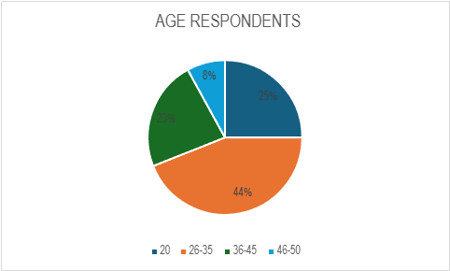

**DATA INTERPRETATION AND INFERENCE**

The table given above shows that 25% of the respondents are >20, 44% of the respondents are 26-35, 23% of the respondents are 36-45 and 8% of the respondents are 46-50.

**2) GENDER RESPONDENTS**

|  |  |  |
| --- | --- | --- |
| **GENDER** | **NO OF RESPONDENTS** | **PERCENTAGE** |
| MALE | 100 | 100 |
| FEMALE | 0 | 0 |
| TOTAL | 100 | 100 |

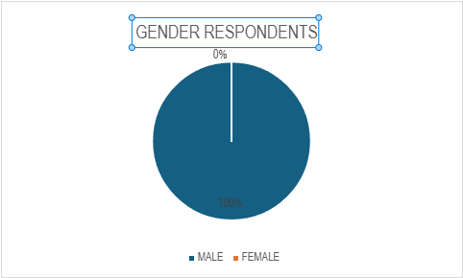

**DATA INTERPRETATION AND INFERENCE**

The table given above shows that 100% of the respondents are male and 0% of the respondents are female.

**3) SATISFACTION OF SOCIAL ACTIVITIES IN TRAINING**

|  |  |  |
| --- | --- | --- |
| **SATISFACTION OF SOCIAL ACTIVITIES IN TRAINING** | **NO OF RESPONDENTS** | **PERCENTAGE** |
| STRONGLY AGREE | 36 | 36 |
| AGREE | 27 | 27 |
| NEUTRAL | 23 | 23 |
| DIAGREE | 12 | 12 |
| STRONGLY DISAGREE | 2 | 2 |
| TOTAL | 100 | 100 |

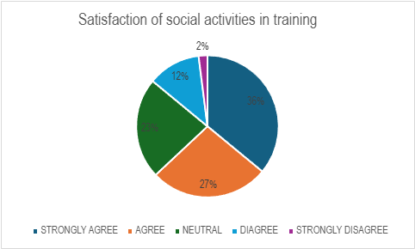

**DATA INTERPRETATION AND INFERENCE**

From the above table its how’s that 36% of the respondents are strongly agree, 27% of the respondents are agree, 23% of the are respondents are neutral, 12% of the respondents are disagree and 2% of the respondents are strongly disagree.

**4) OVERALL SATISFACTION OF TRAINING**

|  |  |  |
| --- | --- | --- |
| **OVERALL SATISFACTION OF TRAINING** | **NO OF RESPONDENTS** | **PERCENTAGE** |
| STRONGLY AGREE | 37 | 37 |
| AGREE | 47 | 47 |
| NEUTRAL | 12 | 12 |
| DISAGREE | 4 | 4 |
| STRONGLY DISAGREE | 0 | 0 |
| TOTAL | 100 | 100 |

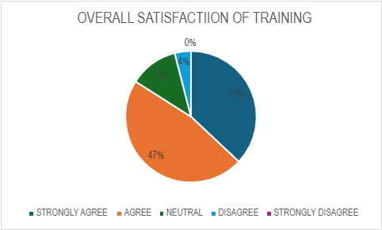

**DATA INTERPRETATION AND INFERENCE**

From the above table it shows that 37% of the respondents are strongly agree, 47% of the respondents are agree, 12% of the are respondents are neutral, 4% of the respondents are disagree and 0% of the respondents are strongly disagree.

**SUGGESTION**

* Suggestion scheme may be opened for staff and technicians. The mains advantage is that would help convince that the organization “Listen to them” and they are the part of organization.
* Training should aim at improving the skill of the employees and so that training should be practically given by importing it on the job.
* Suggestion and experience from other business homes & people from related field should also be taken & in calculated if used.
* New development programs should be used.
* External and internal training program should be connected with each other
* Management can increase the training period for freshers.

**CONCLUSION**

Teamwork has become an essential concept within organizations as many large, ambitious projects demand collaborative efforts. Building effective teams is a crucial step towards achieving sustainable, high-quality results. Companies have increasingly focused on training programs designed to help employees work together more efficiently and accomplish shared objectives, regardless of whether colleagues are physically present or working remotely. As traditional structures are being reformed, organizations are striving to become more adaptable to rapid environmental changes and more responsive to customer needs. The analysis of the questionnaire clearly indicates that implementing an effective training program is essential. Timely and well-organized training sessions are necessary for both new and existing employees to enhance their skills and maintain high performance standards. The findings also reveal that AOTS training is highly valuable for employees, significantly boosting their knowledge, skills, and overall competence. As a result of this training, employees have shown marked improvements in areas where they previously struggled. They have become more creative, responsible, and confident, with enhanced communication skills and heightened awareness of Japanese practices and culture. Additionally, their ability to draft well-structured proposals and demonstrate sound management skills has significantly improved. Safety consciousness among trained employees has also increased, and they have experienced a rise in income levels as a result of their enhanced competence. Furthermore, these employees actively share their training experiences with colleagues, contributing to the collective development of knowledge and skills within the team.

**REFERENCE**

* A competency– based“ hand-on”, training package for direct -care staff, Mary R Burch, MaxinL Reiss, jon S Bailoy, March 1,1987 , vol 12.
* Vocational education and training : a review of world bank investment, middleton, john, demsky, terry, apr 1989 page 143.
* Getting to grips with competency - based & assessment, foyster, john, 1990
* Education and training for the informal sector, mcgrath, simon, mar 1995, volume 2,147
* Competency- based training, review of research, misko, josle, 1999