**OPTIMIZING PROPERTIES OF CONCRETE BY SWAPPING M30 SOLID CEMENT WITH ONION PEEL ASH (OPA) AND GROUND GRANULATED BLAST FURNACE SLAG (GGBS)**

**Bolledula Bhanu Prakash 1, Vanam Sameer Kumar 2**

1PG Student, Civil Engineering, Dr.K.V.Subba Reddy Institute of Technology, Kurnool, Andhra Pradesh, India

2Assistant Professor, Civil Engineering, Dr.K.V.Subba Reddy Institute of Technology, Kurnool, Andhra Pradesh, India

**ABSTRACT**

The suggestion for the use of Agricultural by-products supplies an environmentally friendly strategy for lowering waste and boosting concrete performance. The concrete industry might reduce its adverse environmental effects, facilitate recycling, and use locally sourced, renewable materials. This change minimizes landfill pull and promotes a circular economy in building materials.

The focus of the project includes both Ground Granulated Blast Furnace Slag (GGBS) and onion peel ashes (OPA) have been investigated as partial substitutes for cement in concrete. The objective is to reduce decrease dependence on Portland cement, and improve the sustainability of concrete. When onion peels are burned, a byproduct known as onion peel ash is produced. The pozzolanic capabilities are attributed to the high silica content in the ash. GGBS is a byproduct from the steel sector, particularly from the blast furnace method of rapidly cooling (granulation) liquid iron slag. Combining OPA with GGBS: A mixture consisting OPA and GGBS is typically applied; however, this must be changed according to the necessary performance and regional conditions. The GGBS & OPA both are replaced in place of cement by maintaining GGBS as constant with 15% and OPA with ascending follows from 0%, 4%, 8%, 12%, 15% & 20% in M30 Solid.

Furthermore, the comparison is made between the regular Solid and Solid mixed with proxies such as 0%OPA+0%GGBS, 4%OPA+15%GGBS, 8%OPA+15%GGBS, 12%OPA+15%GGBS, 15%OPA+15%GGBS, and 20%OPA+15%GGBS.

**Keywords:** Portland cement, Onion Peel Ash (OPA), Ground Granulated Blast Furnace Slag (GGBS), & M30 Solid.

1. **INTRODUCTION**

Cement, aggregates such as sand, gravel or stone, and water make up the cement. Despite being the most frequently used construction material in the world, concrete is getting more and more difficult to procure. There are a variety of concerns affecting these raw resources.

The first restriction is the Sand restriction. There has been an exponential growth in mining and usage of sand owing to its rising demand, notably in building. As a consequence, local shortages have emerged. The usage of sand has also been found to impact the environment, such as by shifting river channels or harming other ecosystems.

The second task is the Environmental task. The manufacturing of cement is an energy intensive process that leads to substantial greenhouse gas emissions which eventually adds to global warming. Also, there are locations which have no significant limestone reserves, therefore producing cement looks unfeasible.

The third concern is the Pressure on Domestic Supply. Rock and sand which are fundamental source in the manufacture of cement are already in depletion stages in different places since the mining of such raw materials might over time leads to pollution of the environment as well as deplete the existing supplies.

* 1. **WHAT IS ONION PEEL ASH (OPA)?**

Onion peel ash is the residue left behind following burning of onion peels. Onion peels, which are commonly discarded as agricultural waste, are high in these nutrients and minerals. In particular, the agricultural, construction, and future textile sectors need such ash and its capacity to survive hard circumstances when combined with concrete.

**1.2.1 MAKE-UP OF ONION PEEL ASH:**

Several elements and compounds present within onion peel ash, including the following:

* Calcium (Ca): A difference in the increase of the quality and consistency of concrete is documented.
* Potassium (K): It is utilized in the fertilization of plants and may also impact the hydration rate of cement.
* Magnesium (Mg): Of major relevance to the characteristics of concrete.
* Silica (SiO2): Harnessed from the ashes of numerous plants, silica helps strengthen both the strength and chemical endurance of the concrete.
* Trace Components: Onion peel ash also includes additional trace elements such as iron, phosphorus, and sulfur.

**1.2.2 EMPLOYMENTS OF ONION PEEL ASH:**

* Onion peel ash may be used as a partial replacement for cement in building. The silica present in the ashes has the ability to improve the structural strength of the concrete, comparable to cement. It may also be used to partially replace Portland cement, so reducing the negative environmental effect of cement manufacturing.
* ***Enhanced Performance:*** The use of natural volcanic ash in concrete is believed to enhance properties such as chemical resistance, water retention, and temperature stability.

**1.2.3 BENEFITS OF ONION PEELING ASH:**

* ***Environmentally friendly:*** It aids in waste minimization and might be a low-cost, non-polluting alternative to certain traditional building materials.
* ***Better Concrete Performance Characteristics:*** According to certain research, onion peel ash may increase the workability, durability, and strength of concrete, particularly in terms of resistance to chemical attack and cracking.
  1. **WHAT IS GROUND GRANULATED BLAST FURNACE SLAG (GGBS)?**

GGBS denotes Ground Granulated Blast-furnace Slag, which may function as a byproduct of the steel manufacture process. It is created by quickly cooling molten iron slag from a blast furnace using water or steam, a method called as granulation, and then grinding it into a fine powder. GGBS is frequently exploited as a partial substitute for Portland cement in concrete manufacturing.

**1.3.1 COMPOSITION OF GGBS:**

GGBS principally comprises:

* Silica (SiO₂): Aids in strengthening the strength and durability of concrete.
* Alumina (Al₂O₃): Enhances workability and strength as time goes.
* Calcium Oxide (CaO): Assists in producing the cementitious chemicals when coupled with water.
* Magnesium Oxide (MgO): Contributes to the development of strength over the long term.
* Iron Oxide (Fe₂O₃): Enhances the chemical resistance and overall efficacy of concrete.

**1.3.2 ADVANTAGES & USES OF GGBS**

* Sustainability
* Improved Workability
* Reduced Hydration Heat
* Long-Term Enhancement of Quality
* Carbon Footprint Reduction
* ***In Concrete***: GGBS is generally exploited as a partial substitute for Portland cement in the making of concrete. It has the potential to replace up to 70% of the cement in a combination, dependent upon the individual application.
* ***High-strength concrete***: Employed in high-performance concrete for large-scale foundation constructions.
* ***Durable concrete***: Ideal for maritime constructions, sewage treatment facilities, and diverse scenarios exposed to severe chemicals or dampness.
* ***In Mortar***: GGBS may also be employed in mortar formulations for better workability and strength.

**1.4 MANUFACTURING PROCESS OF MAKING ONION PEEL INTO ASH:**

* Collection and Cleaning: Onion skins are collected, generally as a secondary product of onion processing, then washed to eliminate impurities by cleaning.
* Drying: The washed skins are dried (either by natural air or by a mechanical drier) to decrease moisture levels, enhancing combustion efficiency and the quality of the generated ash.
* Burning or Combustion: The dried skins are torched at tremendous temperatures, either in open flames or controlled ovens, where they break down into ash.
* Cooling and Collection: Following burning, the ash is allowed to cool for safe handling and is then collected in containers as a fine, grayish or white powder.
* Processing of Ash (Optional): The ash may be treated to a finer texture or subjected to chemical treatment, particularly if it is intended for specialist purposes such as fertilizer.
* This procedure leads to the transformation of onion peel refuse into a beneficial byproduct as ash, which serves various purposes across multiple industries.
* Now the idea is implanted to use this ash in place of cement with suitable percentages.

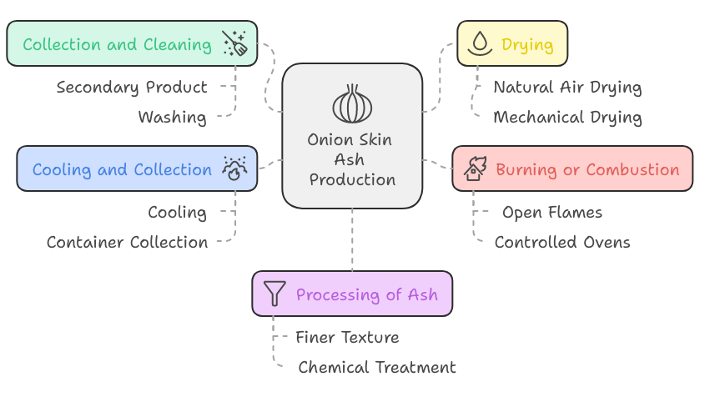

**Figure 1:** The procedure of manufacturing ash from onion peel.

1. **METHODOLOGY**

The Methodology describes the proxies used in place of cement done over this paper:

* Investigating the use of ground granulated blast furnace slag (GGBS) at a fixed ratio of 15% to cement and onion peel ash (OPA) at proportions of 4%–20% for M30 Solid.
* Compressive strength characteristics for 150 x 150 x 150 mm cubes are evaluated.
* Tensile strength characteristics for cylinders of 150 mm in diameter and 300 mm in height are examined.
* Evaluation of 500 x 100 x 100 mm beams' bending strength characteristics

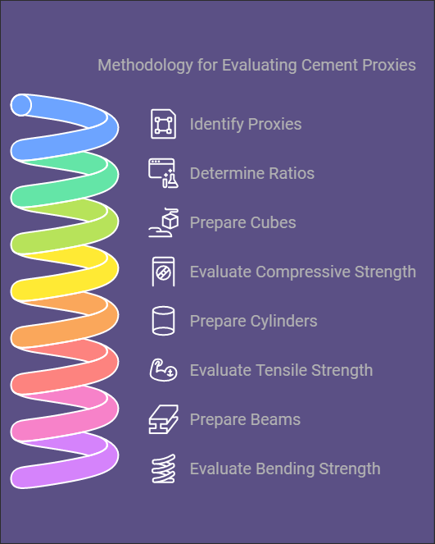

**Figure 2:** Steps involved in methodology of with respect to proxies.

1. **MATERIALS USED**

**Cement:**

It exhibits a cementitious structure that, upon contact with water, establishes a strong adhesion inside the stone. The chemical constituents of the cement persist in the final product, augmenting its advantageous characteristics and facilitating its amalgamation with the cement. The cement used is JAYPEE Cement, especially Standard Portland Cement (OPC 43 Review).

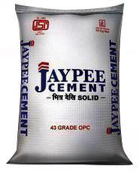

**Figure 3:** Type of Cement

**Fine Aggregate:**

Particles as tiny as 4.75 mm in size are known as fine aggregates, and they find widespread use in the building industry. Primarily composed of 77% calcium oxide, their principal role is to fill the spaces between bigger aggregates. Because of this addition, the concrete mixture is more dimensionally stable. In this case, the sand comes from a nearby location and meets the requirements for zone I. Furthermore, it has been tested in a laboratory setting using sieve analysis in accordance with the guidelines provided in IS 383:1970.

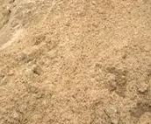

**Figure 4:** Fine Aggregate

**Coarse Aggregate:**

Quarrying produces rough aggregates, which are irregularly shaped bits of varying sizes used for building tasks. These sizes are widely accessible on the market, including those larger than 40mm, as well as 20mm and 10mm. Their inclusion greatly increases the strength of concrete. The amount used is typically one, with a specified measurement of 20mm in compliance with the IS 383-1970 standard.

.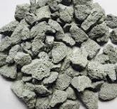

**Figure 5:** Coarse Aggregate

**Water:**

Since water actively participates in the chemical reaction with cement, it is essential to concrete. Tap water is used for mixing and curing throughout the manufacturing process. The pH level is measured at 6.8.

**Onion Peel Ash (OPA):**

Onion peel ash is the waste derived from the burning of onion peels. While these peels are typically thrown aside, their burning creates an ash that is wealthy in a variety of minerals and useful chemicals. This ash is especially noted for its high amount of potassium, calcium, phosphorus, and numerous micronutrients. Additionally, onion peel ash serves as a potential lightweight alternative for usage as a fill material in cement applications, delivering a sustainable choice compared to standard fill materials.



**Figure 6:** Onion Peel Ash (OPA)

**Ground Granulated Blast Furnace Flag (GGBS):**

Ground Granulated Blast Furnace Slag (GGBS) is an industrial by product obtained from the iron manufacturing process, primarily from the operation of a blast furnace where iron ore is coupled with coke and limestone. The descriptor "granulated" signifies the quick cooling of the molten slag by the application of water or steam, resulting in a glass-like, amorphous material. Once this granulated substance is finely crushed, it is classed as GGBS. This substance is widely employed as a supplemental cementitious ingredient in concrete formulations, where its integration with conventional Portland cement (OPC) greatly enhances different performance parameters of the concrete.

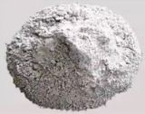

**Figure 7:** Ground Granulated Blast Furnace Flag (GGBS)

**Table No 1.** Physical properties of Onion Peel Ash (OPA):

|  |  |  |
| --- | --- | --- |
| **S. No** | **Physical Property** | **Onion Peel Ash (OPA)** |
| 1 | Size of Particle | Fine, typically below 100 microns |
| 2 | Color | Light gray to brownish |
| 3 | Density | 0.4 to 0.6 g/cm³ |
| 4 | Water absorption | 3–5% |
| 5 | Specific Gravity | 2.37 |

**Table No 2.** Physical properties of Ground Granulated Blast Furnace Flag (GGBS)

|  |  |  |
| --- | --- | --- |
| **S. No** | **Physical Property** | **Ground Granulated Blast Furnace Flag (GGBS)** |
| 1 | Size of Particle | Typically, finer than 45 microns (usually around 30–50 microns) |
| 2 | Color | Light grey to off-white |
| 3 | Density | 1.1 to 1.3 g/cm³ |
| 4 | Water absorption | Less than 1% |
| 5 | Specific Gravity | 2.92. |

1. **LITERATURE REVIEW**

Alternative cement manufacturing methods are being investigated due to the growing demand for eco-friendly building materials. Organic waste materials like onion peel ash (OPA) and industrial byproducts like Ground Granulated Blast Furnace Slag (GGBS) may reduce cement manufacturing's environmental impact. This literature study discusses onion peel ash and GGBS as partial cement alternatives, including their pros and cons in concrete manufacturing.

**Ramesh Vandanapu, Vidya Mohanan et.al;** Compared to control concrete without additive, concrete with GGBS replacement (0%–60%) had no increase in compressive strength at all testing ages (7, 14, and 28 days). The low pozzolanic reactivity expected to increase compressive strength may explain this lack of improvement. Even with 50% cement replacement, compressive strength after 28 days remained above the intended mean strength (38.25 MPa) for M30 concrete, despite a reduction in compressive strength. Flexural strength up to 30% replacement level was unclear, possibly due to cementitious compound delays or incomplete development. Flexural strength increased when cement substitution with GGBS topped 30%. GGBS replaced more cement, reducing concrete slump. GGBS, a finer substance than cement, requires more water to accommodate its surface area. Finally, the flexural strength of concrete was found to be 10% to 20% of its compressive strength, increasing when GGBS substituted cement. <https://doi.org/10.1109/ICASET.2019.8714522>

**Reshma Rughooputh and Jaylina Rana (2014)** conducted a study on the impact of partially substituting cement with ground granulated blast furnace slag (GGBFS) in concrete. Their research focused on various concrete properties, including compressive strength, tensile strength, splitting strength, flexural strength, modulus of elasticity, drying shrinkage, and initial surface absorption. The experiments involved replacement levels of 30% to 50% of ordinary Portland cement (OPC) with GGBFS, evaluated at 7 and 28 days. The findings indicated that while the compressive strength was lower at early ages, it improved significantly over time. Specifically, the flexural strength of the specimens increased by 22% and 24%, while tensile strength rose by 12% and 17% for the 30% and 50% replacement levels, respectively. Additionally, drying shrinkage showed an increase of 3% and 4%, and the static modulus of elasticity improved by 5% and 13%. The study concluded that the optimal mix was achieved with a 50% replacement of GGBFS.

**Hanifi Binici , Orhan Aksogan (2016)** The thermal conductivity coefficients of samples composed of onion skins and peanut shells are significantly lower, ranging from 3.5 to 5 times less than those of the control samples. This reduction is attributed to the fiber composition. These lightweight construction materials are expected to contribute to substantial energy savings in buildings. Additionally, the use of waste materials from onion skins and peanut shells results in a notable reduction in sound permeability values, while maintaining compressive and flexural strengths that meet the required standards. <https://doi.org/10.1016/j.mtcomm.2016.09.004>

**Yehudy Yelitza Lizcano-Delgado et; al (2024)** As resources become scarcer and water is increasingly polluted with heavy metals from rising production levels, a plentiful agro industrial waste like onion peel could help address water treatment needs. Onion peel is a cost-effective option with a strong ability to remove Co2+ from water without harming the environment. The onion peel being examined is a mesoporous material that is high in carbohydrates. These carbohydrates have C=O and O–H groups that aid in the biosorption of cobalt. The outer layer of the biosorbent gets coated with Co2+ until it reaches saturation in a process that is exothermic, non-spontaneous, and partially reversible. Several factors can affect how Co2+ interacts with the biosorbent, including the size of the onion peel particles, the initial concentration of Co2+, the pH and temperature of the solution, and the contact time. The results indicate that the removal of Co2+ by onion peel involves both physical and chemical sorption, with key mechanisms being electrostatic attraction, ion exchange, and chemisorptions. <https://doi.org/10.3390/pr12061263>.

1. **MIX DESIGN & SLUMP VALUE**

**Table No 3.** Slump Cone values

|  |  |
| --- | --- |
| **Mix % Replacement** | **Slump value in mm** |
| 0%OPA + 0%GGBS | 100 |
| 4%OPA + 15%GGBS | 103 |
| 8%OPA + 15%GGBS | 108 |
| 12%OPA + 15%GGBS | 113 |
| 15%OPA + 15%GGBS | 99 |
| 20%OPA + 15%GGBS | 93 |

**Graph No 1:** Slump Cone values

**Table no 4:** Mix proportion of M30

|  |  |
| --- | --- |
| Grade | **M30** |
| Proportion | **1:1.66:2.18** |
| W/C ratio | **0.41** |
| Cement | **428.47** |
| Fine Aggregate | **712.67** |
| Coarse Aggregate | **934.28** |
| Water | **197.16** |

1. **TEST RESULTS**

**Table no 5** Test results of Compressive Strength at 7 days, 14 days & 28 days:

|  |  |  |  |
| --- | --- | --- | --- |
| **Mix % Replacement** | **7 days in Mpa** | **14 days in Mpa** | **28 days in Mpa** |
| 0%OPA + 0%GGBS | 25.82 | 30.83 | 36.19 |
| 4%OPA + 15%GGBS | 26.24 | 31.21 | 37.57 |
| 8%OPA + 15%GGBS | 26.62 | 31.59 | 37.95 |
| 12%OPA + 15%GGBS | 27.01 | 31.98 | 38.53 |
| 15%OPA + 15%GGBS | 23.39 | 26.25 | 32.51 |
| 20%OPA + 15%GGBS | 21.25 | 22.92 | 28.21 |

**Graph No 2:** Contrast values of Compressive strength for 7 days, 14 days & 28 days

**Table no 6** Test results of Split Tensile Strength at 7 days, 14 days & 28 days:

|  |  |  |  |
| --- | --- | --- | --- |
| **Mix % Replacement** | **7 days in Mpa** | **14 days in Mpa** | **28 days in Mpa** |
| 0%OPA + 0%GGBS | 1.25 | 1.65 | 2.03 |
| 4%OPA + 15%GGBS | 1.51 | 1.93 | 2.49 |
| 8%OPA + 15%GGBS | 1.79 | 2.27 | 2.78 |
| 12%OPA + 15%GGBS | 1.98 | 2.58 | 3.02 |
| 15%OPA + 15%GGBS | 1.16 | 1.45 | 1.79 |
| 20%OPA + 15%GGBS | 0.92 | 1.12 | 1.35 |

**Graph No 3:** Contrast values of Split Tensile strength for 7 days, 14 days & 28 days

**Table no 7** Test results of Flexural Strength at 7 days, 14 days & 28 days:

|  |  |  |  |
| --- | --- | --- | --- |
| **Mix % Replacement** | **7 days in Mpa** | **14 days in Mpa** | **28 days in Mpa** |
| 0%OPA + 0%GGBS | 3.13 | 4.64 | 5.05 |
| 4%OPA + 15%GGBS | 3.38 | 4.98 | 5.48 |
| 8%OPA + 15%GGBS | 3.63 | 5.27 | 5.76 |
| 12%OPA + 15%GGBS | 3.86 | 5.61 | 6.08 |
| 15%OPA + 15%GGBS | 2.92 | 3.41 | 4.68 |
| 20%OPA + 15%GGBS | 2.43 | 3.09 | 4.31 |

**Graph No 4:** Contrast values of Flexural strength for 7 days, 14 days & 28 days

1. **CONCLUSION**

Based on the foregoing considerations and developments, this essay can be concluded by concentrating on the following points:

* The result clearly shows that the substitution of GGBS & OPA both are replaced in place of cement by maintaining GGBS as constant with 15% and OPA with ascending follows from 0%, 4%, 8%, 12%, 15% & 20% in M30 Solid.
* Based on results as considered the compressive quality, ductile quality & flexural quality attained maximum strength at percentage of replacing 12%OPA+15%GGBS.
* The maximum Compressive strength quality gained for 28 days is 38.53 MPa.
* The maximum Tensile strength quality gained for 28 days is 3.02 MPa.
* The maximum Compressive strength quality gained for 28 days is 6.08 MPa.
* It can be referred as green concrete due to the replacement of agro based waste OPA.

1. **REFERENCES**
2. Vandanapu, R., Mohanan, V., & Selvan, C. P. (2019). Understanding the influence of replacing cement with GGBS on compressive and flexural strengths of concrete at medium workability conditions. 2022 Advances in Science and Engineering Technology International Conferences (ASET), 1–4. https://doi.org/10.1109/ICASET.2019.8714522
3. Reshma Rughooputh and Jaylina Rana Partial Replacement of Cement by Ground Granulated Blast furnace Slag In Concrete Journal of Emerging Trends in Engineering and Applied Sciences (JETEAS) 5(5): 340-343 © Scholarlink Research Institute Journals, 2014 (ISSN: 2141-7016)
4. Karri, S. K., Rao, G., & Raju, P. (2015). Strength and Durability Studies on GGBS Concrete. International Journal of Civil Engineering, 2(10), 34–41. https://doi.org/10.14445/23488352/IJCE-V2I10P106
5. M. Pavan Kumar , Y.Mahesh The Behaviour of Concrete by Partial Replacement of Fine Aggregate with Copper Slag and Cement with GGBS - An Experimental Study IOSR Journal of Mechanical and Civil Engineering (IOSR-JMCE) e-ISSN: 2278-1684,p-ISSN: 2320-334X, Volume 12, Issue 3 Ver. III (May. - Jun. 2015), PP 51-56 DOI: 10.9790/1684-12335156
6. Binici, H., & Aksogan, O. (2016). Insulation material production from onion skin and peanut shell fibres, fly ash, pumice, perlite, barite, cement and gypsum. Materials Today Communications, 10, 14–24. https://doi.org/10.1016/j.mtcomm.2016.09.004
7. A.O. Familusi, B. E. Adewumi, F. I. Oladipo, D. A. Ogundare, and J. O. Olusami effects of blast furnace slag as a partial replacement for cement in concrete September 2017 Conference: International Conference on Sciences, Engineering and Environmental Technology (ICONSEET 2017) At: Federal Polytechnic Ede Nigeria
8. Magandeep, Ravikanth Pareek, and Varinder Singh Utilization of Ground Granulated Blast Furnace Slag to Improve Properties of Concrete International Journal on Emerging Technologies 6(2): 72-79(2015) ISSN No. (Print) : 0975-8364.
9. Kumar, V. S. (2023). Examination of Halfway Substitution of Cement M20 Concrete with Silica Rage and Quartz Sand in Fine Total. INTERANTIONAL JOURNAL OF SCIENTIFIC RESEARCH IN ENGINEERING AND MANAGEMENT, 07(08). https://www.doi.org/10.55041/IJSREM25269