**Pharmacological, Traditional, And Medicinal Aspects Of Cassia Alata (Senna Alata) Of Diverse Parts**

**Miss.Kajal Vishwakarma1,Mr.Awan Kumar Pandey1 , Mr.Ankit Kumar Vishwkarma2 ,Mr.Ramjivan Singh3**

**1Department of Pharmacy; S.N. College of Pharmacy AKTU, Lucknow Jaunpur Uttar Pradesh 222132.**

**2Department of Pharmacognosy; Kunwar Haribansh Singh College of Pharmacy AKTU, Lucknow Mahrupur Jaunpur Uttar Pradesh 222182.**

**3Department of Pharmaceutics; Vijay Pharmacy College AKTU, Lucknow Gulalpur Jaunpur Uttar Pradesh 222132**

**Abstract**

Herbalism has a lengthy history of use outside of traditional medicine.It is becoming increasingly common as improvements in examination and quality control, as well as advances in clinical research, reveal the value of natural medicine in treating and preventing illness.The World Health Organisation reports that more than 60% of people rely on conventional medications.Plants were used for medicinal purposes long before any history was written.

Herbal medications are one type of dietary supplement. They are sold as tablets, capsules, powders, teas, extracts, and new or dried plants. This article focuses to enhance and prepare a comprehensive review on pharmacological, medicinal and traditional value of Cassia alata plant. Cassia species are outstanding plant broadly dispersed in India and other tropical nations. Diverse parts of the plant (leaves, seed, and root) are presumed for their medicinal values. Several chemical compounds such as anthraquinone glycosides, naphthopyrone glycosides, phenolic compounds, flavonoids etc. have been isolated from this plant and well recognized traditional medicine as laxative and is effective for treatment of leprosy, ringworm infection, ophthalmic, skin diseases and liver disorders. The pharmacological, medicinal and traditional value reported in present review to confirm the therapeutic value of Cassia species to different developing countries. Therefore, this review may provide the compiled information which will guide to develop the novel agent for various disorders from Cassia species. Based on several scientific studies and review articles on Cassia alata species, this plant may suggest a gigantic biolog - ical potential.

**Key words:** Cassia alata, pharmacology, traditional medicine

**Introduction ­**

World Health Organization (WHO) estimates 60 % of individuals living in developing countries believe completely on ancient medicines for their health care (WHO 2000). However, ­e most important ingredients are obtained from medicinal plants. It has been discovered that majority of contemporary drugs are plant-derived therapeutic agents. In the United States, 78% of prescription drug are based on natural sources (Roberson 2008). ­is might be attributed to the very fact that several plants contain a phytochemicals that have found import - ant applications within the ‑eld of human drugs. Natural products play a dominant role within the development of novel drug- leads for the treatment and cure of illness (Newman et al. 2003). Senna alata (Figure 1), commonly named ringworm cassia as the plant leaves were used for treatment of ringworm. It is also, commonly named candle or bush empress candle plant , is so called due to the erect ower spikes when in bud appear like yellow candles.It is a tropical tree that typically grows to 4 m in height with horizontal branche. ­e fruits are straight, up to 25 cm long, black and winged pods. It is oen used speci‑cally as treatment against ringworm, fungicidal. It also has antibac-terial,laxative,anti-inammatory,anti-tumor,and,diuretic properties. (https://pfaf.org/user/Plant.aspx?Latin - Name=Senna+alata/14/10/2018).

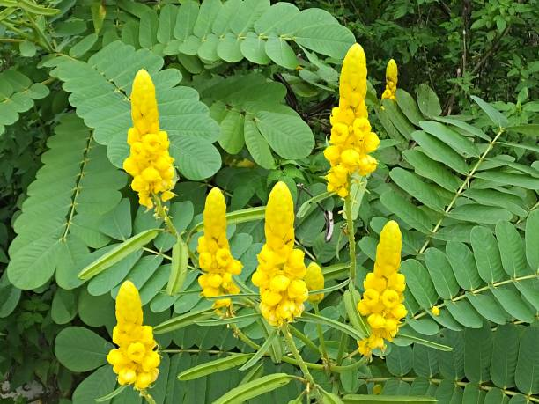

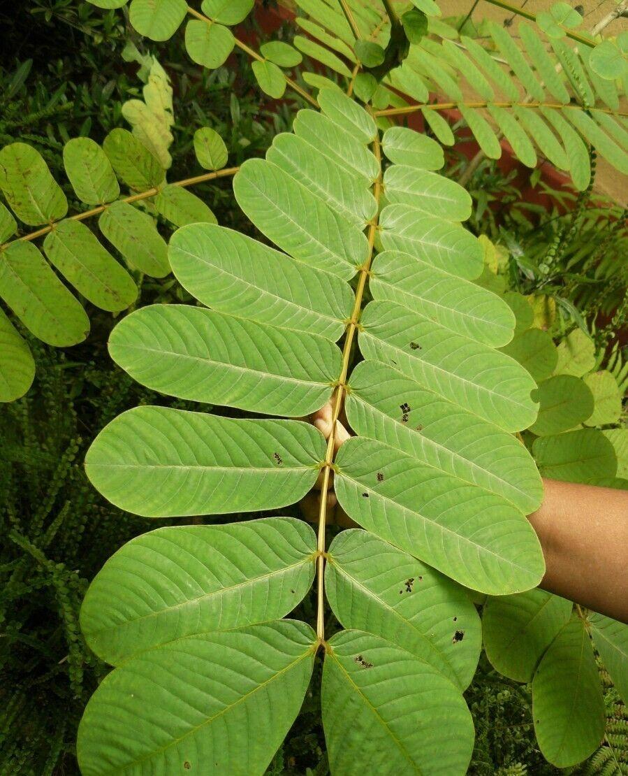

**Cassia alata (whole plant, flower and seeds) adopted from internet.**

­the purpose of this review is to update and provide complete knowledge of the traditional use, chemical constitu - ent, pharmacological activities. Additionally, an elaboration with critical review for the performed experimental studies was made to justify evidences the traditional uses of Cassa alata and to recommend future studies and research.

**Ethnopharmacological Studies**

Complementary and alternative medi - cine is largely found in developing countries such as Africa and Asia. ­is is due to the fact that the people of these countries have their own way of healing via traditional herbs that has been practiced in their culture for ages (Nadimpalli 2017). Ranging from many particular species and sizes, Cassia plants are having plenty bene‑ts for medicinal purposes. In traditional medicine, this plant has been recognized for its bene‑cial medicinal properties such as antimi - crobial (Durapandiyan et al. 2006), antifungal (Makinde et al. 2007), purgative (Ral 1978) anti-inammato - ry (Moriyama et al. 2003), analgesic (Belkin & Fitzgerald 1952), antitumor (Paria 2005), It is called as Ringworm shrub and winged senna in English while in Sanskrit it is known as Dadrughna and Dvipagsti. Also in Tamil, semaiagathi and Vandugolli is the name used for the plants by the locals. It has also famous with its common name for example, Candle bush, Emperor Candle stick, Christmas candle, Acapulo, Ringworm bush and Calabra bush. Apart from that, in Nigeria, the plant is famously known as Ewe Asunwon Oyinbo’. Wild senna (Cassia alata) is found in Ghana and Brazil, but it is now largely distributed in the United States of America and all over Africa, including Nigeria (Adelowo & Oladeji 2017)

**Ethnomedical uses**

The claim efficacies in Thai ethnomedical textbook are as follows (Farnsworthand Bunyapraphatsara, 1992),

**Stems** Treatment of yaws, ringworm, Tenea versicolor, constipation, urinary stone, anthelmintic and cardiotonic

**Leaves** Treatment of skin diseases, urinary stone, ringworm, Tenea versicolor, laxative, cardiotonic and expectorant

**Flowers** Laxative and improvement of appearance and texture of skin

**Pod** As an anthelmintic

**Seed** Treatment of skin diseases, constipation and as an anthelmintic

**Whole plant** As an anthelmintic and antipyretic

**Not specific part** Treatment of skin diseases, haemorrhoids, chronic gastrointestinal aliments of children between the ages of 5 and 13 years characterized by marked malnutrition, usually associated with intestinal parasitism.

**Chemical Constituent of various part of cassia alata.**

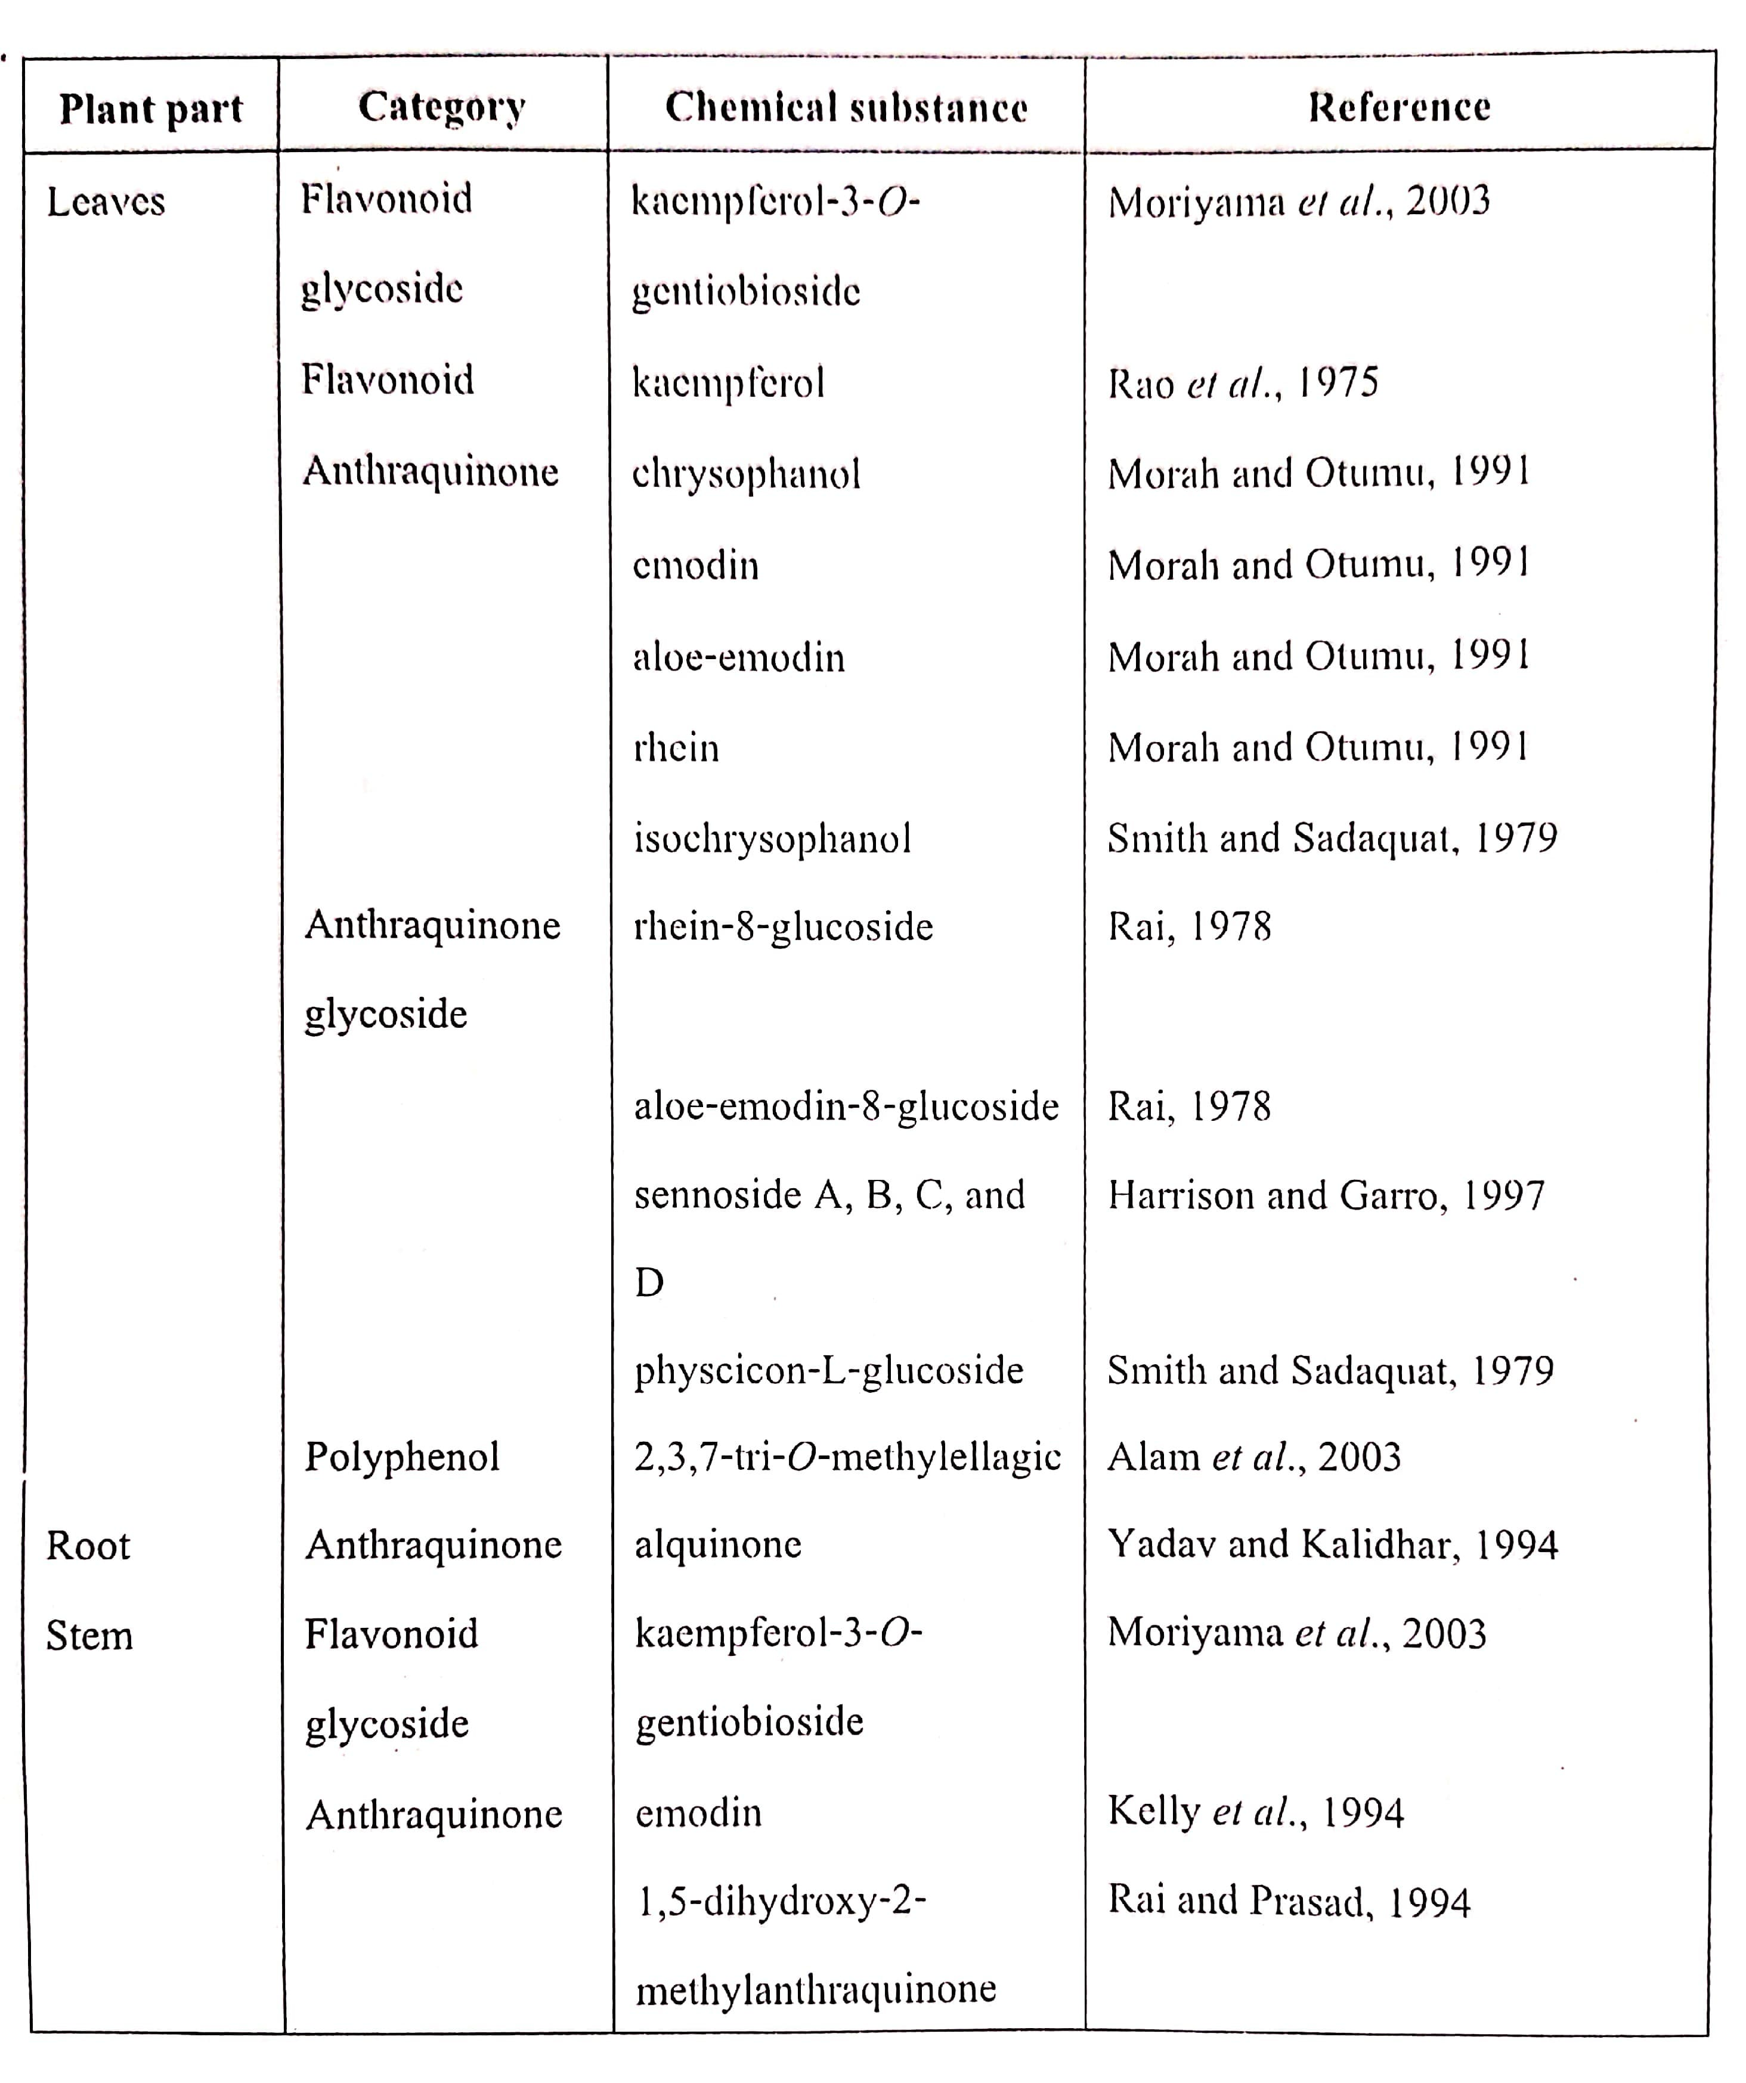

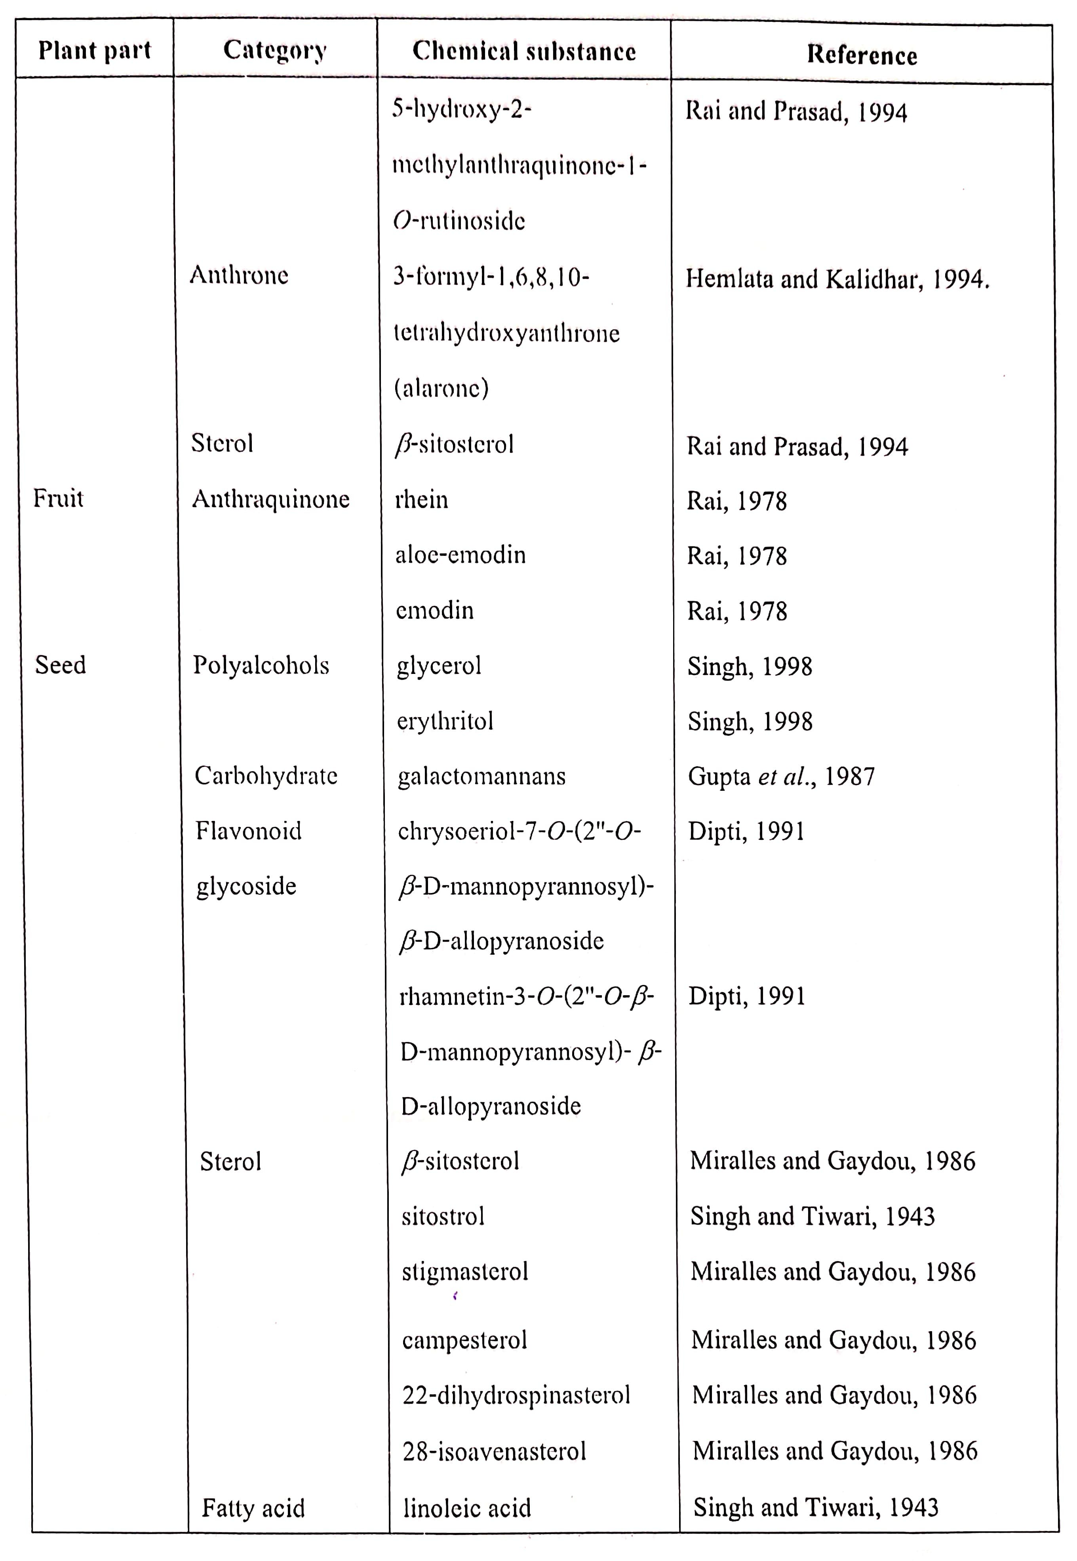

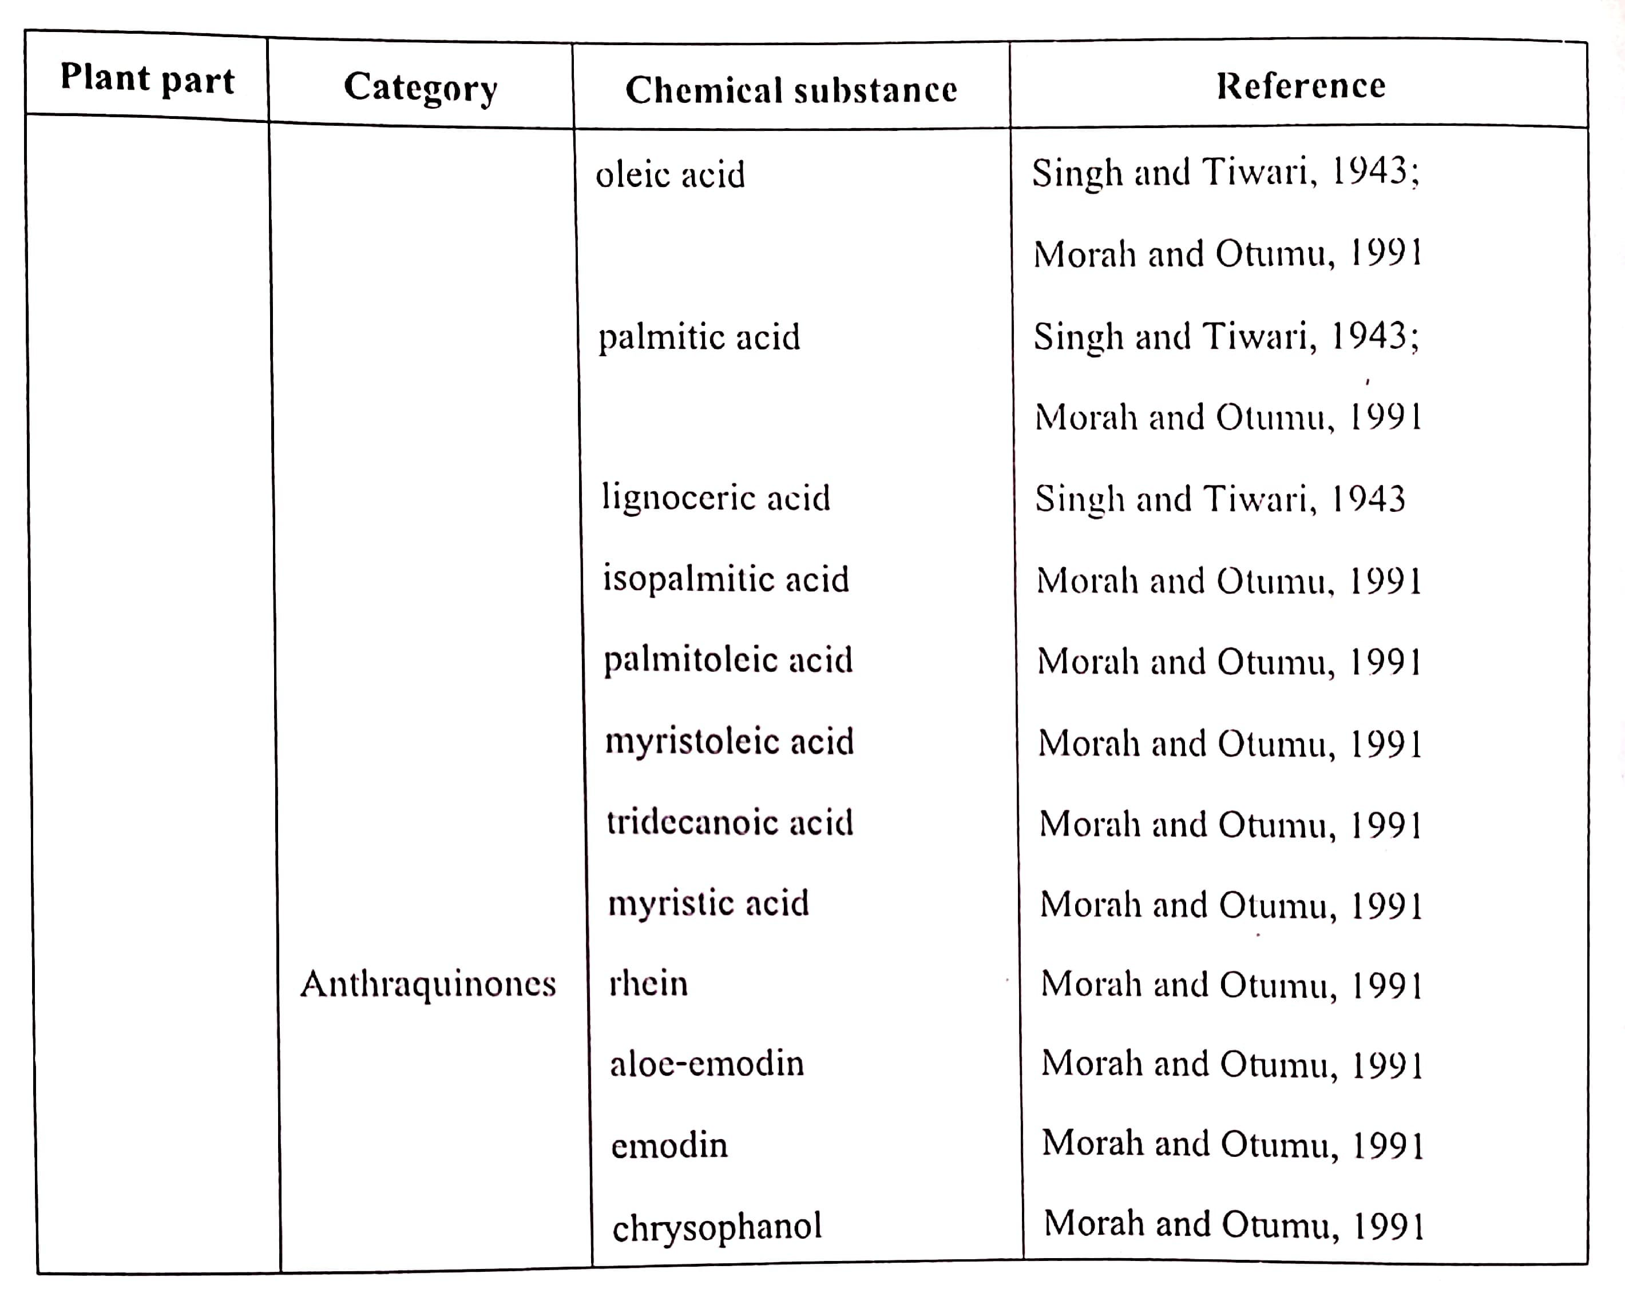

**Chemical Constituent**

Phytochemical studies are known as an assessment done in order to provide the scienti‑c components and the therapeutic potency of a plant. Gener - ally, the screening of the plants phyto - chemicals with healing potency has increased the interest of researchers on discovering type and amount of constituents of each medicinal plant. ­ere is variety type of measures in the procedure of analyzing these phyto - chemicals screening. For Cassia alata plant, it is reported that it contains variety of bioactive compound. It is also stated that, in the most recent studies, the identi‑cation and also the isolation of these thera - peutic compounds of medicinal plants are important for speci‑c disease (Oladeji 2016). In order to promote Cassia alata as herbal medicine, thus the curative and the therapeutic eects must be studied. ­e major component that has been isolated from the HPLC studies is known as ethyl acetate. ­is fraction was isolated with the aid of a combina - tion of gel ‑ltration and silica gel-based chromatography system. From the use of the spectroscopic analysis studies, there were two compounds derived from the ethyl acetate and n-butanol fraction which are identi‑ed as kaempferol and kaempferol 3-O-gentiobioside (Varghese et al., 2013). ­ere are major secondary metabolites of C. alata which has been noti‑ed and it has been reported to be flavonoids including kaempferol and its glyco - sides (e.g., kaempferol-3-O-gentiobio - side and kaempferol-3-O-β-d-gluco - pyranoside), anthraquinones deriva - tives (e.g., alatonal, alatinone, chrysa - phanol, emodin, rhein, aloe-emodin), essential oils, fatty acids and terpenoids (e.g., palmitic, oleic, linole - ic acids, terpenoids (β-sitosterol, stigmasterol, campesterol) and other metabolites for instance, ellagitannins and p-hydroxybenzoic acid (Henne - belle et al., 2009).

**Pharmacological Activities**

antioxidant ability of acetone, ethanol and aqueous root extracts of Cassia alata was revised by measur - ing its DPPH and ABTS radical scavenging , its ferric reducing power and metal chelating activity, ferric reducing power. ­e ethanol extract possess high level of total phenolics and ‑avonoids with values of 78.21 mgGAE/g and 39.29 mgQE/g and exhibited the simplest antioxidant activity within the DPPH and ABTS assays (IC50 = 45.18 and 39.14 μg/mL respectively). Additionally, the aqueous extract had more potent metal chelating and reducing power than the opposite extracts. ­ese results counsel that Cassia alata root might function as new sources of antioxidants that may facilitate stop aerobic stress (Ita & Ndukwe 2017).

**Anti-Inflammatory Activity**

In a study done by Sagnia et al. (2014) the impact of plant extracts on the cytokine production of γδ T lymphocytes was investigated. Isopentenyl pyrophosphate induced TNF-a production was reserved by plant extracts in a dose dependent manner. ­e best inhibition was obtained by 1 mg of Cassia alata, . ­e impact of plant extracts on γδ T cells and immature dendritic cells (imDC) was revealed by the dose dependent reduction in TNF-α production within the presence of Cassia alata (Sagnia et al. 2014). In the hexane extract of Cassia alata, the anti-in‑ammatory mechanism was studied in Complete Freund’s Adjuvant (CFA) arthritis, as a chron - ic model of in‑ammation. ­e extract was administered to CFA arthritic animals at 500mg/kg. ­e CFA model was created by the injection of 0.5ml CFA into the synovial cavity of the proper knee joint of hind leg of rats. Changes in knee joint swelling, cartilage integrity and synovial ‑uid leukocyte counts were assessed in response to Cassia alata treatment. Assessment of the reduction in hinge joint swelling was performed by getting the circumference of the knee joint. Histological analysis was done to assess the cartilage erosion. Cassia alata considerably (p = 0.009) reduced knee joint swelling and provided protection against cartilage degradation. ­e migration of leukocytes to the blood (p= 0.002) and secretion cavity (p=0.019, 0.012, 0.028 and 0.002) was conjointly considerably reduced. ­ese results recommend potent anti-in‑am - matory activities for Cassia alata that would be probably exploited for arthri - tis therapy (Lewis & Levy 2012).

**Antimicrobial Activity ­**

There are many studies done on anti-bacterial property of Cassia alata further (Sharma et al. 2015; Adedayo et al. 2001; Ibrahim & Osman 1995). ­e antibacterial activity of Chloroform extract of the seed oil of Cassia alata and disc diusion technique was used by Mannan et al. (2011) against patho - genic gram positive and negative bacte - rial. ­e extracts showed antibacterial activity at 0.1 ml/disc concentration against Gram (-) bacteria and Gram (+) bacteria. Addiitonally, the seed oil extract showed 8mm, 9mm and 13mm inhibition zone against Staphylococcus aureus, Bacillus cereu, Bacillus subtili, respectively, and 9mm,11mm,,9mm, 10mm and 12mm zone of inhibition was shown against Gram (-) bacteri Shigella sonne, Pseudomonas aerugino - sa, Salmonella typh, E. coli, Vibrio cholera. Adedayo et al. (2001) investigatet crude and partially puried fractions of Senna alata ‑ower against 22 bacterial strains. ­e reported the puried extract was nearly as eective as standard antibiot - ics, exhibiting zones of bacterial growth inhibition ranging from 10 to 25 mm, even against multiple antibiotic resistant and not susceptible to methi - cillin, streptomycin and penicillin. A Additionally, a more recent study showed that acetone extract of root against clinically isolated B. subtilis and P. vulgaris (MTCC 441) whereas least activity was recorded in acetone extracts of root and stem against clinically isolated S. aureus and K. pneumoniae (MTCC 3384) ( Sharma et al. 2015). A previous study performed by Ibrahim & Osman (1995) reported that the extract exhib - ited high activity against many species of dermatophytic fungi but low activi - ty against non-dermatophytic fungi. It can be concluded that Cassia alata is the most potent species for having significant antimicrobial activity (Chatterjeesup et al. 2010).

**Anti-Obesity Study**

Cassia alata has additionally proven to exhibit anti-obesity property. In an exceedingly study done (Chichio - co-Hern & Leonido 2011) was stated that Cassia alata extracts considerably lowered body weight of mice. ­ese plants were chosen on the idea of their phytochemical constituents. Methanol extract of Senna alata was evaluated for its hypolipidemic activity in diet-induced lipedema in mice Additionally, parametrial fat weight of mice was additionally reduced in a dose dependent (Chichioco-Hern & Leonido 2011). Additionally, another study found that Cassia a alata leaf extract restores insulin sensitivity in high-fat diet-induced obese mice and reduced epididymal fat weight and adipocyte size (Naowaboot & Piyabhan 2017)).

**Hepatoprotective Study**

Hepatoprotective activity of the alcoholic extract (95%) of the dried leaves of ringworm Cassia alata (ECA) was studied against Paracetamol induced hepatic injury in albino rats. Pretreatment of the ECA reduced the biochemical markers of hepatic injury like serum glutamate pyru - vate transaminase (SGPT), serum oxaloacetate transaminase (SGOT), alkaline phosphatase (ALP), total bilirubin and gamma glutamate transpeptidase (GGTP). Histopatho - logical observations additionally disclosed that pretreatment with ECA protected the animals from paracetamol induced liver damage. ­e results indicate that the leaves of Cassia alata possess the hepatopro - tective activity. ­is property is also attributed to the ‑avonoids present within the leaves of Cassia alata. Lastly, the current study demonstrat - ed that the ECA of the dried leaves of ringworm Cassia possesses hepato - protective activity. Additionally, the hepatoprotective property is also attributed to the active principles of the plant particularly, ‑avonoids, tannins and alternative polyphenolic compounds (Ramasamy et al. 2009).

**Toxicology Studies**

Although many studies have evaluated the pharmacological effects of Cassia alata, few data are obtained concerning its toxicity. Igbe and Edosuyi (2016) conducted studies to determine the toxicological effects of Cassia alata extract ower in Wistar rats at doses of 100, 400 and 800 mg/kg by oral administration for 4 weeks. ­e extract significantly (Changes at all doses. ­us, they suggest - ed that the aqueous extract of C. alata ‑ower is relatively safe when administered orally in rats. In contrast to this, another study was carried out by Amao et al. (2010) and showed that orally administered methanolic extract of cassia alata into rats induced lethargy and chronic in‑ammatory responses. ­e used doses in this study were extremely high (50, 100 and 150 g/k) so these results are expected and logically acceptable. Furthermore, Pieme et al. (2006) investigated the acute and subacute toxicities of Cassia alata in Wistar albino rats and Swiss mice. Six groups of mice were treated by intra-gastric gavages 0, 4, 8, 12, 16, 20 times 1000 mg/kg dose of hydro-ethano - lic extract of leaves of Cassia alata. Distilled water was used as the negative control. 20 % liver homogenates and blood samples were collected at the end of the treatment after 26 days. ­e medium lethal dose (LD50) was about 18.50 g/kg of body weight. ­ere was significant changes of body weight and some biochemical index of serum and 20% liver homogenates (Aspartate aminotransferase (AST), alkaline phosphatase (APL), glutathion), and haematological parameters (platelets). Additionally, the extract seems to ameliorate the liver architecture.

**Cardiovascular Effect**

Among the effect of Hyperglycemia induced oxidative stress as well as many other health complications in diabetes such as the cardiac dysfunction. ­e study conducted reveals the therapeutic effect of Cassia alata leaf aqueous extract on oxidative stress in aorta as well as heart of streptozotoc in hyperglycemic rats (Ishak et al. 2015). In order to reduce the oxidative stress, the antioxidant enzymes in hyperglyce - mic state needed an extra mechanism. Cassia alata is a plant that has been proved to exhibit an eficient anti-oxidative mechanism. ­is may perhaps increase the rate of the oxidative stress and expression of antioxidant enzymes. ­e contents of phenolic in the plant were identified as exhibiting an antioxidant effect for the activity in reducing the oxidative stress. To be concluded in the experiment, Cassia alata has significantly reduced Malondialdehyde (MDA) levels and also it has increased antioxidant activi - ty, and also, it helps in lowering the blood glucose level. ­erefore, Cassia alata could also be effective therapeu - tic treatment against oxidative stress induced cardiac dysfunction in hyper - glycemia and as well as anti-diabetic functions.

**Cytotoxicity Effect ­**

cytotoxicity effect of different extraction of Cassia alata had been investigated. ­e cytotoxicity effect of Chloroform fraction of leaves was assessed by MTT assay against three human cancer cell lines MDA-MB-231, HepG2 and Caco2 (Mohammed et al. 2017). A remark - able cytotoxicity was observed against HepG2 IC50 = 37.4 μg/ml at treatment time 48 h, whereas weak toxicity effect on MDA-MB-231 and Caco2 cells with IC50 values >100 μg/ml. ­e anticancer activity against HepG2 cells was possibly attributed to anthraquinones content (Mohammed et al. 2017). Levy and Lewis (2011) investigated the cytotoxic effects of hexane extract of the plant leaves in A549 lung cancer cells. ­e MTT assay was used and the IC50 values were 143 microg/ml. ­e toxicity effect was mediated by caspase 8 activation which may attributable to kaempferol. ­ecytotixicity of hydromethanolic leaf extract (HMLE) of Cassia alata was avaluated by the WST-1 assay by using K562 leukaemia cell line (Adebesin et al. 2013). ­e CC50 values was 104.5 ± 3.35 µg/ml which approaching the CC50 value of the herbal control drug Nicosan (115.3 ± 1.99 µg/ml).

**Anti-Diabetic Effect**

When the body failed to produce the su­cient amount of insulin or a resistance towards insulin is developed is known as diabetes mellitus (DM). With the condition of high level of blood glucose, it will lead to a variety of disease conditions such as stroke, kidney failure, blindness, limb amputations, heart diseases, and birth defects. . It is also stated that Cassia alata has one of the most outstanding anti-di - abetic e‑ect in Africa, (Abo et al. 2008). Apart from that, it is famous in the island of Caribbean (Giron et al. 1991) and also in India (Khan & Yadava 2010). rough the previous studies done by the researchers, some preliminary in vivo studies have been conducted to confrmed the antidiabetic potential of the 85% ethanol leaves extract as a reducer of the blood sugar level in the strepto - zotocin-induced hyperglycemic animals (Palanichamy et al. 1988). Kazeem et al. 2015 studied the e‑ects of Cassia alata leaf extracts by oral administration into the sucrose-in - duced hyperglycemic Male wistar rats. results showed a significant reduction in the postprandial blood glucose level. Additionally, Kazeem et al. 2015 found that both hexane and acetone extracts inhibited α-glu - cosidase and α-amylase in vitor in a competitive and uncompetitive manner respectively. However there are large numbers of chemical components identified from Cassia alata. ie active compo - nent responsible for the anti-diabetic properties of the plant was not known. therefore from the study done by Varghese et al. (2013) stated that kaempferol and the major glycoside kaempferol-3-O-gentiobioside from the ethyl acetate and n-butanol fractions respectively displayed a moderate level of anti-α-glucose-inhib - itory activity in the activity of Cassia alata. It is also concluded by Verghese et al. (2013) that by using a major carbohy - drate digestion enzyme, α-glucosidase, revealed that Cassia alata showed an anti-diabetic ability. he reputed use of the plant could therefore be partly attributed due to this mechanism of action.

**Conclusions and future directions**

Several chemical compounds like anthraquinone glycosides, naphthopy - rone glycosides, phenolic compounds, flavonoids etc. are isolated from cassia species plants. these chemical compounds are indicators for pharma - cological activities like hepatoprotec - tive, anti-inflammatory drug, antigeno - toxic, hypolipidemic, spasmogenic and antinociceptive, antiproliferative, hypotensive, purgative, antidiabetic, estrogenic and antiestrogenic, antiulcer, antioxidant, antifungal, antishigellosis, anthelmintic, antimutagenic, antibacte - rial and antiplasmodial. there is no doubt that these plant species are reservoir of potentially helpful chemi - cal compounds which may function a drug, as newer leads and clues for modern drug style by synthesis. It’s thought that thorough data as conferred during this review on pharmacological, traditional and medicinal values of Cassia species could o‑er sturdy proof for the employ - ment of this plant in numerous medi - cines. In conclusion, this study has given strong proof that Cassia alata will exhibit properties like stated above. the scientific studies and review articles on Cassia species represents an enormous biological potential of those plants. Pharmacological, medicinal and traditional studies with standardized extracts and isolated constituents got to be performed to analyze unexploited potential of this plant.

**References**

* Abo K, Fred-Jaiyesimi A, Jaiyesimi A. Ethnobotani - cal studies of medicinal plants used in the manage - ment of diabetes mellitus in South Western Nigeria. Journal of ethnopharmacology. 2008;115(1):67-71. Adebesin O, Okpuzor J, Iroanya O, Adenekan S, Aniekwena C. Antioxidant and cytotoxic properties of Senna alata and Senna podocarpa leaf extracts. Planta Medica. 2013;79(13):PA27.
* Adedayo O, Anderson W, Moo-Young M, Snieckus V, Patil P, Kolawole D. Phytochemistry and antibacteri - al activity of Senna alata flower. Pharmaceutical biology. 2001;39(6):408-12.
* Adelowo F, Oladeji O. An overview of the phytochemical analysis of bioactive compounds in Senna alata. Am J Chem Biochem Eng. 2017;2:7-14
* Amao S, Ajani R, Oladapo O. Cassia alata alters liver structure in rat. African Journal of Biomedical Research. 2010;13(3):231-3.
* Amao S, Ajani R, Oladapo O. Cassia alata alters liver structure in rat. African Journal of Biomedical Research. 2010;13(3):231-3.
* Belkin M, Fitzgerald DB. Tumor-damaging capacity of plant materials. I. Plants used as cathartics. Journal of the National Cancer Institute. 1952;13(1):139-55.
* Chatterjeesup S, Chatterjeesup S, Dutta S. A survey on VAM association in three di‑erent species of Cassia and determination of antimicrobial property of these phytoextracts. Journal of Medicinal Plants Research. 2010;4(4):286-92
* Chichioco-Hern CL, Leonido FMG. Weight-lowering e‑ects of Caesalpinia pulcherrima, Cassia fistula and Senna alata leaf extracts. Journal of Medicinal Plants Research. 2011;5(3):452-5.
* Duraipandiyan V, Ayyanar M, Ignacimuthu S. Antimicrobial activity of some ethnomedicinal plants used by Paliyar tribe from Tamil Nadu, India. BMC complementary and alternative medicine. 2006;6(1):35.
* Girón LM, Freire V, Alonzo A, Cáceres A. Ethnobo - tanical survey of the medicinal flora used by the Caribs of Guatemala. Journal of Ethnopharmacolo - gy. 1991;34(2-3):173-87.
* Girón LM, Freire V, Alonzo A, Cáceres A. Ethnobo - tanical survey of the medicinal flora used by the Caribs of Guatemala. Journal of Ethnopharmacol - ogy. 1991;34(2-3):173-87.
* Hennebelle T, Weniger B, Joseph H, Sahpaz S, Bailleul F. Senna alata. Fitoterapia. 2009;80(7):385-93. https://pfaf.org/us - er/Plant.aspx?LatinName=Sen - na+alata/14/10/2018.
* Ibrahim D, Osman H. Antimicrobial activity of Cassia alata from Malaysia. Journal of ethnophar - macology. 1995;45(3):151-6.
* Igbe I, Edosuyi O. Toxicity profile of aqueous extract of Cassia alata flower in Wistar rats. Journal of Pharmacy & Bioresources. 2016;13(2):92-102.
* Ishak R, Abu IF, Lajis HM, Ambia KM, Noah RM. Effects of cassia alata treatment towards cardiovascular oxidative stress in hyperglycemic rats. International Journal of Pharmaceutical Sciences Review and Research. 2015;34(2):254-8.
* Kazeem MI, Azeez GA, Ashafa AO. Effect of senna alata (L) roxb (fabaceae) leaf extracts on alpha-amylase, alpha-glucosidase and postpran - dial hyperglycemia in rats. Tropical Journal of Pharmaceutical Research. 2015;14(10):1843-8.
* Khan MH, Yadava P. Antidiabetic plants used in Thoubal district of Manipur, Northeast India. 2010. Levy A, Lewis A. Cassia alata leaf extract induces cytotoxicity in A549 lung cancer cells via a mechanism that is caspase 8 dependent. West Indian Medical Journal. 2011;60(6):608-14.
* Lewis AT, Levy AS-A. Anti-inflammatory activities of Cassia alata extract in Complete Freund’s Adjuvant arthritis in rats. Federation of American Societies for Experimental Biology; 2012. Makinde A, Igoli J, Ta’Ama L, Shaibu S, Garba A. Antimicrobial activity of Cassia alata. African journal of biotechnology. 2007;6(13).
* Mannan A, Kawser MJ, Ahmed AA, Islam NN, Alam SM, Khan MAE, et al. Assessment of antibacterial, thrombolytic and cytotoxic potential of Cassia alata seed oil. Journal of Applied Pharmaceutical Science. 2011;1(9):56