**Computerized System Validation**

Anuj Khare1, Prof. Kiran Sharma2

*Computer Science and Engineering Department*

*Parul Institute of Technology Vadodara, Gujarat, India*

**Abstract:** The biopharmaceutical industry increasingly relies on computer systems to enhance production efficiency, reduce costs, and improve product quality. These systems must meet both business and regulatory requirements, as noncompliance is considered a serious GxP deviation. Regulated systems manage data and support decision-making, ensuring quality control, process standardization, and reduced human error. Key regulations, including U.S. CFR Parts 600, 606, 610, and EU Directive 2003/94/EEC, mandate Computer System Validation (CSV), with Annex 11 of EU GMPs providing key guidance. This paper simplifies CSV requirements, emphasizing its role in process improvement and compliance in the biopharmaceutical industry.

***Key words:***

*Computer system validation; CSV, GAMP; , Validation; Qualification; Biopharmaceuticals; GMP*

**1. Introduction**

In 1990, two European pharmaceutical manufacturers failed to meet computer compliance expectations, temporarily losing access to the U.S. market. This highlighted the need for stricter regulations, leading to the issuance of EU GMP Annex 11 in 1993. Biopharmaceutical companies must appoint a senior management representative, often at the Director level, to oversee computer compliance and ensure proper Computer Systems Validation (CSV). Noncompliance can result in financial losses, license delays, or product distribution bans. Successful validation depends on key procedures such as training, document management, change control, and deviation management. CSV remains crucial in the life sciences industry.

**2. Importance of CSV**

Apart from being a regulatory requirement as set out by various regulatory authorities and practices such as the FDA, EMA, GCP, GLP, GMP and all the Predicate Rules; CSV is also very important to implement because not doing so will result in costly consequences such as

• Having a 483form issued.

• Getting warning letter from FDA.

More than anything else, implementation of CSV is also important because it ensures that the data is accurate and the information, secure. Implementing Computer Systems Validation is also an important step in making sure that the organization restricts or prevents any loss of revenue from its main activities or from the CSV exercise itself. It also helps to thoroughly identify and close any gaps in the computer systems. The CSV should ensure that the organization gets the most out of it while meeting regulatory requirements [5].

***2.1.* Definition**

• Computer System: a system with one or more PCs and related software [1].

• Computerized System: A wide range of systems including automated laboratory equipment, laboratory data management, and document management systems, but not restricted to. The computerized system comprises of the parts of hardware, software, and network, along with the regulated tasks and related paperwork [1].

• Commercial (off-the-shelf, configurable) Computerized System: Software commercially available, and whose fitness for use has been demonstrated by a broad spectrum of commercial users [1].

• In-House Developed (custom-made or bespoke) Computerized System: a system produced for a customer, specifically to order, defined set of user requirements [1].

• User Requirement Specifications (URS): portrays what the system ought to do. The client necessities contain logical, business, legitimate, administrative, safety, performance and quality parts of things the future system. The user requirements serve as the basis for the Performance Qualification (PQ) [6].

• Qualification (IQ (Installation Qualification), OQ (Operation Qualification), " and PQ (Performance Qualification): is complete and systematic testing behavior of computer system before the actual use, which directly affect the use quality of computer systems. That is, the "Qualification" is the last link of computer system quality assurance [7].

• Computerized System Validation Plan: The validation plan shall be an approved document, which describes the validation activities and responsibilities. The validation plan specifies the Computerized System subjected to validation and compiles the validation activities to be performed and the validation targets/criteria to be fulfilled. The validation plan shall be prepared and approved prior to conducting the test [8] Black-Box Validation: Validation based on the fact that, for a given computerized system, its source code or design is unknown to the user. Validation is performed from the computerized system or computer system user´s point of view [1].

• Black-Box Test: Periodic check of a computer, computerized system or computerized system based on the black-box validation approach. Black box testing examines the functionality of a system without peering its inner structure or workings [1].

**2.2 CSV Requirements**

The Requirements for validation of computer systems can be found in:

1. FDA 21 CFR part 820.70
2. FDA 21 CFR part 11.10
3. FDA 21 CFR part 11
4. FDA Guidance Document regarding Software Validation (also addressing process software)
5. ISO 13485, clauses 4.1.6, 7.5.2.1 and 8.2.3
6. GMP directives
7. GAMP 5, e.g. regarding the "risk-based approach of testing GxP systems".

**History of GAMP 5**

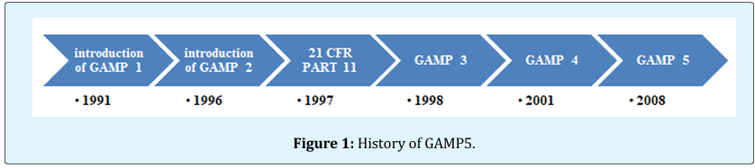 The guidelines laid out in Good Automated Manufacturing Practices GAMP 5, for the computer qualification of automated systems including:

• Automatic computerized manufacturing equipment,

• Control systems, • Automated laboratory systems,

• Manufacturing execution systems

• Computers running laboratory

• Database systems.

The V model of GAMP 5. It is based on the standards of PQLI1, ICH Q8, ICH Q9, ICH Q10, and ASTM E2500. History of GAMP 5 explained briefly in Figure 1.

**GAMP Aim**

GAMP provides principles and procedures to ensure pharmaceutical software meets quality standards. Computer System Validation (CSV) under GAMP guidelines requires collaboration between users and suppliers to define validation responsibilities clearly. As technology evolves, industry standards continue to change, posing challenges for software companies in the Life Sciences sector to stay updated. Since the introduction of GAMP 1, companies have faced the need to adapt to these developments. Computerized systems typically include hardware, software, and network components, along with control functions. GAMP 5 serves as a valuable guide for validating such systems and managing online validation activities.

**GAMP from User Point of View**

For users: GAMP provides a documented assurance that a system is appropriate for the intended use before it goes “live.”

**GAMP from Supplier Point of View**

Suppliers can use GAMP to test for avoidable defects in the supplied system to ensure quality products are produced. It must be remembered at all times that GAMP is collective ideas from the industry and does try to be all things to all people.

**IT Infrastructure Control and Compliance**

The GAMP® Good Practice Guide: IT Infrastructure Control and Compliance: covers a range of IT Infrastructure, from those operating globally to isolated or semi-isolated. Key aspects considered include:

• IQ, OQ of infrastructure components.

• Configuration management and change control of infrastructure components.

• Settings the infrastructure components in a highly dynamic environment.

• Management of risks to IT Infrastructure.

• Service providers for critical infrastructure processes to be evolved.

• Security management in relation to access controls.

• Data integrity.

• Backup, restore, and disaster recovery.

• Archiving.

To avoid unnecessary effort, this Guide describes a horizontal, or platform based, approach, the benefits of which include:

• Higher level of standardization throughout the entire life cycle

• Minimal overlap in documentation

• Minimal overlap in qualification

• Minimal overlap in audits, inspections, and assessments [10].

**Importance of URS**

Recent research has highlighted that in the pharmaceutical and bio-medical industry, 32% of all equipment procurement is unsatisfactory. The major problem has been identified as companies not specifying in sufficient detail and or accuracy, what their actual needs are. The lack of a fully detailed company approved User Requirements Specification (URS), leads to many companies having to resort to otherwise un-necessary and costly retrospective actions in modifying the equipment or producing unspecified documentation or engineering drawings, post procurement. These extraneous GMP requirements often cost more than the equipment [11].

**Typical Software Requirements [12]**

Typical software requirements should specify the following:

• All software System inputs;

• All software System outputs;

• All functions that the software system will perform;

• All performance requirements that the software will meet.

• The definition of all external and user interfaces.

• How users will interact with the system;

• What constitutes an error and how identified errors should be handled?

• Required response times;

• The intended operating environment for the software.

• All ranges, limits, defaults, and specific values. • All safety specifications & features.

**System Development Life Cycle [12]**

The system development life cycle (SDLC) can be defined as, a framework for developing computer based information system. In order words, SDLC is the overall process of developing information system through a multi-step process from investigation of initial requirements through analysis, design, implementation and maintenance. These activities are carried out in different phases, which are explained in figure 2.

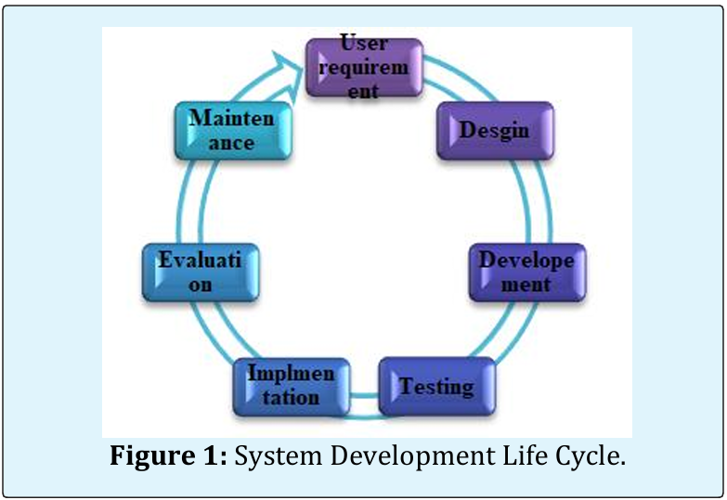

**Qualification Activities [2,13]**

The validation process for 21 CFR Part 11 compliance consists of these core elements:

• Comprehending the regulatory requirements. • Ensuring compliance with CSV requirements in a cost-effective process.

• Preparing validation CSV master plan.

• Writing the CSV protocol.

• Conducting testing protocol of software and computer systems – initial and ongoing.

• Ensuring that the bare minimum documentation that FDA inspectors will ask for are available.

• Qualifying the IT systems network infrastructure and validating the network systems.

• The key activities in computer system qualification explained.

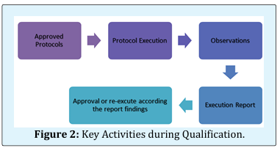

**Conclusion**

Without adequate planning and preparation, computer system validation can encounter several problems, eventually leading to failure of the process so the successful computer system validation (CSV) is highly dependent upon the quality assurance system, a formal System Development Life Cycle, and the qualification tasks performed throughout the this cycle. CSV must establish a level of confidence‖ that the system consistently meets the requirements and user requirements. As most methodologies require that specifications and test protocols are written, approved by qualified staff, and acted upon, it is possible to adapt the validation methodology to most situations, provided that the system requirements and functionality can be shown to be tested and proven, and that the system development, implementation, and operation is under control. Above all the system must be shown to operate correctly. Above all, the device must be shown to function properly, reliably and in compliance with its requirements. The system must be validated according the quality system and approved protocols to provide the user by data integrity, security, traceability and accountability.

**References**

1. Union E (2011) EudraLex The Rules Governing Medicinal Products in the European Union - Volume 4 Good Manufacturing Practice. Medicinal Products for Human and Veterinary Use - Annex 11: Computerized Systems, pp: 1-90.
2. Ostrove SA (2016) How to Validate a Pharmaceutical Process How to Validate a Pharmaceutical Process.
3. (2019) Computer System Validation in the Pharma Laboratory - 10 years of GAMP 5, Pitfalls and Best Practices.
4. Rodríguez-Pérez J (2014) The FDA and Worldwide Current Good Manufacturing Practices and Quality System Requirements Guidebook for Finished Pharmaceuticals.
5. Wingate G (2010) Pharmaceutical Computer Systems Validation Quality Assurance, Risk Management and Regulatory Compliance 2nd (Edn.).
6. Zwetkow M, Tanguay S (2013) Qualification Guideline for Microsoft Office 365. Heal Life Sci Ind Unit Microsoft.
7. (2017) Validation and Automated Validation. Tracelink.
8. Signature E (2017) Current Practices of system validation.
9. Shields S (2013) GAMP 5 A Risk-Based Risk Based Approach to Compliant GxP Computerized Systems. Allergan, pp: 1-29.
10. (2005) GAMP Good Practice Guide: Testing of GxP Systems. ISPE, pp: 1-166.
11. Lead G (2018) Guidelines on Validation - Appendix 5 Validation of Computerized Systems. World Health Organization, pp: 1-29.
12. (2002) U.S. Department Of Health and Human Services Food and Drug Administration and C. for D. and R. H. C. for B. E. and Research, General Principles of Software Validation ; Final Guidance for Industry and FDA Staff.