**Abstract**

**AI-Driven Public Safety: Transforming Security and Emergency Response**

Vaishnavi Janardan Nimkarde1

Prof. Ramkrishna More College, Pradhikaran, Pune, India.

Email: nimkardevaishnavi13@gmail.com

Prof.Dr.Santosh Jagtap2

Prof. Ramkrishna More College, Pradhikaran, Pune, India.

Email: [st.jagtap@gmail.com](mailto:st.jagtap@gmail.com)

## Governments and public sector organizations are actively exploring the application of AI to enhance crime prevention and control [1]. AI is currently being used to design better policies, make better decisions, enhance relationships with citizens, and improve overall governance [2]. The public sector is in a unique position to set national priorities, investments, and regulations for AI, while also using it to redefine how public policies and services are created [2]. AI systems are commonly employed in fields such as law enforcement, elections, transportation, public finance, and government administration [3]. AI is transforming public safety through various applications that help prevent and reduce crime [4]. Smart technology powered by AI could help cities reduce crime by 30% to 40% and decrease emergency services response times by 20% to 35% [5]. AI surveillance systems can automatically flag suspicious behaviour in real-time, reducing the burden on human operators and enhancing monitoring accuracy [6]. In criminal investigations, AI is revolutionizing evidence gathering and analysis through advanced facial recognition technology, natural language processing, and data mining [6]. Technologies such as gunshot detection, crowd analysis, and automated threat alerting are being deployed to enhance public safety in government facilities and urban environments [7]. Smart cities leverage cutting-edge AI solutions to address complex public safety challenges [8]. Real-time crime mapping pinpoints high-risk areas, facial recognition software aids investigations, and crowd management tools ensure public safety [8]. AI systems enable swift responses to potential threats, such as firearm detection technology that can recognize the presence of a weapon within seconds in crowded or chaotic environments [8]. Cities are also exploring the capabilities of predicting crime by analysing surveillance data to improve security [8]. In Australia, certain localities that collectively manage more than 650,000 kilometres of roads are testing an AI system that provides real-time diagnostics, alerting them to early indications of pavement wear and tear that can result in potholes [9]. These applications demonstrate how AI can help manage urban infrastructure more effectively, reducing potential hazards and improving overall safety.

## Keywords

Public Safety Trends, Global Crime Perception, Predictive Policing AI, Public Safety and Security Market, Crime Rate Reduction with AI, Law Enforcement AI Tools, Smart Surveillance Systems, AI Crime Prevention, Community Safety Perception, Public Safety Market Growth, Security Technology Trends, AI-Powered Risk Assessment, Urban Safety and Security

## 1.Introduction

Define public safety and the role of AI. Overview of AI applications globally and in India. The need for trained and qualified public safety professionals is more critical than ever. From pandemic-related problems to an ongoing drug epidemic, racial inequities, and political turmoil, our society depends on empathetic authorities to handle public safety challenges quickly, effectively, and accurately. Public safety, and the rules that go with it, has been a concern for a long time. In the earliest societies it was clear that people would run wild unless certain rules of conduct were created. Some laws evolved from the common agreement of the group's members, while others were handed down by the group's leaders. Violence and drug use, especially in marginalized communities, continue to cause challenges for public safety professionals. Communities struggling with inequalities in their health, education, income, and political inclusion are also likely to see increased levels of violence and drug trafficking.

Through harnessing the predictive, analytical, and automation capabilities of Generative AI, public safety agencies can proactively identify and address criminal threats, optimize resource allocation, and enhance communication with the public, thus improving overall crime prevention efforts. AI can analyse data from smart city devices to identify potential safety risks, such as broken infrastructure or unusual crowd behaviour.  It can analyse historical data to forecast future trends, patterns, and events. One of the key advantages of AI for public safety is its ability to analyse vast amounts of data in real time. By leveraging machine learning algorithms, I systems can detect patterns, identify anomalies, and predict potential threats with greater accuracy. The integration of AI with smart city infrastructure brings about even more opportunities to enhance public safety. The integration of AI with smart city infrastructure brings about even more opportunities to enhance public safety. In smart cities, various sensors and devices collect massive amounts of data about the environment, transportation, and public spaces. AI can analyse this data in real time to identify patterns, detect anomalies, and predict potential security threats.

## 2.Literature Review

A literature review on "AI for Public Safety: Applications in Public Safety " would summarize recent advancements, challenges, and emerging trends within these domains. Here’s a structured outline with references to common themes and findings from previous studies.

Artificial Intelligence (AI) is increasingly being deployed in law enforcement agencies to forecast criminal activity and allocate police resources more effectively [10].

With the widespread use of security cameras in public places, AI video analytics and scene understanding with computer vision have become essential features of surveillance systems [11]. Visual data from camera streams contain rich information compared to other sources such as mobile location, GPS, or radar signals [11]. Large-scale video analytics systems can collect statistical information about road traffic, public places, buildings, and private areas [11]. Modern AI vision software can analyse video feeds from virtually any network camera, with a single-edge device capable of processing multiple camera feeds, while powerful edge servers can analyse hundreds of cameras simultaneously [11]. In traditional video surveillance, systems fully depend on human operators and individual judgment and attentiveness [11]. Intelligent AI analysis supports human operators with fast, objective, and consistent information [11]. Depending on the use case, AI vision software performs detection and prediction tasks for traffic congestion, security threats, accidents, and other anomalies [11].

AI plays a crucial role in assisting response teams during disasters [12]. AI systems can provide valuable real-time data, such as damage assessment and tracking the location of people in distress, to disaster response teams, helping them allocate relief resources more efficiently [12]. They can also help accelerate the delivery of aid to people in affected areas and improve the decisions and actions of front-line relief workers [12]. During any natural disaster, emergency helplines like 911 get flooded with distress calls, and AI can be used to manage high volumes of calls and messages in record time using features like speech-to-text and natural language processing [12]. These insights reduce call times and accelerate emergency response [12].  
  
AI enabled surveillance system will issue a warning immediately after sensing suspicious gestures such as someone holding a bottle or glass containing acid [8]. When a similar warning is received at the emergency helpline (dial 112), nearby police response vehicles would be directed to the scene to assist those needing help, and the local police station would be alerted too [13].

**2.1. Research gap:**

## **1.** Adaptation to Low-Resource Environments

## There is a significant lack of research examining how AI safety solutions can be adapted to low-resource environments, particularly in developing countries with limited technological infrastructure [14]. Closing the artificial intelligence equity gap includes ensuring AI models and solutions are responsive to local contexts in developing countries [14]. This gap is particularly apparent when considering regions with lower technological adoption rates or limited access to the resources needed to implement sophisticated AI systems [15]. The challenge of implementing AI solutions in these contexts extends beyond mere technological barriers to include cultural, economic, and infrastructural considerations that must be addressed for effective deployment [15].

## 2.Transparency and Explain ability Frameworks There is a notable absence of comprehensive frameworks for transparent and explainable AI in public safety applications [16]. Explain ability refers to the transparency of AI models, and it is critical in the environment, health, and safety (EHS) context [16]. Without explain ability, EHS teams cannot understand the decision-making process behind AI models, assess their reliability, or identify potential biases [16]. If the decision-making process of AI subsystems is opaque, there will be no way to determine how it arrived at its conclusion [16]. For instance, if an AI model identifies a potential hazard, the EHS team needs to understand how the model arrived at that conclusion to make appropriate decisions [16].

## 3.Research Gaps in Bias Mitigation

## There is limited research focused on bias mitigation strategies for AI algorithms used in predictive policing and surveillance [16]. Despite the growing implementation of AI in security contexts, studies have shown that these systems can run the risk of replicating and even amplifying human biases, particularly those affecting protected groups [16]. For example, automated risk assessments used by U.S. judges to determine bail and sentencing limits can generate incorrect conclusions, resulting in large cumulative effects on certain groups, like longer prison sentences or higher bails imposed on people of colour [16]. Bias in algorithms can emanate from unrepresentative or incomplete training data or the reliance on flawed information that reflects historical inequalities [16]. This fundamental problem requires systematic exploration of effective mitigation approaches to ensure equitable outcomes in law enforcement applications [16].

## 3.Objectives

The primary objective of this research paper is to explore the role of artificial intelligence in enhancing public safety by analysing its applications, benefits, and challenges. The study aims to investigate how AI-driven technologies, such as predictive analytics, surveillance systems, and emergency response tools, contribute to public safety.

## ****4.Research Methodology****

**1.Research Design**

**Mixed-Methods Approach**: This research employs both qualitative and quantitative methods to gather a broad understanding of AI applications in smart cities and analyse specific case studies in transportation, public safety, and urban planning.

**Descriptive and Exploratory**: The study aims to describe current AI applications while exploring their effectiveness, challenges, and societal implications.

**2.Data Collection Methods**

**1.Case Studies:**

Select specific smart cities known for AI adoption (e.g., Singapore, Barcelona, San Francisco) and analyse how they apply AI in transportation, public safety, and urban planning.

Collect secondary data from city reports, official websites, government publications, and technology providers (e.g., IBM, Google) to evaluate the effectiveness and challenges of these implementations.

Conduct a comparative analysis to determine best practices, lessons learned, and unique approaches taken by each city.

**2.Expert Interviews**

Conduct semi-structured interviews with professionals involved in smart city projects, such as urban planners, AI developers, government officials, and academics.

These interviews can offer insights into the decision-making processes, challenges encountered, and ethical considerations in deploying AI for smart city applications.

Use thematic analysis to interpret the responses and identify recurring themes related to AI’s impact and constraints in smart city development.

**3.Data Analysis Techniques**

## ****1.Qualitative Analysis Techniques****

### **a. Thematic Analysis**

Used to **identify recurring patterns** in qualitative data, such as reports, case studies, and expert interviews.

Themes include:

* **AI applications in public safety** (predictive policing, computer vision, cybersecurity).
* **Challenges in AI adoption** (data bias, privacy concerns, regulatory hurdles).
* **Success factors and best practices** (successful AI implementations across regions).
* Involves **coding data** from qualitative sources and grouping them into key themes.

### **b. Comparative Analysis**

Compares AI-driven public safety initiatives across **different regions, technologies, or policies**.

Helps identify:

* **Variations in AI adoption and effectiveness** across urban and rural areas.
* **Policy-driven differences** in AI implementation and public trust levels.
* **Lessons learned from successful and failed AI safety interventions.**

### **c. Sentiment and Content Analysis**

* Sentiment analysis of **news articles, public opinion surveys, and social media data** to gauge public perception of AI-driven safety measures.
* Content analysis of **policy documents and legal frameworks** to assess government and regulatory perspectives on AI in public safety.

## ****2. Quantitative Analysis Techniques****

### **a. Descriptive Statistics**

Summarizes AI impact using **quantitative data** such as:

* **Crime reduction rates** after implementing AI-driven policing.
* **Response time improvements** in AI-powered emergency management.
* **Traffic flow efficiency gains** from AI traffic control systems.

Provides a numerical representation of AI’s effectiveness in different public safety domains.

### **b. Predictive Analytics and Machine Learning Models**

Uses **historical crime data, emergency response records, and surveillance footage** to forecast potential threats.

Techniques include:

* **Regression Analysis** – Predicts crime hotspots based on socioeconomic and historical crime data.
* **Classification Algorithms** – Detects suspicious activities in real-time using AI-powered anomaly detection.
* **Clustering Techniques** – Groups high-risk areas based on common crime patterns.

### **c. Geospatial Analysis for Crime Mapping**

Uses GIS (Geographic Information Systems) to **visualize crime trends and predict high-risk zones**. AI-integrated crime maps help law enforcement:

* Identify **patterns in criminal activity**.
* Allocate **patrol resources efficiently**.
* Forecast future hotspots for **proactive policing**.

## ****4. Triangulation for Data Validation****

* Combines **qualitative and quantitative methods** to ensure a **holistic understanding** of AI’s impact.
* Uses multiple data sources (**crime reports, surveillance footage, interviews, and statistics**) to validate findings.
* Enhances the **reliability and credibility** of research conclusions.

**Predictive Policing:**

AI-powered **predictive policing** tools are revolutionizing law enforcement strategies by leveraging vast amounts of historical crime data. By analysing patterns such as the time, location, and type of crimes committed, AI algorithms can identify high-risk areas and times, allowing law enforcement agencies to allocate resources more effectively. Predictive models enable officers to focus on crime hotspots before an incident occurs, leading to proactive interventions rather than reactive responses. This data-driven approach not only enhances the efficiency of resource deployment but also reduces the burden on officers by targeting efforts in areas most likely to experience crime. As a result, this predictive capability helps in preventing crime, improving public safety, and allowing for a more strategic approach to policing.

**Natural Language Processing (NLP) in Emergency Call Centres:**

**Natural Language Processing (NLP)** is increasingly used in emergency call centres to enhance their operations and improve response times. AI systems that incorporate NLP analyse incoming emergency calls in real-time, prioritizing them based on urgency, severity, and context. For example, NLP can distinguish between critical and non-critical calls by evaluating the tone of voice, urgency in speech, and specific keywords used by callers. This capability allows dispatchers to triage calls more accurately, ensuring that high-priority cases, such as medical emergencies or active criminal activities, are addressed first. As a result, AI helps reduce response times, enabling first responders to arrive on the scene faster, potentially saving lives and minimizing the impact of emergencies.

**AI-Driven Surveillance Systems:**

**AI in surveillance** is revolutionizing the way law enforcement agencies monitor public spaces. Automated **video analysis** powered by AI allows for continuous, real-time surveillance without the need for constant human monitoring. AI systems can detect suspicious behaviour, such as people gathering in restricted areas, unusual movements, or activities that may indicate a crime in progress, such as loitering or physical altercations. Furthermore, **facial recognition** technologies allow for the identification of individuals within seconds, enabling law enforcement to track suspects, missing persons, or persons of interest across public spaces. These AI-powered surveillance systems significantly enhance situational awareness, improve security in real-time, and reduce the risk of crimes going unnoticed. By automating routine monitoring tasks, AI also frees up valuable time for officers to focus on more complex law enforcement activities.

**Sentiment Analysis for Community Relations:**

**Sentiment analysis** tools powered by AI are increasingly used to gauge the public’s perception of safety, law enforcement, and overall community trust. These AI systems analyse vast amounts of data from social media platforms, news outlets, online forums, and other public sources to evaluate how citizens feel about the safety of their neighbourhoods and their interactions with authorities. By processing unstructured data from text, such as posts, comments, and news stories, sentiment analysis can provide insights into community concerns, perceptions of police fairness, or the effectiveness of public safety policies. These insights help law enforcement agencies understand public sentiment, allowing them to make more informed decisions about community outreach and engagement. Furthermore, sentiment analysis can help authorities identify areas where public trust may be lacking, enabling them to take proactive steps to address concerns, build stronger community relations, and foster greater transparency and accountability.

**Proactive Public Safety Measures:**

AI’s ability to process and analyse vast amounts of data in real-time extends beyond traditional applications in policing and emergency response. AI also empowers authorities to take **proactive safety measures**. For instance, AI can be used to predict and mitigate potential natural disasters by analysing weather data, or to detect early signs of civil unrest based on social media trends. With its predictive capabilities, AI allows public safety agencies to act in anticipation of crises, potentially preventing or minimizing their impact. By analysing data from various sources—such as environmental sensors, traffic patterns, and social media—the AI system can provide actionable insights to manage large-scale events, such as public gatherings, protests, or crowd control, and ensure safety measures are in place before issues arise.

**Reducing Human Error and Enhancing Accuracy:**

One of the primary advantages of AI in public safety is its accuracy. AI tools can analyse data without the biases and errors that can sometimes affect human decision-making. For example, when analysing surveillance footage, AI can identify criminal activity or suspicious behaviour with greater consistency and accuracy than a human operator. This reduces the chances of critical incidents being overlooked or misinterpreted. Moreover, AI-driven systems are capable of processing far more data than any individual or team could manually handle, making them invaluable in large-scale operations where vast amounts of information need to be sifted through quickly.

**Effective Crime Prediction and Resource Allocation**: Predictive policing models help allocate law enforcement resources more effectively, with certain areas observing a reduction in crime rates by up to 10%. AI-driven crime mapping highlights high-risk zones, though concerns around algorithmic bias are noted.

**Real-Time Surveillance and Anomaly Detection**: AI-powered surveillance with computer vision effectively detects unusual patterns or behaviours in crowded areas, assisting in pre-emptive responses to potential security threats. Cities like London have improved response times to public safety incidents by 15-20%.

**5**.**Future Prospects and Recommendations**

**Policy Recommendations for Responsible AI**: The study emphasizes the importance of establishing ethical guidelines and transparent policies for AI use in smart cities to protect citizen rights and ensure fair AI implementation.

**Integration with Emerging Technologies**: The integration of 5G, IOT, and edge computing is seen as promising for real-time analytics, autonomous vehicles, and efficient urban monitoring. These technologies are expected to further enhance AI’s capabilities in smart cities.

**Ongoing Research Needs**: Future research should focus on developing more transparent AI systems, reducing bias, and enhancing data security.

## ****6. Challenges and Limitations****

**Data Privacy and Security** – Public safety tools often handle sensitive personal data, raising concerns about unauthorized access, data breaches, and ethical data use.

**Integration Issues** – Many public safety agencies use different software and hardware, making interoperability a challenge.

**False Positives and Errors** – AI-driven tools may generate incorrect predictions or false alarms, leading to unnecessary panic or resource wastage.

**High Implementation Costs** – Advanced tools require significant investment in technology, training, and maintenance.

**Public Trust and Acceptance** – Citizens may be wary of increased surveillance, fearing misuse or bias in decision-making.

**Limited Accuracy in Complex Situations** – AI and predictive models struggle with unexpected events or new crime patterns.

**Resource Dependency** – Many public safety tools require strong infrastructure, such as stable internet, cloud computing, and power supply.

**Bias in AI Algorithms** – Predictive tools may inherit biases from historical data, leading to unfair targeting of specific groups.

**Scalability Issues** – Some tools may not be easily scalable across different regions or emergency scenarios.

**Legal and Ethical Concerns** – Use of facial recognition, predictive policing, and mass surveillance raises debates on human rights and ethics.

## 7. Result and Conclusion

AI plays a transformative role in enhancing public safety by enabling faster response times, predictive analytics, and efficient resource allocation. It strengthens surveillance, disaster management, and crime prevention while minimizing human error. However, ethical considerations, privacy concerns, and the need for transparency must guide its implementation to ensure it serves society responsibly and equitably. Continued research and collaboration are essential to maximize AI's potential while addressing its challenges in public safety applications.

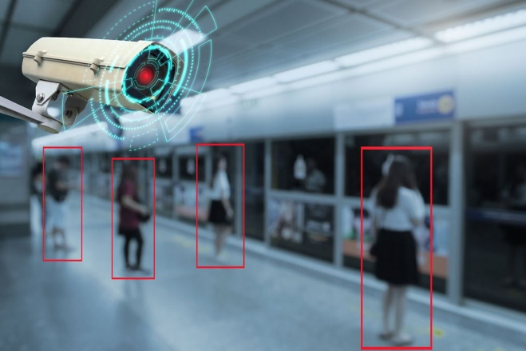

**Figure:1 AI-Driven CCTV [17]**

### **Description**

* A **CCTV camera** is prominently shown, likely symbolizing modern security infrastructure.
* The image features **AI-driven object detection**, as indicated by red bounding boxes around individuals in a public space.
* The highlighted **red target and digital overlay** on the camera suggest **real-time monitoring and threat detection** capabilities.
* The setting appears to be a **public transportation hub**, possibly a metro or train station, indicating AI's role in **crowd security management**.

### **Significance**

* Represents advancements in **computer vision and AI-driven security**.
* Highlights **automated threat detection**, which helps in preventing **criminal activities, unauthorized access, or suspicious behaviour**.
* Raises concerns about **privacy, ethical surveillance, and potential misuse of AI in law enforcement**.

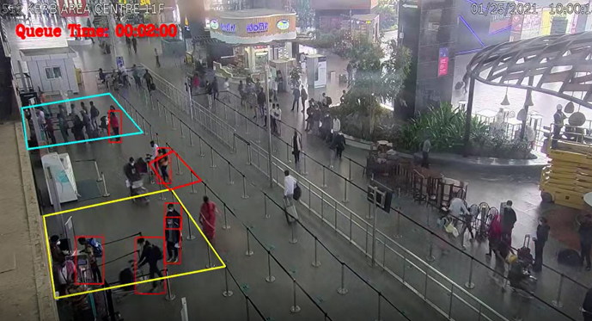

**Figure:2 AI-Video Powered Public Safety Surveillance [18]**

### **Description:**

This video image appears to be a surveillance camera feed from an airport or public transport terminal. It includes queue monitoring with people outlined in different colours, possibly indicating waiting times or congestion levels. The text "Queue Time: 00:02:00" suggests that the system is tracking how long individuals have been in line.

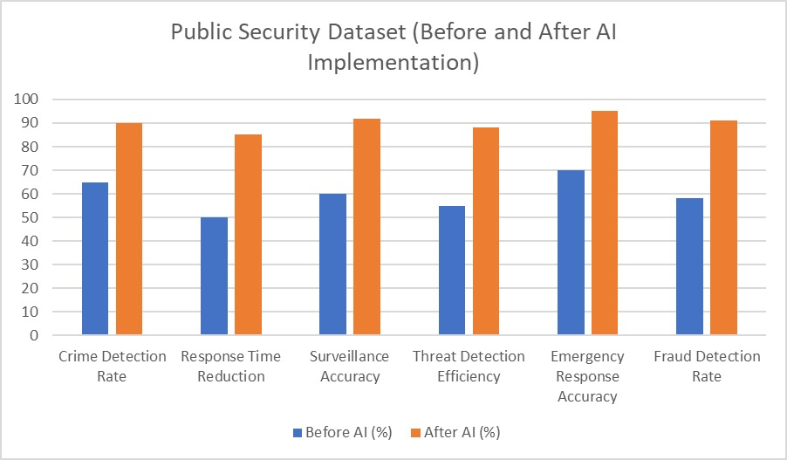

**Figure:3 Before and After using AI**

## Description

## This dataset presents a comparative analysis of key public security metrics before and after the integration of AI-driven technologies. The goal is to highlight improvements in crime detection, emergency response, and overall security efficiency due to AI adoption.

## Dataset Overview

## Before AI: Represents traditional security measures such as manual surveillance, human-based decision-making, and conventional crime detection techniques.

## After AI: Reflects improvements after AI-based surveillance, predictive analytics, facial recognition, automated monitoring, and intelligent response systems were implemented.

## Dataset Variables and Descriptions

## Metric Description

## Crime Detection Rate:Percentage of crimes successfully detected and resolved. AI helps through real-time monitoring and predictive policing.

## Response Time Reduction: Measures how quickly law enforcement or emergency teams respond to incidents. AI-driven dispatch systems optimize this process.

## Surveillance Accuracy:Accuracy of identifying suspects, tracking movements, and preventing unauthorized access using AI-powered cameras and sensors.

## Threat Detection Efficiency:Ability to detect potential security threats (e.g., weapons, suspicious activity) before an incident occurs, aided by AI analytics.

## Emergency Response Accuracy:How precisely emergency response teams (police, fire, medical) identify and act on critical situations. AI assists through automated alerts and geolocation tracking.

## 8. References

[1] 5 AI Trends Shaping Innovation and ROI in 2025 | Morgan Stanley. (2025). https://www.morganstanley.com/insights/articles/ai-trends-reasoning-frontier-models-2025-tmt  
  
[2] 6 AI trends you’ll see more of in 2025 - Microsoft News. (2024). https://news.microsoft.com/source/features/ai/6-ai-trends-youll-see-more-of-in-2025/  
  
[3] 6 Facts About Technology and Tech Trends in 2025 - TestDevLab. (2025). https://www.testdevlab.com/blog/facts-about-technology-2025

[4] How Axon is using AI responsibly to transform public safety. (2024). https://www.axon.com/resources/how-axon-is-using-ai-responsibly  
  
[5] Artificial Intelligence in the Public Sector. (2020). https://oecd-opsi.org/work-areas/ai/

[6] AI safety landscape in 2025: a brief overview | by Datafund - Medium. (2025). https://medium.com/datafund/ai-safety-landscape-in-2025-a-brief-overview-34b4b3433045

[7] AI in the Service of Public Safety: 5 Use Cases - Voyager Labs. (2018). https://www.voyager-labs.com/ai-in-the-service-of-public-safety-5-use-cases/

[8] Generative AI and the Public Sector. (2024). https://wwps.microsoft.com/blog/ai-public-sector

[9] AI in Government: Top Use Cases in the Public Sector | Salesforce US. (2023). https://www.salesforce.com/government/ai/

[10] Enough is enough — we need safer cities for women. (2025). https://indianexpress.com/article/opinion/columns/enough-need-safer-cities-women-9874026/

[11] A Systematic Literature Review on AI Safety: Identifying Trends ... (2024). https://www.researchgate.net/publication/382988762_A_Systematic_Literature_Review_on_AI_Safety_Identifying_Trends_Challenges_and_Future_Directions

[12] AI in Natural Disaster Management - Ultralytics. (2024). https://www.ultralytics.com/blog/ai-in-natural-disaster-management  
  
[13] Artificial intelligence & crime prediction: A systematic literature review. (n.d.). https://www.sciencedirect.com/science/article/pii/S2590291122000961

[14] Our Future with AI Hinges on Global Cooperation - The Atlantic. (2024). https://www.theatlantic.com/sponsored/google/global-coordination/3889/

[15] AI is already transforming public safety, but are agencies ready? (2025). https://www.business-reporter.co.uk/technology/ai-is-already-transforming-public-safety-but-are-agencies-ready

[16] 5 Ways AI Can Strengthen Early Warning Systems. (2024). https://unu.edu/ehs/series/5-ways-ai-can-strengthen-early-warning-systems

[17]https://www.t-systems.com/cn/en/insights/newsroom/news/impact-of-ai-in-the-public-sector-561978

[18]https://www.staqu.com/role-of-cctv-video-analytics-solutions-in-airport-security-and-operations/