Fake Profile Detection on Social Networking Websites using Machine

Learning

Prof. Rohan B. Kokate1 and Laksh Sewani2

MCA Computer Application

1 J D College of Engineering and Management ,

2 Khandala ,Borgaon Phata , Kalmeshwar Road ,Nagpur ,India-441501 [rbk7557@gmail.com](mailto:rbk7557@gmail.com)

sewanilaksh95@gmail@.com

# Abstract:

Nowadays, social media has a tremendous effect on every body’s existence. the majority regularly make use of social media systems.

every of those social media structures gives benefits and disadvantages, as well as safety risks for our information. To decide who poses threats on those structures, it's far essential to differentiate between the actual and faux social media profiles.

There are historically used numerous techniques for figuring out fake social media accounts. but those platforms need to be higher at figuring out phoney accounts. The accuracy rate of figuring out fake accounts utilising timestamp facts sorts is stepped forward on this proposed paintings employing high gradient boosting algorithms and herbal Language Processing. in order to investigate the relationship among numerous machine getting to know techniques and multi-functions in time series, this examine employs a variety of device mastering strategies**.**

**Keywords:**

fake profiles, gadget mastering strategies,herbal Language Processing (NLP), Timestamp,severe Gradient Boosting set of rules

# Introduction

A internet site known as a "social networking web web page" is one wherein users might also connect with pals, make updates, and find new humans who've comparable hobbies. everybody has a profile at the internet site. clients can talk with each different using internet 2.0 era in those on-line social networks [1]. The utilization of social networking sites is expanding quick and affecting how people have interaction with each other. online groups convey together human beings with like hobbies and make it easy for clients to locate new buddies. the principle advantage of net social networking is

that it permits person to without difficulty connect with human beings and speak higher. This has furnished new avenues for capability assaults along with fake identities, disinformation, and further [3]. Researchers are going for walks to decide the effect those online social networks have on people. there may be plenty greater to media than honestly how many human beings use it. This suggests that the wide style of faux money owed has grown throughout the beyond years [4].

ISPs of social networks have a difficult time finding these fraudulent accounts. The want to discover these faux bills is because of the inundation of disinformation, commercials and more on social media [5].The datasets had been taken and skilled for the identity of fake users from the social media networks the use of system mastering algorithms.

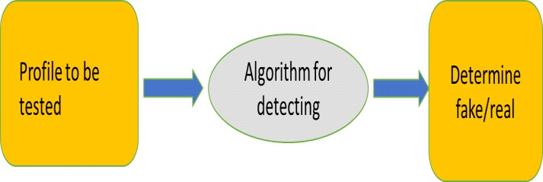

* + Machine layout
* Device architecture

Figure 1: Detection process

Figure below depicts the proposed system.

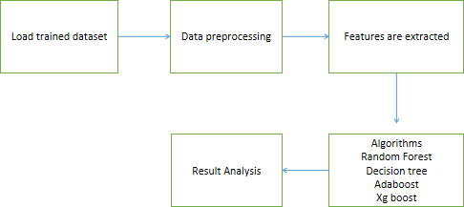

Figure 2: Proposed system

# Raw data

Real users and fake user records are where the raw data is obtained from, which contains 3474 users and 3351 fake users.

* Uploading the data: A dataset is a collection of instances, and typically need a number of datasets for different tasks when utilising machine learning techniques.[17].
* Training Dataset: A dataset that the machine learning system uses to train the model.
* Testing Dataset: A dataset not used to train the model butinstead to test its accuracy and it can be known as the validation dataset.
* Data Preprocessing: Identifying fake accounts is crucial first step. This stage involves getting the data ready for use in the detection procedure [17]. Prior to giving the data into the model, it is essential

to preprocess it, because the valuable information that can be gleaned from it directly affects how well the model learns.

* + Model Algorithms:

The following machine learning algorithms are utilised to find profiles:

# Random Forest

To enhance the prediction accuracy of datasets, classifiers called random forests use different decision trees on specific subsets of the input data [18]. Rather than relying only on one of the decision trees, Random Forest extrapolates predictions from each Decision Tree and bases them on a majority of votes. First, N decision trees are linked to form a random forest. Predictions are then made for each tree generated in the first stage.

# Decision Tree:

It is a graphical representation for locating each potential answer to a question or choice based on predetermined criteria. To forecast the class of the incoming dataset, a decision tree [19] method proceeds upward from the root node. Comparing the values of the record (actual dataset) attribute with those of the root attribute, this algorithm follows the branch and moves on to the next node. The algorithm checks the attribute value with the other subnodes before moving on to the next node.

# AdaBoost:

By integrating numerous weak learners into one strong learner, AdaBoost is implemented. AdaBoost's weak learners

[20] construct a single split decision tree known as the decision stump by taking into account a single input feature. As the initial decision stump is being drawn out, each observation is given equal weight. As the first decision stump's results are analysed, any observations that were incorrectly categorised are given heavier weights. A new decision stump is created by considering the higher-weight observations to be more significant. Once more, misclassified observations are assigned a higher weight, and this process is repeated until all observations belong to the correct class.

# XG boost algorithm:

An enhanced gradient boosting technique is XGBoost [21]. This algorithm's primary goal is to make computations faster and more effective. Because to its sequential data analysis, the Gradient Descent Boosting approach computes the output more slowly. Hence, XGBoost is utilised to enhance or greatly enhance the model's performance. The focus of XGBoost is on model effectiveness and computing speed. The inputs are taken, and the trained dataset is loaded and for every occurrence in the trained data with regard to every feature of the classifier is trained, and the accuracy of the data is predicted.

Pros of XG boost algorithm:

* Multiple weaker models from trained data can be combined to form stronger model to further accurate results.
* It can handle huge amount of data to grow parallel trees for individual features.
* It can handle huge data with missing data also, in order to reduce normalization.

# Evaluation method:

Extreme Gradient Boosting Algorithm, which is a variant of Gradient Boosting Algorithm, is the algorithm utilised to carry out this work.Assume that the input and target, X and Y respectively, have N samples each. Learning the f(x) function, which converts the input characteristics X into the desired variables y, is what should be aimed to be done. The total number of trees is what is boosted.

The difference between the expected and actual variables is the loss function. The loss function is minimised with respect to f.

If the gradient boosting approach is in M stages, the algorithm can add some additional estimators as hm.



The gradient similarly for M trees:

The current solution is,



* + - EXPERIMENTAL ANALYSIS AND RESULTS
  + Comparative Analysis: Existing System:
* Because of privacy issues, some of the social media datasets are very limited and a lot of details are not made public.
* Naive Bayes algorithm having less accuracy.
* There are no features to identify the exact time when the event occurred.

The Random forest method is the one that is most frequently used in fraudulent account detection. A few drawbacks of the technique include its inability to effectively handle category variables with many levels. Additionally, the algorithm's time effectiveness declines as the number of trees rises.

# Proposed System:

In that it mainly utilises decision trees, the gradient boosting approach is comparable to the random forest algorithm. Utilising fresh methods to find them, the method of identifying phoney accounts is modified. Spam comments, engagement rates, and fake behavior are some of the strategies used. The

gradient boosting method uses these inputs in order to create decision trees which are subsequently used by the gradient boosting process. Even when some inputs are missing, this method is still generating a result. Therefore, this algorithm is the main justification for its use. These methods are very precise in their results. XGBoost and GBM performed extremely well in comparison to the earlier study. Even with the default values of, it significantly outperforms the accuracy of false account identification.

# Experimental Analysis:

The trained dataset is given into various algorithms and the accuracy of every algorithm is analysed to find the best fit algorithm for classifying the profiles as either real or fake. Out of the four algorithms used the XgBoost algorithm and Decision tree algorithms achieved atmost same accuracy but when the

datasets are trained again, the accuracy of XgBoost algorithm increases every time it is trained. The given inputs social network profiles are run on the Extreme Gradient Boosting algorithm and these inputs are computed sequentially to produce the results. By the parallel processing of the decision trees, the profile is determined as either real or fake.The graph below gives the model accuracy of XgBoost algorithm, Adaboost algorithm, Decision tree algorithm, and Random Forest algorithm. From the graph below, it can be seen that XgBoost algorithm gives more accuracy.

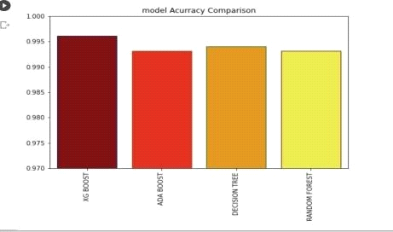Figure 3 : Model Accuracy Comparison

# Experimental result:

When the XgBoost algorithm is executed, the model test accuracy, precision, and recall are given.

Table 1: Model Comparison

|  |  |  |  |
| --- | --- | --- | --- |
| Index | Model  Tes t Accuracy | Model precision | Model Recall |
| 0 | 0.9629 | 0.950641658 | 0.973710819 |

The graph given below gives model test accuracy, model precision, and model Recall.

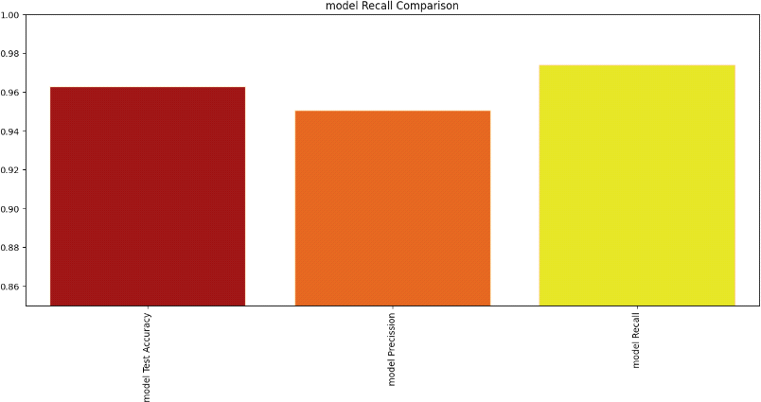

Figure 4 : Model Recall Comparison

# CONCLUSION

In this look at, actual and pretend consumer datasets are used to become aware of actual profiles. The traits are extracted using machine studying strategies such random forest, selection tree, adaboost, and XgBoost, with XgBoost set of rules imparting the quality accuracy to distinguish between actual and fraudulent users on social networking internet site

# REFERENCES

⦁ E. Karunakar, V. D. R. Pavani, T. N. I. Priya, M. V. Sri, and ok. Inf. Comput. Sci., vol. 10, pp. 1071–1077, 2020.

⦁ P. Wanda and H. J. Jie, “Deep profile: making use of dynamic seek to pick out phoney profiles in on line social networks CNN” J. Inf. Secur. Appl., vol. 52, pp. 1–thirteen, 2020.

⦁ P. ok. Roy, J. P. Singh, and S. Banerjee, “Deep mastering to filter out SMS spam,” destiny Gener. Comput. Syst., vol. 102, pp. 524–533, 2020.

⦁ R. Kaur, S. Singh, and H. Kumar, “A modern evaluate of several countermeasures for the rise of spam and compromised bills in on line social networks,” J. Netw. Comput. Appl., vol. 112, pp. 53– 88, 2018.

⦁ G. Suarez-Tangil, M. Edwards, C. Peersman, G. Stringhini, A. Rashid, and M. Whitty, “robotically dismantling on-line relationship fraud,” IEEE Trans. Inf. Forensics Secur., vol. 15, pp. 1128–1137, 2020.

⦁ M. U. S. Khan, M. Ali, A. Abbas, S. U. Khan, and A. Y. dependable secure Comput., vol. 15, no. four, pp. 551–560, Jul./Aug. 2018.

⦁ V. Balakrishnan, S. Khan, and H. R. Arabnia, “improving cyberbullying detection the use of twitter users’ psychological functions and machine studying,” Comput. Secur., vol. ninety, 2020, art. no. 101710.

⦁ Georgios Kontaxis, I. Polakis, S. Ioannidis and E. P. Markatos, "Detecting social network profile cloning," 2011 IEEE international convention on Pervasive Computing and Communications Workshops (PERCOM Workshops), Seattle, WA, u.s., 2011, pp. 295-300, doi: 10.1109/PERCOMW.2011.5766886.

⦁ Monther Aldwairi, and Ali Alwahedi, “Detecting fake information in Social Media Networks”, Procedia laptop science, quantity 141, 2018, Pages 215-222; https://doi.org/10.1016/j.procs.2018.10.171