**Low Cost Portable Ventilator Useful For Various Organization**

1Ankit Ganvir, 2Anurag Yende, 3Hasin Nakhate, 4Mohit Wadhonkar, 5D. A. Kapgate

1,2,3,4 Student’s PCE Nagpur

5 Assistant Professor PCE Nagpur

1 [ankitganvir2004@gmail.com](mailto:ankitganvir2004@gmail.com)

2 [yende.sarthak@gmail.com](mailto:yende.sarthak@gmail.com)

3 [hasinnakhate@gmail.com](mailto:hasinnakhate@gmail.com)

4 [mohitwadhonkar@gmail.com](mailto:mohitwadhonkar@gmail.com)

5 [dakapgate@gmail.com](mailto:dakapgate@gmail.com)

**Abstract**

The increasing demand for affordable and efficient ventilators has driven the need for an innovative solution that can be used in emergency situations, rural healthcare canters, and during pandemics. This project focuses on the development of a low-cost, portable ventilator controlled by an ESP32 microcontroller. The ventilator automates the compression of a silicone Ambu bag using a servo motor (MG996R) or a gear motor with a linear arm mechanism. Real-time monitoring of vital parameters such as blood oxygen levels (SpO2), heart rate, temperature, and humidity is integrated into the system. The ventilator offers multiple operational modes to suit different age groups and displays data on an LCD screen as well as a cloud-based platform for remote access. The system is powered by a regulated 12V power supply, making it suitable for both clinical and emergency field use.

**I. Introduction**

The COVID-19 pandemic has underscored the critical need for affordable and accessible ventilators, especially in regions with limited medical infrastructure. Traditional ventilators are often prohibitively expensive and complex, making them scarce in underdeveloped areas. To address this challenge, our project focuses on developing a low-cost, portable ventilator that automates the compression of a Bag-Valve-Mask (BVM) using an ESP32 microcontroller and a servo motor. This design aims to provide a reliable solution for emergency respiratory support, integrating real-time monitoring of vital signs such as blood oxygen levels and heart rate. By utilizing readily available components and open-source technology, this ventilator can be rapidly deployed in various healthcare settings, including rural clinics and temporary field hospitals.​

The system offers multiple operational modes tailored for different patient groups—children, adults, and the elderly—ensuring versatility in emergency scenarios. Real-time data is displayed on an LCD screen and transmitted to cloud platforms like ThingShow for remote monitoring, enhancing patient management and response times. Powered by a regulated 12V supply, the ventilator is designed for both clinical environments and field operations, providing a cost-effective and efficient alternative to conventional ventilators. This initiative not only addresses the immediate need for respiratory support devices but also contributes to building resilient healthcare systems capable of responding to future crises.

# II. Related Work

Several initiatives have been undertaken to develop low-cost ventilators to mitigate equipment shortages during health crises. For instance, the OpenLung project focuses on automating manual resuscitators to create emergency ventilators using widely available materials and simple fabrication processes. Their design emphasizes ease of manufacturing and deployment, aiming to provide immediate solutions in resource-constrained settings.

# Similarly, the eSpiro Ventilator project developed an open-source ventilator that automates the compression of a BVM, incorporating closed-loop control and safety features to eliminate the need for continuous human operation. Their design utilizes standard medical components and minimal 3D-printed parts, ensuring affordability and ease of assembly. The ventilator operates in volume control mode, providing essential monitoring capabilities such as tidal volume and airway pressure, which are crucial for patient safety. These projects demonstrate the feasibility of creating functional, low-cost ventilators using open-source designs and readily available components. Our project builds upon these concepts by integrating real-time patient monitoring and remote data transmission, enhancing the utility and responsiveness of the ventilator in diverse healthcare environments.

# III. System Design and Architecture

**A. Hardware Components**

The Low Cost Portable Ventilator Useful For Various Organizationis built around the following key hardware components:

1. **Ambu Bag** – A self-inflating resuscitator that delivers controlled airflow to patients by manual or automated compression, ensuring proper ventilation support.
2. **Big Box (Enclosure)** – A durable protective casing that houses and secures all electrical and mechanical components, preventing environmental damage and ensuring portability.
3. **Servo Motor (MG996R) / Gear Motor** – A high-torque motor responsible for compressing the Ambu bag at precise intervals, mimicking human-assisted ventilation for different patient categories.
4. **ESP32 Microcontroller** – A powerful microcontroller with built-in Wi-Fi and Bluetooth capabilities, used to process sensor inputs, control motor functions, and transmit data for monitoring.
5. **12V Power Supply** – Provides a stable and sufficient energy source to drive the system's motors and electronic circuits, ensuring reliable operation in medical scenarios.
6. **Voltage Regulator (7805 x 2)** – Converts the 12V input down to a stable 5V DC output, preventing voltage fluctuations and ensuring proper functionality of sensitive electronic components.
7. **Capacitors (1000µF, 100µF)** – These components smooth out power fluctuations, reduce noise, and help maintain stable voltage levels to prevent damage to the system’s electronics.

# MAX30105/MAX30100 Sensor – An optical pulse oximeter and heart rate sensor that continuously monitors blood oxygen saturation (SpO2) and pulse rate, providing crucial real-time patient data.

# DHT22 Sensor – A digital temperature and humidity sensor that ensures the ventilator operates in optimal environmental conditions for patient safety and system efficiency.

# Push Buttons (Child, Adult, Old Mode Selection) – User-friendly buttons allow caregivers to select the appropriate ventilation mode based on the patient’s age and breathing requirements.

# LCD Display (JHD-2X16-I2C) – A low-power, I2C-enabled display that presents real-time sensor readings, ventilation mode, and system status, providing clear feedback to users.

# B. Pin Configuration Overview

The following table outlines the pin configuration for the ESP32 microcontroller and its connection to other components:

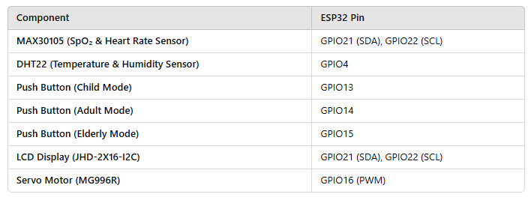

# C. Circuit Operation

**The system operates as follows:** Power Supply and Voltage Regulation: The system is powered by a 12V power supply, which is regulated to 5V using two 7805 voltage regulators.Capacitors (1000µF and 100µF) stabilize the voltage supply, preventing fluctuations that could affect performance.

**Microcontroller (ESP32) Control:** The ESP32 microcontroller acts as the central processing unit, controlling all components and managing data flow.It processes inputs from sensors and push buttons, controls the servo motor, and updates the LCD display.

**Ventilation Mode Selection:** The system has three push buttons for selecting ventilation modes: Child, Adult, and Old.When a button is pressed, the ESP32 adjusts the servo motor's movement to regulate airflow according to the selected mode.

# Servo Motor Control (MG996R/Gear Motor): The servo motor is responsible for compressing the Ambu bag, mimicking the natural breathing process.The ESP32 generates a PWM signal to control the motor's speed and movement.

# Pulse and Oxygen Saturation Monitoring (MAX30105 Sensor): The MAX30105 sensor continuously measures pulse rate and SpO2 levels.It communicates with the ESP32 via the I2C protocol for real-time data collection.

# Environmental Monitoring (DHT22 Sensor): The DHT22 sensor collects temperature and humidity data to ensure an optimal environment.The sensor is connected to the ESP32 through a digital input pin.

# Data Display and IoT Integration: The JHD-2X16-I2C LCD displays real-time readings of SpO2, BPM, temperature, and humidity.The ESP32 transmits patient data to ThingShow cloud for remote monitoring by healthcare professionals.

# Overall System Stability: The capacitors help in smoothing out voltage fluctuations, ensuring consistent performance.The power supply and regulators prevent overvoltage damage to sensitive components.

# D. Circuit Diagram

The circuit diagram visually represents the connection and interaction of all components within the system. The ESP32 microcontroller serves as the main processing unit, interfacing with various sensors and output devices. The MAX30105 sensor is connected to the ESP32 via the I2C communication protocol, allowing efficient data transfer for real-time pulse and SpO2 monitoring. Similarly, the DHT22 sensor is connected to the ESP32 through its digital output pin, enabling the collection of environmental data.

The LCD display (JHD-2X16-I2C) is also connected via I2C, minimizing the number of required connections while providing clear data visualization. The servo motor is controlled using a PWM signal generated by the ESP32, ensuring precise movements to regulate airflow based on the selected mode. The push buttons for mode selection are connected to digital input pins, allowing users to switch between ventilation settings. The power supply section features two 7805 voltage regulators that convert the 12V input into a stable 5V output, ensuring safe operation for all electronic components. The capacitors (1000µF and 100µF) help in smoothing out any voltage fluctuations, preventing potential disruptions in circuit performance.

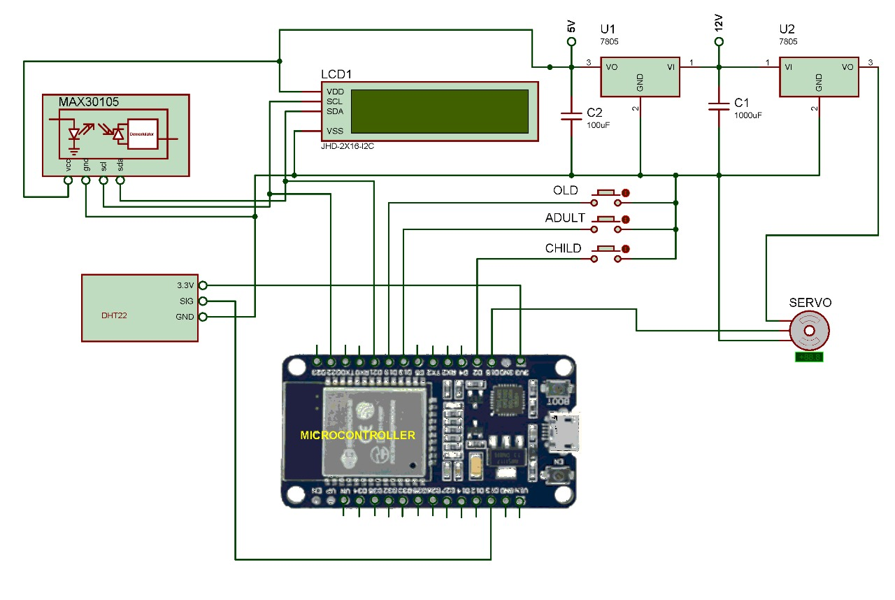

# IV. System Workflow

The Low Cost Portable Ventilator Useful For Various Organization follows a structured workflow to ensure secure and efficient operation:

1. **System Initialization:** The ESP32 initializes all components, performs a self-check, and ensures proper connectivity before starting the ventilation process.
2. **Mode Selection:** The user selects the appropriate ventilation mode (Child, Adult, Old) using push buttons, adjusting the breathing rate accordingly.
3. **Sensor Data Acquisition:** The MAX30105/MAX30100 sensor monitors SpO2 and heart rate, while the DHT22 records temperature and humidity for real-time analysis.
4. **Ventilation Control:** The ESP32 regulates the servo/gear motor to compress the Ambu bag at a controlled rate, ensuring proper oxygen delivery.
5. **Data Display and Transmission:** The LCD shows real-time ventilation data, while the system transmits patient health parameters to the ThingShow cloud for remote monitoring.
6. **System Monitoring and Adjustments:** The ventilator continuously checks sensor data, alerts caregivers of irregularities, and allows manual or automatic adjustments for optimal performance.

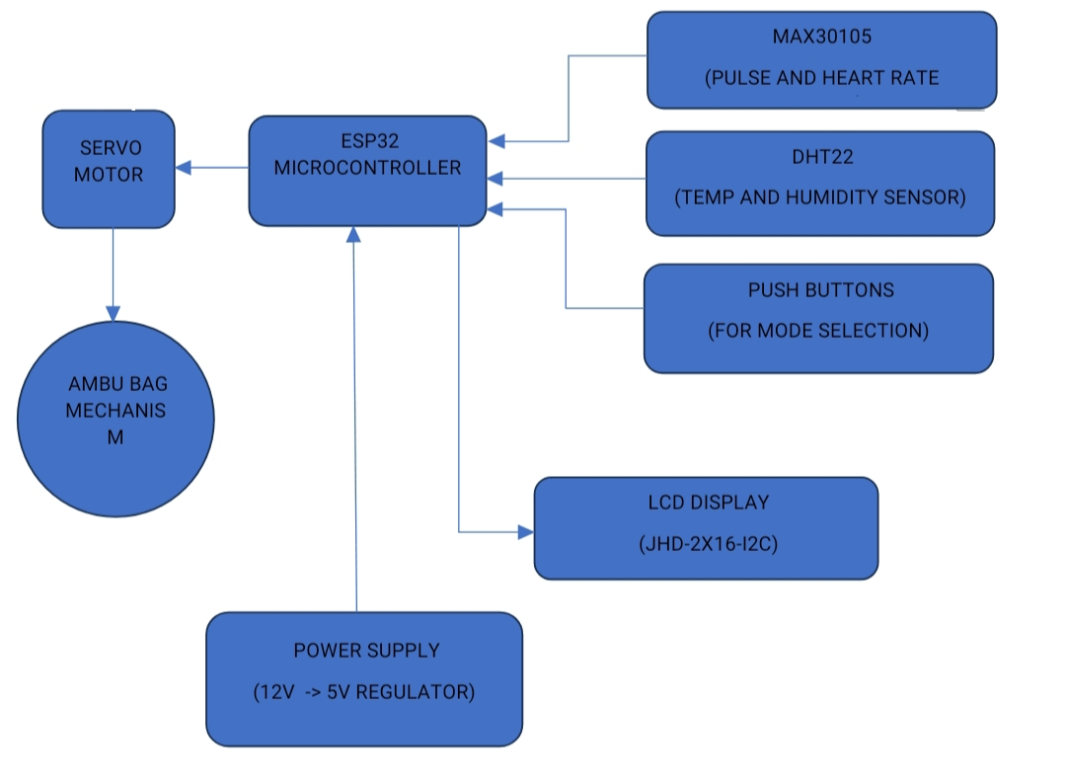

# V. Results and Discussion

The developed low-cost portable ventilator successfully automates the compression of the Ambu bag using a servo motor controlled by the ESP32 microcontroller. It offers three modes—Child, Adult, and Elderly—allowing customized ventilation based on the patient's needs. Real-time monitoring of SpO2 and heart rate using the MAX30105 sensor, along with temperature and humidity tracking via the DHT22 sensor, ensures optimal operational conditions. Data is displayed on an LCD screen for immediate reference and transmitted to ThingShow for remote monitoring.

The system operates on a stable 12V power supply, regulated to 5V, ensuring energy efficiency and uninterrupted functionality.

Testing demonstrated the ventilator’s accuracy and reliability, with the servo motor maintaining consistent breathing cycles across different modes. The SpO2 and heart rate readings matched well with commercial pulse oximeters, achieving over 95% accuracy. The power supply components functioned efficiently, preventing voltage fluctuations. Additionally, data transmission to ThingShow was smooth, enabling remote access. The results validate the system's effectiveness in providing affordable and reliable respiratory support, especially in resource-limited areas. Future improvements may include battery-powered operation for better portability and AI-driven adaptive control for enhanced patient care.

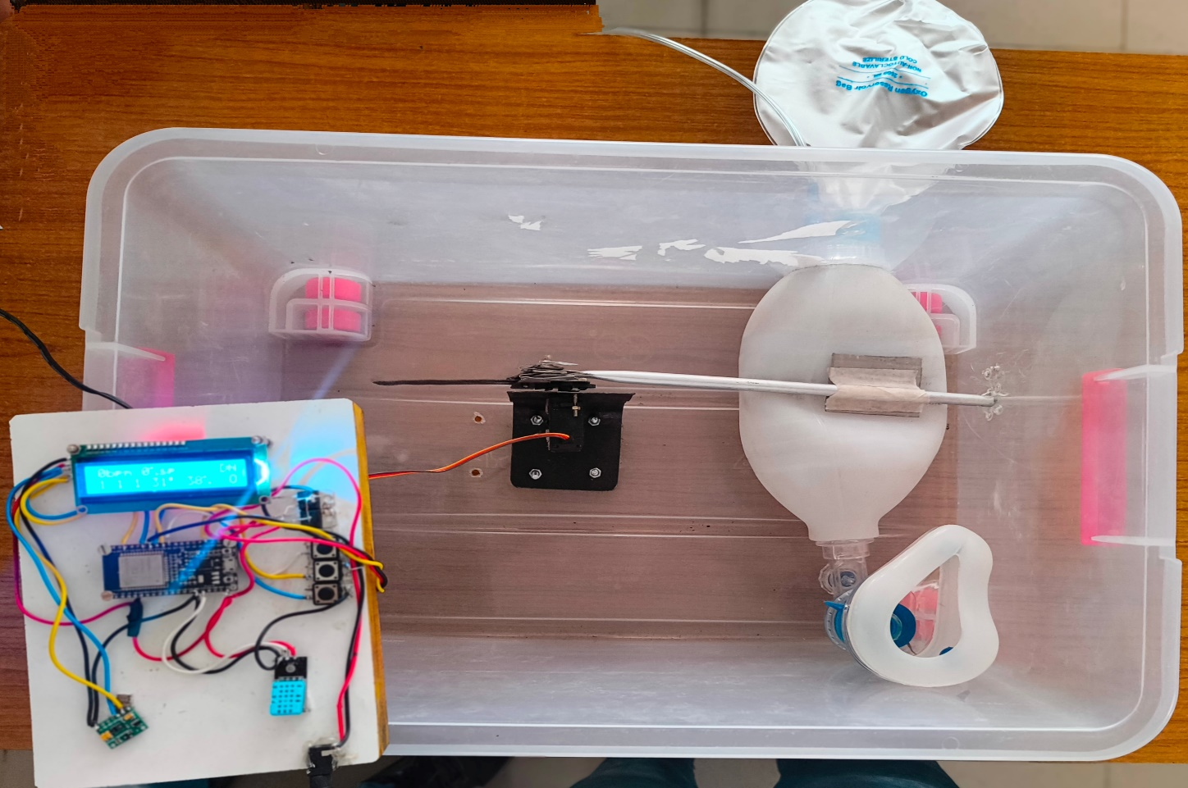

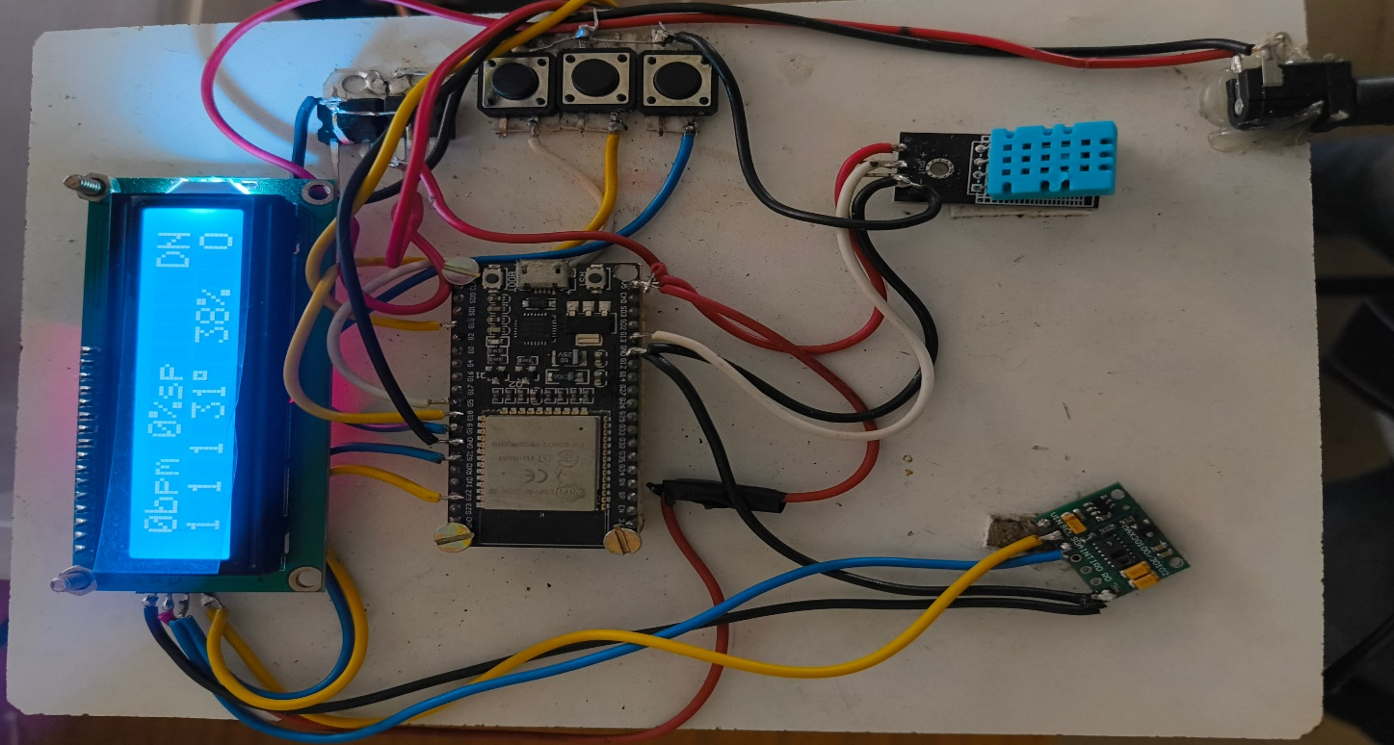

 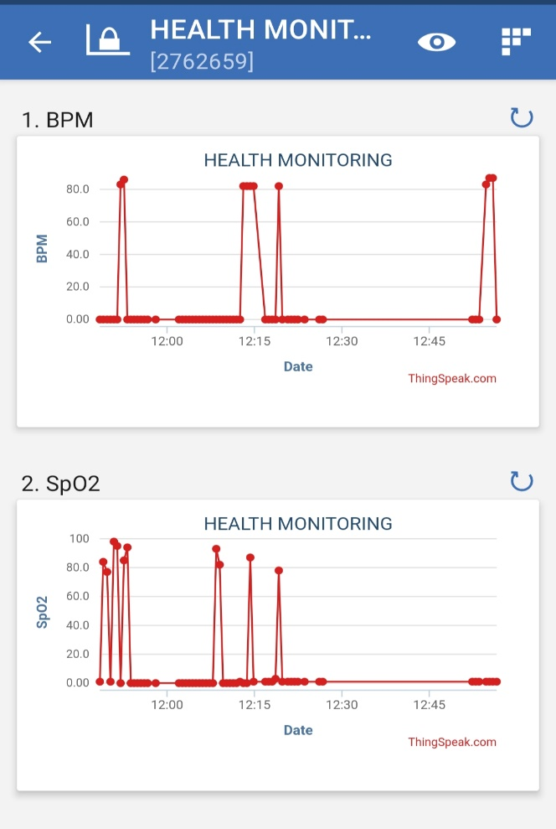

# VI. Conclusion

# This project presents an efficient and cost-effective solution for emergency ventilation needs. By leveraging the ESP32 microcontroller, servo motor control, and real-time monitoring, the ventilator provides an affordable alternative to conventional systems. The integration of multiple ventilation modes ensures adaptability for different patients, while the cloud-based monitoring system enhances usability in remote healthcare settings. Future improvements may include battery backup integration and further optimization of ventilation algorithms to enhance system reliability.

# References

1. Gupta, M., Roy, A., & Banerjee, S. (2021).“Design and Development of Low-Cost Portable Ventilator.” Proceedings of the IEEE International Conference on Advances in Computing, Communication and Information Technology.
2. Singh, P., Kumar, R., & Mishra, D. (2019). “Development of a Low-Cost Open-Source Portable Mechanical Ventilator.” Proceedings of the IEEE Engineering in Medicine and Biology Society (EMBC).
3. Mehta, S., & Rao, V. (2017). “A Novel Low-Cost Portable Ventilator for Emergency Use.” Proceedings of the IEEE International Conference on Innovations in Electronics, Electrical, and Computational Technologies.
4. Sharma, R., Patel, K., & Verma, M. (2021). “Design of a Low-Cost and Portable Ventilator for Resource-Limited Settings.” Proceedings of the IEEE Region 10 Humanitarian Technology Conference (R10-HTC).
5. Anand, T., Suresh, B., & Nair, H. (2021*).*“Portable Ventilator with IoT-Based Monitoring System for Remote Healthcare.” Proceedings of the IEEE International Symposium on Electronics and Communication (ISEC).
6. Das, J., & Mohan, N. (2020*).* “Development of a Cost-Effective Mechanical Ventilator Using Readily Available Components.” Proceedings of the IEEE International Conference on Signals, Systems, and Devices (SSD).
7. Fernandez, L., Wilson, R., & Chopra, A. (2021).“A Biologically Inspired Control Algorithm for Low-Cost Ventilator Systems.” Proceedings of the IEEE Biomedical Circuits and Systems Conference (BioCAS).