**AUTONOMOUS VEHICLE CONTROL USING LIDAR SLAM AND ROS WITH VISSIM SIMULATOR IN RAINY WEATHER**

FARHEEN IQBAL

*1Faculty/Student2, NED University of Engineering & Technology Karachi*

[Engr_farheen@cloud.neduet.edu.pk](mailto:Engr_farheen@cloud.neduet.edu.pk) engr_farheen@yahoo.com

***Abstract*:** Car driving is major issue in bad weather in Pakistan. There are many circumstances of weather like hot,cold and rainy or snowfall. Most of the drivers can’t control this scenario moreover can’t locate the area of direction.Internal combustion engine also can’t produce spark due to raining. In this scenario, ROS fulfil the engine crisis significantly. LIDAR with SLAM(simultaneous localization & mapping) has the capability to increase the efficiency of engine by compensating with ROS and utilization of snow fall reserves with negligible effects of driving. Fuzzy logic system also discussed in paper so that maintain the direction of ROS according to the raining data sheet. The prospects of this technology are explored in VISSIM simulator as a solution to traffic solutions and especially for the utilization of directions adjusting in rainy weather.Issues and challenges are considered for implementation of this technology and finally the roadmap for its implementation in our environment is discussed.

***Keywords*:LIDAR with SLAM,ROS, fuzzy logic design, engine efficiency, .**

**I. INTRODUCTION**

Pakistan faces so many issues of traffic jam in weather ups and down condition.We need position of robots and landmark for navigation.SLAM uses both mapping and localization and pose estimation algorithms to build a map at the same time.Given the environment map use sensor data to estimate current pose of the robot.Other traffic control through VISSIM.SLAM consist of motion model which is kinematics,measure model is a sensor model(RP LIDAR) infront of robotics,vehicle state (poses) and feature location(map) in the back of robotics. The lidarSLAM class performs simultaneous localization and mapping (SLAM) for lidar scan sensor inputs. The SLAM algorithm takes in lidar scans and attaches them to a node in an underlying pose graph. The algorithm then correlates the scans using scan matching. It also searches for loop closures, where scans overlap previously mapped regions, and optimizes the node poses in the pose graph. As figure 1.

[slamObj = lidarSLAM](https://www.mathworks.com/help/nav/ref/lidarslam.html?s_eid=PSM_15028#d124e73749)

[slamObj =lidarSLAM(mapResolution,maxLidarRange)](https://www.mathworks.com/help/nav/ref/lidarslam.html?s_eid=PSM_15028#d124e73759)

[slamObj = lidarSLAM(mapResolution,maxLidarRange,maxNumScans)](https://www.mathworks.com/help/nav/ref/lidarslam.html?s_eid=PSM_15028#d124e73782)

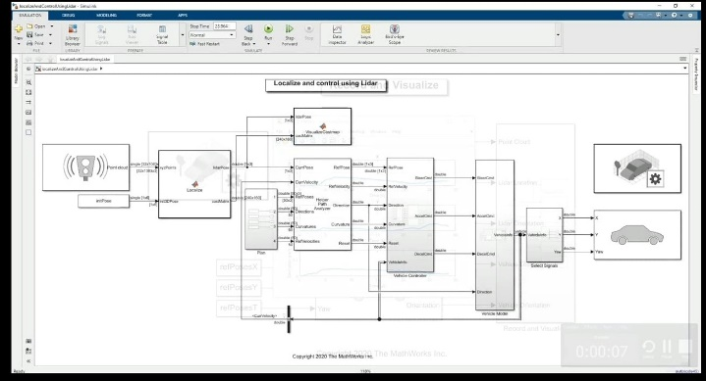

Figure 1:LIDAR SLAM implementation

By using star algorithm we made it admissible if, for any graph, it always terminates in an optimal path from the start state to the goal state if the path exists. We have seen earlier that if the heuristic function ‘h’ underestimates the actual value from the current state to the goal state, then it bounds to give an optimal solution and hence is called an admissible function. So, we can say that A* always terminates with the optimal path in case h is an admissible heuristic function.

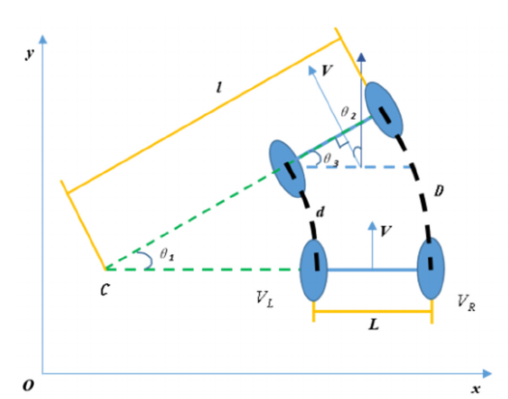

Figure 2:A* algorithm implementation

# II. FUZZY LOGIC SYSTEM DESIGN

Fuzzy logic system design made prediction of memberships values if engine is not working due to different condition of weather and send to ROS too as a feedback with SLAM at poses.The design graph shown in figure 2.

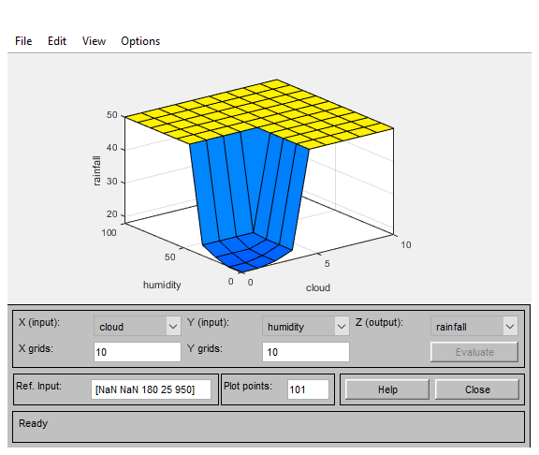

Figure 3:fuzzy logic feedback

The fuzzy based control model for LiDAR SLAM has formulated with feedback system of ROS.Implementation of interfacing model in autonomous vehicle with Bluetooth module can be achieved on run time comparision of estimated and real condition.This process continues until it reaches in final destination of mapping.Fuzzy logic system can also be connected in GUI with c++ but here prefer python for sequence of flow to merge all itmes in one margin.It also loop the A* algorithm in every step.

The sequence will be followed by neural network in which one input detected from lidar slam and one input from fuzzy logic system(one input feed back is also consider as a fuzzy logic system when weather will instantly changed a little bit.All data collected in access system(can also connect through sql in python) will be developed in sequence to form flatten form and one output at a time.Kalman filter can be used for for blur image and connected through HDMI for video detection at real time.Weight will be updated sequently in data collection if ups and down with respect to our requirement.All input connected through labview simulation in ROS (Arduino can also used as actuator).VISSIM through Bluetooth synthesizer also record a mapping in real time then comparison to imaginary data can produce error.Error removed in sub loop of python programming in QT ceator and updated regularly.

**III. ROBOT OPERATING SYSTEM**

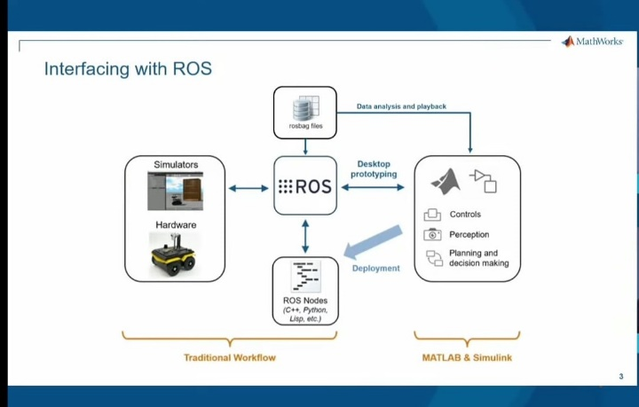

Figure 3:ROS modeling

In this case of studies we created python building GUI with QT creator which is user interface integrated development environment(IDE) and integrate with ROS.We decorate widget,slot and main windows by building application with python using agile algorithm and then interact with QT designer window.The steps included.

1)Introduce

2Add prerequisities

3)Produce static GUI layout

4)Perform widget naming convention

5)Connect vs autonomic convention

6)Define widget functions

7)Create Qt docs

8)Handling user errors

9)Develop Q message box

10) Close & close event

11)Wrap up

The connection of software and hardware is undertaken by our requirement of compatibility of system used and pins connector.Agile algorithm maintain the flow of cost and performance in each step and save in memory and will give a continuous set of data sheet.I did not mention here a perfect calculation of amount of data as it is builten or normalize through access or sql automatically.The resberry pi show the output and can be monitor through any android application(resberry pi monitor).FPGA can also be used so that it provide better memory system.The slop of vehicle can be monitor through equations by initial and final velocities or you can say thirst velocities of gradients and can be resemble to pyfirmata.Tkinter can also be used a library of python except QT creator but Its normally used with ubunto.

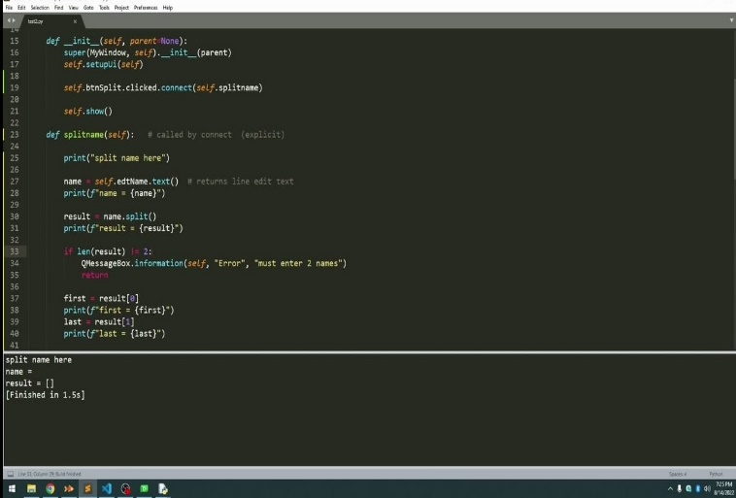

Figure 4:GUI with QTcreator

# IV. VISSIM SIMULATOR WITH BLUETOOTH DETECTORS

We used blue synthesizer application in which wifi,3D GPRS and Bluetooth combine together to collect data using VISSIM simulator.

This software has two modes of execution. The offline mode, can get the output trajectory of simulation as an input and generate Bluetooth hits and detection records similar to what happens in reality. The online mode of this software is capable of calculating traffic measurements, simulating Bluetooth detectors and Bluetooth enabled vehicles, and implementing traffic signal control strategies while the VISSIM simulation is running. This will enable us to verify the performance of proposed adaptive signal control model in variety of traffic conditions. This simulation framework can be used as a test bed for evaluating advanced traffic management strategies that rely on Bluetooth measurements. The proposed Bluetooth simulation model was validated using field measurements collected using a custom built system of hardware and software.

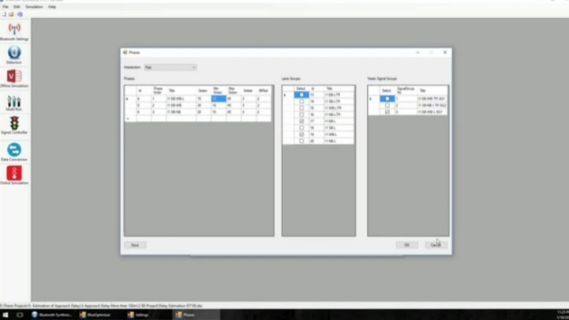

Figure 4:blue tooth synthesizer

I converted VISSIM Vehicle Trajectory (FZP) files to ACCESS database from where I can use the output of this process as an input to the Bluetooth Synthesizer.

The detail process of VISSIM simulator contains set parameters,units,vehicle types and composition,loading project area,drawing links and connectors,reduced speed areas,vehicle input,static routes,vehicle composition,adding signal head and signal controller,adding 3D model and running simulations.

The proximity of two large intersections adds to the complexity of the situation so that a microsimulation study was essential in order to get sound results of the vehicle actuated signalization. Testing it within the safe environment of a microsimulation tool enables the traffic engineer to provide an optimized and fault-proof signalization. This contributes to an efficient use of available road space and keeps maintenance times to a minimum hence providing a maximum capacity to all.

This can be regulate using stopwatch or time handling optimization time so that overall traffic flow move sequentlly.

**V. INTERFACING PLATFORM**

The interfacing technique we used in our research is lab view where we connected ROS,fuzzy logic system,LIDAR SLAM.VISSIMis connected through bluetooth application and send it to resberry pi.Python code also connected to resberry pi to control ROS.fuzzy logic system and lidar SLAM.

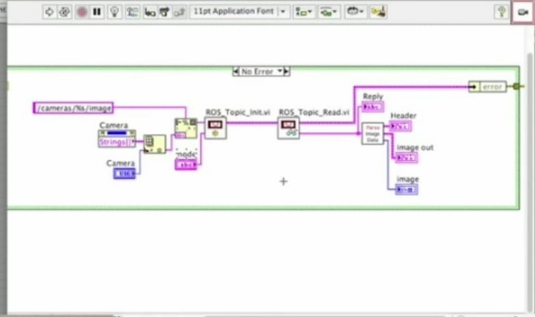

Figure 5:Labview platform

If the weather is hot or cold or rainy then it produce feedback loop to input where lidar produce comparison of data for autonomous detection of recorded and capturing manners with error handling.ROSmove actuator forward or reverse after VISSIM map object detection to make a decision either object may be pedestrian,tree,vehicle,bike,

Traffic signal or any non materialistic object.Brakes may also produce some resistance in gear that slow down the

car automatically.QT creator in python creating a subloop for all system before rotate the ROS.

# VI. CURRENT RESEARCH

The Robot Operating System (ROS) is a set of software libraries and tools used to build robotic systems and applications. The current long term service version of ROS is [ROS Noetic](http://wiki.ros.org/noetic). It is the 13th and latest distribution release of Robot Operating System (ROS1). It was released on May 23, 2020 by Open Robotics, the developer of ROS. It will be supported for 5 years until May 2025. In the future, all the official effort will be put into developing ROS 2, which is a major rewrite of the ROS framework.

ROS Noetic is mainly developed for Ubuntu 20.04, so Ubuntu is the recommended Linux OS for installation. This tutorial explains how to install ROS Noetic from source on the Raspberry Pi OS and how to connect your LiDAR to Raspberry Pi 4 Model B using ROS Noetic middleware. It's not hard, but it will take a long time to compile everything.

In the future study is going to try to investigate the use of GPS technology for stream travel time estimation under Turkey traffic conditions. In this case, some comparable or differences can be found between two technologies such as Bluetooth and GPS. After all, companies like Waze, TomTom, and Google are already able to provide city and country level traffic condition using GPS and other sources of data. For this reason, comparison is made among all technologies for travel time estimation under different conditions.

Today, the LabVIEW platform offers a flexible, fast, easy-to-learn, and complete image analysis infrastructure with various useful modules. For this reason, in this study, a method analysis for color perception with a simple USB webcam and software developed for real-time color analysis on the LabVIEW platform is presented and its success in the basic color analysis is tried to be revealed. The basic application developed for this purpose in LabVIEW v2019 using NI Vision Development Module v19 and NI IMAQ v19 modules.

# VII. CONCLUSION

The mentioned algorithm is little bit difficult to design but Its gives perfect output and simulation for self driving system.Moreover researches are not so much established regarding to that so its new idea to control robotics in the field of information technology.Models number can be change with respect to need of technologies but main phenomena is defined here.

**REFERENCES:**

**1.** L. Yang and W. Lan, "On Secondary Development of PTV-VISSIM for Traffic Optimization," 2018 13th International Conference on Computer Science & Education (ICCSE), Colombo, Sri Lanka, 2018, pp. 1-5, doi: 10.1109/ICCSE.2018.8468743.

**2**.K. B. Swain, S. Dash and S. S. Gouda, "Raspberry PI based Integrated Autonomous Vehicle using LabVIEW," 2017 Third International Conference on Sensing, Signal Processing and Security (ICSSS), Chennai, India, 2017, pp. 69-73, doi: 10.1109/SSPS.2017.8071567.

**3**.S. Gatesichapakorn, J. Takamatsu and M. Ruchanurucks, "ROS based Autonomous Mobile Robot Navigation using 2D LiDAR and RGB-D Camera," *2019 First International Symposium on Instrumentation, Control, Artificial Intelligence, and Robotics (ICA-SYMP)*, Bangkok, Thailand, 2019, pp. 151-154, doi: 10.1109/ICA-SYMP.2019.8645984.

**4**.<https://www.researchgate.net/publication/3454431_Using_Fuzzy_Logic_in_Automated_Vehicle_Control/link/0a85e530756b3bb25e000000/download>

**5**.B. Cao, R. C. Mendoza, A. Philipp and D. Göhring, "LiDAR-Based Object-Level SLAM for Autonomous Vehicles," 2021 IEEE/RSJ International Conference on Intelligent Robots and Systems (IROS), Prague, Czech Republic, 2021, pp. 4397-4404, doi: 10.1109/IROS51168.2021.9636299.

**6**.<https://www.youtube.com/watch?v=T588klKBPNo>