**IMPACT OF ADVERTISEMENT ON CONSUMER PREFERENCE: A REVIEW OF LITERATURE**

**Aditya Tale1, Dr. S.K Singh 2,**

1Student, Department Of MBA, P. R. Pote Patil College of Engineering & Management, Amravati, Maharashtra, India

2Associate Professor, Department Of MBA, P. R. Pote Patil College of Engineering & Management, Amravati, Maharashtra, India

**ABSTRACT**

Advertising plays a crucial role in shaping consumer buying preferences by influencing perceptions, attitudes, and purchase decisions. This study explores the impact of key advertising factors, including celebrity endorsements, advertising appeals (emotional, rational, and humour-based), media influence, consumer engagement, advertisement relevance, visual effects, and consumer psychology. In this study we use descriptive research, collected the secondary data through the various reputed journal and articles. By analysing existing literature, this research highlights how these factors contribute to consumer decision-making and brand perception. Findings suggest that an effective advertisement strategy requires a balance between emotional and rational appeals, personalized engagement, and media selection to enhance consumer responsiveness. The study concludes that while advertising significantly impacts buying behaviour, future research should incorporate primary data collection to gain deeper insights into evolving consumer trends.

**Keywords:** Advertising, Consumer Preference, Celebrity endorsement, Advertising appeals, Media influence, Consumer engagement

**INTRODUCTION**

Advertising plays a pivotal role in influencing consumer preferences and shaping their purchase decisions. It serves as a bridge between brands and consumers, conveying key messages that impact how products and services are perceived in the market. Among various advertising strategies, rational, emotional, and humour appeals are widely employed to engage consumers effectively. Each of these appeals functions uniquely, targeting different aspects of consumer psychology to influence buying behaviour and brand perception (Philip Kotler, 2016).

Rational appeals are rooted in logic and factual information, emphasizing product features, benefits, and value propositions. These advertisements appeal to consumers’ cognitive processes, helping them make informed decisions based on aspects such as price, quality, durability, and utility (Belch, 2021). Such appeals are particularly effective for high-involvement products like automobiles, insurance policies, and financial services, where consumers require substantial information before making a purchase decision (Solomon, 2020).

In contrast, emotional appeals rely on feelings and sentiments to create a connection between the consumer and the brand. These advertisements evoke emotions such as happiness, nostalgia, love, or fear to leave a lasting impression on the audience. Emotional advertising is often used in industries such as fashion, cosmetics, and luxury goods, where purchasing decisions are driven more by perception and lifestyle aspirations than by purely rational evaluation (Chaffey, 2022). Studies suggest that emotionally driven advertisements have a stronger impact on brand loyalty, as they establish deeper psychological associations between consumers and brands (Pelsmacker, 2017).

Humour appeals, on the other hand, aim to entertain the audience while subtly promoting a product or service. Humour in advertising has been found to enhance engagement, improve brand recall, and create a positive attitude toward the brand (Eisend, 2011). When executed effectively, humour can reduce consumer scepticism toward advertisements, making the promotional message more acceptable. However, the effectiveness of humour-based advertising depends on cultural context, target audience preferences, and the nature of the product (Brian Sternthal, 1973).

Despite the extensive research on advertising appeals, their relative effectiveness in shaping consumer preferences remains a topic of debate. While some consumers respond positively to rational arguments, others are more influenced by emotions or humour. Moreover, the rise of digital marketing has introduced new dimensions to advertising, where data-driven personalization allows brands to tailor their messaging based on consumer behaviour and interests (Cait Lamberton, 2016)

This study aims to analyse the impact of rational, emotional, and humour-based advertisements on consumer preferences and purchase decisions. By exploring how these appeals shape consumer behaviour and brand perception, this research will provide valuable insights for marketers seeking to enhance the effectiveness of their advertising strategies.

**OBJECTIVE:**

1. To analyse the impact of advertisements on consumer preferences and purchase decisions.
2. To explore how different types of advertisements influence consumer behaviour and brand perception.

**METHODOLOGY**

This study adopts a descriptive research design to analyse the impact of advertisements on consumer preferences and purchase decisions. Descriptive research is appropriate for understanding and interpreting the influence of different advertising appeals rational, emotional, and humour on consumer behaviour and brand perception. By reviewing existing literature, the study aims to provide insights into how advertisements shape consumer choices and brand associations. The research is based entirely on secondary data, collected from academic journals, books, industry reports, and credible online sources. Various research databases such as Google Scholar, Springer, JSTOR, and ScienceDirect have been used to gather relevant literature. The selection of secondary sources is based on their credibility, relevance, and contribution to the understanding of advertising effectiveness. Since this study does not involve primary data collection, it relies on the findings of previous research to draw conclusions.

**CONCEPTUAL FRAMEWORK**

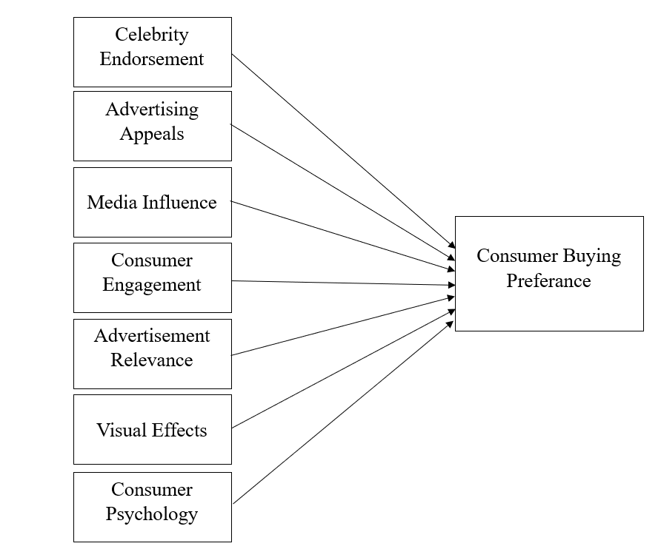

### Figure 1: **Conceptual Framework for the Study of Advertisement Impact on Consumer**

### Celebrity endorsements

serve as a powerful tool in advertising, as they create aspirational value and increase brand credibility. Consumers tend to associate a brand’s attributes with the characteristics of the celebrity endorsing it. Research by (Priyanka, 2021)highlights that the perceived trustworthiness, expertise, and attractiveness of a celebrity significantly impact consumer purchase intentions. The match-up hypothesis further supports the idea that endorsements are most effective when there is a logical connection between the celebrity and the product being promoted (Mohd Shuaib Siddiqui: Amar Johri, 2021). However, a study by (S.P Shobha Devi, 2022) points out that while celebrity endorsements boost brand awareness, they do not always translate into actual purchases. In cases where celebrities endorse multiple brands, consumer trust in the authenticity of their endorsement’s declines. Furthermore, high-profile celebrity controversies can negatively affect the brand image, leading to a decline in consumer trust (Nilukshika Pathirana, 2023).

### ****Advertising Appeals (Rational, Emotional, and Humorous)****

Advertising appeals can be broadly classified into emotional appeals and rational appeals, both of which impact consumer perception and decision-making. Emotional appeals such as humour, nostalgia, fear, and happiness create an affective connection between the consumer and the brand. Research by (Reshma Awati, 2024)indicates that humour-based advertisements are particularly effective in increasing consumer engagement and brand recall. Similarly, emotional storytelling is known to evoke positive brand associations and foster loyalty (R Subhasree, 2023). On the other hand, rational appeals rely on facts, figures, and logical arguments to convince consumers of a product’s benefits. (Kunal Gaurav, 2020)found that rational appeals are more effective for high-involvement products such as financial services, electronics, and healthcare, where consumers seek detailed information before making a purchase. In contrast, for impulse-driven categories like FMCG, emotional appeals tend to drive quicker purchasing decisions (Archana R. Motta, 2023).

### ****Media Influence****

The rise of digital media has significantly altered the way consumers interact with advertisements. Social media, influencer marketing, and personalized digital campaigns have replaced traditional television and print advertisements as dominant sources of brand communication. (Ampofo, 2014)notes that the increasing penetration of smartphones and internet access in India has led to a shift in consumer preferences toward digital advertisements. A study by (Archana R. Motta, 2023)suggests that influencer marketing, where social media influencers promote products, has gained significant traction among Indian consumers, particularly in the fashion and beauty industries. Consumers tend to trust recommendations from influencers they follow, as opposed to direct brand promotions. Furthermore, interactive features such as comments, likes, and shares enable brands to engage with their audience more effectively (Mohd Shuaib Siddiqui: Amar Johri, 2021).

However, (S.P Shobha Devi, 2022)caution that excessive exposure to digital advertisements can lead to “ad fatigue,” where consumers begin to ignore or actively avoid advertisements. This has led to the rise of native advertising, where promotional content is seamlessly integrated into user-generated content to appear more organic and engaging.

### ****Consumer Engagement****

Engagement is a key metric in determining advertising effectiveness, as it reflects consumer interest and involvement. Research by (Priyanka, 2021)suggests that brands that successfully engage consumers through interactive content, contests, and personalized messaging see a higher conversion rate. Social media platforms such as Instagram and YouTube have enabled brands to build communities where consumers actively participate in discussions, share feedback, and contribute to brand advocacy.

A study by (R Subhasree, 2023)found that advertisements featuring user-generated content such as customer reviews, testimonials, and influencer collaborations create a sense of authenticity and credibility. Consumers are more likely to trust brands that demonstrate transparency and actively engage with their audience. Additionally, gamification strategies, such as reward-based advertising and interactive quizzes, have been found to improve consumer attention and brand recall (Archana R. Motta, 2023).

### ****Advertisement Relevance****

The relevance of an advertisement to its target audience determines its success in influencing purchase decisions. (Kunal Gaurav, 2020)emphasize that personalized advertising where ads are tailored based on consumer preferences, browsing history, and purchasing behaviour leads to higher engagement and conversion rates. A study by (S.P Shobha Devi, 2022) found that consumers are more likely to respond positively to advertisements that align with their cultural and socio-economic background. For example, localized content in regional languages resonates more effectively with consumers in tier-2 and tier-3 cities in India. Furthermore, AI-driven programmatic advertising allows brands to display highly relevant ads based on real-time consumer behaviour, increasing the likelihood of purchase (Mohd Shuaib Siddiqui: Amar Johri, 2021).

### ****Visual Effects****

The design and aesthetics of an advertisement play a significant role in capturing consumer attention. (Reshma Awati, 2024) highlight that visually appealing advertisements with high-quality graphics, vibrant colours, and engaging animations enhance brand perception and memorability. (Nilukshika Pathirana, 2023)further explain that visual elements such as typography, symbols, and motion effects can evoke specific emotions that align with the brand’s message. Additionally, a study by (Mohd Shuaib Siddiqui: Amar Johri, 2021)found that advertisements featuring human faces, particularly those displaying genuine emotions, tend to generate stronger consumer responses. Video advertisements, in particular, have a higher engagement rate compared to static images or text-based ads due to their dynamic nature and storytelling ability.

### ****Consumer Psychology****

Consumer psychology plays a fundamental role in determining how advertisements influence buying behaviour. Psychological theories, such as Maslow’s hierarchy of needs, suggest that consumers make purchasing decisions based on their current needs and aspirations (Ampofo, 2014). For instance, luxury brands appeal to the consumer’s need for self-esteem and prestige, while healthcare brands appeal to safety and well-being. (R Subhasree, 2023) found that cognitive biases, such as the scarcity effect and the bandwagon effect, significantly impact consumer choices. Limited-time offers create urgency, prompting impulse purchases, while social proof such as customer reviews and celebrity endorsements reinforces perceived product credibility (Archana R. Motta, 2023).

**Consumer Buying Preference**

Consumer buying preference is the culmination of all the aforementioned factors, reflecting how advertisements shape purchase decisions. (Priyanka, 2021) states that repeated exposure to advertisements increases brand familiarity, which in turn fosters trust and preference. Consumers are more likely to purchase brands they recognize and associate with positive emotions. A study by (Mohd Shuaib Siddiqui: Amar Johri, 2021) found that advertising is particularly influential in categories with low brand differentiation, such as FMCG products. In such cases, aggressive advertising strategies such as price promotions, celebrity endorsements, and emotional appeals are used to create a competitive edge. However, for high-involvement purchases, consumers tend to conduct more extensive research before making a decision, and the impact of advertising is supplemented by peer reviews and product quality perceptions (Kunal Gaurav, 2020).

### ****FINDINGS****

Advertising plays a crucial role in shaping consumer preferences through various factors. Celebrity endorsement enhances brand trust and aspirational appeal, but its effectiveness depends on the celebrity-product fit and the risk of overexposure (Priyanka, 2021; Mohd Shuaib Siddiqui: Amar Johri, 2021). Advertising appeals influence consumer attitudes, with emotional appeals (humour, nostalgia) improving engagement and rational appeals being more effective for high-involvement products (Reshma Awati, 2024; Kunal Gaurav, 2020). Media influence has shifted towards digital platforms, with social media and AI-driven ads outperforming traditional media in consumer engagement (Archana R. Motta, 2023; S.P Shobha Devi, 2022). Consumer engagement through interactive content, user-generated media, and gamification strengthens brand connections and enhances ad effectiveness (R Subhasree, 2023). Advertisement relevance improves response rates, as personalized and targeted advertising resonates better with consumers. However, excessive personalization can lead to privacy concerns (Kunal Gaurav, 2020; Mohd Shuaib Siddiqui: Amar Johri, 2021). Visual effects in advertising, such as high-quality imagery and video content, enhance consumer attention and brand recall (Nilukshika Pathirana, 2023). Consumer psychology plays a key role in response to advertising, with cognitive biases (scarcity effect, bandwagon effect) influencing impulse buying behaviour (Ampofo, 2014). Finally, consumer buying preference is shaped by repeated exposure, emotional connection, and brand positioning, making advertising especially effective for low-involvement products, while high-involvement purchases require additional research and peer influence (S.P Shobha Devi, 2022).

### ****CONCLUSION****

Advertising remains a dominant force in shaping consumer choices, with its effectiveness dependent on multiple factors. The shift from traditional to digital advertising has transformed marketing strategies, making personalized and interactive ads more influential. Brands that align their advertising efforts with consumer psychology, digital trends, and engagement-based strategies can effectively drive consumer preferences. While low-involvement products benefit most from repetitive advertising, high-involvement decisions still rely on additional consumer research. Future studies should explore the impact of AI, virtual reality, and long-term brand loyalty in advertising effectiveness.

# **References**

1. Ampofo, A. (2014). Effects of Advertising on Consumer Buying Behaviour: With Reference to Demand for Cosmetic Products in Bangalore, India. *New Media and Mass Communication*, 22-36.
2. R. Motta, C. M. (2023). Impact of Social Media Advertising on Consumer Buying Behavior - An Empirical Study. Tuijin Jishu. *Journal of Propulsion Technology*, 7747-7753.
3. Belch, G. E. (2021). *Advertising and Promotion: An Integrated Marketing Communications Perspective.* McGraw-Hill Education.
4. Brian Sternthal, C. S. (1973). Humor in advertising. *Journal of Marketing*, 12-18.
5. Cait Lamberton, A. T. (2016). Thematic Exploration of Digital, Social Media, and Mobile Marketing Research. *Journal of Marketing*, 146-172.
6. Chaffey, D. P. (2022). *Digital Marketing: Strategy, Implementation and Practice.* Pearson Education.
7. Eisend, M. (2011). How Humor in Advertising Works: A Meta-Analytic Test of Alternative Models. *Marketing Letters*, 115-132.
8. Kunal Gaurav, A. S. (2020). Impact of Social Media Advertising on Consumer Buying Behavior in Indian E-commerce Industry. *Sumedha Journal of Management*, 41-51.
9. Mohd Shuaib Siddiqui: Amar Johri, A. S. (2021). A Study on the Influence and Impact of Advertising to Consumer Purchase Behaviour in Rural Areas of India. *Academy of Strategic Management Journal, 20*(5), 1-22.
10. Nilukshika Pathirana, A. A. (2023). Impact of Emotional Advertising on Consumer Buying Behavior in Ampara District. *International Journal of Research*.
11. Pelsmacker, P. D. (2017). *Marketing Communications: A European Perspective.* Pearson.
12. Philip Kotler, K. L. (2016). *Marketing Management.* Pearson Education.
13. Priyanka, C. P. (2021). A Study on Impact of Advertising on Consumers Buying Behavior with Reference to FMCG's in Urban Bengaluru. *International Journal of Research in Engineering, Science and Management, 4*(11), 79-83.
14. R Subhasree, D. P. (2023). Study on the Effect of Online Advertising on Consumer Buying Behaviour. *EPRA International Journal of Research & Development, 3*(8), 97-101.
15. Reshma Awati, V. S. (2024, Aug). Study of Role & Effects of Influencer Marketing on Consumer Buying Behavior with Reference to Indian Fashion & Beauty Industry. *International Journal of Research and Analysis in Commerce and Management*.
16. S.P Shobha Devi, D. R. (2022). A STUDY ON IMPACT OF ADVERTISING ON CONSUMERS BUYING BEHAVIOR WITH REFERENCE TO SELECTED FMCG. *The Journal of Contemporary Issues in Business and Government, 14*(3), 926-934. doi: https://doi.org/10.30574/wjarr.2022.14.3.0577
17. Solomon, M. R. (2020). *Consumer Behavior: Buying, Having, and Being. Pearson.* Pearson.