A Implementation on Restaurant Warehouse Optimization Using Advanced Analytics

Assistant Prof. Renuka Naukarkar, Department of Computer Science Engineering (Data Science), Abha Gaikwad

Patil College Of Engineering And Technology, Mohgaon, Wardha Road, Nagpur, Maharashtra, India

Tisha Bagade1, Amisha Patle2, Suhani Sahu3, Yash Mogare4

|  |  |
| --- | --- |
|  | ABSTRACT  Effective warehouse management is crucial for restaurants to ensure the timely delivery of quality food products. This study explores the application of data analytics in optimizing restaurant warehouse management. We collected data from a mid-sized restaurant chain and applied data analytics techniques to identify areas of improvement. Our results show that data-driven decision-making can lead to significant reductions in inventory costs, improvement in supply chain efficiency, and enhanced customer satisfaction. Specifically, we found that data analytics can help optimize inventory levels, reduce stockouts and overstocking, and improve delivery schedules. Our study provides insights into the potential of data analytics in restaurant warehouse management and offers recommendations for restaurants seeking to optimize their operations.  Keywords: Restaurant Warehouse Management, Data Analytics, Inventory Optimization, Supply Chain Efficiency, Customer Satisfaction. |

# INTRODUCTION

This study explores the application of data analytics in restaurant warehouse management, focusing on improving operational efficiency, reducing costs, and enhancing customer satisfaction. By analyzing data from restaurant warehouses and applying data analytics techniques, this research seeks to identify opportunities for optimization, develop data-driven strategies for improvement, and provide insights into the future of restaurant warehouse management. Restaurant warehouse management involves managing inventory, tracking orders, and ensuring the timely delivery of products.

The restaurant industry is a complex and competitive space where efficient operations and effective supply chain management are crucial for success. Warehouse management plays a vital role in ensuring that restaurants receive timely deliveries of quality food products.

While minimizing inventory costs and maximizing customer satisfaction. However, traditional warehouse management practices often rely on manual processes, intuition, and historical data, leading to inefficiencies, stockouts, and overstocking. In recent years, the increasing availability of data and advances in data analytics have transformed the way businesses operate. Data analytics offers unparalleled insights into operational efficiency, customer behavior, and market trends, enabling data-driven decision-making and optimization. In the context of restaurant warehouse management, data analytics can help optimize inventory levels, streamline supply chain operations, and improve customer satisfaction. In today's fast-paced and competitive restaurant industry, effective warehouse management is crucial for delivering high-quality products to customers on time. However, managing a restaurant warehouse can be a complex and daunting task, involving the coordination of inventory, supplies, and logistics.

The consequences of inefficient warehouse management can be severe, resulting in stockouts, overstocking, wasted resources, and compromised customer satisfaction.

This study explores the application of data analytics in restaurant warehouse management, focusing on improving operational efficiency, reducing costs, and enhancing customer satisfaction. By examining the current state of restaurant warehouse management and the potential benefits of data analytics, this research aims to provide insights and recommendations for restaurant warehouses seeking to optimize their operations and improve their competitiveness.

**Ⅱ**. LITERATURE REVIEW

Restaurants can now build their e-reputation and engage with customers in real time, according to a study by Pratik Lanke in 2023 [IRJMETS]. The use of machine learning, data visualization, and other advanced analytics techniques to optimize warehouse operations. Warehouse management involves managing inventory, tracking orders, and ensuring the timely delivery of products. Effective warehouse management is critical for restaurants to ensure the timely delivery of quality food products. The importance of warehouse management in reducing costs, improving efficiency, and enhancing customer satisfaction.

Advanced analytics techniques, such as machine learning and data visualization, have been applied in warehouse management to optimize operations. A study by Wang et al. (2020) applied machine learning algorithms to predict demand for food products in a warehouse, resulting in improved inventory management and reduced waste. The study investigates the factors influencing technology adoption by restaurants, highlighting the benefits and challenges associated with implementing digital solutions for order processing.

A Comprehensive Review (Smith, 2019). Research has highlighted the importance of data-driven approaches in optimizing inventory management. However, there is a gap in research on comprehensive data-driven approaches to restaurant warehouse management, integrating demand forecasting, inventory optimization, and data visualization. This project aims to investigate the application of advanced analytics in optimizing restaurant warehouse management, with a focus on improving inventory management, supply chain efficiency, and customer satisfaction.

This study explores how smart technologies and data availability enable restaurants to make strategic decisions. It discusses the use of data analytics in areas like inventory management, menu design, and multi-channel order management, providing actionable insights for practitioners. A project focused on leveraging data analysis techniques to address inefficiencies in restaurant warehouse management. It aims to optimize inventory levels, reduce stockouts and overstocking, and improve customer satisfaction. Zhang et al. (2020) proposed a data-driven approach to restaurant warehouse management, including inventory management and supply chain optimization.

This automated model seeks to enhance the efficiency of investments in new restaurant sites, enabling businesses to redirect resources toward critical areas such as innovation and employee training. By predicting the revenue potential of new outlets, the proposed system aligns to make informed decisions about opening new restaurant locations and optimizing overall business performance.

The project demonstrates the power of data-driven insights in enhancing decision-making for the restaurant industry by accurately forecasting revenue, enabling optimization in inventory,

staffing, marketing, and financial planning. This paper explores how smart technologies and increased data availability enable restaurants to make strategic decisions. It highlights data analytics applications in areas like inventory management, menu design, and multi-channel order management.

This research introduces a system designed to streamline restaurant operations, including inventory management and order processing. It emphasizes the role of data-driven decision-making in enhancing efficiency and customer satisfaction. Patel et al. (2020) examined the impact of data analytics on restaurant inventory management and customer satisfaction. In the ongoing development of a restaurant revenue prediction project, future steps can focus on deepening the understanding of the available data and enhancing the model’s predictive capabilities. Additionally, exploring the potential for a recommendation system can offer strategic insights into location expansion and menu optimization. Sharma et al. (2019) proposed a data-driven approach to warehouse management in restaurant warehouse management.

Ⅲ. Methodology

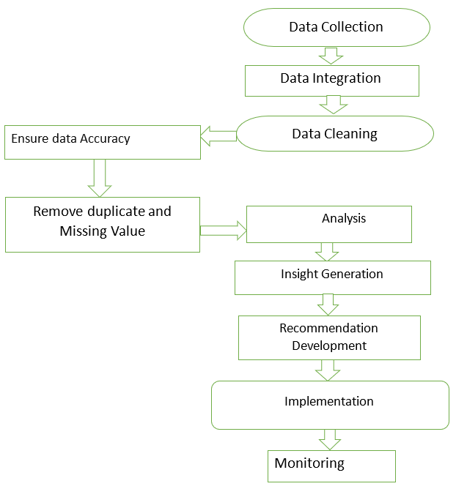

Fig 3.1. Purposed Architecture for RW

3.1 Data Collection

This step involves gathering raw data from diverse sources, like surveys, databases, or sensors. For example, in restaurant warehouse management, this might include tracking inventory levels, supplier information, or customer orders.

3.2 Data Integration

Once data is collected, it needs to be unified into a single dataset. This ensures that everything is consistent, making it easier to process and analyze. For instance, integrating purchase history with inventory records can reveal ordering trends.

* 1. Data Cleaning

Clean data is essential for meaningful analysis. This step removes errors, inconsistencies, and inaccuracies, ensuring high-quality data.

* 1. Ensure Data Accuracy

Verifying the accuracy of the data ensures reliability. This might involve cross-checking supplier delivery data with a

Warehouse records to ensure all items have been accounted for.

3.5 Remove Duplicate and Missing Values

Duplicate entries and missing values can skew results. This step identifies and addresses these issues, like ensuring there’s no duplicate record for the same stock item and filling gaps where delivery dates are missing.

3.6 Analysis

The Statistical techniques and algorithms are applied to find patterns, trends, and relationships in the data. It could help identify peak ordering times or the most frequently reordered items.

3.7 Insight Generation

The insights generated are the takeaways from the analysis. For instance, discovering that certain inventory items are consistently under-stocked.

* 1. Recommendation Development

Using insights, actionable recommendations are devised. These could include suggestions like increasing order quantities for high-demand items.

3.9 Implementation

The recommendations are put into action, such as updating your inventory management strategy or training staff to handle peak times more efficiently.

3.10 Monitoring

Finally, you track the impact of the changes to ensure they're effective. Regularly monitoring supplier performance, inventory accuracy, and customer satisfaction keeps everything on track.

Ⅳ. MODULES

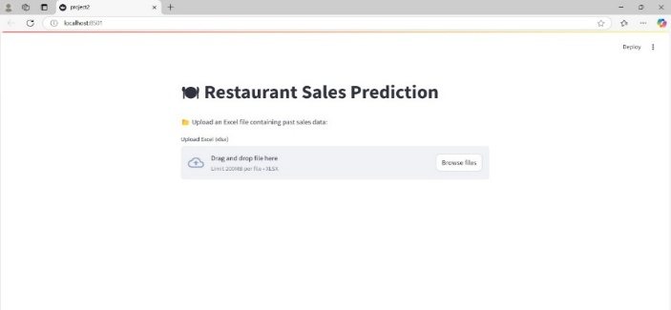

Fig 4.1. Restaurant Sales Prediction

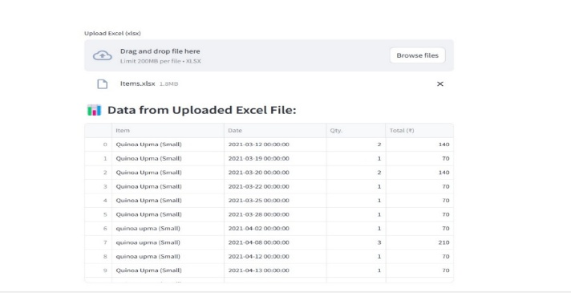

Fig 4.2. Sales Table With Upload Content

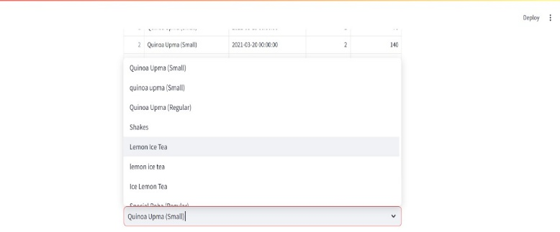

Fig 4.3. Food Items Selection

Ⅴ. RESULT ANALYSIS

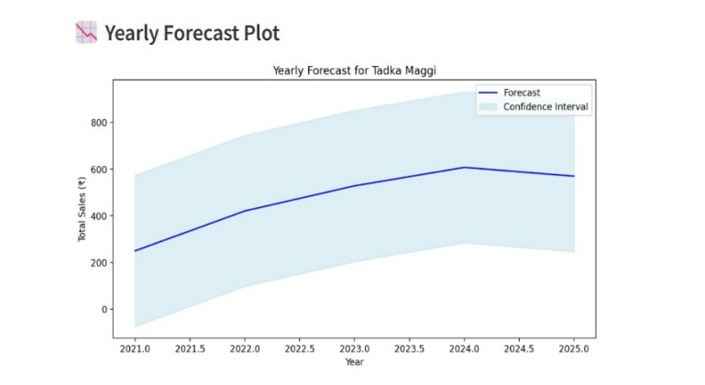

Fig 5.1. Yearly Forecast Plot

This graph provides a visual representation of sales forecasts for Tadka Maggi, with an emphasis on both predicted sales values and the variability in those predictions.

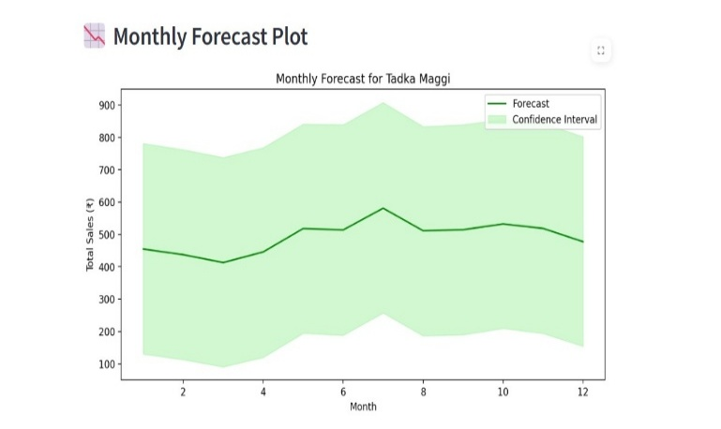

Fig 5.2. Monthly Forecast Plot

This plot helps visualize expected sales trends and understand the variability oruncertainty associated with

The predictions for Tadka Maggi over 12 months.

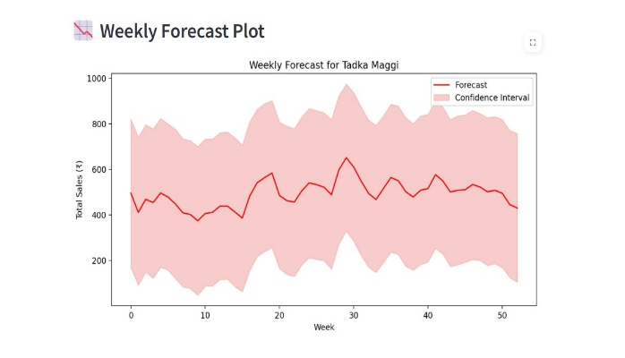

Fig 5.3. Weekly Forecast Plot

Focus on the weekly forecast for Tadka Maggi sales. The graph effectively provides a visual representation of expected sales trends for Tadka Maggi and highlights the variability associated with these predictions. It is a useful tool for analyzing sales performance over a year.

Ⅵ. CONCLUSION

The aim of restaurant warehouse optimization using advanced analytics is to achieve highly efficient, cost-effective, and adaptive operations that cater to the dynamic needs of the restaurant industry. This project has provided valuable insights into the benefits of data-driven decision-making in restaurant warehouse management. There are some key components:

1. Enhanced Inventory Management

2. Improved Decision-Making

3. Enhance Warehouse Efficiency

4. Improve Customer Satisfaction

5. Development of a data-driven

Ⅶ. REFERENCES

[1] Methraskar Swapna. “Inventory orders and e

Schedule management” [IJETIR], 2024.

[2] Omkar Pasalkar. “Provide real-time insights”

Management System [IRJMETS], 2024.

[3] M. Faizan Khandwani. “Allows customers to easily

select the items and track orders.”

[IRJMETS], 2023.

[4] Lee, H., & Kim, J "Integrating Blockchain

Technology for Enhanced Security in Restaurants”

[IRJMETS], 2023.

[5] Abolghasemi, M., Hurley, J., Eshragh, A., & Fahimnia,

explores innovative approaches to accurately predict

demand by incorporating systematic events

[IJCEM] (2020).

[6] Dutta, P., Choi, T. M., Somani, S., & Butala, R.

"Blockchain in Supply Chain Transparency"

[7] Kim, J., Lee, S., & Kim, B. Inventory optimization

Using data analytics in restaurant warehouse

system. [IJCEM], (2020).

[8] Khandwalla, P.N., The Design of Organizations,

and Novack, R.A., "Warehouse Measurement

Systems in Supply Chain Implementation"

Transportation Journal, [IEEE], (2020).

[9] Davis, A. New England’s underutilized seafood

"Species and Marketplace Dynamics"

potential in a changing climate.[IRJCEM],(2020).

[10] Patel, A., & Johnson, R. "Mobile Applications and

Their Role in Enhancing Customer Engagement in

the Restaurant Industry." Journal of Interactive

Marketing [IJRMETS], (2019).

[11] Shina et al. studied tree-based ML methods for

restaurant reviews (ICCCA, 2018).

[12] Park & Lee analyzed integrated POS systems in

restaurants (2017).

[13] Rarh et al. developed a time-series prediction

model for table reservations (ICCES, 2017).

[14] Perera & Caldera worked on opinion mining for

restaurant reviews (ICCIA, 2017).

[15] Kowsari et al. explored ML methods for revenue

prediction (2016).

[16] Bhandge et al. proposed touchpad-based food

ordering via Android (IJARCST, 2015)

[17] Chavan et al. designed an online customizable

food ordering system (IJISET, 2015).

[18] Patel et al. introduced an automated food

ordering solution (IJERD, 2015).

[19] Jakhete & Mankar implemented smart restaurant

concepts with e-menu cards (2015).

[20] Shinde et al. designed a digital dining system

using Android (2014).

[21] Bhargave et al. created a digital ordering system

for restaurants (2013).

[20] Alagoza & Hekimoglub analyzed customer

behavior in online food ordering (2012).