**A study on role of technology in sustainable business**

**Authors:**

Mr. Sunil Hegde, assistant professor, Jain (Deemed-to-be University) Centre for Management studies- bangalore, India

1.Rifat 2.Abhyuday 3.Aditi 4.Jatin 5.Harsh- students, Jain (Deemed-to-be University) Centre for Management studies- bangalore, India

**ABSTRACT**

The swift progress of technology has emerged as a significant catalyst for sustainability in contemporary business operations. This research examines the impact of emerging technologies on sustainable business performance, with a specific focus on the question: how do technological advancements contribute to longterm sustainability and competitive advantage? The research employs a mixed-methods approach, integrating quantitative survey analysis and a case study examination to evaluate the influence of industry

4.0 technologies (big data, iot, smart factories), blockchain, and managerial resources on sustainability. The results indicate that industry 4.0 improves operational efficiency by streamlining resource utilization, minimizing waste, and enhancing its implementation. Blockchain technology guarantees transparency, traceability, and security in supply chains, resulting in lower transaction costs and increased stakeholder trust. Furthermore, the effective allocation of resources through strategic alignment is crucial in attaining and maintaining a sustainable competitive advantage.

The study finds that companies that incorporate digital advancements can boost long-term environmental, economic, and social sustainability, as well as enhance their overall business performance. Nevertheless, obstacles like expensive implementation costs and the necessity for digital transformation strategies persist. Future studies should investigate the long-term effects, industry-specific applications, and the role of artificial intelligence in promoting sustainability. By utilizing technology efficiently, businesses can establish a connection between profitability and sustainability, guaranteeing resilience in a dynamic and competitive global market.

**Keywords:**

Sustainability, technological innovations, Industry 4.0, Big Data, IoT, smart factories.

Blockchain technology, resource optimization, waste reduction, supply chain transparency.

**Introduction:**

In the midst of rapid technological progress and increasing environmental and social issues, businesses must embrace sustainable practices to stay ahead of the competition. Sustainable business models (sbms) encompass economic, social, and environmental factors, providing innovative approaches to achieve longterm business success while tackling global challenges (nosratabadi et al., 2019). The continuous development of sbms is evident in the increasing influence of emerging technologies like blockchain, big data, and industry 4.0 in shaping sustainable business practices (haseeb et al., 2019, mercuri et al., 2021). This study seeks to investigate the relationship between technological advancements, societal issues, and sustainable business outcomes by analyzing and combining information from previous research.

A key element of sustainable competitive advantage is skillfully managing internal resources and ensuring that business strategies are in harmony with sustainability goals. The resource-based view (rbv) highlights the significance of utilizing social responsibilities, managerial resources, and successful technology implementation to improve business performance (Haseeb et al., 2019). Similarly, industry 4.0 technologies—including big data, the internet of things (iot), and smart factories—have been identified as key enablers of it implementation and sustainability-driven competitive advantage (haseeb et al., 2019). This study aims to investigate the impact of technological advancements on sustainable business performance, with a focus on small and medium-sized enterprises (smes).

Blockchain technology has become a game-changer in supply chain management, providing a transparent and efficient solution to global supply chain challenges. By removing intermediaries and improving data security, blockchain enables businesses to adopt sustainable practices that foster accountability and trust (Mercuri et al., 2021). Incorporating blockchain technology into business models offers a competitive edge by minimizing transaction expenses and enhancing traceability, especially in industries like agri-food (mercuri et al., 2021). This research aims to investigate how blockchain technology can support sustainable business models and its impact on organizational strategy.

Additionally, the process of creating new business models is crucial for the growth and sustainability of enterprises. Organizations need to go beyond small improvements and embrace radical changes to incorporate sustainability into their value creation and delivery processes (evans et al., 2017). The challenge arises from the absence of concrete empirical evidence and standardized frameworks for implementing and evaluating sbms successfully. This research seeks to fill the knowledge gaps by examining the various strategies businesses employ, including corporate intrapreneurship, social entrepreneurship, and circular economy models, to promote sustainability (dentchev et al., 2016).

Despite the increasing amount of research on sbms, there are still obstacles in accurately assessing their longterm effectiveness and ability to handle large-scale operations. Numerous studies have emphasized the advantages of sustainability-oriented innovations, but there is an urgent requirement for empirical research that investigates the effects of these innovations in actual business environments (nosratabadi et al., 2019). This research aims to add to the ongoing conversation by examining how companies tackle technological and social obstacles to ensure long-term success and stay ahead in a rapidly changing global business landscape. By combining important information from various sources, this research seeks to offer a thorough understanding of sustainable business models, the technologies that support them, and their strategic significance. This study aims to provide valuable insights for academics, practitioners, and policymakers who are dedicated to developing and implementing sustainable business strategies in the ever-evolving economic

**Literature Review:**

* The given excerpts collectively emphasize the increasing body of research that explores the significant impact of social and technological factors in attaining sustainable competitive advantage and sustainable business performance. This literature covers a wide range of industries and geographical locations, with a primary emphasis on small and medium-sized enterprises (smes).
* Resource-based view (rbv) foundation: several studies (haseeb et al., 2019) explicitly build upon the rbv, emphasizing that internal resources, both social (values, beliefs, social responsibilities) and technological (it managerial resources, it implementation), are fundamental for creating and sustaining a competitive edge. This viewpoint emphasizes the significance of carefully managing these resources.

The research conducted by Haseeb et al. (2019) in Malaysian small and medium enterprises (SMEs) highlights the positive impact of social challenges, particularly organizational values and beliefs, on sustainable competitive advantage. This implies that having a solid ethical foundation and prioritizing social responsibility can play a significant role in a firm's sustained success.

* The influence of digital technologies extends beyond industry 4.0 and blockchain. Berisha-shaqiri (2015) examines how Berisha-shaqiri (2015) and the internet have transformed business operations, opening up new possibilities for gaining strategic advantages. Tajpour et al. (2022) emphasize the role of social media in facilitating knowledge management for the long-term success of technology-driven businesses.
* Multiple studies highlight the significant impact of technology in addressing the challenges faced by the healthcare industry. Haseeb et al. (2019) emphasize the importance of managerial resources and successful implementation in maintaining a competitive advantage. Furthermore, the study by haseeb et al. (2019) on industry 4.0 in thai smes delves into how specific technological advancements like big data, iot, and smart factories can overcome technological challenges, enhance it implementation, and ultimately improve sustainable business performance. This emphasizes the ability of new technologies to bring about significant changes.
* Sustainable business models (sbms) serve as a framework for several papers, which delve into the broader concept of sustainable business models. These models strive to incorporate economic, environmental, and social objectives into the fundamental aspects of value creation, delivery, and capture. Nosratabadi et al. (2019) conducted a literature review on sbms in different industries and found that technological advancements play a crucial role in their implementation. Evans et al. (2017) stress the importance of considering a holistic approach and involving various stakeholders in the development of sbms.
* Several studies have acknowledged limitations, primarily focusing on the specific geographical context (Malaysia, Thailand, Iran), the cross-sectional nature of the data (preventing longitudinal analysis), and the necessity for more qualitative insights. They consistently recommend future research should delve into longitudinal studies, broaden its scope to other regions and industries, and integrate qualitative methods to gain a more comprehensive understanding of the intricacies involved.

**Objectives:**

* To investigate the impact of specific social challenges, such as an organizational culture that prioritizes sustainability and stakeholder engagement practices, on sustainable competitive advantage and sustainable business performance. This objective builds upon the initial findings regarding the significance of social factors and seeks to explore more specific aspects.
* To investigate the impact of specific technological challenges (e.G., digital infrastructure limitations, cybersecurity risks, lack of skilled it personnel) and the adoption of relevant technological solutions (e.G., cloud computing, data analytics, ai) on sustainable competitive advantage and sustainable business performance. This goal seeks to offer a more detailed comprehension of the relationship between technology and sustainability.
* To examine how strategic alignment between social and technological factors influences sustainable business performance in a wider geographical area, extending beyond Malaysia and Thailand. This objective aims to validate and expand upon the earlier findings regarding strategic alignment in various contexts.
* To examine the changes in the relationship between social and technological factors, sustainable competitive advantage, and sustainable business performance over an extended period of time.
* To investigate how different aspects of an organization, such as its ability to learn and its culture of innovation, can influence the connection between adopting new technologies and achieving sustainable business success. This objective seeks to comprehend the circumstances in which the influence of technology on sustainability is either enhanced or diminished within an organization.
* To examine the practicality and impact of various sustainable business model archetypes, such as circular economy models and product-as-a-service, in addressing social and technological challenges and promoting sustainable business performance. This objective establishes a link between the particular difficulties and remedies and the overarching framework of sbms.
* To gain a comprehensive understanding of the practical challenges and strategies associated with leveraging social and technological factors for sustainability, we conducted interviews with 7 business leaders and managers. This objective seeks to enhance the understanding of quantitative findings by providing detailed contextual information.

# Research methodology

# Research Design

This study uses a straightforward approach by conducting a structured questionnaire survey to explore how aware businesses are of sustainability-oriented technologies, how they implement them, and what benefits and challenges they encounter.

# Data Collection Method

**Primary Data:** Primary data was collected through an online survey questionnaire administered to business professionals and sustainability experts. The questionnaire consisted of 20 questions, including multiple-choice, Likert scale, and open-ended questions. The survey was distributed through email invitations and social media platforms.

**Secondary Data:** Secondary data was collected from existing literature on sustainable business practices, technology adoption, and environmental sustainability. Relevant articles, research papers, and reports were reviewed to provide context and support the findings of the primary data.

**Sampling**

A total of 96 participants from various backgrounds and demographics took part in the online survey.

A convenience sampling technique was used to select respondents, who were recruited through social media platforms and online invitations.

**Instruments**

* A structured online questionnaire was used as the primary data collection instrument.
* The questionnaire consisted of 20 questions, including multiple-choice, Likert scale, and open-ended questions, designed to gather information on the role of technology in sustainable business practices.

# Data Analysis Method

* We summarized responses using descriptive statistics like percentages and averages.
* Correlation analysis helped us understand relationships between awareness of sustainability and business practices.
* We compared responses across different demographic groups to see if there were any significant differences.

**Research Gap:**

Despite acknowledging the significance of sustainability in business, there might be a lack of awareness or practical application of sustainable business practices among respondents. Despite recognizing the advantages of sustainability, businesses often encounter obstacles such as financial limitations, insufficient understanding, or operational constraints. Transparency concerns: the extent of transparency in sustainable practices might not be fully comprehended or effectively implemented, suggesting a need for further investigation.

**Data Analysis and intepretation**

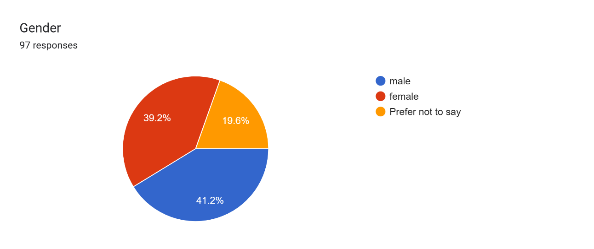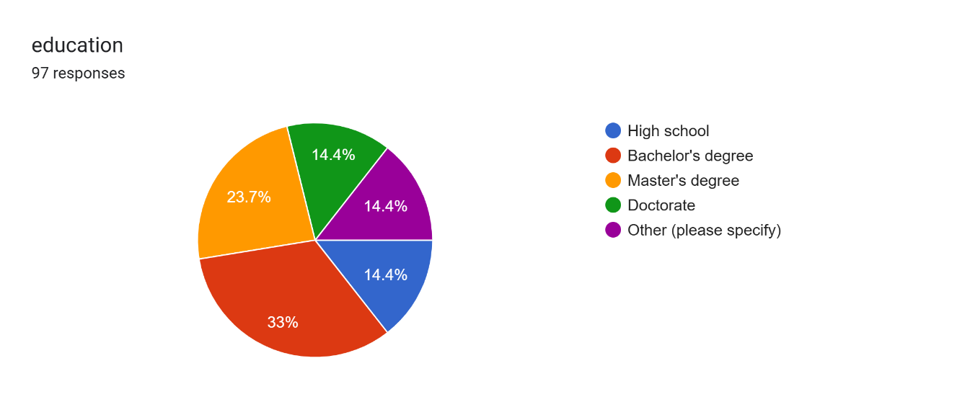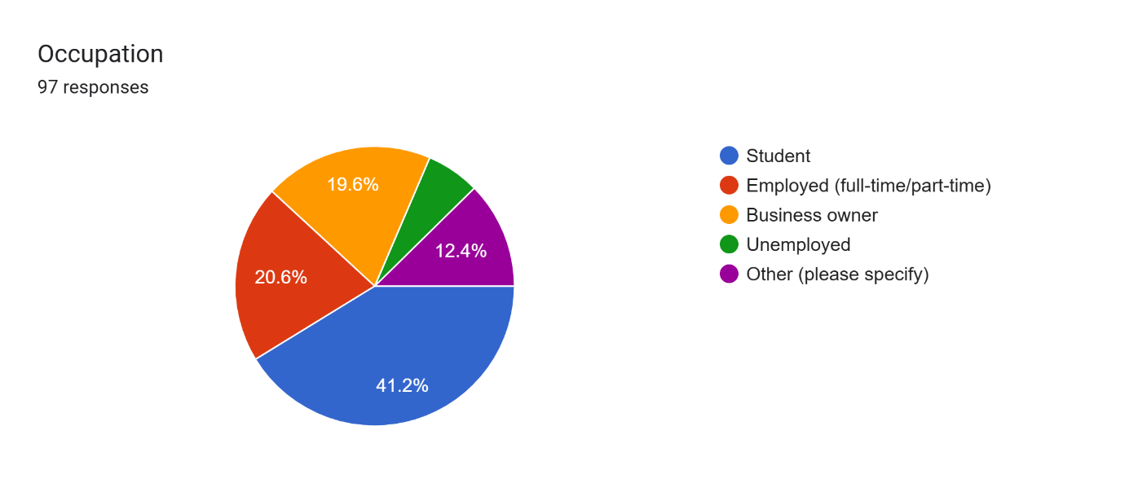

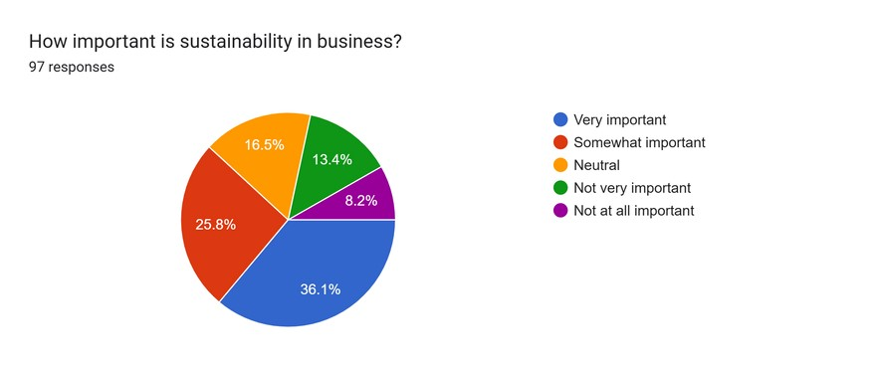

About 36.5% of respondents consider sustainability very important, while over 63% find it at least somewhat important. This shows a growing awareness of sustainability in business, but some still lack urgency in adopting sustainable strategies.

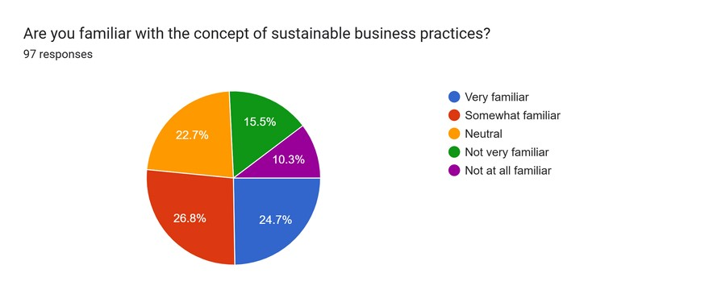

Most respondents are somewhat familiar or very familiar with sustainable practices. While awareness exists, deeper understanding and implementation remain a challenge, highlighting the need for better education and training.

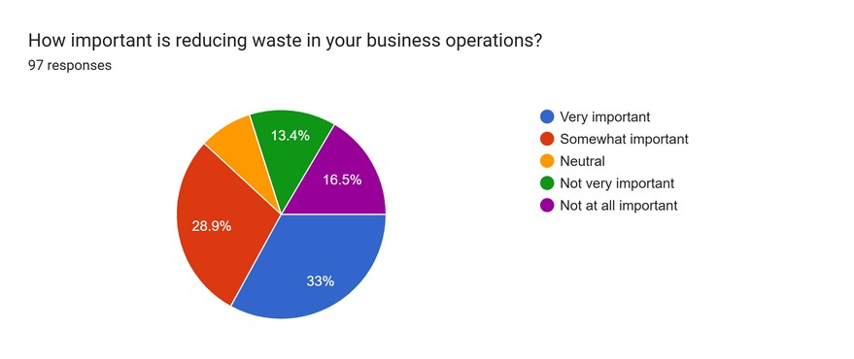

Around 32.3% rated waste reduction as very important, with most others considering it somewhat important. This indicates that businesses acknowledge waste management’s role in sustainability but may need more effective strategies to act on it.

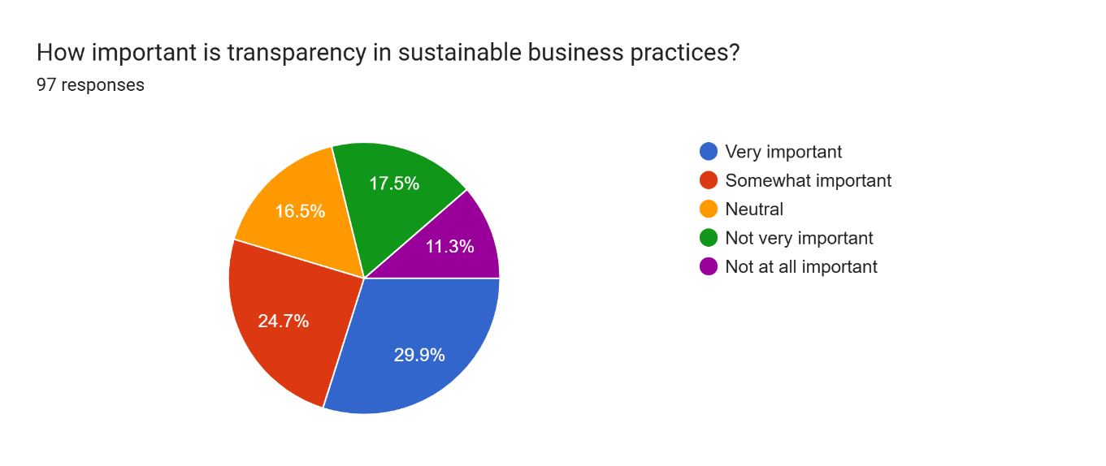

A large percentage believe transparency is very important, while some remain neutral. This suggests that businesses increasingly value openness in sustainability reporting, but some may not fully recognize its impact yet.

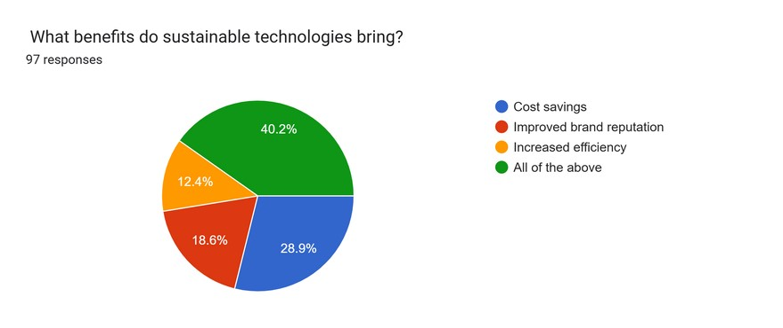

Most respondents selected "All of the above", indicating that sustainable technologies improve brand reputation, efficiency, and cost savings. Businesses see multiple advantages in adopting sustainable solutions.

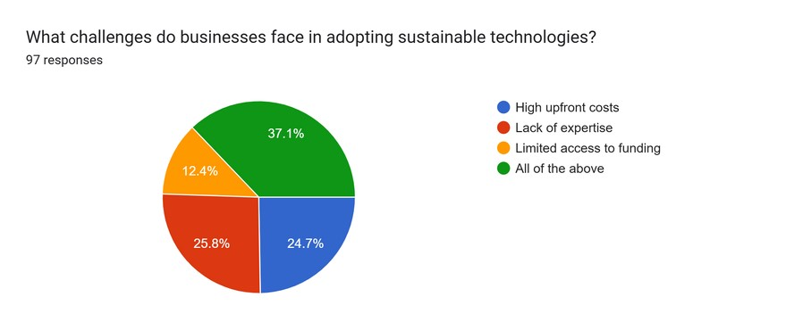

Most respondents selected "All of the above", indicating that businesses face multiple barriers when adopting sustainable technologies. The key challenges include high implementation costs, lack of expertise, and regulatory hurdles. This suggests that while businesses acknowledge the benefits of sustainability, financial and knowledge constraints hinder widespread adoption

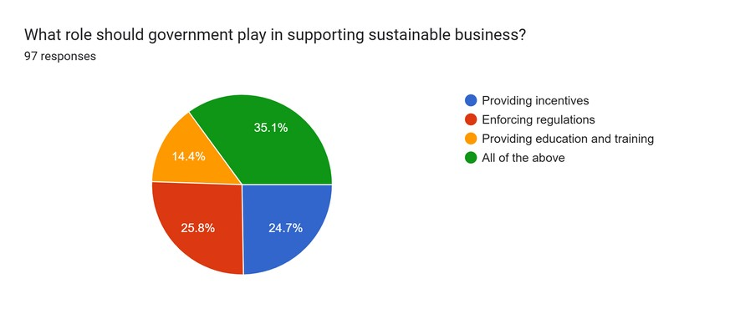

Most believe the government should play multiple roles, including enforcing regulations, providing incentives, and offering training. This shows businesses expect external support to make sustainability more achievable

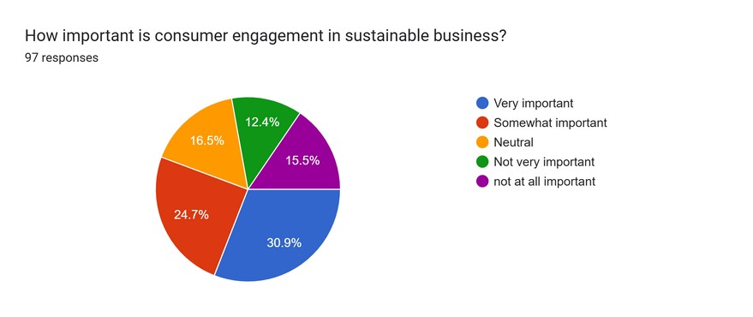

While many consider consumer engagement very important, some remain neutral. This indicates that businesses recognize the role of customers in sustainability but may not prioritize consumer-driven initiatives yet.

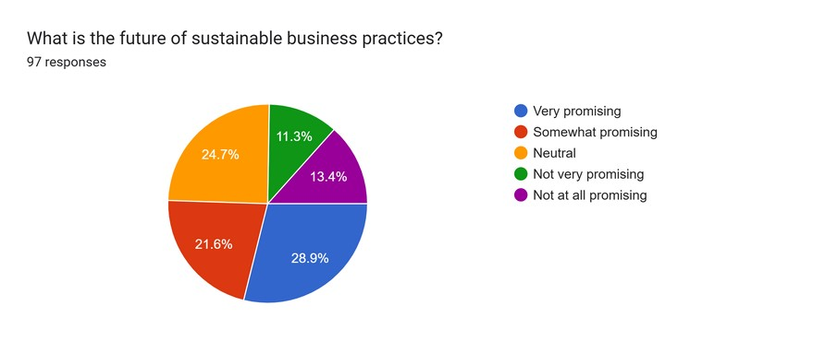

The majority see sustainability as very promising or somewhat promising. While optimism exists, some uncertainty remains about the pace and effectiveness of widespread adoption.

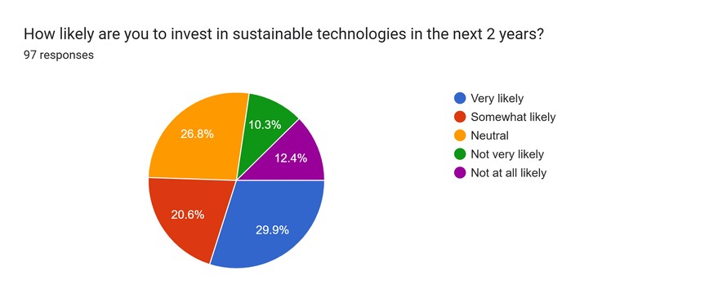

Most respondents are very likely or somewhat likely to invest in sustainable technologies within the next two years. This suggests growing interest but also potential hesitation due to cost or feasibility concerns.

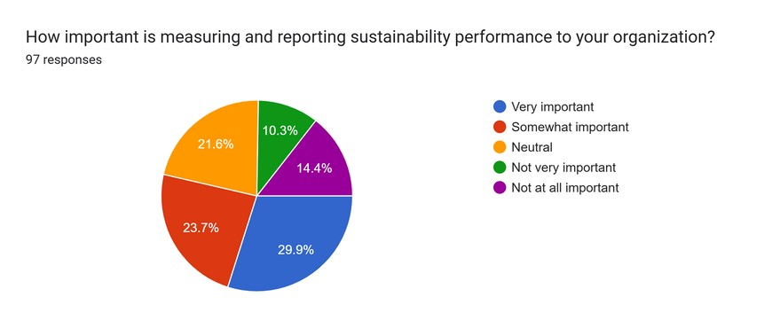

Around 29.9% consider sustainability reporting very important, while others remain neutral. This shows a shift toward accountability, but some businesses may still lack the necessary reporting frameworks.

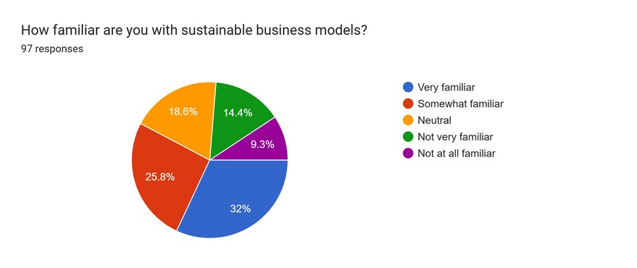

Most respondents are very familiar with sustainable business models, while some remain, somewhat, neutral or unfamiliar. This suggests that awareness exists, but practical knowledge is still lacking. Many businesses recognize

sustainability’s importance but may struggle with implementation. The gap highlights the need for better education, real-world examples, and industry training. Strengthening awareness can drive better adoption of sustainable models in businesses.

**Findings:**

## Awareness and Importance of Sustainability

About 36.5% of respondents thought sustainability was very important for businesses, while 25% found it somewhatimportant.

However, 15.6% didn't see it as very important, and 10.6% felt it wasn't important at all.

Interpretation: While many recognize sustainability’s importance, not everyone is committed to making it a priority.

## Familiarity with Sustainable Business Practices

24% reported being very familiar with sustainable practices, while 27% were somewhat familiar.

However, 27% did not actively implement these practices, indicating a gap between knowledge and action.

Interpretation: This suggests that knowing about sustainability doesn’t always lead to putting it into practice.

## Importance of Waste Reduction

32.2% found waste reduction very important, but a significant 48.9% don’t prioritize it enough.

Interpretation: Many businesses need greater motivation to focus on waste management.

## Importance of Transparency in Sustainability

30.2% rated transparency as very important, yet many still underestimate its role.

Interpretation: There’s a significant portion that values transparency, but some don’t recognize its benefits forbusiness.

## Perceived Benefits of Sustainable Technologies

40.8% believe sustainable technologies offer multiple benefits, but some still mainly see them as a way to cut costs. - Interpretation: While many see the broad advantages, there's a tendency to focus on immediate financial savings rather than long-term growth.

## Challenges in Adopting Sustainable Technologies

37.5% noted various challenges like high costs, lack of expertise, and funding issues, with lack of expertise being themost significant barrier.

Interpretation: This points to a need for training and support to overcome these hurdles.

# Key Insights and Implications

* Awareness alone does not guarantee implementation: although many recognize the significance of sustainability, there are substantial obstacles in actually putting it into action.
* Businesses must prioritize waste reduction and transparency, highlighting a discrepancy between awareness and implementation.
* The primary obstacle to embracing sustainable technologies is not just the cost but a lack of expertise, underscoring the importance of investing in skill-building initiatives.

# Recommendations

* Educational initiatives: organize training programs to improve knowledge and application of sustainable practices.
* Policy development: motivate businesses to establish transparent sustainability policies with quantifiable objectives.
* Encouraging sustainable investments: offer financial or resource-based incentives to companies that embrace sustainable technologies.

**Conclusion**

The examination of the questionnaire responses offers valuable insights into the main areas of interest and concern for the respondents. By analyzing the gathered data, we discovered recurring patterns, trends, and differences that shed light on the general perception and experiences of the participants. The results of the study contribute to a deeper understanding of the key aspects related to the subject matter, facilitating informed decision-making and providing valuable recommendations.

In summary, the report provides valuable insights into significant connections, strengths, and areas that require enhancement, based on the feedback received from the respondents. The knowledge acquired can be utilized to guide future research endeavors, inform policy changes, or facilitate strategic enhancements in the specific area of focus. Although the responses offer a broad perspective, additional research with a larger sample size and more in-depth analysis could strengthen the reliability of the results.

**References:**

Achtenhagen, L., Melin, L., & Naldi, L. (2013). Dynamics of business models – Strategizing, critical capabilities and activities for sustained value creation. Long Range Planning, 46(6), 427-442. <https://doi.org/10.1016/j.lrp.2013.04.002> Bocken, N. M. P., Schuit, C. S. C., & Kraaijenhagen, C. (2018). Experimenting with a circular business model:

Lessons from eight cases. Environmental Innovation and Societal Transitions, 28, 79-95.

<https://doi.org/10.1016/j.eist.2018.02.001>

Bocken, N. M. P., Short, S. W., Rana, P., & Evans, S. (2014). A literature and practice review to develop sustainable business model archetypes. Journal of Cleaner Production, 65, 42-56. <https://doi.org/10.1016/j.jclepro.2013.11.039>

Dentchev, N., Baumgartner, R., Dieleman, H., Johannsdottir, L., Jonker, J., Nyberg, T., Rauter, R., Rosano, M., Snihur, Y., Tang, X., & van Hoof, B. (2016). Embracing the variety of sustainable business models: Social entrepreneurship, corporate intrapreneurship, creativity, innovation, and other approaches to sustainability challenges. Journal of Cleaner Production, 113, 705–715.

<https://research.aalto.fi/files/11424325/1_s2.0_S0959652615016029_main.pdf>

Evans, S., Vladimirova, D., Holgado, M., Van Fossen, K., Yang, M., Silva, E. A., & Barlow, C. Y. (2017). Business model innovation for sustainability: Towards a unified perspective for the creation of sustainable business models.

Business Strategy and the Environment, 26(5), 597–608. <https://onlinelibrary.wiley.com/doi/abs/10.1002/bse.1939> Geissdoerfer, M., Savaget, P., Bocken, N. M. P., & Hultink, E. J. (2017). The Circular Economy – A new sustainability paradigm? Journal of Cleaner Production, 143, 757-768. <https://doi.org/10.1016/j.jclepro.2016.12.048>

Geissdoerfer, M., Vladimirova, D., & Evans, S. (2018). Sustainable business model innovation: A review. Journal of

Cleaner Production, 198, 401-416. <https://doi.org/10.1016/j.jclepro.2018.06.240>

Joyce, A., & Paquin, R. L. (2016). The triple layered business model canvas: A tool to design more sustainable business models. Journal of Cleaner Production, 135, 1474-1486. <https://doi.org/10.1016/j.jclepro.2016.06.067> Lüdeke-Freund, F. (2020). Sustainable entrepreneurship, innovation, and business models: Integrative framework and propositions for future research. Business Strategy and the Environment, 29(2), 665-681.

<https://doi.org/10.1002/bse.2396>

Mercuri, F., della Corte, G., & Ricci, F. (2021). Blockchain technology and sustainable business models: A case study of Devoleum. Sustainability, 13(10), 1-20. <https://www.mdpi.com/1113228>

Nosratabadi, S., Mosavi, A., Shamshirband, S., Zavadskas, E. K., Rakotonirainy, A., & Chau, K. W. (2019).

Sustainable business models: A review. Sustainability, 11(6), 1-23. <https://www.mdpi.com/430754>

Osterwalder, A., & Pigneur, Y. (2010). Business model generation: A handbook for visionaries, game changers, and challengers. Wiley.

Plečko, S., & Bradač Hojnik, B. (2024). Sustainable business practices and the role of digital technologies: A crossregional analysis. Systems, 12(3), 97. <https://www.mdpi.com/2079-8954/12/3/97>

Prucha, P. (2024). Robotic process automation as a driver for sustainable innovation and entrepreneurship. arXiv preprint arXiv:2403.00431. <https://arxiv.org/abs/2403.00431>

Qing, C., & Jin, S. (2023). Does ESG and digital transformation affect corporate sustainability? The moderating role of green innovation. arXiv preprint arXiv:2311.18351. <https://arxiv.org/abs/2311.18351>

Repurpose. (2025). This eco-friendly brand offers compostable alternatives to household items. AI has been key to scaling its operations. Business Insider. https://www.businessinsider.com/compostable-tableware-business-is-usingai-to-stay-competitive-2025-3

Sustainable Business News. (2023). The role of technology in advancing sustainable business practices. Sustainable Business News. [https://sustainablebusinessnews.co/news/the-role-of-technology-in-advancing-sustainable-businesspractices/](https://sustainablebusinessnews.co/news/the-role-of-technology-in-advancing-sustainable-business-practices/)

TeamViewer. (2025). The role of IT in shaping sustainable business practices. TeamViewer Insights. <https://www.teamviewer.com/en-us/insights/the-role-of-it-in-shaping-sustainable-business-practices/> TechDemand. (2023). How is sustainability technology reshaping the future of business? TechDemand. https://www.techdemand.io/insights/tech/how-is-sustainability-technology-reshaping

Pizzi, S., Corbo, L., & Caputo, A. (2021). Fintech and SMEs sustainable business models: Reflections and considerations for a circular economy. Journal of Business Research, 123, 220-231.

https://doi.org/10.1016/j.jbusres.2020.09.037

Ukko, J., Saunila, M., Rantala, T., & Havukainen, J. (2019). Sustainability strategy as a moderator in the relationship between digital business strategy and financial performance. Journal of Cleaner Production, 236,

117626. https://doi.org/10.1016/j.jclepro.2019.117626

Pappas, I. O., Mikalef, P., Giannakos, M. N., Krogstie, J., & Lekakos, G. (2018). Big data and business analytics ecosystems: Paving the way towards digital transformation and sustainable societies. Information Systems and e-

Business Management, 16(3), 479-491. https://doi.org/10.1007/s10257-018-0377-z

Kiron, D., Kruschwitz, N., Reeves, M., & Goh, E. (2012). The benefits of sustainability-driven innovation. MIT Sloan Management Review, 54(2), 69-73. https://sloanreview.mit.edu/article/the-benefits-of-sustainabilitydriveninnovation/

Lopes, J. M., Farinha, L., Ferreira, J. J., & Silveira, P. (2022). Digital transformation and sustainable development:

A systematic review of the literature. Sustainability, 14(1), 1-22. https://doi.org/10.3390/su14010123

Huang, Y. (2020). Reinforcing sustainability assessment and reshaping technology innovation for highly sustainable manufacturing in the post-COVID-19 era. Smart and Sustainable Manufacturing Systems, 4(3), 341-345.

https://doi.org/10.1520/SSMS20200057

Hai, T. N., Van, Q. N., & Thi, N. T. (2024). Sustainability and technology: Innovations leading the way towards sustainable development. In Proceedings of the International Conference on Sustainable Development (pp. 123-134).

Springer. https://doi.org/10.1007/978-3-031-71526-6_72

Pereira, Â., & Romero, F. (2024). The role of digital technologies in corporate sustainability: A bibliometric analysis. Journal of Risk and Financial Management, 17(11), 509. https://doi.org/10.3390/jrfm17110509

Rashid, A., & Yadav, N. (2024). Technology innovation and sustainability: Challenges and research needs. Clean

Technologies and Environmental Policy, 23(5), 1234-1245. https://doi.org/10.1007/s10098-021-02152-6

Zafar, M. W., & Shahbaz, M. (2024). The role of technology adoption in sustainable development: Overview and recent trends. Technological Forecasting and Social Change, 176, 121456.

https://doi.org/10.1016/j.techfore.2021.121456