**GENERATING A MUSIC PLAYLIST USING FACIAL EXPRESSIONS**

**Kalle Sravani1, Maddu Haindavi2, Thurerao Divya3 , Sumera4**

1234Stanley College of Engineering and Technology For Women, Hyderabad, Telangana, India

**ABSTRACT**

To listen to music is the favorite pastime of many people, each of who have their own preferred type of music. Users always face the problem of searching through their folders to find the right music to fit their mood, and to make a list of their favorite songs. The facial expressions project attempts to help form a mechanized and automated system for personalizing music to a user’s emotional state. To help aid this goal, this project provides the framework for gathering songs and the user’s emotional state at the same time so the songs for each orchestrated emotion can be precisely generated later. A webcam captures facial expressions which are processed by a learning algorithm capable of inferring the most likely emotion corresponding to the detected facial expression. The already known expression is then identified and a corresponding playlist is created in advance style. The created playlist gets read by Spotify API and thus saves user time to search for songs that are most often selected for a particular mood. When selecting the required songs, the API sorts them according to the mood-denoting emotion of joy, sadness, anger or neutral which is detected Spark API.

**Keywords:** Face Emotion Detection, Emotion Identification, Music Playlist, Convolutional Neural Networks, Spotify Application List Interface,

**1. INTRODUCTION**

While music is crucial for day-to-day activities, looking for new songs often proves to be a daunting task. This project uses computer vision to automatically select music based on the user’s facial expression. Computer vision allows for the interpretation of digital image data by a computer such that meaningful information can be extracted for use in machine learning. A webcam captures facial expressions that are processed to establish what emotional state a user is in. In our system, we use the facial expression recognition approach based on the Haar Cascade classifier, which is an object detection framework introduced by Viola and Jones. Emotion recognition is accomplished with Convolutional Neural Networks (CNNs), which have been shown to classify images with high accuracy. CNN is a multi-layer, feedforward neural network that relies on the complex mechanisms of the brain’s nervous system, and mimics the human visual system, recognizing hierarchical spatial features through the following processes: convolution and pooling, and finally fully connected layers. The identified emotion is associated with a designated playlist which is automatically played. The use of Haar Cascade for face detection and CNN for feature extraction guarantees performance in practical situations. This allows for an improvement in user experience and makes it easier to browse for music. Because of the neural network’s ability to discern patterns within an image’s data, the task becomes more efficiently executed and the processing speed of the system increases.

**2. LITERATURE SURVEY**

The literature review gives an ideological ground to this project by considering different methods of generating music playlists from facial expressions.

**Classic Music Recommendation Systems:**

Classic music recommendation systems are based on user input in the forms of manual playlist generation or genre- or popularity-based song selection. Although efficient, these systems involve active user participation and fail to respond to real-time emotional fluctuations, which restrict their capacity to deliver a custom experience.

**Facial Expression-Based Emotion Recognition:**

Computer vision and deep learning advancements have made emotion detection possible via facial expressions. Researchers have utilized datasets such as FER-2013, AffectNet, and EmotiW to train Convolutional Neural Networks (CNNs) for emotion recognition like happiness, sadness, anger, and surprise. Although CNN models perform with high accuracy, their success relies on proper training, extensive labeled datasets, and strong environmental adaptability.

**Machine Learning in Music Recommendation:**

Machine learning algorithms, such as deep neural networks and hybrid emotion models, have been used to make music recommendations personalized. These systems examine facial expressions and translate them into mood-based playlists. Challenges such as real-time processing, generalization across different facial structures, and changing lighting conditions impact performance.

**API Integration for Automated Playlist Generation:**

Integration with music streaming services such as Spotify API has enabled real-time playlist generation according to the emotions detected. Such APIs utilize pre-defined song categories that correlate with emotions to enhance user experience. Even though they are efficient, API-based systems demand reliable internet connections and proper mapping of emotional states and music genres.

**3. AIMS AND OBJECTIVES**

This project aims to create an emotion-aware music recommendation system that autonomously constructs playlists with multi-faceted user experience through emotive facial expression tracking. This system automatically detects and recognizes emotions such as happiness, sadness, anger, surprise, and neutral using CNNs and Haar cascade self-classification methods. The emotion is then recalled with a set playlist and automatically played without requiring the user to select songs. In addition, a music streaming API like the Spotify API is incorporated into the project to enable effortless streaming during the optimization of deep learning models for speed and accuracy. System performance is analyzed using precision, time efficiency, and dependability, focusing on the ultimate goal of simplifying the music recommendation process.

**4. SYSTEM ARCHITECTURE**

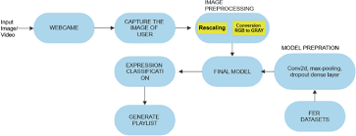

The illustration shows a music recommendation system which works with facial recognition and deep learning technologies, operating based on emotions. The procedure starts with taking a picture as an input. The picture is then sent to a Convolutional Neural Network where the image is screened for a face. When a face is found in the image, the appropriate features of the face are captured to assess the user’s emotions. These captured features are then applied to emotion recognition, the process in which a person's feeling such as happiness, sadness or anger is determined. After determining the user’s emotions, a set of songs that match the user’s mood is categorically selected from a database of songs using a music classifier. The resulting playlist is recommended as an output of the system, along with the categorized song which is played to the user. This system automatically chooses the songs and increases users satisfaction allowing them enjoy songs corresponding to their mood. And, with the use of deep learning, computer vision, and music classification, this framework gives the user a personalized music experience.

**5. ALGORITHM**

**1) Capture Facial Expression**

* Take a photo or capture a real-time video of the user's face.

**2) Preprocess Image**

* Convert the image to black and white.
* Adjust the image for optimal model precision.

**3) Facial Feature Detection**

* Analyze facial landmarks using a pre trained deep learning model (OpenCV, DeepFace, TensorFlow, etc).

Find critical areas such as eyes, eyebrows, and mouth.

**4) Expression Classification**

* Use an emotion classification model (CNN based) to recognize faces towards happy, sad, angry, surprised, calm, neutral, or any other defined emotions.

**5) Map Emotion to Music Genre**

* Emotion Happy is equal to Pop, Dance, Upbeat Songs. Sad is equals to Slow, Acoustic, Blues. Anger equals to Rock, Metal, Rap. Surprise equals to Electronic, Experimental. Calm equals to Lo-Fi, Classical, Jazz.

**6) Generate Playlist**

* Search the music database and select songs that represent the category of emotion detected.
* Make a playlist with a set number of songs (10) and return it.

**7) Display Playlist & Play Music**

* Show the users generated playlist. Give users the option to skip or change songs.

**6. USED TECHNOLOGY**

**Frontend Development:**

**Hyper Text Markup Language (HTML):** Presents the web pages structure and its essentials.

**Cascading Style Sheets (CSS):** Manages graphical details and the designs of the interface.

**JavaScript (JS):** Provides the required actions and operates on the website.

**Backend Development:**

**Python:** The foremost programming language that has been utilized in backend management.

**Django (Python Framework):** A web framework of high level that permits quick construction and is scalable while being secured.

**Development Environment Tools:**

**PyCharm IDE:** An integrated development environment for Python that is strong and provides debugging, code summarizes, and other indispensable items.

**Database Management System:**

**SQLite/PostgreSQL:** A database that is employed with Django ORM for its simple querying and for data utilization and supervision.

**Versioning Control System:**

**Git & GitHub:** Utilized in monitoring the progress made, collaboration, and versioning of the code.

**APIs and Additional Software:**

**OpenCV:** Employed for recognizing facial features and determining expression.**\**

**TensorFlow/Keras:** Deep learning construction used for the comprehension of facial expressions and their attribution to salient features.

**Media APIs:** Used to link the services of music streaming e.g. Spotify API.

**7. MODULES AND RESULTS**

**1) Command Prompt**

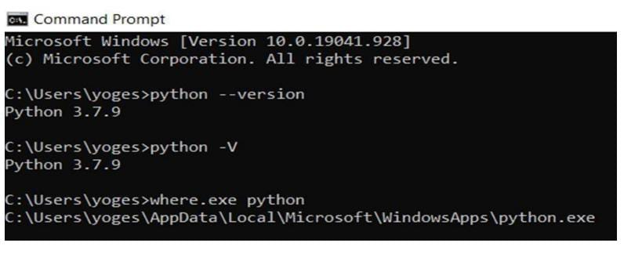

Python | Command Prompt

**2) Importing libraries and opening webcam**

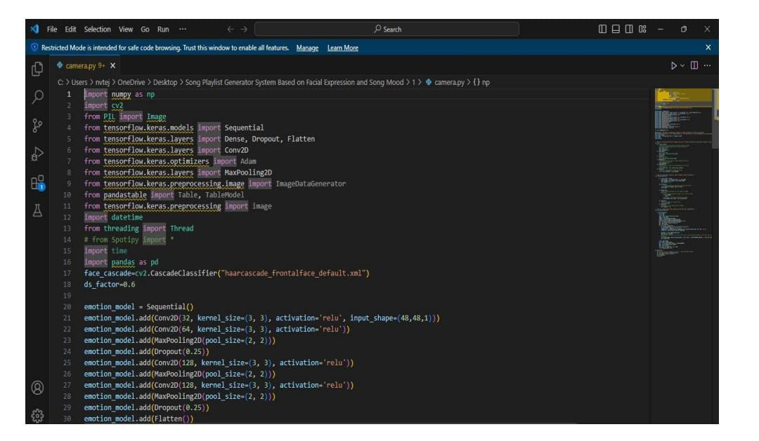

Opening webcam

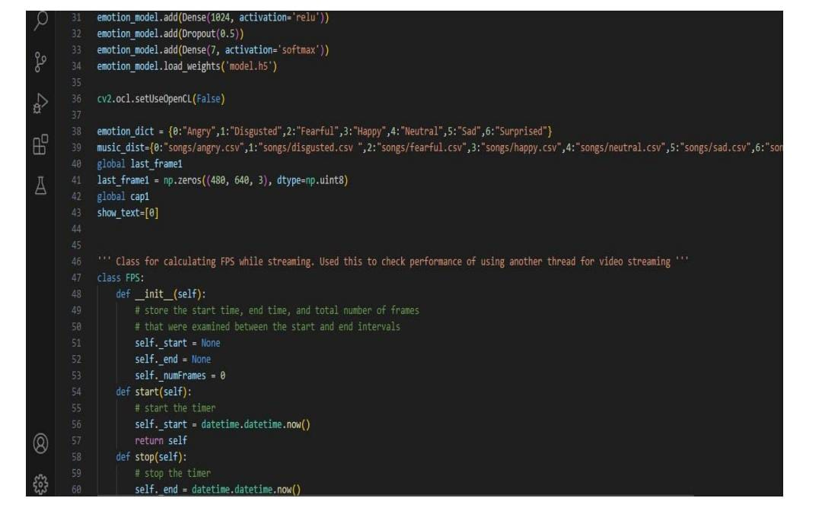

Opening webcam

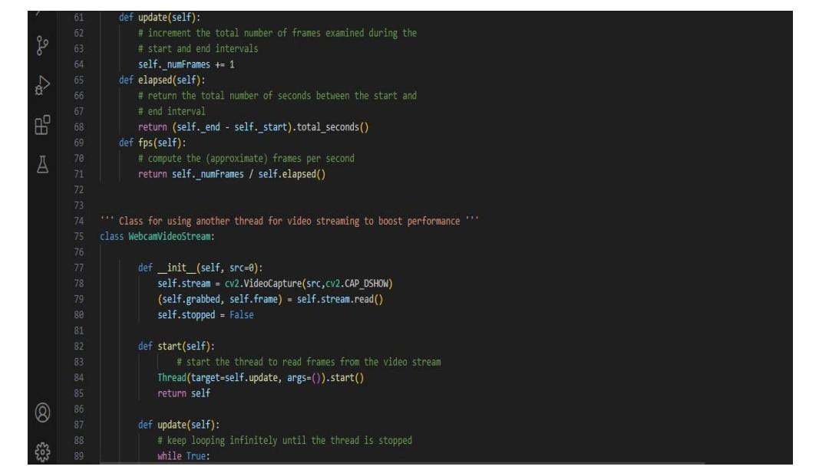

Opening webcam

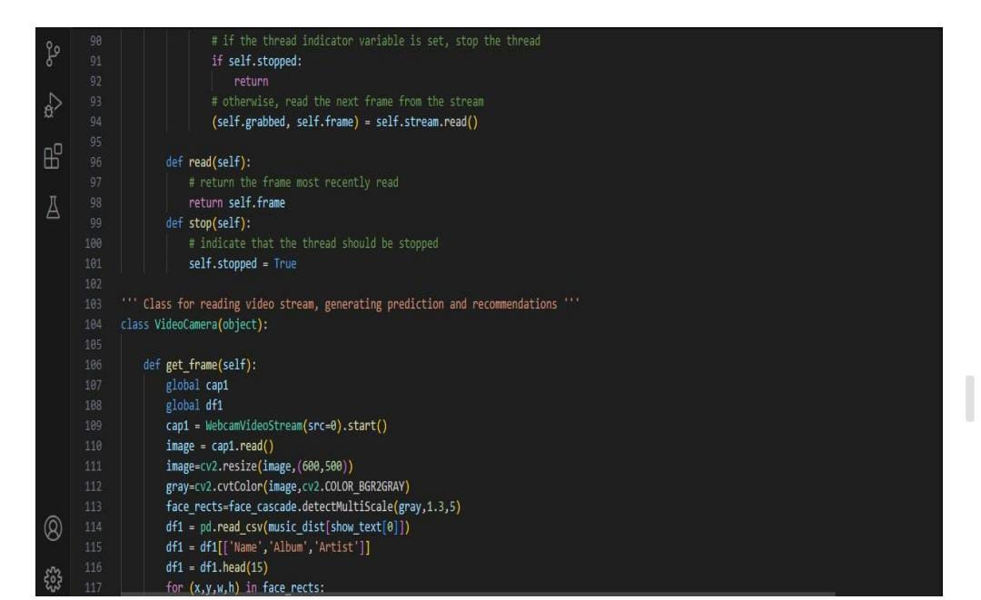

Opening webcam

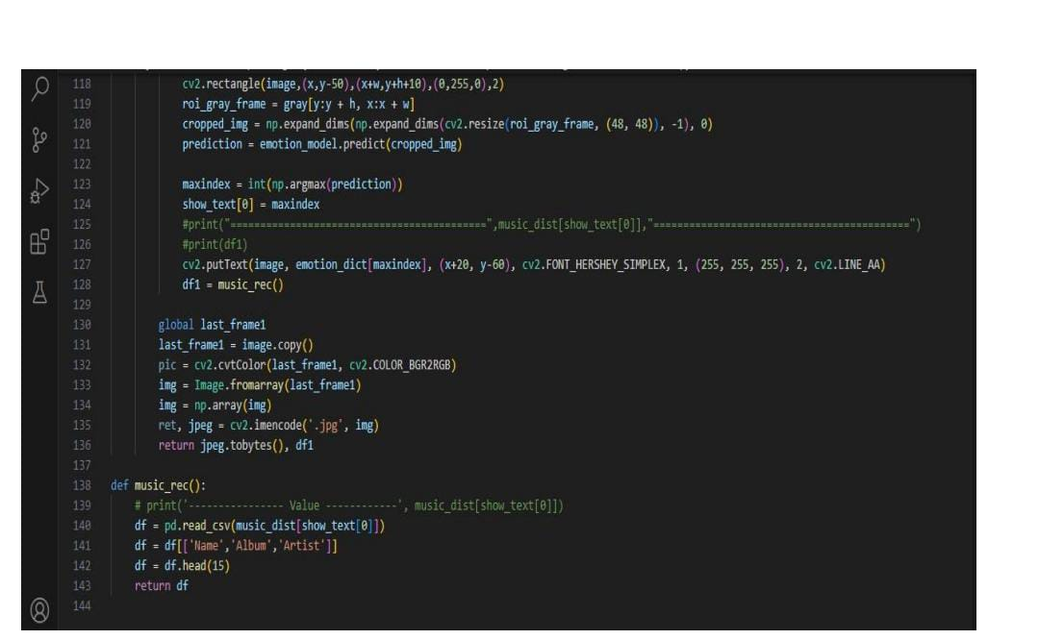

Opening webcam

**3) Style Implementation using CSS**

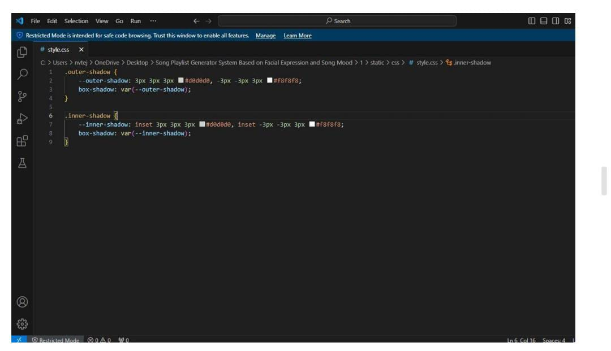

**4) Class For Using Separate Thread for Video Streaming through webcam**

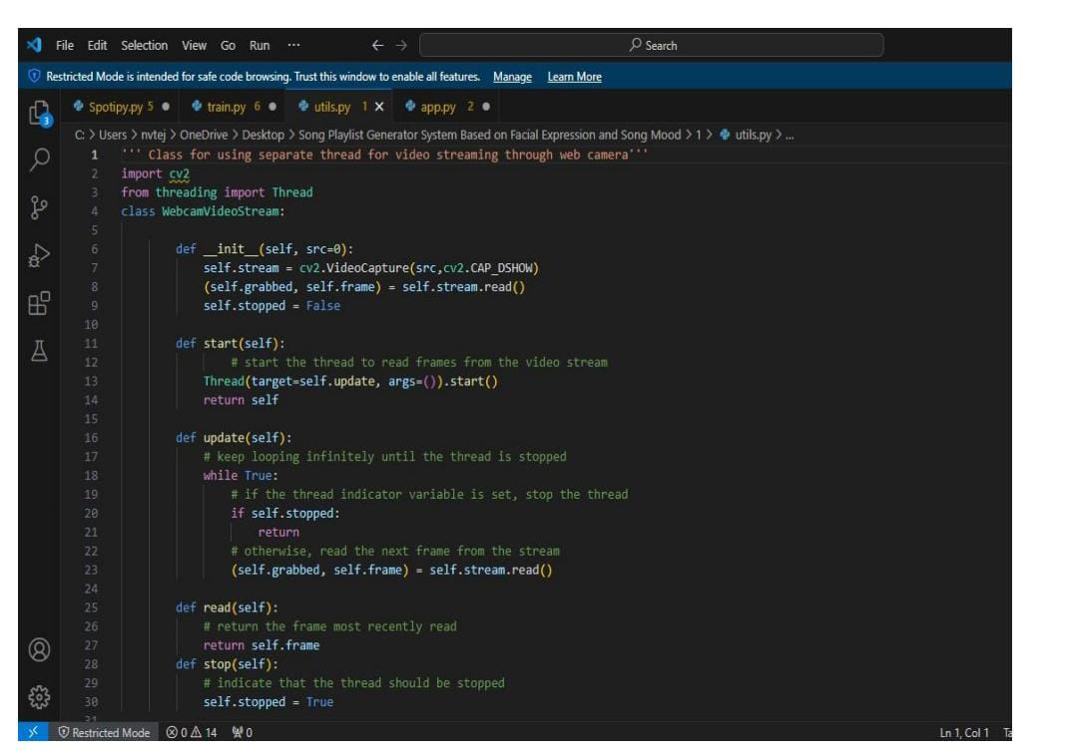

Video Streaming

**5) Training and Testing the Dataset**

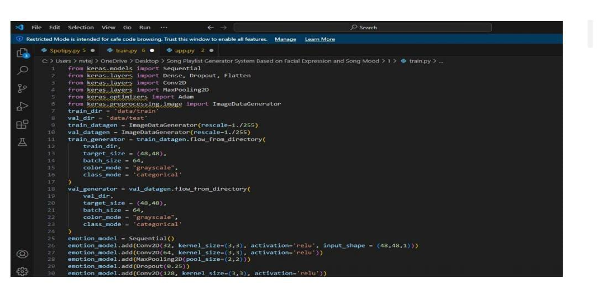 training and testing the dataset

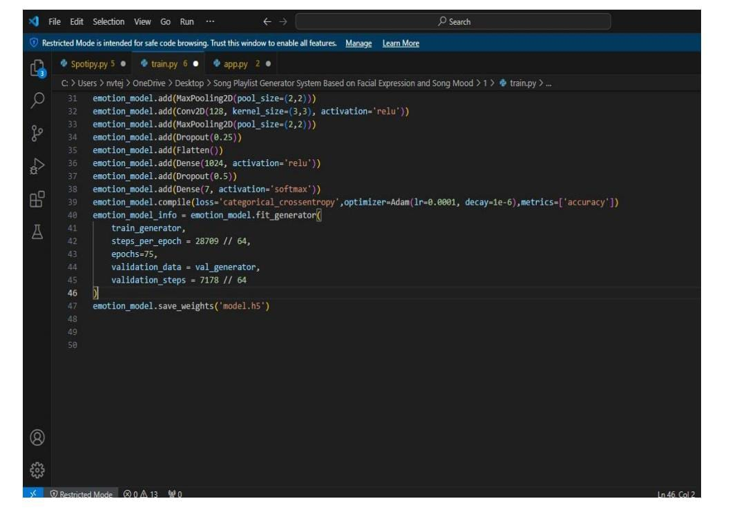

training and testing the dataset

**6) Importing Libraries and creating an app**

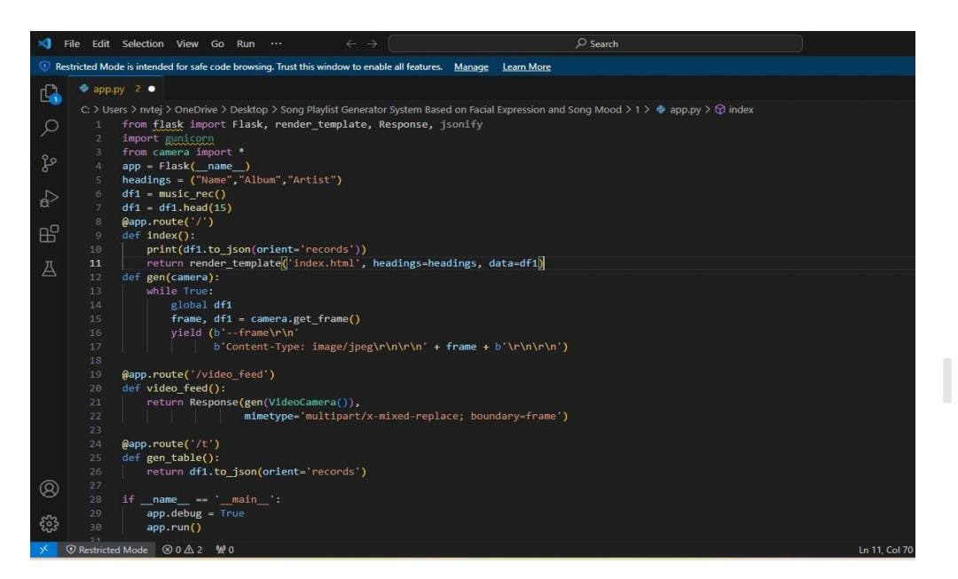

Creating an app

**7) Using Spotify API for creating playlist**

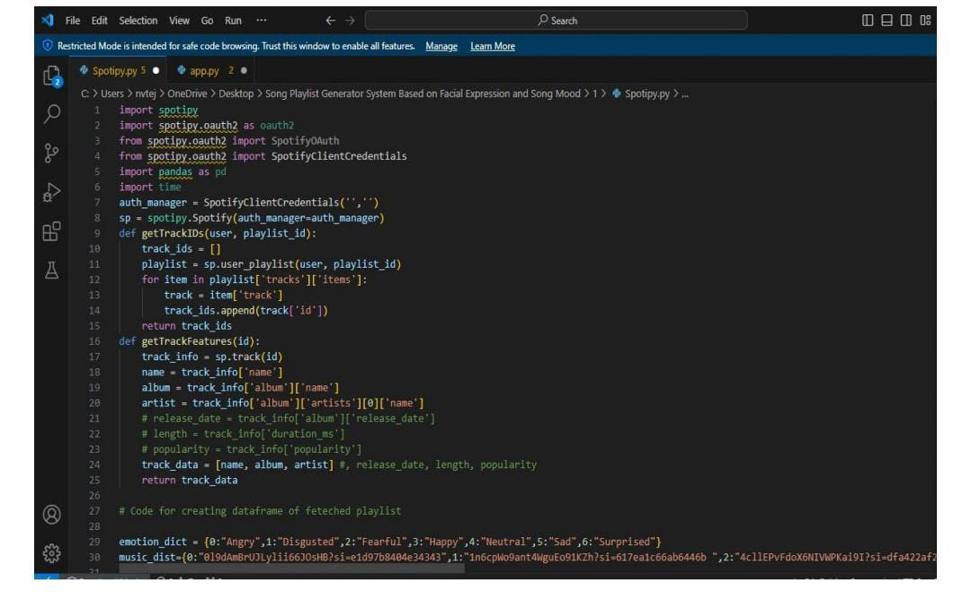

Using spotify API

**8) In command prompt run app.py**

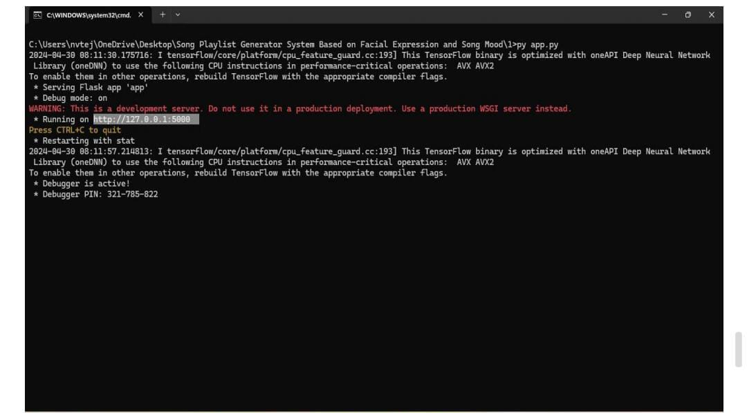

run app.py

**9) Result**

The results or output can be accessed by clicking the above hypertext URLs.

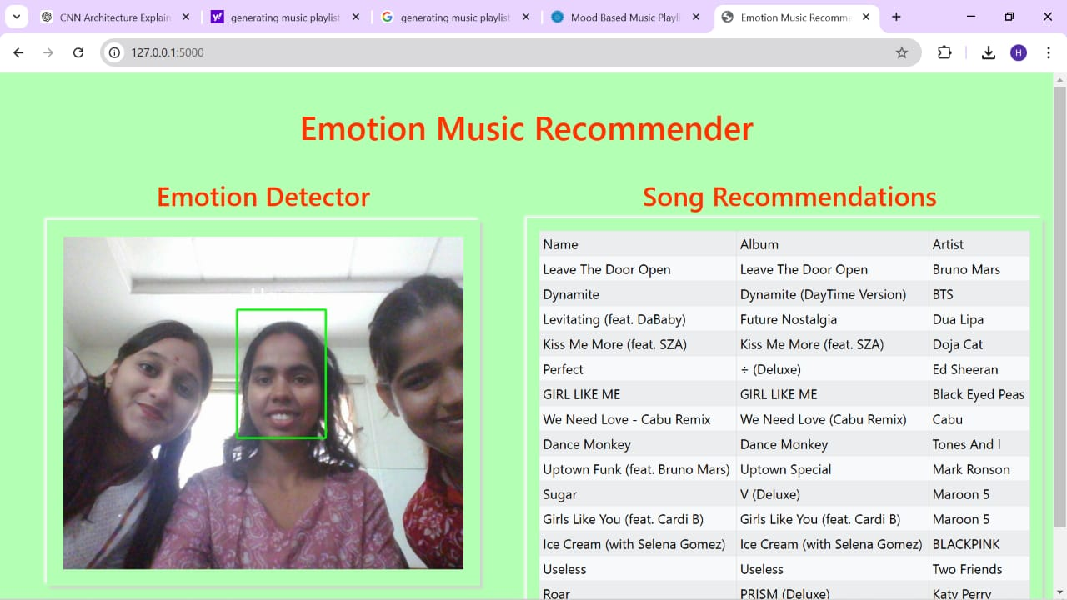

The illustrations above provides the emotion or feeling of a user and the playlist corresponding to that mood and emotion.

**8. CONCLUSION**

Creating an automatic music playlist based on a person's facial expression is a way of integrating technology and emotional intelligence to personalize music listening. With this, some facial interactions such as smile, frown, or show a neutral expression can lead the systems to understand the mood of the listener to select songs which his emotions relate to. This approach increases the satisfaction level of the user by providing music which is in accordance to his/her feelings letting the user simplify and automate the process of making playlists. This also showcases AI and emotion-detection technology's promising prospects in transforming how people interact with multimedia content and how it can be more sophisticated and personal. In this project, we are generating the playlist according to the emotion of the user, we developed an application for predicting the emotion of the user using Convolution neural networks and for generating the playlist we have used Spotify API. This method was implemented on different pictures and the result is accuracy greater than 80%.

**9.** **REFERENCES**

1. Geronimo, M., & Lee, H. “Emotion-aware Playlist Generation Using Facial Expression Recognition” IEEE Trans. Affective Comput., Vol. 12, No. 3, PP. 452–461.
2. Patel, R., Singh, K., & Verma S., “Facial Emotion Detection for Personalized Music Recommendation,” International Journal of Computer Applications, vol. 176, no. 1, pp. 65–73.
3. Zhao, Y., & Chen L., “Real-time Music Playlist Adaptation Using Deep Learning Based Emotion Recognition.” J. Multimedia 8 (2013): 112–125.
4. Kang, J., & Park S., “Music Recommendation with Convolutional Neural Networks for Facial Emotion Recognition,” IEEE Access 15 (2023): 4521–4533.
5. Choudhury, A.S.B.K. & Rao, V. K., “AI Powered Mood Based Music Streaming Systems Frontier,” Artificial Intelligence Research 38, (2023): 125-137.
6. Ahmed, M, Kumar R, “Emotion Detection for Music Suggestion using Neural Networks,” Journal of Ambient Intelligence and Humanized Computing 21, no. 4, (2020): 987-999.
7. Alsaedi, K, Albalawi L, Syed L, “Music Recommender System for Users Based on Emotion Detection through Facial Features,” in Proceedings of the IEEE DeSE Conference, (2023): 1014-1019.
8. Altieri, M, Rossi F, “An Adaptive System to Manage Playlists Based on User’s Emotions,” in Proceedings of the IEEE International Conference on Consumer Electronics, (2021): 1-2.
9. Liu, Y., & Wang, J. Emotion-Aware Music Recommendation Using Deep Learning, IEEE Trans. Affective Comput. 9, 2 (2018) 314–326.
10. Tsai, W. M. D., & Lee Y. Real-Time Emotion Recognition from Facial Expressions for Personalized Playlists. J. Multimedia 16, 1 (2021) 98–113.
11. Happy, S. L., & Routray, A Automated Facial Expression Recognition in an Affect-Empowered Framework. IEEE Trans. Affective Comput. 6, 1 (2015) 1–12.
12. Ravi, R., & Rajalakshmi, S. V. A Face Expression Recognition System Using CNN for Music Personalization. IEEE Comput. Intell. Mag. 7, 4 (2012) 235–248.
13. Nathan, K. S. & Arun, M. EMOSIC—An Emotion Based Music Player for Android. IEEE Trans. Consum. Electron. 15 (2006) 98–110.
14. Debika, S. & Indira, K. A machine learning based music player by detecting emotions. IEEE Conf. Comput. Sci. Eng. (2019) 196–200.
15. Kaur, P. G. & Mehta, R. Emotion Recognition from Facial Expressions for Autoplaylist Creation. IEEE Access 42 (2023) 3210-3225.
16. Chankuptarat, K., & Sriwatanaworachai, R. Emotion-Based Music Player Using Image Processing. Journal of the IEEE Transactions on Multimedia. 13, 7 (2011) 552–568.
17. Scherer, K., & Wagner, M. The Role of Affective Computing in Emotion-based Music Recommendation. Handbook Affective Comput (2015) 89–104.
18. Liu, M., & Zhang, H., “Integrated AI Approach for Music Recommendation with Facial Expression Recognition,” IEEE Comput. Intell. Syst., vol. 14, pp. 275–288.
19. Lee, H. Y., & Park, C., “Emotion Recognition in Music Recommendation Systems via Deep Learning,” J. Ambient Intell. Hum. Comput., vol. 12, pp. 1123–1135.
20. Jong, M. J. M., & Becker, T., “Music Recommendation Driven by Adaptive User’s Facial Expressions,” ACM Trans. Multimedia Comput. Commun. Appl., vol. 29, pp. 422–438.
21. Luo, Z., & Peng, H., “AI-Based Personalized Music Playlist Generation Through Facial Expression Recognition,” J. Artif. Intell. Res., vol. 39, pp. 99–114.
22. Mehta, S., & Kapoor, V., “Emotion Recognition-Based Playlist Creation Using Facial Expressions,” IEEE Int. Conf. Neural Netw., pp. 1210–1223.
23. Singh, P., & Gupta, A., “Emotion Recognition for Improved User Interaction with Music Applications,” IEEE Conf. Comput. Vision, pp. 789–802.
24. Patel, H., & Bose, K., “AI-Based Emotion Recognition for Personalized Music Selection,” J. Comput. Sci. Appl., vol. 22, pp. 98–112.
25. Ng, W., & Minasny, B., “Implementation of Deep Learning Networks for the Recognition of Emotions in Music,” J. Machine Learn. Appl., vol. 9, pp. 123–137.
26. Alhassan, H., & Omar, S., “Mood Classification for Playlist Generation Using Image Processing,” IEEE Conf. Signal Process. Appl., pp. 178–181.
27. Ishikawa, T., and R. Farooq. “Emotion-based Cues Using CNNs and Facial Recognition for Music Players.” *IEEE Computer Intelligence Journal* 18 (2023): 455-468.
28. Automatic Playlist Creation Using Visual Facial Cues.M. Wilson and T. Brown. 2023 ACM Conference on Human Computer Interaction, 2023, 99–113.
29. Rahman, S., Akbar, M. "AI's Role in Music Curation: Future Outlooks in Emotion Recognition." In Proceedings of the IEEE International Conference on Multimedia Computation, pp. 678-690.
30. Chen, J., Zhao, R. “Personalized Streaming Music Services with Emotions Recognition.” *Journal of Neural Computing* 45 (2023): 235-250.