**PERSONALIZED RISK ASSESSMENT FOR MISCARRIAGE USING MACHINE LEARNING AND WEARABLE DEVICE DATA**

Mr. Ramesh Masuna Associate Professor, CSE(AIML),

ACE Engineering College, Hyderabad, India

Sujith Reddy Nalla, Student, CSE(AIML), ACE Engineering College

College, Hyderabad, India.

Adarsh Devajji,

Student, CSE(AIML),

ACE Engineering College, Hyderabad, India.

**ABSTRACT**

Miscarriage, a distressing complication of pregnancy, affects millions of women worldwide, often leading to emotional trauma, physical health challenges, and complications in future pregnancies. Early detection and timely intervention are critical to reducing these risks. This project develops a mobile application that leverages machine learning and wearable device data to assess and monitor miscarriage risk in real time. The app collects health and activity data such as heart rate, body temperature, and stress levels from smartwatches and mobile devices at regular intervals. Using predictive models, the system analyses this data to identify potential risks and sends personalized notifications to pregnant women and their caregivers, empowering them to take preventive measures or seek medical assistance. By integrating advanced technology with healthcare, this scalable solution aims to improve maternal health outcomes and reduce miscarriage-related complications.

**Keywords**: Miscarriage, Machine Learning, Wearable Devices, Real-Time Data, Predictive Modeling, Personalized Risk Assessment, Mobile Application Development.

1. **INTRODUCTION**

Pregnancy is a time of joy and anticipation, yet it can also bring significant health challenges, with miscarriage being one of the most traumatic complications. Defined as the spontaneous loss of a pregnancy before the 20th week, miscarriage affects approximately 10-20% of diagnosed pregnancies (World Health Organization, 2023), often resulting in long-term emotional, physical, and psychological consequences. Risk factors such as irregular heart rate, elevated body temperature, high stress levels, and certain lifestyle habits are associated with increased miscarriage rates, yet these are frequently overlooked until it’s too late. The absence of real-time monitoring and early detection systems exacerbates this issue, delaying interventions that could mitigate risks and improve outcomes for current and future pregnancies.

This project addresses this gap by developing a mobile application that predicts miscarriage risk using machine learning and data from wearable devices. Leveraging the widespread adoption of smartwatches and mobile technology, the app collects real-time physiological and activity metrics heart rate (beats per minute), body temperature, stress levels, and movement patterns at regular intervals. These data are processed by a predictive model trained on a diverse dataset to identify patterns and anomalies indicative of potential miscarriage risk. When a risk is detected, the app delivers tailored alerts to users, offering actionable insights such as seeking medical consultation or adjusting behaviors to reduce risk.

By seamlessly integrating wearable technology with healthcare, this solution bridges the gap between medical care and daily life. It offers a proactive, scalable tool to reduce miscarriage complications and enhance overall pregnancy care. This introduction outlines the motivation, objectives, and technological framework of the project, setting the stage for a detailed exploration of its implementation and impact on maternal health.

1. **LITERATURE REVIEW**

This project focuses on predicting and mitigating miscarriage risk (spontaneous pregnancy loss before 20 weeks) using real-time data and machine learning. Despite advances in maternal healthcare, miscarriage remains prevalent due to limited awareness and delayed risk assessment. Below, we review prior research to contextualize our work, grouping studies by their approach.

**2.1 Real-Time Monitoring Studies**

* **[1] San Lazaro Campillo, I., Meaney, S., & Sheehan, J. (2018**): Conducted by the Pregnancy Loss Research Group at University College Cork, this cross-sectional study explored university students’ awareness of miscarriage risk factors. Key findings showed that 43% recognized fetal chromosomal abnormalities as the primary cause, while valid risk factors like advanced maternal age, smoking, alcohol use, and maternal conditions were noted. Misconceptions included stress, falls, and hair dye as causes. This highlights the need for accurate, data-driven risk assessment tools like ours.
* **[2] Asri, H., Mousannif, H., & Al Moatassime, H. (2017):** This study used real-time data from mobile phones and sensors (e.g., BMI, physical activity, location) to predict miscarriage risk with Apache Spark and the K-Means algorithm. The dataset was clustered into three groups: miscarriage (44%), no miscarriage (21%), and possible miscarriage (34%). While innovative, it lacked physiological data (e.g., heart rate), which our project includes.
* **[3] Asri, H., & Jarir, Z. (2022):** This work collected real-time data via healthcare sensors (temperature, heart rate, alcohol, acceleration) and IoT devices (Raspberry Pi, Arduino) from women in their first trimester. Cluster analysis identified three groups based on age, weight, and thyroid function. Our project builds on this by integrating wearable data with a mobile app for broader accessibility.

**2.2 Static Dataset Analyses**

* **[4] Biswas, S., & Shukla, S. (2022):** This study developed machine learning models (KNN, Logistic Regression, Random Forests) using a 10-feature dataset of 1 million records, reduced to 1,775 via stratified sampling due to age imbalance (99.7% aged 25). It achieved good accuracy but omitted real-time lifestyle factors (e.g., activity), which our wearable-based approach addresses.
* **[5] Aljameel, S. S., Aljabri, M., & Aslam, N. (2022):** Using a dataset of 984 patients from Saudi Arabia with 23 clinical attributes, this study compared KNN, Random Forests, Decision Trees, and Gradient Boosting. Gradient Boosting excelled (93.4% accuracy, 97% ROC-AUC), marking a significant step in early miscarriage prediction. Our project extends this by incorporating real-time wearable data.
* **[6] Sujith, N. Ramesh., M, & Adarsh, D. (2025):** This recent work analyzed a Mendeley dataset with sensor-based lifestyle and physiological data. Tree-based models (e.g., AdaBoost) outperformed linear models (Logistic Regression, Naïve Bayes), with AdaBoost achieving the highest precision and F1-score. Our project adopts similar tree-based models but enhances them with continuous monitoring.

**2.3 Related Stillbirth Research**

* [7] Malakova, E., & Tippaya, S. (2020): Focused on stillbirth prediction using a dataset of nearly 1 million births in Western Australia (1980-2015), this study employed models like XGBoost (45% sensitivity). While stillbirth differs from miscarriage, shared risk factors (e.g., maternal health) make it relevant. Our project adapts such ensemble methods for real-time miscarriage risk.

**2.4 Results of Previous Work**

The table below compares model performance from our previous work on training various machine learning models, highlighting tree-based models’ superiority:

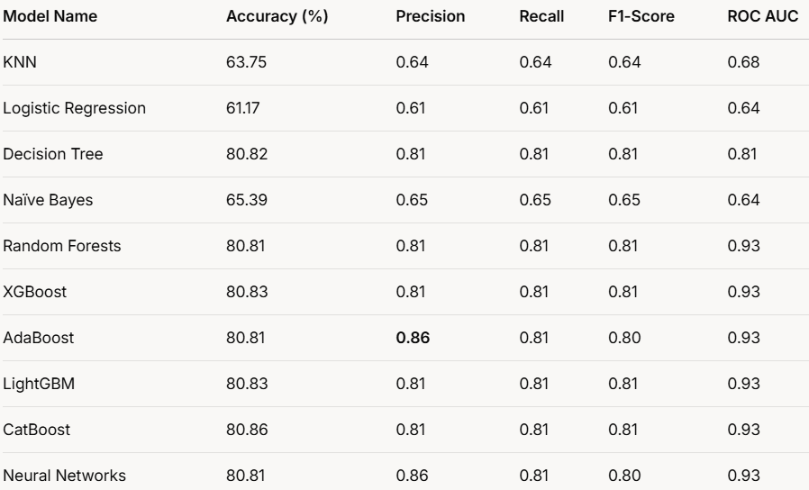

cFig. 1 Model Comparison

1. **SYSTEM ARCHITECTURE**

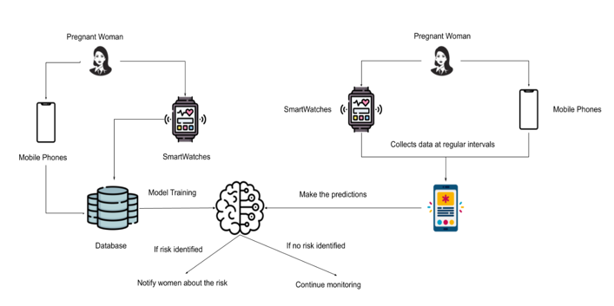The proposed miscarriage risk monitoring system leverages wearable devices, mobile applications, and machine learning models to identify potential risks of miscarriage in real time. Data is collected via wearable devices, such as smartwatches, which monitor key health parameters like heart rate, stress levels, and physical activity, while the mobile application allows manual data entry of symptoms and behaviours. This data is securely transmitted to a centralized cloud database and used to train machine learning models that analyse patterns and correlations to identify risk factors.

Fig. 2 System Architecture

The trained models process real-time data from wearable devices and mobile applications. If a risk is detected, the system promptly notifies the user via the mobile app with details about the risk and actionable recommendations, such as lifestyle adjustments or seeking medical advice. Feedback loops help improve the models over time, ensuring the system delivers timely interventions and personalized healthcare for better maternal health outcomes

1. **WORKFLOW OVERVIEW**

To effectively assess and monitor the risk of miscarriage, our system follows a structured workflow that integrates data collection, processing, and real-time risk assessment. The following flowchart visually represents the step-by-step process, from data acquisition through a wearable device to risk evaluation and notification delivery

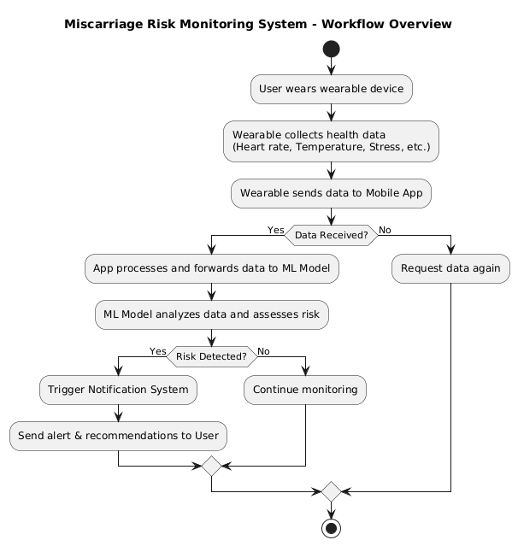

Fig. 3 Workflow Overview

1. **CONCLUSION**

Machine learning has transformed miscarriage risk assessment by enabling real-time monitoring and predictive analysis through wearable health devices and mobile applications. Unlike traditional healthcare approaches that rely on periodic clinical assessments, ML-based methodologies continuously analyze real-time health data to detect early warning signs and assess risk levels dynamically. By integrating machine learning algorithms such as Decision Trees, Random Forest, and AdaBoost, the system enhances predictive accuracy, refines risk classification, and ensures timely alerts for preventive action. These models adapt to evolving health patterns, making miscarriage risk assessment more precise and proactive.

The mobile application plays a crucial role in this system by seamlessly collecting, processing, and displaying real-time health insights to users. It provides an intuitive interface for monitoring vital parameters, receiving risk alerts, and accessing personalized recommendations. By integrating wearable technology with an interactive mobile platform, the system empowers users with actionable insights, enabling them to take timely precautions or seek medical attention when necessary.

As maternal health technology advances, ML-driven mobile applications offer a scalable and intelligent approach to reducing miscarriage-related complications. The integration of real-time monitoring, adaptive risk analysis, and user-friendly app interfaces further strengthens prenatal care, ensuring better health outcomes for expectant mothers. With ongoing advancements in AI, wearable technology, and app development, future improvements will enhance the system’s accuracy, usability, and accessibility, making it a vital tool in modern maternal healthcare.

1. **REFERENCES**

1) San Lazaro Campillo, I., Meaney, S., Sheehan, J. et al. University students’ awareness of causes and risk factors of miscarriage: a cross-sectional study. BMC Women's Health 18, 188 (2018). [https://doi.org/10.1186/s12905-018-0682-1](https://doi.org/10.1186/s12905-018-0682-1%20)

2) Biswas, S., Shukla, S. (2022). A Miscarriage Prevention System Using Machine Learning Techniques. In: Gupta, D., Khanna, A., Kansal, V., Fortino, G., Hassanien, A.E. (eds) Proceedings of Second Doctoral Symposium on Computational Intelligence. Advances in Intelligent Systems and Computing, vol 1374. Springer, Singapore. <https://doi.org/10.1007/978-981-16-3346-1_34>

3) Asri, Hiba & Mousannif, Hajar & Al Moatassime, Hassan. (2017). Real-time Miscarriage Prediction with SPARK. Procedia Computer Science. 113. 423-428. 10.1016/j.procs.2017.08.272.

4) Asri, Hiba and Zahi Jarir (2022). “Real-time miscarriage prediction: A comprehensive real-world dataset and a new model.” FNC/MobiSPC/SEIT.

5) Odiakaose, Christopher. (2021). A comparative analysis of machine learning algorithms : A case study of a higher institution. 10.13140/RG.2.2.33330.58560.

6) Kotsiantis, Sotiris & Kanellopoulos, Dimitris & Pintelas, P.. (2006). Data Preprocessing for Supervised Learning. International Journal of Computer Science. 1. 111-117.

7)Sujith Reddy Nalla, Ramesh Masuna, Devajji Adarsh (2025). Analyzing Real-Time Dataset to Understand the Risk Factors of Miscarriage. <https://doi.org/10.22214/ijraset.2025.66642>