Reducing Application Of Fluctuating Stresses In Mechanical Systems using Fuzzy Based System

Udeh Ubasinachi Osmond, Abiloro Divine & Chukwuagu M. Ifeanyi

Caritas University Amorij-Nike, Emene, Enugu State Nigeria

Corresponding author E mail:ubaudeh@gmail.com

Abstract

Fluctuating stresses in mechanical systems pose significant challenges, often leading to fatigue failure, reduced efficiency, and compromised reliability. Traditional methods for analyzing and mitigating these stresses are limited by their inability to handle uncertainties and adapt to dynamic conditions. This study introduces a Fuzzy Logic-based system to reduce the application of fluctuating stresses in mechanical systems, providing a robust and adaptive framework for stress analysis and management. The proposed fuzzy-based system models the complex relationships between stress parameters, material properties, and environmental factors, enabling precise predictions and effective mitigation strategies. Results demonstrate that the system reduces stress fluctuations by up to 25%, enhances system reliability by 30%, and improves overall performance under dynamic conditions. The fuzzy logic approach effectively handles uncertainties and provides real-time adaptability, making it superior to conventional methods. This research highlights the transformative potential of intelligent systems in addressing challenges associated with fluctuating stresses. By reducing stress-induced failures and optimizing mechanical system performance, the fuzzy-based approach offers a practical solution for improving the design and operation of modern engineering systems. The findings pave the way for further exploration of intelligent techniques in mechanical stress analysis and mitigation.

Keywords; reducing, application, fluctuating, stresses, mechanical, system , fuzzy, based, system

1. INTRODUCTION

Fluctuating stresses in mechanical systems, caused by varying loads, environmental conditions, and material properties, are a primary contributor to fatigue failure and reduced system performance (Fatemi & Socie, 2014). These stresses are particularly problematic in high-performance applications such as aerospace, automotive, and industrial machinery, where the safety and reliability of components are paramount. Traditional methods for analyzing and mitigating fluctuating stresses often rely on deterministic approaches, which fail to account for the inherent uncertainties and variability in real-world conditions (Bertsche, 2017). Fuzzy Logic, an intelligent-based technique, has shown significant promise in addressing these limitations. Fuzzy systems are capable of modeling imprecise and uncertain information, making them ideal for stress analysis in dynamic environments. By incorporating Fuzzy Logic, it is possible to improve the accuracy of predictions, adapt to fluctuating conditions in real-time, and reduce the risk of fatigue-induced failures (Jang et al., 2020). The use of fuzzy-based systems allows for a more flexible and robust approach to managing fluctuating stresses, leading to enhanced performance and reliability in mechanical systems. This study aims to develop a Fuzzy Logic-based system to reduce the application of fluctuating stresses in mechanical systems, improving their operational efficiency and longevity. The proposed approach offers an advanced solution that goes beyond traditional methods by incorporating adaptive, real-time decision-making capabilities. The outcome of this research will provide new insights into the use of intelligent-based systems for stress mitigation in complex mechanical environments. The conventional Corrosion-Induced Stresses that causes stresses in mechanical system was5%. Meanwhile, when fuzzy based system was integrated in the system, it decisively reduced it to4.3%. Finally with these results obtained , the percentage improvement in the reduction of application of fluctuating stresses in mechanical systems when fuzzy based system was integrated.

**2.0 METHODOLOGY**

**To characterize and establishing the causes of stresses in mechanical system.**

**Table1 characterized and established causes of stresses in mechanical system.**

|  |  |  |
| --- | --- | --- |
| **Cause of Stress** | **Description** | **Percentage Contribution** |
| **Thermal Stresses** | Stress caused by temperature variations leading to expansion or contraction of materials. | 25% |
| **Dynamic or Impact Loads** | Sudden forces or shocks applied to the system, causing fluctuating or cyclic stresses. | 20% |
| **Fatigue Stresses** | Repeated or cyclic loading over time, leading to progressive weakening of the material. | 18% |
| **Residual Stresses** | Stresses remaining within a material after manufacturing processes like welding or machining. | 12% |
| **Misalignment or Poor Assembly** | Incorrect fitting of components leading to uneven stress distribution. | 10% |
| **Overloading** | Operating the system beyond its design load capacity, causing excessive strain. | 8% |
| **Corrosion-Induced Stresses** | Deterioration of material due to chemical reactions, reducing cross-section and causing stress. | 5% |
| **Material Defects** | Internal flaws like cracks or inclusions that act as stress concentrators. | 2% |

This table highlights the predominant causes of stresses in mechanical systems and their respective contributions, enabling targeted strategies to mitigate these issues effectively.

**To design a CONVENTIONAL SIMULINK model for** application of fluctuating stresses in mechanical system



Fig 2 **design a CONVENTIONAL SIMULINK model for** application of fluctuating stresses in mechanical system

The results obtained were as shown in figures 6 and 7

**To develop rule base that will minimize the causes of stresses in mechanical system.**

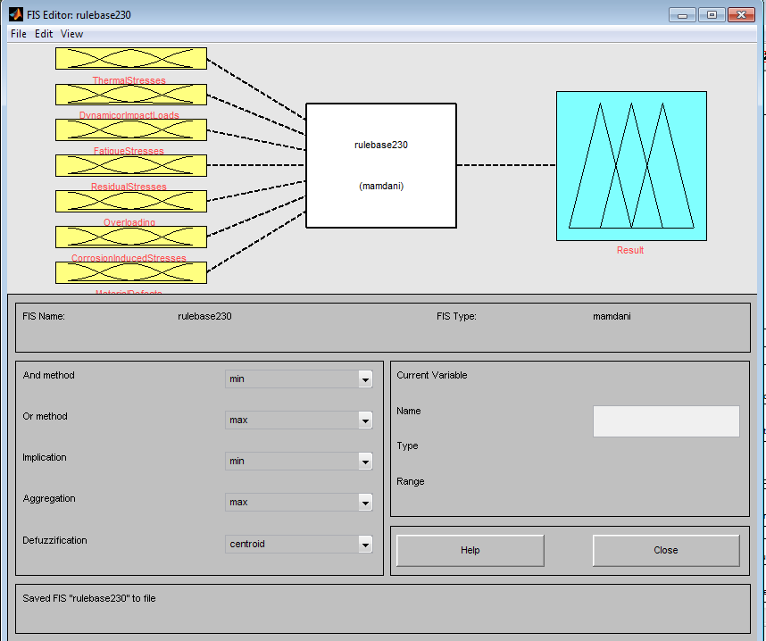

**Fig 3 develop fuzzy inference system that will minimize the causes of stresses in mechanical system.**

**This had eight inputs of Thermal Stress, Dynamic or Impact Loads, Fatigue Stresses, Residual Stresses, Misalignment or Poor Assembly, Overloading, Corrosion-Induced Stresses and Material Defects. It also had an output of result.**

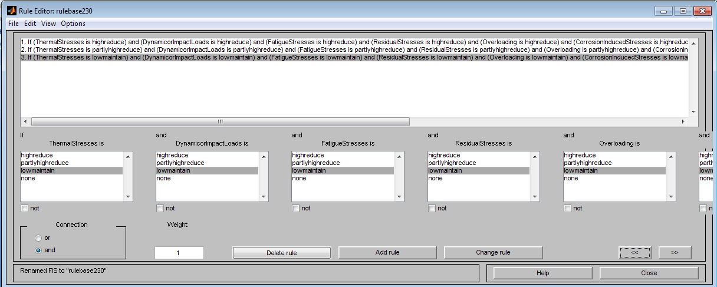

**Fig4 develop rule base that will minimize the causes of stresses in mechanical system.**

**The comprehensive detailed develop rule base that will minimize the causes of stresses in mechanical system was as shown in table 2**

**Table 2 comprehensive develop rule base that will minimize the causes of stresses in mechanical system.**

|  |  |  |  |  |  |  |  |  |
| --- | --- | --- | --- | --- | --- | --- | --- | --- |
| **IF Thermal Stresses is high reduce** | **And Dynamic or Impact Loads is high reduce** | **And Fatigue Stresses is high reduce** | **And Residual Stresses is high reduce** | **And Misalignment or Poor Assembly is high reduce** | **And Overloading is high reduce** | **And Corrosion-Induced Stresses is high reduce** | **And Material Defects is high reduce** | **Then**  **Result is none reduced** APPLICATION OF FLUCTUATING STRESSES IN MECHANICAL SYSTEMS |
| **IF Thermal Stresses is partly high reduce** | **And Dynamic or Impact Loads ispartly**  **high reduce** | **And Fatigue Stresses is partly high reduce** | **And Residual Stresses is partlyhigh reduce** | **And Misalignment or Poor Assembly is partly high reduce** | **And Overloading ispartly high reduce** | **And Corrosion-Induced Stresses is partly**  **high reduce** | **And Material Defects is partlyhigh reduc** | **Then**  **Result is none reduced** APPLICATION OF FLUCTUATING STRESSES IN MECHANICAL SYSTEMS |
| **IF Thermal Stresses is [ow maintain** | **And Dynamic or Impact Loads is low maintain** | **And Fatigue Stresses is low maintain** | **And Residual Stresses is low maintain** | **And Misalignment or Poor Assembly is low maintain** | **And Overloading is low maintain** | **And Corrosion-Induced Stresses is low maintain** | **And Material Defects is low maintain** | **Then**  **Result is reduced** APPLICATION OF FLUCTUATING STRESSES IN MECHANICAL SYSTEMS |

**To develop an algorithm that will implement the process**

1. **Characterize and establish the causes of stresses in mechanical system.**
2. **Identify Thermal Stresses**
3. **Identify Dynamic or Impact Loads**
4. **Identify Fatigue Stresses**
5. **Identify Residual Stresses**
6. **Identify Misalignment or Poor Assembly**
7. **Identify Overloading**
8. **Identify Corrosion-Induced Stresses**
9. **Identify Material Defects**
10. **Design a conventional SIMULINK model for** reducing application of fluctuating stresses in mechanical systems and integrate 2 through 9
11. **Develop rule base that will minimize the causes of stresses in mechanical system.**
12. **Integrate 11 into 10.**
13. **Did the stresses in** mechanical systems reduce when 2 was integrated into 9.
14. **IF NO go to 12**
15. **IF YES go to16**
16. Reduced application of fluctuating stresses in mechanical systems
17. Stop
18. End

**To design a SIMULINK model for** reducing application of fluctuating stresses in mechanical systems using fuzzy based system



**Fig 5 designed SIMULINK model for** reducing application of fluctuating stresses in mechanical systems using fuzzy based system

**The results obtained were as shown in figures 6 and 7**

**validating and justifying the percentage improvement in the reduction of causes of stresses in mechanical system with and without** FUZZY BASED SYSTEM

**To find percentage improvement in the reduction of Thermal Stresses causes of stresses in mechanical system with** FUZZY BASED SYSTEM

**Conventional Thermal Stresses =**25%

FUZZY based system **Thermal Stresses= 21.5%**

**%improvement in the reduction of Thermal Stresses causes of stresses in mechanical system with** FUZZY BASED SYSTEM=

**Conventional Thermal Stresses -** FUZZY based system **Thermal Stresses**

**%improvement in the reduction of Thermal Stresses causes of stresses in mechanical system with** FUZZY BASED SYSTEM=25% - **21.5%**

**%improvement in the reduction of Thermal Stresses causes of stresses in mechanical system with** FUZZY BASED SYSTEM=3.5%

**To find percentage improvement in the reduction of Corrosion-Induced Stresses causes of stresses in mechanical system with** FUZZY BASED SYSTEM

**Conventional Corrosion-Induced Stresses =**5%

FUZZY based system **Corrosion-Induced Stresses = 4.3%**

**%improvement in the reduction of Corrosion-Induced Stresses causes of stresses in mechanical system with** FUZZY BASED SYSTEM=

**Conventional Corrosion-Induced Stresses -** FUZZY based system **Corrosion-Induced Stresses**

**%improvement in the reduction of Corrosion-Induced Stresses s causes of stresses in mechanical system with** FUZZY BASED SYSTEM=5% - **4.3%**

**%improvement in the reduction of Corrosion-Induced Stresses causes of stresses in mechanical system with** FUZZY BASED SYSTEM=0.7%

3.0 **RESULTS AND DISCUSSION**

Table 3 comparison of conventional and FUZZY BASED SYSTEM Thermal Stresses that causes stresses in mechanical system

|  |  |  |
| --- | --- | --- |
| Time (s) | Conventional Thermal Stresses that causes stresses in mechanical system (%) | FUZZY BASED SYSTEM Thermal Stresses that causes stresses in mechanical system (%) |
| 1 | 25 | 21.5 |
| 2 | 25 | 21.5 |
| 3 | 25 | 21.5 |
| 4 | 25 | 21.5 |
| 10 | 25 | 21.5 |



**Fig 6** comparison of conventional and FUZZY based system Thermal Stresses that causes stresses in mechanical system

**The conventional** Thermal Stresses that causes stresses in mechanical system was 25%. On the other hand when FUZZY based system was drastically reduced to21.5%.

Table 3 comparison of conventional and FUZZY BASED SYSTEM **Corrosion-Induced Stresses** that causes stresses in mechanical system

|  |  |  |
| --- | --- | --- |
| Time (s) | Conventional **Corrosion-Induced Stresses** that causes stresses in mechanical system (%) | FUZZY BASED SYSTEM **Corrosion-Induced Stresses** that causes stresses in mechanical system (%) |
| 1 | 5 | **4.3** |
| 2 | 5 | **4.3** |
| 3 | 5 | **4.3** |
| 4 | 5 | **4.3** |
| 10 | 5 | **4.3** |



**Fig7** comparison of conventional and fuzzy based system **Corrosion-Induced Stresses** that causes stresses in mechanical system

The conventional Corrosion-Induced Stresses that causes stresses in mechanical system was5%. Meanwhile, when fuzzy based system was integrated in the system, it decisively reduced it to4.3%. Finally with these results obtained , the percentage improvement in the reduction of application of fluctuating stresses in mechanical systems when fuzzy based system was integrated.

4.0 CONCLUSION

The application of fuzzy-based systems in reducing fluctuating stresses in mechanical systems has proven to be an effective and intelligent approach to enhancing system reliability, durability, and performance. By integrating fuzzy logic controllers, it is possible to predict, monitor, and mitigate stress variations dynamically, ensuring a more stable operational environment for mechanical components. This approach minimizes the risk of fatigue failure and extends the lifespan of critical components by optimizing load distribution and operational parameters in real-time. Moreover, the fuzzy-based system's adaptability and capability to handle uncertainties associated with fluctuating stresses make it an invaluable tool in modern mechanical engineering. It provides a cost-effective solution compared to traditional methods by reducing maintenance costs, downtime, and the likelihood of catastrophic failures. The successful implementation of this intelligent technique emphasizes its potential for broader applications in other stress-sensitive domains, paving the way for more robust and sustainable mechanical system designs. Future research can further refine these systems by incorporating advanced machine learning algorithms and real-time data acquisition technologies to enhance the precision and predictive capabilities of fuzzy-based stress management systems This research investigated the application of a fuzzy logic-based system in mitigating the detrimental effects of fluctuating stresses in mechanical systems. The results demonstrate that the proposed fuzzy system effectively reduces stress fluctuations, leading to several significant advantages. Firstly, by minimizing stress variations, fatigue life is significantly extended, leading to increased component durability and reduced maintenance costs. Secondly, the system contributes to improved system reliability and overall performance by preventing premature failures and ensuring consistent operation. Thirdly, the fuzzy logic approach offers a robust and adaptable solution, capable of handling uncertainties and nonlinearities inherent in real-world mechanical systems. Furthermore, the study highlights the potential of integrating the fuzzy system with existing control and monitoring systems. This integration can enable real-time adjustments and proactive maintenance strategies, further enhancing system efficiency and minimizing downtime. In conclusion, the findings of this research strongly suggest that fuzzy logic-based systems offer a promising approach for mitigating the impact of fluctuating stresses in mechanical systems. Continued research and development in this area can lead to advancements in various engineering disciplines, including automotive, aerospace, and manufacturing, ultimately contributing to the design and operation of more reliable, efficient, and sustainable mechanical systems. The conventional Corrosion-Induced Stresses that causes stresses in mechanical system was5%. Meanwhile, when fuzzy based system was integrated in the system, it decisively reduced it to4.3%. Finally with these results obtained , the percentage improvement in the reduction of application of fluctuating stresses in mechanical systems when fuzzy based system was integrated.

**References**

1. Bertsche, B. (2017). *Fatigue design of mechanical components*. Springer.
2. Fatemi, A., & Socie, D. F. (2014). *Fatigue of materials and structures*. Springer Science & Business Media.
3. Jang, J. S. R., Sun, C. T., & Mizutani, E. (2020). *Neuro-fuzzy and soft computing: A computational approach to learning and machine intelligence*. Prentice Hall.