A Case of Molluscum Contagiosum
AUTHOR: Dr. Anuj Milind Sathe ^{*1}, Dr. Nimish P. Shukla
*1: Corresponding author
ABSTRACT:
Molluscum contagiosum is a common cutaneous viral infection primarily affecting children, though it can also present as a sexually transmitted disease in adults. This report presents a case of a 3.5-year-old male with multiple dome-shaped papular eruptions across various body regions. Diagnosis was confirmed based on characteristic morphology. The treatment strategy included homeopathic remedies, beginning with Calcarea Phosphorica, followed by Tuberculinum. This case highlights the effectiveness of individualized homeopathic treatment for molluscum contagiosum.
KEYWORDS: Molluscum contagiosum, homoeopathy, anti-miasmatic prescription
ABBREVIATIONS: DNA- Deoxyribonucleic acid, HIV- Human Immunodeficiency Virus, OPD – Outpatient Department, pt – Patient, NAD – No Abnormality Detected, SQ – Status Quo
INTRODUCTION:
This is a common viral skin infection caused by molluscum virus, a DNA virus of the pox group, mostly seen in children. In adults, it can occur occasionally through sexual transmission. Young children usually get this infection through skin to skin contact while playing (1).

Morphology:
A classic lesion appears as smooth, shiny, pearly white or yellowish dome shaped papule with a central umbilication. Early lesions don’t have central umbilication and yellow cheesy material can be expressed from the centre of a fully developed lesion (1).

Distribution:
In children, face, extremities (exposed sites) and trunk are most commonly affected in that order. Sexually acquired infections affect the male/female genital and perigenital areas. If the infection is widespread, HIV has to be ruled out. Lesions often cluster in one area due to spreading of infection by autoinoculation (1).

Diagnosis:
Diagnosis is usually by clinical examination.

Treatment:
This is done by removing lesions with a sharp instrument like small curette or tiny forceps or hypodermic needle under topical anaesthesia with EMLA. Cryotherapy is another option available (1).

CASE REPORT
A 3.5 year old male pre-schooler patient from M came to the OPD with complaints of multiple small popular, dome shaped eruptions on arms, face, neck, trunk, legs, groins, since 1 year. Itching present 1+. The eruptions came on left side then on right side. No modalities/ concomitants were found.
HISTORY OF PRESENTING COMPLAINTS:
The onset of eruption was gradual in duration of 1 year. No any associated complaints.
PAST HISTORY: Allergy to insect bite at 9 months of age.
FAMILY HISTORY: Mother – Nothing specific, Father - Migraine
PERSONAL HISTORY:
Appearance: Lean, wheatish complexion
Appetite: Good, Eats both Veg./ Non-Veg food
Thirst: Profuse, half glass of water at a time at small intervals, cold water
Likes: Dal, rice, chapati, sweets 2+
Perspiration: Profuse on neck, head, offensive.
Stool: Normal, 3-4 times/day, no straining.
Sleep: 8-9 hours, refreshing, talks in sleep, sleeps on left side
Thermals: Hot patient.
Dreams: Nothing Specific, occasionally of cars
BIRTH HISTORY AND MILESTONES:
The child was born through normal full term delivery, weighing 2.8 kg. Teething began at 2 years old, talking started at 3-4 months, and walking began at 9 months.
Vaccination: Done.
MIND:
Active even during illness like fever. Moody, rejects what he doesn’t like. Pt likes travelling, swimming, running, drawing. He also likes cars. Pt wants colourful clothes. He shouts in anger, has fear of insects, can stay alone and wants attention.
INVESTIGATIONS: - Diagnosis was based on presence of characteristic morphology.
GENERAL EXAMINATION:
Temperature: Afebrile, Pulse = 88 beats per minute, Respiratory Rate = 20 respirations/minute Height: 99 cm Weight: 12 kg. General Examination – Nothing specific
SYSTEMIC EXAMINATION:
Respiratory System – AEBE clear, Nose – NAD, Throat - NAD
Cardiovascular System. – S1S2 heard, Central Nervous System- conscious, oriented,
Per Abdomen – Soft Non-Tender, Non-Distended, Bowel sounds heard
Local Examination: Multiple small papular, dome shaped lesions on Arms, Face, Neck, Trunk, Legs, Arms, Groins
DIAGNOSIS: MOLLUSCUM CONTAGIOSUM (ICD 11: 1E76)
TOTALITY:
Fear of insects, likes to travel, want of attention, perspiration on neck, thirst for small quantities frequently, desire for sweets, sleeping on left side, complaints going from left side to right, lean built.
ANALYSIS AND EVALUATION OF SYMPTOMS:
SYMPTOMS | ANALYSIS | EVALUATION
Fear of insects | Mental general | 3+
Likes to travel | Mental general | 3+
Want of attention | Mental general | 3+
Perspiration on neck | Physical general | 3+
Thirst for small quantities frequently | Physical general | 3+
Desire for sweets | Physical general | 2+
Sleeping on left side | Physical general | 3+
Complaints going from left side to right | Physical general | 3+
Lean built. | Physical general | 3+

REPERTORIZATION:
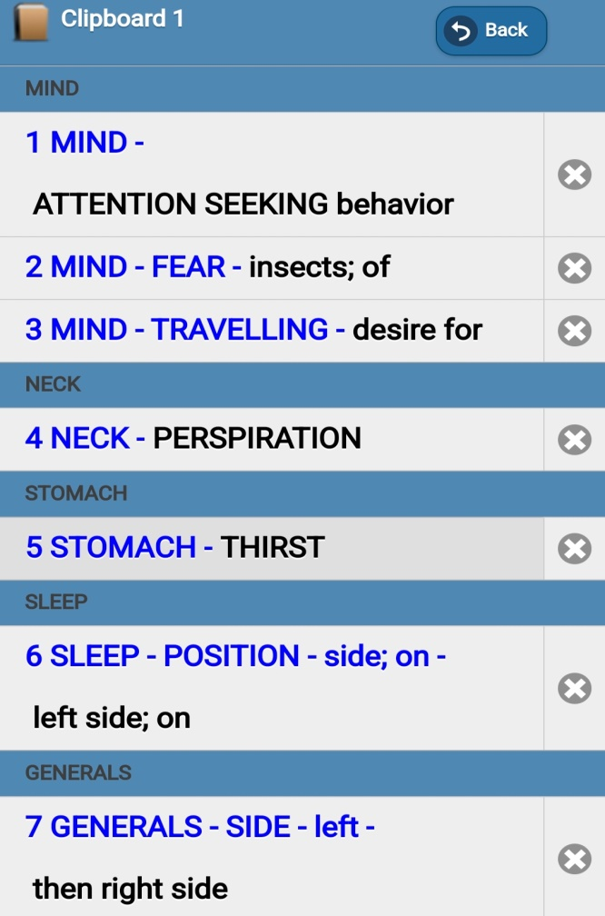 | 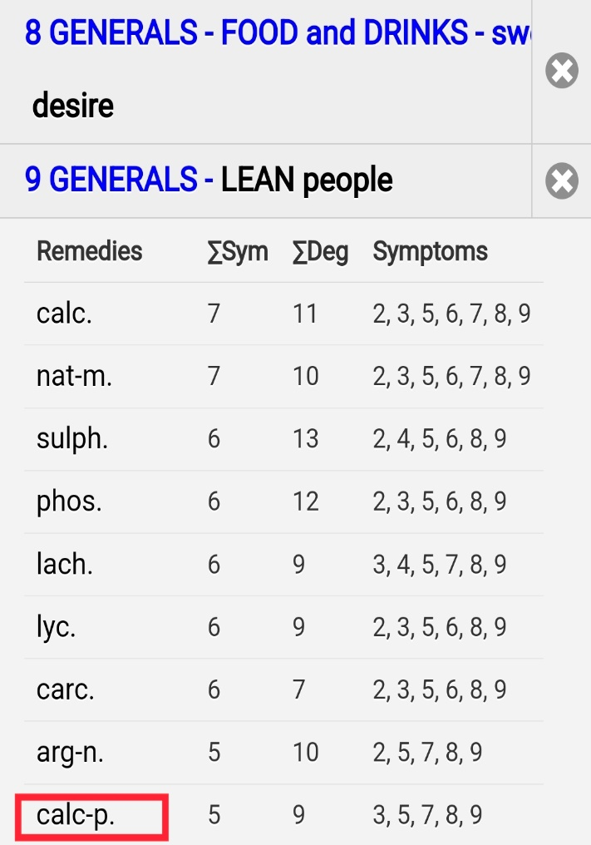

FIRST PRESCRIPTION: Calc. Phos 200 3 Doses, SL 200 tds * 2 weeks
FOLLOW UP:
Date | Complaints | Rx
05/10/2023 | Eruptions on face, neck, groin, legs size -SQ-,  Number of eruptions -SQ-  Itching -SQ-  No new eruptions  Appetite reduced  Weight – 12.5 kg  Complaints were not improving; hence anti-miasmatic medicine was given. | Tub. 1M 3 Doses  SL 200 tds * 2 weeks
27/10/2023 | Eruptions on face, neck, trunk, legs > 30%  Number of eruptions >>  Itching -SQ-  No new eruptions  Appetite has improved.  Weight – 13.5 kg, Height – 99 cm | Calc. Phos. 1M 3 Doses SL 200 tds * 2 weeks
23/11/2023 | Eruptions on face, neck, trunk, legs >>  No new eruption  Previous eruptions are dying.  Itching <  Coryza < for 1 week, cough with yellow expectoration at night, running nose.  No H/O Fever, sneezing. H/O consumption of milk at night and A/F eating cold things.  Generals – Normal  In General, >>40 % | Hepar Sulph 200 tds * 1ST week  Calc. Phos. 1M 3 Doses  SL 200 tds * 2nd week
21/12/2023 | Eruptions on face, neck, trunk, legs >>  No new eruption  Previous eruptions are dying.  Itching >>  No coryza and running nose.  Generals – Normal | Calc. Phos. 10 M 3 Doses  SL 200 tds * 2 weeks
02/03/3024 | Eruptions in groin region +  Red, round lesion  Itching +, no burning  Eruption on face & itching -0-  Weight – 14.5 kg, Height – 102 cm | Calc. Phos. 10 M 3 Doses SL 200 tds * 2 weeks
06/05/2024 | Eruptions in groin region -0-  No itching  Eruption on face -0-  Appetite reduced occasionally since 1 month  Weight – 15 kg, Height – 102 cm  Pt is still under treatment | SL 10 M 3 Doses  SL 200 tds * 30 Days

CASE SUMMARY:
From the above, we can see child had fear of insects, likes to travel, want of attention, perspiration on neck, thirst for small quantities frequently, desire for sweets, sleeping on left side, complaints going from left side to right, lean built. Calc carb came first in repertorization by using Synthesis Repetory. If we refer Boericke Materia Medica, Calc carb is apprehensive, averse to work or exertion (2). On the other hand, Calc Phos always want to go somewhere (3) and has more marked desire for travelling (4). Hence Calc phos 200 was given after differentiating with Calc carb. When 200th potency failed to give further results and complaints were not improving, Tuberculinum 1 M was given as anti-miasmatic medicine. After this, Calc. Phos 1M potency was used considering the susceptibility of the patient. When Calc. Phos.1M potency failed to give further results, Calc. Phos. 10 M was used.
BEFORE  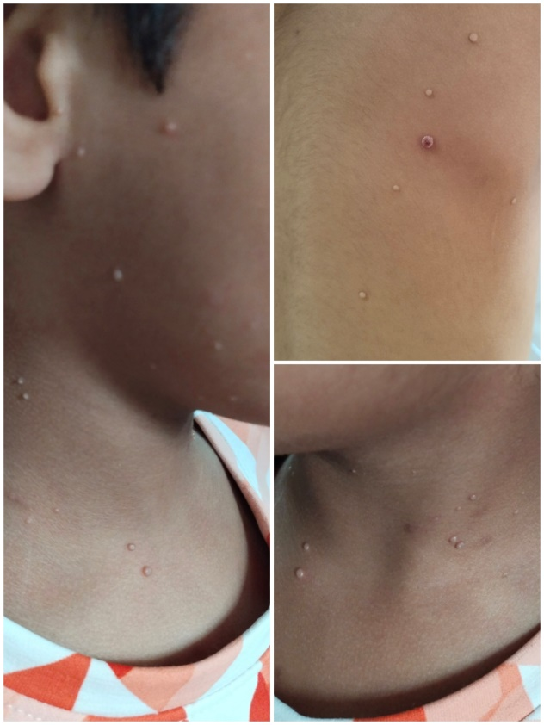 | AFTER  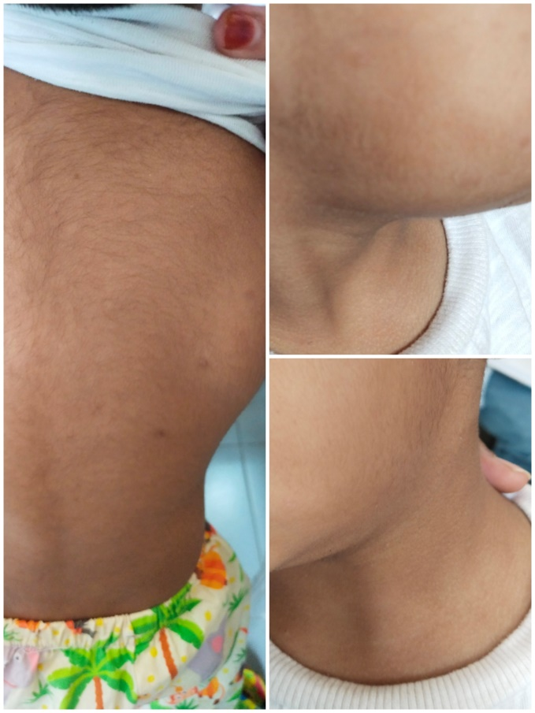

CONCLUSION:

This case of molluscum contagiosum demonstrates the effectiveness of a tailored homeopathic approach in managing viral skin infections. The progressive improvement in lesions and overall patient well-being underscores the importance of symptom-based remedy selection. Calcarea Phosphorica, in varying potencies, played a pivotal role in resolving the condition, with Tuberculinum providing essential support when needed. While recurrence is common in molluscum contagiosum, this case suggests that homeopathy can offer a sustainable treatment option, potentially reducing recurrence rates and improving patient quality of life. Further studies are recommended to explore its broader applicability in dermatological viral infections.

ACKNOWLEDGEMENT:
I would like to thank management staff and teachers of Smt. Chandaben Mohanbhai Patel Homeopathic Medical College, Vile Parle West, Mumbai, namely Dr. Mohanbhai Patel, Dr. Asmita Parikh, Dr. Parizad Damania, Dr. Nimish P. Shukla, Dr. Jenil Panthaki, Dr. Rajesh Barve, Dr. Archana Mehan.

BIBLIOGRAPHY:

1. | Khopkar DU. Skin Diseases & Sexually Transmitted Infections With MCQs. 6th ed. Khopkar DU, editor. Navi Mumbai: BHALANI PUBLISHERS; 2015.
2. | BOERICKE W. BOERICKE'S NEW MANUAL Of HOMEOPATHIC MATERIA MEDICA With REPERTORY Including Indian Drugs, Nosodes, Uncommon Rare Remedies, Mother Tinctures, Relationships, Sides of the Body, Drug Affinities & List of Abbreviations. Third Revised & Augmented Edition Based on Ninth Edition ed. BOERICKE W, editor. New Delhi: B. JAIN PUBLISHERS (P) LTD.; 2016.
3. | BOERICKE W. BOERICKE'S NEW MANUAL Of HOMEOPATHIC MATERIA MEDICA With REPERTORY Including Indian Drugs Nosodes, Uncommon Rare Remedies, Mother Tinctures, Relationships, Sides of the Body, Drug Affinities & List of Abbreviations. Third Revised & Augmented Edition Based on Ninth Edition ed. BOERICKE W, editor. New Delhi: B. JAIN PUBLISHERS (P) LTD.; 2016.
4. | J.T.Kent. REPERTORY OF THE HOMEOPATHIC MATERIA MEDICA. ENRICHED INDIAN EDITION REPRINTED FROM SIXTH AMERICAN EDITION ed. Clara Louise Kent MD, editor. New Delhi: B. JAIN PUBLISHERS (P) LTD.; 2010.

Details of authors:
- Corresponding author: Dr. Anuj Milind Sathe
Assistant Professor in Dept. of Practice of Medicine, Smt. C.MP.H.M.C Mumbai
Address: H-Wing, Flat no. 001, Ground Floor, Dattaramanand C.H.S., Hanuman Cross Road No.2, Near Shivaji Vidyalaya, Vile-Parle(East), Mumbai -400057.
Email-id: satheanuj@rediffmail.com
Contact no.: 9769043190

- Dr. Nimish P. Shukla
Professor & H.O.D. in Dept. of Practice of Medicine, Smt. C.M.P.H.M.C Mumbai
Email-id: drnimishshukla@gmail.com
Contact no.: 9322293128

