**FarmNest: Connecting Farmers and Consumers Through a Smart Organic Platform**

**Shivangi Patel1, Aman Maddheshiya2**

1Assistant Professor, Dept. Of Computer Science & Engineering, Parul University, Vadodara, Gujarat, India.

2Student, Dept. Of Computer Science & Engineering, Parul University, Vadodara, Gujarat, India.

**ABSTRACT**

This paper outlines the development and design of a new organic farming website built with ReactJS and Firebase to support farmers, engage consumers, and simplify administrative tasks. The platform features an integrated educational section where farmers can access learning materials on organic farming techniques, promoting sustainable agricultural practices. Additionally, an e-commerce marketplace enables farmers to showcase and sell their organic products directly to consumers, fostering a direct and transparent supply chain. For consumers, a subscription model ensures a consistent supply of fresh organic products, encouraging healthier eating habits. The platform also includes an intuitive admin panel that facilitates the management of users, products, subscriptions, and transactions, ensuring seamless operations. Leveraging Firebase for real-time data management and authentication, along with ReactJS for a dynamic and user-friendly interface, the website offers a scalable and efficient digital solution. This research explores the technical framework, essential functionalities, and socio-economic impact of the platform, contributing to the broader adoption of digital solutions in the organic farming industry.

**Keywords:** Organic Farming, E-commerce Marketplace, Subscription Model, Digital Platform, Sustainable Agriculture.

1. **INTRODUCTION**

The growing digital economy presents significant opportunities for the agricultural sector, particularly in promoting rural household agricultural entrepreneurship and increasing farmers' income [1]. In this context, an organic farming website offering learning resources, an e-commerce space for farmers to sell their goods, and a subscription model for consumers directly addresses several key trends highlighted in the sources [4, 16]. **Digital skills are crucial for farmers to access information, enhance their agricultural entrepreneurship, and improve factor availability** such as production credit, modern technology, and social capital [1]. By providing easily accessible learning materials on organic farming practices, the website empowers farmers with the knowledge necessary to adopt sustainable methods and improve their production [11, 16].

Furthermore, the establishment of an e-commerce space on the platform directly tackles the challenge of market access for farmers [14, 16]. E-commerce offers a powerful tool for farmers to **diversify their agribusiness, connect with new markets, and potentially bypass intermediaries**, leading to increased profitability [6, 14, 16]. This is particularly relevant for farmers producing specialty products like organic goods, as it allows them to directly reach consumers who value these attributes [15]. The platform's e-commerce functionality aligns with the increasing trend of farmers utilizing online channels to market their products and engage in agricultural entrepreneurship, a key driver for rural revitalization [1].

Finally, the integration of a subscription model for consumers to receive a regular supply of organic goods caters to the evolving consumer demand for convenience and access to fresh, locally sourced products [4, 6]. The concept of **subscription-based models in agriculture is gaining traction**, as evidenced by existing systems focused on organic produce delivery [8, 10]. This feature not only provides a stable revenue stream for farmers but also fosters a direct and potentially long-term relationship between producers and consumers, enhancing trust and transparency in the organic food supply chain [10, 14]. The utilization of technologies like ReactJS for a user-friendly interface and Firebase for backend support will be instrumental in creating a robust and scalable platform that meets the needs of both farmers and consumers in the burgeoning organic food market [9, 12].

1. **LITERATURE REVIEW**

The integration of digital technologies into the agricultural sector is rapidly transforming traditional farming practices and market dynamics. **Digital skills are increasingly recognized as a critical factor in promoting agricultural entrepreneurship, enhancing farmers' access to essential resources, and ultimately contributing to rural revitalization [1, 2]**. The concept of digital literacy, encompassing the ability to utilize digital media for learning, working, and accessing information, forms a crucial element in bridging the "usage gap" within the digital divide [1, 11]. Initiatives like your proposed organic farming website, which aims to provide learning resources, an e-commerce platform for farmers, and a subscription model for consumers, directly align with the growing emphasis on leveraging digital tools to empower farmers and improve the agricultural value chain [2, 16].

A central pillar of your project is the provision of learning resources on organic farming. The sources underscore the significance of information access for farmers, highlighting that **agricultural production decisions are often constrained by information incompleteness and asymmetry [1]**. Digital skills enable farmers to overcome these constraints by accessing timely agricultural production and market information [1]. E-commerce platforms can serve as vital channels for disseminating knowledge on sustainable agricultural practices, offering real-time guidance and training modules that include organic farming techniques [16]. Furthermore, the development of digital platforms presents a valuable opportunity to digitize and distribute agricultural knowledge, directly supporting farmers in adopting more sustainable and potentially more profitable methods [16]. By offering readily available educational content, your website directly addresses the need for enhanced digital literacy and access to crucial information within the farming community [1].

The inclusion of an e-commerce space for farmers to sell their organic goods directly responds to the growing recognition of e-commerce as a transformative force in agriculture [14, 15]. **E-commerce platforms offer farmers the potential to diversify their income streams, access new and wider markets, and interact directly with consumers, thereby reducing reliance on traditional intermediaries [14, 16]**. This direct-to-consumer approach is particularly advantageous for producers of specialty goods like organic produce, allowing them to capture a greater share of the value and cater to a growing consumer demand for such products [6]. The positive influence of digital skills on farmers' agricultural entrepreneurship further supports the rationale for integrating e-commerce functionality into your platform [1]. By providing an online marketplace, your website empowers farmers to engage in online marketing, manage their sales, and build direct relationships with their customer base, fostering agricultural entrepreneurship in the digital age [2, 14].

The implementation of a subscription model for consumers seeking a regular supply of organic goods reflects an evolving trend in agricultural e-commerce. **Subscription-based models offer a promising avenue for creating stable market linkages between farmers and consumers, ensuring a predictable demand for organic produce and a consistent revenue stream for producers [10]**. The concept of a "consumer and farmer-centric subscription-based organic vegetable fruit delivery system" specifically highlights the viability and mutual benefits of such models [4]. By facilitating regular purchases, your platform can contribute to building long-term relationships and fostering trust between organic farmers and health-conscious consumers [10]. This approach aligns with the broader movement towards service-oriented business models in various industries, including agriculture, where bundling products with convenient services like regular delivery can enhance customer value propositions [10].

Finally, the choice of technology, specifically ReactJS and Firebase, is pertinent to the development of a user-friendly and efficient platform for your envisioned services. ReactJS, as a component-based library, is well-suited for building interactive and dynamic user interfaces, essential for both the learning resources and the e-commerce sections of your website [12]. Firebase, a cloud-based platform, offers a scalable and reliable backend infrastructure for managing user data, product listings, and subscription information in real-time [13]. The combination of these technologies allows for the creation of a robust and maintainable platform that can effectively serve the needs of both farmers managing their online stores and consumers accessing information and subscribing to regular deliveries of organic produce [12]. This technological foundation is crucial for realizing the potential of your project in the rapidly evolving landscape of digital agriculture and e-commerce [10].

**Theoretical Background**

Your proposed organic farming website, encompassing learning resources, an e-commerce platform, and a subscription model, directly addresses the digital transformation of the agricultural sector and the imperative of enhancing digital literacy among farmers [1, 2]. By providing accessible learning materials on organic farming practices, the platform aims to bridge the digital usage gap and equip farmers with the necessary skills to adopt sustainable methods and engage more effectively in the digital economy [1, 11]. This focus on improving digital skills is crucial, as it has a statistically significant positive influence on farmers’ agricultural entrepreneurship by increasing their access to essential factors like modern technology and social capital [1].

The integration of an e-commerce space for farmers to sell their organic goods taps into the theoretical benefits of digital markets and disintermediation [14]. By creating a direct-to-consumer channel, the platform empowers farmers to bypass traditional intermediaries, potentially leading to better price realization and increased profitability, especially for specialty products like organic produce [14]. This aligns with the understanding that digital skills incentivize farmers’ agricultural entrepreneurship by facilitating broader market access and reducing information asymmetry [1]. The e-commerce functionality directly supports farmers in engaging in online marketing and building relationships with consumers who value organic products, fostering a more resilient and equitable food system [6, 14].

Finally, the inclusion of a subscription model for consumers reflects the growing importance of service-oriented business models and the potential of the subscription economy in agriculture [10]. This model offers consumers convenience and a consistent supply of organic goods while providing farmers with a more predictable revenue stream and fostering stronger, long-term relationships with their customer base [10, 16]. By combining the product (organic produce) with the service (regular delivery), the platform enhances its value proposition and creates a more stable economic environment for participating farmers, aligning with the broader trend of servitisation in various industries [10]. The strategic use of technologies like ReactJS and Firebase will be instrumental in building a user-friendly and scalable platform to support these interconnected features [9, 13].

**Review of Existing Research**

Drawing upon the reviewed research, your organic farming website project is strategically positioned to address key trends in the agricultural sector. The evidence strongly suggests that **digital skills play a crucial role in fostering agricultural entrepreneurship** by improving farmers' access to vital resources like technology and social capital [1]. Your platform, by providing learning resources, directly tackles the need to enhance these skills among organic farmers, moving beyond basic internet access to focus on higher-level digital competencies [1, 2]. Furthermore, the integration of an e-commerce platform aligns with the growing body of research on **Agri-food E-commerce (AE)**, which highlights its potential to improve market access for smallholders by disintermediating traditional supply chains and reducing information asymmetry [14, 15, 16]. This direct-to-consumer model can empower organic farmers to realize better prices and build stronger relationships with consumers [4].

The inclusion of a **subscription model** taps into the emerging trend of service-oriented business models and the subscription economy, offering a convenient way for consumers to access organic produce while potentially providing farmers with more stable revenue streams [10]. While specific research on subscription models in organic agriculture within the provided sources is limited, the broader concept of **servitization** supports the value proposition of combining products with regular delivery services. Your choice of **ReactJS and Firebase** for development aligns with modern web development practices for creating interactive and scalable platforms suitable for e-commerce and user management [12]. Overall, your project addresses critical areas identified in existing research and has the potential to contribute valuable insights into the practical application of digital technologies in the organic agricultural sector.

1. **METHODOLOGY**

Developing your organic farming website using ReactJS and Firebase will involve a structured methodology encompassing planning, design, development, testing, deployment, and ongoing support. A crucial first step is **comprehensive planning and requirements gathering**, where you will define the specific features and functionalities for each of the three core components: the learning resources for farmers, the e-commerce space, and the subscription model for consumers. For the learning resources, identify the key topics in organic farming that you aim to cover, considering the diverse skill levels and experiences of farmers [11]. This might involve categorizing content based on beginner, intermediate, and advanced levels, and including various formats such as articles, videos, and downloadable guides. The e-commerce section needs detailed specifications for product listings (including organic certifications, pricing, inventory management), farmer profiles, secure payment gateway integration, order processing, and potentially logistics management or integration with existing delivery services. For the subscription model, define the subscription tiers, product options within each tier, billing cycles, delivery schedules, and how farmers will manage their subscription inventory. Throughout this planning phase, it is vital to keep in mind the importance of **enhancing digital literacy among farmers** [2, 11] and designing a user interface that is intuitive and accessible, potentially drawing inspiration from e-extension models that utilize mobile communication [5].

The next stage involves **designing the technology stack and infrastructure**, where your choice of ReactJS for the front-end and Firebase for the back-end offers significant advantages. ReactJS, as a component-based JavaScript library [7, 9], will enable you to build a dynamic and interactive user interface for both farmers and consumers, facilitating a seamless and pleasing experience [7]. Its ability to update the virtual DOM efficiently contributes to fast and responsive applications, crucial for an engaging e-commerce platform [9]. Firebase, as a comprehensive cloud-based platform [13], provides a suite of services that are well-suited for this project, including a real-time NoSQL database (Firestore), authentication services for managing farmer and consumer accounts, cloud storage for learning materials and product images, and hosting for deploying the website. Carefully designing your Firestore database structure will be critical to efficiently manage user data, product information, learning content metadata, subscription details, and order history. Consider how to link farmer accounts with their product listings and subscription offerings, and how to manage the relationships between consumers and their subscriptions. Leveraging Firebase authentication will ensure secure user management, while Cloud Storage can host the various digital assets of your platform.

The core of the project lies in the **iterative development of the website's features**, following an Agile methodology that allows for flexibility and adaptation based on feedback [12]. You might start by building the foundational structure with user authentication and basic profile management for both farmers and consumers. Subsequently, you can focus on developing the learning resources section, implementing features for content display, search, and potentially progress tracking for farmers. Concurrently or in the next iteration, develop the e-commerce functionality, enabling farmers to list products with relevant details, including adherence to organic standards, and allowing consumers to browse, search, add to cart, and securely checkout. Integrating a reliable payment gateway will be essential for processing transactions. The subscription model can be implemented next, building upon the e-commerce platform to manage recurring orders and deliveries based on consumer preferences and farmer availability. Throughout the development process, prioritize **user-centric design**, especially for the farmer interface, considering their potential limitations in digital literacy [6]. Incorporate clear navigation, helpful tooltips, and potentially multilingual support if your target audience requires it. Regular testing at each stage of development is crucial to identify and fix bugs, ensuring the platform is functional, user-friendly, and secure.

Finally, after thorough testing, you will proceed with **deployment and ongoing support**. Firebase hosting provides a straightforward way to deploy your ReactJS application to the web. Post-launch, it is vital to provide **comprehensive training and support for the farmers** to effectively utilize all the features of the platform, especially the learning resources and the e-commerce functionalities [16]. This might involve creating tutorials, FAQs, and offering direct support channels. Gathering feedback from both farmers and consumers will be essential for identifying areas for improvement and further development. Consider implementing analytics to track user engagement and identify popular learning resources or best-selling products. Continuously updating the learning content with the latest information in organic farming practices and providing ongoing technical support will be key to the long-term success and sustainability of your organic farming website [2]. The platform's success will hinge on its ability to not only provide technological solutions but also to foster a supportive ecosystem that empowers farmers in the digital economy [1].

**Proposed System**

The proposed system for the organic farming website is designed as a comprehensive platform addressing multiple needs within the organic agriculture sector. At its core, the platform will offer educational resources for farmers, focusing on various aspects of organic farming practices [1, 2, 11]. This directly tackles the importance of digital skills in modern agriculture, aiming to empower farmers with the knowledge needed for successful organic cultivation and entrepreneurship [1, 2]. Complementing the educational component, the system will feature a dedicated e-commerce marketplace where these farmers can list and sell their certified organic produce directly to consumers [15, 16]. This aligns with the growing trend of Agri-food E-commerce (AE), seeking to improve market access for farmers by potentially disintermediating traditional supply chains and fostering direct relationships with their customer base [14].

Furthermore, the proposed system will incorporate a subscription model for consumers [8, 10]. This feature will allow customers to subscribe to regular deliveries of organic vegetables and fruits, offering convenience and potentially providing farmers with a more stable and predictable revenue stream [10]. The entire platform will be built using a modern technology stack, primarily ReactJS for the front-end development to ensure a dynamic and interactive user experience, and Firebase as the back-end service providing essential functionalities such as database management, user authentication, and hosting [7, 9, 12, 13]. By integrating these key components, the proposed system aims to create a supportive digital ecosystem that benefits both organic farmers and consumers, fostering sustainability and direct market engagement.

**Problem Definition**

The primary problem addressed by the organic farming website project is the **existing gap in digital literacy and market access for organic farmers**, which hinders their entrepreneurial growth and limits consumer access to their produce [1, 16]. While the digital era offers significant opportunities for rural development through technologies like e-commerce [1], many farmers, particularly those in developing regions, lack the necessary **digital skills** to effectively leverage these tools for business growth [1, 11]. This digital divide prevents them from accessing vital agricultural information, adopting modern technologies, and participating in online marketplaces to expand their reach beyond local channels [1, 11, 16].

Furthermore, traditional agricultural supply chains often result in **limited profitability for farmers** due to the involvement of intermediaries [16]. The lack of direct connection with consumers also leads to **information asymmetry**, where farmers may not fully understand market demands and consumers may struggle to find and purchase directly from local organic producers [1, 15]. The absence of convenient and reliable channels for consumers to access organic produce further exacerbates this issue. By creating a platform that combines **educational resources to enhance farmers' digital and organic farming skills with a direct-to-consumer e-commerce space and a subscription model**, this project aims to bridge these gaps, empowering organic farmers to thrive in the digital economy and providing consumers with easier access to sustainably produced goods.

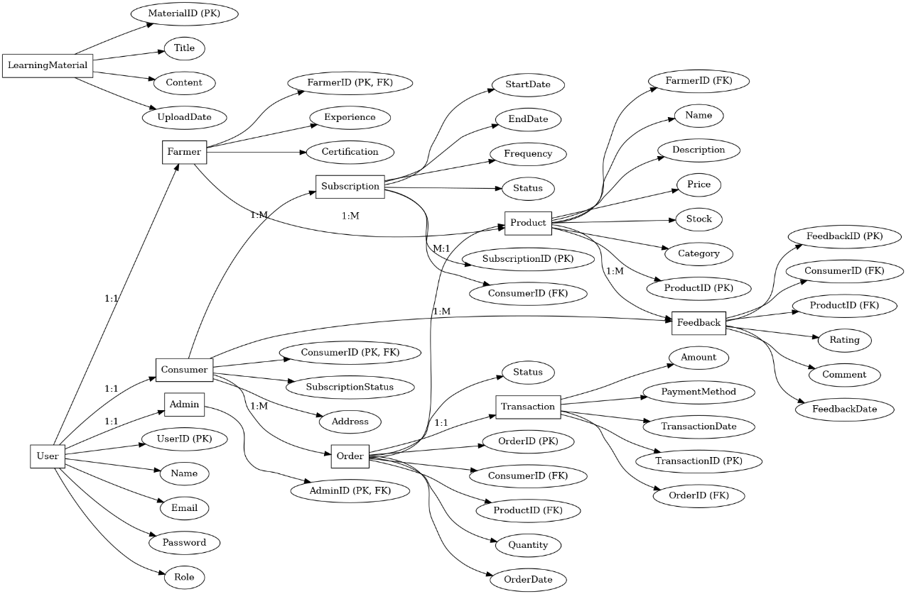

**Figure 1:** Entity-Relationship Diagram

**System Design**

The system design for your organic farming website will follow a **modular architecture**, leveraging the component-based nature of **ReactJS** for the front-end and the comprehensive suite of services offered by **Firebase** for the back-end. The **presentation layer**, built with ReactJS components, will be responsible for handling user interactions and dynamically displaying information to both farmers and consumers. This layer will be designed with a strong emphasis on **usability and accessibility**, featuring intuitive navigation, clear information presentation, and responsive layouts that adapt to different devices. For farmers, the interface will provide access to learning resources, functionalities for managing their product listings and inventory, and tools to handle subscription orders. For consumers, the front-end will offer browsing and search capabilities for organic products, secure checkout processes, and management of their subscriptions.

The **business logic layer** will primarily reside within Firebase services. **Firebase Authentication** will manage user registration, login, and security for both farmers and consumers. The core data, including learning content details, farmer profiles, product information (including adherence to organic certifications), subscription plans, and order history, will be stored and managed in **Firebase's NoSQL database (Firestore)**. The relationships between different data entities, such as linking farmers to their products and consumers to their subscriptions, will be carefully model in Firestore to ensure efficient data retrieval and management. **Firebase Cloud Storage** will be utilized to host the various digital assets of the platform, including images of organic produce and downloadable learning materials.

Furthermore, **Firebase Cloud Functions** can be employed to implement specific business logic, such as handling order processing triggers, managing subscription billing cycles (if not using a third-party integration), and potentially sending notifications to farmers about new orders or to consumers about upcoming deliveries. This serverless compute environment allows for the execution of backend code in response to events without the need to manage dedicated servers. The **real-time capabilities of Firebase** can also be leveraged to provide up-to-date information to users, such as displaying current product availability or order statuses. The modular design, facilitated by ReactJS components on the front-end and the distinct services of Firebase on the back-end, will promote maintainability, scalability, and the ability to add new features to the platform in the future.

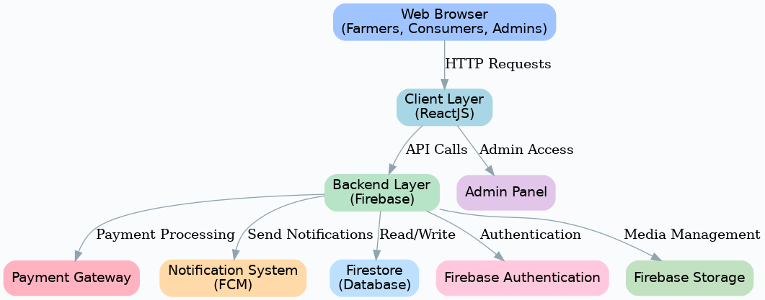

**Figure 2:** System Architecture

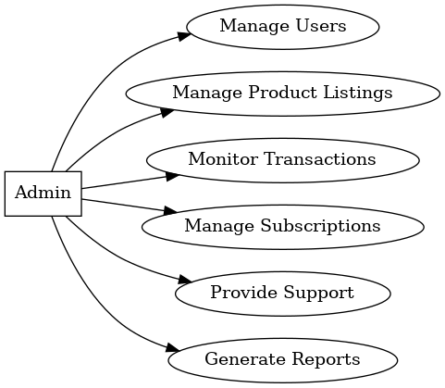 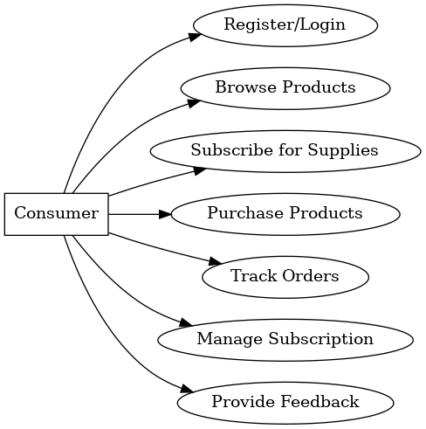

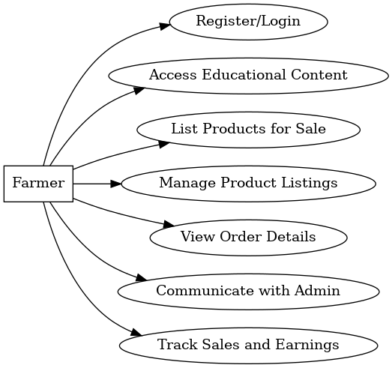

**Figure 3:** Use Case Diagrams

1. **RESULTS AND DISCUSSION**

Firstly, the integration of **educational resources within the platform is anticipated to significantly enhance the digital literacy and skills of participating farmers [1, 2]**. The sources emphasize the crucial role of digital skills in modern agricultural entrepreneurship, enabling farmers to access vital information, adopt modern technologies, and engage in online markets [1]. By providing targeted learning content, the project can empower farmers to overcome the digital divide, improve their farming practices, and effectively manage their online businesses [11]. This increased digital competence is a foundational step towards greater economic empowerment and sustainability in the agricultural sector [2, 11].

Secondly, the **establishment of a dedicated e-commerce marketplace on the platform is expected to substantially improve market access and sales opportunities for organic farmers [2, 14]**. The sources highlight that e-commerce can revolutionize market access for smallholders by potentially disintermediating traditional supply chains and fostering direct connections with consumers [2, 14]. This direct-to-consumer model can lead to **increased profitability for farmers** as they can capture a larger share of the value chain [2]. Furthermore, the online platform can expand their customer base beyond local geographical limitations, reaching a wider audience interested in organic produce [1]. The features for managing product listings and inventory will streamline their operations and facilitate efficient sales processes.

Thirdly, the incorporation of a **subscription model for consumers is projected to create more stable and predictable revenue streams for the farmers** participating in the platform [10]. Subscription-based models have demonstrated the potential to revolutionize the financial architecture of businesses, offering recurring revenue and improved customer lifetime value [8]. For organic farmers, this model can provide a more secure financial foundation, allowing for better planning and investment in their farms [1, 10]. Simultaneously, it offers convenience to consumers, ensuring regular access to fresh organic produce. This mutually beneficial arrangement can foster stronger relationships between farmers and their customers, built on trust and consistent supply [10].

Finally, the **system's modular architecture, built with ReactJS and Firebase, emphasizes usability, accessibility, and scalability**, which are critical for the project's success. The intuitive navigation and clear information presentation will make the platform user-friendly for farmers with varying levels of digital literacy and for consumers seeking organic products. The use of Firebase as a robust and scalable back-end ensures that the platform can handle a growing number of users and transactions efficiently [13]. Overall, the expected results of this project include more digitally skilled and economically empowered organic farmers, enhanced market access and profitability, a stable revenue model through subscriptions, and improved access to organic produce for consumers, all facilitated by a user-friendly and scalable digital platform.

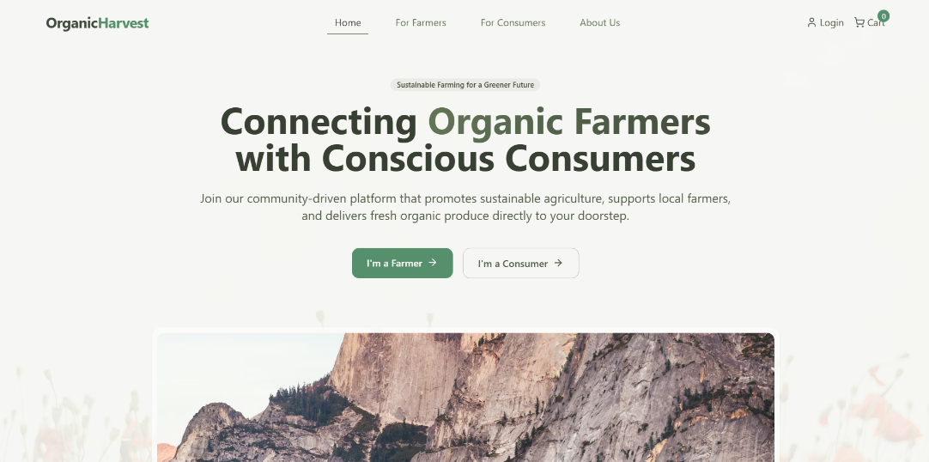

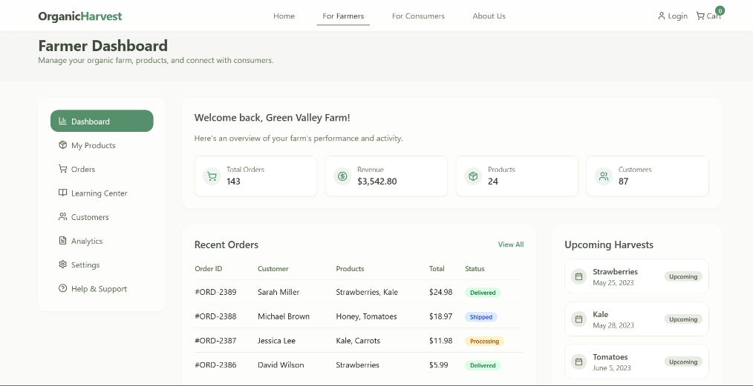

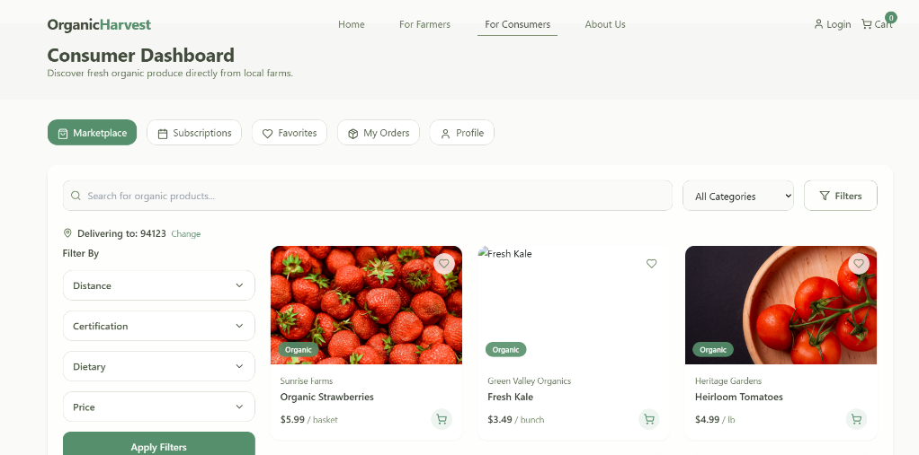

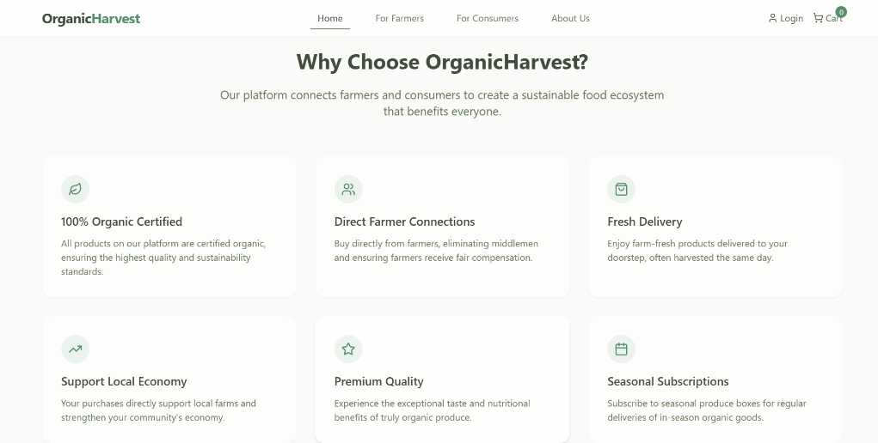

**Figure 4:** Expected Results

1. **CONCLUSION**

In conclusion, this organic farming website project aims to create a **digital ecosystem that significantly benefits organic farmers**. By integrating **educational resources**, the platform will empower farmers with crucial **digital skills**, enabling them to access information, adopt modern practices, and manage their online presence effectively [1, 2]. The establishment of a dedicated **e-commerce marketplace** directly addresses the issue of **market access**, potentially disintermediating traditional supply chains and allowing farmers to connect directly with consumers, thereby increasing their profitability [1, 14, 16]. This aligns with the broader trend of **Agri-food E-commerce** and its potential to revolutionize how agricultural products are bought and sold [14, 15].

Furthermore, the incorporation of a **subscription model** offers the promise of **stable and predictable revenue streams for farmers** while providing convenience to consumers seeking regular access to organic produce. The system's **modular architecture, built with ReactJS and Firebase**, ensures **usability, accessibility, and scalability**, creating a robust foundation for future growth and the addition of new features. Ultimately, this project is expected to foster a more digitally enabled, economically sustainable, and directly connected organic agriculture sector.

**REFERENCES**

1. Cheng, C., Gao, Q., Ju, K. and Ma, Y., 2024. How digital skills affect farmers’ agricultural entrepreneurship? An explanation from factor availability. Journal of Innovation & Knowledge, 9(2), p.100477.
2. Syafuddin, K. and Meidina, A.P., 2023. Collaboration to Build Resilient Farmers' Human Resources: Digital Literacy Program in Agriculture as a Joint Education Effort. WIMAYA, 4(02), pp.94-103.
3. Emeka, O., Christiana, I., Emmanuel, O., Akunna, T.A., Esther, N., Rachael, I. and Kelechi, E., 2023. A Review on Digitalization of Agriculture and Economic Business Model Strategies in the 21 st Century. American Journal of Operations Management and Information Systems, 8(2), pp.30-41.
4. Karunarathna, T.M.N.P., Kumari, M.M.A., Kulasinghe, W.D.K.A., Liyanage, T.P., Kodagoda, N., Suriyanwsa, K. and Kumari, D., 2021, December. Consumer and Farmer Centric Subscription Based Organic Vegetable/Fruit Delivery System. In 2021 3rd International Conference on Advancements in Computing (ICAC) (pp. 109-115). IEEE.
5. Ra, S., Ahmed, M. and Teng, P.S., 2019. Creating high-tech ‘agropreneurs’ through education and skills development. International Journal of Training Research, 17(sup1), pp.41-53.
6. Lilavanichakul, A., 2020. Development of agricultural e-commerce in Thailand. The FFTC Journal of Agricultural Policy, 1, pp.7-17.
7. Aggarwal, S., 2018. Modern web-development using reactjs. International Journal of Recent Research Aspects, 5(1), pp.133-137.
8. Pila, L.D., 2025. The evolution of subscription models in agriculture and construction: A technical analysis. International Journal of Science and Research Archive, 14(1), pp.1543-1549.
9. Bhalla, A., Garg, S. and Singh, P., 2020. Present day web-development using reactjs. International Research Journal of Engineering and Technology, 7(05).
10. Suryakala, B., 2019. Towards A Subscription Economy: Digital Transformation Journey of a Traditional Product-Based Company (Master's thesis).
11. Mokhtar, W.N.H.W., Izhar, T.A.T., Zaini, M.K. and Hussin, N., 2022. The importance of digital literacy skills among farmers for sustainable food security. International Journal of Academic Research in Business and Social Sciences, 12(1), pp.235-246.
12. Khuat, T., 2018. Developing a frontend application using ReactJS and Redux.
13. Chougale, P., Yadav, V., Gaikwad, A. and Vidyapeeth, B., 2021. Firebase-overview and usage. International Research Journal of Modernization in Engineering Technology and Science, 3(12), pp.1178-1183.
14. Zeng, Y., Jia, F., Wan, L. and Guo, H., 2017. E-commerce in agri-food sector: a systematic literature review. International Food and Agribusiness Management Review, 20(4), pp.439-460.
15. Wheatley, W.P., Buhr, B.L. and DiPietre, D., 2001. E-Commerce in agriculture: development, strategy, and market implications.
16. Morepje, M.T., Sithole, M.Z., Msweli, N.S. and Agholor, A.I., 2024. The influence of E-commerce platforms on sustainable agriculture practices among smallholder farmers in Sub-Saharan Africa. Sustainability, 16(15), p.6496.