VEHICLE VIOLATION DETECTION AND FINE PROCESSING WITH YOLOv5

AKASH B1

Student

Dept of Computer Science with Cognitive Systems Dr. N. G. P. Arts and Science College

Coimbatore, India

Email: [b.akash5566@gmail.com](mailto:b.akash5566@gmail.com)

Dr. R. SENTHIL KUMAR2

Professor

Dept of Computer Science with Cognitive Systems Dr. N. G. P Arts and Science College

Coimbatore, India

Email:

[senthilkumar.r@drngpasc.ac.in](mailto:senthilkumar.r@drngpasc.ac.in)

# Abstract

Traffic violations are the major challenge, causing accidents and safety risks. Traditional methods to identify violations are slow to process, require more labor, and cause human error. This paper introduces an automated Vehicle Violation Detection and Fine Processing System using YOLOv5, a real-time object detection model for detection.  
The system identifies violations such as tripling, illegal parking, and mobile phone usage while driving by analyzing traffic footage. A pre-trained Haar Cascade XML file detects vehicle number plates, while EasyOCR extracts plate numbers to retrieve owner details from the database. The system classifies detected violations, calculates fines, and securely stores data in the Firebase Realtime Database. Vehicle owners will receive SMS notifications through the Twilio API, which contains a violation ID, a short description, and a link to view the violation details with the payment process. After successful payment, an e-challan is generated for download. By automating violation detection and fine processing, this system improves the efficiency, accuracy, and transparency of traffic law enforcement while minimizing manual work.

**Keywords - (**Vehicle Violation detection, YOLOv5, Haar Cascade XML, Firebase Realtime Database, Twilio API)

1. INTRODUCTION

Traffic violation is a significant challenge that cities face, which can lead to accidents, congestion, and safety consequences. Frequent violations, including triple riding, using mobiles while driving, and illegal parking, impact the flow of traffic and increase risks to both pedestrians and other users of the road. Enforcing these traffic violations currently relies on a human monitoring system that is often time-consuming, labor-intensive, and susceptible to human error. Imperfect resources to enhance a thorough monitoring system and enhance the fairness of enforcement are barriers to successful outcomes. This paper proposes an Automated Vehicle Violation Detection and Fine Processing System that uses YOLOv5, a real-time object detection model. The system processes traffic footage and accurately identifies vehicles, people, and mobile phones to support the vehicle violation detection system. The pre-trained Haar Cascade XML file is used to recognize vehicle number plates while EasyOCR is leveraged to extract plate numbers in order to contact the appropriate owner details of the vehicle. After a violation occurs, the system engages to categorize the offense and ultimately calculate the fine, and all of the relevant data is updated on the Firebase real-time database for managing records efficiently. To enhance communication and transparency, vehicle owners receive an automated SMS notification to their registered mobile number, using Twilio API. The SMS includes the violation ID, a summary of the violation, and a link to view the violation details and evidence (Violation Image) with the payment process. Once a successful payment is confirmed an e-challan will be generated and downloaded for future reference and inquiries.

1. LITERATURE REVIEW

The use of AI to detect traffic violations has greatly increased the efficiency and accuracy of traffic law enforcement. Franklin and Mohana (2020) [1] used YOLOv3 for detecting red light violations and speed violations, achieving an accuracy of 97.67%. Dede et al. (2023) [2] developed a traffic violation detection system that utilizes YOLOv5 along with strongSORT to detect red light violations, illegal parking, and illegal road usage. Smith and Patel (2021) [3] used EasyOCR as an automated vehicle number plate recognition tool to extract vehicle details accurately. Bradski (2000) [5] recognized the role of OpenCV as a monitoring tool in its real-time video analysis of traffic. Cloud computing also plays an important role. Firebase [8] allows for secure storage of violation information in the cloud, while Twilio API [9] automates SMS notifications to violators when the violation is recorded. Building on these advancements, this paper provides a solution for Automate Vehicle Violation Detection and Fine Processing System that utilizes a real-time object detection model and OCR-based number plate recognition with cloud-based access. This system enhances the accuracy and ability to detect traffic violations, promotes efficiency in processing violations, and develops seamless communication and transparency with violators.

1. METHODOLOGY
2. *Role of Python in the System*

The Vehicle Violation Detection and Fine Processing System is created in Python, which has a strong and flexible framework for computer vision and automation. Python’s libraries enable a wide range of image processing, machine learning, and data manipulation operations. The system utilizes OpenCV for pre-processing, YOLOv5 for violation detection, Haar Cascade for license plate detection, and EasyOCR to extract the plate number. In addition, Firebase SDK provides storage to the cloud while Twilio API is concerned with automating SMS functions. Python is not only simple, but has a great number of libraries and supports multiple platforms which makes it easy to build an effective end-to-end traffic violation detection system.

1. *Data Acquisition*

The system begins by acquiring data through a graphical user interface (GUI) implemented with the Tkinter library, which allows to upload images of traffic scenes.

**Tkinter Library:**

Tkinter is Python's built-in GUI library and is a simple and effective way to develop interactive applications with buttons, labels, text fields, and the option to upload a file. Tkinter is lightweight and works with Python, so it is frequently used to develop desktop applications. The system provides an easy-to-use interface to upload traffic scene images, which simplifies data acquisition for image processing.

1. *Object Detection & Violation Classification*

The system employs YOLOv5 to identify vehicles, human beings, and mobile devices, in addition to providing classification of the common traffic violations. Any classified violations are visually represented with bounding boxes and labels for ease of interpretation. Examples of violations include:

* **Tripling:** More than two members on a two-wheeler.
* **Mobile Usage:** Using a mobile phone while riding on a two-wheeler.
* **No Parking Violation:** A vehicle that in the restricted area.

**YOLOv5 Model:**

YOLOv5 (You Only Look Once version 5) is a model for real-time object detection created by Ultralytics that is designed to perform fast and accurate detection. Unlike previous approaches which scan an image multiple times, YOLOv5 will perform a single scan of the whole image, making it more efficient. YOLOv5 is optimized for real-time applications that require speed due to its lightweight architecture and performs efficiently with no issues using Pythons Pytorch resolving the issues of installing and integrating other libraries. YOLOv5 has been trained on COCO and other datasets, thus object categories it will accurately predict include mobile phones, humans, and vehicles, making it ideal for traffic monitoring and automated surveillance.

1. *License Plate Detection & Recognition*

The system will make use of Haar Cascade XML for license plate detection and EasyOCR to extract the vehicle’s registration number from the detected image.

**Haar Cascade XML:**

Haar Cascade is an object detection model based on machine learning. This model finds patterns in images using square-like features using a sequence of trained classifiers to detect objects, such as human faces, eyes, or in this case a license plate. The pre-trained Haar Cascade XML license plate file can be effective in detecting license plates for automatic traffic monitoring and is an efficient means of performing license plate detection.

**EasyOCR Library:**

EasyOCR is an Optical Character Recognition (OCR) library based in Python that uses deep learning to extract text from an image. The library was developed by Jaided AI and is capable of formatting multiple varying fonts; character styles, or cases & formatting. EasyOCR will in this system be used to identify the registration number of the vehicle along with the detected license plate used to identify the vehicle which violates the regulations.

1. *Identification of Vehicle Owner*

The extracted license plate number is compared with existing vehicle details on the database to obtain owner details. The system skips any vehicle whose number is not found and continues processing further detections.

1. *Violation Data Storage*

All violations collected by the system along with their details will be stored in the Firebase Realtime Database for management purposes. Saved information includes:

* Vehicle number and owner details.
* Type of violation and timestamp.
* Fine amount and payment status.

**Firebase Realtime Database:**

Firebase Realtime Database is a cloud-based NoSQL database service, provided by Google. Firebase Realtime Database provides real-time data synchronization and instant updates across all devices. Firebase Realtime Database is optimized for fast reading of data and seamless collaborations while providing automatic scaling, encrypted security, and industry-standard security in order to guarantee secure and reliable violation management.

1. *Notification System*

Once a violation is noted, the system sends an automatic SMS notification to the vehicle owner via the Twilio API. The SMS contains the following information:

* Information about the violation with evidence.
* A link to view evidence of the violation as well as pay their fine.

**Twilio SMS Service:**

Twilio is a cloud-based communication service that has APIs for SMS, Voice Calls, and email notification systems. This system will support automated SMS-based notifications to inform vehicle owners of violations. Twilio provides secure, scalable, and cost-effective notifications. Because Twilio can use any programming language including Python to integrate notifications, it is an excellent choice for automated notification systems.

1. *Fine Payment & e-Challan Generation*

The owners can check the violations and make payments online by accessing a web-based platform. It will show the following after the payment has been made:

* The platform will allows the owner to download an e-challan (digital receipt).
* The fine status is updated in Firebase for tracking.

1. *Web-Based Violation Management*

The web-based violation platform will give access to the various user roles. Users will access the system based of their user roles:

* **Vehicle Owners:** View violations, make payments and download e-challans.
* **Authorities:** Manage violations, review evidence, and check payment status.

**Web Development:**

Web development with HTML, CSS, and JavaScript ensures the interface is interactive and user-friendly experience. HTML serves as the structure for the information, CSS provides the visual appeal, and JavaScript provides the dynamic experience. JavaScript can also handle user authentication, database requests, and real-time updates on the interface when used with Firebase. The layers of JavaScript and Firebase create a responsive, scalable, and efficient system to manage violation seamlessly to users.

1. ARCHITECTURE

The system integration of various technologies provides intelligent support for enforcing traffic laws. It begins with uploading traffic footage, which is analyzed by the YOLOv5 model to detect violations such as triple riding, use of mobile phones while driving, and illegal parking. A Haar Cascade XML model was employed to detect the vehicle number plates while EasyOCR was utilized to extract the plate number and then obtain the vehicle owner's information from the database. After detection the system issues fine, and the violation record is securely stored in the Firebase Realtime Database. The vehicle owner received an automated SMS through the Twilio API regarding the violation details. After a successful payment was made, an e-challan PDF was generated to download. The system developed an automated solution for violation detection, monitoring, notifying, and managing the penalties, whilst minimizing manual processing of a citation and encouraging compliance with traffic safety laws. Overall, this paper provides an extensive workflow of the system demonstrating the potential improvement in vehicle violation detection.

To help clarify this Vehicle Violation Detection and Fine Processing System, the first flowchart represents each stage of the process to detect and process traffic violations. This visual representation also demonstrates how multiple technologies, such as YOLOv5 for detecting violations, Haar Cascade for license plate recognition, and EasyOCR for text recognition, can all be integrated into the system for efficient and accurate enforcement in both design and function.

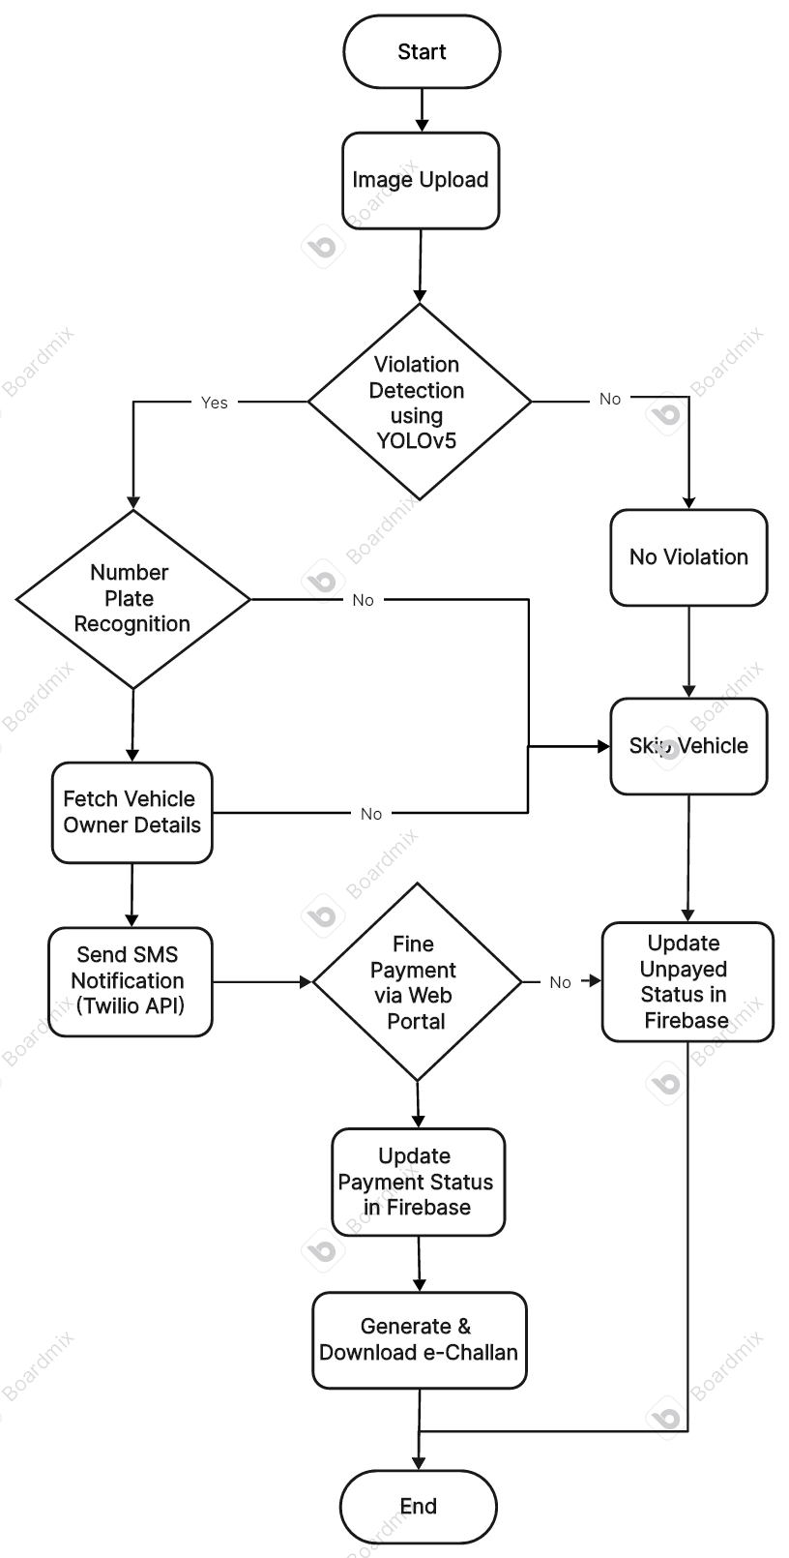

**Flowchart 1:** System Architecture

1. IMPLEMENTATION

The software integrates OpenCV, YOLOv5, EasyOCR, Tkinter, Firebase, and Twilio API to automate traffic violation detection and fine processing. The system initiates by uploading a Tkinter-based GUI to capture various traffic images or video frames. YOLOv5 detects vehicles and detects violations including triple riding, using the mobile while riding, and illegal parking, while the vehicle license plate is detected using Haar Cascade. EasyOCR returns the license plate number, which is then checked against a database to locate the properties of the vehicle owner. All detected violations and additional metadata including the evidence image when the violation occurred, the date and time of the evidence, and the fine amount are stored in the Firebase Realtime Database to facilitate tracking. The Twilio API automatically sends the vehicle owner a SMS about the violation, fine information and payment options are included in the SMS. If the vehicle owner wishes a web-based portal is included to pay fines along with detecting the past due fines. If the fine is paid through the portal, the Firebase record is updated regarding the payment status, the system will generate a digital e-challan as receipt of payment. This paper describes effective, automated, and precise traffic law enforcement to minimize manual intervention of law enforcement agencies and increase compliance through AI-enhanced violation detection and cloud data management.

1. RESULT

The Vehicle Violation Detection and Fine Processing System successfully automates the detection and fine processing of traffic violations. The system identifies three main types of violations, tripling, mobile phone usage, and illegal parking, with YOLOv5. The model efficiently detects each violation with high accuracy. License plate recognition is completed using Haar Cascade and EasyOCR and has demonstrated success, also enabling the retrieval of the vehicle owner's information. All violation records evidence images, timestamps, fine amount, and payment status are securely stored in the Firebase Realtime Database and the data can be accessible at any time, anywhere. Vehicle owners receive an automated SMS via Twilio API, thus reducing the need for human interference; all of the violations can be observed and brought to finalization utilizing the web-based platform that stores violations and simplifies fine payments and E-Chalan downloads. This paper presents both the efficacy of the tool and the possibilities that it creates for improved traffic law enforcement such as increased efficiency, accuracy, compliance, and less manual effort.

1. DISCUSSION

The proposed system automates traffic violation detection and fine processing, reducing reliance on manual enforcement. YOLOv5 ensures accurate violation identification, while EasyOCR's performance depends on image clarity. Firebase manages structured records, and Twilio SMS enhances transparency by notifying violators with evidence and payment options. Challenges include low-quality image handling and OCR accuracy, with future improvements focusing on real-time CCTV integration for a more scalable enforcement solution.

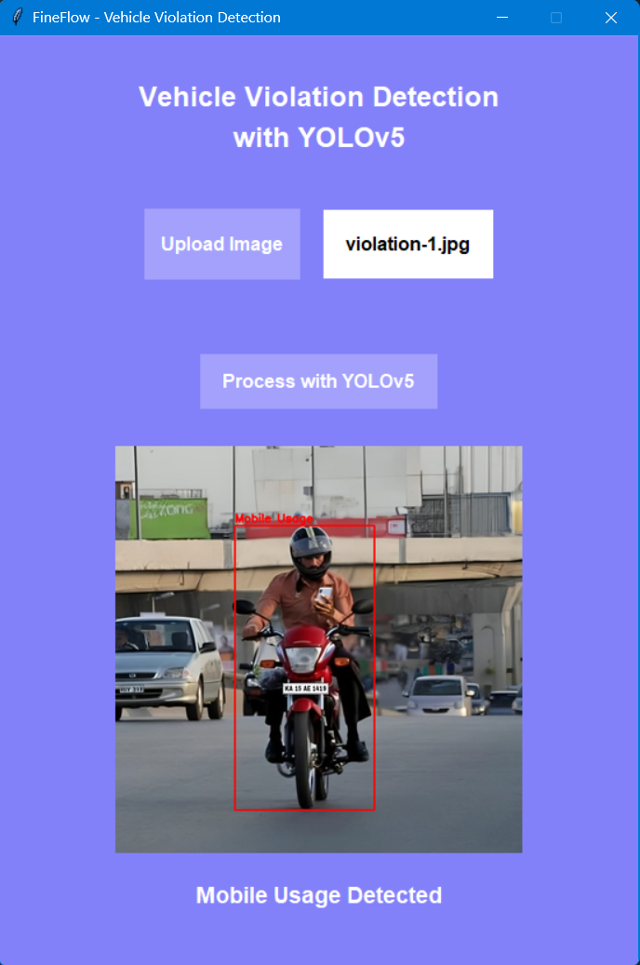

**Figure 1: Mobile Usage Detected**

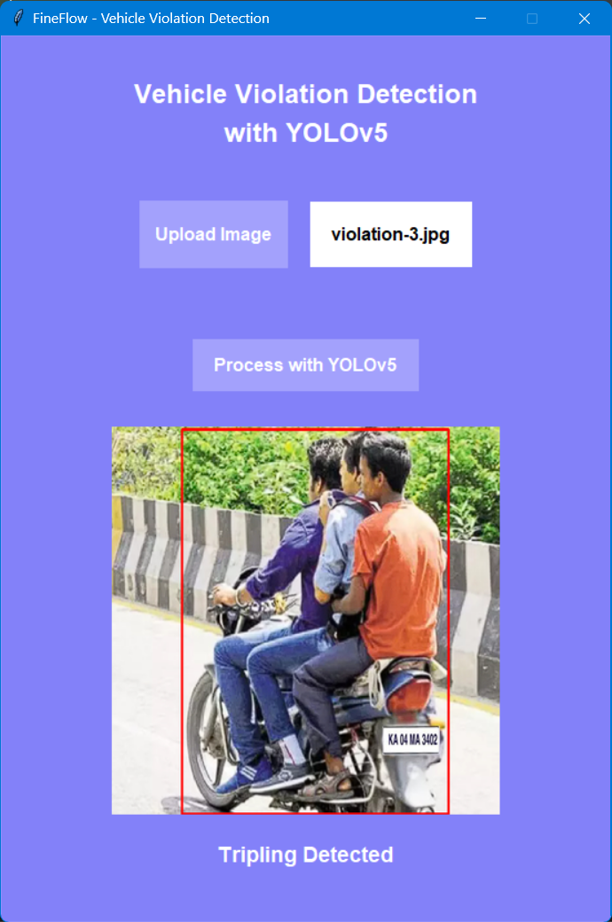

**Figure 2: Tripling Detected**

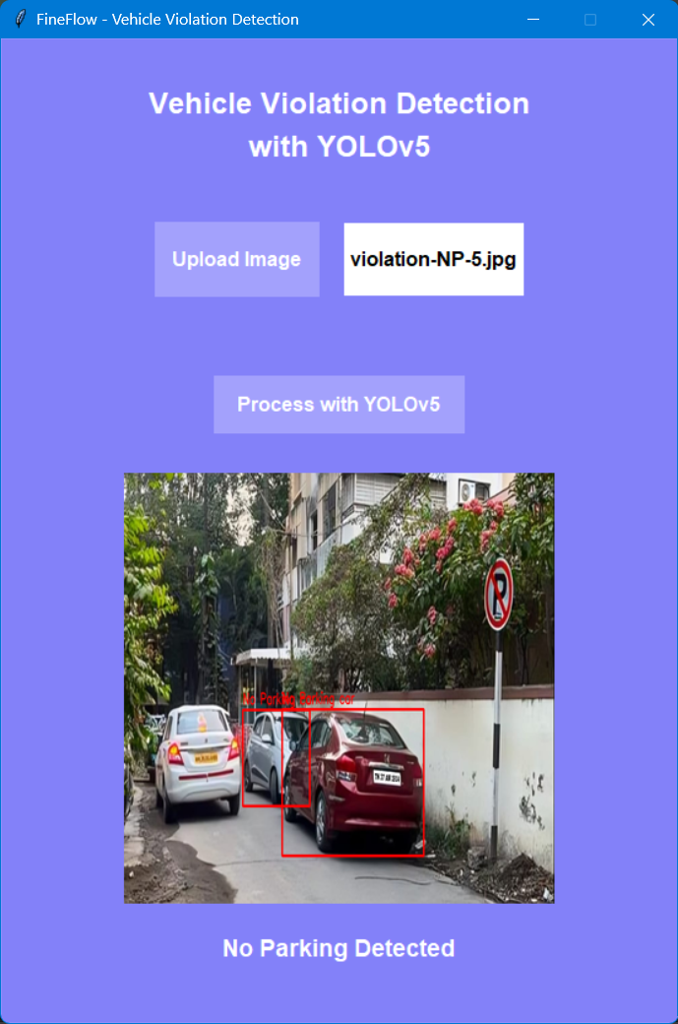

**Figure 2: No Parking Detected**

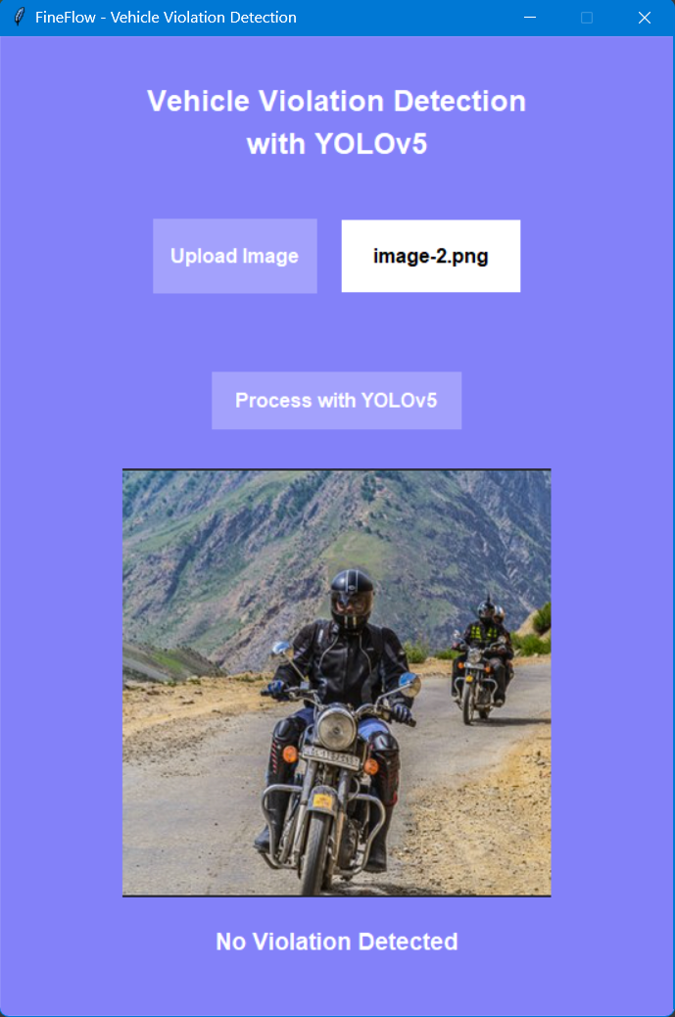

**Figure 4: No Violation Detected**

The vehicle violation detection system interface uses YOLOv5 for live analysis of traffic images and makes an accurate detection of violations like usage of mobile phones while riding, tripling on two-wheelers, and illegal parking. Once a breach is determined, the system outlines the vehicle of concern in a red bounding box and labels the detection as "Mobile Usage Detected", "Tripling Detected", or "No Parking Detected". This automated process allows for accurately recognizing violations which aids law enforcement and road safety management.

The system’s interface is designed to be clear and easy to access. when a violation is detected, the system highlights it with a bounding box and label. When no violations are detected, the image is displayed without bounding boxes and provides the label "No Violation Detected". The integration of an object detection model and the ability to process images magnifies the advantages of traffic monitoring, minimizes human intervention, and provides enhanced fine processing. The structured process increases high accuracy, transparency, and efficiency in traffic law enforcement, therefore promoting improved road safety and better compliance with traffic laws.

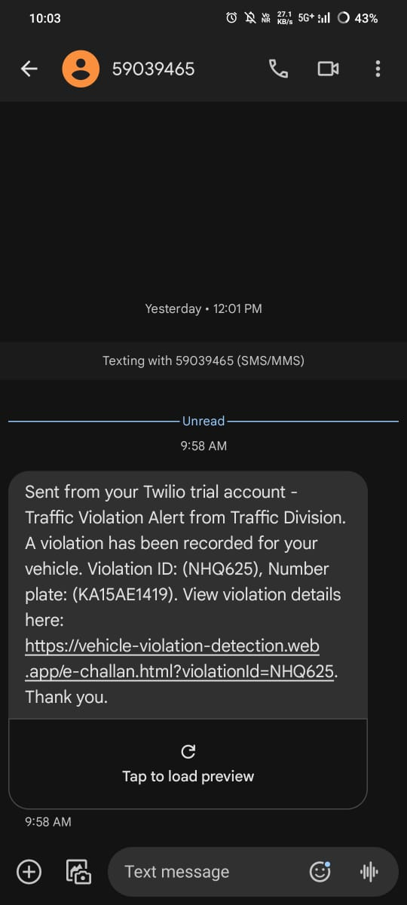

**Figure 5: SMS Notification**

The illustration presents an automated traffic violation alert message transmitted through Twilio API. This message contacts the owner of a vehicle concerning a recorded traffic violation and includes a Violation ID (NHQ625) along with a vehicle number plate (KA15AE1419). Also included in the alert, is a link for the recipient to view more detailed information about the violation information online. This showcases the system's ability to integrate automated detection and SMS notifications for improved efficiency, ultimately supporting more effective traffic law enforcement.

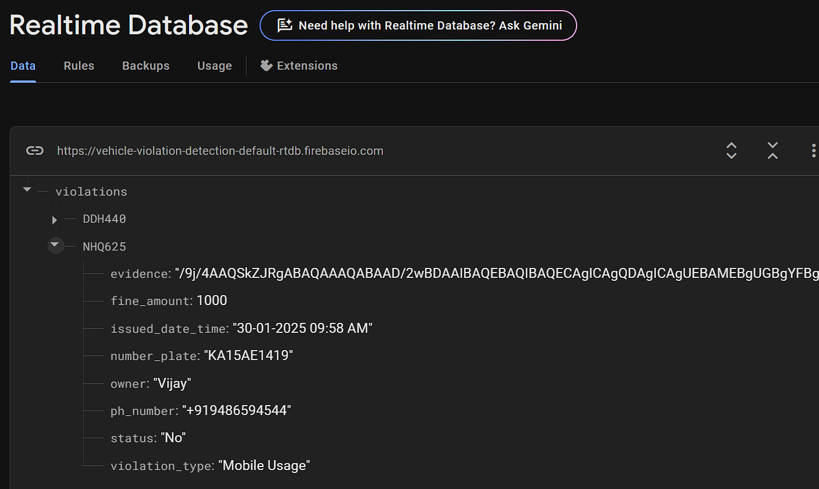

**Figure 6: Violation Record Stored**

The visual illustrates an entry in a Firebase Realtime Database for a traffic infringement. It stores the violation data such as Vehicle Number – KA15AE1419, the Violation type - Mobile Usage, Fine Amount - ₹1000, and the owner details. Additionally, it records the date and the time (30-01-2025, 09:58 AM) in which the incident occurred and an Evidence image. The status node is defined as "No", indicating the fine has not been paid. The automation process of a database that records your traffic violation information will assist in streamlining the process of tracking and managing traffic violations.

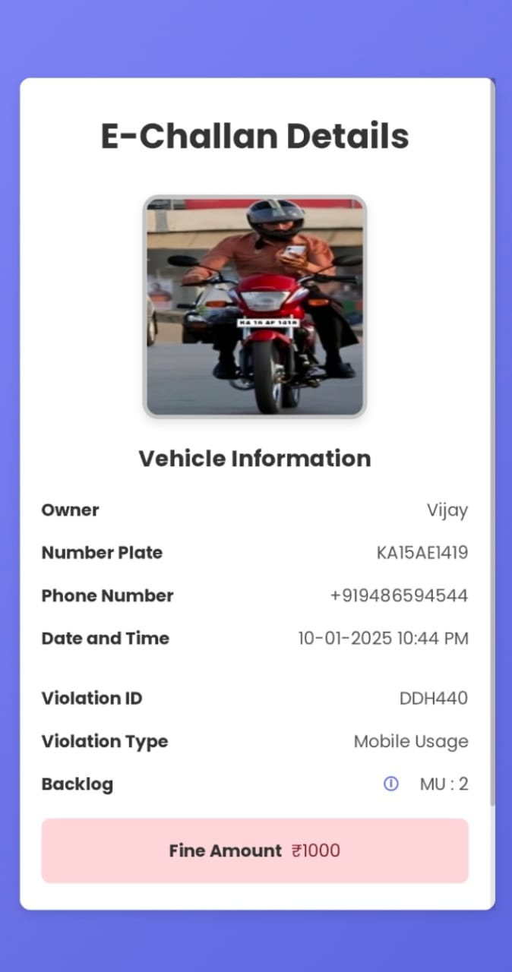

**Figure 7: E-Challan Details**

The image shows an E-Challan Details page about a traffic violation committed by an individual. It includes information related to the violator, such as the owner's name (Vijay), the vehicle registration number (KA15AE1419), and their phone number (+91 9486594544). The violation occurred on the date of 10-01-2025, at the time of 10:44 PM, with a Violation ID of DDH440 for "Mobile Usage" when riding, and further suggests it has tracked history of backlogs for such violations​ (MU: 2). A total fine of ₹1000 is charged, which is displayed on the bottom right prominently. Throughout the screen, information is presented in a clear manner, understandable sequence, with an image of the violation.

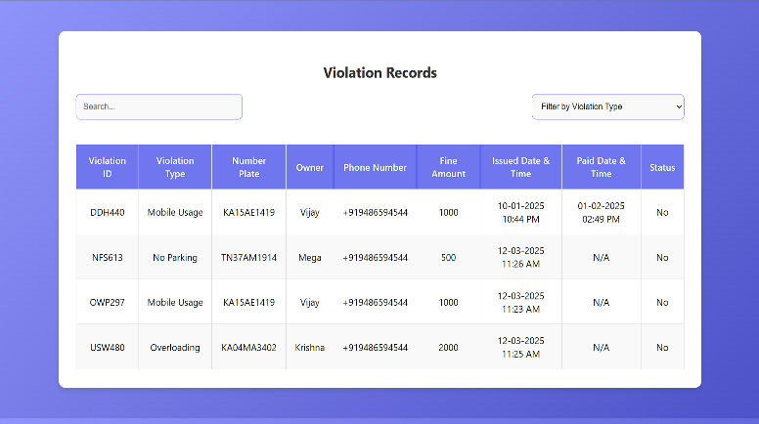

**Figure 8: Violation Records**

The website has a Violation Records table showing traffic violations with Violation ID, Violation Type, Number Plate, Owner Name, Phone Number, Amount (Fine), Date & Time Issued, Date & Time Paid, and Status. The authorities can search for records by using a search bar, and they can filter by violation type using a dropdown menu. The table shows multiple violations, including mobile phone utilization, parking violations, tripling violations, and the payment status of fines.

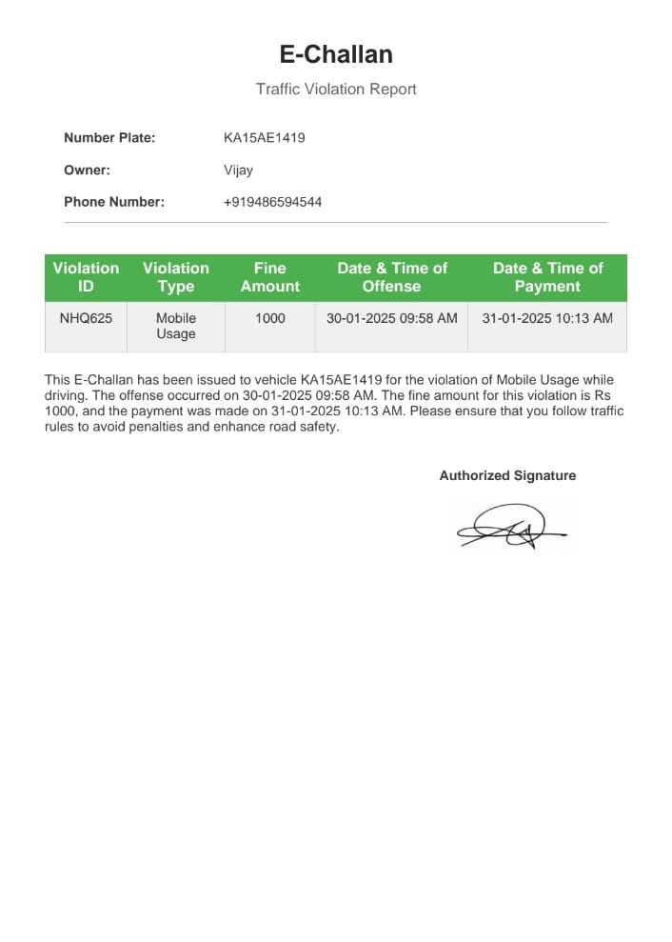

**Figure 9: E-Challan (PDF)**

This E-Challan was issued to vehicle KA15AE1419 registered to the individual named Vijay. The E-Challan records a violation for talking on the mobile phone while driving a motor vehicle on 30-01-2025 at 09:58 AM. A fine of ₹1000 was paid on 31-01-2025 at 10:13 AM. The document serves the purpose of transparency in traffic enforcement and aims to promote compliance. This E-Challan contains a signature from the authority so that the information here is verified.

1. CONCLUSION

The Vehicle Violation Detection and Fine Processing System improves traffic law enforcement by applying AI-based technologies for real-time detection of violations and simplified fine processing. The combination of violation detection through YOLOv5, license plate recognition through EasyOCR, and data management and fine processing through Firebase allows the system to identify traffic violations accurately and efficiently process fines. Vehicle owners receive automated notifications via SMS using Twilio API, advising them of their violation along with instructions for payment, increasing transparency and accountability. The web-based platform streamlines the fine payment system, allowing vehicle owners to deal with their violations easily while giving law enforcement authorities the ability to track and manage traffic offense infractions effectively. It is highlighted within the paper that the system reduces reliance on manual enforcement while offering a scalable, accurate, and efficient solution to ticketing. Future improvements to the system will include real-time organizational capabilities through CCTV integrations for constant monitoring, improved OCR for better recognition in challenging weather conditions, and more options for payment gateways. The advanced technology enhances traffic management, road safety, and compliance with regulations in the public.

1. REFERENCES
2. **J. Franklin and G. Mohana (2020) –** "*Traffic Signal Violation Detection using AI and Deep Learning*" IJARET, vol. 11, no. 12. The researchers used the YOLOv3 object detection model, making it possible to achieve results showing an accuracy of 97.67%.
3. **D. Dede, M. A. Sarsıl, A. Shaker, O. Altıntaş, and O. Ergen** (2023) – "*AI-assisted Mobile Traffic Violation Detection System*" *arXiv:2311.16179*. This research uses YOLOv5 and strongSORT for detecting traffic infractions like red light violations.
4. **J. Smith, K. Patel** (2021) – *"Automated License Plate Recognition using OCR and Deep Learning"*, International Journal of Computer Vision. International Journal of Computer Vision. This article includes OCR methods as EasyOCR which is used in this project to extract text from license plates.
5. **A. Lundh** (2013) – *"An Introduction to Tkinter"*, Pythonware. This reference is used for information on Tkinter, which is the Python GUI library used in the project to create the image upload and result displaying interface.
6. **G. Bradski** (2000) – *"The OpenCV Library"*, Dr. Dobb’s Journal of Software Tools. This paper tells about OpenCV, an open-source computer vision library used in this project for image processing and real-time video analysis.
7. **J. Duckett** (2011) – *"HTML & CSS: Design and Build Websites"*This book provides a introduction to HTML and CSS, covering website structure, layout, and responsive design.
8. **B. Wargo** (2021) – *"JavaScript: The Definitive Guide"*  
   This book shows JavaScript fundamentals, including DOM manipulation, event handling, and API integration for dynamic web applications.
9. **Firebase Documentation** (2023) – *"Cloud Firestore and Realtime Database"*, Google Developers. The documentation contains information about Firebase Realtime Database, which is used for housing violation records and managing user data.
10. **Twilio API Documentation** (2023) – *"Programmable Messaging API"*, Twilio Developers. This reference explains how Twilio API will send SMS notifications to a mobile number.