**A Review on Restaurant Warehouse Management Using Data Analysis**

Prof. Renuka Naukarkar  
Assistant Professor   
Abha Gaikwad Patil college of engineering and Technology

Tisha Bagade

Abha Gaikwad Patil college of engineering and Technology

Suhani Sahu   
Abha Gaikwad Patil college of engineering and Technology

Amisha Patle  
Abha Gaikwad Patil college of engineering and Technology

Yash Mogare  
Abha Gaikwad Patil college of engineering and Technology

Abstract - This study explores the application of data analytics in restaurant warehouse management, leveraging data-driven insights to optimize inventory control, streamline logistics, and enhance overall efficiency. The potential of data analytics to revolutionize restaurant warehouse management, driving business success and sustainability in the competitive food service industry. Restaurant Warehouse Management Systems is one of the key applications in restaurant warehouse that help keep the logistics flow seamless while fulfilling the customer orders as expected. The power of data analytics to transform restaurant warehouse management, driving business success and sustainability in the competitive food service industry. It analyzes menu item popularity and ingredient usage patterns, enhances warehouse operations, and reduces labor costs. This Smart application and increased data availability enable restaurateurs to gather more information about customers and their behavior. These data can be combined with data from other sources to make a wide range of strategic and operational restaurant decisions and can, therefore, generate value for restaurants and their customers.

I. INTRODUCTION

This project aims to develop a data-driven approach to optimize restaurant warehouse management by leveraging data analysis techniques. However, many restaurants struggle with inefficient inventory management, leading to stockouts, overstocking, and reduced customer satisfaction. In the competitive restaurant industry, optimizing warehouse management is crucial for success. Restaurant Warehouse management plays a vital role in ensuring that food and supplies are efficiently stored, tracked, and delivered to meet customer demand. By leveraging data analytics, restaurant managers can gain valuable insights into their warehouse operations, identifying areas for improvement and opportunities for cost savings. With data analytics, restaurants can optimize inventory levels, streamline logistics, and improve supply chain management, ultimately leading to reduced food costs, improved customer satisfaction, and increased profitability.

This is where data analytics comes into play, offering a powerful toolset for restaurant managers to gain insights into their warehouse operations and make data-driven decisions. This enables them to respond quickly to changes in demand, reduce food costs, improve customer satisfaction, and increase profitability. Moreover, data analytics can help restaurants identify opportunities to improve their menu engineering, reduce waste, and optimize their menu offerings to better match customer preferences. Data analytics becomes a strategic asset for restaurant managers, enabling them to transform their warehouse management from a cost center to a competitive advantage. By harnessing the power of data, restaurants can drive business growth, improve operational efficiency, and enhance the overall customer experience. In the following sections, we will explore the applications of data analytics in restaurant warehouse management in more detail, including demand forecasting, inventory optimization, supply chain optimization, and menu costs.

Data analytics offers a game-changing solution by providing restaurant managers with actionable insights and data-driven information. By harnessing the power of data, restaurants can drive business growth, improve operational efficiency, and enhance the overall customer experience. In the following sections, we will explore the applications of data analytics in restaurant warehouse management in more detail, including demand forecasting, inventory optimization, supply chain optimization, and menu costs.

Effective warehouse management is a critical component of the restaurant industry, where seamless operations rely on accurate inventory control, cost optimization, and demand forecasting. With the advent of digital transformation, data analysis has emerged as a powerful tool to address the complexities associated with warehouse management. By leveraging data-driven insights, restaurant businesses can enhance decision-making processes, minimize waste, reduce costs, and ensure uninterrupted supply chain operations.

This research project focuses on the implementation of data analysis techniques in restaurant warehouse management to achieve operational efficiency. The study examines how data-driven strategies, such as predictive analytics, inventory optimization, and real-time monitoring, can improve inventory turnover, reduce the risk of stockouts or overstocking, and maintain consistent quality standards. Furthermore, the project explores the integration of modern technologies like machine learning algorithms and data visualization tools to streamline warehouse processes and generate actionable insights.

The overarching aim of this research is to provide a comprehensive framework for utilizing data analysis in warehouse management to address the challenges of perishable inventory, fluctuating demand, and supply chain disruptions in the restaurant industry. By showcasing the benefits and implications of data analytics, the study contributes to the growing body of knowledge in data-driven supply chain management while offering practical solutions for restaurant businesses seeking to enhance their operational performance.

The restaurant industry operates in a dynamic and competitive environment, requiring seamless coordination of multiple components to ensure customer satisfaction and profitability. One of the critical elements of operational success lies in effective warehouse management. Restaurant warehouses are tasked with the responsibility of storing a diverse range of perishable and non-perishable items, ensuring their timely replenishment, and delivering materials efficiently to support kitchen operations. However, the challenges associated with warehouse management, including inventory control, demand fluctuation, supply chain disruptions, and cost optimization, make it a highly complex task.

In recent years, data analysis has emerged as a transformative approach to addressing these challenges and enhancing warehouse efficiency in the restaurant industry. By leveraging data analytics, restaurant managers can gain actionable insights into inventory trends, supplier performance, and customer demand patterns. This allows them to make informed, data-driven decisions that minimize waste, reduce operational costs, and improve overall service quality.

The implementation of data analytics in warehouse management is multifaceted, encompassing predictive analytics, inventory optimization, and real-time monitoring. Predictive analytics enables restaurants to forecast demand accurately, ensuring that inventory levels align with customer preferences and seasonal variations. Inventory optimization techniques help in maintaining the delicate balance between avoiding stockouts and minimizing overstock, thereby reducing costs associated with excess inventory. Real-time monitoring and data visualization tools provide instant insights into warehouse operations, enabling swift responses to discrepancies or inefficiencies. Despite the demonstrated benefits of data analytics in warehouse management, there remains a gap in research on comprehensive frameworks that integrate various data-driven methodologies to address the specific needs of restaurant warehouses. Existing studies have focused on isolated aspects of warehouse optimization, such as inventory control or demand forecasting, without exploring their interplay in a cohesive system. This research aims to bridge this gap by developing a holistic data analysis framework tailored to the unique requirements of restaurant warehouse management.

II. LITERATURE REVIEW

The importance of effective warehouse management in the restaurant industry, according to a study by Kumar et al. (2022), is that restaurant warehouses play a critical role in ensuring that food and supplies are stored and delivered efficiently to meet customer demand. However, optimizing warehouse operations can be a complex challenge, requiring careful planning, coordination, and decision-making. This is where data analytics comes into play, offering a powerful toolset for restaurant managers to gain insights into their warehouse operations and make data-driven decisions. Research by Singh et al. (2020) has shown that data analytics can be used to optimize inventory levels, streamline logistics, and improve supply chain management in restaurant warehouses. By analyzing data on inventory levels, demand patterns, and supplier performance, restaurants can reduce food costs, improve customer satisfaction, and increase profitability. Moreover, data analytics can help restaurants identify opportunities to improve their menu costs, reduce waste, and optimize their menu offerings to better match customer preferences.

Our purpose to effective warehouse management is crucial for restaurants to maintain profitability and customer satisfaction. Research has highlighted the importance of data-driven approaches in optimizing inventory management. However, there is a gap in research on comprehensive data-driven approaches to restaurant warehouse management, integrating demand forecasting, inventory optimization, and data visualization. This project aims to address this gap by developing a holistic data analysis framework for restaurant warehouse management. A study by Choi et al. (2019) found that data analytics could also be used to improve labor productivity in restaurant warehouses. By analyzing data on labor hours, tasks, and workflows, restaurants can identify areas for improvement and optimize their labor resources. Additionally, data analytics can help restaurants improve their order accuracy rates and enhance the overall customer experience.

III. METHODOLOGY

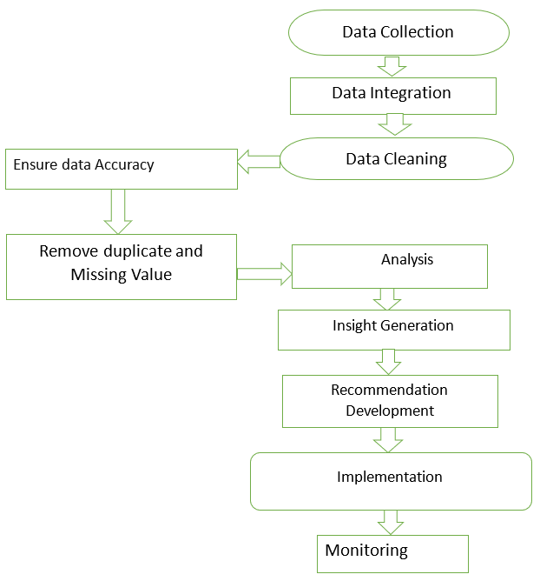

*A. Data Collection:*

The study begins with the collection of data from various sources, including historical inventory records, supplier logs, sales trends, and demand forecasts. Additional data, such as seasonal variations, customer preferences, and market conditions, are also gathered to provide a comprehensive dataset for analysis. This step ensures that all relevant information needed for effective warehouse management is accounted for.

*B. Data Integration:*

The collected data, which may come from multiple sources, is integrated into a unified database. This integration process ensures that the data is consistent and can be analyzed holistically. Tools and technologies such as data warehouses or cloud-based solutions are used to centralize the information.

*C. Data Cleaning and Validation:*

Before analysis, the data undergoes cleaning to address inconsistencies, errors, missing values, and duplicates. Validation techniques are employed to ensure the accuracy and reliability of the dataset. This step is crucial for maintaining the integrity of the analysis and deriving actionable insights.

*D. Data Analysis:*

In this step, advanced analytical techniques are applied to extract meaningful insights. Predictive analytics is used to forecast demand patterns, while inventory optimization algorithms identify optimal stock levels. Data visualization tools are employed to create dashboards that provide real-time updates on warehouse operations.

*E. Insight Generation and Recommendations:*

Based on the data analysis, insights are generated to address key areas such as inventory turnover, supplier performance, and demand fluctuations. Recommendations are developed to minimize waste, improve stock accuracy, and optimize labor productivity. For instance, by analyzing labor tasks and workflows, inefficiencies can be identified and corrected.

*F. Implementation of Recommendations:*

The generated recommendations are implemented in the restaurant warehouse operations. This could include adjusting inventory levels, adopting new supplier strategies, or using technology for real-time monitoring. Implementation strategies are tailored to ensure minimal disruption to ongoing operations.

*G. Monitoring and Evaluation:*

Once implemented, the outcomes of the recommendations are continuously monitored to evaluate their effectiveness. Metrics such as inventory costs, waste reduction, and order accuracy rates are tracked to assess improvements in efficiency. This feedback loop enables further refinements and ensures sustained operational excellence.

IV. CONCLUSION

The Restaurant Warehouse Management System (RWMS) project has successfully demonstrated the potential of data analysis in improving inventory management, supply chain visibility, and ordering and replenishment processes. Key accomplishments include:

A. Improved inventory turnover rate

B. Reduced stockout frequency

The RWMS project has provided valuable insights into the benefits of data-driven decision-making in restaurant warehouse management.

*Work on:*

Short-term (6-12 months):

Integrate predictive analytics for demand forecasting. Develop a mobile app for warehouse staff.

Mid-term (1-2 years):

Develop machine learning models for automated inventory optimization. Conduct regular data quality audits.

Long-term (2-5 years):

Develop a cloud-based RWMS platform. Integrate with third-party logistics providers. Explore augmented reality (AR) for warehouse navigation.

REFERENCES

1. Omkar Pasalkar. “Provide real-time insights for data-driven decision-making” in an Integrated Restaurant Management System [IRJMETS], 2024.
2. Methraskar Swapna. “Inventory orders and employee scheduling” in a refereed journal [JETIR], 2024.
3. Lee, H., & Kim, J. "Integrating Blockchain Technology for Enhanced Security in Restaurant Management Systems." Information Systems Security. [IRJMETS], 2023.
4. M. Faizan Khandwani. “Allows customers to easily select their desired items and track their orders”. [IRJMETS], 2023.
5. Akash Gill discusses the role of real-time data integration in inventory management through POS systems (IJCEM, 2021).
6. Martinez, G., et al. "Adoption and Implementation of Cloud-Based Solutions in Restaurant Management: A Comparative Analysis." International Journal of Hospitality & Tourism Administration. [IRJMETS], 2021.
7. De Koster and Balk highlight warehouse benchmarking and monitoring practices in Europe (IRJMETS, 2023).
8. Wijaya, N. K. B. Zainal and K. S. B. Harun, "Restaurant Enterprise Resources Plannings in the System," 2022 IEEE 2nd International Conference on Mobiles Networks and Wireless systems Communications (ICMNWC), Tumkur, Karnataka, India. (2023) [IEEE]
9. Chen, Gong, De Koster, and Van Nunen propose a flexible framework for evaluating order-picking systems (IEEE, 2021).
10. V. Liyanage, A. Ekanayake, H. Premasiri, P. Munasinghe and S. Thelijjagoda, "Foody - Smart Restaurant Management and Ordering System," 2018 IEEE Region 10 Humanitarian Industrial Technology Conference, Malambe, Sri Lanka. (2023) [IEEE].
11. Shina et al. studied tree-based ML methods for

restaurant reviews (ICCCA, 2018).

.