**BUTTERFLY COUNTING OF FIVE DIFFERENT FAMILIES IN THE SELECTED AREA IN VISUVASAMPATTI,UTHANGARAI,KRISHNAGIRI,TAMILNADU**

**S.Sathiyavathi **and V.Hemalatha\***

**P G Research Department of Zoology, Adhiyaman Arts and Science College for Women, Krishnagiri, Tamilnadu**

**\*\*Asssitant Professor and *PG Student**

**\*\* Corresponding Auther-sathyaselvaraj.able@gmail.com**

**Abstract**

Butterflies are the lepidopteran indicates the climatic changes in the basic manner. Tamilnadu is having represents an huge number of butterflies, spotted in various seasons through out the year, Increase and decrease in the butterfly population show the present conditions of the current environment, diversity of butterflies in terms of species richness and abundance in relation to different habitats and seasons. Lepidoptera are beneficial as pollinators, silk producers, indicators of environmental quality and are appreciated for aesthetic value. In the study nearly 5 species Papilionidae, Peridae Nymphalidae Hesperidae and Lycaenidae were carried out for six months from Sep 2024- Feb 2025. . Butterflies were the healthy indicators of the ecosystem because they have been serves as an major pollinators and essential need for the agriculture. Due to urbanization, pollution and over grazing, we are losing the certain species of the butterflies

**Keywords**: Butterfly, Climatic changes, Environment

**INTRODUCTION**

Butterfly research and counting in Tamil Nadu have revealed a diverse range of species. According to recent studies, there are approximately 329 species of butterflies expected to be found in Tamil Nadu.Some tropical butterflies show changes in species composition in response to selective logging (Hamer et al.,2003)that would be unlikely to affect ungulates or carnivores to the same degree.Therefore,the current study was conducted to see the diversity of butterflies in terms of species richness and abundance in relation to different habitats and seasons at Gulele Botanical Garden.Anthropogenic environment stresses such as rising human land use and global climate change are altering natural ecosystems. Urbanization is perhaps the most major anthropogenic modifier globally,with a significant fraction of the world’s rural inhabitants migrating to large and small urban agglomerations (Nagendra et al.,2001).

Rapid ecological changes threaten local and regional biodiversity (De Caceres et al.,2010),requiring the establishment of a monitoring system to address diverse environmental challenges. In the rainy season June-September,more species are directly correlated with the increased relative abundance of species assemblage. In contrast, the species richness remained the same in the summer and winter,but the relative abundance varied between seasons

Lepidoptera are beneficial as pollinators, silk producers, indicators of environmental quality and are appreciated for aesthetic value. Butterflies and moth (order Lepidoptera)offer good opportunities for studies on population and community ecology (Pollard,1991) Butterflies,widely appreciated for their aesthetic value and flagship taxa in biodiversity inventors.Butterflies are among the most easily recognizable of all animals.They are instantly familiar and universally popular. Their wings, unlike those of most other insects, are colourful, opaque and are of characteristic shape.The development of colour the range, diversity, brilliance and kaleidoscopic assortment of patterns exhibited by butterflies is unrivalled anywhere in the animal’s kingdom, except possibly by the birds. Butterflies are typically active during the day and because they are so skilled in flight they have achieved an almost world-wide distribution, though as with most animal groups. Many butterflies occupy vast ranges, covering parts of Europe, Africa,Asia and Australia.As part of their adaptation to survive in the varied environments they inhabit, one often finds that the same butterfly species looks quite in different parts of its range(Mathew,2001).

**MATERIALS AND METHODS**

**Study area**

In the study five species Papilionidae, Peridae Nymphalidae Hesperidae and Lycaenidae were carried out for six months from sep 2024- Feb2025. In Papilionidae - Indra swallow tail (Papilo indra), Crimson rose – (Papilopta hector). In pieridae common emigrant (catopsilia Pomona), mottled emigrant (catopsilia pyranthae), White orange tip( Ixias marianne) and common jezebel (Delias ecuharis). In Nymphalidae Plain tiger( Danus chirysippus), Danaid eggfly(Hypolimnas missippus),Glassytiger (Parantica aglea), Stripped tiger (Danus genutia),Common Indian crow ( Euploea core), Lemon pansy(Junonia lemonias), Common nawab(Polyura athamas),Lemon pansy (Junonia lemonias). Among the study the Nymphalidae family is dominant and 10 species have been monitored through the study period were else only 5 in the Papilionidae and 6 in the pieridae species Hesperidae family is 5 only and Lycaenidae family species 4 only monitored. Butterflies were the healthy indicators of the ecosystem because they have been serves as an major pollinators and essential need for the agriculture. Due to urbanization, pollution and over grazing, we are losing the certain species of the butterflies

**Counting method: Pollard walk method**

**BUTTERFLY SPECIES COUNT :**

**TABLE 1**

|  |  |  |  |  |  |  |
| --- | --- | --- | --- | --- | --- | --- |
| **FAMILIES** | **SEP** | **OCT** | **NOV** | **DEC** | **JAN** | **FEB** |
| NYMPHALIDAE | **12** | **12** | **12** | **10** | **9** | **8** |
| PIERIDAE | **11** | **11** | **10** | **9** | **8** | **7** |
| PAPILIONIDAE | **10** | **10** | **9** | **9** | **7** | **6** |
| HESPERIDAE | **9** | **9** | **8** | **7** | **6** | **5** |
| LYCAENIDAE | **8** | **8** | **7** | **7** | **6** | **4** |

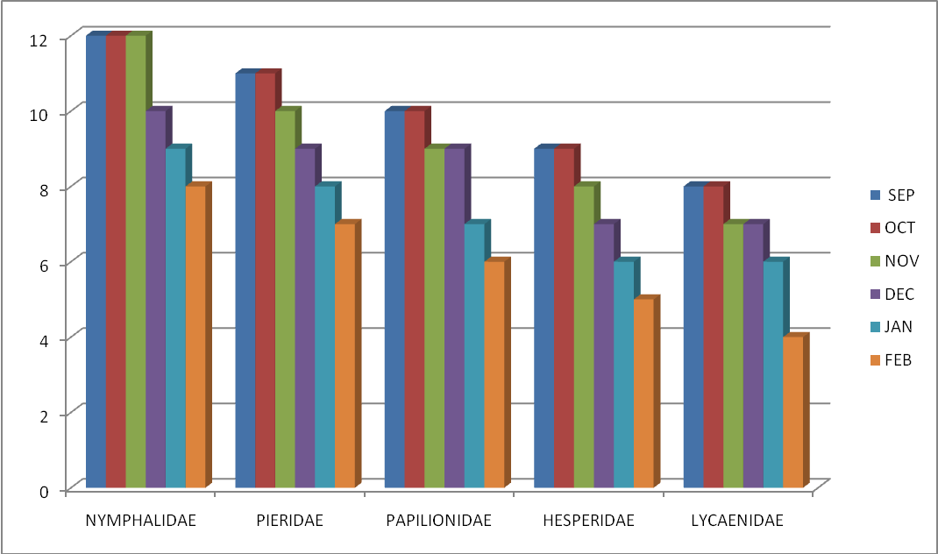

**NYMPHALIDAE FAMILY RESULT:**

**TABLE:2**

|  |  |  |  |  |  |  |  |
| --- | --- | --- | --- | --- | --- | --- | --- |
| **SPECIES** | **SEP** | **OCT** | **NOV** | **DEC** | **JAN** | **FEB** | **TOTAL** |
| BLACKRAJA | 9 | 9 | 8 | 7 | 6 | _ | 39 |
| COMMON NAWAB | 7 | 7 | 6 | 6 | 5 | _ | 31 |
| DANAID EGGFLY | 15 | 15 | 10 | 9 | 8 | 7 | 64 |
| BUSH BROWN | 9 | 9 | 8 | 8 | 7 | 6 | 47 |
| COMMON CROW | 10 | 9 | 9 | 8 | 7 | _ | 43 |
| GLASSY TIGER | 12 | 9 | 8 | 8 | 7 | 5 | 49 |
| LEMON PANSY | 13 | 13 | 12 | 9 | 7 | 6 | 60 |
| PLAIN TIGER | 16 | 12 | 10 | 9 | 9 | 8 | 64 |
| TAWNY COSTER | 15 | 14 | 13 | 12 | 9 | 7 | 70 |
| STRIPED TIGER | 13 | 12 | 10 | 9 | 8 | 6 | 58 |
| **TOTAL** | **119** | **100** | **94** | **85** | **73** | **45** | **516** |

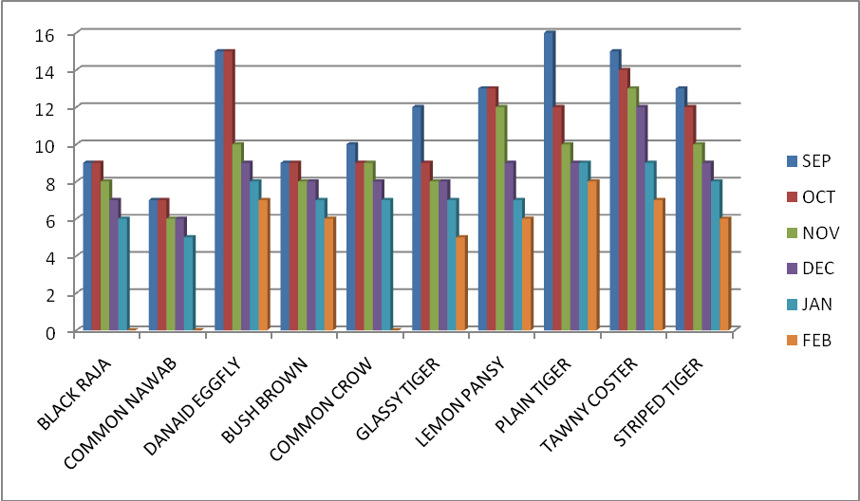

**NYMPHALIDAE MONTHS COMPARISON :**

**TABLE:3**

|  |  |
| --- | --- |
| **MONTH** | **BUTTERFLY COUNT** |
| SEPTEMBER | 119 |
| OCTOBER | 100 |
| NOVEMBER | 94 |
| DECEMBER | 85 |
| JANUARY | 73 |
| FEBUARY | 45 |
| **TOTAL** | **516** |

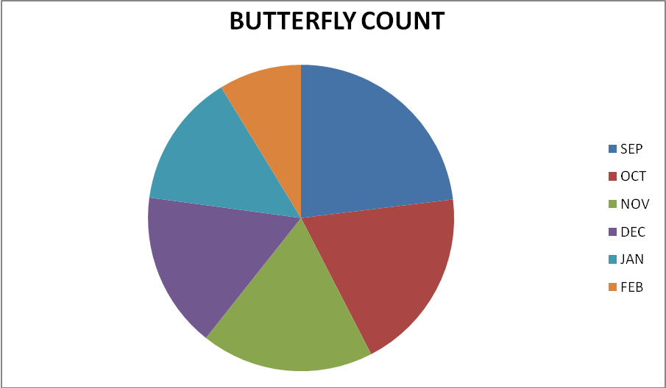

**PIERIDAE FAMILY RESULT :**

**TABLE :4**

|  |  |  |  |  |  |  |  |
| --- | --- | --- | --- | --- | --- | --- | --- |
| **SPECIES** | **SEP** | **OCT** | **NOV** | **DEC** | **JAN** | **FEB** | **TOTAL** |
| WHITE ORANGE TIP | **13** | **9** | **8** | 7 | 5 | - | **42** |
| COMMON JEZEBEL | **10** | **8** | **8** | 7 | 3 | 2 | **38** |
| COMMON GULL | **9** | **7** | **7** | 5 | 4 | - | **32** |
| MOTTLED EMIGRANT | **11** | **9** | **7** | 6 | 5 | 4 | **42** |
| PSYCHE | **10** | **9** | **9** | **8** | **7** | **-** | **43** |
| COMMON EMIGRANT | **8** | **8** | **7** | **7** | **6** | **5** | **41** |
| **TOTAL** | **61** | **50** | **46** | **40** | **30** | **11** | **238** |

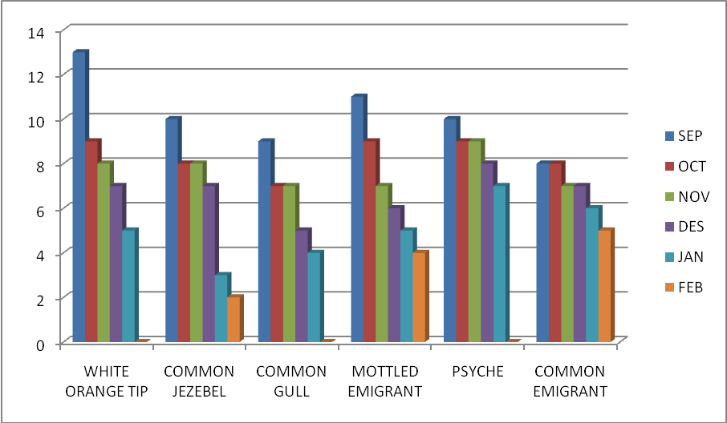

**PIERIDAE MONTH COMPARISON:**

**TABLE:5**

|  |  |
| --- | --- |
| **MONTH** | **BUTTERFLY COUNT** |
| SEPTEMBER | 61 |
| OCTOBER | 50 |
| NOVEMBER | 46 |
| DECEMBER | 40 |
| JANUARY | 30 |
| FEBUARY | **11** |
| **TOTAL** | **238** |

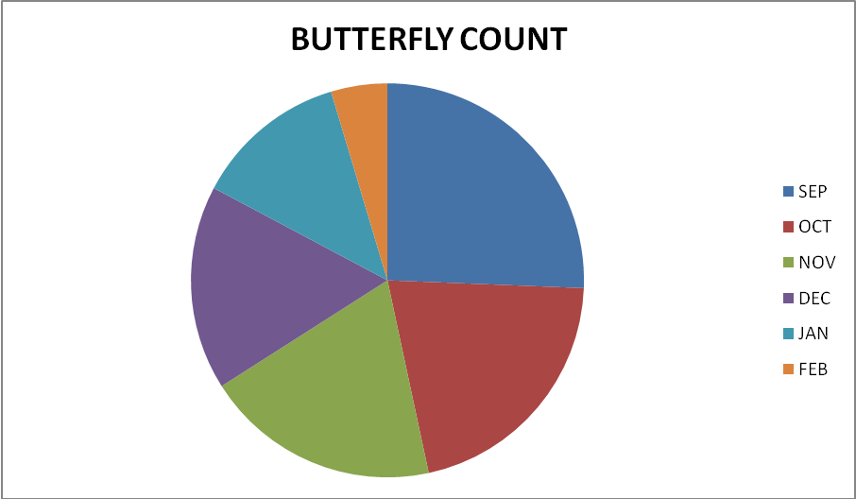

**PAPILIONIDAE FAMILY RESULT :**

**TABLE:6**

|  |  |  |  |  |  |  |  |
| --- | --- | --- | --- | --- | --- | --- | --- |
| **SPECIES** | **SEP** | **OCT** | **NOV** | **DEC** | **JAN** | **FEB** | **TOTAL** |
| INDRA SWALLOW TAIL | 9 | 8 | 8 | 6 | 5 | 2 | 38 |
| CRIMSON ROSE | 11 | 10 | 8 | 7 | 7 | 6 | 49 |
| BLUE MORMON | 10 | 7 | 7 | 6 | 5 | - | 35 |
| LIME BUTTERFLY | 12 | 10 | 9 | 7 | 5 | - | 43 |
| COMMON MORMON | 8 | 7 | 6 | 5 | 4 | - | 30 |
| **TOTAL** | **50** | **42** | **38** | **31** | **26** | **8** | **195** |

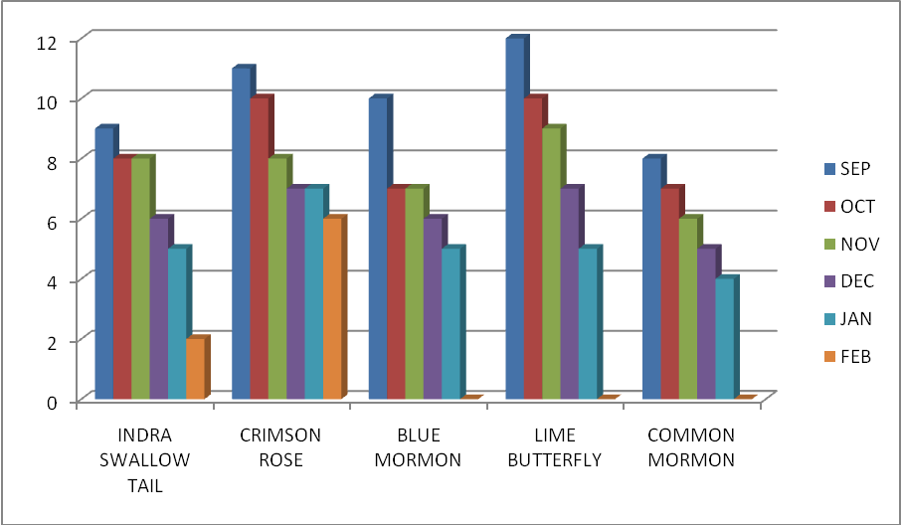

**COMPARISON**:

**TABLE:7**

|  |  |
| --- | --- |
| **MONTH** | **BUTTERFLY COUNT** |
| SEPTEMBER | 50 |
| OCTOBER | 42 |
| NOVEMBER | 38 |
| DECMBER | 31 |
| JANUARY | 26 |
| FEBUARY | 8 |
| **TOTAL** | **195** |

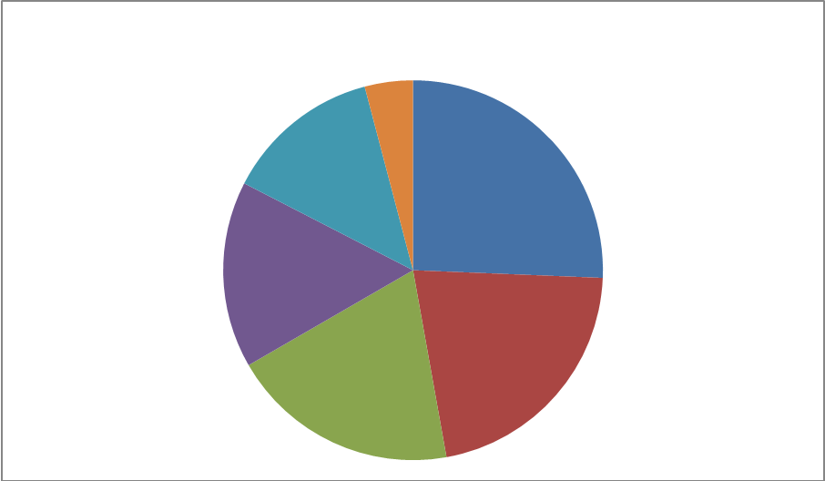

**HESPIERIDAE FAMILY RESULT :**

**TABLE:8**

|  |  |  |  |  |  |  |  |
| --- | --- | --- | --- | --- | --- | --- | --- |
| **SPECIES** | **SEP** | **OCT** | **NOV** | **DEC** | **JAN** | **FEB** | **TOTAL** |
| INDIAN PALM BOB | 13 | 10 | 8 | 7 | 5 | 2 | 45 |
| SMALLER DARTLET | 10 | 8 | 7 | 7 | 6 | 5 | 43 |
| CHEST NUT BOB | 9 | 5 | 4 | - | - | - | 18 |
| BUSH HOPPER | 7 | 5 | 3 | 2 | 2 | 1 | 20 |
| GRASS DART | 6 | 5 | 4 | 2 | - | - | 17 |
| **TOTAL** | **45** | **33** | **26** | **18** | **13** | **8** | **143** |

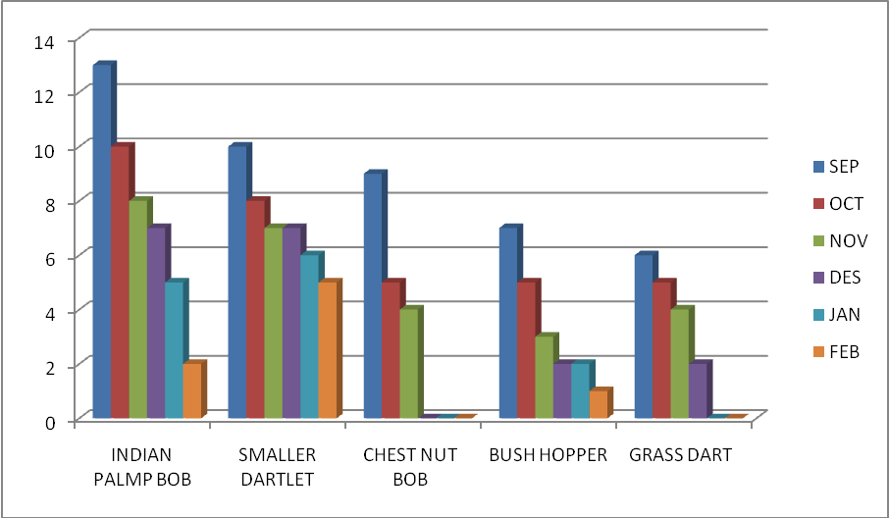

**HESPERIDAE MONTHS COMPARISON:**

**TABLE:9**

|  |  |
| --- | --- |
| **MONTH** | **BUTTERFLY COUNT** |
| SEPTEMBER | **45** |
| OCTOBER | **33** |
| NOVEMBER | **46** |
| DECEMBER | **18** |
| JANUARY | **13** |
| FEBUARY | **8** |
| **TOTAL** | **143** |

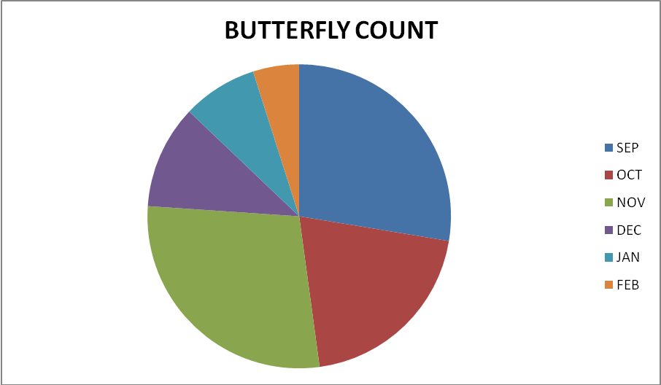

**LYCAENIDAE FAMILY RESULT:**

TABLE:10

|  |  |  |  |  |  |  |  |
| --- | --- | --- | --- | --- | --- | --- | --- |
| **SPECIES** | **SEP** | **OCT** | **NOV** | **DEC** | **JAN** | **FEB** | **TOTAL** |
| COMMON GUAVA BLUE | 11 | 10 | 9 | 7 | 5 | 5 | 47 |
| PEACOCK ROYAL | 8 | 7 | 7 | 6 | 3 | - | 31 |
| TINY GRASS BLUE | 10 | 9 | 9 | 7 | 5 | 3 | 43 |
| PIERROT | 13 | 9 | 8 | 7 | 4 | - | 41 |
| **TOTAL** | **42** | **35** | **33** | **27** | **17** | **8** | **162** |

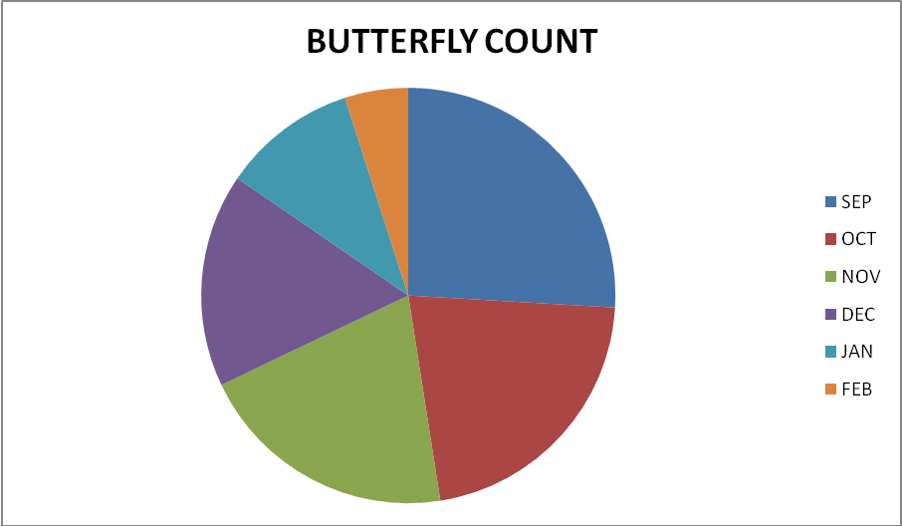

**LYCAENIDAE MONTHS RESULT:**

**TABLE:11**

|  |  |
| --- | --- |
| **MONTH** | **BUTTERFLY COUNT** |
| SEPTEMBER | 42 |
| OCTOBER | 35 |
| NOVEMBER | 33 |
| DECEMBER | 27 |
| JANUARY | 17 |
| FEBUARY | 8 |
| **TOTAL** | **162** |



**RESULT**

In our elaborate survey had been conducted in for our data collection and butterfly observation 1254 butterflies studied and recorded grouped in 5 category of different families such as, Nymphalidae, Pieridae, Papilionidae, Hesperidae, Lycaenidae. In our study a number of 30 species were recorded, among the five various family species Nymphalidae-10, Pieridae-6, Papilionidae-5, Hesperidae-5, Lycaenidae-4

**DISCUSSION**

The sustainable season for the butterfly appearance is rainfall and spring season. Hence we conducted in the study in month of September to February, the more butterflies occurs in September that is starting of spring.The diversity of butterfly is very high compare than other species.Season-wise diversity indicate that the diversity of butterfly was high during the post monsoon(August to October) and less during monsoon.Maximum number of diversity indicates the evenness was showed in the paddy fields, millet and various flower plants. The least number of evenness shown in the sugarcane field.

In our study, correlation of where is butterfly population and weather parameters indicated that the butterfly population was positively significance with rainfall and relatively humidity (spring) while negatively correlated with maximum temperature (summer) minimum temperature (winter).Pollution is the main source which reduce the occurrence of butterfly.With the host plant- butterfly appears more in a particular season. Climatic condition a vital role in the occurrence of butterflies.In the life cycle of the butterfly it should undergo egg, larva, pupa, adult is depends upon the environmental stability Lepitoptera were the best group of insects for examining the pattern and distribution of terrestrial biotic diversity(Robbins and Opler, 1997). They are highly sensitive to changes in temperature, humidity, light level and typically affected by habitat disturbance and also species variation in accordance to its micro climatic conditions (Das and Parida,2015)

**REFERENCE**

1.De Caceres, M., Legendre, P. and Moretti, M.2010. Improving indicator species analysis by combining groups of sites. Oikos,119,1674-1684.

2. Nagendra, H., Nagendra, S., Paul, S.and Pareeth, S.2001 Graying,greening and fragmentation in the rapidly expanding Indian city of Bangalore. Landscape Urban Plan.,105,400-406.

3. Mathew, G. (2001). Conservation of Invertebrates through Captive Breeding: A study With Reference to Butterflies. KFRI Research Report No.220:210.

4.Pollard, E. (1991). Monitoring Butterfly Number in Monitoring for Conservation and Ecology(ed.). F.B.Goldsmith (London;Chapman and Hall);87

5. Hamer, K.C., Hill,J. K., Benedick, S., Mustaffa, N., Sherratt, T.N., Maryati, M.& Chey, V.K.(2003). Ecology of butterflies in natural and selectively logged forestsbof northern Borneo: the importance of habitat heterogeneity.J. Appl.Ecol.40:150-162

6. Robbins R.K.,Opler P.A.,1997. Butterfly diversity and a preliminary comparison with bird and mammal diversity. In: Biodiversity II, understanding and protecting our biological resource Wilson,D,E., Reaka Kudlam M.L., Wilson E.O.,(Eds.).Joseph Henry Press, Washington.

7. Das J., Parida S.P.,2015. Preliminary study of butterfly species variation in FRL campus in accordance to its micro-climatic condition. Current Life Science,1(3),112-117