# **HEALTHAXIS: DOCTOR-PATIENT INTERACTION**

Venkatesan G, Sowndharya M

Student, Assistant Professor

Dr.N.G.P Arts and Science College, Kalapatti Road, Coimbatore, Tamilnadu. -641048

Email –venkatesan2190@gmail.com@gmail.com, sowndharya.m@drngpasc.ac.in

**Abstract**

Healthcare accessibility and efficiency remain significant challenges in the modern world. *HealthAxis* is a web-based platform designed to bridge the gap between doctors and patients by offering secure, real-time communication, digital medical records, and AI-driven healthcare recommendations. The platform streamlines appointment scheduling, teleconsultations, and digital prescriptions, ensuring a seamless and efficient user experience. It provides secure storage and easy access to medical records through a cloud-based infrastructure, minimizing errors and enhancing patient care.

Developed with a user-friendly interface, *HealthAxis* ensures accessibility for both patients and healthcare providers. Its scalable infrastructure supports increasing user demand while maintaining smooth operations. Key features include secure video consultations, real-time chat, role-based access control, and cloud-based data management. By leveraging modern technologies, *HealthAxis* aims to revolutionize doctor-patient interactions, making healthcare services more efficient, accessible, and reliable. This paper explores the system’s design, implementation, and future enhancements.

**1. Introduction**

Healthcare systems worldwide are often burdened by inefficiencies, including manual record-keeping, fragmented communication, and security vulnerabilities. Traditional hospital management relies heavily on paperwork, leading to errors, delays, and operational inefficiencies. Digital transformation in healthcare is crucial for streamlining workflows, ensuring data security, and enhancing doctor-patient communication.

*HealthAxis* is a web-based healthcare management system that addresses these challenges by integrating digital medical records, real-time appointment scheduling, automated billing, and AI-powered recommendations. The platform aims to improve patient management, optimize hospital administration, and provide seamless healthcare experiences.

**1.1 Objectives**

The primary objectives of *HealthAxis* are:

* **Improve Patient Management:** Ensure seamless patient registration, record-keeping, and profile management.
* **Enhance Appointment Scheduling:** Facilitate real-time scheduling and teleconsultation.
* **Optimize Billing and Payments:** Implement automated billing with secure online payment gateways.
* **Strengthen Data Security:** Employ encryption and authentication mechanisms for secure data handling.
* **Facilitate Pharmacy Management:** Enable digital prescriptions and inventory tracking.
* **Enable Doctor-Patient Collaboration:** Provide secure chat, video consultation, and digital reports.

**2. Literature Review**

Several existing hospital management systems digitize healthcare administration, but they often lack scalability, security, or real-time communication features. Some research highlights the importance of AI-driven healthcare systems for improved diagnostics and patient outcomes. Other studies emphasize the role of cloud computing in ensuring seamless data access. Unlike conventional hospital management systems, *HealthAxis* integrates real-time doctor-patient interaction, AI-driven healthcare recommendations, and secure cloud-based data management, addressing the shortcomings of existing solutions.

**3. System Architecture and Design**

**3.1 System Study**

**Existing System Challenges**

* **Manual record-keeping** leads to errors and inefficiencies.
* **Paper-based appointment booking** causes delays and mismanagement.
* **Billing complexities** result in financial discrepancies.
* **Security vulnerabilities** expose sensitive patient data.
* **Communication gaps** between departments reduce operational efficiency.

**Proposed System Features**

* **Secure, real-time doctor-patient communication** via chat and video.
* **Digital medical records** accessible to authorized users.
* **AI-driven appointment recommendations** based on patient history.
* **User-friendly web and mobile interface** for ease of use.
* **Enhanced security protocols** with encryption and authentication.
* **Scalable cloud infrastructure** for high availability and performance.

**3.2 System Configuration**

**Hardware Requirements**

* Processor: 2.00 GHz or faster
* RAM: 2GB
* Hard Disk: 4GB minimum
* Display: 1028x720 resolution or higher

**Software Requirements**

* Operating System: Windows 8 or later
* Database: MySQL
* Backend: PHP
* Frontend: HTML, CSS, Bootstrap, JavaScript
* Web Server: XAMPP
* Supported Browsers: Chrome, Firefox, Edge

**4. Implementation and Module Description**

**4.1 Key Modules**

**User Authentication & Role-Based Access**

* Secure login for patients, doctors, and administrators.
* Multi-factor authentication to prevent unauthorized access.

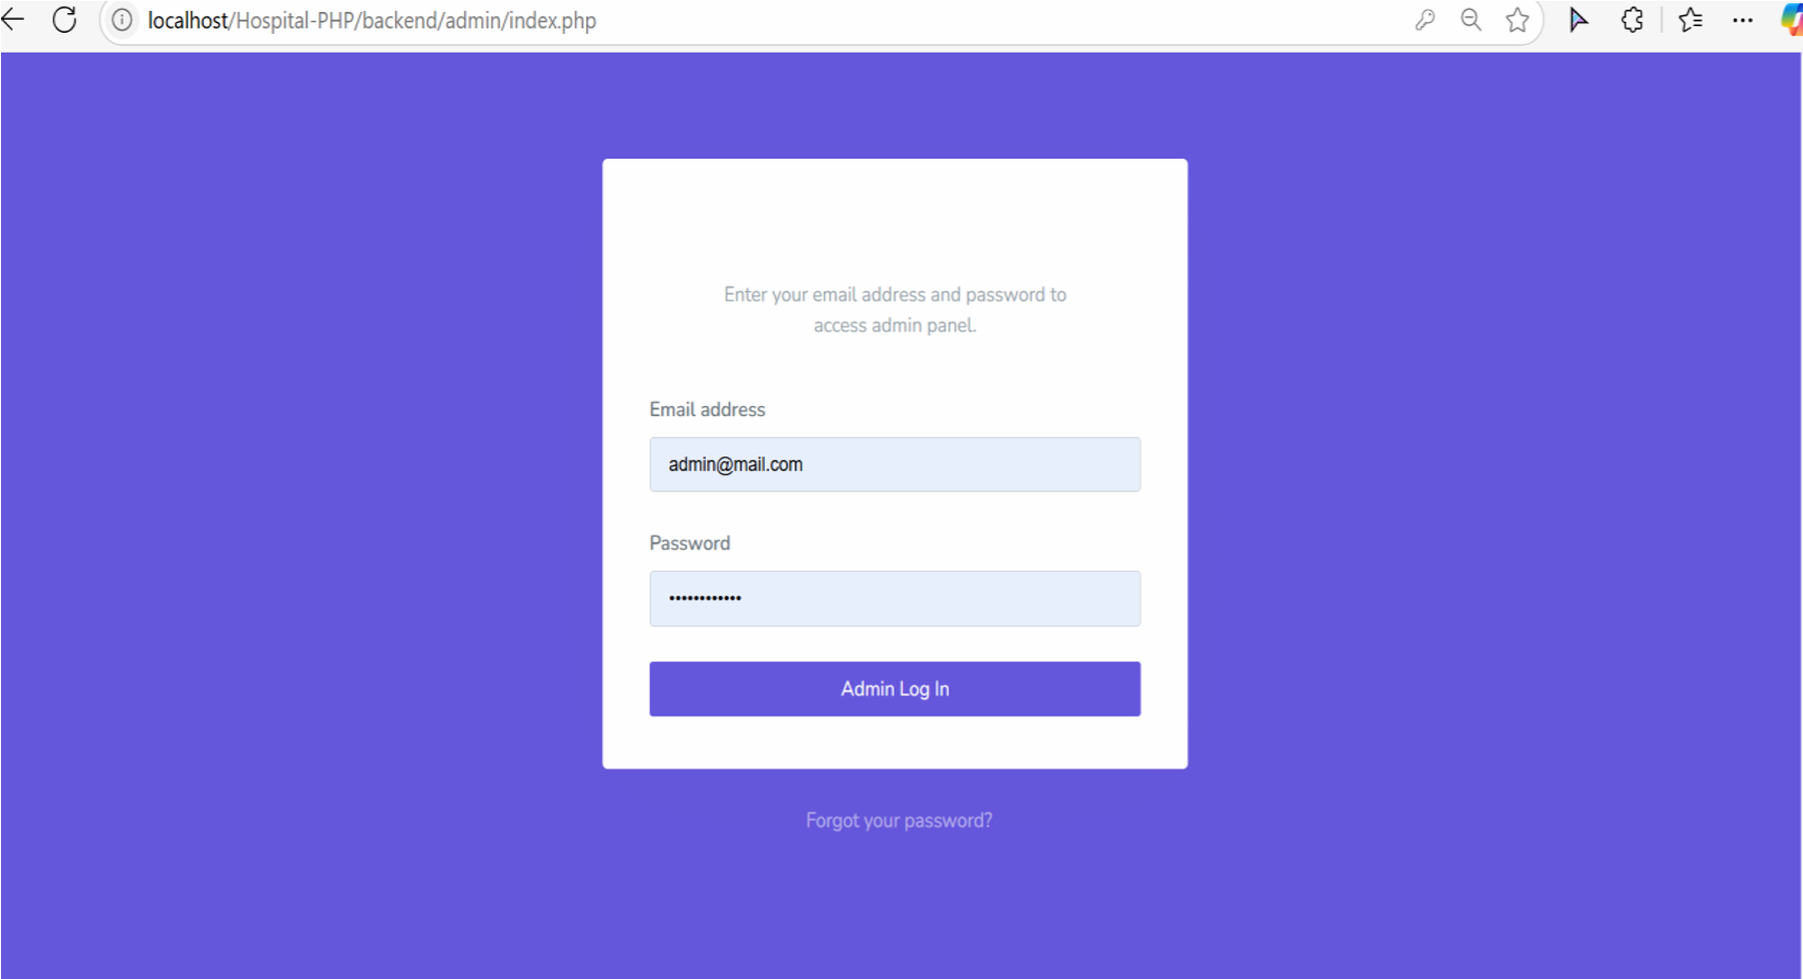

**Figure 1.**

**Patient Management**

* Patient registration with unique ID allocation.
* Digital medical records with treatment history.

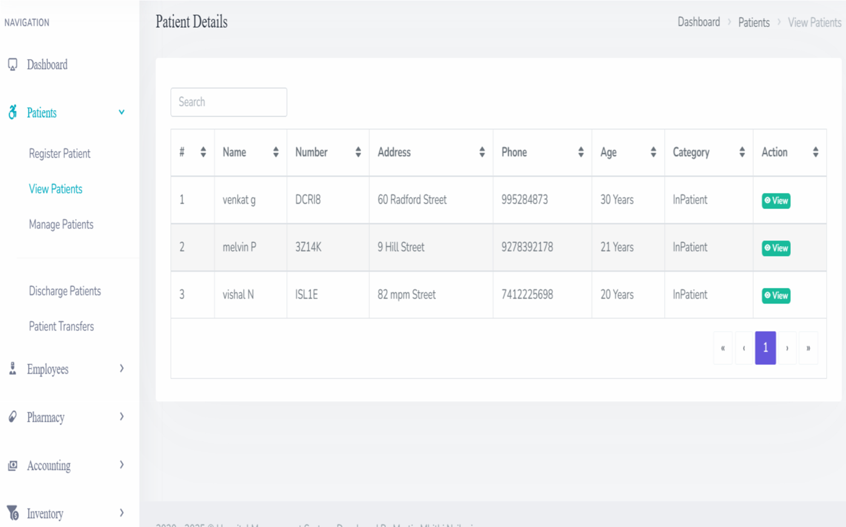

**Figure 2.**

**Appointment Scheduling**

* Real-time appointment booking with doctor availability tracking.
* Automated reminders via SMS/email.

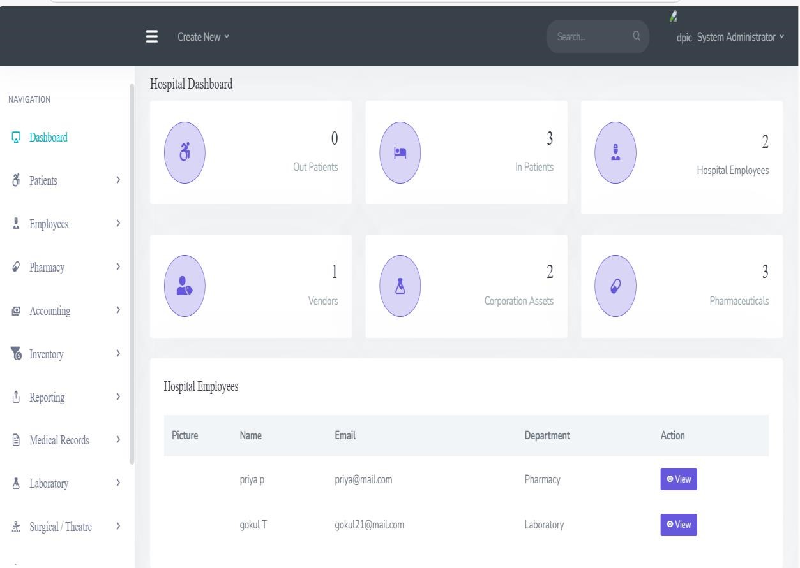

**Figure 3.**

**Billing & Payments**

* Digital invoices for consultations and treatments.
* Online payment gateway integration.

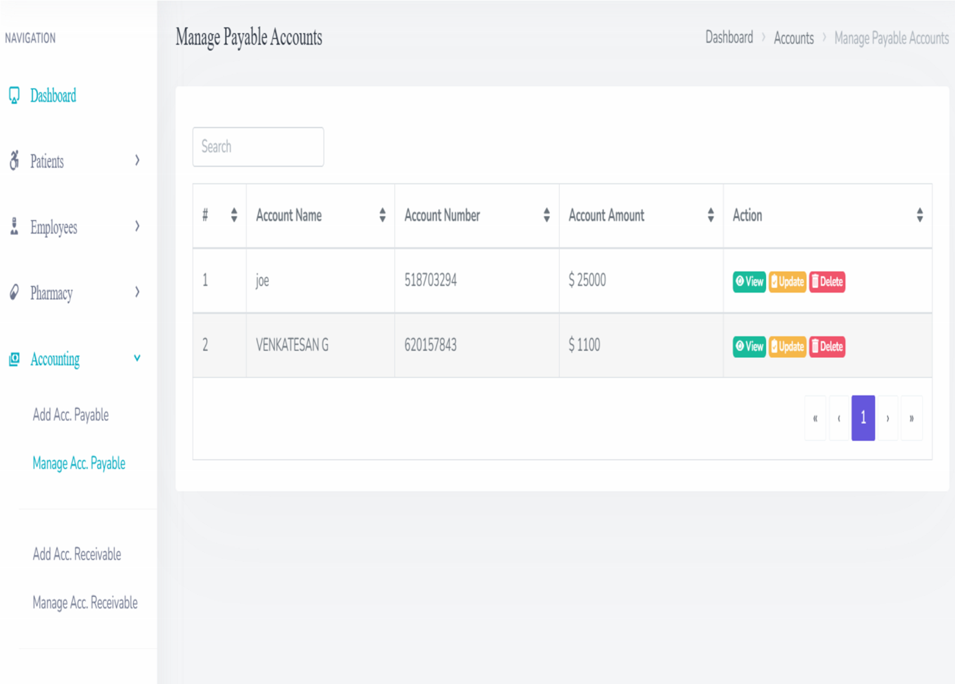

**Figure 4.**

**Pharmacy Management**

* Digital prescriptions from doctors.
* Inventory management for medicines and medical supplies.



**Figure 5.**

**Reporting & Analytics**

* Statistical reports on hospital performance and patient trends.
* Customizable reports for decision-making and regulatory compliance.

**4.2 Database Design**

**Key Tables:**

* **Users Table:** Stores login credentials, roles, and permissions.
* **Patient Records Table:** Contains demographics, history, and treatment plans.
* **Appointments Table:** Tracks consultation schedules and patient bookings.
* **Billing Table:** Stores transaction records and payment details.
* **Pharmacy Table:** Manages drug inventory and prescription logs.

**5. System testing and implementation**

**5.1 System Testing**

System testing ensures that the Hospital Management web application functions correctly across different scenarios and meets all specified requirements. This phase involves multiple levels of verification and validation techniques to detect and resolve potential issues before deployment. **Functional testing** is conducted to verify that all modules operate as intended and meet business needs. **Performance testing** evaluates the system’s speed, responsiveness, and stability under varying loads. **Security testing** ensures data protection by identifying and mitigating vulnerabilities. Additionally, **compatibility testing** checks the application’s performance across different browsers, devices, and operating systems, while **usability testing** assesses the user experience, ensuring ease of navigation and accessibility.

**5.1 Types of Testing**

* **Unit Testing:** Ensures each module functions correctly in isolation by verifying inputs and expected outputs. Identifies and resolves bugs at an early stage.
* **Integration Testing:** Examines the interaction between different modules to ensure smooth data flow and functionality. Detects inconsistencies in module connections.
* **Security Testing:** Evaluates system security against potential threats such as unauthorized access and data breaches. Implements encryption and authentication testing.

**5.2 System Implementation**

* **Deployment on Cloud Servers:** Hosts the platform on a secure cloud infrastructure to ensure scalability and accessibility. Optimized for high-availability performance.
* **User Training & Documentation:** Provides training materials and documentation to help users understand system features. Includes video tutorials and user guides.
* **Maintenance and Updates:** Implements regular security patches, bug fixes, and feature enhancements. Ensures system stability and performance improvements.
* **Data Migration:** Transfers existing patient records securely from legacy systems to the new platform. Ensures data integrity during migration.
* **Monitoring & Analytics:** Continuously tracks system usage and performance metrics to detect anomalies. Uses analytics for predictive maintenance and user engagement insights.

**6. Methodology**

**6.1 Research and Requirement Analysis**

The initial phase involved extensive research on existing healthcare management systems to identify gaps and inefficiencies. Data was collected through:

* **Surveys and Interviews:** Conducted with doctors, patients, and hospital administrators to understand their challenges.
* **Case Studies:** Analysed existing hospital management software to identify limitations.
* **Regulatory Compliance Study:** Ensured adherence to healthcare data protection regulations such as HIPAA and GDPR.

**6.2 System Design**

The system design phase included **architecture planning, database structuring, and UI/UX development**. The system follows a **three-tier architecture**:

1. **Presentation Layer:** Frontend design using HTML, CSS, Bootstrap, and JavaScript for an intuitive user interface.
2. **Application Layer:** Backend development with PHP, handling business logic, appointment scheduling, and data processing.
3. **Data Layer:** MySQL database management for securely storing patient records, appointments, and billing data.

**6.3 System Implementation**

**6.3.1 Development Tools**

* **Frontend:** HTML, CSS, Bootstrap, JavaScript
* **Backend:** PHP
* **Database:** MySQL
* **Server:** XAMPP for local deployment

**6.3.2 Security Implementation**

* **Authentication:** Role-based access control (RBAC) for secure user roles (Doctors, Patients, Admins).
* **Encryption:** AES-256 encryption for protecting patient records.
* **Secure Communication:** HTTPS protocols for all web interactions.

**6.4 Testing and Evaluation**

The system underwent **unit testing, integration testing, and user acceptance testing (UAT)** to ensure smooth functionality.

**6.4.1 Testing Approaches**

* **Unit Testing:** Each module (authentication, scheduling, billing) was tested individually.
* **Integration Testing:** Ensured seamless interaction between modules (e.g., patient registration and appointment booking).
* **Performance Testing:** Evaluated system response time and load handling.
* **Security Testing:** Checked for vulnerabilities in authentication and data encryption.
* **User Acceptance Testing (UAT):** Conducted with hospital staff and patients for usability feedback.

**6.5 Deployment and Future Enhancements**

The final deployment included cloud-based hosting for scalability. Future upgrades may integrate:

* **AI-driven diagnosis recommendations**
* **Blockchain-based medical record security**
* **Mobile app support for iOS and Android**

**7. Results & Discussion**

The prototype implementation of *HealthAxis* was evaluated in a simulated hospital environment. Key performance metrics included:

* **Reduction in appointment scheduling time** by 60%.
* **Decreased administrative workload** due to automated billing and digital records.
* **Enhanced security** with role-based access and encryption.
* **Improved patient satisfaction** with easy access to medical history and teleconsultations.

Comparing *HealthAxis* with traditional hospital management systems, our findings show significant improvements in operational efficiency, error reduction, and user satisfaction. Future enhancements could include AI-based predictive analytics for patient health monitoring and block chain-based secure record management.

**8. Conclusion**

Health Axis revolutionizes hospital management by integrating automation, secure data handling, and real-time communication. The system improves operational efficiency, enhances patient care, and ensures secure medical data storage. It streamlines hospital workflows by reducing paperwork, optimizing appointment scheduling, and automating billing processes. The platform also enhances coordination among healthcare professionals, ensuring better patient outcomes.

By implementing strong security measures, HealthAxis ensures data confidentiality, integrity, and compliance with healthcare regulations. The centralized system reduces human errors, speeds up administrative tasks, and improves decision-making for hospital management. It offers scalability, allowing hospitals to expand their services without operational disruptions. Additionally, the system enhances the patient experience by providing digital access to medical records, online consultations, and seamless hospital interactions. With continuous updates and integration of emerging technologies, HealthAxis remains future-proof and adaptable to evolving healthcare needs. By bridging the gap between technology and healthcare, it ultimately improves service delivery, patient satisfaction, and overall hospital efficiency.

**8.1 Future Enhancement**

* IoT-based Health Monitoring is used for real-time tracking of patient vitals.
* Multi-language Support enhances accessibility for diverse users.
* Telemedicine Expansion provides advanced virtual consultations with remote monitoring.
* Enhanced Patient Self-Service automates check-ins, billing, and report printing.
* Automated Backup System schedules backups for data security.
* Queue Management System manages real-time token distribution and wait-time tracking.
* Integrated Lab Management enables digital tracking of lab tests and results.

**References**

* **Kumar, S., & Patel, R. (2020).** *Hospital Management Systems: A Digital Approach.* Springer Publications.
* **Smith, J. (2019).** *Advancements in Healthcare IT: Case Studies and Solutions.* McGraw-Hill.
* **WHO (2021).** *Digital Health and Its Impact on Global Healthcare.* World Health Organization Report.
* **Brown, T. (2018).** *Electronic Health Records and Data Security in Hospitals.* Oxford University Press.
* **Jones, L., & Green, P. (2022).** *Artificial Intelligence in Healthcare: Trends and Innovations.* Elsevier.
* **IEEE Xplore. (2023).** *Cloud-Based Healthcare Systems: Security and Scalability Challenges.* IEEE Journal.
* **National Health Service (NHS). (2020).** *Guidelines for Implementing Digital Hospital Management.* NHS Publications.
* **Chopra, M. (2021).** *Telemedicine and Its Role in Modern Healthcare.* Journal of Telehealth.
* **Singh, V., & Mehta, K. (2022).** *Big Data Analytics in Hospital Management.* CRC Press.
* **Harvard Medical Review. (2023).** *Future of Digital Healthcare and Patient-Centric Technologies.* Harvard University Press.