Subscription-Based Meal Delivery Services

Chinmay Mishra Kiran Sharma

*Computer Science and Engineering Department Computer Science and Engineering Department*

*Parul Institute of Technology Parul Institute of Technology*

*Vadodara, Gujarat, India Vadodara, Gujarat, India*

## **Abstract :** Subscription-based meal delivery services have emerged as a significant trend in the food industry, driven by changing consumer behavior, convenience, and dietary preferences. These services offer curated meal plans, delivery schedules, and customized menus based on individual needs, ensuring both convenience and health-conscious choices. This paper explores the development of a full-stack solution for such services, incorporating front-end, back-end, and database design, as well as the integration of APIs for payment gateways, user management, and meal customization. We discuss the various aspects of building a subscription-based meal delivery platform, focusing on technological considerations, scalability, and user experience.

***Key words:***

Subscription-Based Services*,* Meal Delivery Platform*,* Subscription Management*,* Delivery Tracking APIs*,* Order Processing Workflow

1. **Introduction**

In recent years, subscription-based meal delivery services have witnessed a surge in popularity due to factors such as time constraints, health- consciousness, and the growing reliance on e- commerce. These platforms aim to simplify the process of meal planning and cooking, offering customers the ability to subscribe to weekly or monthly meal plans. The primary objective of these services is to provide convenient, nutritious, and cost-effective meals that align with users' dietary preferences and schedules.

## This paper aims to explore the development of a full- stack application to support a subscription-based meal delivery service. By utilizing a modern tech stack, such a platform can scale to handle varying levels of user traffic, provide personalized meal options, and integrate with third-party services for payments and logistics.

## The rise of these platforms is connected to the great changes in technology, customer trends, and lifestyles. The planning, shopping, and cooking involved in the traditional approach

to meal preparation often clashes with the busy modern consumer’s schedule. Subscription-based meal delivery services resolve these issues by serving relaxed meal plans designed around people’s preferences, allergy restrictions, and nutrition goals. These platforms focus on fresh ingredients, portion control, and simple cooking methods to ensure that

meals are healthy and easy to prepare.

One of the key factors for the success of these services is technology, which makes it easy for users to interact with service providers. A well-designed digital platform serves as the backbone of the service, enabling features such as meal plan setting,

subscription, delivery tracking, and payments. Such a platform requires the employment of a strong full- stack architecture that combines an appealing front-end interface, a powerful back-end system, and a safe database.

A well-designed, effective, and robust user-friendly platform is very important for these subscription-based meal delivery services due to the competition in the market. With these developments, those who order are also expecting smoother systems that will not require too much navigational efforts.

Despite significant advancements, challenges persist in ANPR systems due to variable plate formats, adverse environmental conditions such as poor lighting, occlusions, and motion blur. These challenges necessitate robust solutions incorporating advancements in artificial intelligence, machine learning, and computer vision.

This paper examines the core components of ANPR systems, including image acquisition, pre-processing, license plate detection, character segmentation, and recognition. Additionally, it explores challenges encountered during implementation and discusses future advancements, including the integration of modern algorithms and hardware technologies, to enhance system performance. The ongoing development of ANPR underscores its critical role in intelligent transportation systems and its potential to address the growing demands of modern urban mobility.

1. **Problem Statement**

Building a robust, scalable platform for a subscription-based meal delivery service involves numerous challenges, including:

* Designing a dynamic front-end interface that enhances user experience.
* Creating a secure and efficient back-end system to manage subscriptions, meal preferences, and customer data.
* Ensuring scalability to handle growing numbers of users and meal deliveries.
* Integrating with third-party APIs for payments

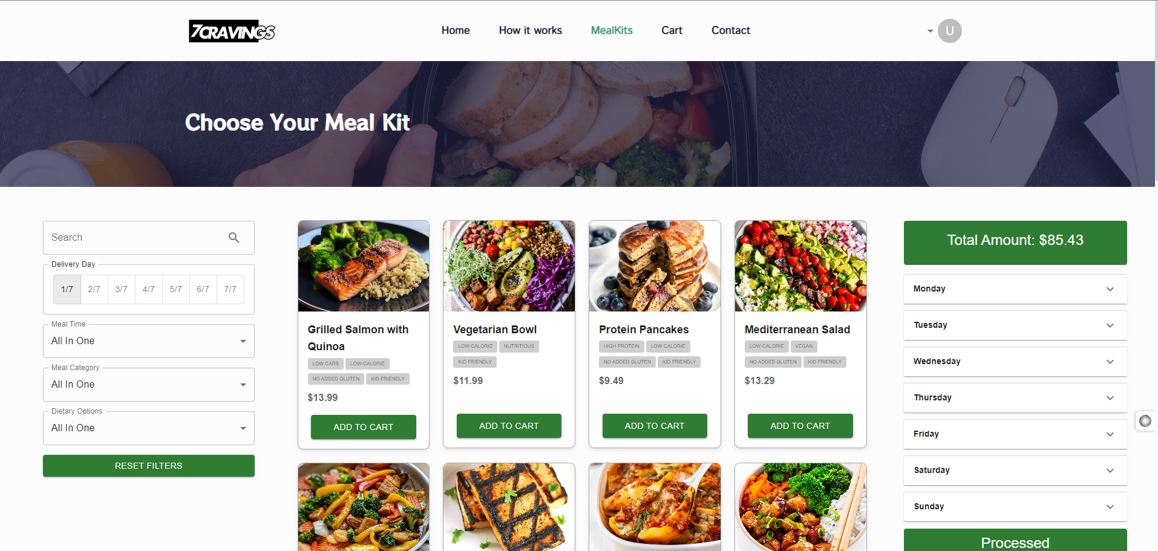

Fig. 1

* 1. Designing a dynamic front-end interface that enhances user experience

The frontend interface for food service is designed to provide users with a seamless and intuitive experience, allowing them to easily browse menu options, customize likes, and manage their names. The interface is the main point of interaction for users, so its functionality and design are of great importance for user satisfaction and retention. Selection, personalization, and profile settings. Personalized diet recommendations based on your dietary preferences and registration history. Information and details are available. Easy to change subscription plans, allowing users to change meal preferences, delivery times, or pause/resume subscriptions. Optimized for all devices, offering a unique experience across desktop, tablet, and mobile.

### Reception, delivery, and new food options. Single-page

application (SPA) improves user experience through fast and responsive connections. CSS framework: Tailwind CSS or Material UI for consistent styling and responsive design. The platform encourages customer engagement and ng-term trust by providing a satisfying user experience with front-end competition. of the license plate, are particularly important for localization.

## Creating a secure and efficient back-end system to manage subscriptions, meal preferences, and customer data.

for secure and efficient backend system for subscription-

based meal delivery

The backend processes that are the foundation of subscription-based meal delivery are user authentication, subscription activity, meal preferences, and customer information. It ensures that the platform remains reliable, secure, and able to meet user needs.

User Authentication **&** Authorization*Secure login and

(employees, customers) are used to manage permissions and

subscription management Dynamically manage subscription

Dietary Preferences & Customization: Store and manage customer-specific dietary preferences like dietary restrictions (vegetarian, keto, etc.) and allergic reactions.

customer management:

Keep personal information (name, address, payment information) secure in a relational database. accepted.

### NOT REQUIRED*

### Manage orders including meal plans, deliveries, and

***2.4*.** Integrating third-party APIs for payments, delivery tracking, and meal planning is important to improve performance and user experience. Previous experience inRegister-based food delivery. Payment APIs like Stripe or PayPal provide a secure and reliable foundation for business transactions, including reorders, returns, and multiple payment methods like credit cards and digital wallets. APIs also support tokenization to ensure customer data protection, while providing automatic notifications and billing to make it transparent and easy for users. The API enable real time order tracking, letting customers know their items are being delivered quickly. These integrated solutions help improve route quality, reduce delays, and ensure on-time service. Notifications about shipments, ETAs, and potential delays further enhance the user experience by ensuring accuracy and reliability. Carefully extract food selections with restrictions and historical information. These systems use advanced algorithms to identify an individual’s nutritional needs and recommend a diet that suits their needs. Leveraging third party APIs, the platform creates a

***2.5.*** Designing a dynamic front-end interface that enhances user experience

The frontend interface for food service is designed to provide users with a seamless and intuitive experience, allowing them to easily browse menu options, customize likes, and manage their names. The interface is the main point of interaction for users, so its functionality and design are of great importance for user satisfaction and retention. Selection, personalization, and profile settings. Personalized diet recommendations based on your dietary preferences and registration history. Information and details are available. Easy to change subscription plans, allowing users to change meal preferences, delivery times, or pause/resume subscriptions. Optimized for all devices, offering a unique experience across desktop, tablet, and mobile.

### Reception, delivery, and new food options. Single-page

application (SPA) improves user experience through fast and responsive connections. CSS framework: Tailwind CSS or Material UI for consistent styling and responsive design. The platform encourages customer engagement and ng-term trust by providing a satisfying user experience with front-end competition. of the license plate, are particularly important for localization.

**.**

# System Flowchart

**The**systemflow**ofa**subscriptionbased meal delivery service

**starts** with

**users signing up/logging in. Users** can **use the real account creation** or secure **login.** Once **verified,** users **will be directed** to **the Food** Selection and **Customization**

**section to** browse **the** menu, filter options based on dietary preferences, and customize meal **plans.**

**Subscription management allows** users to choose **their** subscription plans, set delivery schedules, and **change** subscriptions as needed. This **will enable**

**payment processing** where **transactions including registration fees, refunds, and payment processing are handled by a** secure payment **gateway. For users** and meal preparation **teams.** The process moves **on** to **the meal preparation stage** where orders are prepared **as per customer preferences and** quality control **is applied. **To ensure** that **our** customers **get instant** updates on their **order** status. Notifications are sent at key **stages such as** dispatch, estimated delivery time, and **delivery completion.** and report **any** issues. This feedback is stored in **a database to continue improving our services in** the **future** and **provide** personalized recommendations. The flowchart **treats the** end-to-end process as a **simple,** interconnected system.

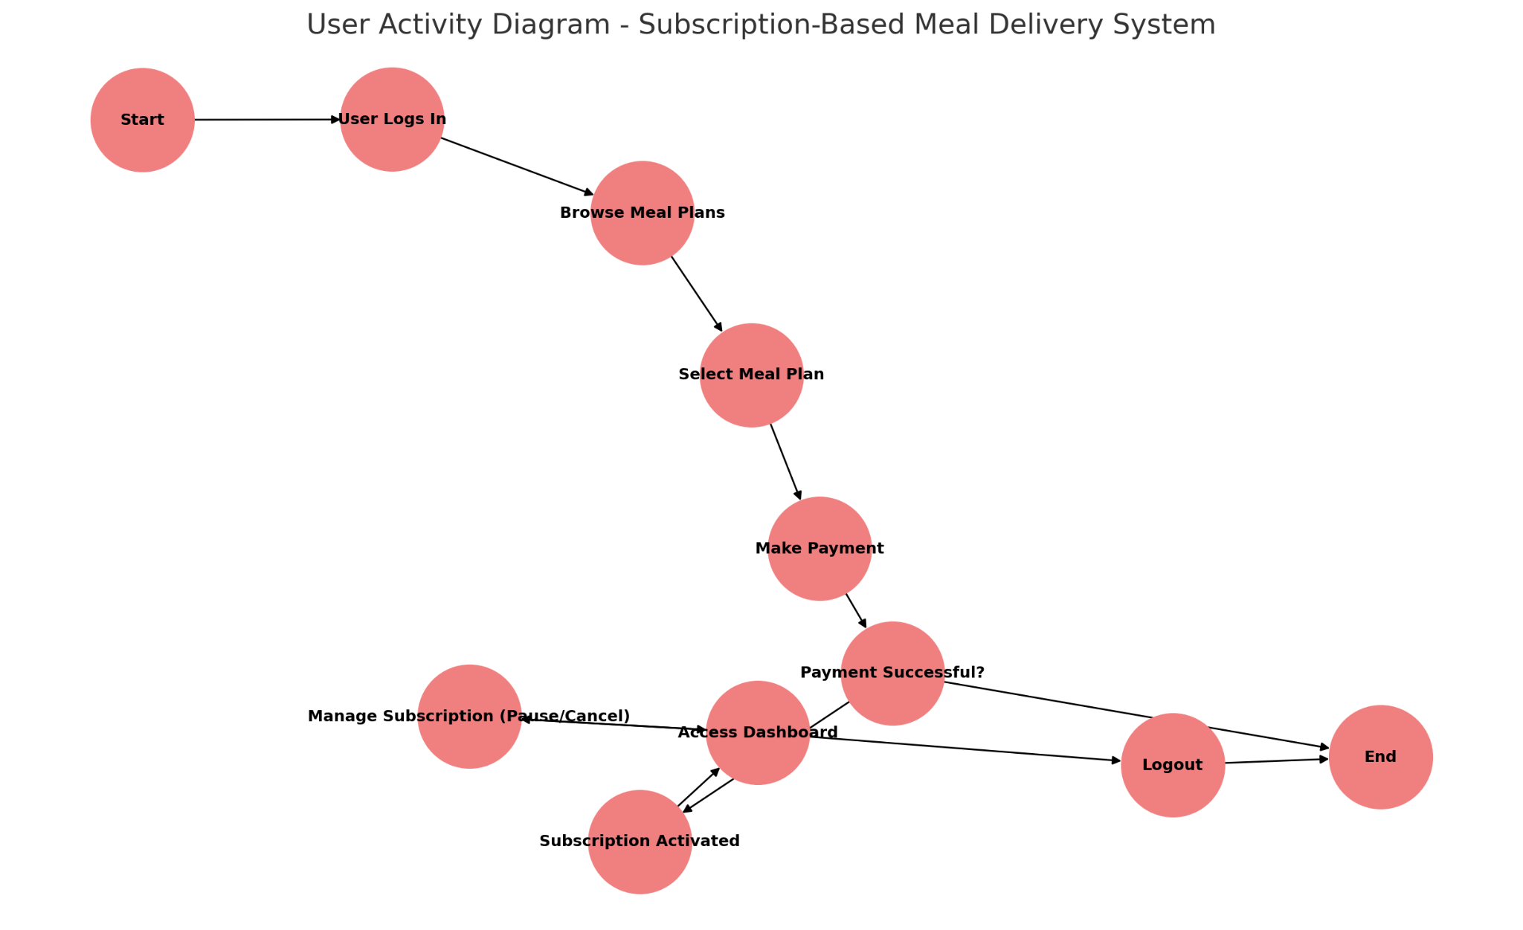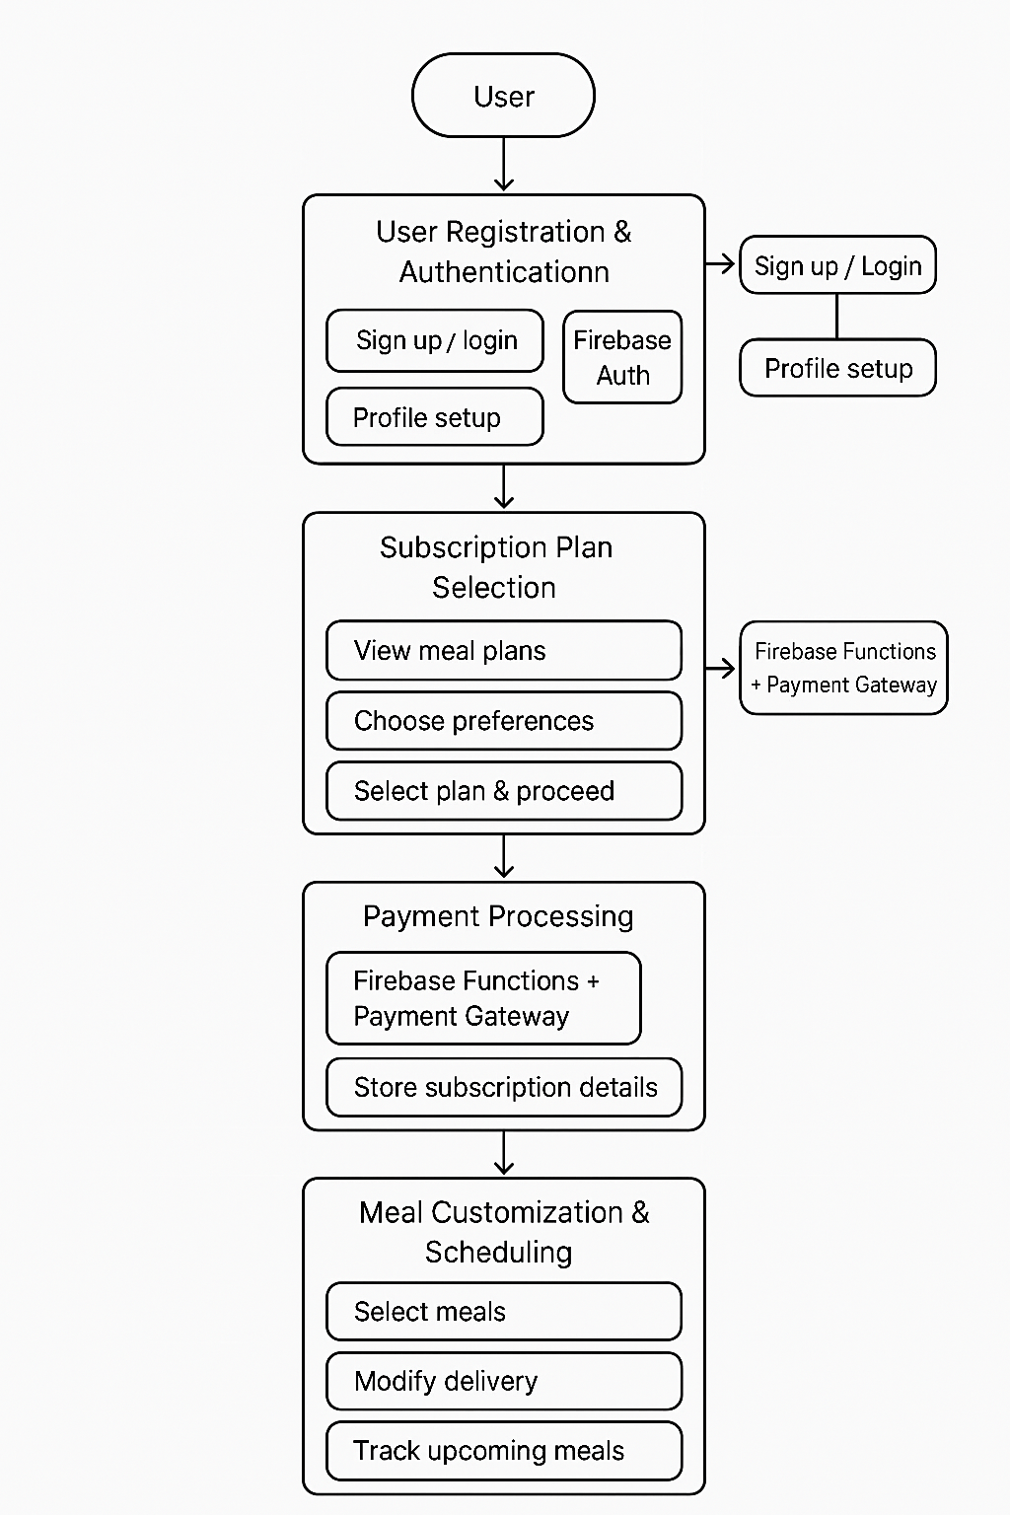

Fig 2

Fig 3

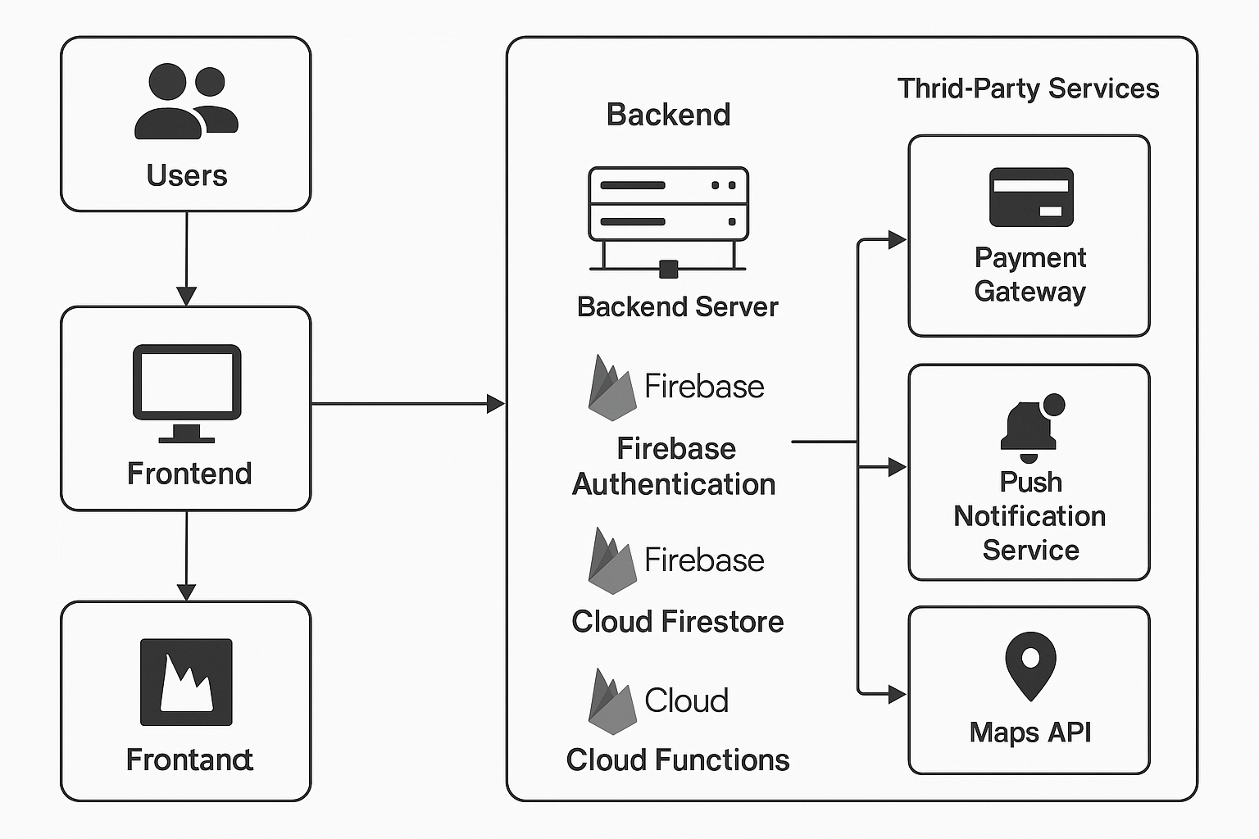

*Fig4*

*4 Objective*

* + - React.js: A JavaScript library for building dynamic user interfaces, React.js enables creating single-page applications (SPAs) with real-time updates, ensuring that users have a responsive and engaging experience.
    - Redux: For state management, Redux helps handle complex user interactions, ensuring that meal preferences, delivery schedules, and user data

The primary objective of this research paper is to outline the full-stack development process required to build a subscription-based meal delivery service. The paper will provide insight into the tools, technologies, and best practices for building an end-to-end solution.

#### Litrature eview

* Recent studies on subscription-based meal delivery services have focused on user behavior, service personalization, and logistical challenges
* . A significant body of work has been dedicated to understanding how consumers choose meal services based on dietary restrictions, food quality, and delivery timeliness (Smith et al., 2020). Additionally, researchers have explored the scalability of meal delivery platforms and the potential for integrating machine learning to predict consumer preferences and optimize meal choices (Khan et al., 2021).
* Full-stack development, which integrates both front-end and back-end technologies, has proven to be an
* efficient approach for building interactive, user-centric
* restrictions, food quality, and delivery timeliness (Smith et al., 2020). Additionally, researchers have explored the scalability of meal delivery platforms and the potential for integrating machine learning to predict consumer preferences and optimize meal choices (Khan et al., 2021).
* Full-stack development, which integrates both front-end and back-end technologies, has proven to be an efficient approach for building interactive, user-centric applications (Johnson, 2019). The combination of frameworks such as React.js for the front end and Node.js for the back end has been widely adopted due to their flexibility and scalability.

#### Methodology

* 1. ***Front-End Development***

The front-end of the subscription-based meal delivery service is critical in providing a seamless user experience. The primary technologies employed for the development incl

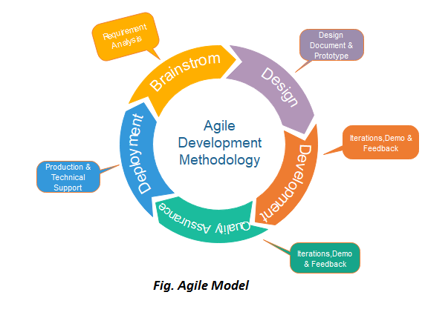

* 1. ***Back-End Development***

## The back-end system is responsible for handling user data, subscriptions, payments, and meal preferences. The chosen technologies for the back end include:

* + - Node.js with Express.js: Node.js provides a fast, scalable environment for handling real-time data, while Express.js simplifies the creation of APIs for interacting with the database and handling HTTP requests.
    - Database: A relational database (e.g., MySQL or PostgreSQL) is used to store user data, meal subscriptions, and historical order data. SQL queries enable efficient management of user profiles, meal options, and subscriptions.
    - Authentication: JSON Web Tokens (JWT) are used for secure user authentication and authorization, ensuring that user sessions are securely managed.

Key Feature

* + - Subscription Management: Manage and update subscription plans, including recurring billing and frequency of deliveries.
    - User Management: Provide secure login, registration, and profile management functionalities.
    - Meal Customization: Allow users to store their dietary preferences and receive personalized meal options.
    - Payment Integration: Integration with third-party payment gateways (e.g., Stripe or PayPal) for secure transactions.

#### Database Design

The database schema includes the following key tables:

* + - Users: Stores user information such as name, email, password hash, address, and payment details
    - Meals: Contains details about each meal, including ingredients, preparation instructions, and nutritional values.
    - Orders: Records all order history, including details on meals delivered, timestamps, and delivery statuses.
    - Subscriptions: Tracks user subscriptions, including meal preferences, delivery schedules, and payment status

#### Integration With Third-Party APIs

To extend functionality and ensure a smooth user experience, the platform integrates with third-party APIs:

* + - Payment Gateway: For handling secure online payments, integrating APIs such as Stripe or PayPal ensures seamless payment processing.
    - Delivery Tracking: Integration with a logistics API (e.g., Postmates or Uber Eats) enables users to track the status of their meal deliveries in real- time.
    - Meal Recommendations: Machine learning algorithms and APIs can be used to analyze user preferences and suggest personalized meal plans based on dietary history

Result and Discussion

The implementation of the full-stack solution results in a highly interactive and user-friendly platform for meal subscription management. Key findings include:

* User Engagement: The use of React.js ensures that users can interact with the platform smoothly, providing real-time

**5.conclusion**

A full-stack solution for a subscription-based meal delivery service can provide a comprehensive platform that addresses both user needs and operational challenges. By utilizing modern technologies such as React.js, Node.js, and PostgreSQL, the system can efficiently manage subscriptions, handle user data securely, and scale to accommodate growth. Future work may explore the integration of machine learning for more accurate meal recommendations, as well as advanced analytics to optimize

**6.Refrence**

[1] Johnson, R. (2019). *Building Scalable Web Applications with Full Stack Development*. Tech Press

[2] Khan, A., Zhang, Y., & Patel, R. (2021). *Optimizing Meal Delivery Services with Machine Learning*. Journal of Food Tech, 35(2), 45-60