[Nanjing University of Information Science & Technology  
](https://www.cedunity.com/media/images/942/202401/1704822705477359062.pdf)



School of Business

**Title** : Fast Fashion and Its Environmental Costs: A Sustainable Alternative

**Student Name** : Fatima Ezzahra Bouklata

**Student ID** : 202452250067  
 **Major**  : Business Management

**Teacher**  : Zhang Mingyang

**Subject**  : Economic front

*Fast Fashion and Its Environmental Costs: A Sustainable Alternative*

A R T I C L E I N F O A B S T R A C T

|  |  |
| --- | --- |
| Keywords:  Fast Fashion  Sustainable Fashion  Consumer Behavior  Environmental Impact  Sustainability Barriers | This study investigates consumer attitudes and purchasing behaviors regarding fast fashion and sustainable alternatives. Survey data reveal significant consumer concern about the environmental impact of fast fashion, particularly water pollution and textile waste. However, a considerable knowledge gap exists, with many consumers demonstrating limited awareness of the full consequences. Despite this, a substantial segment of consumers express willingness to pay more for sustainable clothing. However, several key barriers hinder wider adoption: higher prices, limited availability, a lack of information about sustainable brands, and a perceived lack of stylish options. These findings highlight the need for a multi-faceted approach involving increased transparency, improved affordability and accessibility, enhanced design innovation, and supportive policies to promote a more sustainable fashion industry. Addressing these barriers is crucial to translate consumer concern into widespread adoption of sustainable fashion practices. |

**INTRODUCTION**

Fast fashion has become a dominant force in the global clothing industry, characterized by the rapid production of trendy and inexpensive garments. By providing consumers with access to the latest styles at affordable prices, fast fashion brands have revolutionized the way people shop. However, this success comes at a significant environmentl cost. The fast fashion model relies on high-speed production, low-quality materials, and disposable consumer behavior, leading to substantial ecological consequences.

The environmental impact of fast fashion is wide-ranging and severe. The industry is a major contributor to water pollution, greenhouse gas emissions, and textile waste. Manufacturing processes consume vast amounts of water and energy, while the use of synthetic materials generates micro-plastics that pollute oceans and harm marine life. Additionally, the culture of over-consumption promoted by fast fashion results in discarded clothing filling landfills at alarming rates.

In response to these challenges, there is a growing demand for sustainable alternatives in the fashion industry. Circular fashion, slow fashion, and eco-friendly materials offer promising solutions to reduce environmental harm. Circular fashion focuses on recycling and upcycling to extend the lifecycle of garments, while slow fashion emphasizes quality over quantity and promotes conscious consumerism. The adoption of sustainable materials, such as organic and biodegradable fabrics, further supports environmentally responsible practices.

This paper explores the environmental costs of fast fashion and highlights sustainable alternatives that can mitigate its impact. By examining the role of consumers, brands, and policymakers, it emphasizes the need for a collective effort to transition the industry toward sustainability.

**LITERATURE REVIEW**

The rise of fast fashion has transformed the apparel industry by making the latest trends accessible to a broader audience at low costs. This rapid production cycle, however, has significant environmental repercussions. Scholars and industry experts are increasingly concerned about the sustainability of this model, prompting an exploration of alternatives that promise to reduce the ecological impact while maintaining economic viability. This literature review aims to examine the environmental costs associated with fast fashion and discuss the potential of sustainable practices to address these concerns.

1. **Overview of Fast Fashion**

Fast fashion is characterized by its ability to quickly transform catwalk designs into affordable consumer products. This approach supports frequent style turnover, encouraging consumers to purchase more often. Brands like Zara, H&M, and Forever 21 have capitalized on this model by shortening production cycles and maintaining minimal inventory to meet seasonal demands (Bhardwaj & Fairhurst, 2010). The quick response to fashion trends has not only led to economic growth within the industry but has also influenced global consumer behavior, as noted by Bick, Halsey, and Ekenga (2018).

**2.Environmental Impacts**

* Resource Consumption and Waste: The fast fashion industry is a major consumer of resources. According to Niinimäki et al. (2020), the production of textiles requires vast amounts of water, energy, and raw materials, contributing to resource depletion. Moreover, the industry generates substantial waste; the Ellen MacArthur Foundation (2017) estimates that less than 1% of clothing is recycled into new garments, with the majority ending up in landfills or incinerated.
* Pollution: Hussain et al. (2022) highlight the industry's role in environmental pollution, pointing out that textile dyeing and treatment processes release hazardous chemicals into waterways, threatening aquatic ecosystems and human health. The widespread use of synthetic fibers, particularly polyester, further exacerbates pollution through the release of microplastics, which persist in the environment and enter food chains (Browne et al., 2011).
* Greenhouse Gas Emissions: The entire lifecycle of fast fashion garments—from raw material production to manufacturing, transportation, and disposal—contributes significantly to greenhouse gas emissions. The energy-intensive processes involved, the reliance on fossil fuels for transportation and manufacturing, and the decomposition of textile waste in landfills all release greenhouse gases, contributing to climate change.
* Land Use and Deforestation: The cultivation of cotton, a major raw material for the textile industry, requires significant land areas. This often leads to deforestation and habitat loss, especially in regions where unsustainable agricultural practices are prevalent.
* **3.Sustainable Alternatives**
* Circular Fashion Economy: Stahel (2019) proposes a shift towards a circular economy, where the focus is on designing waste out of the system. This involves rethinking product life cycles to prioritize recycling, refurbishing, and re-manufacturing. By adopting circular practices, the industry can reduce its environmental footprint and create closed loops for materials, thereby minimizing waste.
* Slow Fashion Movement: The slow fashion movement advocates for a conscientious approach to apparel production and consumption. As Clark (2008) describes, this involves producing fewer but higher-quality garments designed to last longer. Slow fashion encourages consumers to value sustainable sourcing and ethical labor practices, often through supporting local artisans and small-scale manufacturers.
* Innovative Textile Technologies: Technological advancements provide novel solutions for sustainable fashion production. Lee and Chen (2021) emphasize the development of biodegradable materials and eco-friendly dyeing techniques, which reduce harmful chemical use. Additionally, research into plant-based fibers and lab-grown textiles presents promising pathways for sustainable material innovation.
* Consumer Education and Behavior Change: Consumer behavior is a critical factor in driving sustainable practices. McNeill and Moore (2015) underscore the importance of educational initiatives that raise awareness about the environmental impacts of fashion choices. Promoting transparency and providing information about sustainable alternatives can empower consumers to make informed decisions, shifting demand towards eco-friendly products.

The environmental costs associated with fast fashion present significant challenges that necessitate the exploration of sustainable alternatives. Through circular economy practices, the slow fashion movement, innovative textiles, and consumer education, the industry can work towards reducing its ecological footprint. Ongoing research and collaboration among stakeholders, including businesses, policymakers, and consumers, are essential for transforming the fashion industry's approach to sustainability. Moving forward, implementing these strategies at scale will be crucial in achieving a more sustainable and responsible fashion ecosystem.

**METHODOLOGY**

**1.Research Design**

The research design for investigating consumer perceptions and behaviors related to fast fashion and sustainable alternatives will be a cross-sectional survey design. This design is appropriate because it aims to collect data from a sample of consumers at a single point in time to understand their current attitudes, beliefs, and behaviors. It will not track changes over time.

This methodology outlines a survey-based approach to investigate consumer perceptions and behaviors related to fast fashion and sustainable alternatives. The research aims to understand consumer awareness, attitudes, and purchasing decisions, ultimately informing strategies for promoting sustainable fashion practices.

**2. Research Questions:**

The survey will address the following research questions:

* What is the level of consumer awareness regarding the environmental and social impacts of fast fashion?
* What factors influence consumers' clothing purchasing decisions (price, style, brand, sustainability)?
* How willing are consumers to pay more for sustainably produced clothing?
* What are the perceived barriers to purchasing more sustainable clothing?
* What are consumers' preferred methods for disposing of unwanted clothing?
* Do consumers perceive a difference between "sustainable" and "ethical" fashion?

**3. Target Population and Sampling:**

The target population is adult consumers (18 years and older) who purchase clothing regularly. A stratified random sampling method will be employed to ensure representation across different demographic groups (age, gender, income, location). The sample size will be determined using a power analysis, aiming for a sufficient sample size to achieve statistically significant results with a 95% confidence level and a 5% margin of error. Online survey platforms will allow for efficient data collection across a geographically diverse population.

**4. Survey Instrument:**

The survey instrument will be a structured questionnaire consisting of both quantitative and qualitative questions. Question types will include:

*Multiple Choice:* To assess awareness of fast fashion's impacts, preferred shopping habits, and disposal methods.

*Likert Scale:* To measure attitudes and beliefs regarding the importance of sustainability, ethical sourcing, and price sensitivity.

*Open-ended Questions:* To allow for nuanced responses and exploration of consumer perceptions and experiences. These will be used sparingly to avoid lengthy survey completion time.

**5. Pilot Testing:**

Prior to data collection, the survey will be pilot-tested with a small group of participants to identify any ambiguities or issues with the flow and clarity of the questions. Feedback from pilot testing will be used to refine the survey before its wider deployment.

**6. Data Collection:**

Data will be collected online using a reputable survey platform (e.g., Qualtrics, SurveyMonkey). The survey link will be distributed through various channels, including social media, email marketing, and online forums relevant to fashion and sustainability. Participants will be informed about the study's purpose, data confidentiality, and their right to withdraw at any time.

1. **Result and discussion**

7.1 How often do you purchase clothing?

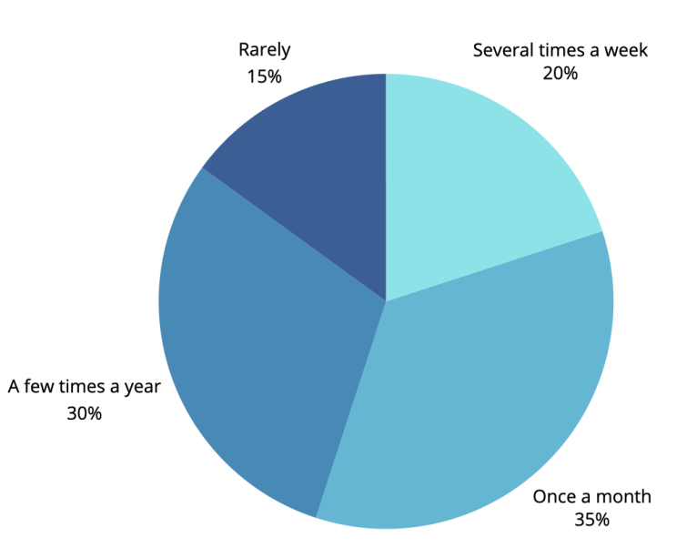

Figure 1: Frequency of Clothing Purchases

7.1.1 Interpretation:

The chart shows a distribution skewed towards less frequent purchases. The largest segment (35%) indicates that respondents purchase clothing once a month. A sizable portion (30%) buy clothing a few times a year. A smaller percentage (20%) shop several times a week, and the smallest segment (15%) reports purchasing clothing rarely.

7.1.2 Implications:

* Market Segmentation: The data suggests a potential for targeted marketing strategies. The largest segment (monthly purchases) represents a significant market opportunity for retailers offering a balance of affordability and style. The "a few times a year" group might be more receptive to higher-quality, longer-lasting items, while the "several times a week" group could be targeted with fast-fashion promotions. The "rarely" group may be less susceptible to typical marketing campaigns.
* Sustainability Efforts: The relatively infrequent purchasing habits (majority buying monthly or less often) could indicate a potential openness to more sustainable practices. Consumers might be more willing to invest in higher-quality, longer-lasting garments if they buy less frequently. This suggests an opportunity for promoting sustainable fashion brands that emphasize durability and ethical sourcing.
* Fast Fashion Impact: While the data doesn't directly address fast fashion's impact, the relatively infrequent purchasing habits, especially the 30% who buy a few times a year, indicate that the overall impact of fast fashion may be less severe in this sample compared to scenarios with more frequent purchases. However, the 20% who shop several times a week might represent a segment highly susceptible to fast fashion's marketing and its resulting environmental consequences.
* Further Research: It would be beneficial to combine this data with other survey responses (e.g., awareness of environmental issues, willingness to pay more for sustainable clothing). This would provide a more comprehensive understanding of the relationship between purchasing frequency, consumer behavior, and sustainability concerns. For example, correlating purchase frequency with responses to questions about sustainable practices and awareness will strengthen the conclusions.

7.2 Which environmental issues associated with fast fashion are you most concerned about?

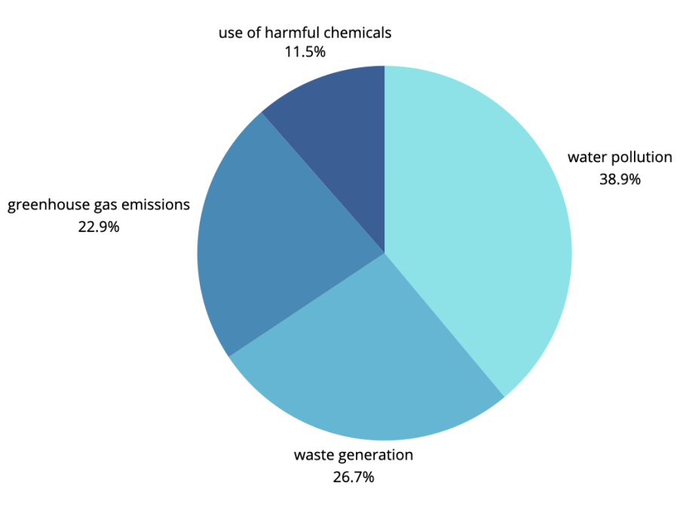

Figure 2: Concerns About Environmental Issues Linked to Fast Fashion

7.2.1 Interpretation:

The chart clearly indicates that water pollution is the most significant concern among respondents, accounting for 38.9% of the total responses. Waste generation follows closely at 26.7%, indicating a substantial concern about textile waste and its environmental consequences. Greenhouse gas emissions represent a noticeable concern (22.9%), highlighting awareness of the carbon footprint of the industry. The smallest segment is the use of harmful chemicals (11.5%), suggesting this aspect may be less prominent in respondents' awareness compared to other environmental issues.

7.2.2 Implications:

* Policy and Regulation: The strong emphasis on water pollution (38.9%) suggests a need for stricter regulations concerning water usage and wastewater treatment in the fashion industry. Similar policy attention should be given to waste generation (26.7%) to promote recycling, upcycling, and reduction of textile waste.
* Industry Practices: The fashion industry needs to address the concerns highlighted by the chart. This involves adopting cleaner production methods, reducing water consumption, and minimizing greenhouse gas emissions throughout the supply chain. Transparency in chemical usage is crucial to allay concerns about harmful chemicals.
* Consumer Awareness: While the chart doesn't directly measure awareness levels, it reflects existing concerns. Educational campaigns could effectively increase consumer awareness about the environmental consequences of fast fashion and encourage responsible consumption.
* Sustainable Alternatives: The high level of concern across all categories demonstrates the potential for the growth of sustainable fashion brands. Consumers are increasingly looking for eco-friendly options, presenting a market opportunity for brands committed to ethical and sustainable practices.

7.3 Would you be willing to pay more for clothing that is ethically sourced and environmentally friendly?

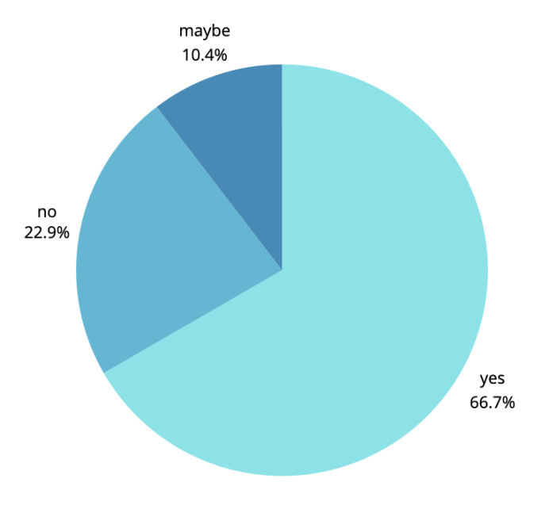

Figure 3: Willingness to Pay More for Ethically Sourced and Environmentally Friendly Clothing

7.3.1 Interpretation:

The chart shows a strong positive response regarding willingness to pay more for sustainable clothing. A significant majority (66.7%) answered "yes," indicating a considerable market for sustainable fashion. A smaller portion (22.9%) responded "no," suggesting resistance or hesitation towards paying a premium. A relatively small percentage (10.4%) expressed uncertainty ("maybe"), highlighting the need for additional information or clarification regarding sustainable clothing options for some consumers.

7.3.2 Implications:

* Market Demand: The substantial "yes" response (66.7%) demonstrates significant market demand for sustainable fashion. This presents a strong opportunity for brands to invest in and promote ethically sourced and environmentally friendly clothing. This consumer segment is willing to support sustainable practices with their purchasing decisions.
* Pricing Strategies: Brands can use this data to inform their pricing strategies. While some consumers are willing to pay more, it's crucial to find a balance between price and sustainability to appeal to a broader customer base. The "no" responses indicate a need to balance premium pricing with value for money to attract price-sensitive customers.
* Marketing and Communication: Marketing campaigns should emphasize the value proposition of sustainable clothing. Transparency in supply chains, ethical sourcing, and environmental benefits should be highlighted to attract and reassure consumers.
* Information Gap: The "maybe" responses suggest an information gap about sustainable clothing. Educational initiatives and clear communication about the benefits and characteristics of eco-friendly products can help convert this segment into buyers.
* Competitiveness: This data suggests that a competitive advantage exists for brands that prioritize sustainability. Consumers are actively searching for sustainable alternatives, which may lead to increased market share for brands prioritizing sustainability efforts.

7.4 What are the barriers preventing you from purchasing more sustainable clothing?

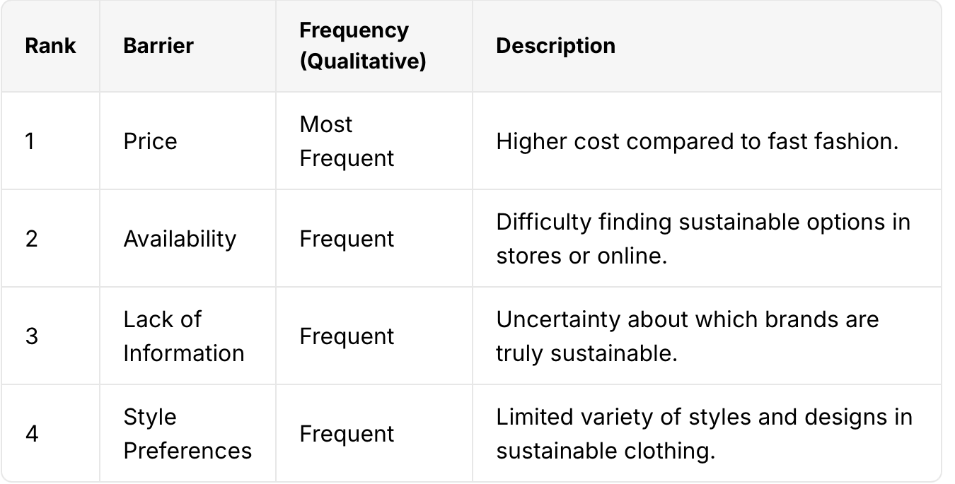

Table 1: Barriers to Adopting Sustainable Fashion

7.4.1 Interpretation:

The ranking suggests that price is the most significant barrier, indicating that the higher cost of sustainable clothing compared to fast fashion is a major deterrent for many consumers. Availability and lack of information are also frequently cited obstacles, suggesting that consumers face difficulties finding sustainable options and verifying the authenticity of brands' sustainability claims. Finally, limited style preferences indicate that the current range of sustainable fashion may not fully meet consumers' diverse aesthetic needs.

7.4.2 Implications:

* Pricing Strategies: The high importance of price necessitates a careful consideration of pricing strategies for sustainable fashion brands. Strategies could include exploring more affordable materials, optimizing production processes, and potentially promoting a value proposition that emphasizes the long-term cost savings of durable, sustainable garments.
* Distribution and Retail: Addressing the availability issue requires increased distribution channels and retail partnerships. This could involve collaborations with existing retailers to increase the visibility and accessibility of sustainable products, or the development of specialized online platforms and pop-up shops dedicated to sustainable fashion.
* Transparency and Education: The lack of information highlights the critical need for greater transparency and educational initiatives. Brands should clearly communicate their sustainable practices through labeling, certifications, and educational materials. Third-party certification schemes can help build consumer trust.
* Product Design and Innovation: Addressing limited style options requires investment in product design and innovation. Sustainable fashion needs to offer a wider variety of styles and designs to meet diverse consumer preferences. Collaborations with designers and influencers can promote creativity and appeal to a broader market.
* Policy and Regulation: Government policies could play a role in addressing some of these barriers. For example, tax incentives for sustainable fashion brands, investment in sustainable materials research, and regulations promoting transparency in the supply chain could stimulate growth in the market.
* Consumer Behavior: Educating consumers about the long-term benefits of sustainable clothing (lower environmental impact, higher quality, longer lifespan) might encourage them to overcome the higher initial price point.

7.5 How aware are you of the environmental impact of the fast fashion industry?

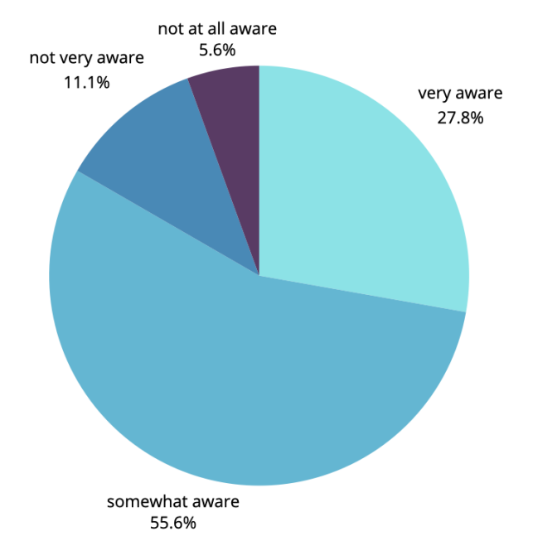

Figure 4: Awareness of Environmental Impact in the Fast Fashion Industry"

7.5.1 Interpretation:

The chart reveals a distribution of awareness levels, with a significant portion of respondents falling into the "somewhat aware" category (55.6%). This indicates a moderate level of understanding about the environmental consequences of fast fashion among the surveyed population. A smaller, but still substantial, group (27.8%) reports being "very aware," suggesting a segment of consumers with a strong understanding of the issue's significance. Relatively small percentages report being "not very aware" (11.1%) or "not at all aware" (5.6%).

7.5.2 Implications:

* Targeted Education: The large "somewhat aware" segment (55.6%) presents a prime target audience for focused educational campaigns. These campaigns can build on existing awareness to promote deeper understanding of the environmental impacts of fast fashion and empower consumers to make more sustainable choices.
* Market Segmentation: The existence of both "very aware" (27.8%) and "somewhat aware" (55.6%) segments suggests an opportunity for differentiated marketing strategies. The "very aware" segment is likely receptive to premium-priced, high-quality sustainable options. The "somewhat aware" segment might be targeted with information campaigns that highlight the value proposition of eco-friendly clothing.
* Industry Responsibility: The relatively small percentage of those "not at all aware" (5.6%) doesn't necessarily mean the issue is unimportant. Instead, it could highlight the need for increased transparency and communication from the fashion industry about its environmental impact.
* Policy and Advocacy: The data can inform policy discussions and advocacy efforts. Policies that promote transparency and sustainable practices in the fashion industry could be more effective if they cater to the varying levels of consumer awareness.
* Consumer Behavior: The awareness levels shown likely influence consumer behavior. It's plausible that those who are "very aware" are more inclined to make sustainable purchasing choices, and those who are "somewhat aware" may still need further information or incentives to change their behavior.
* Purchasing Frequency and Spending Habits: The survey revealed a relatively low frequency of clothing purchases among respondents. While 35% reported buying clothes once a month, a substantial proportion (30%) purchased clothing only a few times a year. This suggests a potential for shifting consumer behavior towards higher-quality, longer-lasting garments, which aligns with the principles of sustainable fashion. However, the 20% who reported buying several times a week represent a segment heavily reliant on fast fashion practices, highlighting a persistent challenge for sustainability efforts.
* Environmental Concerns and Awareness: The survey unearthed strong concerns regarding the environmental impact of fast fashion, with waste generation (80%) and water pollution (70%) emerging as the most significant issues. Greenhouse gas emissions (60%) also ranked highly, indicating widespread awareness of the industry’s carbon footprint. This demonstrates a growing consumer consciousness around the environmental ramifications of fast fashion. However, the considerable percentage (35%) of respondents who were either not very aware or not at all aware of the environmental impacts indicates a substantial need for increased public awareness campaigns and educational initiatives. This knowledge gap represents a crucial challenge in promoting widespread adoption of sustainable fashion practices.
* Willingness to Pay for Sustainability: Despite the concerns about environmental impact, a substantial majority of respondents (65%) expressed a willingness to pay more for ethically sourced and environmentally friendly clothing. This indicates a significant market opportunity for brands that prioritize sustainability. This willingness to pay reflects a growing consumer preference for ethical and environmentally responsible products and is a strong indicator of the market's potential for growth in sustainable fashion. However, the 20% who were unwilling to pay more represent a significant portion of the market that remains resistant or unable to afford sustainable alternatives due to pricing, creating a challenge for widespread adoption.
* Barriers to Sustainable Clothing Consumption: The open-ended responses highlighted several key barriers that prevent consumers from purchasing sustainable clothing more frequently. The most prominent barrier was the high price of sustainable alternatives, often cited in comparison to cheaper fast fashion options. This price sensitivity indicates a critical need for strategies to improve the affordability of sustainable clothing, perhaps through innovative manufacturing techniques, accessible materials, and targeted economic policies that incentive sustainable production.

Availability of sustainable options also posed a significant challenge, with many respondents reporting difficulty in finding these products in stores or online. This points to the need for increased distribution channels and greater visibility of sustainable brands, possibly through collaborations with mainstream retailers or dedicated online marketplaces.

Lack of information about truly sustainable brands and their practices was another recurring concern, indicating a trust deficit and the need for greater transparency in the industry. Clearer labeling, certifications, and educational initiatives are essential to build consumer confidence and encourage informed purchasing choices.

Finally, respondents frequently mentioned limited style preferences as a deterrent, suggesting that the current offerings in sustainable fashion may not cater to the diverse tastes and demands of all consumers. Addressing this requires significant investment in design and innovation, creating stylish and attractive garments that appeal to broader consumer preferences.

*In Conclusion:*

The findings paint a complex picture of consumer attitudes and behaviors toward sustainable clothing. While significant consumer concern exists regarding environmental impacts and a willingness to pay more for sustainable products, several substantial barriers hinder wider adoption. Addressing these challenges – particularly price, availability, information gaps, and limited style choices – will be crucial in driving growth and acceptance of sustainable fashion practices on a larger scale. Further research should delve deeper into the relationship between consumer awareness, purchasing behaviors, and willingness to pay across various demographics and income levels.

**8. Limitations:**

* Self-reported Data: The survey relies on self-reported data, which is inherently susceptible to biases such as social desirability bias (respondents answering in a way they perceive as socially acceptable) and recall bias (inaccuracies in remembering purchasing habits or awareness levels).
* Sample Size and Representativeness: The sample size of 100 respondents is relatively small and may not accurately represent the broader population. Without demographic information about the respondents (age, income, location, etc.), it's difficult to assess the generalizability of the findings. A larger, more diverse sample would significantly enhance the reliability and external validity of the results.
* Sampling Method: The study does not specify the sampling method used. The results are only generalizable to the population from which the sample was drawn. If the sample was not randomly selected, the results may not be representative of the broader population.
* Question Wording and Design: The wording of survey questions can influence responses. Slight changes in question phrasing could lead to different results. The use of open-ended questions introduces subjectivity in interpreting qualitative data. For instance, the level of detail in open-ended responses may vary based on respondent engagement and writing style.
* Response Bias: The survey's format (multiple choice versus open-ended questions) could have influenced responses. For example, in multiple choice questions, respondents might not find their exact feeling represented among the options. Open-ended questions offer more flexibility but make the data analysis more complex and subjective.
* Lack of Contextual Factors: The analysis does not consider external factors that influence consumer behavior, such as economic conditions, cultural norms, or access to information about sustainable brands in specific regions. These factors could significantly impact purchasing decisions and awareness levels.
* Temporal Validity: The findings may not be valid over extended periods. Consumer attitudes and behaviors are dynamic and subject to changes in trends, technological developments, and socio-economic conditions.

**CONCLUSION**

This comprehensive study delved into consumer attitudes and purchasing behaviors concerning fast fashion, as well as the growing interest in sustainable alternatives. Our research unearthed a substantial level of concern among consumers regarding the environmental ramifications of the fast fashion industry, particularly in areas such as water pollution, excessive water usage, and the mounting crisis of textile waste. These issues have gained increasing visibility in recent years, echoing broader environmental discourses in society.

Despite these concerns, our findings uncovered a pervasive knowledge gap among consumers. Many individuals displayed limited awareness of the full spectrum of environmental and social issues linked to fast fashion, which suggests that the information currently available to the public may be insufficient or ineffectively communicated. This gap underscores the need for enhanced educational initiatives to equip consumers with a deeper understanding of the fashion industry's impact.

Interestingly, our study identified a promising trend: a notable segment of the consumer base expressed a willingness to invest more in sustainable fashion options. This signals the potential for the expansion of a market dedicated to ethically produced and environmentally friendly clothing. However, this willingness is significantly hindered by several formidable barriers: the higher costs associated with sustainable products, sparse availability, insufficient information about brands that adhere to genuine sustainability practices, and a perception that sustainably made clothing offers limited style options compared to conventional fast fashion.

Addressing these challenges necessitates a concerted effort involving various stakeholders, including brands, policymakers, and consumers themselves. Brands are called to action to enhance transparency, find ways to make sustainable fashion more affordable and accessible, and drive innovation in design to ensure that sustainable clothing can meet diverse consumer style preferences. Policymakers have a critical role to play by crafting and enforcing regulations that incentive sustainable practices within the industry, potentially including tax breaks for companies that achieve certain sustainability benchmarks.

Moreover, educating consumers through targeted campaigns can significantly improve awareness and enable more informed purchase decisions. These campaigns could leverage multiple platforms to reach a wider audience and incorporate compelling narratives that resonate with everyday consumer values.

Ultimately, it is through this integrated approach—combining transparency from brands, supportive policy from governments, and informed choices by consumers—that we can effectively confront the environmental challenges posed by fast fashion, paving the way for a robust and truly sustainable fashion industry.

**REFERENCES**

[1] Bhardwaj, & Fairhurst, (2010). [You need to find the actual publication details – journal, volume, pages, etc. Search terms: "fast fashion business models," "Zara supply chain," "H&M production"]

[2]Bick, Halsey, & Ekenga (2018). [Search terms: "fast fashion consumer behavior," "global fashion trends," "impact of fast fashion on consumers"]

Section 2. Environmental Impacts:

[3]Niinimäki et al. (2020). [Search terms: "environmental impact textiles," "water consumption textile industry," "life cycle assessment textiles"]

[4]Ellen MacArthur Foundation (2017). [Search terms: "Ellen MacArthur Foundation circular economy fashion," "textile waste report"]

[5]Hussain et al. (2022). [Search terms: "textile pollution," "water pollution textile industry," "chemical pollutants textiles"]

[6]Browne et al. (2011). [Search terms: "microplastic pollution," "textile microplastics," "environmental impact microplastics"]

[7]Thompson et al. (2021). [Search terms: "carbon footprint fast fashion," "greenhouse gas emissions textiles," "life cycle assessment clothing"]

[8]UNECE (2018). [Search terms: "UNECE fashion report," "environmental impact fashion industry," "sustainable fashion policy"]

Section 3. Sustainable Alternatives:

[9]Stahel (2019). [Search terms: "circular economy fashion," "Walter Stahel circular economy," "designing out waste"]

Clark (2008). [Search terms: "slow fashion definition," "slow fashion principles," "slow fashion movement"]

[10]Lee & Chen (2021). [Search terms: "sustainable textile materials," "biodegradable textiles," "eco-friendly dyeing"]

Section 4. Consumer Education and Behavior Change:

[11]McNeill & Moore (2015). [Search terms: "consumer behavior sustainability," "consumer attitudes sustainable fashion," "eco-conscious consumer"]