**EFFICIENT ROAD DRAINAGE SYSTEM IN YEOLA MANMAD HIGHWAY**

**Prof. Bharud Sakshi P 1, Mr. Vyawahare Ganesh A 2, Mr.Pahilwan Aayush V 3, Jadhav Akshay B 4**

1Lecturer, Department Of Civil Engineering, Santosh N Darade Poltechnic, Babhulgaon, Yeola, Maharashtra, India.

2 3 4 Students, Department Of Civil Engineering, Santosh N Darade Poltechnic, Babhulgaon, Yeola, Maharashtra, India.

**ABSTRACT**

We have developed by this study is carried out to review various research works carried out by researcher on effective drainage system of roads and highways. Poor drainage system of road can cause structure failures of road. But these failures can be avoided by carrying out some studies of physical factors and by following some structural guidelines of road drainage.

Conventional drainage system that has been applied with the concept of discharging or draining water to the drainage channel has not been able to evade rain water that falls on the road surface. To date, the load of drainage channel is increasing. This is contributed by the decrease of the drainage function in order to flow water through the channel. To overcome the problem, a new concept of drainage is introduced. This study aims to develop a good highway drainage system by increasing the ability to measure the efficiency and effectiveness of the drainage system.

**Keywords:** **Disturbance, Standard Drainage, inundation, Avoid Flooding, Stormwater Drainage, Design,**

**microdrainage.**

1. **INTRODUCTION** 
   * **General:**

Efficient road drainage design solution areessantial for the managing urban stormwater runoff and to prevent flooding in cities. With the increasing urbanization and climate change impacts, there is a growing need for innovative drainage solutions that can efficiently handle the increasing volume of stormwater runoff due to newly developed impervious surfaces in urban areas. Removing excess surface water on the roadway (waterlogging) and restoring the natural drainage network are major challenges in the storm drainage design of roads and transportation facilities. Rain and road waterlogging can cause hazardous situations due to the reduction of both driving visibility and friction coefficients between vehicle wheels and the roadway . For this reason, most government administrations responsible for the design and management of roads and highways publish recommendations or design guidelines to provide safe passage of vehicles during such events.

The aforementioned guidelines for removing waterlogging on roads in different countries are fundamentally based on directing water from the roadway to lateral gutters.The design criteria of the gutters are generally based on limiting the spread of the flow using a simple uniform flow equation. Ultimately, the flow in the gutters is incorporated into underground drains by different types of inlets, for which the recommendations provide some basic guidelines regarding their location. These circulars in Spain, the USA, and Queensland present the different types of gutters that can be used, how they should be lined, and where they must be placed according to the slopes of the cuts and embankments of the roadway; all guidelines explicitly indicate that the hydraulic behavior for the design discharge should be checked under a uniform regime.It is a widely known proven fact that water in pavement systems is one among the principal causes of premature pavement failure. Indian road network at over 3.3 million metric linear unit falls below one of the world's longest road networks. Most of the highways and airfield pavements engineered in our country within the past thirty years about, have very slow exhausting systems, largely as a result of normal style practices emphasizes on density and stability however place very little importance on emptying. Drainage is a key component within the style of pavement systems. However, inadequate drainage continues to be known as a major reason behind pavement distress. Drainage is the process of interception and elimination of water from over, and underneath the vicinity of the paved surface. Drainage is surface (where water is conveyed on the paved surface and drainage. channels), or subsurface (water flows underneath the pavement. structure). Surface and subsurface drainage of roads highly affects their structural integrity, life and safety of users, and is thus very important during highway design and construction. Road designs therefore must provide efficient means for removal of this water; hence the need of road drainage designs, drainage facilities are compulsory to guard the road against damage from surface and sub-surface water. Traffic safety is additionally crutial as poor drainage

may end up in dangerous conditions like hydroplaning. Poor drainage may compromise the structural integrity and life of a. pavement. Drainage systems combine various natural and non natural facilities e.g. ditches, pipes, culverts, curbs to clear away this water safely.

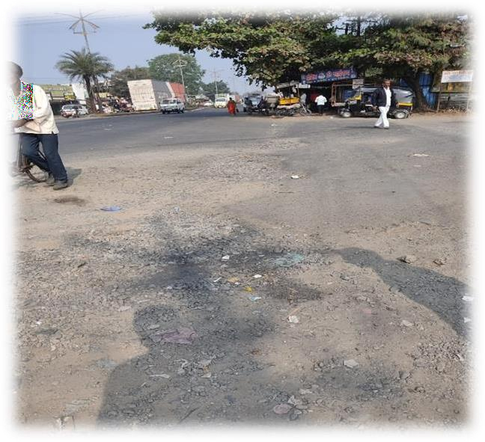

**Fig 01: Study Area (location).**

1. **OBJECTIVES**

To minimize the erosive effects of water concentrated by road drainage features; to disperse runoff from disturbances within the road clearing limits; to lessen the sediment yield from roaded areas; to minimizeerosion of the road prism by runoff from road surfaces and from uphill areas.

These systems are designed to manage the flow of water, preventing damage to the road surface and ensuring the safety of motorists and pedestrians. Effective road drainage helps minimise the impact of rainfall, stormwater runoff, and other water- related issues, such as flooding and erosion.

Reduce Maintenance Costs: Reduce maintenance costs by minimizing the need for frequent repairs and maintenance.

Extend Road Life: Extend the life of the road by reducing the impact of water on the road surface. Improve Property Values: Improve property values by maintaining a safe and efficient road surface.

1. **ADVANTAGES**
   * **Flood control-** Diverts rainwater away from structures and highways, reducing the risk of property damage and flooding.
   * **Infrastructure maintenance-** Protects buildings, bridges, and roads from water damage, reducing maintenance needs and extending the life of these structures.
   * **Soil erosion prevention-** Reduces soil erosion, which can lead to landslides and sedimentation in bodies of water.
   * **Improved traffic flow-** Reduces waterlogging on roads, which can cause accidents, road closures, and traffic jams. **Environmental protection-** Prevents soil erosion and cleans up contaminated water sources, which helps preserve water quality and reduce the impact of contaminants on ecosystems.
   * **Less maintenance-** A well-designed drainage system reduces the need for maintenance on properties.
   * **Reduced soil compaction-** Reduces soil compaction, which can allow for more timely field operations and a longer growing season.
   * **Increased crop yields-** Improved water management and plant nutrient uptake can increase crop yields.
2. **METHODOLOGY**

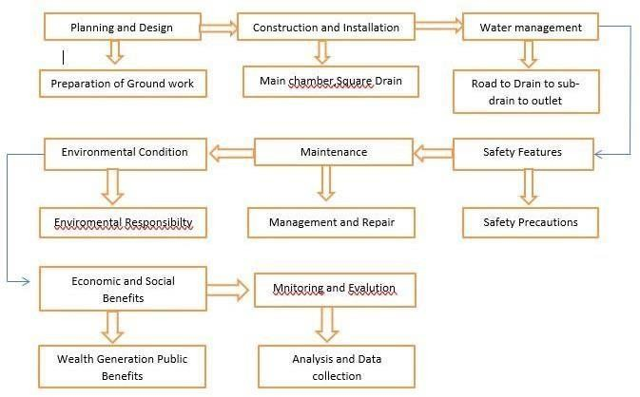

**Fig: 02**

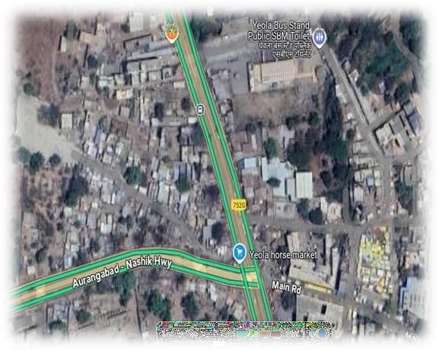

**Fig 03: Mapping location**

1. **DRAINAGE ASSET COST PER KM IN ($)**

|  |  |  |  |  |  |
| --- | --- | --- | --- | --- | --- |
| **SR. NO** | **Drainage Asset Type** | **Size of Item** | **No of Item** | **Cost/Item** | **Total Amount** |
| 01 | Concrete Pipe | 900x900  mm | 400  Nos | 5,500 | 22,00,000. |
| 02 | Steel mesh | 800x1000  mm | 125  Nos | 1,500 | 1,87,000. |
| 03 | Maso nary work | 1000x100  0m m | 25 Nos | --- | 4,01,000. |
| 04 | Filter Drain | 150x150  mm | 30 Nos | 300 | 9,000. |
| 05 | Manh ole | 1000x100  0m m | 25 Nos | 4,000 | 1,00,000. |
| 06 | Manh ole cover s | 950x950  mm | 25 Nos | 1,100 | 27,500. |
| 07 | Total Labo ur cost | ------ | 20  Person | 1,000 | 4,00,000. |

1. **WORKING PROCESS**

At the first we are planning and designing about the sub- surface drainage system to avoid the dieses spread in the atmosphere then constructing and installation of the drainage pipe main chamber we have providing suitable drain pipe like square or circle to be adjustable for the road, Then the water management should be given proper outlet to the drainage for the reuse the water for agriculture or water treatment plant then the safety features should be taken about proper outlet or the cages given to the drain should be strong and proper to the road without disturbing the car or pedestrian on road proper maintenance and repair should be given for avoiding blockage on the road and overloading of the water there should be less small and proper treatment of water for that the every time or once in a month proper monitoring and evaluation on the site is necessary of the contractor this is the process of building proper drainage system on a highway.

1. **NEW DESIGN OF WORK**

As per the new design we have adopted following process:

Preparing the site-firstly we visited the site for the clearance and excavation of site where the drainage is going to be constructed to assessing the amount of rainfall in the area the slope of the land and type of soil.

Determine the layout plan after completing the site survey and deciding on the drainage and material it is time to determine layout of drainage and system it will define the path of the drainage to be taken for water take to reach the drainage system.

Excavate the site-After the layout of the plan excavation should be done to required depth and width. The excavation should be done be level in slope in the direction of drainage system

Placing the pipes-Once the excavation is complete the pipes can be installed it should be buried under proper depth and all joined should be sealed by rubber or silicon repair tape to prevent water seeping out

Install drainage channels we have designed a concrete drainage channels and they should be installed in proper manner and proper slope and level to ensure good water flow.

Install Outlet-Outlet such as basins are used to collect the water from drainage system we are designing outlet to the agricultural or the waste water treatment plant to properly treat the water without any type of mistake of which can lead to diseases.

Cover the Drainage System-The final step is to cover the drainage system with soil or other material to prevent debris from entering the system and we will place a level of gravel or stone to make proper bonding which will help the system to neat water flow.

1. **MEASUREMENT OF THE FOLLOWING DESIGN (METER)**
   * Road length:1000M (1km).
   * Road width:7M.
   * Partion wall:0.254M.
   * Side walk:1.21M.
   * Main drainage:1.70M.
   * Sub-Drainage:1.097M.

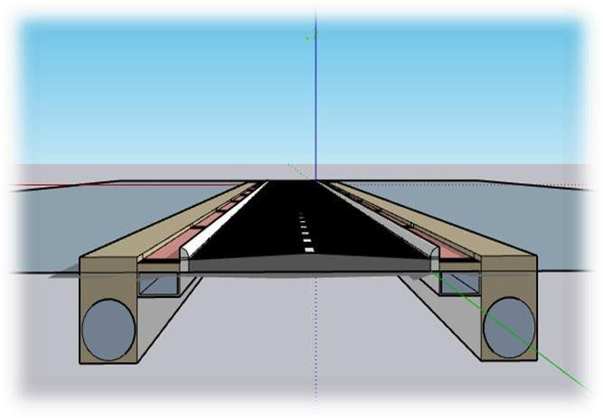

**Fig 04: Road Drainage System.**

1. **CAPITAL COST**

The expenses of material pipes, gravel, etc. Labor equipment and land grinding with cost varying significantly based on soil, drain spacing and installation methods.

Some breakdown of cost-

Material cost-pipe, gravel, other material.

Labor cost- Installation, specialization, contractor.

Land Grading- Land Preparation, slope, Permits, and Inspection- Other cost, soil Types.

1. **MAINTENANCE COST**

The maintenance cost for a sub-surface drainage system can vary depending o n serval; factors including the size of the system the types of material used in local climate and the specific maintenance.

* Inspection and monitoring:-
  + Cleaning and flushing.
  + Repair and replacement.
  + Vegetation management.
  + Pumping and energy.
  + Water quality.
  + Labour.cost.

1. **CONCLUSION**

From the review an efficient road drainage system in highways is for preventing the water accumulation extending road life span, and enhancing the safety and ensuring road stability ultimately reducing maintenance cost and improving traffic condition it also helps in preventing structural damage and also excess moisture in the pavement layers can be lead to various form of structural damage including cracking and we can minimize storm water runoff issues by reducing the risk of flooding and erosion in surrounding areas. Thus the proper design construction and maintenance practices should be adopted to the keep roads drained.

1. **ACKNOWLEDGMENT**

We would like to express our sincere gratitude to all those who contributed to the successful completion of this project. This journey has been both challenging and rewarding, and it would not have been possible without the support, guidance, and encouragement of many individuals and institutions.

First and foremost, we would like to extend our deepest appreciation to **prof. Bharud S.P.** who provided invaluable guidance, constructive feedback, and unwavering support throughout this project. Their patience, expertise, and insightful suggestions played a crucial role in shaping the outcome of this work.

We are also immensely grateful to **S.N.D. Polytechnic Babhulgaon yeola,** for providing the necessary resources, infrastructure, and a conducive environment that enabled to carry out this project effectively. The facilities and access to research materials greatly contributed to the depth and quality of our work.

A special note of thanks goes to our professors and mentors, whose knowledge and encouragement have been instrumental in broadening our understanding of the subject. Their teachings have inspired me to push our limits and strive for excellence.

We would also like to acknowledge the support of my healpers and peers **prof. Dane M.A**, who have been a constant source of motivation and inspiration. The discussions, brainstorming sessions, and mutual encouragement helped me refine my ideas and stay focused.

Our heartfelt gratitude goes to my family and friends, who stood by me throughout this journey. Their unconditional support, patience, and belief in me kept me motivated, especially during challenging times. Their encouragement has been a driving force in overcoming obstacles and staying committed to the project.

Lastly, we would like to thank everyone who directly or indirectly contributed to the successful completion of this project. Your help, guidance, and support have been invaluable, and we truly appreciate each and every one of you.

This project is a testament to the collective efforts of many individuals, and we forever grateful for the opportunity to learn, grow, and accomplish this milestone.

Thank you.

1. **REFERENCES**
   * World Road Association (PIARC): "Drainage of Road Pavements" (2018).
   * "Efficient Design of Road Drainage Systems" by Aranda et al. (2021)
   * Types of Road Drainage Systems: Need, Requirements, Defects"
   * Guidelines for road Drainage, Department of environment, Heritage and local government, Ireland [April 2004]
   * A manual of Guidelines of road drainage by Indian Road Congress “IRC-SP- 42:2014”
   * A course in Highway Engineering “S.P.Bindra”.
   * [https://www.scribd.com/doc/60301080/Un](https://www.scribd.com/doc/60301080/Unit-8-) [it-8-](https://www.scribd.com/doc/60301080/Unit-8-)
   * HIGHWAY-DRAINAGE
   * [http://www.aboutcivil.org/highway-](http://www.aboutcivil.org/highway-drainage-design-guidelines-structures.html) [drainage-design-guidelines-structures.html](http://www.aboutcivil.org/highway-drainage-design-guidelines-structures.html)
   * Optimal Layout and Pipe Sizing of Urban Drainage Networksto Improve Robustness and Rapidity. Journal of Water Resources Planning and Mgt. Vol. 147 Issue 4 – April 2021.