**Speed Synchronization of Multiple Motor in Industry**

**Prof. M. R. Wankhade, Mr. R. S. Mundokar, Mr. R. G. Sonar, Mr. S. I. Lande, Mr. U. U. khan, Miss. S. A. Kale, Miss. A. G. Piwate, Miss. S. S. Ingale**

Department of Electrical Engineering, (Polytechnic)

Padmshri Dr V B Kolte college of Engineering, Malkapur, Buldhana, 443101

**Abstract:**

In several industries, such as textile production, woodworking for paper, and metallurgy in steel plants, speed synchronization among motors is essential to allow functioning together without hurting the material. The mechanical transmission-based synchronization methods were traditional but cumbersome and offered little flexibility in operation.

This project revolves around a wireless scheme for speed synchronization of multiple motors via the HC-05 Bluetooth module, without having to use a dedicated transmitter. In the given setup, one motor acts as a master and the others are slaves. The speed of the master motor is monitored and then wirelessly transmitted through the HC-05 module to the slave motors. Each slave motor reads the speed details of the master and adjusts its speed so that synchronization is achieved.

The implementation uses microcontrollers for processing speed details and controlling the operation of the motors through PWM signals. The control mechanism also comprises feedback devices such as sensors mounted on the shafts to provide real-time speed information for accurate control. This wireless method of speed synchronization provides the advantage of flexibility, minimizes the complexity of wiring, and enhances scalability, making it attractive to modern industrial applications.

**Keywords:** **Speed synchronization of motor, Automation, Protection, Control, Microcontroller, Fault Detection, Real Time Control.**

**INTRODUCTION**

As electric motor-driven machines are becoming increasingly favoured in modern industries, they have gained significance. Induction motors are economical, hardly demand any maintenance due to their simple rotor design, and good with a power factor because their construction is compact and has high durability and cost efficiency. The induction motor is endowed with excellent speed control, overload capability on a continuous basis, and leading starting torque. This gives rise to the applications of induction motors in industries, crane elevators, home, and farm motors.

Internet of Things (IOT), which received growing interest as a technology making possible the current wave of wireless communication improvements, has countless advantages. Remote access is part of the duty that IoT plays in achieving industrial automation. A commonplace system can interconnect many IoT devices. From this system, vital data and performance optimization parameters are exchanged across different devices to maximize performance.

The prototype illustrated the IOT- supported parameters such as speed measurement using a sensor and cloud for Induction motor monitoring, and controlling Induction motor speed through TRIAC control since its speed can easily be adjusted by changing the supply voltage. Its main goal is to build an inexpensive and efficient protection design for induction motors. The protection system shall protect against under and over voltage, ensuring that production in industries is sustained. Continuous measurement of parameters can also improve the efficiency of motors. Identifying any fault developed in the induction motor.

**LITERATURE SURVEY**

1. **"Centralised Speed Synchronization of DC Motor using Wireless Communication"**  
   *Authors:* Abhishek B, Yashaswini S, Lokesh Kumar, Sandhya M N  
   *Published in:* International Journal of Engineering Research & Technology (IJERT), Volume 6, Issue 13, 2018  
   *Summary:* This paper discusses a system designed to control the speed and synchronization of DC motors using wireless modules, enhancing efficiency and reducing maintenance in industrial settings.
2. **"Speed Synchronisation of Multiple Motors and Variable Flow Controlling of Motor"**  
   *Authors:* Gauri R. Shinde, Ashwini T. Deshmukh, Prof. R. V. Katre  
   *Published in:* International Research Journal of Engineering and Technology (IRJET), Volume 4, Issue 2, 2017  
   *Summary:* The study presents a microcontroller-based design and implementation for speed control of motors, addressing the need for effective control methods in industrial applications.
3. **"Speed Synchronization of Multiple BLDC Motor Drive using Arduino"**  
   *Authors:* Not specified  
   *Published in:* IEEE Conference Publication, 2023  
   *Summary:* This paper explores the use of Arduino microcontrollers for the speed synchronization of multiple Brushless DC (BLDC) motors, highlighting the system's design and performance in industrial applications.
4. **"Speed & Direction Control of DC Motor through Bluetooth HC-05 Using Arduino"**  
   *Authors:* Not specified  
   *Published in:* IEEE Conference Publication, 2019  
   *Summary:* The study focuses on controlling the speed and direction of a DC motor via Bluetooth communication using the HC-05 module and Arduino, demonstrating a wireless approach to motor control.
5. **"Speed Control of Single Phase Induction Motor by Android Bluetooth"**  
   *Authors:* Not specified  
   *Published in:* International Research Journal of Engineering and Technology (IRJET), Volume 4, Issue 1, 2017  
   *Summary:* This paper presents a method for controlling the speed of a single-phase induction motor using an Android device and Bluetooth technology, showcasing the integration of mobile platforms in industrial motor control.
6. **"A Review Paper on Synchronization Speed Control of Multiple Motors"**  
   *Authors:* Prof. S. D. Lavange, Vaibhav D. Kakar, Gaurav H. Bhagat, Abhishek S. Rodhe, Aarti S. Kale, Ujvala A. Thorat  
   *Published in:* International Journal for Science and Advance Research in Technology (IJSART), Volume 11, Issue 1, 2025  
   *Summary:* This review paper discusses various methodologies for synchronizing and controlling the speed of multiple motors, emphasizing the role of microcontrollers and wireless communication in modern industrial automation.
7. **"Speed Synchronization and Control of Multiple Motors Using PWM"**  
   *Authors:* Not specified  
   *Published in:* International Research Journal of Engineering and Technology (IRJET), Volume 4, Issue 2, 2017  
   *Summary:* The paper explores the use of Pulse Width Modulation (PWM) techniques for the synchronization and control of multiple motors, highlighting the advantages of microcontroller-based systems in industrial applications.
8. **"Speed Control of 3-Phase Induction Motor using Single Phase Supply and Bluetooth Technology"**  
   *Authors:* Engr. Manan Shah  
   *Published in:* Not specified  
   *Summary:* This study investigates the control of a three-phase induction motor powered by a single-phase supply, utilizing Bluetooth technology for wireless speed regulation, and discusses the practical implementation and benefits in industrial settings.
9. **"Speed Synchronization of Multiple Motors in Industries using PIC Microcontroller"**  
   *Authors:* Ibrar Ayyub  
   *Published in:* PIC Microcontroller Projects, 2023  
   *Summary:* The project aims to synchronize multiple motors using wireless technology, specifically employing PIC microcontrollers and radio frequency communication, to enhance operational efficiency in industries like textile and steel plants.

**PROBLEM IDENTIFICATION**

To achieve synchronized operations among the motors, speed synchronization becomes essential in many motor applications such as industrial applications. This applies a need for resolving issues that could suffice synchronization challenges:

* **Differentiations Among Motor Specifications:** At their respective differences in terms of power rating, manufacturing tolerances, load conditions, etc., inconsistencies arise concerning speed and torque outputs, therefore making synchronization difficult.
* **Control Strategy Limitations:** Traditional control approaches such as parallel or master-slave configurations would fail to adequately respond to disturbance and dynamic shifts, causing loss of synchronization.
* **Communication Delays and Latencies:** Delays accrue in systems where motors no longer carry signals and rely on wireless communication systems due to signal transmission time, resulting to asynchronous operations of the motors.
* **Environmental Interference:** The industrial environment is generally very harsh, suffering from such adverse conditions as electromagnetic interference, temperature changes, and obstructions and/or flunkiness in the computer or physical base where such systems are housed, making even wired or wireless communication systems susceptible to the influence of adverse conditions, inviting more or fewer synchronization problems.
* **Scalability Problems:** The increasing number of motors in such a system increases the complexity associated with synchronization design and maintenance; hence, sophisticated algorithms and communication protocols are necessary.

**COMPONENTS(TOOLS)**

**Arduino uno (Microcontroller):**

Operating based on temperature, speed, and current inputs to monitor the operation of motor and control it.

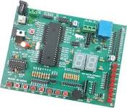

Fig.1. Micro Controller

**Temperature Sensors:**

Provides Overheat Protection RTD (Resistance Temperature Detector) or Thermocouple – to observe the temperature of the motor.

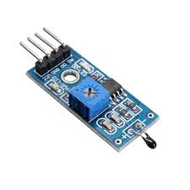

Fig.2. Temperature Sensor

**Speed and Position Sensors:**

**Ultrasonic sensor**

Senses motor shaft speed and is an important input to control systems, protecting against abnormal speeds.

**Vibration Sensor (SW420):**

It provide a protection from Imbalance in motor and give protection from damaging it.

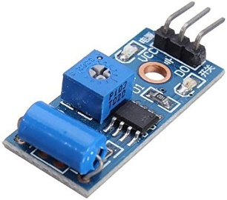

Fig.3. Vibration Sensor

**Power Electronics Components**:

**Transistor:**

Used in soft starters for controlling the voltage and current supplied to the motor.

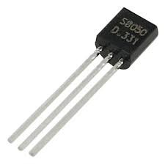

Fig.4.Transistor

**Diodes and Rectifiers:**

For converting AC to DC in the motor drive system.

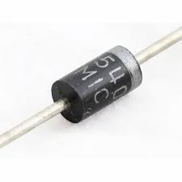

Fig.5. Diode

**Arduino IDE exe software:**

For programming of Micro controller(Arduino uno)

**Alarm System:**

Provides visual or audible warnings when a fault is detected, such as overload, over-temperature, or phase failure.

**RESULT(OUTPUT)**

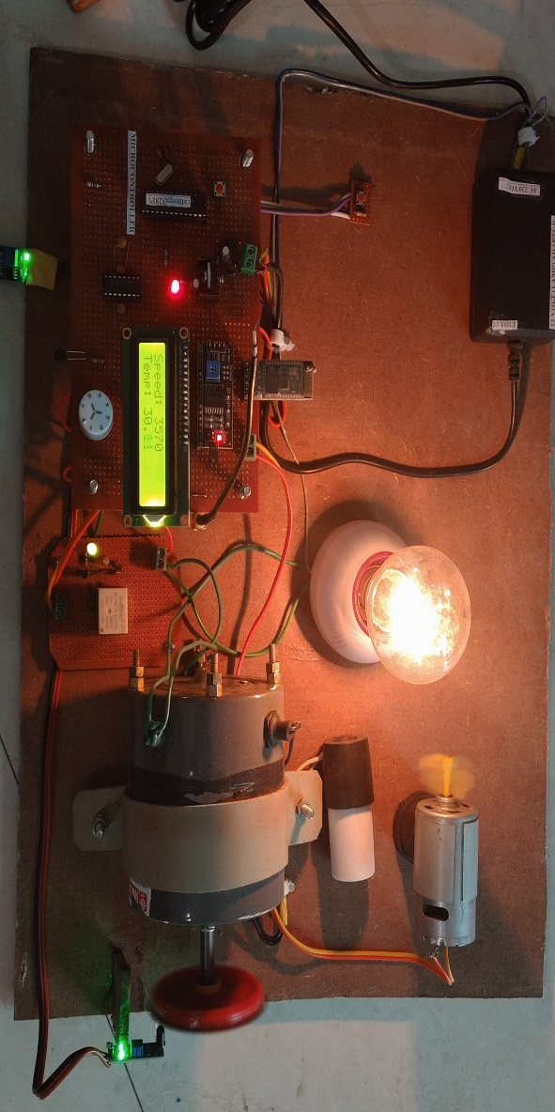

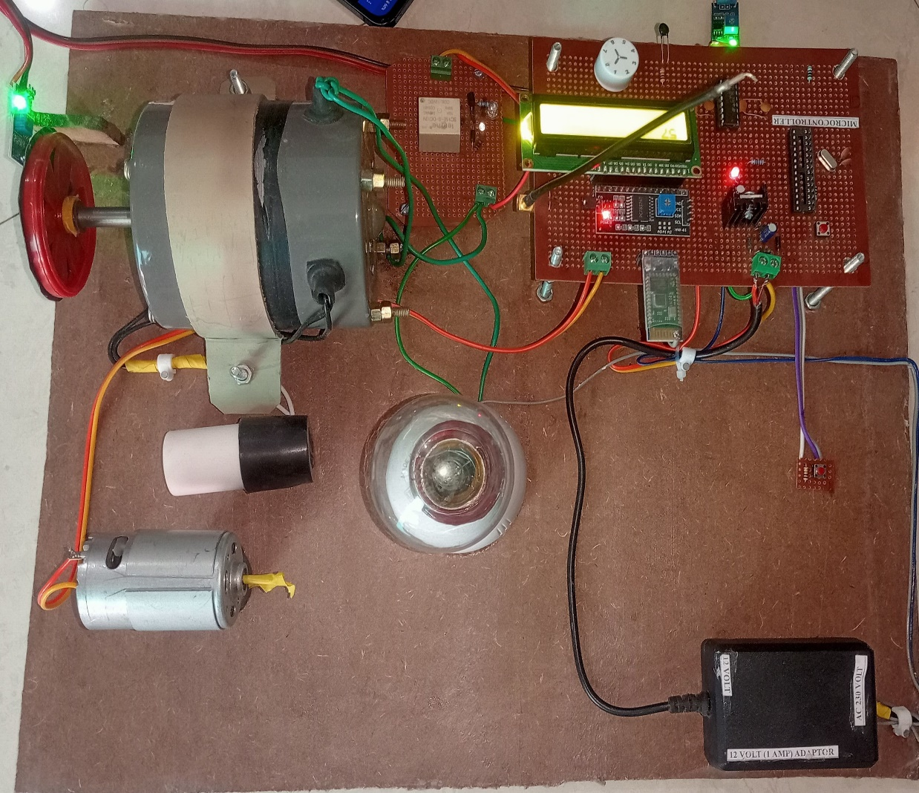

**CONCLUSION AND FUTURE SCOPE**

**Conclusion:**

The precise speed synchronization of multiple motors is vital for coordinated operations and to prevent damage to the products in various industrial applications, such as textile mills, paper mills, and conveyor systems. Conventional methods involving mechanical transmissions can be cumbersome since they involve setup with line shafts, gears, and pulleys, increasing maintenance requirements and lowering flexibility. Wireless technologies come into play in this arena, especially using devices like HC-05 Bluetooth.

The wireless speed synchronization revolves around microcontrollers monitoring the motor speeds of the different setups. The speed of a master motor in a setup is typically transmitted to slave motors that adjust their speeds to maintain synchronization. This approach frees up highly complex wiring and makes the system more scalable. However, limitations exist when it comes to range and interference with industrial power electronics in addition to ensuring real-time performance to maintain integrity.

To conclude, wireless speed synchronization with an HC-05 Bluetooth module stands to be a foremost weaponry to modernize an industrial motor control scheme, which must be carefully studied and evaluated through environmental conditions, system design, and communication protocol strength to reap its benefits.

**Future scope:**

The future of speeding up sync among multiple motors and motor driven operations in different categories of industrial application through wireless technology like HC-05 Bluetooth module looks very bright and promising in many aspects. It has various avenues in their future:

* **Market Growth and Adoption:** The international wireless motor control systems market is poised for a significant turnaround, and it would cross the estimated value of $957.3 million by 2032, following the increasing demand for automation and flexible manufacturing processes.
* **Integration with New Age Technologies:** The integration of wiress motor synchronization with IoT and deep analytics would also allow real-time monitoring, predictive maintenance, and energy optimization, thereby enhancing operational efficiency and decision making.
* **Technological Advancements in Wireless Communication:** As the new emerging wireless communication technologies such as 5G, NB-IoT provide higher performance and lower latency and ensure better reliability for motor synchronization applications they will pave the way for more robust and scalable solutions.
* **Emerging Industries Extension:** New industries such as renewable energy, electric vehicles and smart infrastructure provide wider room for opportunities in wireless motor synchronization solutions, as most of them will need good and flexible motor control systems actually to operate their novel business processes.
* **Focus on security and standardization:** With the increasing penetration of wireless systems in different industries, securing the system robustly and developing standards will certainly go a long way in protecting unauthorized access and providing seamless integration of varied industrial platforms.

**REFERENCE**

1. Rakesh Makode1 , Vibha Nikose2 , Zeeshan Ahmad3 , Adarsh Ramteke4 , Nidhi Paunikar5 , e4 , Nidhi Paunikar5 , Vishal Dashriya6 , Prof. D.D. Dhawale “IOT Based Automation and Monitoring of Motor” National Conference on “Recent Trends in Elec- trical Engineering” NCRTEE-19 Organized by Pri- yadarshini College of Engineering, Nagpur-440019 In- ternational Journal of Innovations in Engineering and Science, Vol. 4, No.7, 2019, e-ISSN: 2456-346.
2. Lata Chavan 1 , Prerana Chafekar2 , Avnish Bhatt3 , Mitesh Patel4 , Sarika Kuhikar “PIC Based Protection of Single Phase motor” International Ad- vanced Research Journal in Science, Engineering and Technology ISO 3297:2007 Certified Vol. 4, Issue 4, April 2017 Copyright to IARJSET DOI10.17148/IARJSET.2017.4404 22.
3. Jose L. Gonzalez-Cordoba, Roque A. Osornio-Rios” Thermal impact-based protection of induction motors under voltage unbalance conditions” Member, IEEE, David Granados-Lieberman, Member, IEEE, Rene de J. Romero-Troncoso, Senior Member, IEEE, and Martin
4. Hannan, M. A., Ali, J. A., Mohamed, A., & Hussain, A. (2018). Optimization techniques to enhance the performance of induction motor drives: A review. Renewable and Sustainable Energy Reviews, 81(September 2016), 1611–1626. https://doi.org/10.1016/j.rser.2017.05.240
5. Subasri, R., Meenakumari, R., Panchal, H., Suresh, M., Priya, V., Ashokkumar, R., &Sadasivuni, K. K. (2020). Comparison of BPN, RBFN and wavelet neural network in induction motor modelling for speed estimation.
6. International Journal of Ambient Energy, 0(0), 1–6. https://doi.org/10.1080/01430750.2020.1817779
7. Talla, J., Leu, V. Q., Smidl, V., & Peroutka, Z. (2018). Adaptive speed control of induction motor drive with inaccurate model. IEEE Transactions on Industrial Electronics, 65(11), 8532–8542. https://doi.org/10.1109/TIE.2018.2811362
8. Sobhi, S.; Reshadi, M.; Zarft, N.; Terheide, A.; Dick, S. Condition Monitoring and Fault Detection in Small Induction Motors Using Machine Learning Algorithms. *Information* **2023**, *14*, 329. <https://doi.org/10.3390/info14060329>
9. Gudiño-Ochoa, A.; Jalomo-Cuevas, J.; Molinar-Solís, J.E.; Ochoa-Ornelas, R. Analysis of Interharmonics Generation in Induction Motors Driven by Variable Frequency Drives and AC Choppers. *Energies* **2023**, *16*, 5538. https://doi.org/10.3390/en16145538
10. Chang, Y., Yan, H., Huang, W., Quan, R., & Zhang, Y. (2023). A novel starting method with reactive power compensation for induction motors. *IET Power Electronics*, *16*(3), 402-412.
11. Priya V. Kale, Amit M. Kale, Nikhil R. Kamdi, Prof. Ankita A. Yeotikar, “Protection of induction motor using classical method”, International Research Journal of Engineering and Technology, Volume: 04 Issue: 01 | Jan -2017.