**Virtual Personal Desktop Assistant**

**Ritesh T, Dr. M. Praneesh**

UG Student, Computer Science With Data Analytics, Sri Ramakrishna College of Arts & Science, Coimbatore, Tamilnadu, India.

Assistant Professor, Computer Science With Data Analytics, Sri Ramakrishna College of Arts & Science, Coimbatore, Tamilnadu, India.

**ABSTRACT**

A virtual assistant is an advanced application developed to understand and respond to spoken prompts delivered through ordinary language. This revolutionary technology has consistently gained common acceptance. It can easily do a lot of things on a computer. Virtual assistants represent diverse resources upon which users are able to depend across multiple uses, including a checking of the current date and time, a searching across the internet, an opening of applications easily, and an engaging across specific interactions, for example, across warmly greeting users. These assistants provide a good deal of flexibility as well, empowering people to change their characteristics in order to accommodate personal preferences along with requirements. During the creation of a digital helper, a firm grounding in Python is needed, spanning simple coding ideas to advanced executions. By leveraging on Python's capabilities, developers can create assistants that understand voice commands as well as process information cleverly, in addition to executing through several different tasks smoothly. Virtual assistants in this category notably improve user interactions alongside computers, making daily activities controllable and efficient

**Keywords:** Voice Commands, Natural Language Processing (NLP), Speech Recognition, Text-to-Speech (TTS),API Integrations, Web Scraping, Application Control, Hardware Detection

1. **INTRODUCTION**

A Virtual Personal Desktop Assistant (VPDA) is like having a smart helper on your computer that listens to your voice or text commands and performs tasks for you. It makes everyday computing easier by automating actions like opening applications, searching the web, setting reminders, and even monitoring system performance. At its core, the VPDA has different modules working together. The Speech Recognition Module listens to your voice and converts it into text, while the Natural Language Processing (NLP) Module understands what you’re asking. Once it figures out your request, the Command Execution Module acts, whether it’s adjusting system settings, launching an app, or fetching information from the internet. After completing the task, the Response Module provides feedback either through voice or text, so you know the job is done. Beyond just following commands, the assistant can connect with other applications and tools through its Integration Layer, allowing it to control browsers, file managers, or cloud services. The Memory Module helps personalize your experience by remembering your preferences and frequently used commands, while the Monitoring Module keeps an eye on your CPU and RAM usage, ensuring smooth performance. The VPDA follows a simple process it listens, understands, executes, and responds making your interaction with the computer effortless. Whether you want to open an app, check the weather, or optimize system performance, it acts as a smart companion, helping you save time and work more efficiently.

1. **METHODOLOGY**
2. Input Stage
3. Speech Recognition Module
4. Voice Command Processing
5. Python Processing Unit
6. API Calls
7. Content Extraction
8. Speak-to-Text and Text-to-Speech (TTS)
9. Output Stage
10. **INPUT STAGE:** In the Input Stage, the user interacts with the desktop voice assistant through voice commands for tasks like opening apps, fetching weather updates, or setting reminders. The assistant captures and processes the voice input, ensuring accuracy for effective execution.
11. **SPEECH RECOGNITION MODULE:** The Speech Recognition Module uses ASR technology to convert spoken words into text for processing. Its accuracy depends on factors like background noise, pronunciation, and language model efficiency.
12. **VOICE COMMAND PROCESSING:** The Voice Command Processing Module uses NLP to analyze text input and understand user intent. It maps commands like “Open Google Chrome” or “What’s the weather like?” to the appropriate actions for execution.
13. **PYTHON PROCESSING UNIT:** The Python Processing Unit acts as the system’s brain, executing commands and fetching data when needed. It handles tasks like retrieving word definitions or automating system operations, ensuring smooth assistant functionality.
14. **API CALL:** API Calls enable the assistant to fetch real-time data from external sources like news or weather services. By interacting with APIs, the assistant provides dynamic and up-to-date responses to user queries.
15. **CONTENT EXTRACTION:** The Content Extraction Module retrieves and processes data from websites or databases, ensuring relevant and structured output. For example, if asked “What is Python?” it extracts key information from sources like Wikipedia for a clear response.
16. **SPEAK-TO-TEXT AND TEXT-TO-SPEECH (TTS):** The Text-to-Speech (TTS) Module converts processed text into speech for verbal responses, enabling hands-free interaction. If in text mode, responses are displayed on-screen, ensuring clear and effective communication**.**
17. **OUTPUT STAGE:** The Output Stage delivers responses through speech, text, or actions. Whether providing the time or launching an application, this stage ensures smooth and interactive user experiences**.**
18. **MODELING AND ANALYSIS**

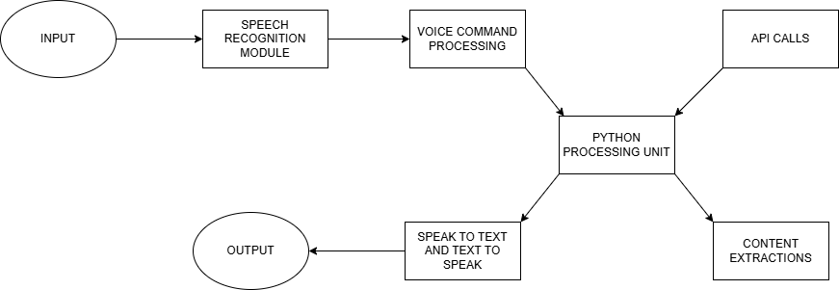

Figure 1: System Work Flow

1. **RESULTS AND DISCUSSION**

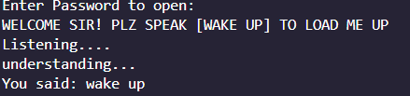

**Figure 2:** Wake word activation

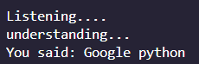

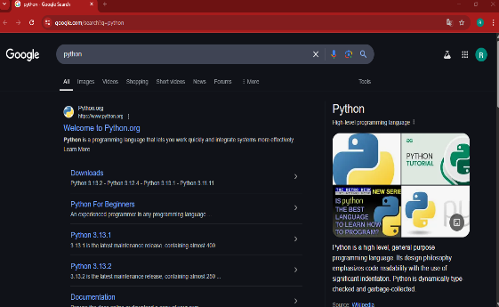

**Figure 3:** Google python and then performing a Google search for python.

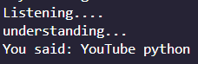

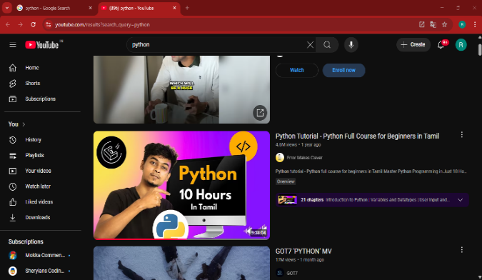

**Figure 4:** YouTube python and subsequently displaying YouTube search results for python

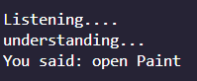

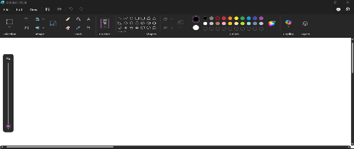

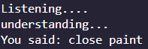

**Figure 5:** To open paint and close paint

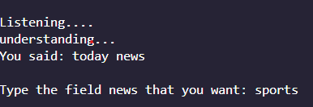



**Figure 6**: News

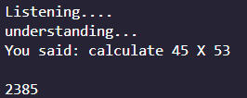

**Figure 7:** Calculate

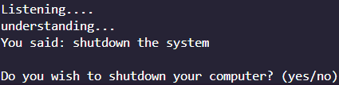

**Figure 8:** Shutdown the System



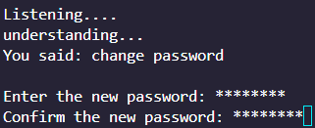

**Figure 9:** To enter the password and change the password

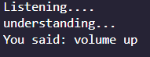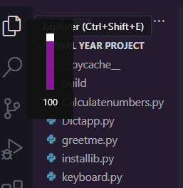

**Figure 10:** To increase the volume

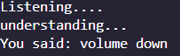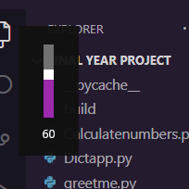

**Figure 11:** To decrease the volume

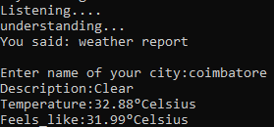

**Figure 12:** Weather report

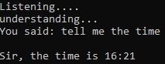

**Figure 13:** Time

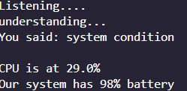

**Figure 14:** Checking the System Condition

1. **CONCLUSION**

The proposed Virtual Personal Desktop Assistant enhances user interaction with computers through voice commands, offering seamless automation and efficiency in performing various tasks. By integrating speech recognition, natural language processing, text-to-speech conversion, and automation tools, the assistant allows users to open applications, browse the internet, fetch real-time news and weather updates, monitor system performance, and manage documents effortlessly. With its ability to learn and adapt to user preferences, the system significantly improves productivity, minimizes manual effort, and provides a more intuitive computing experience. This project demonstrates the potential of AI-driven personal assistants in transforming daily digital interactions, making technology more accessible and user-friendly.

1. **REFERANCE**
2. Akhil Cherian Jacob, Harigovind M, M. Nikhil, Sharon Geo Reji, and Jyothis Joseph. Developed a virtual personal AI desktop assistant using Python and the Speech Recognition API to enable voice-controlled functionalities such as emailing, web searches, and application launches.
3. V. Appalaraju, V. Rajesh, K. Saikumar, P. Sabitha, and K. R. Kiran. Designed an intelligent voice personal assistant using Python for improved computer interaction.
4. S. Subhash, P. N. Srivatsa, S. Siddesh, A. Ullas, and B. Santhosh. Developed an AI-based voice assistant for natural user interaction and response processing.
5. K. V. Kulhalli, K. Sirbi, and M. A. J. Patankar Developed a personal assistant with voice recognition to execute user instructions.