Door unlock system using face recognition 
Dinkey Banchhorª, Dimple Gayakwad^{b}, Shweta Tiwari^{c} , Amar Kumar Dey^{d}
ªStudent, Department of Electronics and Telecom, BIT Durg, 490006, Chhattisgarh, India
^{b} Student, Department of Electronics and Telecom, BIT Durg, 490006, Chhattisgarh, India
^{c} Student, Department of Electronics and Telecom, BIT Durg, 490006, Chhattisgarh, India
^{d}Associate professor, Department of Electronics and Telecom, BIT Durg, 490006, Chhattisgarh, India
Abstract
Face recognition is a technique for recognizing or validating an individual\'s identification by looking at their face. Face recognition software can identify persons in photographs, videos, or in real time. During police stops, officers may use mobile devices to identify persons. Computer vision is a method for understanding how photos and movies are stored, as well as manipulating and retrieving data from them. Artificial Intelligence relies on or is mostly based on computer vision. Self-driving cars, robotics, and picture editing apps all rely heavily on computer vision. The software used is OpenCV Library which is useful to display and process the image produced by webcam. In this paper, we employ Haar Cascade Classifier in an image processing of user face to render the face detection with high accuracy

- Introduction
A ubiquitous property of human perception is our ability to tell apart between different faces even once they look similar and recognize many different Individuals with almost no effort. Automated face recognition is vicinity within Computer Vision inspired by this ability. Biometric identification systems specialize in extracting faces from static images and video sequences and deciding whether
or not they belong to a database of known individuals.[1]. Now-A-days in this world is connected to the smart devices there is a crucial need that is to improve the existing objects and make them smart. Especially to our door locks. The major disadvantages in a normal door locking system are that anybody can open a normal door by a duplicate key and it's very difficult if we want our friends and family to get into our house. This is why we cannot decrease these problems. So just change this
normal door locking system into a facial recognition enabled smart door lock, which we can open the door whenever we want, so this implementation has come where devices can interact

with the users and at the same time verify the safety and keeping them smart. To avoid thefts and identity fraud, a face recognition system should be established. The objective of the project is to develop a security management application supported by face recognition. Face recognition has become one of the most important user identification methods. For attaining the accuracy and effectiveness we tend to use OpenCV libraries and python computer-oriented
language. Microsoft face API application is used, in hardware part we are using Microcontroller, Solenoid lock, Relay driver, and camera module etc..[2].

We live in the twenty first century wherever everything is most well-liked to be quick contactless and automatic. COVID has even additional accrued the necessity for contactless systems. Well, here we tend to propose a contactless button further as safety system mistreatment IOT for automatic travel recognition and alerting homeowner.
Biometrics is unique to an individual and is used in many systems that involve security. Face is one of such biometrics that has gained importance in applications like security systems, identification of criminals, control of door access, attendance, identity verification, emotion recognition etc... Face recognition can be considered as one of the most reliable methods for security check since it is non-invasive and can be done without the subject being aware of it. The face recognition algorithms can be grouped into three categories: Holistic, Feature-based and Hybrid. The complete face is taken as input data in holistic methods, whereas in feature-based approach, the local features are extracted first. Hybrid method is a combination of both these methods. Most of the face recognition systems available today work under controlled environment. Variation in lighting, pose, facial expression, occlusion, ageing, etc., are some of the key factors that greatly influence the accuracy and efficiency of face detection and recognition [3].
2. Propose System
The proposed works are as follows:
(1) Interfacing of camera to capture live face images.
(2) Create a database of authorized person if they exist.
(3) Capturing current image, save it and compare with
the database image.

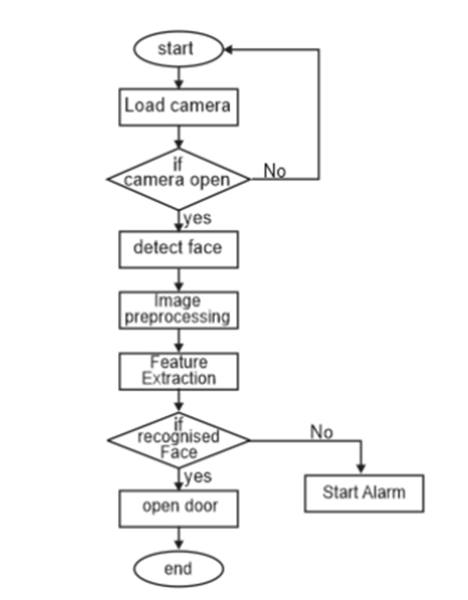

The system will works in two different parts. The first part is for capturing and creating a database by storing the image. And the second one is to compare the image with the stored images in the database.
Camera Module: Camera module is pi camera interfacing to the raspberry pi module. It is used to capture images and send the clicked images to the raspberry pi module. Camera contains LEDs and flashes to handle that light condition that is not explicitly supplied by the environment and these light conditions are known as ambient light conditions.

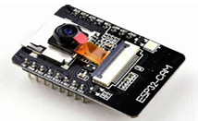

Raspberry Pi Module: Raspberry pi 3 module is a small computer board. When an image is taken by raspberry pi it is compared with database image. For the first time when we capture an image to Create a database raspberry pi module captures many images to create a database in the system and this database is compared with the live captured images. After comparing the two images, based on whether the output is positive or negative it gives commands to GSM module.

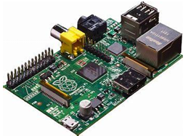

GSM Module: GSM module is used to send a message to the authorized people based on the output. If the output is positive “Information matched Access granted” message will be sent to the authorized people, otherwise in case of unauthorized access it will send an “Access denied. Some unknown person is trying to unlock the door”. Message to the certified users of the system.

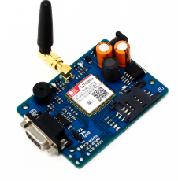

3. IMPLEMENTATION
The paper is face recognition with the help of Raspberry Pi for the door unlocking, which ensures that our homes are safely protected. Raspberry Pi operates the video camera to capture images and monitors them. Open CV/ Python Library is developed by using a stored facet database as a given picture of a scene to recognize or check one or more people in the scene. The pictures are then derived and will match photographs from the collection. The door opens automatically if the pictures are paired. Otherwise, the door lock remains closed.
In this research, 3 very distinct phases for Face Recognition were considered:
A. Data Collection
We worked with face detection using this Haarcascade classifier. We need to extract features from positive and negative
images and train the model which then detects the faces. The OpenCV consists of a trainer as well as a detector. OpenCV already contains many pre-trained classifiers for face, eyes, smile, etc. Those XML files can be download from Haarcascades directory. This python code consists of 2 phases face detection and then gathering the detected data into a dataset. For collecting the data into the dataset, create a folder to hold the data inside the project directory.
B. Train the Model
On this second step, we took all user data from the dataset and train the OpenCV Recognizer. This is done straight by a specific OpenCV function. The result will be a .yml file that will be saved on a “trainer/” directory. A new python file training.py is created to write the trainer program.
C. Recognize the Faces
In the final step of the project, we will capture a fresh face on our camera through a live video stream and if this human’s face is snapshotted and features extracted before, the recognizer model makes a prediction returning the person’s name and an index, shown how confident the recognizer is with this match. And then the solenoid lock is opened to which the electrical is send by raspberry Pi through the relay module.

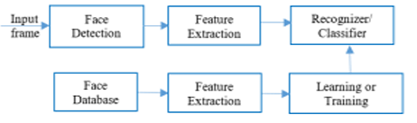

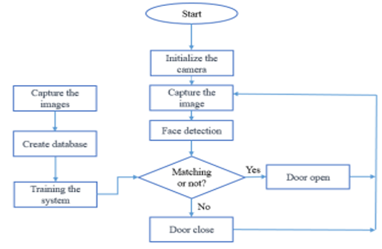

Flowchart

4. Result and Discussion
The Result of this project is showed in below photos: If raspberry pi recognizes a face, it will open the door lock and send an email alert. Here, a solenoid lock and a Pi camera will be used with Raspberry Pi to build this face recognition-based door lock system using Raspberry pi.

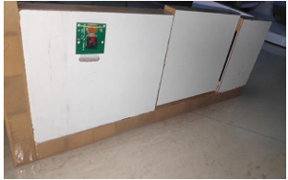

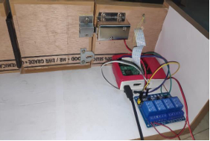

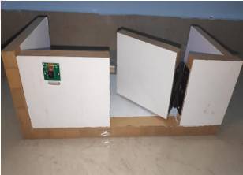

Advantages:
- Maximizing home security.
- Remote control of home functions.
- Increased energy efficiency.
- Consumes less power.
- Home management insights.
Disadvantages:
- Reliable internet connection is crucial.

5. Future Scope
1. The Face Recognition Lock Door Lock System using Raspberry Pi is a cutting-edge security solution designed to enhance access control in residential or commercial settings.
2. This system combines two secure authentication methods for door entry. First, it utilizes facial recognition technology to grant access to authorized individuals, ensuring seamless and convenient entry.
3. Additionally, a keypad lock is integrated for those who prefer or require a traditional PIN-based entry method.
Users can easily switch between these two methods based on their preference or security needs.
4. The Raspberry Pi serves as the central processing unit, managing access permissions and logging entry data. This system offers flexibility, convenience, and heightened security for any environment

6. Applications
- Offices: Physical access to workspace facilities
- Government: Transfer important document
safely
- Banking and Telecom: Help to know the current process to the customer, allow authentication of credit/debit cards
- Education: Allow attendance tracking of the
students and entry to labs
- Construction: Control access to specific point at a site
- Real Estate Commercial: Offers access to
campus facilities like residence halls, common
area, cafeteria, etc.
- Manufacturing: Control and record access to
specific locations for employees, visitors, vendors
and maintenance staff.
- Aviation: Paperless travel at airports
- Warehouse: Control process to provision entry
and exit of vehicles
- Entertainment: Access to multiplex cinema
- Hotels: Entrance and exit after reservation in hotels

7. Conclusion
The proposed facial recognition secure door operating system is built, in which an Haar classifier is used for face detection, local binary pattern histogram algorithm for facial recognition, camera to capture the images and raspberry pi for processing these operations along with sending the signals to relay for door locking and unlocking.

In this project, a Secured Door Lock System Based on Face Recognition using Raspberry Pi and GSM module is presented. We designed the system which provides security locks for door, comfort, connivance security and energy efficiency for user.

References
- Nwukor Frances Nkem. (2022). Face recognition door lock system using raspberry pi. GSJ: Volume 10, Issue 8, 2320-9186.
- Saim Khot, Shivraj Kadam, Chinmay Patil, Ankita Raut, Swapnil Kharat.Smart door unlock system using face recognition. International Research Journal of Modernization in Engineering Technology and Science, Volume:04/Issue:04/April-2022
- Mr.Rishabh Mantri, Mr.Rohit Kalveni, Mr. Mayur Vishwakarma, Prof.Amruta B.Kale (2023). Door locking System using face recognition. IRJMETS Volume 05, Issue 04, 2582-5208.
- A Raghu Prasath, Aditya Kumar, Akanksha Yadav, Bhuvishri Acharya, Md Tauseef. (2020). Face recognition door lock system. IRJET Volume 07, Issue 05, 2395-0056 ,2395-0072.
- Mr.Saurabh bhangale, Mr.Lalit Patil, Mr.Umesh Patil, Mr.Yogesh Patil. (2024). Face recognition door lock system using raspberry pi. IJERMCA Vol. 13, Issue 4, 2319-7471.
- ] M.Manasa, B.Sanjay Kumar, K.Harshavardhan Reddy, A.Rajesh. (2022). Face recognition door lock system using raspberry pi. IRJMETS Volume 04, Issue 06, 2582-5208.

