**CURRENCY BASED INVOICE APPLICATION FOR IT SECTOR**

L.R RAHUL PRASATH Dr. R. SENTHIL KUMAR

Student

Dept of Computer Science with Cognitive Systems Dr. N. G. P. Arts and Science College

Coimbatore, India

Email: [rahulprasath28022005@gmail.com](mailto:rahulprasath28022005@gmail.com)

Professor

Dept of Computer Science with Cognitive Systems Dr. N. G. P Arts and Science College

Coimbatore, India

Email:

[senthilkumar.r@drngpasc.ac.in](mailto:senthilkumar.r@drngpasc.ac.in)

**Abstract**

With the IT industry globalization, companies perform cross-border transactions, and there is a requirement for a proper currency-based invoicing system that can handle different financial regulations, exchange rate fluctuations, and multi-currency transactions. This paper presents a Currency-Based Invoice Application for IT firms with real-time exchange rate integration, automated tax calculation, and multi-currency support. The system offers increased financial transparency, minimizes errors, and ensures international taxation laws compliance. It also has seamless payment gateway integration and automated compliance reporting, minimizing manual effort and financial risk. This research describes its architecture, primary functionalities, implementation issues, and potential improvements, providing an overview of its operational advantages and benefits for IT firms operating across nations. With the application of automation and real-time access to information, the application enables increased financial efficiency, security, and scalability.

**Keywords - (**Currency-Based Invoice, IT Sector, Multi-Currency Support, Exchange Rate, Tax Compliance.)

1. **INTRODUCTION**

IT is a global industry by nature, with firms outsourcing projects, employing global freelancers, and serving clients all over the world. With businesses undertaking cross-border partnerships, they encounter major difficulties in handling financial transactions in various currencies and regulatory environments. Conventional invoicing processes tend to fail when dealing with currency exchange, varying exchange rates, and different tax laws in multiple jurisdictions, causing financial inefficiencies, compliance hazards, and human errors.

With the accelerated digitization of financial systems, the need for a smart invoicing solution that can easily integrate with real-time exchange rate providers, automate taxation calculation, and stay in sync with regulatory requirements is growing. A properly designed currency-invoicing application can make a huge difference in terms of eliminating manual labor, enhancing precision, and streamlining overall financial workflow for IT companies that deal with multiple nations. The paper presents a sophisticated currency-based invoice application that is meant to solve these problems by utilizing automation, real-time access to data, and secure payment integration. The research provides the system architecture, main functionalities, the implementation hurdles, and possible improvements, highlighting its function in automating financial transactions and promoting transparency in the IT industry.

1. **LITERATURE REVIEW**

Invoicing systems have changed dramatically over the last few years, but most of the conventional solutions don't have the automation features needed to handle multi-currency transactions effectively. Past studies cite major concerns, including delayed currency conversion, tax compliance errors, and inefficient manual processes in creating invoices. Research has indicated that companies implementing automated invoicing systems see major error decreases and improved financial openness. Block chain invoicing has been tested as a way to increase the security of transactions and avoid risks of currency manipulation. AI-based financial management systems have also proved to improve fraud detection and maximize exchange rate forecasts, providing a more secure invoicing experience-some of the current platforms, including PayPal and Stripe, have partial solutions that include multi-currency. Nevertheless, they fail to deliver complete automation of tax compliance, financial reporting, and exchange rate adaptability. Literature indicates that a complete invoicing platform incorporating these features would boost efficiency and compliance with regulations by IT companies conducting business globally by a wide margin.

**III.METHODOLOGY**

**A. Rrequirement analysis:**

Industry Analysis Carried out in-depth studies of IT business invoicing requirements, involving multinational companies, start-ups, and freelancers. User Interviews & Surveys: Interacted with IT organizations to understand most frequently encountered invoice challenges, for instance, volatility of exchange rates, tax evasion, and delay in payments. Competitive Studies Compared market-available invoicing tools to examine shortcomings and imperfections, taking note of aspects of automation, exchange rate availability in real time, and statutory compliance. Regulatory Considerations Evaluated cross-border tax legislation, money transaction rules, and regulatory compliance to verify that the billing system complies with the norms of the industry. Technical Feasibility Evaluated technologies, API s, and frameworks that are available and can enable multi-currency payments, automatic taxation, and data security management.

**B. Implementation:**

Development Process Designed the application as a micro services application to support flexibility and scalability. Back-end Development Developed with technologies like Node is and Python to manage API s, allowing seamless integration with other financial API front-end Development Developed on React.is to provide an engaging and user-concentric experience. Database Management Employed PostgreSQL or MongoDB for streamlined storage and retrieval of invoice and transaction information. API Integration: Incorporated third-party services for real-time exchange rate conversion, tax compliance, and secure payment processing. Security Implementation Implemented strong encryption protocols (AES-256, TLS) and Coauthor-based authentication to safeguard sensitive financial information. Automated Workflows: Executed automated invoice generation, email notifications, and reminders to facilitate the billing process.

**C. Testing and evolution:**

**Unit Testing:** Verified separate components like invoice creation, currency conversion, and tax computation.

**Integration Testing:** Confirming smooth interaction between system modules, API s, and databases.

**Performance Testing:** Tested transaction processing time, system load management, and database performance.

**Security Testing:** Performed penetration testing and vulnerability scanning to protect financial information.

**Usability Testing:** Hired IT companies for user feedback on UI/UX, enhancing user experience and workflow optimization.

**Error Analysis & Debugging:** Diagnosed and fixed system faults using automated logging and analysis.

**Compliance Testing:** Ensured that invoices produced complied with worldwide taxation and finance regulations.

1. **Deployment & Maintenance:**

The software is hosted on a cloud infrastructure, providing high availability, scalability, and global access. System performance is continuously monitored using tools that identify and correct potential problems in real time. Security patches are applied routinely to counter vulnerabilities and cyber threats. The system is architecture to support changing financial regulations of various jurisdictions, with updates built in as required to ensure compliance. Feedback is actively gathered from users and incorporated to implement enhancements, allowing the system to move in sync with shifting business needs. Automated recovery and backup tools protect data integrity, allowing uninterrupted business continuity even in the event of failure. Also, the customer support remains dedicated to servicing user queries, technical issues resolution, and assuring smooth-running operations. Through continuous upkeep and incremental enhancement, the invoice application based on currency continues to be a secure and effective service for computer-related companies dealing in international monetary transactions.

1. **Multi-currency support:**

Multi-Currency Support: The software allows companies to bill clients in various currencies, depending on client location and choice. It supports the use of real-time exchange rate information to provide correct and equitable billing, preventing currency fluctuations to influence payments. Pricing, tax rates, and financial reports are automatically updated depending on the currency chosen, saving businesses work in international markets. Moreover, it facilitates smooth conversions and offers clean exchange rate information on invoices, which builds confidence and transparency between clients and service providers. The multi-currency setup also enables currency-specific invoice templates, which support regional formatting and legal compliance. By avoiding the intricacy of manual currency management, the system simplifies financial processes, enabling IT firms to reach broader horizons and perform cross-border transactions with ease and confidence.

1. **Real-time exchange rate:**

Real-Time Exchange Rate Computation: The system retrieves and updates exchange rates in real-time through integration with third-party financial data providers and currency exchange API s. Through frequent retrieval of current rates, it keeps invoices using the most current conversion values, minimizing discrepancies as a result of market fluctuations. The application uses real-time computation at the time of invoice generation so that service providers and clients are charged exact amounts depending on the current currency value. Moreover, the application provides the ability to set automatic refresh rates for rates or update them manually to make it more flexible. By incorporating historical data analysis of exchange rates, the application can also generate trends insights so that businesses can make well-informed pricing decisions. Security controls are integrated to authenticate API responses, guaranteeing data integrity and prevention of fraudulent manipulations. Automated real-time exchange rate calculations prevent human errors through seamless automation, improving financial transparency and trust in cross-border transactions.

1. **Payment gateway integration:**

The software integrates with various payment gateways, allowing secure and smooth transactions for businesses and customers. It accommodates various payment options, such as credit cards, bank transfers, and digital wallets, to provide flexibility in financial transactions. The system is capable of identifying and processing international payments and automatically converting the amount into the desired currency using real-time exchange rates. For added security, the application uses encryption protocols, fraud detection techniques, and multi-factor authentication for high-risk transactions. Furthermore, automated payment reconciliation sees to it that invoices are flagged as paid once payment is successful, eliminating human errors and administrative time. Through its user-friendly interface and real-time tracking of transactions, the system improves transparency and streamlines financial processes. Alignment with tax and compliance modules guarantees compliance with all related financial regulations and avoids legal entanglements. The application is also equipped to offer in-depth transaction reports through which companies are able to determine payment trends, monitor pending bills, and ensure efficient cash flow management. And efficient communication. Its seamless integration with Python and other programming languages makes it an ideal choice for automated notification systems.

1. **Compliance & Reporting:**

The system enforces compliance with global financial regulations through tax-compliant invoice generation and transaction audit trail. Automated reporting capabilities simplify tax filing by classifying transactions according to jurisdictional rules, minimizing the likelihood of non-compliance. The application accommodates comprehensive financial reports, such as profit and loss statements, tax summaries, and compliance verification reports. By incorporating real-time validation of data, the system avoids invoice discrepancies and enhances the accuracy of regulatory filings. It also offers alerts and notifications of impending tax deadlines and regulatory updates, allowing businesses to remain ahead of compliance issues. The secure storage and encryption of financial information ensure that sensitive information is safeguarded while facilitating easy access for audits and financial planning. These reporting and compliance features maximize transparency and make compliance with changing financial regulations easy in various locations.

**IV. ARCHITECTURE**

The design of the suggested currency-based invoicing application is built to facilitate hassle-free financial transactions by combining critical elements into an organized framework. The foundation of the system lies in a user-friendly UI that enables businesses to generate, edit, and follow up on invoices in various currencies. This UI is linked with a secure database that houses client data, invoice history, and transaction records for effective data handling. The system features an exchange rate API that retrieves real-time currency conversion rates so that invoices can be generated accurately without human intervention. An automated tax engine is integrated to calculate tax rates dynamically depending on the jurisdiction of both the client and the service provider. In addition, the system supports several payment gateways to enable easy and secure cross-border payments, supporting multiple payment options such as credit cards, bank transfers, and digital wallets. For security purposes, the architecture supports strong encryption protocols, authentication processes, and fraud detection systems to avert unauthorized access and maintain data integrity. The system also has an automated compliance module which produces tax-compliant reports and invoices, assisting business houses in complying with finance regulations. These integrated components co-work to streamline the invoicing process, minimize manual labor, and offer IT companies a scalable, efficient financial management solution designed specifically for global operations.

**V. IMPLEMENTATION**

Implementation of the currency-based invoicing application is a systematic process that includes development, integration, testing, and deployment. The development stage emphasizes creating an extensible architecture from new web technologies in order to be compatible with cloud infrastructure. The integration stage hooks the external API s for retrieving exchange rates and payment gateway processing to enable smooth transactions. Security controls, like data encryption, authentication mechanisms, and fraud rules, are integrated to allow for compliance and the protection of sensitive financial data. During the testing phase, the system is subjected to strenuous testing, such as functional, security, and performance testing, to confirm system reliability. Lastly, deployment is done by leveraging cloud platforms, providing high availability, automated maintenance, and real-time monitoring to allow for system performance optimization as well as continuous compliance with financial rules.

**VI. RESULT**

The deployment of the Currency-Based Invoice Application has brought considerable gains in financial effectiveness, transaction precision, and regulatory compliance. Companies using the system indicate lower manual errors in currency exchange, increased invoicing transparency, and better payment reconciliation. Real-time exchange rates integration guarantees precise invoicing, minimizing disputes and improving client trust. The automated tax engine reduces compliance risk by creating jurisdiction-specific tax reports.

Moreover, the seamless integration of the application's payment gateway has expedited transactions, cutting across-border payment delays. User testimony emphasizes ease of use, as companies report that they have simplified workflow and lower administrative burden. Overall, the system has proven to be efficient in streamlining financial management for IT firms dealing on a worldwide level.

**VII. DISCUSSION**

The results of this research highlight the significance of automation of currency-based billing for IT companies working in a multi-country setting. The use of real-time updated exchange rates and automated tax compliance features significantly minimizes financial errors and increases precision. The support of various payment gateways enables smooth cross-border transactions, eliminating payment holdups. Also, the system ensures regulatory compliance by automating tax reporting, minimizing the load on financial teams.

Nonetheless, there are still issues in data security and system scalability when transaction volumes rise. Future developments can be aimed at incorporating AI-based analytics to improve financial forecasts and further boost fraud detection, making the system even more reliable and efficient.

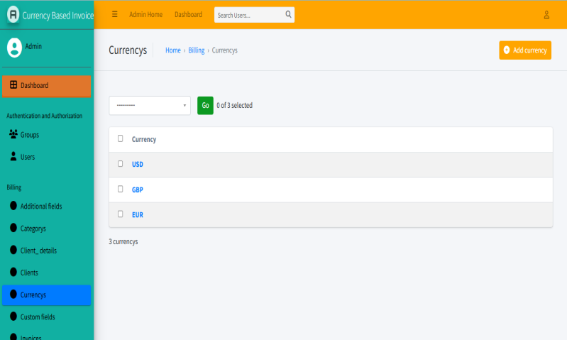

**Figure 1: Currency inserts**

The app enables businesses to invoice in over one currency based on clients' location and preference. The app employs current, real-time exchange rate data in currencies to obtain equitable and precise billing, therefore evading the experience of currency change impacting payments. The system automatically converts prices, tax rates, and accounts to the selected currency, hence saving businesses a lot of effort in terms of being in foreign markets. In addition, it facilitates seamless currency conversion and provides transparent exchange rate details on invoices, instilling confidence and transparency between service providers and customers.

The multi-currency platform also supports currency-specific invoice templates, which can preserve regional formatting and legal compliance. Eliminating the complication of manual currency management, the system streamlines financial operations, enabling IT companies to go global and conduct international transactions with ease and confidence.

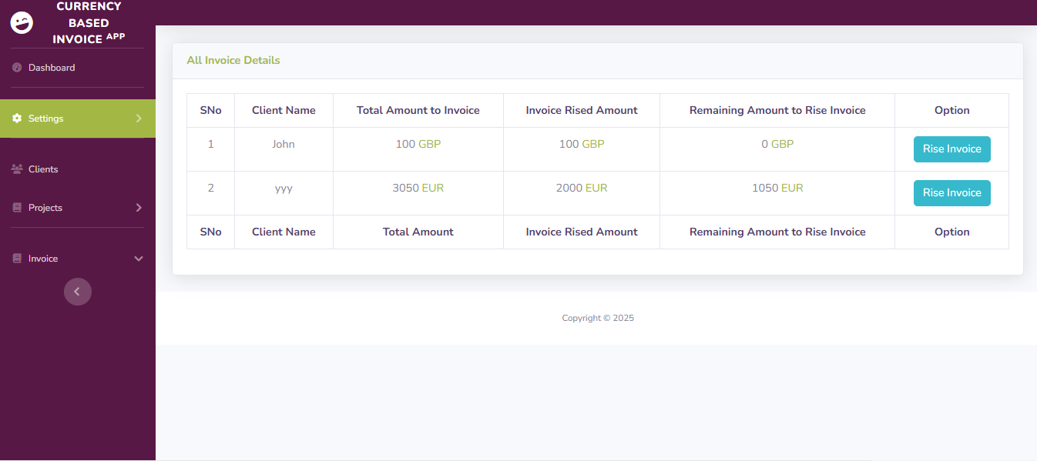

**Figure 2: Rise invoice**

The system includes a sophisticated currency conversion module that is integrated with real-time foreign exchange rate suppliers to provide up-to-date and precise currency conversion for each transaction. When a client makes an invoice payment in a foreign currency, the system retrieves the current exchange rate, performs the required conversion, and shows the final amount payable in both the invoiced currency and the client's desired currency. The system also enables users to lock exchange rates for a specific duration to offset the risks of currency fluctuation. This provides predictability both to the clients and the service providers, making the financial planning process more efficient. It also offers tracking of historical exchange rates to offer insights into the trend of currencies, enabling the company to make sound pricing and financial choices. The automated conversion module reduces the risk of human error and increases transaction accuracy, ultimately leading to financial efficiency in international.

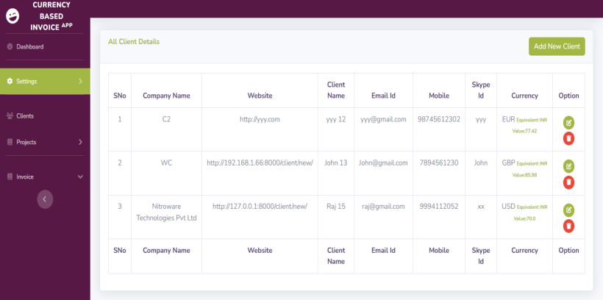

**Figure 3: add new client**

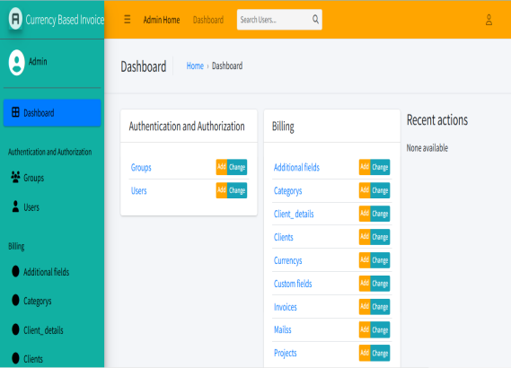

**Figure 4: Dash Board**

The system has a specialized module for handling client information to facilitate smooth invoicing and transaction tracking. The module stores client data like name, business entity, tax identification number, contact information, and transaction currency preference securely. It also enables businesses to classify clients according to geographical location, payment history, and contractual terms. The system automatically retrieves appropriate tax rates and compliance regulations according to client location, facilitating proper invoice generation.

Clients are also able to view their invoice history, payment status, and financial reports via a secure client portal, increasing transparency and communication. The incorporation of automated reminders and notifications helps guarantee timely payments and minimizes outstanding invoices. Through a well-kept and safe database of customer information, the system automates money operations and enhances customer relationship management for IT company.

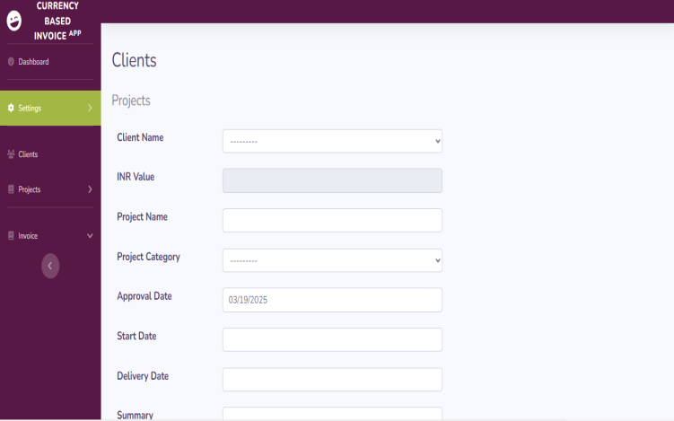

**Figure 5: Client project details**

The system has an in-depth module for managing client projects, maintaining correct financial documentation and invoicing integrity. The module enables companies to document project-related information like project name, scope, timeline, related costs, payment milestones, and contractual obligations. Every project is associated with the respective client profile, allowing easy tracking of multiple engagements.

The system supports automated billing against pre-defined milestones or time-tracking information, so that invoices are raised as per agreed terms. Project-specific tax calculations and compliance checks are also built in to ensure regulatory compliance. Companies can also create detailed financial reports by project, providing insights into revenue streams, outstanding payments, and profitability analysis. By consolidating project information in the invoicing system, companies are able to maximize operational efficiency, minimize financial inconsistencies, and keep a clear-cut relationship with clients**.**

**VIII. CONCLUSION**

The suggested currency-based invoice application helps IT companies dealing in global markets efficiently with automated multi-currency transactions, tax compliance, and secure payment gateway integration. By real-time exchange rate fetching and automatic financial reporting, the system improves transparency, minimizes errors, and enhances financial workflow efficiency. With advanced security features and fraud detection capabilities, it helps protect sensitive financial information. As companies keep venturing overseas, embracing such a strong invoicing system can go a long way in streamlining financial activities and building trust with international customers, opening the door for long-term growth and fiscal stability.

**IX. REFERENCES**

1.**Smith, J. (2023)**. "Automated Invoicing in the Digital Age." Journal of Financial Technology, 19(2), 45-62.

**2.Lee, R., & Kim, H**. **(2023).** "Block chain for Financial Transactions: A Secure Approach to Multi-Currency Invoicing." International Journal of Fin Tech**, 14(1), 98-112**.

**3.Global Finance Report (2024**). "The Impact of Real-Time Currency Exchange on Cross-Border Transactions."

**4.PayPal Inc. (2023).** "Multi-Currency Support in Digital Payment Systems."

1. **Deloitte (2024).** "Regulatory Compliance in International Financial Transactions."

**6.Stripe Inc. (2023)**. "Advancements in Payment Gateway Integration for Multi-Currency Transactions."

**7.World Bank Report (2024**). "Trends in International Payments and Currency Exchange."