**Classifying Soil Texture using RGB Images in Uncontrolled Field Conditions**

**Ketha Rithika1, Kavali Neha Rani2, Pujari Eshwari3, Lavanya Marella4**

1,2,3,4 Stanley College of Engineering and Technology for Women, Hyderabad, Telangana, India

**ABSTRACT**

Soil structure affects agricultural productivity by affecting water retention, distribution of nutrients, and general crop health. Methods for traditional soil classification, which depend on laboratory analysis, are often slow and impractical for large-scale agriculture. To remove these boundaries, appoint our project Convolutional Neural Network (CNN) to classify the soil structure from the images taken in the uncontrolled Field Conditions (UFC), such as accounting for environmental variations such as light, background and moisture level. The approach involves shaping the 48 × 48 pixels and preparing ground images by training a CNN model to distinguish between different soil types, including black, red, clay, peat, yellow, and cinder. In addition, an integrated crop recommendation system detects the most appropriate crops based on the soil type. The model's performance is evaluated using accuracy, precision, recall and F1 score, which ensures high reliability in classification results. For ease of use, the system is distributed through a Django-based network interface so that users can upload soil images for real-time classification and crop recommendations. This solution provides a scalable and cost-effective alternative for traditional soil testing and reduces the difference between laboratory analysis and practical agricultural applications.

**Keywords:** Soil Classification, Agriculture, CNN [Convolutional Neural Networks], UFC [Uncontrolled Field Conditions], Crop Recommendation.

**1.** **INTRODUCTION**

Soil structure is fundamental when it comes to determining the properties of the soil and affecting important properties such as Water-holding capacity, nutrients and air flow, which are crucial for agriculture. Traditional cutting methods, such as collecting soil samples and testing them in a laboratory, taking a lot of time and effort, It is difficult to use them on a large scale. New ways that use images can help but they typically required controlled conditions, such as proper lighting and pure background, which is not feasible in real-world settings. This project introduces a simple and scalable way such as classifying the soil structure of the state of the Uncontrolled Field Conditions (UFC) using image processing and Deep Learning. Uncontrolled situations include open areas of sunlight, shade, plants in the background, and different moisture levels in the soil. Using Convolutional Neural Network (CNNS), our method can work in these challenging environments where it can improve classification of accuracy and soil to make fast, easy and more useful for growing large scale.

**2. LITERATURE REVIEW**

The entire literature survey with an ideological basis for this project is briefly mentioned here.

**Traditional soil texture analysis**

Manual methods such as hydrometer and pipe techniques have been widely used for classifying soil texture. These methods produce reliable results, but are often time-consuming, labor-intensive and accuracy requires controlled conditions. Despite their efficiency, they are impractical for mass applications and lacks adaptation capacity to automated systems [1,2].

**Image-based land classification**

Progress in imaging has enabled classification of soil texture using RGB images. Studies have shown that color and texture functions obtained from earth images can be used to effectively classify soil properties. However, these methods are very dependent on environmental conditions, light variations and image resolution, making them less reliable in uncontrolled field settings [3.4].

**Machine learning approach**

Machine learning techniques, especially fixed nervous networks (CNN), have improved accuracy for soil texture classification. These methods benefit from large datasets to extract complex patterns from earth images. However, the CNN model requires sufficient computational power, well -labeled datasets and strong training methods for generalization in different soil types and environmental conditions [5.6].

**Digital and spectral analysis**

Spectroscopy-based techniques such as close -concentrated (NIR) and perfect spectroscopy provide accurate soil classification by analyzing spectroscopy spectral signatures. While these methods increase accuracy, they require expensive equipment, calibration and competence for implementation. High costs and dependence on specific circumstances restrict their wide.

**3. AIMS AND OBJECTIVES**

* Develop an image-based system for classifying the soil structure accurately using advanced image processing techniques.
* Use a future indication model to recommend the most appropriate crops depending on the type of soil identified.
* Make sure the system works effectively under real conditions, including individual lighting and environmental factors.
* Design a user-friendly Django-based GUI for uploading uninterrupted image, soil classification and crop recommendation.

**4. SYSTEM ARCHITECTURE**

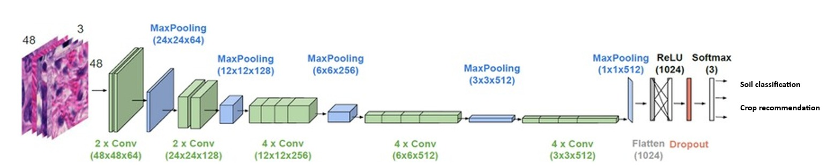

The classification of many types of soil prediction, architecture (from reference [10]), the image depicts a Convolutional neural network (CNN) architecture designed for soil classification in the image. The network size begins with an input layer of 48 × 48 × 3, where the dimensions correspond to an RGB image input. The first conversion blocks consist of two conference teams, each with 64 filters with size 3 × 3, followed by a maximum wave layer, which reduces spatial dimensions to 24 × 24 × 64. Subsequent blocks follow a similar pattern, with filter size (128, 25 and 58 and 51) 312 respectively. The network infections through four main conversion blocks, with each block having 2 or 4 affects layers, and their filter grows to increase the function extraction. After fixing and merging layers, the network infections are perfectly connected. The exit from the final interdisciplinary block is flat in a

1024 size vector. Raising is used here to prevent overheating, and add a non-linearity to ReLU activation function. Finally, the model ends with a soft-max activation layer, which provides opportunities for three soil classes, effectively classifies the entrance picture. This hierarchy architecturally prisoners effectively spatial and structured based functions from soil images for strong classification.

**5. ALGORITHM**

**1) Image collection and pre processing**

* Catch or upload soil images from the area.
* Change the shape of images for a certain dimension (32x32 pixels).
* Standardize pixel values ​​of a limit of [0,1] for better model performance.
* Store the preprocessed image in the dataset.
* **Input:** Soil image
* **Output:** Processed picture

**2) Functional recovery and data text**

* Remove properties related to texture such as color, opposite and grain structure.
* Save extracted functions for model training.
* **Input:** Processed picture
* **Output:** Dataset The improved image

**3) Soil classification using CNN**

* Load the foremost CNN model using label data sets.
* Pass the processed image through CNN for functional learning and classification.
* Make soil types from predetermined categories (eg: black soil, clay, red soil, etc.)
* **Input:** Features taken from pictures
* **Output:** Soil Type Predicted

**4) Crop recommendation system**

* Map classified soil type for appropriate crops based on predefined agricultural knowledge.
* Retrieve and show the recommendations from the crop for the type of soil identified.
* **Input:** Classified soil type
* **Output:** Recommended crops

**5) Graphical User Interface (GUI) Implementation**

* Design a Django-based web interface for user interaction.
* Let users upload photos and get classification results.
* Show the detected soil type and recommended crops.
* **Input:** User -uploaded soil image
* **Output:** GUI-based classification and crop recommendation

**6) Show evaluation and adaptation**

* Evaluate model performance by using accuracy, precision, recall and F1 score.

**6. USED TECHNOLOGY**

* **Hypertext Markup Language (HTML):** It provides the structure and material on a web page.
* **Cascading Style Sheet (CSS):** It controls the presentation and style of elements.
* **Java-script (JS):** A website adds interaction and dynamic behavior.
* **Django (Python Framework):** A backend framework for creating web applications when using Python.

**7. MODULES AND RESULTS**

**1) Command Prompt**

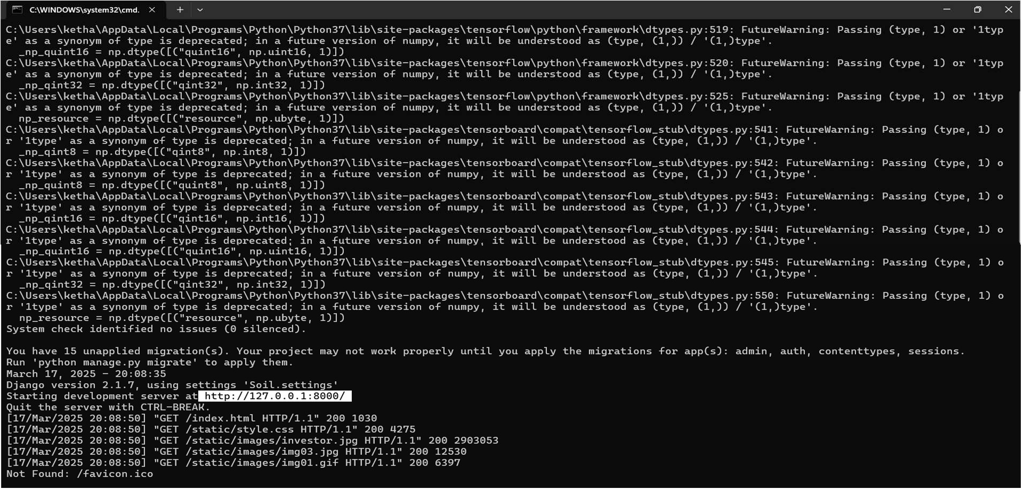

This image suggests that when you reach http: //127.0.1: 8000/, it rejuvenates you Web page.

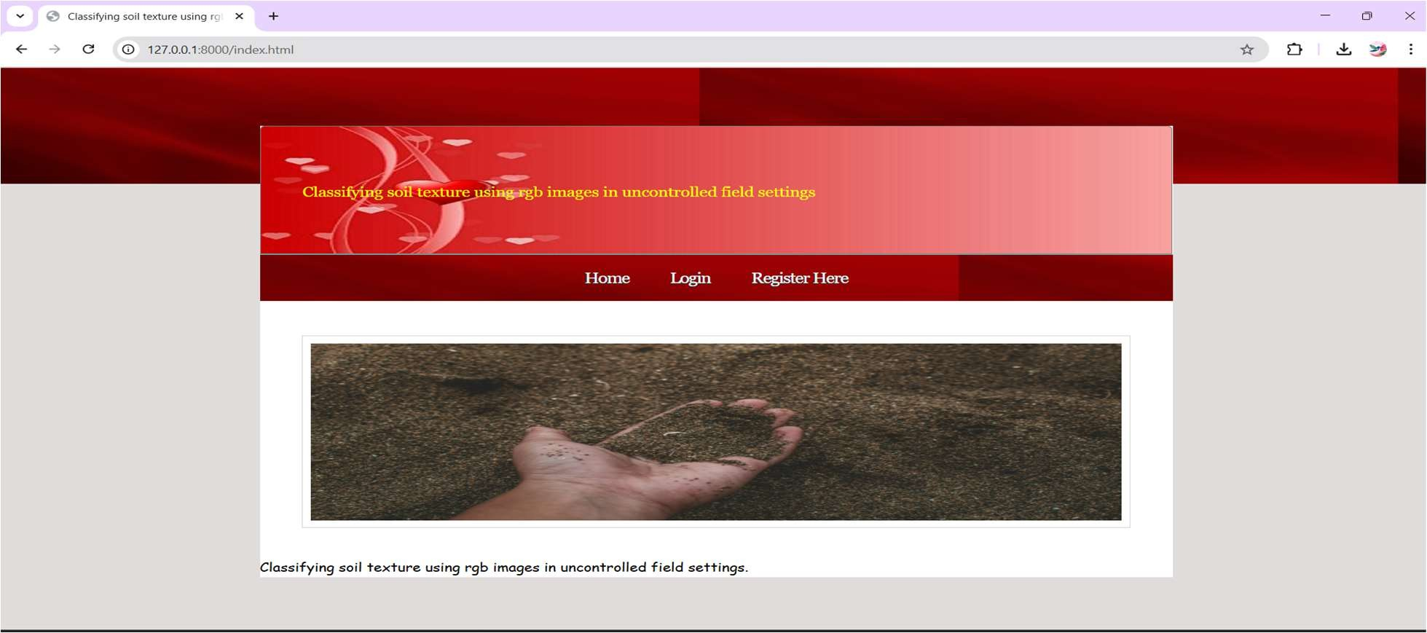**2) Main Page**

This image suggests that the main page allows users to register for a new account or log in to what exists. From here they can use their personal materials and functions.

**3) Registration Page**

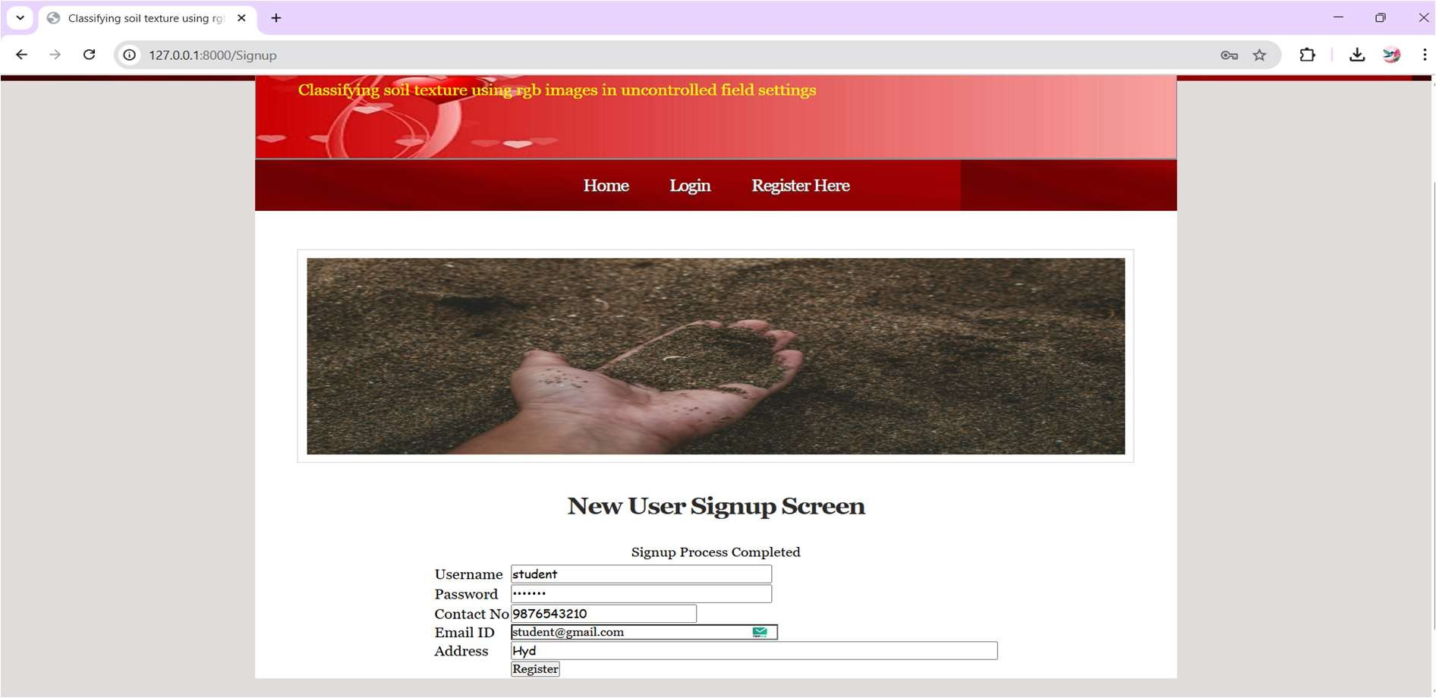

This image shows that the registration page allows new users to create an account by providing details such as name, e-mail and

password. When registered, they can log in and access the site's features.

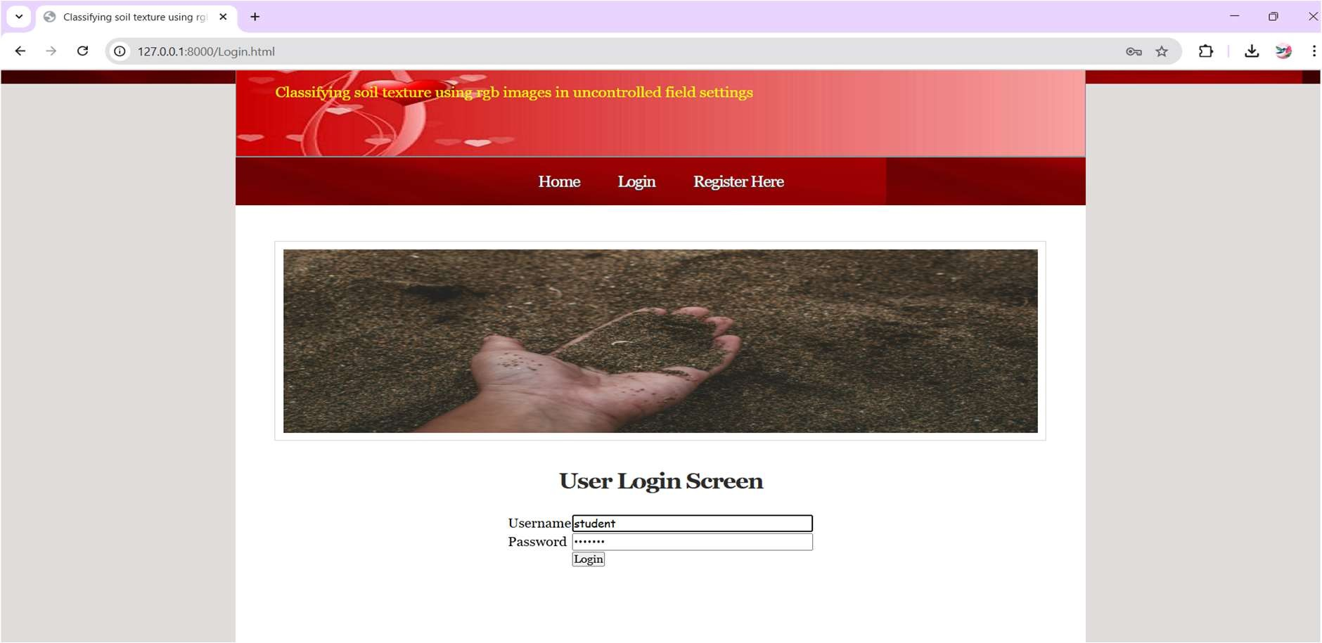**4) Login Screen**

This image suggests that the login screen allows users to enter the e -mail and password to reach their accounts. If they have no

account, they can navigate the registration page to register.

**5) Welcome Page**

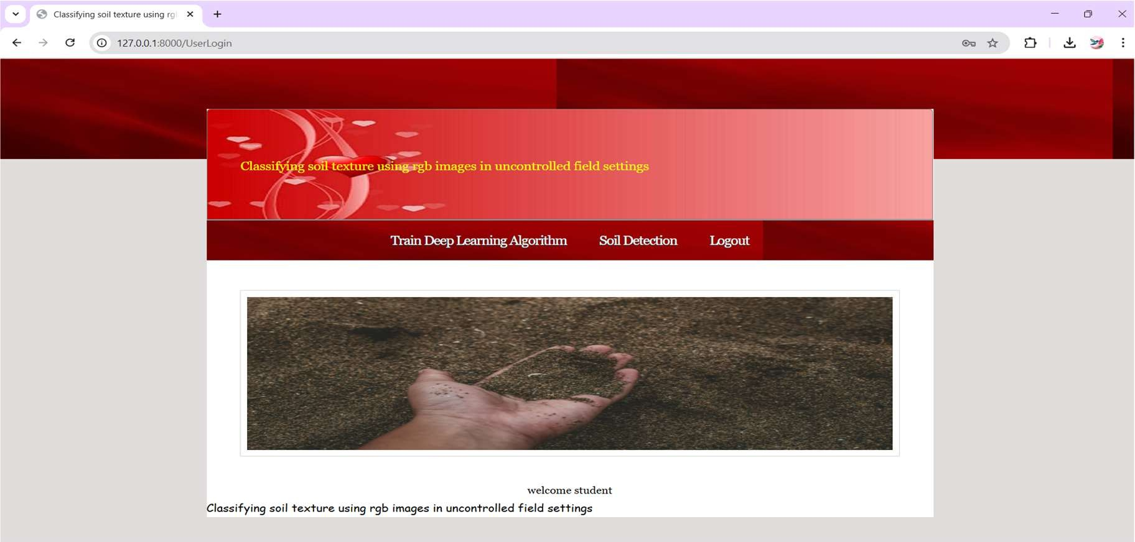

This image suggests that the site after logging the welcome page provides an observation of the features and navigation options. This acts as the first point for their experience.

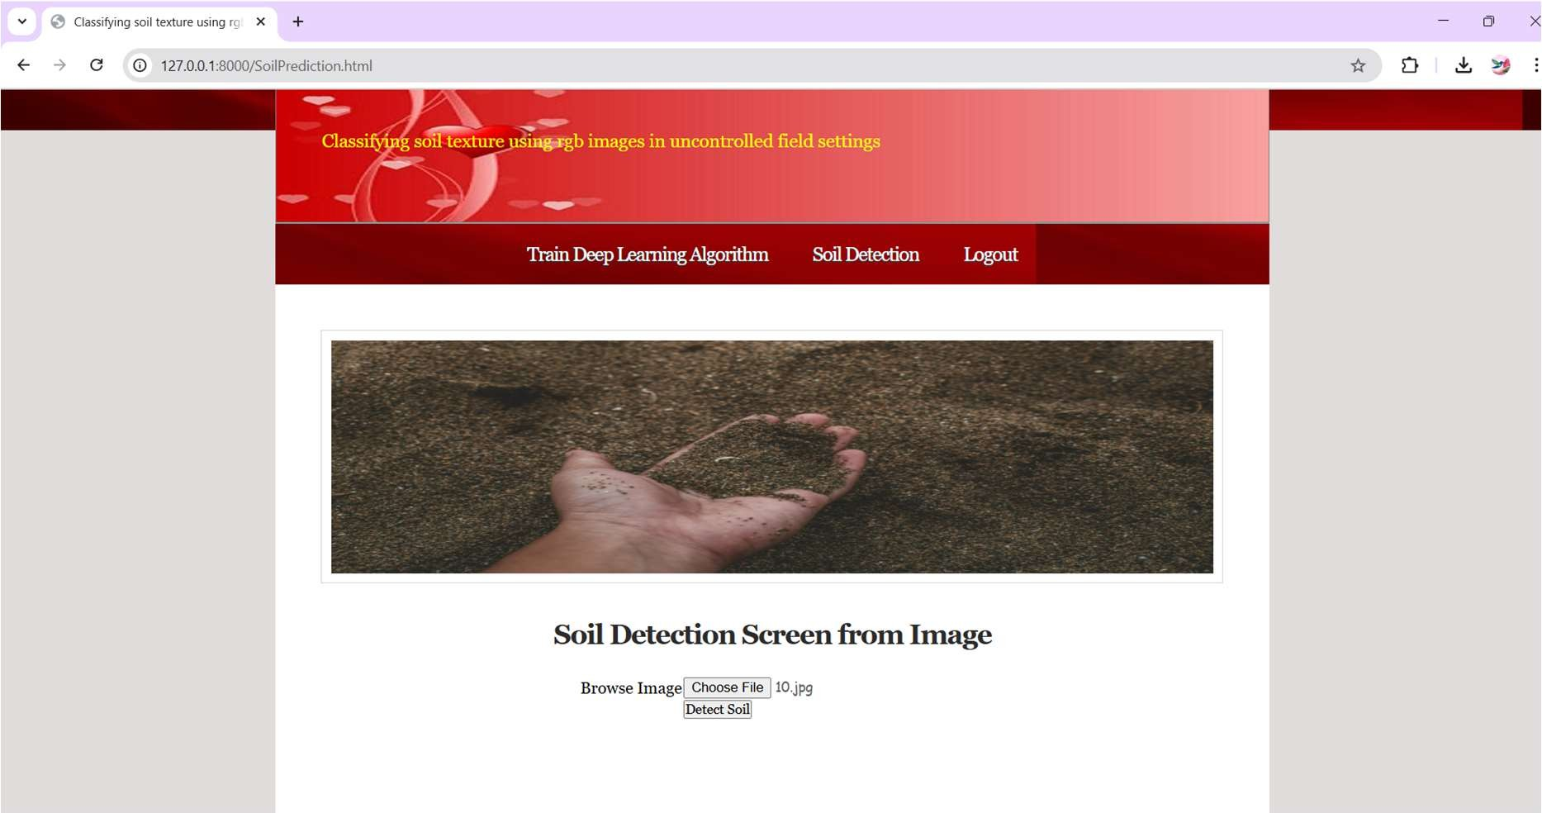**6) Soil Detection**

This image suggests that the upload page allows users to upload the ground image. The system then analyzes the image and

identifies the soil type.

**7) Soil Detection Output along with Crop Recommendation**

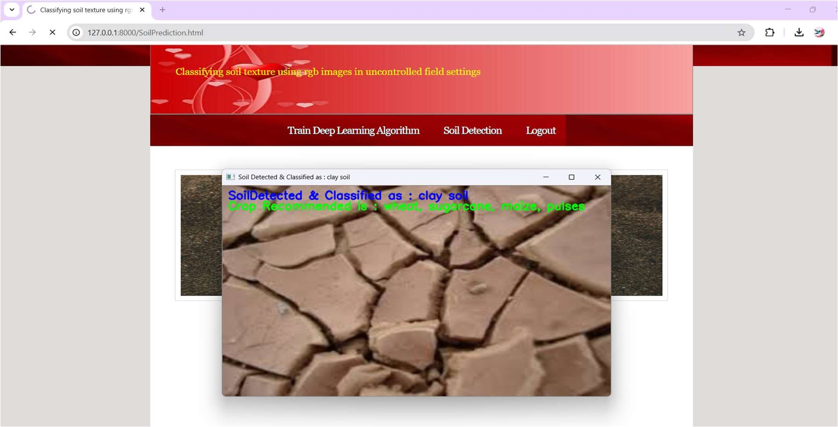

This image shows that the production of soil detection shows the type of land identified with recommended crop suitable for

that soil.

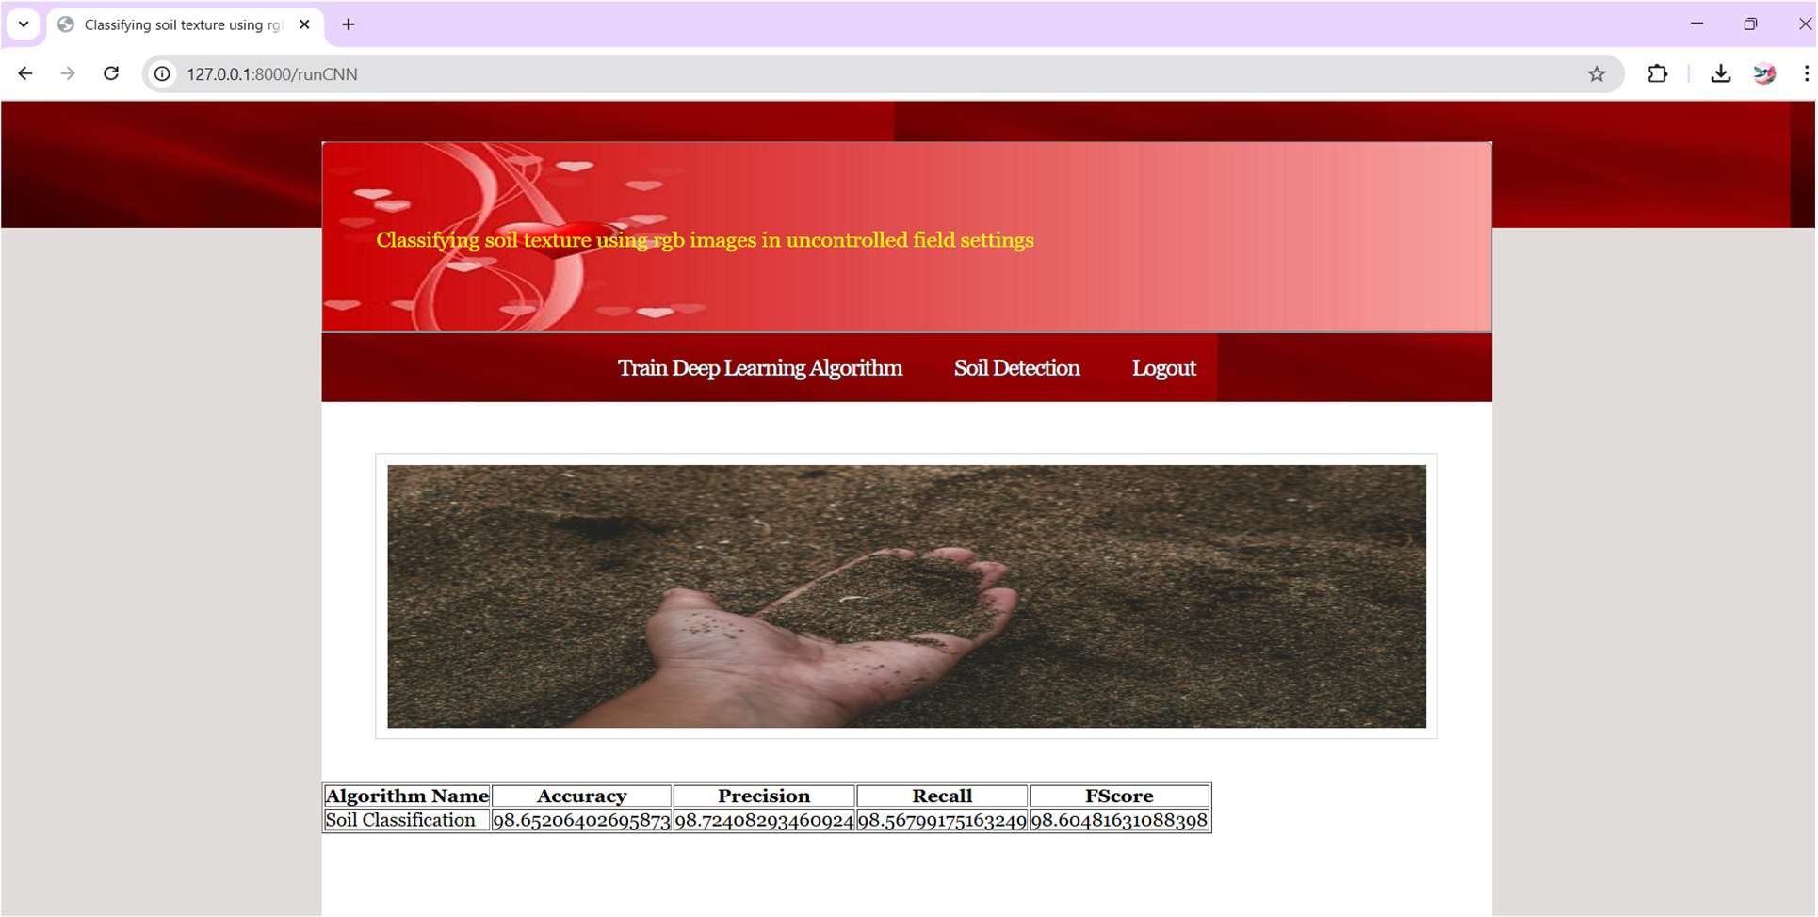**8) Performance Analysis**

The result analysis presents greater assessment matrix, including accuracy, accurate, recall and F1 score. These matrices help to assess the effectiveness of the soil detection models by identifying the soil types correctly.

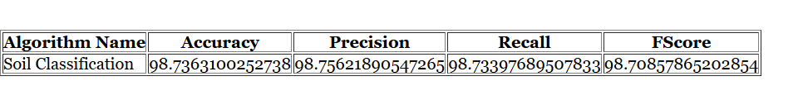

Therefore, the accuracy is 98.7363100252738 for overall module before testing.

After testing the accuracy for the above test image is 98.65206402695873.

**8. CONCLUSION**

The project presents a skilled soil texture classification and crop recommendation system. By integrating RGB imaging with CNN, it enables real-time soil analysis, eliminating the need for traditional expensive and time-consuming laboratory tests. The system includes an image processing module, a CNN-based classification module and a recommended crop module, available through a Django-based interface. The results show high accuracy, but the challenges include light variation, moisture effects, data set diversity and internet addiction. Despite these limitations, the system offers a sharp, scalable and cost-effective alternative for traditional soil testing methods.

**9. REFERENCES**

1. Gerakis and B. Baer, ‘‘A computer program for soil textural classification,’’ Soil Sci. Soc. Amer. J., vol. 63, no. 4, pp. 807–808, Jul. 1999.
2. C. P. Fernandez-Illescas, A. Porporato, F. Laio, and I. Rodriguez-Iturbe, ‘‘The ecohydrological role of soil texture in a water-limited ecosystem,’’ Water Resource. Res., vol. 37, no. 12, pp. 2863–2872, Dec. 2001.
3. Q. Xia, T. Rufty, and W. Shi, ‘‘Soil microbial diversity and composition: Links to soil texture and associated properties,’’ Soil Biol. Biochem., vol. 149, Oct. 2020, Art. no. 107953.
4. J. Van den Akker and B. Soane, ‘‘Compaction,’’ in Encyclopedia of Soils in the Environment. Amsterdam, The Netherlands: Elsevier, 2005.
5. K. Chakraborty and B. Mistri, ‘‘Importance of soil texture in sustenance of agriculture: A study in Burdwan-I CD Block, Burdwan, West Bengal,” Eastern Geographer, vol. 21, no. 1, pp. 475-482,2015.
6. P. R. Chaudhari, D. V. Ahire, V. D. Ahire, M. Chakravarty, and S. Maity, ‘‘Soil bulk density as related to soil texture, organic matter content and available total nutrients of Coimbatore soil,” Int. J. Sci. Res. Publications, vol. 3, no. 2, pp. 1-8, 2013.
7. A. Cihan, J. S. Tyner, and E. Perfect, ‘‘Predicting relative permeability from water retention: A direct approach based on fractal geometry,’’ Water Resource. Res., vol. 45, no. 4, pp. 1-8, Apr. 2009, DOI: 10.1029/2008WR007038.
8. K. H. Yusof, F. Aman, A. S. Ahmad, M. Abdulrazaq, M. N. Mohammed, M. S. Z. M. Zabidi, and M. Y. H. Sauzi, ‘‘Determination of soil texture using image processing technique,’’ in Proc. IEEE 18th Int. Colloq. Signal Process. Appl. (CSPA), May 2022, pp. 178–181.
9. E. Šarauskis, M. Kazlauskas, V. Naujokiene, I. Bručien ˙ e, D. Steponavičius, K. Romaneckas, and A. Jasinskas, ‘‘Variable rate seeding in precision agriculture: Recent advances and future perspectives,’’ Agriculture, vol. 12, no. 2, p. 305, Feb. 2022.
10. Ekunayo-Oluwabami Babalola, Muhammad H. Asad, Abdul Bais, “Soil Surface Texture Classification Using RGB Images Acquired Under Uncontrolled Field Conditions”, IEEE publications, vol. 11, 28 June 2023, pp. 140-155.
11. G. J. Bouyoucos, ‘‘A comparison between the pipette method and the hydrometer method for making mechanical analyses of soil,’’ Soil Sci., vol. 38, no. 5, pp. 335–346, Nov. 1934.
12. J. T. Elfaki, M. A. Gafer, M. M. Sulieman, and M. E. Ali, ‘‘Hydrometer method against pipette method for estimating soil particle size distribution in some soil types selected from central Sudan,’’ Int. J. Eng. Res. Adv. Technol., vol. 2, no. 2, pp. 25–41, 2016.
13. J. Ashworth, D. Keyes, R. Kirk, and R. Lessard, ‘‘Standard procedure in the hydrometer method for particle size analysis,’’ Commun. Soil Sci. Plant Anal., vol. 32, nos. 5–6, pp. 633–642, Apr. 2001.
14. G. W. Gee and D. Or, ‘‘2.4 Particle-size analysis,’’ in Methods of Soil Analysis: Part 4 Physical Methods, vol. 5. Madison, WI, USA: Soil Science Society of America, 2002, pp. 255–293.
15. T. A. Kettler, J. W. Doran, and T. L. Gilbert, ‘‘Simplified method for soil particle-size determination to accompany soil-quality analyses,’’ Soil Sci. Soc. Amer. J., vol. 65, no. 3, pp. 849–852, May 2001.
16. S. Mwendwa, ‘‘Revisiting soil texture analysis: Practices towards a more accurate bouyoucos method,’’ Heliyon, vol. 8, no. 5, May 2022, Art. no. e09395.
17. L. Liu, J. Chen, P. Fieguth, G. Zhao, R. Chellappa, and M. Pietikäinen, ‘‘From BoW to CNN: Two decades of texture representation for texture classification,’’ Int. J. Comput. Vis., vol. 127, no. 1, pp. 74–109, Jan. 2019.
18. M. Uddin, B. Joseph, and M. Hussain, ‘‘Environmental implications of the use of hydrogen peroxide and other alternative chemical products for soil and groundwater remediation,’’ J. Environ. Sci. Health, A, vol. 40, no. 5, pp. 905– 926, 2005.
19. A. B. McBratney, M. L. Mendonça Santos, and B. Minasny, ‘‘Integrating digital soil mapping and soil sensing for precision agriculture,’’ Precis. Agricult., vol. 6, no. 4, pp. 377–393, 2005.
20. A. Jaconi, C. Vos, and A. Don, ‘‘Near infrared spectroscopy as an easy and precise method to estimate soil texture,’’ Geoderma, vol. 337, pp. 906–913, Mar. 2019.
21. J. A. Coblinski, É. Giasson, J. A. Demattê, A. C. Dotto, J. J. F. Costa, and R. Vašát, ‘‘Prediction of soil texture classes through different wavelength regions of reflectance spectroscopy at various soil depths,’’ Catena, vol. 189, Jun. 2020, Art. no. 104485.
22. W. Ng, B. Minasny, W. D. S. Mendes, and J. A. M. Demattê, ‘‘The influence of training sample size on the accuracy of deep learning models for the prediction of soil properties with near-infrared spectroscopy data,’’ Soil, vol. 6, no. 2, pp. 565–578, Nov. 2020.
23. P. A. de Oliveira Morais, D. M. de Souza, B. E. Madari, and A. E. de Oliveira, ‘‘A computer-assisted soil texture analysis using digitally scanned images,’’ Comput. Electron. Agriculture, vol. 174, Jul. 2020, Art. no. 105435.
24. Z. Fan, J. E. Herrick, R. Saltzman, C. Matteis, A. Yudina, N. Nocella, E. Crawford, R. Parker, and J. Van Zee, ‘‘Measurement of soil color: A comparison between smartphone camera and the Munsell color charts,’’ Soil Sci. Soc. Amer. J., vol. 81, no. 5, pp. 1139–1146, Sep. 2017.
25. J. M. Prats-Montalbán, A. de Juan, and A. Ferrer, ‘‘Multivariate image analysis: A review with applications,’’ Chemometric Intell. Lab. Syst., vol. 107, no. 1, pp. 1–23, May 2011.
26. R. M. Haralick, ‘‘Statistical and structural approaches to texture,’’ Proc. IEEE, vol. 67, no. 5, pp. 786–804, May 1979.
27. S.-O. Chung, K.-H. Cho, J.-W. Cho, K.-Y. Jung, and T. Yamakawa, ‘‘Texture classification algorithm using RGB characteristics of soil images,’’ Kyushu Univ. Library, Nishi Ward, Tech. Rep., 2012.
28. N. Iqbal, R. Mumtaz, U. Shafi, and S. M. H. Zaidi, ‘‘Gray level co- occurrence matrix (GLCM) texture-based crop classification using low altitude remote sensing platforms,’’ PeerJ Computure Sci., vol. 7, p. e487, Apr. 2021.
29. R. Suresh and K. L. Shunmuganathan, ‘‘Feature selection using statistical method for image texture classification with GLCM,’’ ARPN J. Eng. Appl. Sci., vol. 7, no. 12, pp. 1540–1545, Dec. 2012.
30. K. Ramola, S. K. Dutta, and A. Maity, ‘‘A review on statistical and machine learning-based texture classification methods,’’ Eurasian J. Anal. Chem., vol. 15, no. 2, pp. 1–7, Feb.