USER INTERFACE AND SYSTEM DESIGN

# user interface for specific domain[VR]

Jeet Vani

Abstract

In the modern world where there is a tremendous growth in field of technology, the concept of Virtual Reality is getting recognized and utilized in most of the sector like gaming, education, training, stimulation and many more. Although the applications of VR are quite impressive, it also comes with a lot of aspects which are not that optimized and user friendly.

Therefore, this paper is about factors that influence the user preferences for the interface and design of the system in the VR environment. In this article firstly there will discuss about the user expectations of VR continuing with comparison of different

user’s experiences and how a user interface design affects the

user experiences along with the use of VR in fields like VR Education and VR gaming further concluding the article with providing an outlook for future of VR and its improvement, enhancement, scalability, and interactivity with user interface design and user experiences.

Keywords: Virtual Reality, User Interface design, User Experience

# Introduction

Virtual Reality (VR) has a deep history in field of science and technology. In 1968 Sutherland, with his student Bob Sproull, created the first virtual reality HMD, named The Sword of Damocles. This head-mount connected to a computer rather than a camera and was quite

primitive as it could only show simple virtual wire-frame shapes. Further with development in the field of VR stimulating a three- dimensional environment based on user expectations is possible and having new form of human- computer interaction created with the help of computer systems and various sensor technology generations which allow user to interact, modify and experience a real-world like environment. VR is totally a user preferred virtual environment created by user themselves to experience a real- world like situation or visit a

real-world place without being actually present at that place. VR also have been utilized in different sectors one of the most common and renowned sector is “Gaming”, playing games in virtual reality is taking the user experience of playing a game on whole another level and it’s the hot topic of current trends as gaming is something almost everyone has done in their lives and having an experience of playing a game with being in the game like it’s a real world is what making VR Gaming so hyped topic. Other than gaming VR also present in educational

sector where a student can learn with the environment like a classroom without actually present in a classroom and learn with not just normal videos streaming but also can see three dimensional models and diagrams which enhance the understanding of the topic and take the learning to new heights, For example: A student of biology can watch three dimensional diagram of a human body and can also move, modify, zoom, and even can focus on particular aspect of the diagram with help of sensors present in the VR system helping student to actually know and understand the thing rather than theoretically memorizing it.

VR with all this new high-tech technology and revolutionary aspects is growing on a very rapid scale by providing user experiences with a sense of creating a personal world but other than this the design of user interface is also a main component playing an important role in connecting VR with the user. The design interface of VR should be user friendly and easy to understand and access, for

example: VR having motion sensors provide user to interact with system just with some motion of their body like hand gestures which is a more convenient design interface than having a whole joystick or some machine which help user to interact with the system.

The user has active visual control and spatial movement in the VR interface, which makes the user a part of the interface. Therefore, the mode of interface design greatly affects the user's experience in VR scenarios, and it is through the construction and design of these interactive interfaces that the information between the user subject and the computer network platform is formed, thus ensuring the accurate dissemination of perceptual data information in the VR environment. Nowadays, the modes of user interface design are mainly divided into scenario-based interface design, global interface design, and handheld interface design.

Scenario-based interface design: Scenario-based interface design mode is to integrate the interface and operation information into the virtual space and scene,

which is the interface of direct contact between human and virtual space. Therefore, in the VR scenario, the scenario-based interface design mode can restore the real-world scenes most intuitively, allowing users to enter the virtual space scenario and use their real-world experience to quickly learn and adapt to the operation process and make "interactive" interactions with the environmental objects in the virtual space. When users can bring all the visual and operational habits of the real world into the VR scenario experience, it greatly deepens the immersion of users in the interactive process and enhances the user experience.

# Related Work

Virtual reality (VR) is a computer-generated, three- dimensional environment that users can interact with via displays like head-mounted displays (HMDs) or multiple screens. It can be non-immersive (using screens around the user) or immersive (using HMDs),

with augmented reality (AR) blending digital imagery with the real world, and mixed reality (XR) combining AR and VR.

The concept of VR dates back to the 1960s, with early technologies like the Telesphere Mask and Sensorama. Recent advancements, particularly since the early 2010s with devices like Oculus, have made VR more accessible to consumers.

While VR was initially focused on gaming, its applications have expanded to education, training, simulations, healthcare, and more. However, there are challenges. Users may experience discomfort or motion sickness, and high hardware costs limit accessibility.

Technical standards and health considerations also pose issues.

Despite these challenges, VR's potential across various sectors is significant. It offers immersive experiences that can enhance learning, training, and entertainment. Research and improvements aim to address current limitations and make VR

more widely accessible and beneficial.

This summary captures the key points of your literature review, including VR's evolution, applications, and ongoing challenges in a concise manner.

In education, VR presents opportunities for immersive learning experiences, such as virtual field trips, historical reenactments, and interactive simulations. It can enhance engagement and understanding, especially in complex subjects like science or history.

In training and simulations, VR enables realistic scenarios for workforce training, medical simulations, and safety drills.

Users can practice skills in a controlled environment, reducing risks and costs associated with real-world training.

Healthcare applications of VR include pain management, therapy for mental health disorders, and surgical simulations. VR can create environments that promote relaxation, distraction from pain,

and exposure therapy for phobias.

Despite these benefits, challenges persist. Technical issues like latency, resolution, and motion tracking can affect user experience. Moreover, ethical concerns regarding data privacy, virtual addiction, and the impact of prolonged VR use on physical and mental health require careful consideration.

Future developments in VR technology aim to address these challenges, with advancements in hardware, software, and user experience design.

Standardization efforts, improved affordability, and research into mitigating health risks will contribute to VR's wider adoption and acceptance.

In conclusion, VR continues to evolve as a transformative technology with diverse applications and potential benefits. Understanding its strengths and limitations is crucial for harnessing VR's full potential while addressing challenges to ensure its

responsible and effective use across various domains. [1]

Virtual reality (VR) technology, also known as lingjing technology, is characterized by immersion, interactivity, and visualization. It works by utilizing various technologies such as computer graphics, emulation techniques, multimedia technology, artificial intelligence, network technology, parallel processing, and multi- parameter environmental sensing to simulate human senses like vision, auditory perception, touch, and others. This simulation allows users to immerse themselves in a virtual world where they can interact naturally, creating a multi- dimensional data space with wide-ranging applications.

The essential characters of VR are immersion, interactivity, and visualization. Immersion enables natural interaction with computers in the virtual world, unlike traditional interfaces.

Interactivity distinguishes VR systems from traditional 3D animations, allowing users to actively operate virtual objects

and change the virtual environment. Visualization helps users gain perceptual and rational recognition, enhancing understanding and sensory experiences.

Components of a VR system include professional picture processing computers, utility software systems, input devices like helmets, earphones, data gloves, and display equipment. The software describes dynamic characteristics, organizational structures, and interaction rules of the virtual environment, while the computer system and audio- visual equipment form the external components.

The rapid development of VR has led to its wide application in various fields such as CAD, simulation modeling, visual computing, telerobotics, computer art, education and training, entertainment, design, remote manipulation, and more. Countries worldwide, including China, have invested significantly in VR technology, integrating it into major events like the Olympic Games and competition stages. VR has

become a crucial component of modern sports and continues to evolve with advancements in technology and applications. [2]

Scenario-based Interface Design: This mode integrates interface and operation information directly into the virtual space and scenes. It allows users to interact with environmental objects in a way that mimics real-world experiences, leading to deeper immersion and a more intuitive learning curve for users.

Global Interface Design: Also known as Systematic Interface Design, this mode presents the interface elements in a hovering manner, typically superimposed on the virtual space. While it offers basic functional interfaces and interaction instructions, it can cause visual fatigue and dizziness if not designed carefully. The layout and design of the global interface should align with user interaction behavior to enhance the overall experience.

Handheld Interface Design: This mode follows the user's hand gestures, resembling daily

interactions with handheld devices. It simplifies operations for users, avoiding visual fatigue and leveraging the familiarity of hand movements for a comfortable user experience. [3]

# Proposed Work

* USER EXPECTATION OF VR:

User expectations from a VR is mainly divided into seven key expectations.

1. Immersion: user expect from VR is high immersion means they should feel that they are physically present there from the realistic graphics experience, sound effects, and a sense of spatial presence of being present there physically without being there in real world.
2. Interactivity: user expect from VR is to have meaningful ways to interact, this include exploring virtual world, manipulating object in virtual world and many more.
3. Realism: user expect from VR is to provide a real-world like experience which refers the virtual world should be realistic

and accurate replica of the real world whether it is a training program, a game, or a tour experience.

1. Multi-sensory experience: user expect from VR is to provide multiple sense engagement including vision, hearing, and touch in some modern technologies VR.
2. Comfort and safety: user expect from VR is that the hardware should be comfortable for user to use and wear along with the sense of safety while using it and not feeling anxious about there privacy being disturbed.
3. Interconnectivity: user expect from VR is that in virtual world they can connect with other VR users through some avatars and should able to communicate through voice chats and should have multiplayer capabilities.
4. Content Variety: user expect from VR is that it should provide a diverse range of content including education materials, entertainment, productivity work, and many more.
   * USER INTERFACE (UI) DESIGN CAN AFFECT

USER EXPERINCE IN VR:

|  | c design  and motion sickness  mitigation | or motion  sickness issues |
| --- | --- | --- |
| Interconnect | Enables | Fails to |
| ivity | seamless | support |
|  | social | multiplayer |
|  | interactio | or social |
|  | ns and | features, |
|  | collaborat | limiting |
|  | ion | engageme |
|  |  | nt |
| Content  Variety | Offers a  diverse range of high- quality content and  experienc | Provides  limited or low-quality content, reducing overall enjoyment |
|  | es |  |

| Aspect | Good UI Design | Poor UI Design |
| --- | --- | --- |
| Immersion | Enhances immersio n through intuitive controls and realistic feedback | Breaks immersion with confusing controls or unrealistic interaction s |
| Interactivity | Facilitates natural and intuitive interactio ns | Results in frustration due to complex or non- responsive controls |
| Realism | Creates realistic environm ents and interactio ns | Causes disbelief or detachmen t due to inconsisten cies or glitches |
| Multi- sensory Experience | Integrates haptic feedback, spatial audio, and  realistic visuals | Lacks sensory feedback, leading to a less engaging experience |
| Comfort and Safety | Prioritizes comfort  with ergonomi | Neglects comfort,  leading to discomfort |

* + - VR EDUCATIONAL

Contribution: Immersive Learning

Experiences: VR provides immersive experiences that engage learners more deeply than traditional methods. It allows students to interact with virtual environments, objects, and scenarios, enhancing understanding and retention[Figure 1].

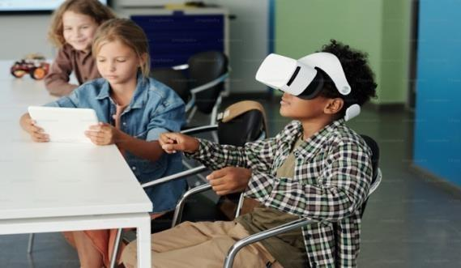

[Figure 1]

Access to Remote Learning: Especially in the wake of the COVID-19 pandemic, VR has gained traction as a tool for remote learning. It enables students to participate in virtual classrooms, field trips, and collaborative projects from anywhere in the world.

Enhanced Engagement: VR stimulates curiosity and motivation among students by offering interactive and experiential learning opportunities. It caters to diverse learning styles and fosters active participation.

Practical Training: VR is particularly valuable for training in fields where hands- on experience is crucial, such

as medicine, engineering, and aviation. It allows learners to practice skills in a safe and controlled environment[Figure2].

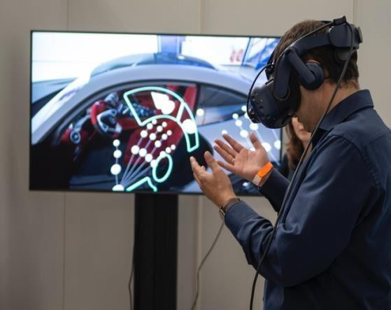

[Figure 2]

Cost Savings: While initial setup costs can be high, VR can ultimately reduce expenses associated with physical equipment, travel, and maintenance. It offers a cost-effective solution for simulation-based training.

Drawbacks:

Cost: Implementing VR technology in educational settings requires significant investment in hardware, software, and maintenance. This cost can be prohibitive

for many institutions, especially those with limited budgets.

Technical Challenges: VR systems are complex and require technical expertise to set up and maintain. Technical glitches, compatibility issues, and system downtime can disrupt learning experiences.

Content Development: Creating high-quality educational content for VR platforms can be time- consuming and resource- intensive. Additionally, ensuring the accuracy and relevance of content across different subject areas poses a challenge.

Health and Safety Concerns: Prolonged use of VR headsets may cause discomfort, motion sickness, or eye strain in some users. Adequate breaks and ergonomic considerations are necessary to mitigate these risks.

Access and Equity: Not all students have equal access to

VR technology due to disparities in resources,

infrastructure, and internet connectivity. This can exacerbate existing inequalities in education.

* VR GAMING

VR games are referred to as new generation of games utilizing VR technology to provide user real-world experience while playing a game. VR games mainly focus on user experience along with providing user interface design easy to understand by majority of the targeted audience. Many companies like Sony, Samsung, Apple and many more are trying to bring the VR headsets which were firstly for normal uses like watching movies but now it’s a multipurpose device, user can play games, watch shows movies, do professional work, and much more.

There are various headsets in the market but the most hyped right now is Apple vision pro [Figure 3].

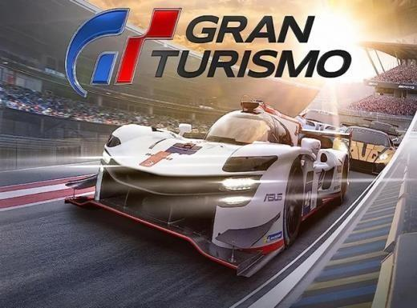

[Figure 3]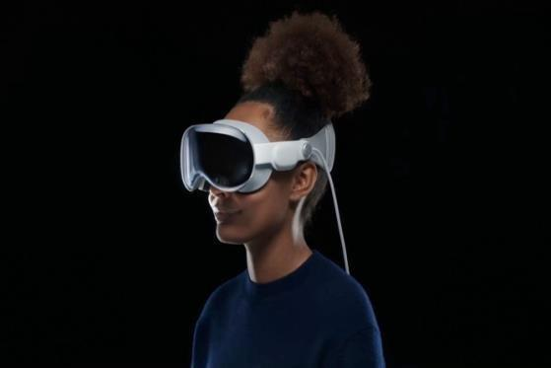

For gaming purpose there are lots of games giving real- world experience to the user for example a game name “Gran Turismo 7” [Figure 4], Claimed that there game provide real-world like experience to user that a player driving a race car in the game is capable of driving a race car in real world and with company like Nissan they prove it by winning a race in Le mans having driver named “Jann Mardenborough”, a former gran turismo player in a real race car racing in real world and wining, this story showcase that the VR gaming is went on whole another level in current world.

[Figure 4]

How does a VR gaming works actually work?

VR gaming systems are composed of a game and hardware. The games are designed to create an immersive experience that gives users the feeling that they are interacting with a world outside their physical bodies. These systems are designed to have as

little latency as possible to give fast and accurate feedback to users based on their actions.

VR gaming systems generate realistic sensations that simulate users' physical presence in a computer- generated environment. The goal of VR gaming systems is to let users believe they inhabit a virtual world. People

using VR gaming systems move around the virtual world and interact with virtual features and items.

At its simplest, a VR game is a 3D image that can be explored interactively on a computing device by manipulating keys, mouse or touchscreen. More commonly, virtual reality uses a head-mounted display with a screen that wraps around the eyes. These systems also use specially designed rooms with multiple projectors and large screens.

VR rooms may be enhanced with wearable technology and sensory components, such as scents and Haptic devices for tactile feedback.

Types of VR gaming accessories:

* steering wheels and accelerator controllers for racing games;
* treadmills that sense running distance and speed;
* full-body haptic suits;
* gun stocks that simulate a real gun in a virtual environment;
* table tennis paddle grips;
* haptic foot controllers and shoes;
* base stations that locate and track wireless VR objects and incorporate them into a game;
* cloth covers for increased headset comfort; and
* portable battery packs to power more complex VR technology.

# Conclusion

In conclusion after exploring various point and factors on user experience and user interface design in VR there are various point which can be improved in future, the following point are:

1. **Cross-Platform Compatibility**: Improving cross-platform compatibility is a key area for VR technology to become more accessible and widely adopted. This includes ensuring seamless integration across devices and platforms, allowing

users to easily switch between different VR systems and applications.

1. **Integration of AI**: Leveraging AI for personalized and intelligent interactions can significantly enhance the user experience in VR. This includes using AI to create more realistic and responsive virtual environments, as well as developing intelligent virtual assistants that can help users navigate and interact with VR content.
2. **Social Experiences**: Facilitating social interactions in virtual spaces is another area where VR technology can be improved. This includes developing more sophisticated avatars and social features that allow users to interact with each other in more natural and engaging ways.
3. **Accessibility**: Addressing inclusivity concerns for diverse users is important for VR technology to become more mainstream. This includes developing

more accessible VR systems and content that can be used by people with different abilities and needs.

1. **Ethical Considerations**: Managing privacy and ethical implications is crucial for the long-term success of VR technology. This includes addressing concerns around data privacy, user consent, and the potential impact of VR on mental and physical health.
2. **Content Creation**: Streamlining tools for democratized content creation can help lower the barriers to entry for VR content creation. This includes developing more user-friendly VR content creation tools and platforms that allow users to easily create and share their own VR experiences.
3. **Environmental Impact**: Addressing sustainability concerns in VR technology is important for the long- term viability of the industry. This includes developing more energy-

efficient VR systems and reducing the environmental impact of VR content creation and distribution.

References

| [1] | A. H. a. B. Jia, “How Virtual Reality Technology Has Changed Our Lives: An Overview of the Current and Potential Applications and Limitations,” *Int J Environ Res Public Health,* pp. 8- 10, 2022. |
| --- | --- |
| [2] | J. Wang, “Research on Application of Virtual Reality Technology in  Competitive Sports,” *International Workshop on Information and Electronics Engineering (IWIEE) ,* pp. 4-5, 2012. |
| [3] | H. Xie, “The Applications of Interface Design and User Experience in Virtual Reality,” *Highlights in Science, Engineering and Technology,* vol. 44, p. 10, 2023. |
| [4] | PREETAM, ““a step toward future”- VR,” *FAIRFIELD INSTITUTE OF MANAGEMENT AND TECHNOLOGY,*  pp. 55-60, 2021. |