**Automatic Number Plate Recognition System**

Archita Sharma1

Prof Kiran Sharma2

*Computer Science and Engineering Department*

*Parul Institute of Technology Vadodara, Gujarat, India*

**Abstract :** Automatic Number Plate Recognition (ANPR) is an advanced technology that uses imaging equipment to identify and extract license plate information from drivers. It has become an indispensable tool in applications such as traffic monitoring, toll collection, parking management, and policing. The system usually consists of several stages, such as image capture, preprocessing, location authorization, character classification, and optical character recognition (OCR). Recent advances in machine learning and computer vision have increased the accuracy and performance of ANPR systems, even in low-light, traffic congestion, or similar challenging conditions. License is not a model. This article examines the basic principles and techniques of ANPR systems, highlights their performance, and discusses challenges and future developments in the field.

***Key words:***

*Automatic Number Plate Recognition (ANPR),* *License Plate Localization, Optical Character Recognition (OCR), Traffic Monitoring, Pattern Recognition*

**1. Introduction**

The rapid increase in vehicle ownership and urbanization has posed significant challenges to traffic management, road safety, and law enforcement. Efficient vehicle movement management is critical for applications such as toll collection, parking control, and traffic regulation. Automatic Number Plate Recognition (ANPR) has become a pivotal technology to address these challenges, enabling automated identification of vehicles by detecting and recognizing license plate information. ANPR systems utilize image processing techniques and Optical Character Recognition (OCR) to extract textual data from vehicle license plates effectively.

ANPR systems are widely used in traffic monitoring, automated toll collection, parking management, and law enforcement operations. These systems automate processes, minimize human intervention, improve accuracy, and provide real-time data for decision-making. In law enforcement, ANPR aids in identifying stolen vehicles, tracking violators, and ensuring compliance with registration requirements, thereby improving public safety.

Several methods for number plate detection and recognition have been proposed in the literature. Hao Chen et al. [1] introduced a two-step approach where potential license plate candidates are extracted based on texture information. In the second step, a combination of auto-correlation-based binary image processing and a projection algorithm is applied to verify the actual plate. Gisu Heo [2] proposed a method that identifies license plate boundaries using groups of lines forming a rectangular structure, followed by a vertical edge density algorithm to locate the plate area. Ozbay et al. [3] devised a smearing algorithm to locate license plates, while Mei Yu et al. [4] developed a method for Korean license plates that involves vertical edge detection, size and shape filtering, and edge matching based on a predefined plate model.

Farhad Faradji et al. [5] employed Sobel vertical edge detection for identifying potential plate areas, followed by vertical projection analysis to determine the location of the plate. A compactness factor was then used to eliminate false candidates by identifying the densest vertical edge areas corresponding to the true license plate.

Once a number plate is detected, character segmentation becomes a crucial step in ANPR systems. Various segmentation techniques, including projection analysis, Hough Transform, and region-growing algorithms, have been explored. Xinagjian He et al. [6] utilized horizontal and vertical projection analysis for character segmentation. Similarly, Yuangang Zhang et al. [7] implemented the Hough Transform to define the horizontal edges of the plate, enabling the segmentation of characters, even for rotated plates. This was followed by vertical projection analysis, leveraging prior knowledge of the plate model. Feng Yang et al. [8] proposed a region-growing algorithm for segmenting characters, while Shen Zheng Wang et al. [9] used connected component analysis to achieve this task.

Despite significant advancements, challenges persist in ANPR systems due to variable plate formats, adverse environmental conditions such as poor lighting, occlusions, and motion blur. These challenges necessitate robust solutions incorporating advancements in artificial intelligence, machine learning, and computer vision.

This paper examines the core components of ANPR systems, including image acquisition, pre-processing, license plate detection, character segmentation, and recognition. Additionally, it explores challenges encountered during implementation and discusses future advancements, including the integration of modern algorithms and hardware technologies, to enhance system performance. The ongoing development of ANPR underscores its critical role in intelligent transportation systems and its potential to address the growing demands of modern urban mobility.

**2. Number Plate Detection**

Number plate extraction is a critical step in Automatic Number Plate Recognition (ANPR) systems. It involves identifying and isolating the region of the image that contains the license plate, which serves as the foundation for the subsequent processes of character segmentation and recognition. In the context of Indian vehicles, where number plates exhibit significant variation in size, font, and orientation, it is essential to design a robust extraction technique that can handle such diversity.

***2.1. Pre-Processing of Input Image***

Before extracting the number plate, it is important to apply pre-processing techniques that enhance the quality of the image and improve the reliability of plate detection. *Histogram equalization* is first used to improve the contrast of the image, ensuring that the license plate stands out from the background, even in poorly lit or high-contrast conditions. Histogram equalization adjusts the pixel intensity distribution, which makes the vehicle's number plate more distinguishable. In addition to contrast enhancement, *median filtering* is applied to reduce the effect of noise, such as random speckles, without blurring the edges of the plate. This helps in maintaining the integrity of the number plate’s boundary while improving overall image quality.

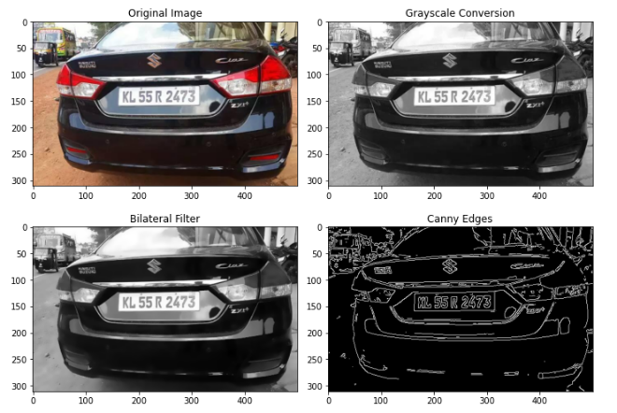

Fig. 1

***2.2. Edge Detection for Plate Localization***

Once the image has been pre-processed, the next step is to detect the edges that define the number plate region. In this research, *Sobel vertical edge**detection* is used. This technique focuses on detecting vertical edges in the image, as the majority of vehicle number plates are horizontally aligned, with vertical edges being the most prominent features of the plate. The Sobel operator computes the gradient of image intensity at each pixel, which highlights transitions between regions of the image. Vertical edges, which typically correspond to the left and right boundaries of the license plate, are particularly important for localization.

By applying the Sobel filter, regions of the image that contain strong vertical edges are detected. These areas are then further processed to isolate the plate area from other regions of the vehicle or background. The Sobel edge detection method is effective in emphasizing the number plate’s edges, even when the plate has slight tilts or is partially occluded.

***2.3.Morphological Operations for Refining Plate Detection***

To further refine the detection of the number plate, *morphological operations* are applied. Morphological transformations like *dilation* and *erosion* are used to enhance the features identified by the Sobel edge detection process. Dilation helps to connect broken edges and fill small gaps in the detected edges, while erosion is applied to eliminate small irrelevant regions, such as noise or background artifacts, that may interfere with plate detection. These operations work together to strengthen the structure of the detected number plate, ensuring that the bounding region is accurately defined.

By using these morphological operations, the algorithm improves the continuity of the vertical edges and smooths the boundaries, making the number plate area more distinct. This refinement is crucial for accurately isolating the number plate, which is essential for the next step of character segmentation.

***2.4. Detection of the Number Plate Region***

The number plate extraction process culminates in detecting the specific region of the image that contains the license plate. By combining the results of histogram equalization, Sobel edge detection, and morphological operations, the system identifies a candidate region in the image that most likely corresponds to the number plate. This region is then isolated for further processing.

Given the diverse nature of Indian number plates, which may vary in size, font, and orientation, it is essential to apply the detection process across different scales and orientations. The system can be configured to handle different plate aspect ratios, ensuring that plates with slight rotations or tilts are still detected effectively.

**3.System Flowchart**

The flowchart illustrates the sequential steps involved in the **Automatic Number Plate Recognition (ANPR) system**. The process follows a structured approach, starting from image acquisition and progressing through pre-processing, number plate localization, character segmentation, and recognition, ultimately producing an output through a graphical user interface (GUI). Each phase is explained below:

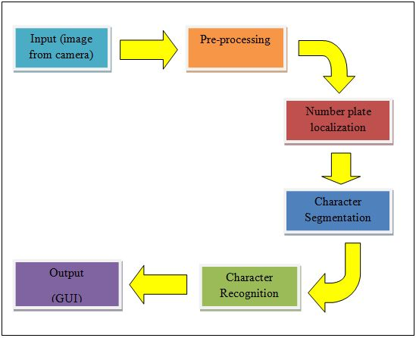

Fig.2

#### *****3.1 Input (Image from Camera)*****

The ANPR system begins with acquiring an image of a vehicle, typically captured using a **camera or CCTV system.** The image may contain a vehicle with a number plate in various orientations, lighting conditions, and background noise.

#### *****3.2. Pre-Processing*****

Before number plate detection, the image undergoes ***pre-processing*** to enhance quality and remove unwanted noise. The key steps in this stage include:

* ***Histogram Equalization***: Enhances contrast to improve visibility.
* ***Median Filtering***: Reduces noise while preserving edges.
* ***Grayscale Conversion***: Converts the image into a single-channel format for efficient processing.

#### *****3.3. Number Plate Localization*****

This stage focuses on identifying and extracting the ***Region of Interest (ROI)*** where the number plate is located. Techniques used include:

* ***Edge Detection (Sobel Operator)***: Highlights the vertical edges characteristic of number plates.
* ***Morphological Operations***: Helps refine detected edges and remove unwanted artifacts.
* ***Bounding Box Analysis***: Filters the detected regions based on the expected size and shape of number plates.

#### *****3.4. Character Segmentation*****

Once the number plate is detected, individual **characters** must be isolated for further recognition. This step involves:

* ***Projection Analysis***: Identifies the vertical and horizontal boundaries of characters.
* ***Connected Component Analysis***: Groups similar pixel clusters to differentiate characters.
* ***Noise Removal***: Filters out small unwanted objects that do not belong to the number plate characters.

#### *****3.5. Character Recognition*****

After segmentation, the individual characters are classified using an ***Optical Character Recognition (OCR) algorithm.*** This research employs a ***Support Vector Machine (SVM)*** classifier trained on alphanumeric characters for high-accuracy recognition. The OCR model identifies each segmented character and reconstructs the complete number plate sequence.

#### *****3.6. Output (GUI Display)*****

The final recognized number plate is displayed on a ***Graphical User Interface (GUI).*** The recognized number can be:

* Stored in a **database** for record-keeping.
* Compared with a **vehicle database** for law enforcement or toll systems.
* Used in **automated parking or access control** applications.

**4.Dataset**

The dataset used for the Automatic Number Plate Recognition (ANPR) system was sourced from an open repository and contains a collection of vehicle images with annotated number plates. The dataset consists of 237 images, each labeled with bounding box coordinates specifying the location of the number plates. The annotations were initially provided in JSON format and later converted into the YOLO (You Only Look Once) format for compatibility with the object detection model.

For effective training, the dataset underwent a pre-processing phase where the JSON annotations were reformatted to include class labels and bounding box information. The images were resized and normalized to enhance the model's ability to generalize across different lighting conditions, angles, and backgrounds. The dataset, though limited in size, was optimized for high-resolution images to ensure better detection and recognition accuracy.

The detection phase of the system was implemented using the YOLO v3 model, which was trained on the prepared dataset. This model enabled the identification and localization of number plates in real-time scenarios. Once the number plate region was extracted, Optical Character Recognition (OCR) was applied to recognize alphanumeric characters using the Pytesseract library. The effectiveness of the ANPR system was directly influenced by the diversity and quality of the training dataset. Challenges such as variations in plate design, different fonts, occlusions, and lighting conditions were addressed by enhancing the dataset through augmentation techniques.

To improve the system's accuracy and reliability, future work will involve expanding the dataset with more diverse and high-quality images. The inclusion of manually labeled images and advanced augmentation techniques will help refine the detection and recognition process, ensuring a more robust and adaptable ANPR system.

**5.Conclusion**

This research presents an Automatic Number Plate Recognition (ANPR) system designed for efficient and accurate vehicle identification. The system follows a structured approach, beginning with image acquisition, followed by pre-processing techniques to enhance image quality, number plate localization, character segmentation, and character recognition using machine learning algorithms. The YOLO v3 model was employed for detecting number plates, while Optical Character Recognition (OCR) was used to extract alphanumeric characters.

The experimental results demonstrate that the proposed system effectively detects and recognizes number plates under varying conditions, including changes in lighting, orientation, and background complexity. However, challenges such as partial occlusions, low-resolution images, and variations in plate design were observed, which can impact overall recognition accuracy. To address these limitations, future improvements will focus on expanding the dataset with a more diverse set of number plates, incorporating advanced image enhancement techniques, and utilizing deep learning models for improved accuracy.

In conclusion, this ANPR system provides a reliable approach to automatic vehicle identification, making it applicable in areas such as traffic monitoring, law enforcement, toll collection, and automated parking systems. With further enhancements, the system can be made more robust and adaptable for real-world deployment, ensuring higher efficiency in intelligent transportation systems.

**6.References**

[1] Hao Chen, Jisheng Ren, Huachun Tan, Jianqun Wang, “ A novel method for license plate localization”, 4th Proc. of ICIG 2007, pp. 604-609. [2] Gisu Heo, Minwoo Kim, Insook Jung, Duk Ryong Lee, Il Seok Oh, “Extraction of car license plate regions using line grouping and edge density methods”, International Symposium on Information Technology Convergence, 2007, pp. 37-42.

[3] Serkan Ozbay, Ergun Ercelebi, “Automatic vehicle identification by plate recognition”, Proc. of PWASET, vol. 9, no. 4, 2005, pp. 222-225.

[4] Mei Yu and Yong Deak Kim, “An approach to Korean license plate recognition based on vertical edge matching”, IEEE International Conference on System, Man and Cybernetics, 2000, vol.4, pp. 2975-2980.

[5] Farhad Faradji, Amir Hossein Rezaie, Majid Ziaratban, “A Morphological based License Plate Location”, ICIP, 2007, pp. I 57-I 60.

[6] Xiangjian He et al, “Segmentation of characters on car license plates”, 10th Workshop on Multimedia Signal Processing, Oct. 2008, pp. 399-402.

[7] Yungang Zhang, Changshui Zhang, “A New algorithm for character segmentation of license plate”, Proc. of IEEE Intelligent Vehicles Symposium, 2003, pp. 106-109.

[8] Feng Yang, Zheng Ma, Mei Xie, “A Novel approach for license plate character segmentation”, ICIEA, 2006, pp.1-6.

[9] Shen-Zheng Wang, His-Jian Lee, “Detection and recognition of license plate characters with different appearances,” Proc. of 16th International Conference on Pattern Recognition, vol.3, 2003, pp. 979-983.

[10] GitHub Repository, "Automatic Number Plate Recognition (ANPR) Dataset," Available at: [*https://github.com/sid0312/ANPR*](https://github.com/sid0312/ANPR), Accessed on [Date of Access].

Top of Form

Bottom of Form