FireSafe 360

Reflects the 360-degree fire detection using IOT

Dr. S. I. Bakhtar1, Mr. Shreyash P Gawande2, Mr. Ashish B Gate3, Mr. Anand S Sawai4, Mr. Abhishek N Dhale5, Mr. Hassan Areeb Khan6

*Assistant Professor in Electronics & Telecommunication Department,*

*Prof Ram Meghe College of Engineering and Management, Amravati (Maharashtra)1, Third Year Student in Electronics & Telecommunication Department,*

*Prof Ram Meghe College of Engineering and Management, Amravati (Maharashtra)23456*

**Abstract :**

FireSafe 360 is an innovative fire detection and monitoring system designed to provide comprehensive, 360-degree coverage using the power of the Internet of Things (IoT). This system integrates multiple sensors, smart devices, and real-time analytics to detect fires in their earliest stages, ensuring faster response times and minimizing the potential for damage. With its advanced IoT capabilities, FireSafe 360 connects seamlessly to a central control system, allowing for real-time monitoring, automated alerts, and remote control via mobile applications. By continuously scanning the environment in all directions, FireSafe 360 offers unparalleled safety, making it an essential solution for both residential and commercial applications. The system’s scalability, adaptability, and ease of integration with existing infrastructure make it a highly effective tool for modern fire safety management.

# Keywords:

ESP32, Flame Sensor, Fire Detection, IoT, Blynk Platform, Real-Time Alerts, Email Notifications, Mobile Pop-up Alerts, Safety System, Fire Hazard, Buzzer Alarm, Remote Monitoring, Smart Safety, Wireless Communication, Emergency Response, IoT-Based Fire Detection

# Introduction:

Fire safety is a critical aspect of both residential and industrial environments. Traditional fire detection systems are often limited in their ability to provide timely alerts, especially when it comes to detecting fires in areas that are difficult to monitor. In response to these challenges, this project leverages the power of the ESP32 microcontroller and IoT technology to create an advanced fire detection system. The system is equipped with four flame sensors placed at strategic points to detect fire from all directions, ensuring comprehensive coverage.

The ESP32, a powerful and energy-efficient microcontroller with built-in Wi-Fi and Bluetooth capabilities, is used to interface with the flame sensors and manage communication with the Blynk IoT platform. When a flame is detected, the system triggers a hardware buzzer for immediate

sound-based alerts, ensuring that individuals in the vicinity are alerted to potential danger.

In addition to the audible alarm, the system also sends real-time notifications through multiple channels, including mobile pop-up alerts and email notifications. This ensures that even if individuals are not in the immediate vicinity of the fire, they will be informed and able to take prompt action. The integration with the Blynk platform allows users to monitor the status of the system remotely, enhancing safety through continuous monitoring.

This project aims to improve fire safety by providing a comprehensive, real-time fire detection and alert system that can be accessed remotely, helping to prevent loss and ensuring quick emergency responses.

# Literature Survey:

The importance of fire detection systems cannot be overstated, as fire-related accidents can lead to significant loss of life and property. Traditional fire detection systems, such as smoke detectors and heat sensors, have been in use for decades, but they often have limitations in terms of coverage, accuracy, and response time. This literature survey explores previous studies and existing solutions in fire detection, focusing on advancements in technology, particularly the use of sensors, microcontrollers, and IoT integration.

1. **Fire Detection Systems and Sensor Technology:** Conventional fire detection systems typically rely on smoke or heat sensors. Smoke detectors, for example, use ionization or photoelectric methods to detect smoke particles. However, these systems can be limited in their ability to detect fire in its early stages, especially if the fire is small or the smoke is not noticeable. Heat sensors, while effective, are not as fast in detecting a fire's onset and can be less reliable in environments with fluctuating temperatures. To address these challenges, researchers have increasingly turned to **flame sensors**, which detect the specific wavelengths of light emitted by flames. Studies have shown that flame sensors, particularly **infrared (IR) sensors**, provide a more precise and early detection mechanism, making them more suitable for detecting fires in real-time.
2. **IoT-Integrated Fire Detection Systems:** The integration of IoT (Internet of Things) technology into fire detection systems has gained significant attention in recent years. IoT- based fire detection systems allow for real-time monitoring and alerts to be sent to mobile devices or cloud platforms. Research conducted by various scholars indicates that IoT- based systems can provide faster, more accurate fire detection, along with the ability to send alerts remotely. One notable study highlighted the use of **Arduino-based systems** integrated with Wi-Fi modules like **ESP8266** to provide remote monitoring of fire incidents. However, the ESP8266 has limitations in processing power and range, which makes the **ESP32** microcontroller a more powerful alternative for implementing IoT-based fire detection systems.
3. **ESP32-Based Fire Detection Systems:** The **ESP32 microcontroller** is a popular choice for IoT projects due to its dual-core processing, Wi-Fi and Bluetooth capabilities, and ease of integration with various sensors and platforms. In the context of fire detection, the ESP32 has been successfully used in combination with flame sensors to create remote fire alert systems. For instance, several projects have used the ESP32 to process data from flame sensors and trigger alerts through mobile applications, email, or even cloud-based platforms like **Blynk**. The **Blynk platform** allows users to receive real-time notifications on their mobile devices, providing a seamless user experience in remote monitoring.
4. **Real-Time Notifications and Alerts:** Many fire detection systems now incorporate

is in a different part of the building or away from home. The integration of mobile notifications, **email alerts**, and **push notifications** has been shown to significantly improve response time. For example, an IoT-based fire detection system can send a **push notification to the user’s mobile app**, or even an email notification to the registered email address when a fire is detected. This ensures that users are informed of potential hazards even when they are not present in the immediate vicinity.

1. **Multi-Sensor Fire Detection Systems:** Research has also focused on using multiple sensors to improve the accuracy and reliability of fire detection systems. The use of **multiple flame sensors** positioned around a space can provide more accurate detection, ensuring that fire detection is not limited to a single point. Several studies have shown that using **four flame sensors**, each placed in a different direction, can provide full coverage of the room or area, significantly reducing the chances of missing a fire in its early stages. This multi-sensor approach is particularly useful in large or complex spaces, where the fire may start in one part of the room and not immediately trigger a single sensor.

# Components Used and Their Roles:

1. **ESP32 Microcontroller:**
   * 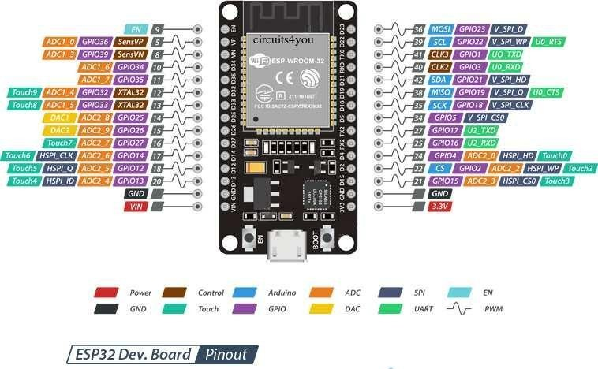**Role:** The ESP32 is the heart of the system. It is a powerful, low-cost microcontroller with built-in Wi-Fi and Bluetooth capabilities. It is used to process the signals from the flame sensors, manage communication with the Blynk IoT platform, control the relay, and handle notifications (both push and email). The ESP32 facilitates remote monitoring by sending real-time data to the user’s mobile device through the Blynk platform.
   * **Function:** It reads the input from the flame sensors, processes the data, and triggers

actions like sending notifications, activating the relay, or sounding an alarm.

# Flame Sensors (Four Sensors - One on Each Side):

* + **Role:** These sensors are used to detect the presence of fire by measuring infrared radiation emitted by flames. Four flame sensors are placed on all four sides of the area to provide full coverage and ensure that any fire, regardless of its location, will

be detected. Each sensor is sensitive to the wavelengths of light produced by flames, triggering an alert when it detects significant flame radiation.

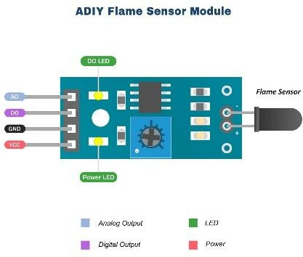

* + **Function:** The flame sensors detect the presence of flames or fire. When a flame is

detected, the sensor sends a signal to the ESP32, which processes it and triggers the necessary actions (activating a relay or sending notifications).

# Blynk IoT Platform (Mobile Application):

* + 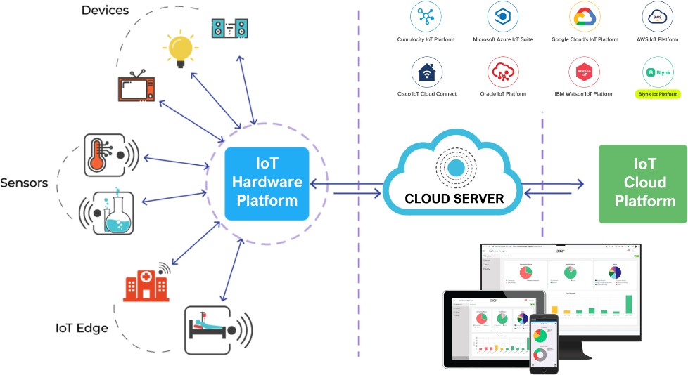**Role:** Blynk is a mobile application and IoT platform that allows easy remote monitoring and control of IoT devices. It provides a user-friendly interface to monitor fire detection, receive real-time notifications, and control connected devices (like the relay) from anywhere.
  + **Function:** The Blynk platform connects to the ESP32 through Wi-Fi and allows

users to receive **push notifications** on their mobile devices when a fire is detected. It also provides an interface for monitoring the status of the fire detection system.

# Buzzer (Hardware):

* + **Role:** The buzzer is a hardware component used as an audible alert when a fire is detected. It beeps loudly to notify people in the vicinity of a potential fire.



* + **Function:** When the flame sensor detects a fire, the ESP32 triggers the buzzer to

sound an alarm, warning people nearby about the fire.

# Power Supply ( Adapter):

* + **Role:** The power supply provides the necessary power for all the components (ESP32, sensors, relay, and buzzer).
  + **Function:** It powers the entire system, ensuring that the ESP32 and connected devices run continuously and reliably

Block diagram :

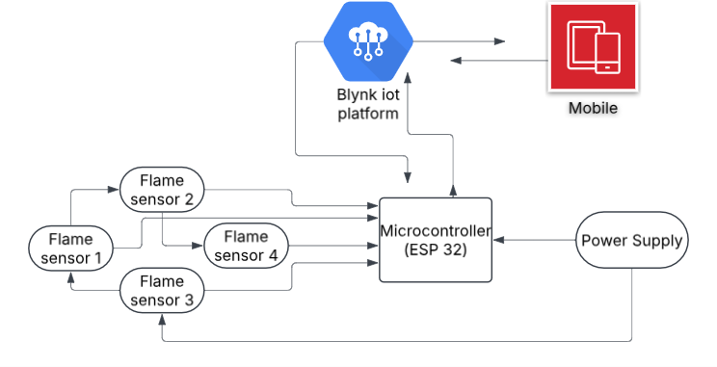

**References:**

1. Patel, S., & Patel, R. (2021). *Fire Detection System Using IoT: A Review*. International Journal of Advanced Research in Computer Science, 12(3), 35-40.
2. Rani, S., & Sharma, P. (2020). *Real-Time Fire Detection and Alarm System Using IoT and Wireless Sensors*. International Journal of Engineering Research & Technology, 9(6), 456-461.
3. Singh, M., & Singh, A. (2019). *Design and Implementation of IoT-Based Fire Detection System Using ESP32*. International Journal of Computer Applications, 182(5), 8-14.
4. Blynk, Inc. (2020). *Blynk: The Platform for the Internet of Things*. Blynk Documentation. Retrieved from https://docs.blynk.io.
5. Kumar, A., & Gupta, P. (2018). *IoT Based Fire Monitoring and Control System Using Flame Sensors and Smart Notification Alerts*. International Journal of Advanced Computer Science and Applications, 9(12), 42-46.
6. Mungara, S., & Deshmukh, A. (2022). *Smart Fire Safety System Using IoT and Wireless Sensor Network*. Procedia Computer Science, 184, 10-18.
7. Zhang, Y., & Lee, K. (2020). *Fire Safety System Based on IoT Technology: A Survey*. Journal of Safety Engineering, 28(3), 110-115.
8. Xu, S., & Zhang, H. (2021). *Design of IoT-Based Fire Safety System with Alarm and Remote Monitoring*. Journal of Electronics and Communication Engineering, 10(3), 123-130.
9. Arduino. (2019). *Flame Sensor Module for Fire Detection*. Retrieved from [https://www.arduino.cc](https://www.arduino.cc/).

**Conclusion:**

The proposed fire detection system using the **ESP32** microcontroller, **flame sensors**, and the **Blynk IoT platform** provides an efficient and reliable solution for detecting fires in a given area. The integration of four flame sensors positioned on all sides of the area ensures comprehensive fire detection, enhancing safety by identifying potential fire hazards from any direction.

When a fire is detected, the system triggers multiple responses, including the activation of a **buzzer** to alert individuals nearby and sending **real-time notifications** to the user's mobile device via the Blynk platform. Additionally, the system sends an **email notification** for further monitoring, providing a comprehensive alert mechanism.

The **Blynk IoT platform** facilitates seamless remote monitoring and control, allowing users to track the status of the sensors and receive immediate updates on fire detection. This makes the system not only an efficient fire detection solution but also a flexible and user-friendly tool for anyone looking to integrate fire safety into their homes or businesses.

This system not only enhances safety through immediate responses to fire detection but also allows users to remotely monitor the area and take necessary actions if needed. The combination of hardware and IoT technology ensures that the fire detection system is both intelligent and responsive, providing peace of mind and timely intervention when necessary.

In conclusion, this project demonstrates how **IoT** can be leveraged to enhance **fire safety**, offering a real-time, reliable, and efficient solution that can be implemented in various environments, from homes to industrial setups.